West Virginia Statewide Parcel Program

# Overview

Parcel records management is a critical governmental function that directly impacts arguably the most diverse sectors of government, commerce, security, safety, and citizenry of any governmental function. Parcel management can be divided into three systems - records management, valuation, and public engagement. A statewide parcel system would drive the state forward beyond the capabilities that any one county or one region can do on its own.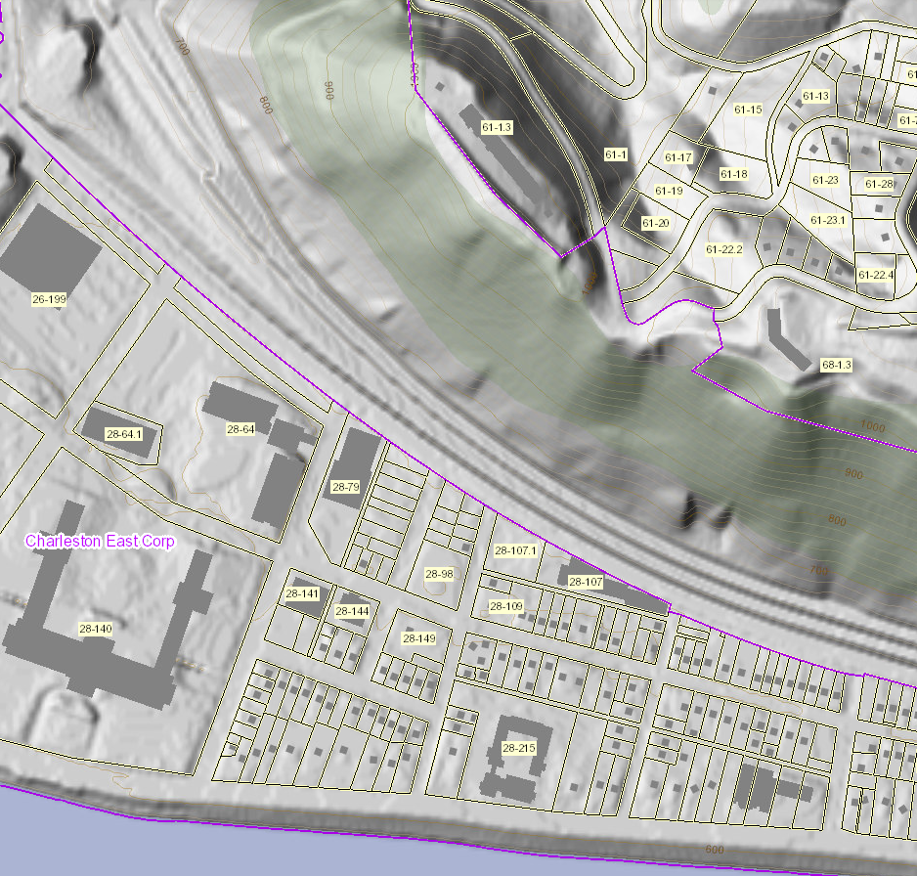

## Why do Parcels matter so much?

Quality parcel information gives users an insight not just land ownership, but parcel buildings, building quality, construction type, age, assessment history, and a host of other pieces of information. Combined with other foundational layers, such as addresses, imagery, or elevation, parcels provide an important understanding of the landscape citizens, private users, and governmental users.

## Why a Parcel Addressing Program?

Parcels are collected at the locality level but then shared with the state and then to the general public. WV completed the move to digital tax parcels in 2021 only through state and federal assistance. Maintaining that effort will fall back to localities absent a statewide program. Furthermore, a statewide program can provide necessary minimal standards, training, integration, and one-stop dissemination to users. Counties that need assistance can use a statewide program to supplement their own efforts.

## What benefits does a Parcel Addressing Program provide?

Parcel mapping is a labor intensive effort and in WV, it is undertaken at the local level. Localities have developed localized standards that meet their individual needs. Those standards led to unevenness in quality making integration efforts a challenge. Derivative products that build upon the quality of the data can only be as powerful as the lowest standard quality. A statewide program can help set standards and engage in quality control to make certain the entire state meets minimal standards. A statewide program can harmonize discrepancies between assessment and mapping efforts both within counties and between counties. These can further be combined with a statewide addressing program to assure owners and potential owners the parcel features exactly as advertised.

A statewide program helps create a more responsive government as well. Citizens and landowners have an efficient and accessible method to check existing records without having to spend valuable time traveling to specific locations. A statewide parcel program will also allow a faster turnaround time from data collection to publication. Owners and potential owners will see changes reflected more frequently. It is important to note, a statewide parcel program would not supplement important survey work! However, it can be a critical linkage between owners and local governments to make certain both are in agreement.

Moreover, a statewide program would allow the creation of products that can provide additional capabilities to the public. Examples such as combining the Delinquent Properties database with parcel records or combining economic development sites with parcel information highlight these capabilities.

# How would it work?

A statewide parcel program would fundamentally build upon the existing data and processes within the state. The State Tax Office already acts as a collection agent and the WV GIS Technical Center provides a public face to that data via the WV Property Viewer. The program would build upon these processes to make them more integrated and temporally responsive, not to mention assure quality control standards for data production.