Compressing and Decompressing LAS Files Using LAS Optimizer 1.2
Caleb Malay
7/15/2019

To decompress zlas files, download the LAS Optimizer 1.2 here: https://www.arcgis.com/home/item.html?id=787794cdbd384261bc9bf99a860a374f
*There are two versions: the 64-bit edition named EzLAS.exe, and the 32-bit edition named EzLAS_32.exe. We recommend use of the former but if you need to use the option to modify the spatial reference (i.e., 'Import PRJ file'), and have Desktop ArcGIS installed, then the 32-bit version is needed. *
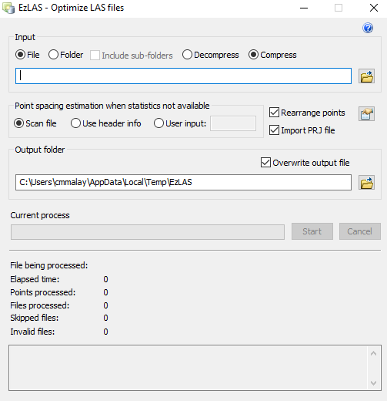
1. The software used is called EzLAS.
2. The user can choose to input files or folders. They can also decide whether to include sub-folders and whether to compress or decompress.
3. Leave all other options default with the exception of the Overwrite output file which should be checked.
4. Set the output location as the folder you want your las files to go.
5. Once output location is set, click Start. After the Current process bar is fully loaded, the process is complete.

