Braxton County BAS26 Notes
Compiled by Kurt Donaldson, WVU GIS Technical Center
Map exhibits have been created to attach to the attestation letters. The map exhibits for the attestation letters can be viewed and downloaded from the links below:
- Burnsville
- Flatwoods (change polygons, topo map)
- Gassaway
- Sutton (alternative streets map)

The Census geographic identifiers or GEOID numeric codes for the attestation letters are listed below in Table 1.

Table 1. Census GEOID codes that identify legal geographic areas.

GOVID | GEOID for Letter | Name | MTDB Expanded Lsad | NameLSAD for GUPS | County Name
15400011716 | 5411716 | Burnsville | town | Burnsville town | Braxton
15400027868 | 5427868 | Flatwoods | town | Flatwoods town | Braxton
15400030220 | 5430220 | Gassaway | town | Gassaway town | Braxton
15400078580 | 5478580 | Sutton | town | Sutton town | Braxton
25400700000 | 54007 | Braxton | County | Braxton County | Braxton

Below are notes and recommendations for each town.

(1) Burnsville
Notes: A precise boundary was mapped from the 1993 survey plat of the town limits. The coordinate geometry (COGO) mapping differs from the tax assessor map boundary at select locations.
Recommendation: Adopt the GIS mapped boundary from the survey plat.
Map View: https://arcg.is/izPmm2 (Census Boundary = red dash-dot line; Tax Map Bdry = teal shaded polygon; Revised Municipal Boundary/COGO Survey = grey hachured polygon)
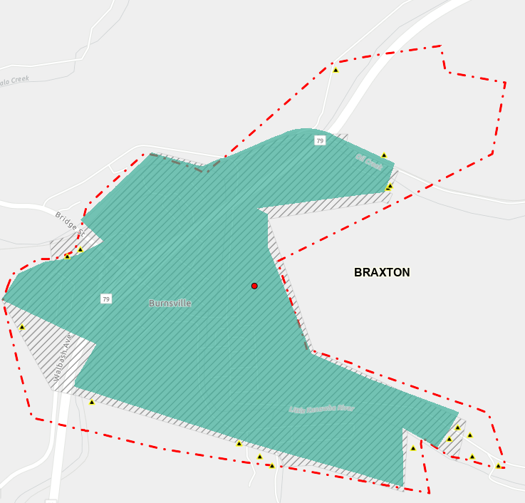

(2) Flatwoods
Notes: A precise boundary was mapped from the 2004 survey plat of the town limits. The difference between the survey boundary and the tax map boundary is minimal.
Recommendation: Adopt the GIS mapped boundary from the survey plat.
Map View: https://arcg.is/0zCXGb1 (Census Boundary = red dash-dot line; Revised Municipal Boundary/COGO Survey = brown shaded polygon with hachures)
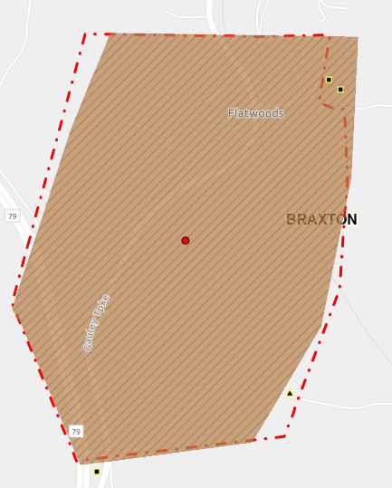

(3) Gassaway
Notes: No legal documents of the municipal boundary were obtained.
Recommendation: Adopt the tax map boundary. An attestation letter from the mayor is required.
Map View: https://arcg.is/8e1jC1 (Census Boundary = red dash-dot line; Tax Map Bdry = green shaded polygon)
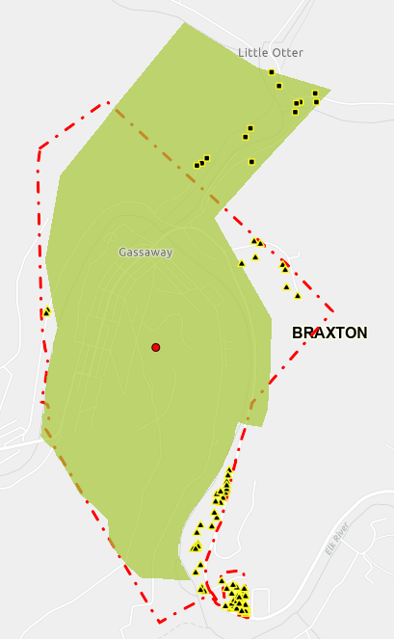
(4) Sutton
Notes: No legal documents of the municipal boundary were obtained.
Recommendation: Adopt the tax map boundary. An attestation letter from the mayor is required.
Map View: https://arcg.is/SOHDu1 (Census Boundary = red dash-dot line; Tax Map Bdry = green shaded polygon)
