Tucker County BAS26 Notes
Compiled by Kurt Donaldson, May 2026
WVU GIS Technical Center

GOVID | GEOID for TIGERweb | Name | MTDB Expanded Lsad | NameLSAD for GUPS | County Name
15400020428 | 5420428 | Davis | town | Davis town | Tucker
15400034492 | 5434492 | Hambleton | town | Hambleton town | Tucker
15400036460 | 5436460 | Hendricks | town | Hendricks town | Tucker
15400062284 | 5462284 | Parsons | city | Parsons city | Tucker
15400080020 | 5480020 | Thomas | city | Thomas city | Tucker
25409300000 | 54093 | Tucker | County | Tucker County | Tucker

The map exhibits for the cities of Parsons and Thomas can be viewed from the links below:
- Map Exhibit for Parsons
- Map Exhibit for Thomas

(1) Thomas Corporation
The northern annexation submitted previously to Census was never official and thus needs to be deleted from the Census incorporated place file. The county tax maps are the most reliable data source for the municipal boundary. Note that the corporation does include some discontiguous parcels north of the main corporation boundary. The shared boundary of Davis and Thomas shown by Census will not change.

Recommendation: Submit to Census the current municipal boundary shown on the Assessor's tax maps. A signed mayoral attestation letter and map exhibit are needed for the BAS countywide submission.

Boundary Map View: https://arcg.is/0WCivy (Red dash-dot line is current Census boundary; shaded polygons are boundary corrections from Tucker County)
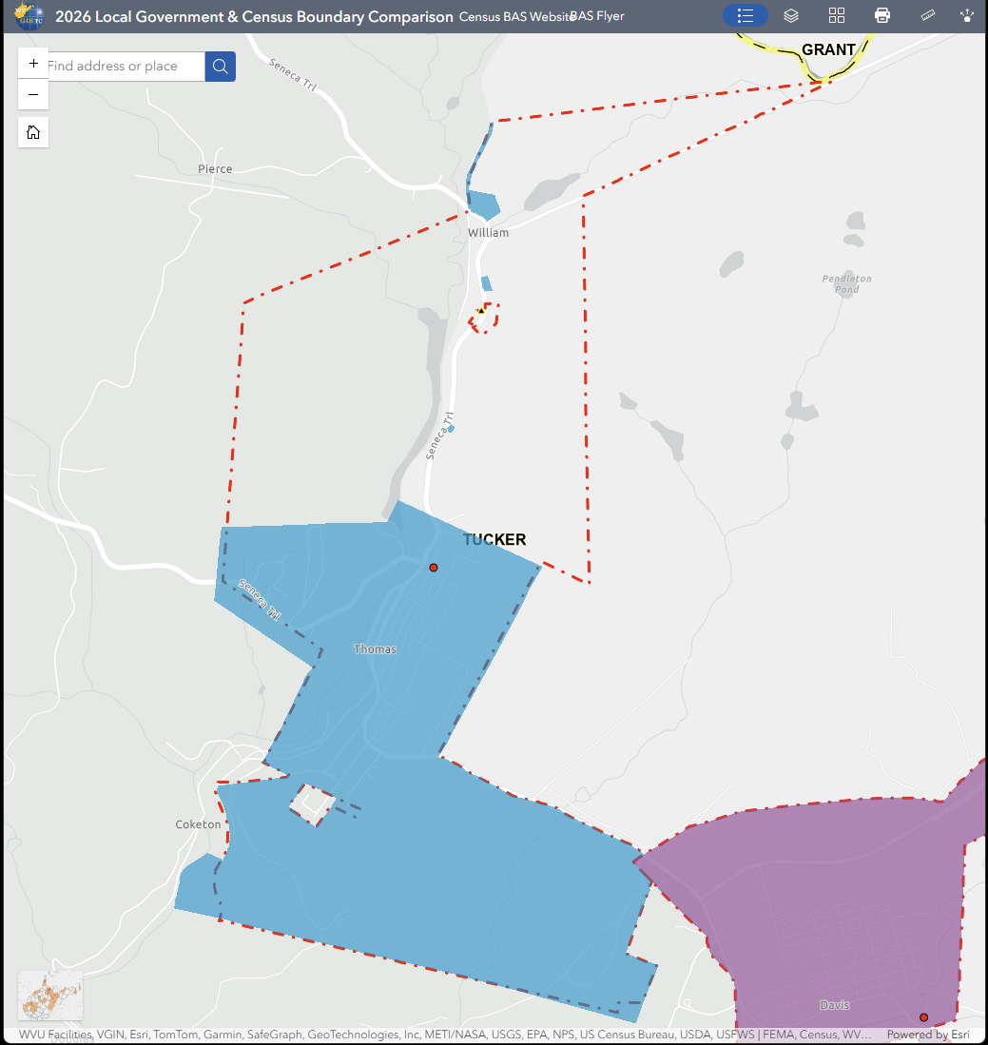

(2) Parsons Corporation
There are no legal documents to verify boundaries, and city documents perished from the 1985 flood. The tax map boundaries provide the most current information about the municipal boundaries. Links to the county's PDF tax maps with municipal boundaries are listed below.

Structures Affected between current Local & Census Boundaries:
7 structures: Southern boundary of city (Tax Map 10-10)
8 structures: Western boundary of city ((Tax Map 1-283 , Tax Map 10-4, Tax Map 10-2)
24 structures: Northern boundary of city (Tax Map 10-2)

Recommendation: Submit to Census the boundary changes according to the boundaries on the county tax maps, along with an attestation letter and map attachment from the Mayor.

Boundary Map View: https://arcg.is/1rrP1i0
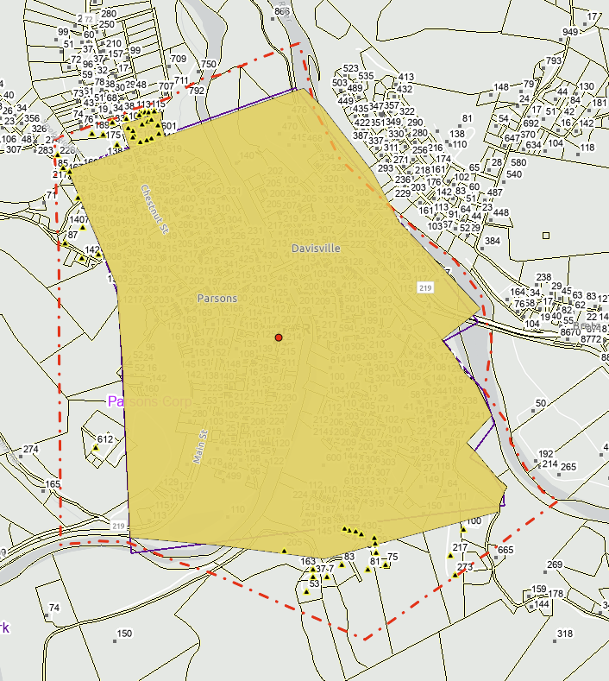

(3) Hendricks Corporation
The coordinate geometry mapping of the survey plat matches the findings of Andrew Meadows as shown on the BAS Comparison Viewer. No structures are affected.

Recommendation: Submit to Census BAS the boundary corrections according to the survey plat document.

Boundary Map View: https://arcg.is/0D8WSS2
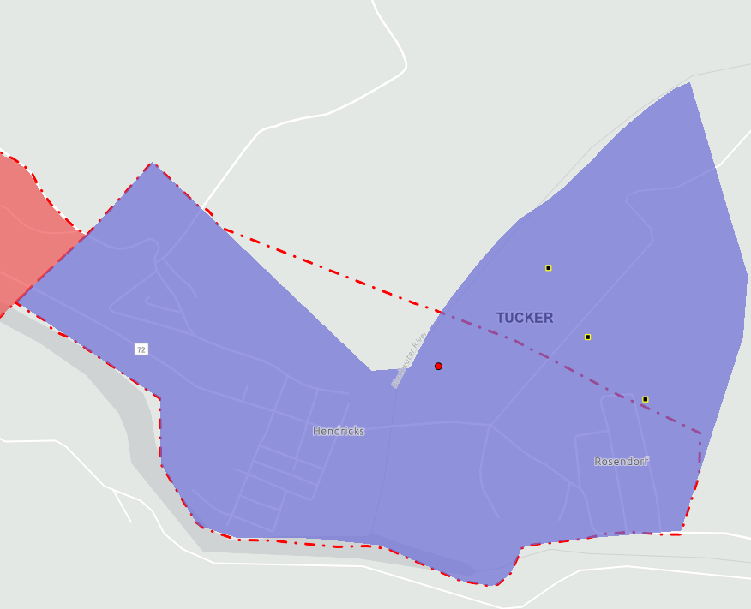

(4) Hambleton Corporation
The coordinate geometry mapping of the town's legal description matches the findings of Andrew Meadows as shown on BAS Comparison Viewer. The structure at 9346 SENECA TRL, PARSONS, WV, 26287 should not be part of the Hambleton Corporation in contrast to the Census boundary.

Recommendation: Submit to Census BAS the boundary corrections with the legal description document.

Boundary Map View: https://arcg.is/0LHbG90
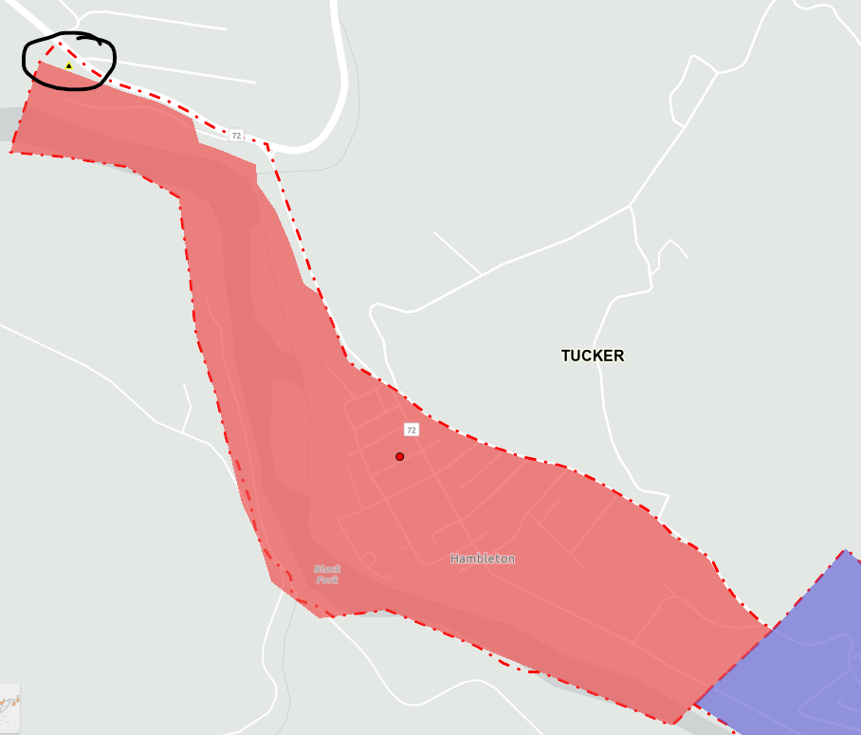

(5) Davis Corporation
The coordinate geometry mapping of the survey plats matches the findings of Andrew Meadows and the Census Boundary as shown on BAS Comparison Viewer. No structures are affected.

Recommendation: No submission to BAS is necessary since the community boundary matches the Census boundary.

Boundary Map View: https://arcg.is/0bf0fy3
