Series Information File for the 2018 TIGER/Line Shapefile, Current Place State-based

Metadata
File Identifier: SeriesCollection_tl_2018_place.shp.iso.xml
Metadata Language: eng
: UTF-8
Resource Type: Series
Responsible Party:
Metadata Date: 2018-12-12
Metadata Standard Name: ISO 19115 Geographic Information - Metadata
Metadata Standard Version: 2009-02-15
Data Identification
Abstract: The TIGER/Line shapefiles and related database files (.dbf) are an extract of selected geographic and cartographic information from the U.S. Census Bureau's Master Address File / Topologically Integrated Geographic Encoding and Referencing (MAF/TIGER) Database (MTDB). The MTDB represents a seamless national file with no overlaps or gaps between parts, however, each TIGER/Line shapefile is designed to stand alone as an independent data set, or they can be combined to cover the entire nation. The TIGER/Line shapefiles include both incorporated places (legal entities) and census designated places or CDPs (statistical entities). An incorporated place is established to provide governmental functions for a concentration of people as opposed to a minor civil division (MCD), which generally is created to provide services or administer an area without regard, necessarily, to population. Places always nest within a state, but may extend across county and county subdivision boundaries. An incorporated place usually is a city, town, village, or borough, but can have other legal descriptions. CDPs are delineated for the decennial census as the statistical counterparts of incorporated places. CDPs are delineated to provide data for settled concentrations of population that are identifiable by name, but are not legally incorporated under the laws of the state in which they are located. The boundaries for CDPs often are defined in partnership with state, local, and/or tribal officials and usually coincide with visible features or the boundary of an adjacent incorporated place or another legal entity. CDP boundaries often change from one decennial census to the next with changes in the settlement pattern and development; a CDP with the same name as in an earlier census does not necessarily have the same boundary. The only population/housing size requirement for CDPs is that they must contain some housing and population. The boundaries of most incorporated places in this shapefile are as of January 1, 2015, as reported through the Census Bureau's Boundary and Annexation Survey (BAS). The boundaries of all CDPs were delineated as part of the Census Bureau's Participant Statistical Areas Program (PSAP) for the 2010 Census.
Purpose: In order for others to use the information in the Census MAF/TIGER database in a geographic information system (GIS) or for other geographic applications, the Census Bureau releases to the public extracts of the database in the form of TIGER/Line Shapefiles.
Language: eng
Thumbnail:

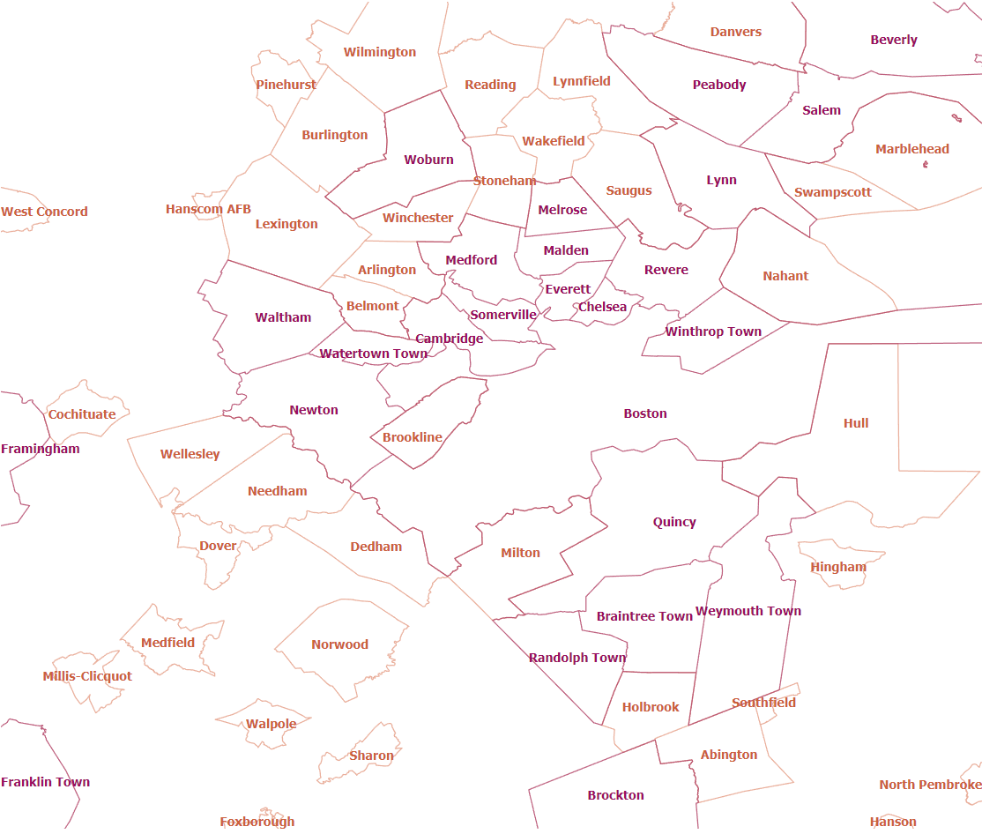

Browse Graphic: https://tigerweb.geo.census.gov/arcgis/services/TIGERweb/tigerWMS_Current/MapServer/WmsServer?REQUEST=GetMap&SERVICE=WMS&VERSION=1.3.0&LAYERS=Census Designated Places,Census Designated Places Labels,Incorporated Places,Incorporated Places Labels&STYLES=default,default,default,default&FORMAT=image/svg+xml&BGCOLOR=0xFFFFFF&TRANSPARENT=TRUE&CRS=EPSG:4326&BBOX=42.299053,-71.408142,42.35679,-70.798861&WIDTH=891&HEIGHT=751
Browse Graphic Type: URL for the TigerWeb Web Mapping Service
Browse Graphic Caption: URL for the TigerWeb Web Mapping Service
Citation:
Title: Series Information File for the 2018 TIGER/Line Shapefile, Current Place State-based
Alternate Title: National Geospatial Data Asset (NGDA) Place
Date:
Date: 2018
Date Type: Publication Date
Edition: 2018
Point Of Contact:
Representation Type: Vector
Topic Category: Administrative and Political Boundaries
Keyword Collection:
Keyword: NGDA
Keyword: Governmental Units and Administrative and Statistical Boundaries Theme
Keyword: National Geospatial Data Asset
Associated Thesaurus: NGDA Portfolio Themes
Keyword: State or equivalent entity
Keyword: Polygon
Keyword: Census Designated Place
Keyword: CDP
Keyword: City
Keyword: Village
Keyword: Town
Associated Thesaurus: None
Keyword: U.S.
Keyword: United States
Keyword: State or Equivalent Entity
Associated Thesaurus: ISO 3166 Codes for the representation of names of countries and their subdivisions
Spatial Extent:
West Bounding Longitude: -179.231086
East Bounding Longitude: 179.859681
North Bounding Latitude: 71.441059
South Bounding Latitude: -14.601813
Legal Constraints:
Access Constraints: Other Restrictions
Use Constraints: Other Restrictions
Other Constraints: Access Constraints: None
Distribution
Distribution Format:
Format Name: TGRSHP (compressed)
Format Version:
File Decompression Technique: The TIGER/Line shapefiles contain geographic data only and do not include display mapping software or statistical data. For information on how to use the TIGER/Line shapefile data with specific software package users shall contact the company that produced the software.
Distribution Format:
Format Name: HTML
Format Version:
Transfer Options:
URL: https://www2.census.gov/geo/tiger/TIGER2018/PLACE
Name:
Transfer Options:
URL: https://www.census.gov/geo/maps-data/data/tiger-line.html
Name:
Description:
Transfer Options:
URL: https://tigerweb.geo.census.gov/arcgis/services/TIGERweb/tigerWMS_Current/MapServer/WMSServer
Application Profile:
Name:
Description:
Function: Download
Transfer Options:
URL: https://tigerweb.geo.census.gov/arcgis/rest/services/TIGERweb/Places_CouSub_ConCity_SubMCD/MapServer
Application Profile:
Name:
Description:
Function: Download
Transfer Options:
URL: https://meta.geo.census.gov/data/existing/decennial/GEO/GPMB/TIGERline/TIGER2018/nectadiv/tl_2018_us_nectadiv.shp.iso.xml
Name:
Distributor:
Distributor Contact:

