**Series Information File for the 2018 TIGER/Line Shapefile, Current Place State-based**

**Metadata**

***File Identifier:***SeriesCollection_tl_2018_place.shp.iso.xml

***Metadata Language:***eng

***:***UTF-8

***Resource Type:***Series

***Responsible Party:***

***Metadata Date:***2018-12-12

***Metadata Standard Name:***ISO 19115 Geographic Information - Metadata

***Metadata Standard Version:***2009-02-15

**Data Identification**

***Abstract:***The TIGER/Line shapefiles and related database files (.dbf) are an extract of selected geographic and cartographic information from the U.S. Census Bureau's Master Address File / Topologically Integrated Geographic Encoding and Referencing (MAF/TIGER) Database (MTDB). The MTDB represents a seamless national file with no overlaps or gaps between parts, however, each TIGER/Line shapefile is designed to stand alone as an independent data set, or they can be combined to cover the entire nation. The TIGER/Line shapefiles include both incorporated places (legal entities) and census designated places or CDPs (statistical entities). An incorporated place is established to provide governmental functions for a concentration of people as opposed to a minor civil division (MCD), which generally is created to provide services or administer an area without regard, necessarily, to population. Places always nest within a state, but may extend across county and county subdivision boundaries. An incorporated place usually is a city, town, village, or borough, but can have other legal descriptions. CDPs are delineated for the decennial census as the statistical counterparts of incorporated places. CDPs are delineated to provide data for settled concentrations of population that are identifiable by name, but are not legally incorporated under the laws of the state in which they are located. The boundaries for CDPs often are defined in partnership with state, local, and/or tribal officials and usually coincide with visible features or the boundary of an adjacent incorporated place or another legal entity. CDP boundaries often change from one decennial census to the next with changes in the settlement pattern and development; a CDP with the same name as in an earlier census does not necessarily have the same boundary. The only population/housing size requirement for CDPs is that they must contain some housing and population. The boundaries of most incorporated places in this shapefile are as of January 1, 2015, as reported through the Census Bureau's Boundary and Annexation Survey (BAS). The boundaries of all CDPs were delineated as part of the Census Bureau's Participant Statistical Areas Program (PSAP) for the 2010 Census.

***Purpose:***In order for others to use the information in the Census MAF/TIGER database in a geographic information system (GIS) or for other geographic applications, the Census Bureau releases to the public extracts of the database in the form of TIGER/Line Shapefiles.

***Language:***eng

***Thumbnail:***

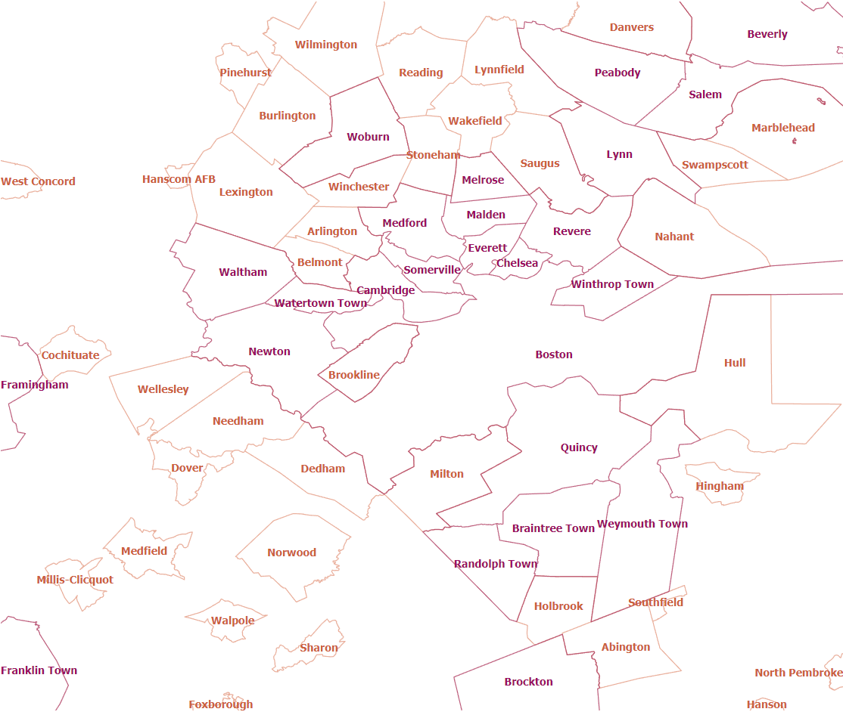

***Browse Graphic:***https://tigerweb.geo.census.gov/arcgis/services/TIGERweb/tigerWMS_Current/MapServer/WmsServer?REQUEST=GetMap&SERVICE=WMS&VERSION=1.3.0&LAYERS=Census Designated Places,Census Designated Places Labels,Incorporated Places,Incorporated Places Labels&STYLES=default,default,default,default&FORMAT=image/svg+xml&BGCOLOR=0xFFFFFF&TRANSPARENT=TRUE&CRS=EPSG:4326&BBOX=42.299053,-71.408142,42.35679,-70.798861&WIDTH=891&HEIGHT=751

***Browse Graphic Type:***URL for the TigerWeb Web Mapping Service

***Browse Graphic Caption:***URL for the TigerWeb Web Mapping Service

***Citation:***

***Title:***Series Information File for the 2018 TIGER/Line Shapefile, Current Place State-based

***Alternate Title:***National Geospatial Data Asset (NGDA) Place

***Date:***

***Date:***2018

***Date Type:***Publication Date

***Edition:***2018

***Point Of Contact:***

***Representation Type:***Vector

***Topic Category:***Administrative and Political Boundaries

***Keyword Collection:***

***Keyword:***NGDA

***Keyword:***Governmental Units and Administrative and Statistical Boundaries Theme

***Keyword:***National Geospatial Data Asset

***Associated Thesaurus:***NGDA Portfolio Themes

***Keyword:***State or equivalent entity

***Keyword:***Polygon

***Keyword:***Census Designated Place

***Keyword:***CDP

***Keyword:***City

***Keyword:***Village

***Keyword:***Town

***Associated Thesaurus:***None

***Keyword:***U.S.

***Keyword:***United States

***Keyword:***State or Equivalent Entity

***Associated Thesaurus:***ISO 3166 Codes for the representation of names of countries and their subdivisions

***Spatial Extent:***

***West Bounding Longitude:***-179.231086

***East Bounding Longitude:***179.859681

***North Bounding Latitude:***71.441059

***South Bounding Latitude:***-14.601813

***Legal Constraints:***

***Access Constraints:***Other Restrictions

***Use Constraints:***Other Restrictions

***Other Constraints:***Access Constraints: None

**Distribution**

***Distribution Format:***

***Format Name:***TGRSHP (compressed)

***Format Version:***

***File Decompression Technique:***The TIGER/Line shapefiles contain geographic data only and do not include display mapping software or statistical data. For information on how to use the TIGER/Line shapefile data with specific software package users shall contact the company that produced the software.

***Distribution Format:***

***Format Name:***HTML

***Format Version:***

***Transfer Options:***

***URL:***<https://www2.census.gov/geo/tiger/TIGER2018/PLACE>

***Name:***

***Transfer Options:***

***URL:***<https://www.census.gov/geo/maps-data/data/tiger-line.html>

***Name:***

***Description:***

***Transfer Options:***

***URL:***<https://tigerweb.geo.census.gov/arcgis/services/TIGERweb/tigerWMS_Current/MapServer/WMSServer>

***Application Profile:***

***Name:***

***Description:***

***Function:***Download

***Transfer Options:***

***URL:***<https://tigerweb.geo.census.gov/arcgis/rest/services/TIGERweb/Places_CouSub_ConCity_SubMCD/MapServer>

***Application Profile:***

***Name:***

***Description:***

***Function:***Download

***Transfer Options:***

***URL:***<https://meta.geo.census.gov/data/existing/decennial/GEO/GPMB/TIGERline/TIGER2018/nectadiv/tl_2018_us_nectadiv.shp.iso.xml>

***Name:***

***Distributor:***

***Distributor Contact:***