Support for Hazard Mitigation Plans
Flood Risk aSSESSMENT
METHODOLOGY
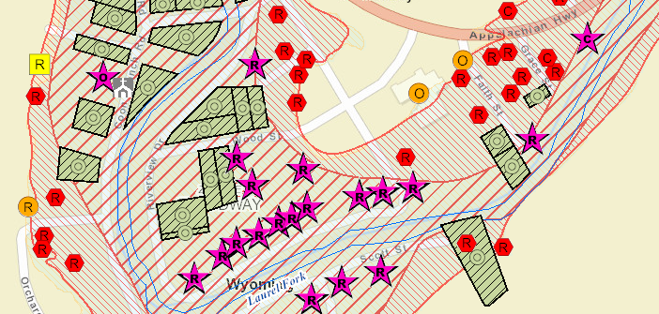

August 10, 2021

Prepared by:
Kurt Donaldson
Maneesh Sharma
WV GIS Technical Center
Department of Geology & Geography
330 Brooks Hall, PO Box 6300
West Virginia University
Morgantown, WV 26506


Special thanks for support from FEMA, WV DHSEM, and DOGAMI.

CONTENT
Overview 1
Building Inventory 2
Water Depth Grids 2
Flood Risk Assessment Products 3
Community Exposure and Risk 3
Building-Level Exposure 4
Building-Level Flood Risk Assessment 5
Mitigation Opportunities 6
Community Engagement & Field Verification 6
References 7
Appendix 1: Primary Structures 8
Appendix 2: Mobile Homes and OBY Assessment Table 11
Appendix 3: Dilapidated or Vacated Structures 14
Appendix A: Tables and Figures 15
Appendix B: Glossary 51

TABLES
Table 1. Flood Risk Products 14
Table 2. Flood Risk Layers 18
Table 3. Spatial Identifiers 26
Table 4. Hazus Model Inputs: Building Characteristics 27
Table 5. Hazus Mode Inputs: Flood Water Depth 27
Table 6. Hazus Mode Inputs: Building Point 27
Table 7. RESIDENTIAL Basement Information from Assessment Records 28
Table 8. COMMERCIAL Basement Information from Assessment Records 28
Table 9. Foundation Type, Foundation Code, First Floor Height for Hazus Flood Model 29
Table 10. Hazus Occupancy Class Descriptions 30
Table 10A. Occupancy Classifications 34
Table 11. WV Assessment Land Use Codes 35
Table 12. Average Mobile Home Appraisal Values by County 42
Table 13. Data Issues and Quality Control Measures 44
Table 14. Building Inventory Enhanced (BIE) Attributes 45
Table 15. Hazus FAST Inputs. Building Input FAST (BIF) Attributes 47
Table 16. Hazus FAST Outputs. Building FAST Outputs (BOF) 48

FIGURES
Figure 1. Hazus Building-Level Flood Loss Estimates 1
Figure 2. Flood Risk Products: Flood Risk Grids, Flood Zone Changes, Risk Per Structure 19
Figure 3. Building-Level Flood Risk Products 20
Figure 4. Building-Level Flood Risk Assessments Published to WV Flood Tool 21
Figure 5. WV Flood Tool, WV Property Viewer, and Web Parcel Assessment Report 22
Figure 6. Flood Risk Map 23
Figure 7. Flood Risk Database 23
Figure 8. Building-Level Flood Risk Assessment Cycle 24
Figure 9. Building Inventory Workflow 24
Figure 10. Hazus Flood Loss Flowchart 25

Methodology

Overview
Funded by a FEMA Hazard Mitigation Grant Program (HMGP) and the State Hazard Mitigation Office, building-level flood risk assessments are being completed statewide for a 1% annual chance flood (100-year) event in support of local and state hazard mitigation plans. The building-level flood risk assessments utilize FEMA’s Flood Assessment Structure Tool (FAST), a GIS-based, open source utility designed by FEMA’s Hazus Program for estimating potential building losses from flood disasters. FAST was built from the ArcGIS Python script developed by Oregon’s Department of Geology and Mineral Industries (DOGAMI). A Hazus Level 2 advanced analysis increases the accuracy and precision of an analysis by incorporating user-supplied data relevant to the hazard. The flood model results support local hazard mitigation plans and other flood reduction efforts.

The Hazus utility employs a standardize methodology in which building and water depth inputs utilize Depth Damage Functions (DDFs) to calculate economic damage loss estimates. The proper Depth Damage Function (DDF) is assigned based on the Occupancy Type, Foundation Type, and Number of Stories of each structure. The First Flood Height for each structure point is subtracted from the Water Depth to calculate the Depth-in-Structure flood depth, in feet above ground level.

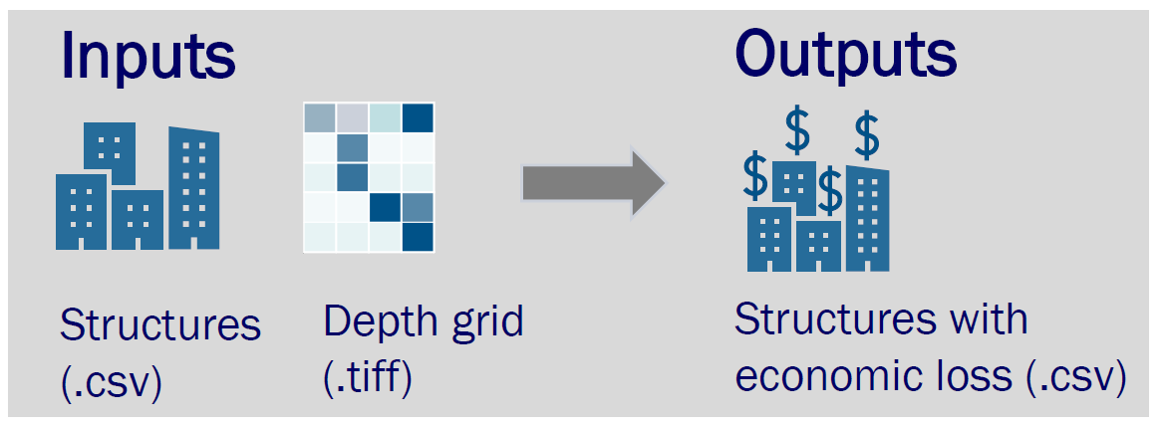

Figure 1. Hazus Building-Level Flood Loss Estimates. Source: FEMA.

The FAST performs a Hazus Flood Model analysis, using the most accurate 100-year depth grid available. It generates damage loss estimates for building, content, and inventory, building debris, and building repair/replacement times. Population displacement estimates are computed from the Residential Occupancy Types and census average household size. All building-level risk assessments are output to tabular reports, geodatabase, and the RiskMAP View of the WV Flood Tool.

The Hazus Program designed FAST to make flood risk assessments quicker, simpler, and more cost effective. FAST provides planners, analysts and policymakers with a free and user-friendly tool to characterize flood risk in their communities using completely open methods and technology.

Building Inventory
Detailed building inventories are developed by pinpointing all primary structures in the high-risk effective and advisory floodplains. Historical and community assets (government buildings, churches) are also inventoried. Essential facilities are inventoried to the 0.2-pecent (500-year) annual chance flood event. Required building characteristics are Occupancy Class, Foundation Type, First Floor Height, Number of Stories, Area, and Replacement Cost. Default values are populated from the most current State Parcel Assessment Database which us updated annually, and then where necessary modified with user-defined values that override the Assessment Database values. User-defined values can be entered for the building address, parcel geometry and assessment identifiers, essential building characteristics, and base flood water depth. Building pictures can be linked to the risk assessment using the unique building identifier.
GIS Specialists use desktop mapping software to pinpoint the building location to the most restrictive flood zone, identify insurable primary structures, match building points to the correct building assessment records, complete missing building attributes, and modify default assessment building values with user-supplied values. The following GIS Reference Layers are used to improve the location accuracy and building attributes: E-911 Addresses, Parcels/Attributes, Aerial Imagery, Building Footprints, Street View Pictures, Elevation Certificates, and other building reference databases. All the building points in the Special Flood Hazard Area and High-Risk Advisory Zones are manually captured, processed, and then quality checked using nine square mile grids. Data error flags are recorded for missing assessment values, parcel misalignments, missing E-911 address numbers, etc. User-supplied values that override the default assessment values are recorded as red text in the building inventory tables. A unique building identifier is formed from concatenating the Parcel ID and Building Address Number.

Water Depth Grids
The Water Depth Grid communicates information about the flood depth for a 1-percent (100-year) annual chance flood. Flood Depth Grids illustrate the flood depth, in feet above the ground surface, to demonstrate the variability of flood depths in flood prone areas. Officials can use depth grids to help individuals visualize the depth of flooding their home might experience; an easier concept than understanding a base flood elevation. The depth grid, combined with an inventory of the built environment, is used by the Hazus Flood Model to determine flood loss potential, by applying the appropriate depth- damage curves. For the Flood Model Analysis, Model-Backed Depth Grids created from engineering software like HEC-RAS are preferred over the less-accurate Hazus Depth Grids. In the WV Flood Tool, the Water Depth is displayed in the (1) Flood Results Query Panel, (2) Flood Risk Layers Menu, and (3) 3D Flood Visualization.

Flood Risk Assessment Products
Flood Risk Products are presented at the building and community levels for each county. Primary products include a Flood Risk Report, Flood Risk Map, Flood Risk Database, Flood Risk Tables, Flood Risk Grids (Water Depth, Water Surface Elevation), Flood Zone Changes resulting from active or future flood map studies, and Building-Level Flood Risk Assessments. Building Exposure information like structure values, occupancy type, owner occupancy, and household population are tabulated per structure. The Hazus Flood Model calculates per structure Building Damage Loss Estimates, Debris Removal, and Restoration Time for a 1% annual chance flood event. The Population Displacement is computed per residential structure from the building inventory and census average household size which provide inputs for Short-Term Shelter Models. Other data layers and products which support floodplain management and risk assessments include dams, levees, landslides, high-water marks, LOMA verified points, elevation certificates, assessment reports, CRS program variables, and 3D flood visualizations. Building Flood Risk Products are viewable in both tabular or graphical formats. Building-level risk assessments are aggregated to the community-level, which in turn can be summarized at the regional and state levels. Risk assessment reports can also be generated at the stream and watershed levels.
Although the Flood Risk Reports and data are organized primarily at the community and building levels, users can access the detailed risk assessments of each structure by viewing the Flood Risk Tables or WV Flood Tool. Mitigation layers (e.g., buyout properties, open space preservation) provide information for communities to identify flood reduction activities. FEMA’s Community Engagement Prioritization Tool (CEP-Tool) will be used to rank communities by risk indicators and prioritize for engagement.

Community Exposure and Risk

There are 287 communities (232 municipalities and 55 unincorporated counties), 11 planning regions, and 55 counties.
- Demographic / Social Vulnerability
  - Population Growth
  - Population in SFHA
  - Social Vulnerability (SOVI)
  - Ownership
  - Income
  - Age
- Land Use / Impervious Surfaces
- Historical Flooding
  - Presidential-Declared Disasters
  - Date of Last Disaster
  - High Water Marks
- Insurance Claims
- Insurance Policies
- Flood Zones
  - Stream Miles
  - Regulatory Floodway
  - High-Risk Advisory Zones (Advisory A, Updated AE, Preliminary NFHL)
  - Area in SFHA (aSFHA)
- Structures Summary
  - Buildings in SFHA (counts, values, occupancy class, etc.)
  - Facilities (Essential, Community, Government)
  - Historical
  - Repetitive Loss Structures
  - Dams and Levees
  - Transportation Infrastructure (Roads / Bridges)
- Flood Risk Assessment Summary
  - Building Damage
  - Debris Removal
  - Population Displaced
    - Short-Term Sheltering
    - Companion Pets

Building-Level Exposure
The data variables below identify flood exposure to buildings and communities:

Flood Zones
- Regulatory / Non-Regulatory / Floodway
- High-Risk Advisory Zones / Future Map Conditions
  - Mapped-In SFHA
  - Mapped-Out SFHA
  - No Change SFHA
  - Floodway
- LOMA (Positional Accuracy Verified)
  - Structure Removal
  - Structure Non-Removal
  - Structure Out as Shown
- Flooding Source by Stream Name / Watershed
- Population in SFHA

Water Depth
- Water Depth
- Water Depth-in-Structure
- Water Surface Elevation

Structures
- Building Exposure
- Building Exposure Cost
- Building Occupancy Class (Residential/Commercial/Other)
- Building Owner Occupied / Rental
- Basement / Foundation Type
- First-Floor Height / Lowest Floor
- Building Year / Construction / New Development (Pre-FRIM, Post-FIRM)
- Essential Facilities / Community Assets
- Historical Structure
- Riparian Zone Structure

Building-Level Flood Risk Assessment

Site-specific flood assessments are conducted for a 1% annual chance flood (100-year flood) event. FEMA’s OpenHazus Flood Assessment Structure Tool is employed for the Flood Analysis Model.

- Building Damage Percent (Hazus)
- Building Damage Loss U.S. Dollars (Hazus)
- Content and Inventory Loss (Hazus)
- Debris Removal (Hazus)
- Restoration Time (Hazus)
- Population Displacement

Mitigation Opportunities

Factors to identify flood reduction measures and areas of mitigation interest:

- Open Space Preservation / Restore Floodplain to Natural Functions
  - Buyout Properties (Deed-Restricted)
  - Public Lands
  - Private Lands
  - Riparian Zones
- Natural Flood Zone Functions
  - Riparian Zones
  - Wetlands
  - Habitat
  - Permeable Surfaces
- Repetitive Loss Structures
- Community Rating System (CRS) Class
- Adoption of Higher Standards / Building Code Standards
- CAV/CAC Compliance of Last Visit
- Active or Mapping Studies
- Risk Communications

Community Engagement & Field Verification
Field verification and outreach are an important component of the flood risk assessments in support of local hazard mitigation plans. Local officials, planners, emergency managers, or floodplain managers are the primary target audience for community engagement. The Flood Risk Products (Report, Map, Tables, Database) will be provided to each community to verify the risk assessment findings and identify potential mitigation actions. Reports will also be provided to the Regional Planning and Development Councils which are responsible for coordinating local hazard mitigation plans. The Flood Risk Report will provide links to FEMA and State Resource Guides that may include:
- Reducing Damage from Localized Flooding: A Guide for Communities
- Community Rating System Coordinators Manual
- WV Floodplain Management Quick Guide
Communities will be provided with a form or survey to provide feedback on the Flood Risk Report, Maps, and Tables. Important variables for the communities to validate include structure type (e.g., primary, accessory, seasonal, dilapidated) and the foundation type / first floor height of elevated structures. It would be beneficial if communities can provide Finished Construction Elevation Certificates, especially of elevated structures, to verify the first-floor heights, lowest floor elevation, and water depth-in-structure. The Building Inventory follows a cyclic workflow in that new structure-level flood risk assessments can be generated fairly quickly from edits to the building stock or flood depth grids, and then published to the RiskMAP View of the WV Flood Tool. Communities do not need mapping software since the Building-Level Flood-Risk Assessments can be viewed in a Spreadsheet Table with web links to the WV Flood Tool. Areas of Mitigation Interest should be identified by the communities and submitted to the State via the form or survey. The Areas of Mitigation Interest (AoMI) dataset should capture the mitigation interests of the community and provide targets for future mitigation action.

References

Open-File Report O-18-04, ArcGIS Python script alternative to the Hazus-MH Flood Model for User-Defined Facilities by John M. Bauer; ArcGIS® Python® script, library, 28 p. user guide, https://www.oregongeology.org/pubs/ofr/p-O-18-04.htm

FEMA's Natural Hazards Risk Assessment Program (NHRAP), Hazus Flood Model FEMA Standard Operating Procedure for Hazus Flood Level 2 Analysis, 2018,https://www.fema.gov/media-library-data/1530821743439-e16c13c1f6266bbe374dc00a00ac9910/Hazus_Flood_Model_SOP_level2analysis.pdf

FEMA’s Flood Assessment Structure Tool (FAST), https://github.com/nhrap-hazus/FAST, Hazus User Release Notes Fact Sheet, https://www.fema.gov/media-library-data/1579211964765-77a8d16172c28267e657b2ad02eb8656/FAST_Factsheet.pdf

Appendix 1: Primary Structures

  - PRIMARY STRUCTURES: How many primary structures are in the high-risk flood zones? What are the building count and dollar value by stream name (flood source)?
    - Primary structures are mapped to high-risk effective and advisory floodplains for a 1-percent annual flood. Essential facilities are mapped the 0.2-percent-annual flood.
    - Building Definition: For floodplain management and flood risk assessment purposes, a structure is a walled and roofed building that is principally above ground, as well as a manufactured home. The terms "structure" and "building" are interchangeable in the National Flood Insurance Program (NFIP). For mitigated new construction of residential and non-residential structures, residential buildings built in a floodplain must be elevated above the Base Flood Elevation (BFE), whereas non-residential buildings may be elevated or floodproofed by dry floodproofing or other measures.
      - A “Building” is
        - A structure with two or more outside rigid walls and a fully secured roof and that is affixed to a permanent site; or
        - A manufactured home (a "manufactured home," also known as a mobile home, is a structure built on a permanent chassis, transported to its site in 1 or more sections and affixed to a permanent foundation); or
        - A travel trailer without wheels, built on a chassis and affixed to a permanent foundation, that is regulated under the community’s floodplain management and building ordinances or laws.
      - “Building” does not mean
        - A gas or liquid storage tank, a recreational vehicle, a park trailer, or other similar vehicle, except as described above; or
        - Outbuildings, garages, carports, accessory structures, or other secondary structures; or
        - Secondary structures less than 300 square feet in size and valued at less than $7,000. See the State Model Floodplain Ordinance.
      - As part of the State Flood Risk Assessment, all insurable primary structures in high-risk floodplains are inventoried and published to the RISK MAP View of the WV Flood Tool.
        - Primary Structures: All insurable primary structures are counted. Accessory Structures as defined above. Primary structures typically are addressable and have a driveway for vehicles.
        - Accessory Structures: Accessory structures are not included when counting buildings in the floodplain. For example, a house with a detached garage and shed is counted as one building. The flood insurance policy is based on the elevation of the house. However, if a lot has several principal buildings, each is counted separately because each normally is insured under a separate policy. For example, a motel with three principal buildings counts as three buildings. If one of the three buildings is an unheated bathhouse for the swimming pool and houses only showers and supplies, then the motel would be counted as two buildings. Detached garages, barns, sheds, outbuildings, and other secondary structures are not apportioned but linked to the primary addressable structure and assumed all secondary structures will be covered by an umbrella insurance policy. Often a flood insurance umbrella policy will cover the primary and accessory structures.
        - Multiple Structures and Values in a Single Parcel:
          - Non-Residential Properties with Multiple Buildings: Typically, non-residential properties are not apportioned into separate building values if all the structures are located within the floodplain. This allows the building replacement values to be automatically updated when the new appraisal values of the Tax Year are released. Often these properties are characterized by a single address for the primary structure with secondary buildings (e.g., warehouses, utility buildings, storage units). Floodplain managers, however, must always permit every type of development and structure in the floodplain.
          - Mobile Homes: Every mobile home is counted as a primary structure. If the mobile home has an appraised value along with secondary building values, then the secondary building values are included in the total appraised building value. Singlewide and doublewide mobile homes that are not real property and have not appraisal value are given default replacement values according to a county lookup table.
          - Source of Building Replacement Values: Assessment Records, BRIM Insurance, RS Means, Neighborhood Values, or any other available sources.
        - Modified Values: Modified or user-defined values are entered to override default E-records values, data issues, and data gaps.
          - Parcel Geometry: If there is a parcel shift and the entire building footprint is in another parcel, then the correct parcel identifier is entered in the modified parcel field. The Building Identifier is a combination of the correct 20-character parcel identifier plus the building address number.
          - Assessment Records: User-defined inputs are entered to override the assessment data with more accurate values for Occupancy Class, Foundation Code (First-Floor Height), Area, and Replacement Cost. If assessment data elements for a structure are in a neighboring parcel, then the parcel identifier with the values is entered in the modified parcel field.
          - E-911 Address: If an E-911 house number does not exist for a structure, then the number “9999” is used. If there are additional missing structures, then the numbering sequence decreases by a step value of one with the next address numbers 9998, 9997, 9996, etc. If an E-911 address exists in a parcel for one structure but not another, then add a suffix to the primary address. As an example, there is a structure in the parcel address with 1140 Snyder Street; however, two other primary insurable structures have no address. If this is the case, then the missing structures are annotated with a letter suffix. Therefore, the two missing structures are identified as 1140A and 1140B.
          - Post FIRM/Pre-FIRM (Building Year): Special Circumstances Due to Map or Regulatory Changes. A post-FIRM structure that was in full compliance at the time of construction may not meet current floodplain development standards. This can result from a map revision that expands the regulated floodplain 1 area and/or increases the calculated height of the 100-year flood (Base Flood Elevation). It can also result from enactment of stricter standards for floodplain development. If the site of a post-FIRM structure was not mapped as a Special Flood Hazard Area at the time of construction, then repairs or alterations are regulated as though it is a pre-FIRM structure. A code of “3333” is entered for the Modified Building Year for the status “Post-FIRM regulated to Pre-FIRM (Mapped into SFHA)”.
        - References:
        - https://www.nh.gov/osi/planning/programs/fmp/documents/nfip-03-existing-structures.pdf
        - https://www.crystalriverfl.org/sites/default/files/fileattachments/community/page/5301/modification_to_existing_flood_plain_structuresorc.pdf
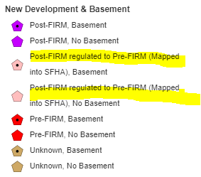
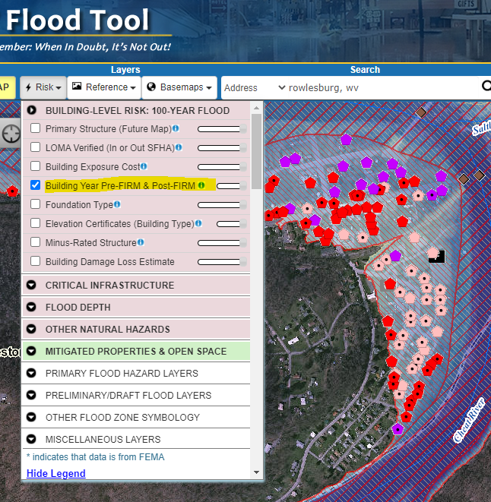
        - Example – Rowleburg, WV

Appendix 2: Mobile Homes and OBY Assessment Table

OBY Table: Make sure for mobile homes (RES2) that the Modified Building Year (M-Year) from the Other Building Yard (OBY) assessment section is being entered in the Building Inventory. All structures should have a building year. If there is no building year listed for a structure, then check the historical aerial imagery for determinations. Historical aerial imagery is also available at https://historicaerials.com/viewer to determine if structures are of Post-FIRM construction.

If you are unsure of the exact year but know that it is Post-FIRM then use the value '9999' for Modified Year. Use the value '1111' for Pre-FIRM. Here is a link to the dividing line for Pre-FIRM/Post-FIRM. Someone can add this to the Google Document. https://data.wvgis.wvu.edu/pub/RA/_resources/FRA/Pre-FIRM_Post-FIRM_Dividing_Line_20210102.xlsx
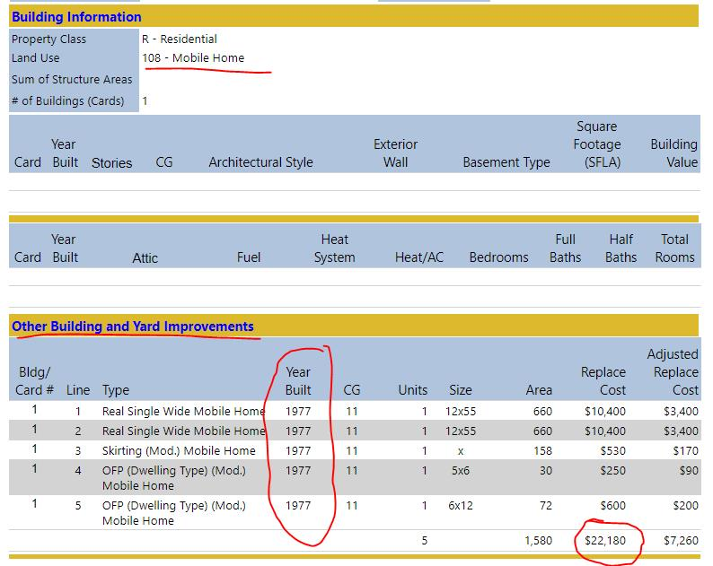
Mobile Home Attributes: If there is no appraisal value for mobile homes then manually enter the Modified Building Replacement Value from the OBY Section. We typically enter the highest value which is generally the Replacement Cost instead of the Adjustment Replacement Cost; however, use situational awareness and building values of similar mobile homes in the neighborhood as a guide.
During the creation of population assessment attributes, parcels where the Mobile Home (LUC) assessment information is in the Other Building and Yard Improvements (OBY) Table, a programming script populates the Building Year, Grade, and Area.
Mobile Home Auto-Population of Attributes: Data processing of parcels that only have only a single mobile home where Land Use Code = 108 Mobile Home. All other instances will have to be done manually where there are multiple structures on a single parcel and values must be apportioned, mobile home parks, or Land Use Code <> 108.
If (LUC = 108 Mobile Home) and (DWELLDAT/COMDAT tables Building Area = Null or Building Year = Null) then Search OBY Table for RM1 (singlewide) or RM2 (doublewide). Populate YEAR and AREA. Use OBY Value or Adjusted Replacement Cost. Singlewide (OBY Code = RM1) and Doublewide (OBY Code = RM2) Trailers
https://mapwv.gov/assessment//Detail/?PID=4108049A000400000000
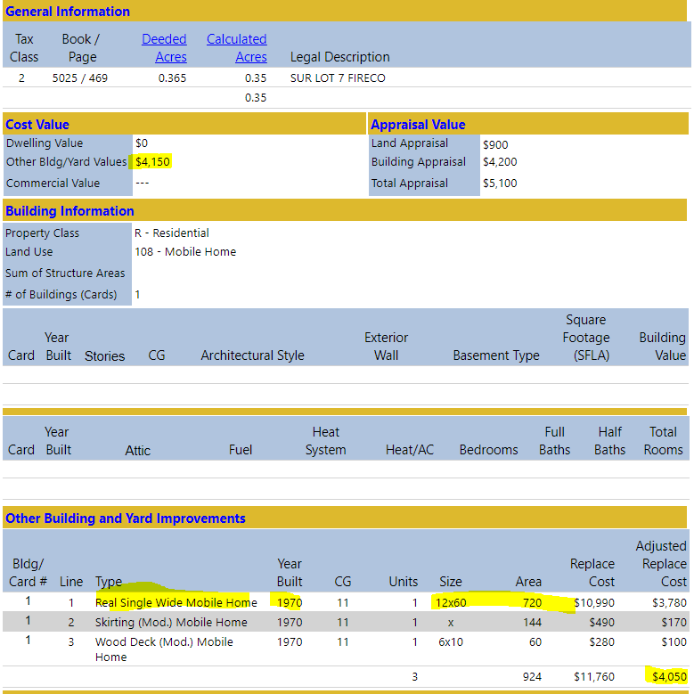

Note that churches are also auto populated. If (LUC = 620 Religious) and (DWELLDAT/COMDAT tables Building Area = Null or Building Year = Null) then Search OBY Table Code for EC1 ((Church Exempt) to populate Built Year, Grade, and Area. Use OBY Value or Adjusted Replacement Cost.
https://mapwv.gov/assessment//Detail/?PID=55050004001400010000
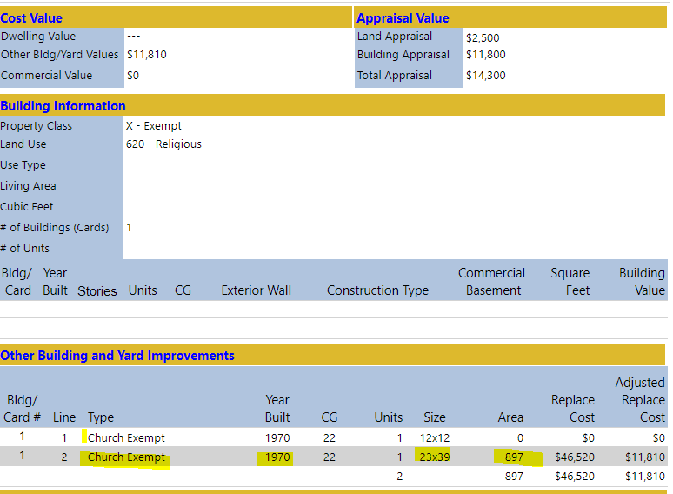

Date of Construction—Manufactured (Mobile) Homes/Travel Trailers. The date of construction for a
manufactured (mobile) home is different from a standard building and depends upon the location of the manufactured (mobile) home.
- Mobile Home Parks: For manufactured (mobile) homes located in manufactured (mobile) home parks or subdivisions, the date of construction is the date facilities were constructed for servicing the manufactured (mobile) home site, or the date of the permit, provided that construction began within 180 days of the permit date. This rule applies to all manufactured (mobile) homes even if the manufactured (mobile) home is rated and classified as single family.

- Mobile Homes on Individually Owned Lots: For manufactured (mobile) homes not located in manufactured (mobile) home parks or subdivisions, but located on individually owned lots or tracts of land, the date of construction is the date the manufactured (mobile) home was permanently affixed to the site or the permit date if affixed to the site within 180 days of the date of permit.
Source: https://www.fema.gov/pdf/nfip/prodmanual200610/supprod102006.pdf

Appendix 3: Dilapidated or Vacated Structures
Dilapidated Structures: How to know if a structure is dilapidated, abandoned, or not an active primary structure? No parked vehicles, vehicular tracks, driveway, etc. Review available building pictures but don’t totally depend on Google StreetView images that are often older than 10 years. From the assessment records, a low building Appraisal Value or poor Construction Grade may indicate a dilapidated structure.
Mobile Home as Secondary Structure: Mobile homes of low value, poor construction grade, abandoned, inhabitable, and listed in the Other Buildings/Yard Improvements Assessment Section and secondary (outbuildings, garages, car ports) to a higher-valued primary structure on the same parcel can be incorporated with the primary structure represented by the OBY appraisal value. This does not apply to mobile home parks or addressable mobile homes that appear habitable.
Construction Grade Conversion Table
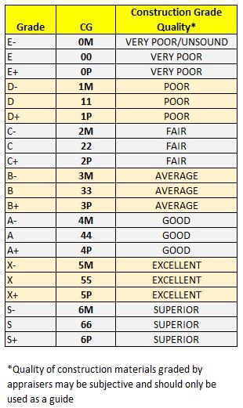

Appendix A: Tables and Figures
Table 1. Flood Risk Products
FLOOD RISK PRODUCT | DESCRIPTION
Flood Risk Report | A narrative or a community’s flood risk assessment study to support the floodplain management and flood reduction activities. A Flood Risk Report is published for each county to supplement it Local Hazard Mitigation Plan.
Flood Risk Map | A map that illustrates the overall flood risk for a community. The map can be used as an outreach tool to communicate risk more clearly and to support mitigation planning. The Flood Risk Map is viewable as an interactive map on the WV Flood Tool or as a PDF print-ready static map.
Flood Risk Tables | Excel tables that list per structure the primary building exposure and flood risk assessment attributes for communities to verify. Specific tables for Essential Facilities, Buyout Properties, etc. are also provided to communities for verification. These tables can be used by communities to enhance floodplain management and risk reduction efforts. Share links are included in tables to link records to RiskMAP View of WV Flood Tool.
Flood Risk Database | Provides communities with geospatial information collected during the risk assessment process and offers effective ways to visualize and communicate flood risk. The Flood Risk Assessment GIS (FRAGIS) is the name for West Virginia’s flood risk geodatabase.
Flood Risk Community Engagement Form or Survey | Communities are provided with instructions on how to validate and provide feedback on Flood Risk Report, Maps, or Tables. Communities are encouraged to identify Areas of Mitigation Interest (AoMIs) for the State and FEMA to review. The Areas of Mitigation Interest (AoMI) dataset should capture the mitigation interests of the community and provide targets for future mitigation actions.
Flood Depth Grid | Communicates information about the flood depth for a 1-percent (100-year) annual chance flood. Flood Depth Grids illustrate the flood depth, in feet above the ground surface, to demonstrate the variability of flood depths in flood prone areas. Officials can use depth grids to help individuals visualize the depth of flooding their home might experience; an easier concept than understanding a base flood elevation. The depth grid, combined with an inventory of the built environment, is used by the Hazus Flood Model to determine flood loss potential, by applying the appropriate depth-damage curves. Model-backed DEMs are preferred over Hazus-generated depth grids for the Flood Models. In the WV Flood Tool, the Water Depth is displayed in the (1) Flood Results Query Panel, (2) Flood Risk Layers Menu, and (3) 3D Flood Visualization.
Water Surface Elevation Grid (Base Flood Elevation, Flood Height) | Provides the base flood elevations for A Zones. The Water Surface Elevation is an effective tool for evaluating risk when combined with the lowest floor or first-floor elevations for buildings. Base flood heights are important for floodplain management and mitigation activities in determining flood elevations in relation to structure (building, bridges, etc.) elevations. Remember that Flood heights measure elevations above sea level and correspond to a vertical elevation datum, whereas depth grids measure flooding above ground level. Where new mapping has occurred with updated topographic data, Advisory Base Flood elevations (or Advisory Flood Heights) are available for select communities The Water Surface Elevation is displayed in the Flood Results Query Panel of the WV Flood Tool.
Future Flood Zone Changes | High-risk advisory flood zones are generated from new model-backed flood studies or from redelineation mapping. Redelineation is the method of updating effective flood hazard boundaries to match updated topographic data based on the computed water surface elevations from effective models. The public should be informed that these non-regulatory zones will most likely become effective when new Flood Insurance Rate Maps (FIRM) are published, and thus any development in these zones should be regulated to the same standards as effective high-risk flood zones. High-risk advisory zones (Preliminary NFHL, Advisory A, Updated AE) are represented as orange-colored flood zones in the WV Flood Tool. In local floodplain ordinances, communities may choose to adopt high-risk advisory zones as "community-identified floodplains" and regulated the same as the Special Flood Hazard Area of the official FIRM.
Building-Level Flood Risk Assessment | Flood Risk Assessment datasets are developed by pinpointing all primary insurable structures in the Special Flood Hazard Area or 100-year floodplain. Historical and community assets (government buildings, churches) are also inventoried. Essential facilities are inventoried to the 0.2-pecent (500-year) annual chance flood event. Required building characteristics are Occupancy Class, Foundation Type, First Floor Height, Number of Stories, Area, and Replacement Cost. Default values are populated from the State Parcel Assessment Database and modified with user-defined values. Building pictures can be linked to the risk assessment using the unique building identifier.  - Buildings Exposed to Flooding: An inventory of all buildings exposed to flooding. A replacement value is determined for each primary structure.  - Buildings - Future Map Conditions: Buildings are classified according to LOMA’s verified for positional accuracy and non-regulatory flood zones. Categories are Mapped out SFHA (yellow), Mapped in SFHA (orange), No Change (red), and Regulatory Floodway (magenta star). The color symbols have land use category letters for Residential, Commercial, and Other. Buildings “Mapped Out SFHA” should be considered for a LOMA Structure Removed status while Buildings “Mapped out SFHA” should be regulated to the 100-year floodplain standard until new effective maps are published. For buildings in the “Floodway” there should be no development unless a No-Rise Certificate is issued.  - Buildings - New Development and Basement: The Building Year from Assessment Database is symbolized by FIRM (Pre-FIRM/Post-FIRM/Unknown) and Basement (Basement/No Basement) status. Note: A basement in the assessment database my not be a subgrade basement but a walkout basement. Hence, basement designations from the assessment records should be field verified. An audit of minus rated properties for Pre-FIRM and POST-FIRM structures should be performed and verified with Elevation Certificates or field surveys.  - Building Damage Loss Estimates (Hazus): The Flood Risk Assessment dataset is generated from FEMA’s OpenHazus Flood Assessment Structure Tool (FAST) and presents loss estimates in dollar values and damage percent. The depth grid, combined with an inventory of the built environment, is used by the Hazus Flood Model to determine flood loss potential, by applying the appropriate depth-damage curves, for a 100-year flood event. Besides the Building Damage Percent/Dollars Loss, other model outputs of the FAST Utility site-specific risk assessment include the Contents Damage, Inventory Damage, Debris Removal, and Maximum Restoration Time. Population per building is derived from the assessment Occupancy Type Class (e.g., Residential Single Family, Residential Multi Family) and census average residential household size. Owner-occupied homes are determined from assessment fields Tax Class and Occupancy Class.
Other Risk Layers | Other risk layers displayed in the WV Flood Tool include Dams, Levees, Landslides (other natural hazard), and High-Water Marks.
CRS Program Variables | The building-level inventory provides key program variables for FEMA’s Community Rating System (CRS) Program: Buildings in the SFHA (bSF) and Area in the SFHA (aSFHA).
LOMA Verified | Verified positional accuracy of LOMAs. Current and historical LOMAs categorized as Structure Non-Removal, Removal, or Out as Shown.
Elevation Certificates | Elevation Certificates are useful for determining lowest floor elevations for BFE regulatory compliance and for determining first-floor heights for building-level risk assessments.
3D Flood Visualizations | 3D Flood Visualizations are rendered from the base flood water depth and building type (residential one- or two-story homes, mobile home, commercial/industrial) to effectively communicate flood risk. By describing the depth-in-structure damage according to varying flood depths, visualizations are easier for non-technical users to understand flood risks to their property in feet of water rather than comprehending the base flood elevation (BFE).
Parcel Assessment Report | Detailed Parcel Assessment Reports provide information of all primary and secondary structures on a single parcel. The reports include parcel and E-911 addresses, building values, primary and secondary structure attributes, parcel history, etc. Both the E-911 site addresses, parcels, and assessment records are integrated from local sources into statewide databases that are beneficial for identifying property locations and building parameters (building cost, year, property class, etc.). The parcel geometry and assessment records are updated annually by the WV Property Tax Division and WV GIS Technical Center, while the statewide addressing and geocoding services are typically updated twice a year by the WV Division of Homeland Security and WV GIS Technical Center.
Mitigation Layer: Areas of Mitigation Interest | The Areas of Mitigation Interest (AoMI) dataset assists communities in determining specific actions to increase their resilience from floods. AoMI identifies currently planned mitigation activities as well as areas of potential future action. It encourages collaboration among communities within the project area by providing with them the basis to assess how various mitigation action scenarios can successfully reduce their collective flood risk. AoMIs are identified by communities as part of the State's Flood Risk Assessment.
Mitigation Layer: Open Space Preservation | Open Space Preservation layers restore the floodplain to its natural function and provides opportunities for credits from FEMA’s Community Rating System (CRS). Open Space Preservation layers include Deed Restricted Buyout Properties, Private Lands (Nature Preserves, Land Trust) and Public Lands (state and local lands).

Table 2. Flood Risk Layers (Flood Risk Assessment GIS Geodatabase)
RISK LAYER | CATEGORY | SOURCES
1% Chance Flood Event (100-Year)
- Flood Depth Grid  - Model-Backed  - Hazus | Flood Risk Grid | FEMA RiskMAP Restudies, Non-Restudies, Hazus
- Water Surface Elevation Grid  - Base Flood Elevations  - Advisory BFEs | Flood Risk Grid | FEMA Restudies, Non-Restudies
- Preliminary NFHL  - Changes Since Last FIRM (CSLF) | Flood Zone Changes | FEMA Preliminary NFHL
- High-Risk Advisory Flood Zones  (Non-Regulatory) | Flood Zone Changes | Non-Restudies (Advisory A & Updated AE)
- Future Map Conditions for Buildings  - Map In SFHA  - Map Out SFHA  - No Change  - Floodway  - LOMA Verified | Building-Level Risk  Flood Zone Changes | Enhanced Building Inventory, Non-Regulatory Flood Zones
- Buildings Exposed to Flooding  - Building Replacement Cost  - Essential Facilities  - Community Assets  - Historical Structures | Building-Level Risk | Inventories of buildings and facilities
- New Development & Basement  - Pre-FIRM / Post-FIRM  - Basement (First Floor Height) | Building-Level Risk | WV Building Inventory, WV Assessment Records, Building Pictures
- Building Damage Loss Estimate (Hazus)  - Percent Damage  - Dollars Loss | Building-Level Risk | Hazus Level 2 Analysis, Enhanced Building Inventory (or UDF), Depth Grids
No Specific Flood Probability Occurrence
- Levees (FEMA/USACE)  - Dams (NID) | Critical Structures | FEMA / USACE
- Landslides | Other Natural Hazards | WV Landslide Inventory, LiDAR-Derived DEMs

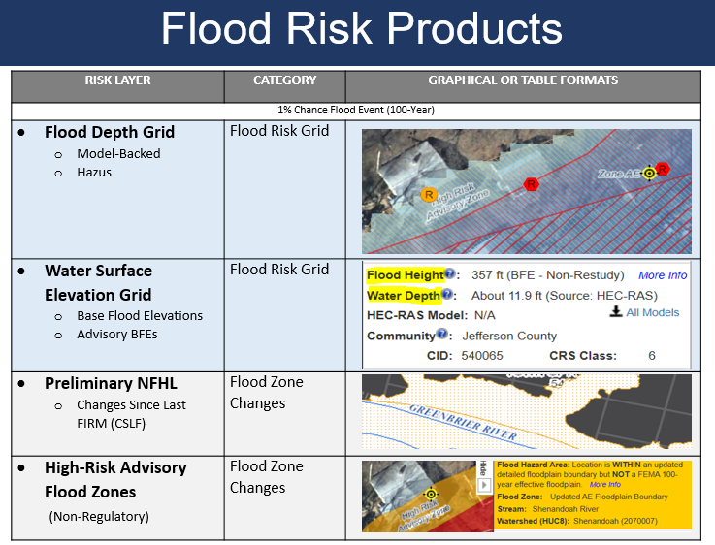
Figure 2. Flood Risk Products: Flood Risk Grids, Flood Zone Changes, Risk Per Structure

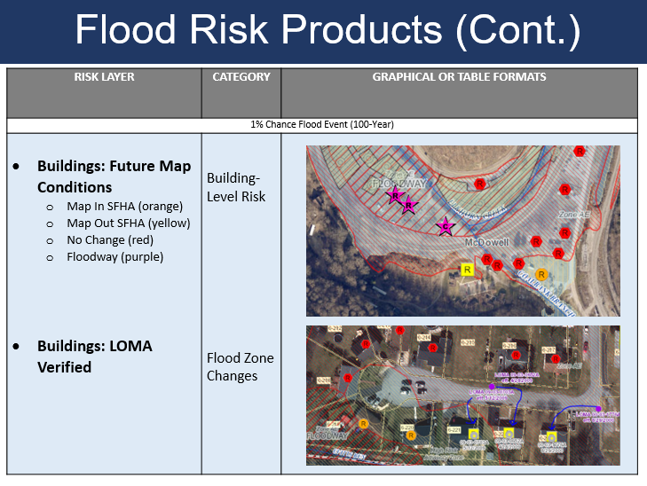

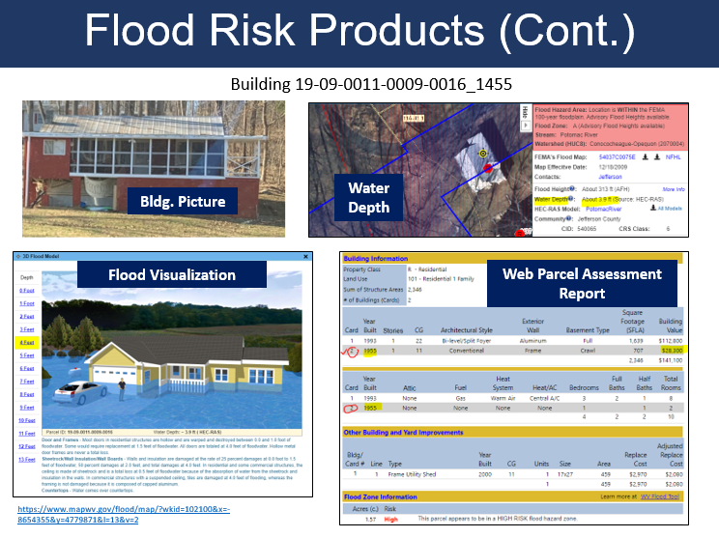
Figure 3. Building-Level Flood Risk Products
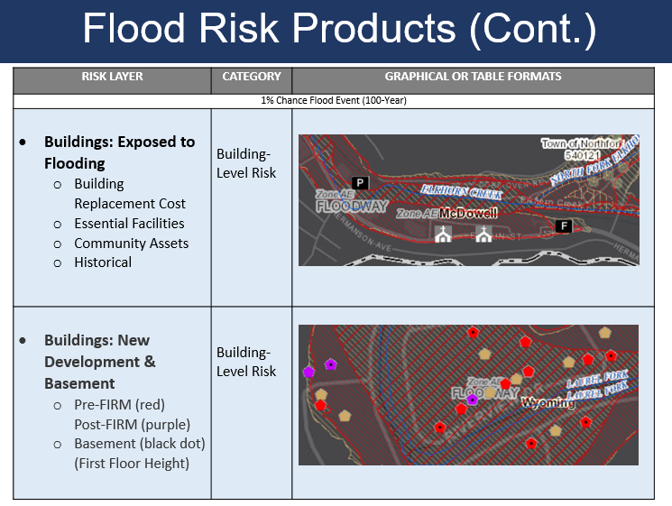

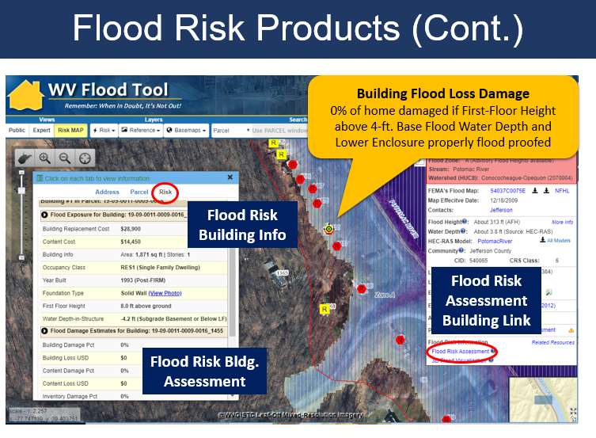
Figure 4. Building-Level Flood Risk Assessments Published to WV Flood Tool
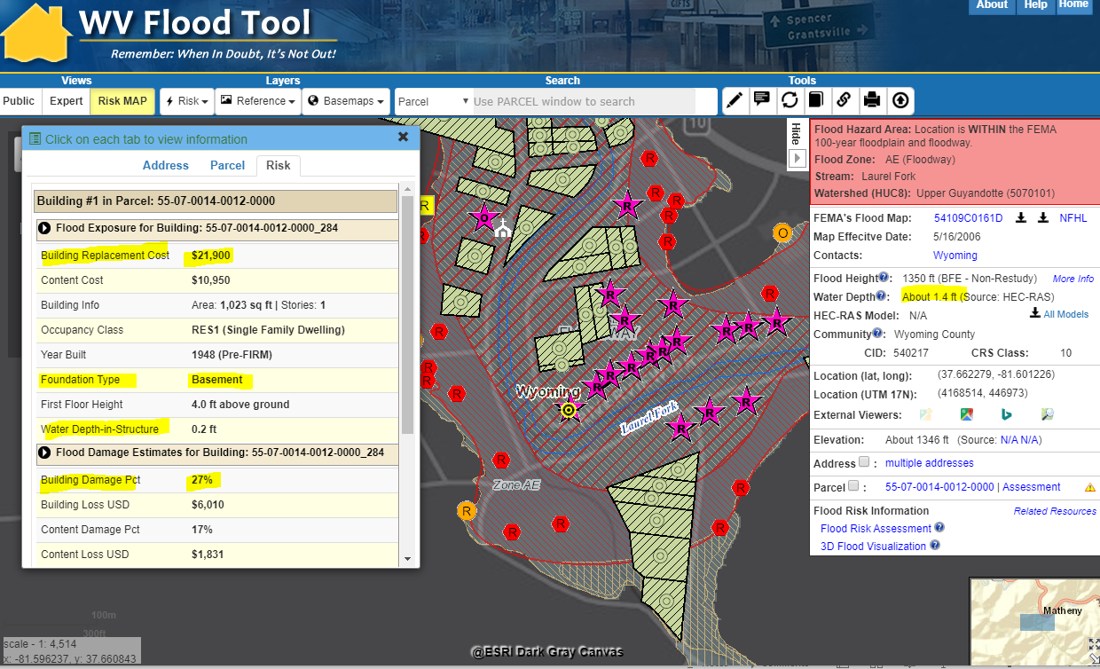

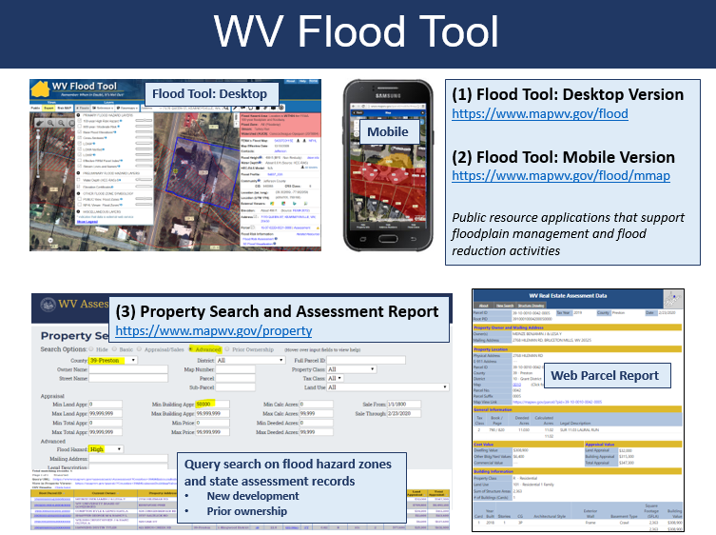
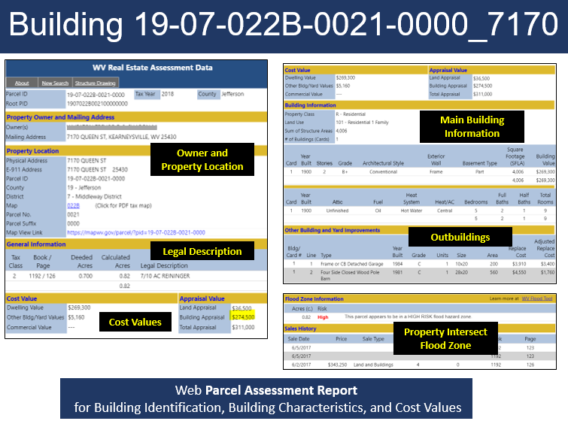
Figure 5. WV Flood Tool, WV Property Viewer, and Web Parcel Assessment Report
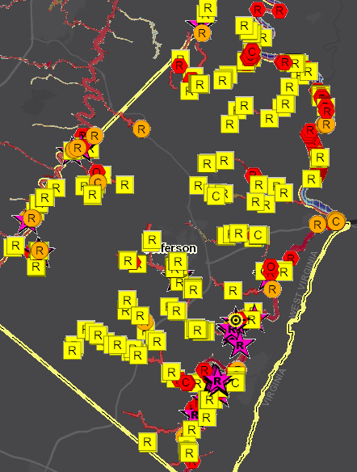
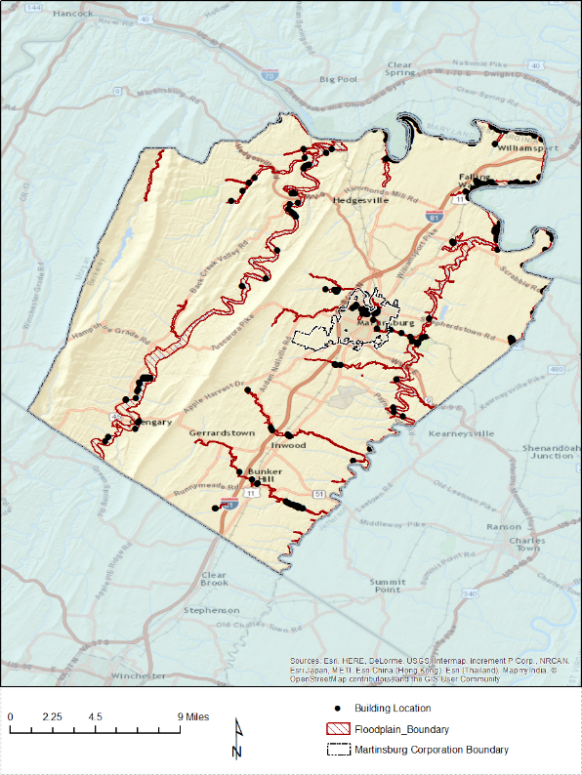
Figure 6. Flood Risk Map. Static Map and WV Flood Tool.

Figure 7. Flood Risk Database. Also known as Flood Risk Assessment GIS (FRAGIS).
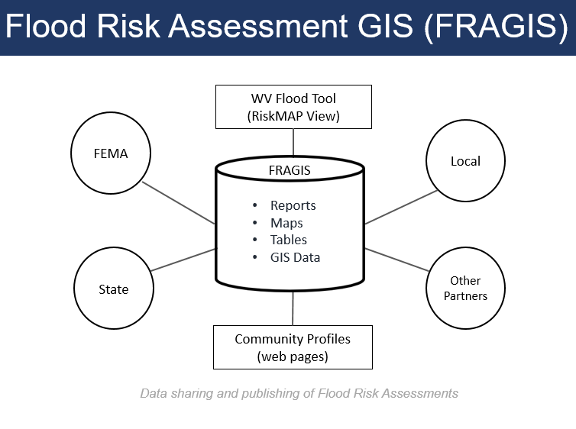

Figure 8. Building-Level Flood Risk Assessment Cycle
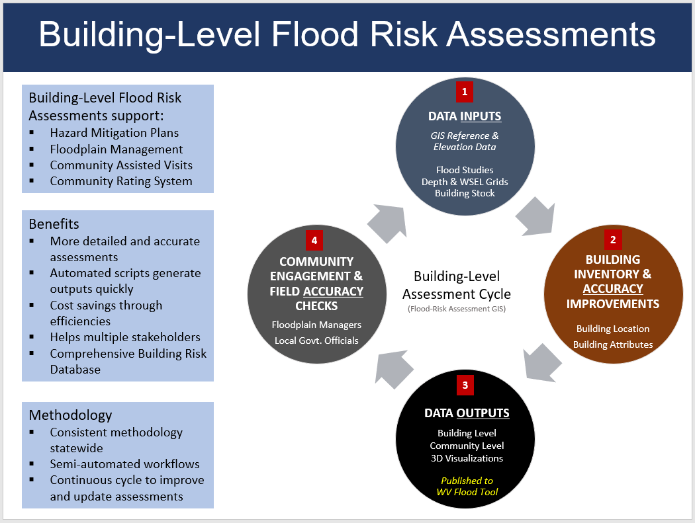

Figure 9. Building Inventory Workflow
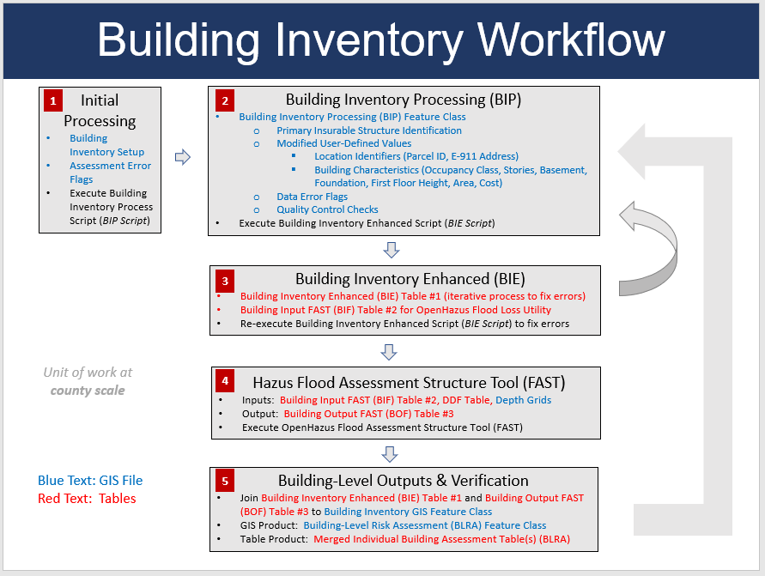

Figure 10. Hazus Flood Loss Flowchart
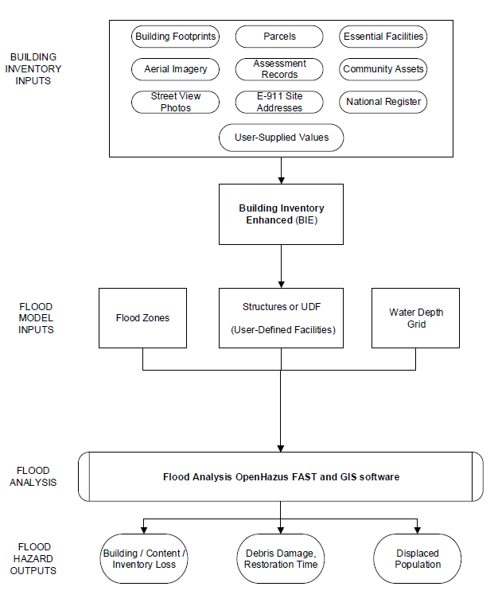

Table 3. Spatial Identifiers. The standardized Building Identifier is a combination of the 20-character parcel identifier and building address number.
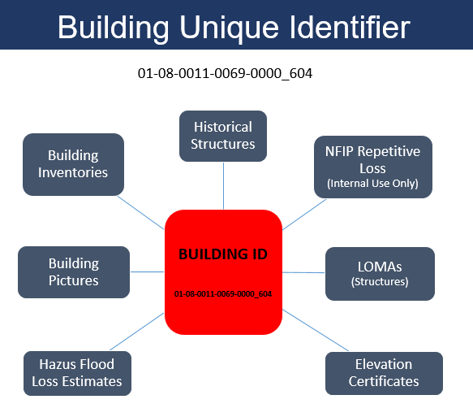
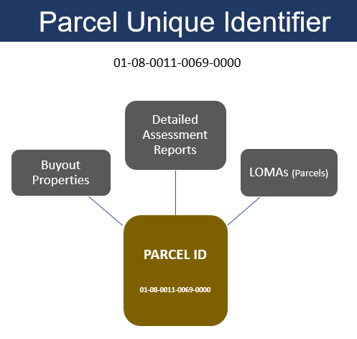
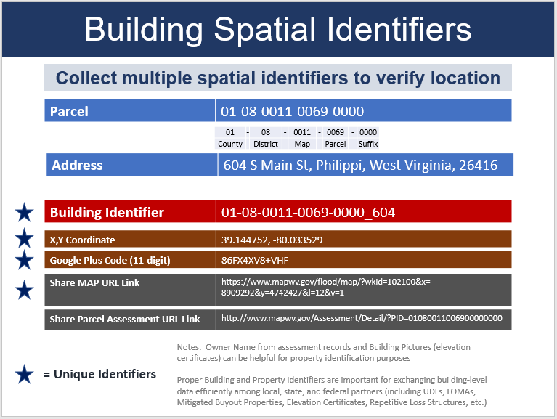
Table 4. Hazus Model Inputs: Building Characteristics. User-defined modified values in red text.
Primary Assessment Source | Hazus Codes | Modified Values (User Defined) | Secondary Sources | Hazus Input | Notes
Basement & Building Year | Foundation LUT (Pre-FIRM, Post-FIRM) | M-Foundation | Elevation Certificates, Building Pictures, Change Detection of aerial imagery acquired during different years | Foundation Type | See Foundation Code LUT for descriptions
Basement & Building Year | Foundation LUT (Pre-FIRM, Post-FIRM) | M-FFH |  | First Floor Height
Basement & Building Year | Foundation LUT (Pre-FIRM, Post-FIRM) | M-Year |  | First Floor Height | Building Year determines Pre-FIRM and Post-FIRM first flood heights. If specific year is unknown, Pre-FIRM = “1111” and Post-FIRM = “9999”.
Land Use | Occupancy Class LUT | M-OccupClass | Building Pictures, Business Directories | Occupancy Class | See Occupancy Class LUT for descriptions
Number of Stories |  | M-Stories | Building Pictures | Number of Stories | Unknown Stories value = 1 Story
Building Cost |  | M-Cost | Neighboring Parcels, RS Means, Insurance Databases | Cost | Unknown value for RES2 trailers: Single wide = $23K, Doublewide = $46K
Area |  | M-Area | Sketch Diagrams, Measure Tools | Area | Singlewide Area = 1,000 sq. ft.; Doublewide Area = 2,000 sq. ft. See Mobile Home table for countywide default values for singlewide and doublewide trailers

Table 5. Hazus Mode Inputs: Flood Water Depth
Depth Grid Source | Modified Values | Secondary Sources | Hazus Input
HEC-RAS model-backed & Hazus | M-Depth | FIRM BFE, Elevation Certificate | Water Depth

Table 6. Hazus Mode Inputs: Building Point
Mapping Structure Point | Data Sources | Hazus Input Location
Pinpoint primary building in most restrictive flood zone | Building Footprint, Parcel, Site Address, Aerial Imagery, Assessment Records, Verified LOMA, Essential Facility Databases, Business Directories | Building Point (Longitude, Latitude). Also known as Hazus User-Defined Facility (UDF)

Table 7. RESIDENTIAL Basement Information from Assessment Records
WV CAMA Assessment Code | Residential Basement Type | Residential Assessment Description | Hazus Foundation Code | Hazus Foundation Description
1 | None | NONE to indicate slab construction or no basement | 7 | Slab-on-Grade
2 | Crawl | CRAWL to indicate crawl space to 1/4 basement area | 5 | Crawlspace
3 | Part | PART to indicate 1/4 to 3/4 basement area | 4 | Basement
4 | Full | FULL to indicate 3/4 to full basement area | 4 | Basement

Table 8. COMMERCIAL Basement Information from Assessment Records
WV CAMA Assessment Floor Level | Commercial Basement Type | Commercial Basement Description | Hazus Foundation Code | Hazus Foundation Description
 | None | No "B" or "C" Level values indicate no basement. | 7 | Slab-on-Grade
C1 | Crawl | Crawl Space | 5 | Crawlspace
B1 | Basement | First Basement | 4 | Slab-on-Grade
B2-B5 | Sub- Basement | Second Basement. Up to 5 sub basements | 4 | Basement

Table 9. Foundation Type, Foundation Code, First Floor Height for Hazus Flood Model
 | Foundation Type |  |  |  | First Floor Height
WV Assessment Record Values for BASEMENT | Foundation Type | Foundation Code | Modified-FdtnCode | Description | FirstFloorHt (PRE-FIRM) ft. | FirstFloorHt (POST-FIRM) ft. | Modified-FFH
 | Pile | 1 | 1 | Piles support an elevated structure and consist of multiple columns driven into the ground and embedded several feet below grade. | 7.0 | 8.0 | <value>
 | Pier | 2 | 2 | This system is often used on manufactured housing and consists of multiple small piers or post that support the structure and are shallowly embedded into the ground. | 5.0 | 6.0 | <value>
 | Solid Wall | 3 | 3 | Load-bearing perimeter walls greater than 4 ft. in height, usually supported by shallow footings. | 7.0 | 8.0 | <value>
FULL or PART (Residential)  FIRST BASEMENT, SUB BASEMENT (Commercial) | Basement | 4 | 4 | Structure that has any floor beneath grade. | 4.0 | 4.0 | <value>
CRAWL (Residential)  CRAWL SPACE (Commercial) | Crawlspace | 5 | 5 | Short load bearing masonry or concrete wall. Default for Trailers RES2 Occupancy Class. If there is no Building Year then an average 3.5 feet is used for the First Floor Height. | 3.0 | 4.0 | <value>
 | Fill | 6 | 6 | Soil built up above the ground elevation. | 2.0 | 2.0 | <value>
NONE or blank | Slab-on-Grade | 7 | 7 | Concrete slab resting on the ground. Default if no basement value except for Trailers (RES2 Occupancy Class). | 1.0 | 1.0 | <value>
Note: Basement values of assessment records for residential and commercial properties are used to generate Foundation Codes 4 (Basement),5 (Crawlspace), and 7 (No Basement).

Table 10. Hazus Occupancy Class Descriptions
Hazus Label | Occupancy Class | Standard Industrial Codes (SIC) | Description / Notes
Residential
RES1 | Single Family Dwelling
RES2 | Mobile Home |  | A titled owner of a mobile home, house trailer, or manufactured home has the option to convert their home to real property and obtain a deed in place of a certificate of title if it has been permanently affixed to real property. Owner-occupied property is designated as Tax Class = 2. The following default values are used for missing attributes. Foundation Type = Crawlspace; Single Wide Trailer: Avg. Value = $23,000 and Area = 1,000 sq. ft.; Double Wide Trailer: Value = $46,000 and Area = 2,000 sq. ft.
RES3A | Multi Family Dwelling – Duplex
RES3B | Multi Family Dwelling – 3-4 Units
RES3C | Multi Family Dwelling – 5-9 Units
RES3D | Multi Family Dwelling – 10-19 Units
RES3E | Multi Family Dwelling – 20-49 Units
RES3F | Multi Family Dwelling – 50+ Units
RES4 | Temporary Lodging | 70 | Hotels, motels, boarding houses, sports and recreation camps, recreational vehicle parks and campsites, lodging houses, and hotels open to the public operated by membership organizations for the benefit of constituents
RES5 | Institutional Dormitory
RES6 | Nursing Home | 8051, 8052, 8059 | Skilled or intermediate nursing care facilities providing continuous or non-continuous nursing and rehabilitative services to patients, personal care facilities providing inpatient nursing and rehabilitative services to people with special mental or physical condition
Commercial
COM1 | Retail Trade | 52, 53, 54, 55, 56, 57, 59 | Establishments selling lumber and a general line of building materials, basic hardware lines, garden supplies, plants and mobile homes, department stores, supermarkets, grocery stores, food stores, fruit and vegetable markets, confectionary stores, dairy product stores, bakeries, motor vehicle and boat dealers, gasoline service stations, clothing, accessory and shoe stores, furniture and household appliance stores, electronics and computer software stores, drug stores, liquor stores, tobacco stores and stands, sporting goods and bicycle stores, book and stationary stores, jewelry stores, camera and photographic supply stores, toy and game shops, gift shops, luggage and leather goods stores, florists, etc.
COM2 | Wholesale Trade | 42, 50, 51 | Trucking with or without storage, courier services except by air, general, farm product and refrigerated warehousing and storage, terminal facilities for motor freight transportation, wholesale and distribution of motor vehicles and parts, furniture, electrical appliances, hardware, lumber and wood products, construction materials, office equipment, medical equipment and drugs, metals, coal, minerals, petroleum products, agricultural, industrial and construction machinery, livestock, groceries, food and beverages, paper, clothing, footwear and accessories, plastics, chemicals, etc.
COM3 | Personal and Repair Services | 72, 75, 76, 83, 88 | Laundry and dry-cleaning, photography, beauty and hair styling services, funeral services, tax return preparation services, rental vehicles, automobile parking services, automotive repair and paint shops, car washes, appliance and furniture repair shops, social services, job training and vocational rehabilitation services, child daycare services, and private households
COM4 | Business/Professional/Technical Services | 40, 41, 44, 45, 46, 47, 49, 61, 62, 63, 64, 65, 67, 73, 78 (except 7832), 81, 87, 89 | Railroads establishments, local and suburban transit, school buses, transportation terminals and service facilities, water transportation, air transportation, travel agencies, packing and crating, petroleum pipelines, electric services, water supply, sewerage systems, refuse systems, steam and air conditioning supply, irrigation systems, credit institutions and agencies, mortgage bankers and loan correspondents, dealers and flotation companies, security and commodity exchanges, investment advice, all types of insurance, building operators, real estate agents and managers, land or cemetery sub-dividers and developers, holding and investor companies, advertising agencies, building cleaning and maintenance services, heavy construction equipment rental, medical equipment rental, employment agencies, computer programming services, motion picture production, legal services, engineering and architectural services, research organizations, and management services
COM5 | Depository Institutions | 60 | Federal reserve banks, central reserve depository institutions, commercial banks, saving institutions, credit unions, branches of foreign banks, and non-deposit trust facilities
COM6 | Hospital | 8062, 8063, 8069 | General medical and surgical hospitals, psychiatric hospitals, and specialty hospitals
COM7 | Medical Office/Clinic | 80 (except 8051, 8052, 8059, 8062, 8063, 8069) | Offices and clinics of doctors of medicine, dentists, osteopathy, chiropractors, optometrists, podiatrists, health practitioners, medical and dental laboratories, home health care services, and kidney dialysis centers
COM8 | Entertainment & Recreation | 48, 58, 79 (except 7911), 84 | Radiotelephone, telephone, telegraph and other message communications, radio or television broadcasting stations, cable and other pay television services, eating and drinking places, theatrical producers, bands, orchestras, actors, and other entertainers, bowling centers, professional sports clubs and promoters, racing including track operations, physical fitness facilities, public golf courses, amusement parks and devices, and membership sports and recreation clubs
COM9 | Theaters | 7832, 7911 | Motion picture theaters except drive-in and dance studios, schools and halls
COM10 | Parking
Industrial
IND1 | Heavy | 22, 24, 26, 32, 34, 35 (except 3571, 3572), 37 | Fabric, textile, carpets and rugs, logging, structural wood members, mobile homes, prefabricated wood or metal buildings and components, paper and cardboard products, sanitary food containers, plastics, foil and paper bags, glass products, cement, brick and structural clay tile, ceramic tiles, china bathroom accessories, kitchen articles, electrical supplies, wire products, cut stone and products, concrete products, lime, gypsum, mineral wool, metal products, turbines, agricultural, construction, mining and petroleum machinery, industrial patterns and machinery, power-driven hand tools, office machines, building equipment such as elevators, air conditioning and heating machinery, motor vehicles, aircrafts, ships and boats, and railroad equipment
IND2 | Light | 23, 25, 27, 30, 31, 36 (except 3671, 3672, 3674), 38, 39 | Clothing, footwear and accessories, household furniture, office and store furniture and fixtures, public building furniture, household appliances, printing and publishing, tires and other rubber products, plastics products, power generators and transformers, carbon and graphite products, lighting fixtures and equipment, audio and video equipment, electronic components, batteries, laboratory instruments, measuring and controlling devices, surgical and medical instruments, musical instruments, toys and games, sporting and athletic goods
IND3 | Food/Drugs/Chemicals | 20, 21, 28, 29 | Meat products, dairy and creamery, vegetables, canned, dried and frozen food, bakery products, confectionary products, table oils, beverages, pet food, tobacco products, manufactured ice, industrial chemicals, medicinal chemicals, detergents, perfumes and cosmetics, fertilizers, pesticides and other agricultural chemicals, adhesives, explosives, petroleum refining, asphalt, and lubricating oils
IND4 | Metals/Minerals Processing | 10, 12, 13, 14, 33 | Iron, copper, lead, zinc, gold, silver, ferroalloy, uranium, radium and vanadium mining services, steel, aluminum and copper works, surface and underground coal mining and services, petroleum and natural gas exploration and field services, stones, sand and gravel, clay, ceramic, refractory mineral and other nonmetallic mineral services
IND5 | High Technology | 3571, 3572, 3671, 3672, 3674 | Electronic computers, computer storage devices, electron tubes, printed circuit boards, semiconductors and related services
IND6 | Construction | 15, 16, 17 | General contractors of residential and non-residential buildings, operative builders, highway, street, bridge and tunnel construction, water and sewer pipelines, communications and power line construction, demolition and excavation work, masonry and stone work, concrete work, structural steel erection, plumbing, heating and air-conditioning, electrical work, carpentry work, glazing work, painting and paper hanging, water well drilling, and installation of building equipment
Agriculture
AGR1 | Agriculture | 01, 02, 07, 08, 09 | Production of cereals, cotton, tobacco, sugarcane and sugar beets, vegetables, fruits, ornamental nursery products, cattle, hogs, sheep and goats, poultry, horses, dairy farms, soil preparation services, crop planting, protection and harvesting, crop preparation for market, veterinary services, farm labor contractors and management services, landscape counseling and planning, timber and forestry services, fishing and hunting
Religion/Non-Profit
REL1 | Church/Membership Organizations | 86 | Professional and business membership organizations, labor unions, civic, social and fraternal associations, political organizations, and religious organizations
Government
GOV1 | General Services | 43, 91, 92 (except 9221, 9224), 93, 94, 95, 96, 97 | United States postal service, executive offices, legislative bodies, courts, legal counsel and prosecution, correctional institutions, public order and safety, public finance, taxation and monetary policy, administration of educational, health, social and general economic programs, administration of veterans’ affairs, management of air, water and solid waste, conservation of land, minerals, wildlife and forests, administration of housing programs, urban planning and rural development, regulation and administration of transportation, communications and utilities, regulation of agricultural marketing, space research and technology, national security, and international affairs
GOV2 | Emergency Response | 9221, 9224 | Police and fire protection
Education
EDU1 | Schools/Libraries | 82 (except 8221, 8222) | Elementary and secondary schools, libraries, data processing schools, business and secretarial schools, and educational services
EDU2 | Colleges/Universities | 8221, 8222 | Colleges, universities, professional schools, junior colleges, and technical institutes

Table 10A. Occupancy Classifications
Table web link: << insert here >>

Table 11. WV Assessment Land Use Codes. 186 LUCs Classified to 33 Hazus Occupancy Class Types

 |  |  | Flood Loss Estimation Models (Based on Structure Use) |  |  |  |  | (Structure Construction Type)
ID | CAMA/ Assessment Land Use Code | Description | Hazus Occupancy Class Type Code | Hazus General Occupancy Class | Abbrev. General Occupancy Class | Hazus Population Displacement Models - People Occupied (Residence) | People Per Unit | Residential/  Non-Residential
1 | 100 | Residential Vacant | UNK | Unknown | UNK | No
2 | 101 | Residential 1 Family | RES1 | Residential | RES | Yes | 1 | Residential
3 | 102 | Residential 2 Family | RES3A | Residential | RES | Yes | 2 | Residential
4 | 103 | Residential 3 Family | RES3B | Residential | RES | Yes | 4 | Residential
5 | 104 | Residential 4 Family | RES3B | Residential | RES | Yes | 4 | Residential
6 | 105 | Mixed Residential/Commercial | RES1 | Residential | RES | Yes | 1 | TBD
7 | 106 | Condominium (common element) | RES3A | Residential | RES | Yes | 2 | Residential
8 | 107 | Condominium (fee simple) | RES3A | Residential | RES | Yes | 2 | Residential
9 | 108 | Mobile Home | RES2 | Residential | RES | Yes | 1 | Residential
10 | 109 | Auxiliary Improvement | UNK | Unknown | UNK | No
11 | 110 | Salvage Value Building | UNK | Unknown | UNK | No |  | Non-Residential
12 | 112 | Active Farm (Residential or Commercial) | RES1, AGR1 | Residential, Agricultural (Other) | RES or AGR | Yes | 1 | Residential
13 | 113 | Inactive Farm (Residential or Commercial) | RES1, AGR1 | Residential, Agricultural (Other) | RES or AGR | Yes | 1 | Residential
14 | 114 | Conservation easement perpetual | UNK | Unknown | UNK | UNK
15 | 115 | Unsound Residential Structure | RES1 | Residential | RES | No | 1 | Residential
16 | 123 | Large Vac Tract - Unknown Potential | UNK | Unknown | UNK | No
17 | 200 | Vacant Apartment Land | UNK | Unknown | UNK | Yes
18 | 201 | Residential Structure on Apartment land | RES1 | Residential | RES | Yes | 1 | Residential
19 | 211 | Apartment-Garden (1-3 stories) | RES3C to RES3E | Residential | RES | Yes | 5 to 49 | Non-Residential RES3C to RES6
20 | 212 | Apartment- High Rise | RES3F | Residential | RES | Yes | 75 | Non-Residential
21 | 213 | Mobile Home Park | RES2 | Residential | RES | Yes | 1 | Residential
22 | 300 | Vacant Commercial Land | UNK | Unknown | UNK | No
23 | 301 | Residential Structure on Commercial Land | COM1 | Commercial | COM | No |  | Non-Residential
24 | 310 | Unsound Commercial Structure | COM1 | Commercial | COM | No |  | Non-Residential
25 | 314 | Hotel/Motel-High Rise | RES4 | Residential | RES | No |  | Non-Residential
26 | 315 | Hotel/Motel-Low Rise | RES4 | Residential | RES | No |  | Non-Residential
27 | 316 | Nursing Home | RES6 | Residential | RES | No |  | Non-Residential
28 | 318 | Boarding and Rooming Houses | RES4, RES5 | Residential | RES | No |  | Non-Residential
29 | 319 | Mixed Commercial/Residential | COM1 | Commercial | COM | Yes | 1 | TBD
30 | 321 | Restaurant | COM8 | Commercial | COM | No |  | Non-Residential
31 | 323 | Food Stand | COM8 | Commercial | COM | No |  | Non-Residential
32 | 325 | Franchise Food | COM8 | Commercial | COM | No |  | Non-Residential
33 | 326 | Ice House | COM8 | Commercial | COM | No |  | Non-Residential
34 | 327 | Bar/Lounge | COM8 | Commercial | COM | No |  | Non-Residential
35 | 328 | Night Club/Dinner Theater | COM9 | Commercial | COM | No |  | Non-Residential
36 | 330 | Kwik Lube | COM3 | Commercial | COM | No |  | Non-Residential
37 | 331 | Auto Dealer-Full Service | COM1 | Commercial | COM | No |  | Non-Residential
38 | 332 | Auto Service Garage | COM3 | Commercial | COM | No |  | Non-Residential
39 | 333 | Service Station with Bays | COM3 | Commercial | COM | No |  | Non-Residential
40 | 334 | Service Station without Bays | COM3 | Commercial | COM | No |  | Non-Residential
41 | 335 | Truck Stop | COM4 | Commercial | COM | No |  | Non-Residential
42 | 336 | Car Wash-Manual | COM3 | Commercial | COM | No |  | Non-Residential
43 | 337 | Car Wash-Automatic | COM3 | Commercial | COM | No |  | Non-Residential
44 | 338 | Parking Garage/Deck | COM10 | Commercial | COM | No |  | Non-Residential
45 | 339 | Parking Miscellaneous | COM10 | Commercial | COM | No |  | Non-Residential
46 | 340 | Super Regional Shopping Mall | COM1 | Commercial | COM | No |  | Non-Residential
47 | 341 | Regional Shopping Mall | COM1 | Commercial | COM | No |  | Non-Residential
48 | 342 | Community Shopping Center | COM1 | Commercial | COM | No |  | Non-Residential
49 | 343 | Neighborhood Shopping Center | COM1 | Commercial | COM | No |  | Non-Residential
50 | 344 | Strip Shopping Center | COM1 | Commercial | COM | No |  | Non-Residential
51 | 345 | Discount Department Store | COM1 | Commercial | COM | No |  | Non-Residential
52 | 346 | Department Store/Anchor Store | COM1 | Commercial | COM | No |  | Non-Residential
53 | 347 | Supermarket | COM1 | Commercial | COM | No |  | Non-Residential
54 | 348 | Convenience Food Market | COM1 | Commercial | COM | No |  | Non-Residential
55 | 349 | Medical Office | COM7 | Commercial | COM | No |  | Non-Residential
56 | 351 | Bank | COM5 | Commercial | COM | No |  | Non-Residential
57 | 352 | Savings Institution | COM5 | Commercial | COM | No |  | Non-Residential
58 | 353 | Office Building-Low Rise (1-4 stories) | COM4 | Commercial | COM | No |  | Non-Residential
59 | 354 | Office Building-High Rise (>4 stories) | COM4 | Commercial | COM | No |  | Non-Residential
60 | 355 | Office Condominium | COM4 | Commercial | COM | No |  | Non-Residential
61 | 356 | Retail Condominium | COM1 | Commercial | COM | No |  | Non-Residential
62 | 361 | Funeral Home | COM4 | Commercial | COM | No |  | Non-Residential
63 | 362 | Veterinary Clinic | COM7 | Agricultural | AGR | No |  | Non-Residential
64 | 363 | Legitimate Theater | COM9 | Commercial | COM | No |  | Non-Residential
65 | 364 | Motion Picture Theater | COM9 | Commercial | COM | No |  | Non-Residential
66 | 365 | Cinema/Theater | COM9 | Commercial | COM | No |  | Non-Residential
67 | 366 | Radio/TV/Motion Picture Studio | COM8 | Commercial | COM | No |  | Non-Residential
68 | 367 | Social/Fraternal Hall | REL1 | Religious | REL | No |  | Non-Residential
69 | 368 | Hangar | COM4 | Commercial | COM | No |  | Non-Residential
70 | 369 | Day Care Center | COM3 | Commercial | COM | No |  | Non-Residential
71 | 370 | Greenhouse/Florist | COM1 | Commercial | COM | No |  | Non-Residential
72 | 371 | Downtown Row Type | COM4 | Commercial | COM | No |  | Non-Residential
73 | 373 | Retail-Single Occupancy | COM1 | Commercial | COM | No |  | Non-Residential
74 | 374 | Retail-Multiple Occupancy | COM1 | Commercial | COM | No |  | Non-Residential
75 | 375 | Retail-Drive Up | COM1 | Commercial | COM | No |  | Non-Residential
76 | 381 | Bowling Alley | COM8 | Commercial | COM | No |  | Non-Residential
77 | 382 | Skating Rink | COM8 | Commercial | COM | No |  | Non-Residential
78 | 383 | Health Spa | COM8 | Commercial | COM | No |  | Non-Residential
79 | 384 | Swimming Pool-Indoor | COM8 | Commercial | COM | No |  | Non-Residential
80 | 385 | Tennis Club-Indoor | COM8 | Commercial | COM | No |  | Non-Residential
81 | 386 | Racquet Club-Indoor | COM8 | Commercial | COM | No |  | Non-Residential
82 | 387 | Country Club without Golf Course | COM8 | Commercial | COM | No |  | Non-Residential
83 | 388 | Club House | COM8 | Commercial | COM | No |  | Non-Residential
84 | 389 | Country Club with Golf Course | COM8 | Commercial | COM | No |  | Non-Residential
85 | 390 | Amusement Park | COM8 | Commercial | COM | No |  | Non-Residential
86 | 391 | Cold Storage Facility | COM2 | Commercial | COM | No |  | Non-Residential
87 | 392 | Lumber Storage Facility | COM2 | Commercial | COM | No |  | Non-Residential
88 | 393 | Comm Auxiliary Improvement | COM1 | Commercial | COM | No |  | Non-Residential
89 | 395 | Truck Terminal | COM4 | Commercial | COM | No |  | Non-Residential
90 | 396 | Mini Warehouse | COM2 | Commercial | COM | No |  | Non-Residential
91 | 397 | Office/Warehouse | COM2 | Commercial | COM | No |  | Non-Residential
92 | 398 | Warehouse | COM2 | Commercial | COM | No |  | Non-Residential
93 | 399 | Warehouse-Prefabricated | COM2 | Commercial | COM | No |  | Non-Residential
94 | 400 | Vacant Industrial Land | UNK | Unknown | UNK | No
95 | 401 | Manufacturing | IND2 | Industrial | IND | No |  | Non-Residential
96 | 405 | Research & Development | COM4 | Commercial | COM | No |  | Non-Residential
97 | 411 | Aircraft Engine Plant | IND1 | Industrial | IND | No |  | Non-Residential
98 | 412 | Aluminum & Foil Mfg | IND4 | Industrial | IND | No |  | Non-Residential
99 | 413 | Asphalt Plant | IND3 | Industrial | IND | No |  | Non-Residential
100 | 414 | Automobile Parts Mfg | IND1 | Industrial | IND | No |  | Non-Residential
101 | 415 | Bakery | IND3 | Industrial | IND | No |  | Non-Residential
102 | 416 | Bottling Plant | IND1 | Industrial | IND | No |  | Non-Residential
103 | 417 | Broom Mfg | IND2 | Industrial | IND | No |  | Non-Residential
104 | 418 | Candy Mfg | IND3 | Industrial | IND | No |  | Non-Residential
105 | 419 | Cement Mfg | IND1 | Industrial | IND | No |  | Non-Residential
106 | 420 | Concrete Mfg | IND1 | Industrial | IND | No |  | Non-Residential
107 | 421 | Chemical Mfg | IND3 | Industrial | IND | No |  | Non-Residential
108 | 422 | Clay Mfg | IND1 | Industrial | IND | No |  | Non-Residential
109 | 423 | Clothing Mfg (exc Leather/Rubber) | IND2 | Industrial | IND | No |  | Non-Residential
110 | 424 | Coal Processing | IND4 | Industrial | IND | No |  | Non-Residential
111 | 425 | Compressor Station (not Pub.Util) | IND4 | Industrial | IND | No |  | Non-Residential
112 | 426 | Dairy | IND3 | Industrial | IND | No |  | Non-Residential
113 | 428 | Dental and Medical Lab | IND3 | Industrial | IND | No |  | Non-Residential
114 | 429 | Electronic Components Prods. Mfg | IND5 | Industrial | IND | No |  | Non-Residential
115 | 430 | Electronic Equipment Mfg | IND5 | Industrial | IND | No |  | Non-Residential
116 | 431 | Feed & Flower Mfg | IND3 | Industrial | IND | No |  | Non-Residential
117 | 432 | Foundry Products | IND2 | Industrial | IND | No |  | Non-Residential
118 | 433 | Food Processing | IND3 | Industrial | IND | No |  | Non-Residential
119 | 434 | Glass Mfg | IND1 | Industrial | IND | No |  | Non-Residential
120 | 435 | Glass Mfg-Special Tools | IND1 | Industrial | IND | No |  | Non-Residential
121 | 436 | Grain & Milling Products Mfg | IND3 | Industrial | IND | No |  | Non-Residential
122 | 437 | Ice Plant | IND3 | Industrial | IND | No |  | Non-Residential
123 | 438 | Leather Products Mfg | IND2 | Industrial | IND | No |  | Non-Residential
124 | 439 | Liquified Natural Gas Plant | IND4 | Industrial | IND | No |  | Non-Residential
125 | 440 | Logging, Cutting of Timber | IND1 | Industrial | IND | No |  | Non-Residential
126 | 441 | Machinery & Equipment Mfg | IND1 | Industrial | IND | No |  | Non-Residential
127 | 442 | Meat Packing & Slaughterhouse | IND3 | Industrial | IND | No |  | Non-Residential
128 | 443 | Metal Working | IND6 | Industrial | IND | No |  | Non-Residential
129 | 444 | Mining, Deep | IND4 | Industrial | IND | No |  | Non-Residential
130 | 445 | Mining, Strip | IND4 | Industrial | IND | No |  | Non-Residential
131 | 446 | Natural Gas Extracting Facility | IND4 | Industrial | IND | No |  | Non-Residential
132 | 447 | Nickel Mfg | IND4 | Industrial | IND | No |  | Non-Residential
133 | 448 | Newspaper Plant | IND2 | Industrial | IND | No |  | Non-Residential
134 | 449 | Oil & Gas Pipeline (not Public Utility) | COM4 | Commercial | COM | No |  | Non-Residential
135 | 450 | Optical Mfg | IND2 | Industrial | IND | No |  | Non-Residential
136 | 451 | Paint Mfg | IND3 | Industrial | IND | No |  | Non-Residential
137 | 452 | Paper Finishing & Converting | IND2 | Industrial | IND | No |  | Non-Residential
138 | 453 | Petroleum Refinery | IND3 | Industrial | IND | No |  | Non-Residential
139 | 454 | Pipeline Mfg | IND1 | Industrial | IND | No |  | Non-Residential
140 | 455 | Plastics Products Mfg | IND1 | Industrial | IND | No |  | Non-Residential
141 | 456 | Plastics Products Mfg - Special Tools | IND1 | Industrial | IND | No |  | Non-Residential
142 | 457 | Print Shop | IND2 | Industrial | IND | No |  | Non-Residential
143 | 458 | Pulp & Paper | IND1 | Industrial | IND | No |  | Non-Residential
144 | 459 | Quarries Incl st&gr, ls, ss,sh,cl | IND4 | Industrial | IND | No |  | Non-Residential
145 | 460 | Railroad Car Mfg | IND1 | Industrial | IND | No |  | Non-Residential
146 | 461 | Rubber Mfg-Tire Recapping | IND2 | Industrial | IND | No |  | Non-Residential
147 | 462 | Shoe Mfg | IND2 | Industrial | IND | No |  | Non-Residential
148 | 463 | Steel Mill | IND1 | Industrial | IND | No |  | Non-Residential
149 | 464 | Steam Generating Plant | IND1 | Industrial | IND | No |  | Non-Residential
150 | 465 | Saw Mills-Permanent | IND1 | Industrial | IND | No |  | Non-Residential
151 | 466 | Saw Mills-Temporary | IND1 | Industrial | IND | No |  | Non-Residential
152 | 467 | Textile Mfg | IND1 | Industrial | IND | No |  | Non-Residential
153 | 468 | Tobacco Products Mfg | IND3 | Industrial | IND | No |  | Non-Residential
154 | 469 | Woodworking Shop | IND1 | Industrial | IND | No |  | Non-Residential
155 | 470 | Wire Products Mfg | IND1 | Industrial | IND | No |  | Non-Residential
156 | 471 | Jewelry/Musical Instruments | IND2 | Industrial | IND | No |  | Non-Residential
157 | 600 | Vacant Exempt Land | UNK | Unknown | UNK | No |  | Non-Residential
158 | 601 | Cemetery | UNK | Unknown | UNK | No |  | Non-Residential
159 | 602 | Post Office | GOV1 | Governmental | GOV | No |  | Non-Residential
160 | 603 | Federal/State Building | GOV1 | Governmental | GOV | No |  | Non-Residential
161 | 604 | Other Miscellaneous Exempt | UNK | Unknown | UNK | No |  | Non-Residential
162 | 610 | Recreational/Health | COM8 | Commercial | COM | No |  | Non-Residential
163 | 611 | Library | EDU1 | Educational | EDU | No |  | Non-Residential
164 | 612 | School | EDU1 | Educational | EDU | No |  | Non-Residential
165 | 613 | College & University | EDU2 | Educational | EDU | No |  | Non-Residential
166 | 620 | Religious | REL1 | Religious | REL | No |  | Non-Residential
167 | 630 | Auditorium | COM8 | Commercial | COM | No |  | Non-Residential
168 | 640 | Hospital | COM6 | Commercial | COM | No |  | Non-Residential
169 | 660 | Police or Fire Station | GOV2 | Governmental | GOV | No |  | Non-Residential
170 | 670 | Correctional | GOV1 | Governmental | GOV | No |  | Non-Residential
171 | 680 | Cultural | COM8 | Commercial | COM | No |  | Non-Residential
172 | 690 | Rail/Bus/Air Terminal | COM4 | Commercial | COM | No |  | Non-Residential
173 | 700 | Utility Vacant Land | UNK | Unknown | UNK | No |  | Non-Residential
174 | 701 | Water System | COM4 | Commercial | COM | No |  | Non-Residential
175 | 702 | Gas Distribution System | COM4 | Commercial | COM | No |  | Non-Residential
176 | 703 | Electric Company | COM4 | Commercial | COM | No |  | Non-Residential
177 | 704 | Telephone Company | COM4 | Commercial | COM | No |  | Non-Residential
178 | 705 | Railroad | COM4 | Commercial | COM | No |  | Non-Residential
179 | 706 | Pipeline | COM4 | Commercial | COM | No |  | Non-Residential
180 | 707 | Sewage Treatment | COM4 | Commercial | COM | No |  | Non-Residential
181 | 710 | Telephone Equipment Building | COM8 | Commercial | COM | No |  | Non-Residential
182 | 715 | Telephone Service Garage | COM8 | Commercial | COM | No |  | Non-Residential
183 | 720 | Radio/TV Transmitter Building | COM8 | Commercial | COM | No |  | Non-Residential
184 | 721 | Wireless Serv Facility on leased land | COM8 | Commercial | COM | No |  | Non-Residential
185 | 722 | Wireless Serv Facility with land | COM8 | Commercial | COM | No |  | Non-Residential
186 | 723 | Land leased to Wireless Service | COM8 | Commercial | COM | No |  | Non-Residential

Table 12. Average Mobile Home Appraisal Values by County. Computed from Tax Year 2019 Assessment Records. Median appraisal values calculated property tax records where LUC = 108. Doublewide trailer appraisal value = singlewide x 2. Singlewide Home Area = 1,000 sq. ft.; Doublewide Area = 2,000 sq. ft.
County | Count | Average Mobile Home Appraisal | Min Bldg. Appraisal | Max Bldg. Appraisal |  | Median (LUC 108) | Single Wide | Double Wide
Barbour | 702 | $15,587 | $400 | $130,100 |  | $12,300 | $12,000 | $24,000
Berkeley | 3,393 | $18,707 | $100 | $180,400 |  | $12,100 | $12,000 | $24,000
Boone | 1,871 | $33,459 | $300 | $193,700 |  | $27,550 | $28,000 | $56,000
Braxton | 1,203 | $28,129 | $100 | $178,400 |  | $19,600 | $20,000 | $40,000
Brooke | 330 | $21,420 | $200 | $102,200 |  | $15,000 | $15,000 | $30,000
Cabell | 1,899 | $28,674 | $200 | $144,100 |  | $25,900 | $26,000 | $52,000
Calhoun | 143 | $21,811 | $100 | $157,300 |  | $10,200 | $10,000 | $20,000
Clay | 510 | $13,860 | $200 | $142,300 |  | $7,000 | $7,000 | $14,000
Doddridge | 225 | $16,716 | $300 | $185,500 |  | $7,000 | $7,000 | $14,000
Fayette | 1,390 | $16,466 | $100 | $152,300 |  | $10,500 | $11,000 | $22,000
Gilmer | 270 | $20,539 | $100 | $171,900 |  | $11,300 | $11,000 | $22,000
Grant | 835 | $24,609 | $100 | $178,400 |  | $19,400 | $19,000 | $38,000
Greenbrier | 1,686 | $24,441 | $100 | $149,500 |  | $17,600 | $18,000 | $36,000
Hampshire | 1,922 | $25,989 | $200 | $147,700 |  | $18,300 | $18,000 | $36,000
Hancock | 311 | $12,246 | $200 | $183,900 |  | $9,000 | $9,000 | $18,000
Hardy | 887 | $21,125 | $100 | $788,000 |  | $12,600 | $13,000 | $26,000
Harrison | 2,139 | $41,536 | $100 | $258,100 |  | $24,300 | $24,000 | $48,000
Jackson | 1,824 | $33,915 | $100 | $208,600 |  | $28,750 | $29,000 | $58,000
Jefferson | 905 | $32,361 | $500 | $307,900 |  | $25,450 | $25,000 | $50,000
Kanawha | 5,903 | $32,195 | $100 | $235,400 |  | $24,800 | $25,000 | $50,000
Lewis | 649 | $13,273 | $100 | $60,600 |  | $10,600 | $11,000 | $22,000
Lincoln | 1,839 | $23,160 | $100 | $222,000 |  | $18,200 | $18,000 | $36,000
Logan | 2,421 | $20,570 | $100 | $105,100 |  | $15,800 | $16,000 | $32,000
Marion | 1,420 | $24,879 | $100 | $163,600 |  | $16,600 | $17,000 | $34,000
Marshall | 514 | $17,663 | $100 | $271,200 |  | $11,500 | $12,000 | $24,000
Mason | 1,092 | $17,682 | $100 | $185,300 |  | $13,650 | $14,000 | $28,000
McDowell | 1,050 | $14,360 | $100 | $74,000 |  | $7,400 | $7,000 | $14,000
Mercer | 3,591 | $31,237 | $100 | $153,600 |  | $26,500 | $27,000 | $54,000
Mineral | 999 | $20,437 | $100 | $140,600 |  | $13,700 | $14,000 | $28,000
Mingo | 2,285 | $17,743 | $200 | $126,100 |  | $13,900 | $14,000 | $28,000
Monongalia | 1,549 | $26,246 | $100 | $219,900 |  | $15,300 | $15,000 | $30,000
Monroe | 929 | $23,875 | $100 | $197,800 |  | $13,700 | $14,000 | $28,000
Morgan | 920 | $28,480 | $100 | $160,600 |  | $20,600 | $21,000 | $42,000
Nicholas | 1,380 | $19,957 | $100 | $243,000 |  | $9,900 | $10,000 | $20,000
Ohio | 292 | $19,748 | $200 | $98,700 |  | $12,900 | $13,000 | $26,000
Pendleton | 467 | $19,737 | $100 | $304,000 |  | $12,800 | $13,000 | $26,000
Pleasants | 205 | $16,768 | $100 | $92,700 |  | $12,550 | $13,000 | $26,000
Pocahontas | 679 | $10,797 | $200 | $181,800 |  | $7,600 | $8,000 | $16,000
Preston | 1,193 | $15,295 | $200 | $164,600 |  | $12,700 | $13,000 | $26,000
Putnam | 1,359 | $15,197 | $400 | $305,000 |  | $11,450 | $11,000 | $22,000
Raleigh | 3,955 | $31,491 | $100 | $205,300 |  | $25,600 | $26,000 | $52,000
Randolph | 1,017 | $21,853 | $100 | $190,300 |  | $13,100 | $13,000 | $26,000
Ritchie | 574 | $32,052 | $200 | $178,100 |  | $16,600 | $17,000 | $34,000
Roane | 582 | $13,725 | $300 | $86,300 |  | $10,400 | $10,000 | $20,000
Summers | 774 | $18,845 | $200 | $156,800 |  | $11,350 | $11,000 | $22,000
Taylor | 702 | $46,681 | $100 | $238,500 |  | $25,200 | $25,000 | $50,000
Tucker | 284 | $23,705 | $200 | $206,300 |  | $13,300 | $13,000 | $26,000
Tyler | 423 | $26,439 | $100 | $170,900 |  | $13,350 | $13,000 | $26,000
Upshur | 1,120 | $27,775 | $100 | $233,800 |  | $14,300 | $14,000 | $28,000
Wayne | 2,158 | $18,928 | $100 | $181,500 |  | $11,750 | $12,000 | $24,000
Webster | 880 | $19,763 | $100 | $102,600 |  | $12,100 | $12,000 | $24,000
Wetzel | 403 | $17,675 | $100 | $144,300 |  | $13,400 | $13,000 | $26,000
Wirt | 524 | $8,962 | $100 | $81,600 |  | $7,200 | $7,000 | $14,000
Wood | 2,103 | $37,984 | $200 | $229,000 |  | $25,600 | $26,000 | $52,000
Wyoming | 2,244 | $20,094 | $300 | $194,900 |  | $16,000 | $16,000 | $32,000
Average |  | $22,670 | $156 | $186,656 |  | $15,368 | $15,418 | $30,836

Table 13. Data Issues and Quality Control Measures
Data Category | Data Issue | Validation Check
Building Identifier | Building Identifier not unique | BIE Table
Building Identifier | Building elements missing, incomplete, duplicate | BIE Table
Building Identifier | Parcel ID/Address No. don’t correspond correctly to Building-ID | BIE Table
Parcel Geometry | Parcel Geometry misalignment | GIS Map Check
Parcel Geometry | No GIS Parcel Geometry | GIS Map Check
E-911 Address | Site Address wrong | BIE Table, GIS
E-911 Address | Site Address for structure located outside of parcel | GIS Map Check
E-911 Address | No Site Address | BIE Table
E-911 Address | Missing any elements of Full Address (Address Number, Street Name, City, Zip) | BIE Table
E-911 Address | Duplicate Addresses | BIE Table
Imagery | Imagery - No building visible in imagery | GIS Map Check
Assessment Record | Neighboring parcel assessment record matches to parcel with structure. Ensure correct BIE foundation type, occupancy class, etc. from neighboring parcel are copied to parcel with structure. | BIE Table, GIS
Assessment Record | Missing key building attributes: Building Value, Occupancy Class, Foundation Code, Stories, Area | BIE Table
Assessment Record | Sort on highest building values - verify | BIE Table
Assessment Record | Verify with other Essential Facility and Community Asset geodatabases | BIE Table, GIS
Stream Name | Stream Name missing. Update Stream Query Layer. | BIE Table
Water Depth | Sort on highest water depth values - verify | BIE Table
Flood Zone | Building located in most restrictive flood zone | GIS Map Check
Flood Zone | Verify future map conditions of Non-Regulatory High-Risk Advisory Zones | GIS Map Check
Note: All user-supplied values should be red color in Building Inventory Enhanced File. Make sure corresponding Data Issue description codes are selected.
Table 14. Building Inventory Enhanced (BIE) Attributes
Field Name | Description | Category | Sample Data Value
Lat | Latitude | Identification | 39.463181
Long | Longitude | Identification | -77.83959
Plus_Code | Google Plus Code (11-Digits) | Identification | 87F4F576+75F
Building_ID | Unique Building Identifier | Identification | 02-08-0013-0013-0000_801
Building_Type | Primary Building (P Code) | Identification | P
Full_E-911_Address | Complete E-911 Address | Identification | 801 TURNER RD, SHEPHERDSTOWN, WV, 25443
GIS_Parcel_ID | GIS Parcel Identifier | Identification | 02-08-0013-0013-0000
IAS_ID | Assessment Record Override ID | Identification
WV_Flood_Tool_Link | WV Flood Tool Link (RiskMAP View) | Identification | https://mapwv.gov/flood/map/?wkid=102100&x=-8665063.574442726&y=4788237.0562021565&l=13&v=2
WV_Parcel_Assessment_Link | WV Detailed Assessment Report | Identification | https://mapwv.gov/Assessment/Detail/?PID=02080013001300000000
CID | FEMA Community Identifier | Community | 540065
Community_Name | Community Name | Community | Jefferson County
County | County Name | Community | JEFFERSON COUNTY
Incorporated_Unincorporated | Incorporated or Unincorporated | Community | Unincorporated
Stream_Name | Stream Name | Stream Info | Rockymarsh Run
Watershed_HUC8 | Watershed Name (HUC-8) | Stream Info | Conococheague-Opequon (2070004)
Flood_Zone_Designation | Flood Zone Designation (MAP-IN, MAP-OUT) | Flood Zone | Effective 100 yr Zone A (N/A)
Floodway | Floodway (Y/N) | Flood Zone | No
FloodPlainType_RiskLayer | Floodplain Risk Layer Symbol | Flood Zone | Effective A (N/A)
Non_Regulatory | Non-Regulatory High Risk Advisory Zones | Flood Zone | Regulatory
FIRM_Status | Pre-FIRM or Post-FIRM | Flood Zone | Pre-FIRM
Flood_Depth_Value | Flood Depth Value | Flood Zone | N/A
Flood_Depth_Source | Flood Depth Source | Flood Zone | N/A
WSEL_Value | Water Surface Elevation | Flood Zone | N/A
WSEL_Source | Water Surface Elevation Source | Flood Zone | N/A
Ground_Elevation | Ground Elevation | Flood Zone | 405.5
Ground_Elevation_Source | Ground Elevation Source | Flood Zone | 2012 FEMA Jefferson, Berkeley & Morgan Lidar
Full_Owner_Address | Assessment: Owner Address | Building Info | 801 TURNER RD, SHEPHERDSTOWN, WV 25443
Owner_Name_s | Assessment: Owner Name | Building Info | MILLER LEIGHTON B BETTY V
Year_Built | Assessment: Building Year | Building Info | 1885
Grade | Assessment: Building Grade | Building Info | C
Property_Class_Code | Assessment: Property Class (R,F,C,I,A,U,X) | Building Info | F
Property_Class_Description | Assessment: Property Class Description | Building Info | Farm
Tax_Class | Assessment: Tax Class (Owner-Occupied = 2) | Building Info | 2
Land_Use_Code | Assessment: Land Use Code | Building Info | 112
Land_Use_Description | Assessment: Land Use Description | Building Info | Active Farm
Hazard_Occupancy_Code | Assessment: Hazus Occupancy Class Code | Building Info | AGR1
General_Occupancy_Code | Assessment: Hazus General Occupancy Class | Building Info | Agriculture
Stories | Assessment: Number of Stories | Building Info | 2
Exterial_Wall_Type | Assessment: Exterior Wall (Residential or Commercial) | Building Info | Aluminum
Architectural_Style | Assessment: Architectural Style (Residential) | Building Info | Conventional
Structure_Area | Assessment: Structure Area (R or C) | Building Info | 1864
Basement_Type | Assessment: Basement Type (R or C) | Building Info | Part
Foundation_Type | Assessment: Foundation Type - Hazus LUT | Building Info | Basement
First_Floor_Height | Assessment: First Floor Height | Building Info | 4.0
Dwelling_Value | Assessment: Dwelling Value | Building Info | 97400
Commercial_Value | Assessment: Commercial Value | Building Info | 0
OBY_Value | Assessment: Out Buildings Value | Building Info | 8590
Building_Appraisal | Assessment: Building Appraisal Value | Building Info | 106000
Building_Value_Source | Assessment: Building Value Source | Building Info | Assessment (IAS)
Total_Structures | Assessment: Total Structures on Parcel | Building Info | 1
Accessory_Structures_Count | Assessment: Owner Name | Building Info | 6
Units | Assessment: Number of Untis | Building Info | 1
Critical_Infrastructure | Essential Facilities | Other
Governmental_Building | Governmental Building (F, S, L) | Other
Historical_Structure | Historical Structure (Yes or No) | Other
Federal_Land | Federal Land (FED) | Other
Comments | General Comments | Other | Moved point to flood zone and updated parcel ID / building appraisal
Data_Issue_1 | Data Issue Flag 1 | Other
Data_Issue_2 | Data Issue Flag 2 | Other
Timestamp | Time Stamps | Other | 02/03/2020
Average_Household_Size | Census Average Household Size | Population Displacement | 2.6
Residential_Units_FLD | Number of Residential Units | Population Displacement | 0
Displaced_Population_FLD_BLD | Population Displaced Per Building | Population Displacement | 0

Table 15. Hazus FAST Inputs. Building Input FAST (BIF) Attributes
Input Attribute | Data Type | Range or Length | Notes
UserDefinedFltyId | Text |  | Unique FAST identifier
OccupancyClass | Text | 5 | One of 33 Hazus-defined types, e.g., {RES1, RES2, COM3, IND4, AGR1, GOV2, REL1}. Script will skip row if not specified, or if an unrecognized value is provided.
Cost | Long | > 0 | Replacement Cost of Structure, in U.S. dollars. Records D51with '0' cost: the script will accept a zero value, but any estimated dollar damage to the structure will be 0. Consider correcting the UDF record or deleting it.
NumStories | Short | ≥ 1 | Number of Stories. Must be an integer.
FoundationType | Text | {1,2,3,4,5,6,7} | Foundation Type of the building. Text type, per Hazus-MH Flood Model convention. Must be an integer from 1 to 7, inclusively.
FirstFloorHt | Float | ≥ 0.0 | First Floor Height, in feet. Height can be specified in fractional feet.
Area | Long | > 0 | Total Area for the structure, in square feet. Used for Inventory Loss calculation when Inventory Cost is not supplied. Used for debris estimates. Must be greater than 0.
Latitude | Float |  | Latitude decimal degrees
Longitude | Float |  | Longitude decimal degrees
Input Attribute | Data Type | Range or Length | Notes
UserDefinedFltyId | Text |  | Unique FAST identifier
OccupancyClass | Text | 5 | One of 33 Hazus-defined types, e.g., {RES1, RES2, COM3, IND4, AGR1, GOV2, REL1}. Script will skip row if not specified, or if an unrecognized value is provided.
Cost | Long | > 0 | Replacement Cost of Structure, in U.S. dollars. Records D51with '0' cost: the script will accept a zero value, but any estimated dollar damage to the structure will be 0. Consider correcting the UDF record or deleting it.
NumStories | Short | ≥ 1 | Number of Stories. Must be an integer.
FoundationType | Text | {1,2,3,4,5,6,7} | Foundation Type of the building. Text type, per Hazus-MH Flood Model convention. Must be an integer from 1 to 7, inclusively.
FirstFloorHt | Float | ≥ 0.0 | First Floor Height, in feet. Height can be specified in fractional feet.
Area | Long | > 0 | Total Area for the structure, in square feet. Used for Inventory Loss calculation when Inventory Cost is not supplied. Used for debris estimates. Must be greater than 0.
Latitude | Float |  | Latitude decimal degrees
Longitude | Float |  | Longitude decimal degrees

Table 16. Hazus FAST Outputs. Building FAST Outputs (BOF)
Output Attribute | Data Type | Range or Length | Notes
Depth_Grid | Float | ≥ 0.0 | Flood Depth Grid, in feet.
Depth_in_Struc | Float |  | Depth-in-Structure Adjusted flood depth grid at the UDF point, in feet. Simple calculation: If the Depth_Grid is a NoData or -9999 value, value is -9999. Else value is Depth_Grid − FirstFloorHt
flExp | Short | {0,1} | UDF is exposed to a flood. Simply 0 or 1. If the UDF is in a flood depth grid, then the value is 1, regardless of depth-in-structure.
SOID | Text | 5 | Specific Occupancy ID. The Hazus-MH Flood shorthand that compresses OccupancyClass, NumStories, and FoundationType into a concise 4- to 5-character code, e.g. R11N for a RES1, no basement, single story. Used to access the look-up tables where the user does not specify a DDF. XXXX for buildings not in the flood zone.
BDDF_ID | Text | 3 | Building Depth Damage Function (DDF): If not provided by the user, defaults will be assigned based on Hazus methodology by computing Specific Occupancy ID based on Occupancy Type, Foundation Type, num stories and flood type. If populated by user, the script will check to ensure that only valid DDFs are used.
BldgDmgPct | Float | 0 – 100 | Building Damage Percentage. Interpolated from the lookup tables, depending on flood depth. Value ranges between 0 and 100. For UDFs outside the flood zone, the value is set to 0.0.
BldgLossUSD | Long | ≥ 0 | Loss, in US dollars, to the building. Formula: Cost × BldgDmgPct
ContentCostUSD | Long | ≥ 0 | Content Cost: Building Content Cost, in US dollars. If user supplied a ContentCost attribute, and the record’s value is non-null, the value is ContentCost. Otherwise, depending on OccupancyClass, it is calculated at 0.5, 1.0, or 1.5 times the user-supplied building Cost. See Hazus-MH Flood Technical Manual (FEMA, 2011).
CDDF_ID | Text | 3 | Content Depth Damage Function ID. If not provided by the user, defaults will be assigned based on Hazus methodology by computing Specific Occupancy ID based on Occupancy Type, Foundation  Type, num stories and flood type. If populated by user, the script will check to ensure that only valid DDFs are used.
ContDmgPct | Float | 0 – 100 | Building Content Damage Percentage. Interpolated from the lookup tables, depending on flood depth. Value ranges between 0 and 100. For UDFs outside the flood zone, the value is set to 0.0.
ContentLossUSD | Long | ≥ 0 | Loss, in US dollars, to the Building Content. Formula: ContDmgPct × ContentCostUSD
InventoryCostUSD | Long | ≥ 0 | Hazus estimates are provided based on Occupancy Class and Area unless provided by the user. Must be greater than or equal to 0.
IDDF_ID | Text | 3 | Inventory Depth Damage Function ID. If not provided by the user, defaults will be assigned based on Hazus methodology by computing Specific Occupancy ID based on Occupancy Type, Foundation Type, num stories and flood type. If populated by user, the script will check to ensure that only valid DDFs are used.
InvDmgPct | Float | 0 – 100 | Building Inventory Damage Percentage. Interpolated from the lookup tables, depending on flood depth. Value ranges between 0 and 100. For UDFs outside the flood zone, the value is set to 0.0. Note that only certain types of OccupancyClass have a standard Inventory Loss function defined.
InventoryLossUSD | Long | ≥ 0 | Loss, in US dollars, to the Inventory Content. If user supplied an inventory cost attribute, the value is InvDmgPct × InventoryCostUSD. (Note the significant discrepancy between the computed values and Hazus 4.0 loss estimates. Hazus 4.0 does not correctly implement the Inventory Loss calculation at the UDF level.)
Debris_Tot | Long | ≥ 0 | Total debris, in tons. Combines Finish, Structure, and Foundation debris estimates. Based on Occupancy Class, Square Footage, Foundation Type, and Depth-in-Structure.
Restor_Days_Min | Short | ≥ 0 | Restoration time, in days — Minimum bound. Note there is no direct Hazus equivalent. The name is identical to what is in the Hazus lookup table. Note that the restoration times assume, like the debris, that a ‘substantially damaged’ structure (one which experiences > 50% loss) is torn down and replaced.
Restor_Days_Max | Short | ≥ 0 | Restoration time, in days — Maximum bound. Note there is no direct Hazus equivalent. The name is identical to what is in the Hazus lookup table. Note that the restoration times assume, like the debris, that a ‘substantially damaged’ structure (one which experiences > 50% loss) is torn down and replaced.
GridName | Text | 50 | Name of flood depth grid. This may seem redundant, given the output file naming convention, but

Appendix B: Glossary

Refer to the Glossary for the WV Flood Tool and Flood Risk Assessments. Also refer to FEMA glossary and definition web pages.
- WV Flood Tool and Flood Risk Assessment Glossary
- FEMA Definitions Site
- FEMA Glossary Site
- FEMA Definitions of FEMA Flood Zone Designations (PDF)
- What Is A Flood Zone?

1% Annual Chance Flood: A one percent annual chance flood event (a.k.a. 100-year flood) has a one percent (1 in 100) chance of being equaled or exceeded during any given year. The one percent annual chance flood was selected in the early 1970s when the National Flood Insurance Program was tasked with mapping all floodplains in the U.S. It was considered a reasonable balance of protection and cost between the 0.5% (1 in 200) to 0.2% (1 in 500) variable reference used at the time by the U.S. Army Corps of Engineers for floodwater control structure design. The term 100 year (or 5 year or 500 year) refers to the expected frequency of return of a given flood event. The area of inundation associated with a given flood event is called the floodplain (e.g. 1% floodplain, etc.).
Source: The 100 Year Flood Myth, Federal Emergency Management Agency, Region 10, handout.

CAMA/IAS: Computer Assisted Mass Appraisal (CAMA) is the process of using a computer to assist in property tax appraisal and equity evaluation. Administered by the Tax Commissioner, the CAMA system for West Virginia is a centralized Oracle database also known as the Integrated Assessment System (IAS). A number of years ago the State Tax Department purchased real estate mass appraisal software called IAS. This software is installed on the network server in Charleston and is accessed through computers in each County Assessor's Office.

