Picture Sources:
NWS:
https://www.weather.gov/media/rlx/April1977FloodsinAppalachianRegion.pdf
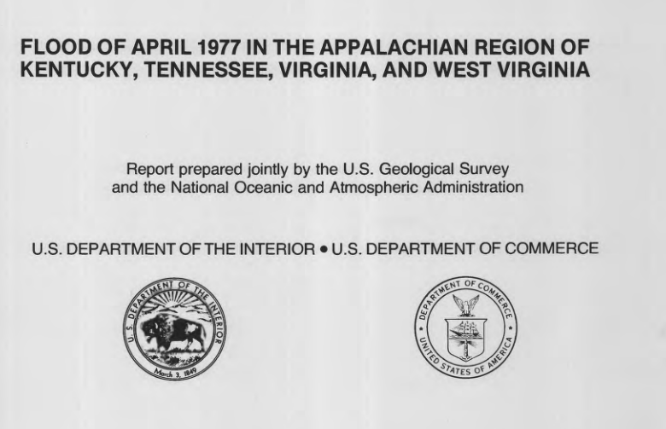
------------------------------------------------------------------------------------------------------------------------
The Byrd Center Blog:
https://www.byrdcenter.org/blog/the-long-road-to-recovery-the-tug-fork-valley-floods-part-i
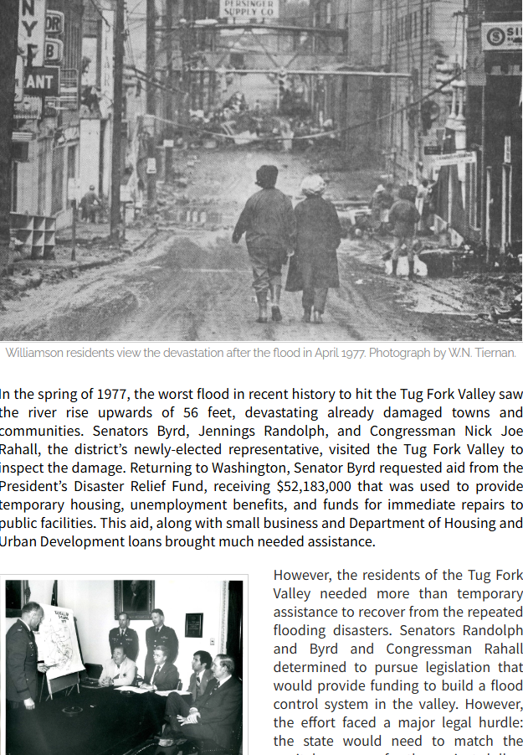

----------------------------------------------------------------------------------------------------------------------------
Mountain Citizen:
https://mountaincitizen.com/2023/04/05/remembering-the-devastating-1977-tug-river-flood/
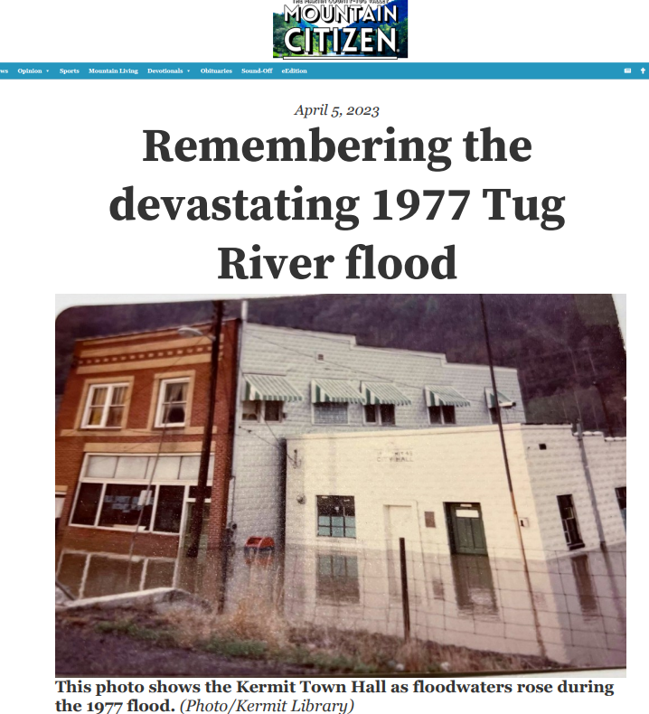
-------------------------------------------------------------------------------------------------------------------------
https://www.facebook.com/groups/191994984280420/posts/3359692197510667/
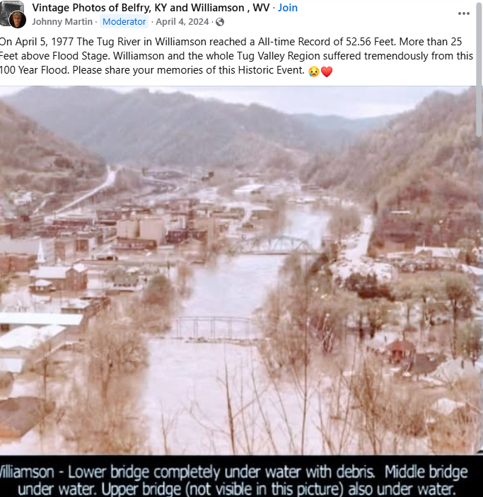
-----------------------------------------------------------------------------------------------------------------------

https://www.williamsondailynews.com/news/memories-of-great-flood-remain-45-years-later/article_682a6578-5ad4-5de8-9133-81f8ecdfc92c.html
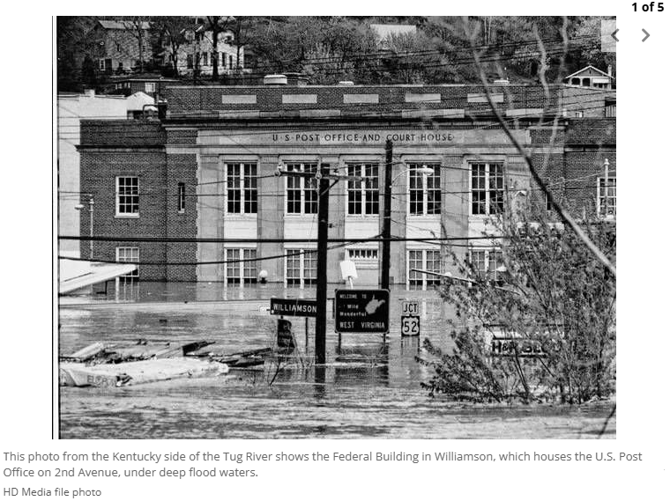
------------------------------------------------------------------------------------------------------------------------------------
Wes Wilson Photography
https://www.facebook.com/photo.php?fbid=1630367073714482&id=202797173138153&set=a.275093095908560



