Video Sources:


Residents reflect on anniversary of historic flooding
https://www.wowktv.com/weather/residents-reflect-on-anniversary-of-historic-record-flooding/
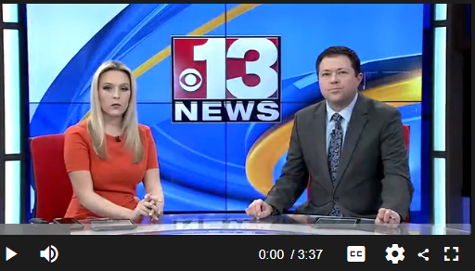
----------------------------------------------------------------------------------------------------------------------------

https://www.youtube.com/watch?v=MFrtjwy-tDg

Disaster on the Tug

Katherine Endicott
In April of 1977, the largest flood on record for the Tug Fork Valley struck the southern portion of West Virginia. The disaster's impact on Mingo County, in particular, revealed astronomical damages. Mr. and Mrs. Byron Thornton, owners of Thornton's Department Store in Kermit, West Virginia, compared the incident to the biblical great flood found in Genesis. Although the Thornton's were able to recover their store, many businesses in the area were completely destroyed or never fully restored. Amazingly only one life was taken in the Mingo area of the flood, but the effects of the disaster left the Tug Valley region in an economic slump for thirty-five years. To be sure, the people suffered a long reconstruction period that left many communities unrecoverable. Not only that, but the delay in government protection for flood control projects caused local uproars to emerge as Mingo citizens feared another disaster. Disaster on the Tug will reveal the damages caused by the flood, show its impact on the hard-hit cities of Kermit, Matewan, and Williamson, and demonstrate how the community banded together in order to receive sufficient flood control measures. Filmed By: Katherine Endicott JMC 575 Completed On: November 30, 2013 Director/Videographer: Katherine Endicott Starring: Samuel Kapourales, Edward Nenni, and Johnny Linville Editors: Crystal Hall, Todd Hall, and Katherine Endicott Editing Software: iMovie Maker Special thanks to: Samuel Kapourales, Edward Nenni, and Johnny Linville for allowing me to film them and share their photos and documents; J.W. and Elaine Endicott for their support; Todd Hall and Crystal Hall for their editing help; and Garage Band and WMUL for their music. Interview with Samuel Kapourales filmed in his office at Hurley's Drug Store in Williamson, WV. Interview with Edward Nenni filmed in his store at Nenni's Department Store and Shoe Repair in Matewan, WV. Interview with Johnny Linville filmed at City Hall in Kermit, WV. All scenes recorded were filmed on location in Williamson, Matewan, and Kermit, WV. Music: '3-4 Prog 01' courtesy of WMUL (Marshall University). 'Timeless', 'Dewdrops', and 'Comin' Home' all courtesy of Garage Band. Sources: Department for Natural Resources and Environmental Protection Commonwealth of Kentucky and Department of Natural Resources State of West Virginia. Special Flood Hazard Information Report: Tug Fork of Big Sandy River Kentucky and West Virginia. Prepared by the Huntington District Corps of Engineers. Huntington, WV: Government Printing Office, 1978. Fanning, Michael, John Fanning, and Greg Carannante. "The Wake of the Flood." The Mountain Call, July 1977. Lovern, Kyle. Memories of Tug Valley: A Trip Back in Time. Chapmanville, WV: Woodland Press, LLC, 2012. Sanders, Charlotte. "The Great Flood of '77." The Williamson Daily News, May 18, 1977. Smith, Graham. Williamson 1977 Flood Photos. DVD. Williamson, WV: The Williamson Historical Foundation, Inc., 2012. U.S. Department of the Army. The 1977 Tug Fork Valley Flood. Prepared by the Huntington District Corps of Engineers Huntington, WV: Government Printing Office, 1978. White, Rodney. "Lafe Ward Leads Pilgrims' 'Charge': Congressional Delegations Addressed." The Herald Dispatch, April 12, 1978.
--------------------------------------------------------------------------------------------------------------------------------------------

