Video Sources:

The Great Flood 1985 (West Virginia)
WV Cinema
Oct 17, 2021
News coverage from the great flood of 1985. Includes coverage of West Virginia.
https://www.youtube.com/watch?v=1ly20lXUtWI
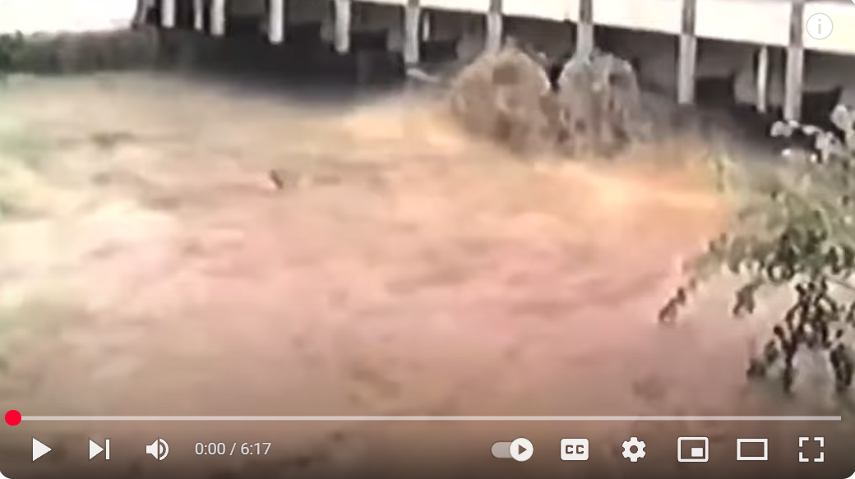
------------------------------------------------------------------------------------------------------------------------------------------
A Slideshow of the 1985 Flood in West Virginia
Charleston Gazette-Mail
Nov 4, 2015
A slideshow of photos of the 1985 Flood in West Virginia from the staffs of the Charleston Gazette and Charleston Daily Mail, with recollections by photographers and staffers who shot photos and wrote stories from the front lines of the flood-damaged counties. A total of 47 people were killed in the floods. Pendleton and Grant counties had the most fatalities. Towns such as Parsons, Rowlesburg, Philippi, Marlinton, Glenville, Petersburg, and Moorefield were severely damaged, according to the wvencyclopedia.org. A companion video to a story in the Thursday, Nov. 4, 2015 Charleston Gazette-Mail: http://www.wvgazettemail.com/article/...
https://www.youtube.com/watch?v=4a3F_aSW4o0

------------------------------------------------------------------------------------------------------------------------------------------
The 1985 Flood along the Cheat River from Forks of Cheat
West Virginia Public Broadcasting
Jun 24, 2016
The 1985 Flood along the Cheat River from the WNPB documentary Forks of Cheat
https://www.youtube.com/watch?v=4vdgEDsuolE
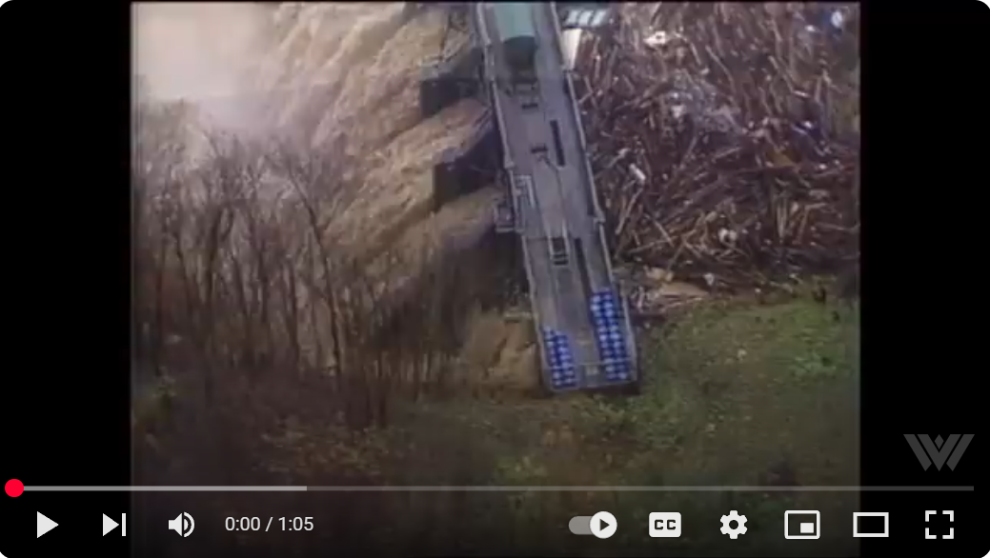
------------------------------------------------------------------------------------------------------------------------------------------
40 years later, 1985 flood still stirs troubling memories
MetroNews
Nov. 5, 2025
40 years later, 1985 flood still stirs troubling memories
https://wvmetronews.com/2025/11/05/40-years-later-1985-flood-still-stirs-troubling-memories/



