Video Sources:
59 NEWS
https://www.wvnstv.com/top-stories/emergency-services-director-looks-back-on-2001-floods/?utm_campaign=socialflow&utm_medium=referral&utm_source=facebook.com&fbclid=IwY2xjawTgNYpleHRuA2FlbQIxMQBzcnRjBmFwcF9pZBAyMjIwMzkxNzg4MjAwODkyAAEeKQ3AT3E4YFBby4QNGv72hVknFMwdTyNY74quIfl-zMi2Tfa7hizfFwxryz4_aem_cNjzZUCQDA5aTDIHBEuXsw
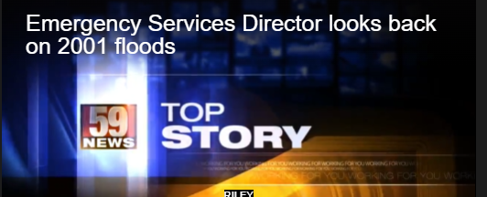

-----------------------------------------------------------------------------------------------------------------------
Forgotten Appalachia Facebook Page
https://www.facebook.com/reel/1325396086472146
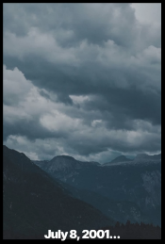

-----------------------------------------------------------------------------------------------------------------------
Videographer Larry Marrs Facebook Page
https://www.facebook.com/watch/?v=864862564387830
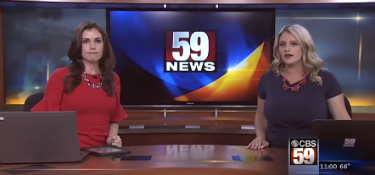

-----------------------------------------------------------------------------------------------------------------------
WVVA Web Site
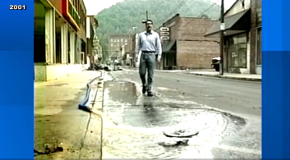
https://www.wvva.com/video/2026/07/08/troubled-waters-wvva-special-floods-2001/

-----------------------------------------------------------------------------------------------------------------------

