Picture Sources:
Rainelle:
Image courtesy of The Register Herald at https://www.register-herald.com/flood/gallery-rainelle-flood-of-2016/collection_59999528-56d8-11e7-9c45-5b4aa2a44464.html

Richwood:
Image courtesy of Rick Adams at Pinterest https://www.pinterest.com/pin/nicholas-county-nursing-center-richwood-west-virginia--484559241140725830/

Image courtesy of Jeromy Rose at https://uploads.knightlab.com/storymapjs/b8790431114df443c14b9a4f147293a0/2016-wv-floods/draft.html

Image courtesy of abcNEWS at https://abcnews.go.com/US/inside-flooded-richwood-west-virginia-devastated-small-town/story?id=40186248

Clendenin:
Image courtesy of WOWK-TV retrieved from the National Oceanic and Atmospheric Administration (NOAA) at https://www.weather.gov/rlx/2016-historic-june-flooding

Clay County:
Image courtesy of West Virginia Public Broadcasting retrieved from https://wvpublic.org/clay-county-begins-to-rebuild-after-record-flood-destroys-hundreds-of-homes/

White Sulphur Springs (WSS):
Picture_1 to Picture_3:
Image courtesy of CNN at https://www.cnn.com/2016/06/24/us/west-virginia-flooding-deaths/index.html

Picture_4 to Picture_9:
Image courtesy of The Register Herald at https://www.register-herald.com/flood/gallery-white-sulphur-springs-flood-of-2016/collection_cdf2d4b0-56d9-11e7-a382-7b8f9ba26dee.html

--------------------------------------------------------------------------------------------------------------------------------
https://www.weather.gov/rlx/2016-historic-june-flooding
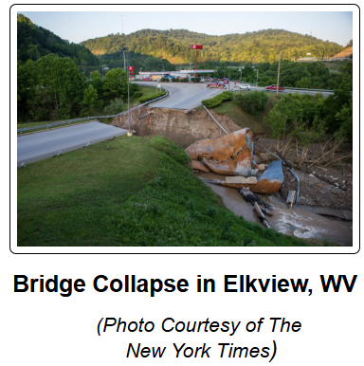
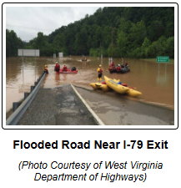
--------------------------------------------------------------------------------------------------------------------------------
https://www.weather.gov/rnk/2016_06_23_Flood
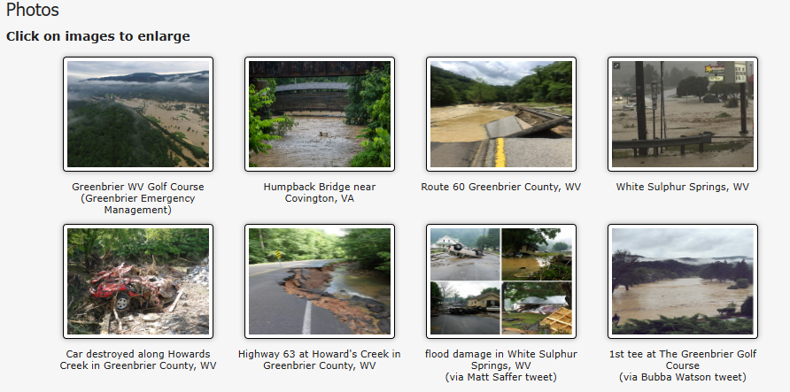
--------------------------------------------------------------------------------------------------------------------------------

https://slate.com/news-and-politics/2016/06/west-virginia-flooding-kills-at-least-26.html
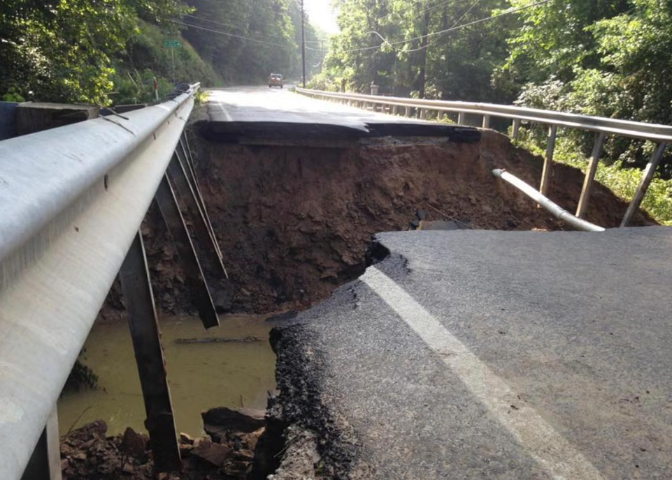
--------------------------------------------------------------------------------------------------------------------------------

https://x.com/WVEMD/status/746755552043241472
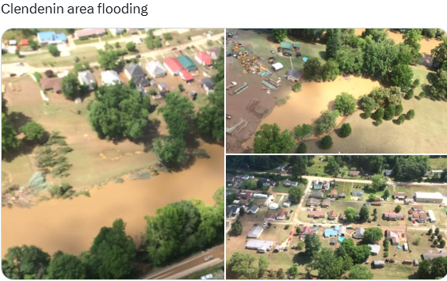
--------------------------------------------------------------------------------------------------------------------------------

https://discover.hubpages.com/politics/West-Virginia-Flooding-West-Virginia-Strong
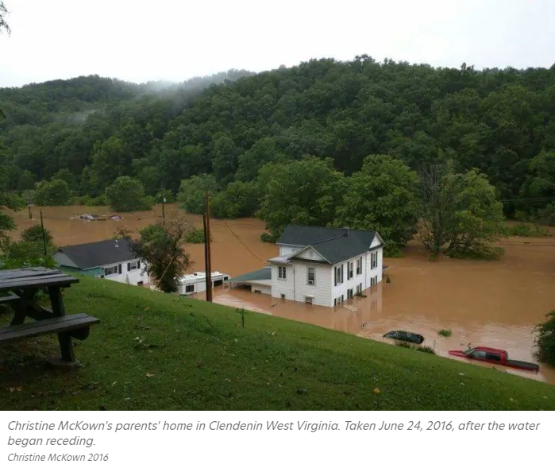
--------------------------------------------------------------------------------------------------------------------------------

https://abc7ny.com/post/video-powerful-images-of-historic-w-virginia-floods/1399863/
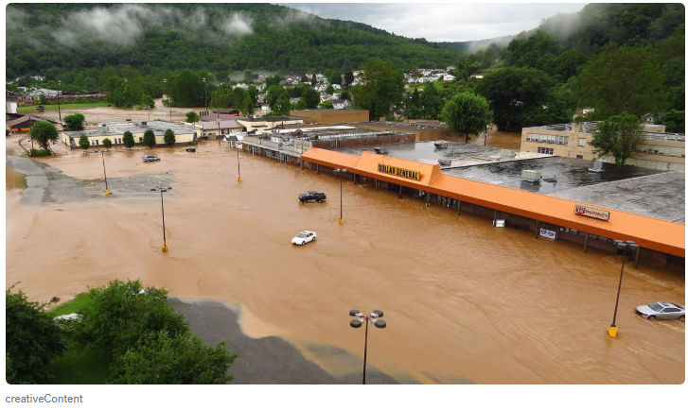
--------------------------------------------------------------------------------------------------------------------------------
https://www.onlineathens.com/story/news/nation-world/2016/06/25/crews-rescue-stranded-west-virginia-flooding-23-dead/15456117007/
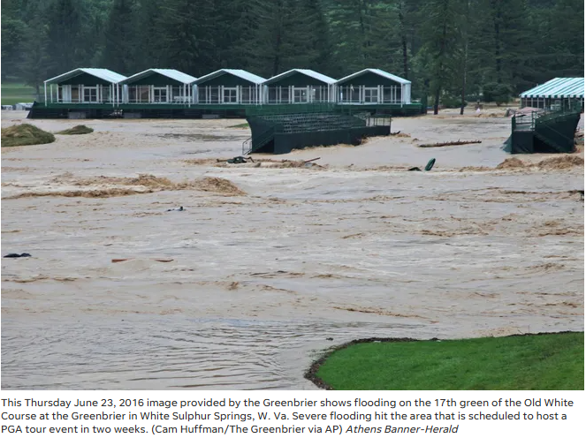
--------------------------------------------------------------------------------------------------------------------------------

https://dailyyonder.com/too-poor-to-protect-when-cost-benefit-analysis-leaves-towns-to-wash-away/2021/04/29/
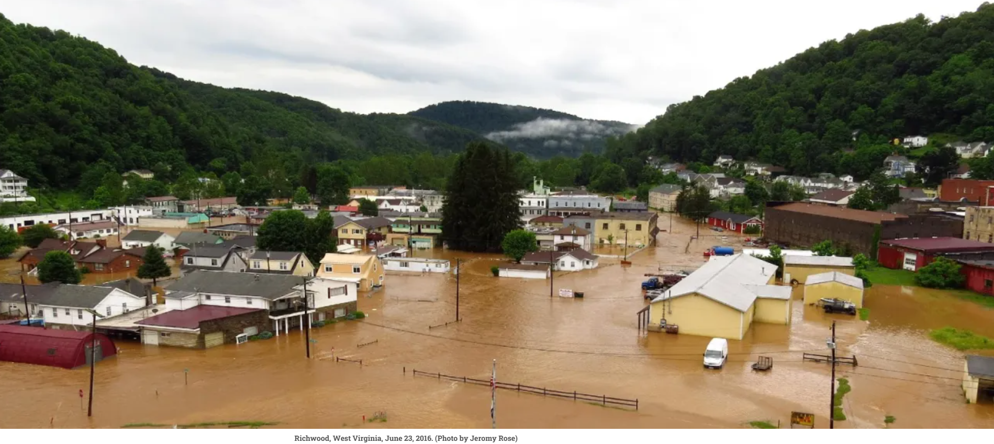
--------------------------------------------------------------------------------------------------------------------------------

https://www.popularmechanics.com/science/environment/a21509/floating-burning-house-virginia-flood/
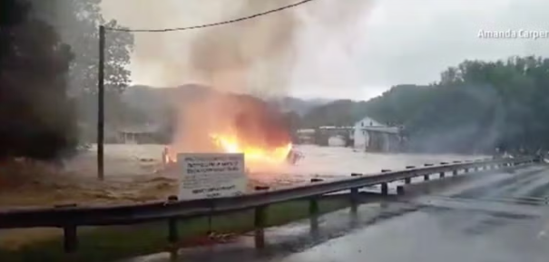
--------------------------------------------------------------------------------------------------------------------------------

https://www.wvtf.org/news/2024-10-16/what-recovery-after-2016-w-va-floods-can-tell-us-about-rebuilding-after-helene
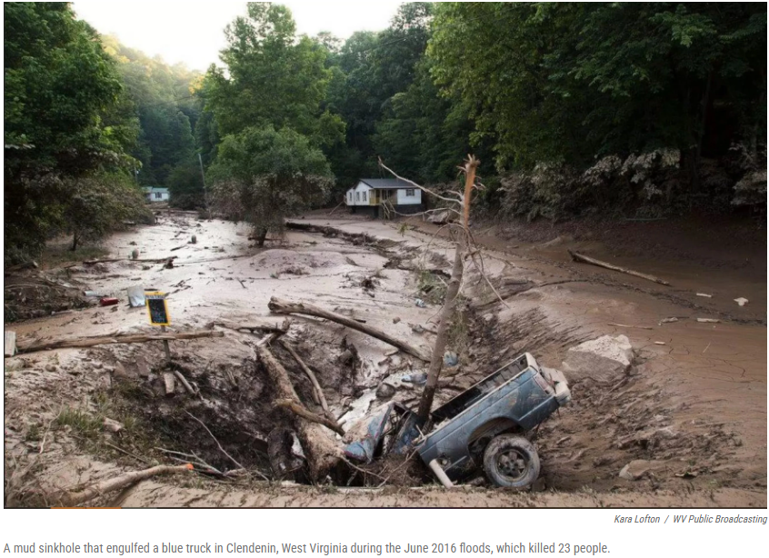
--------------------------------------------------------------------------------------------------------------------------------

https://revealnews.org/article/from-bad-to-worse-towns-can-lose-damaged-institutions-in-fema-loophole/
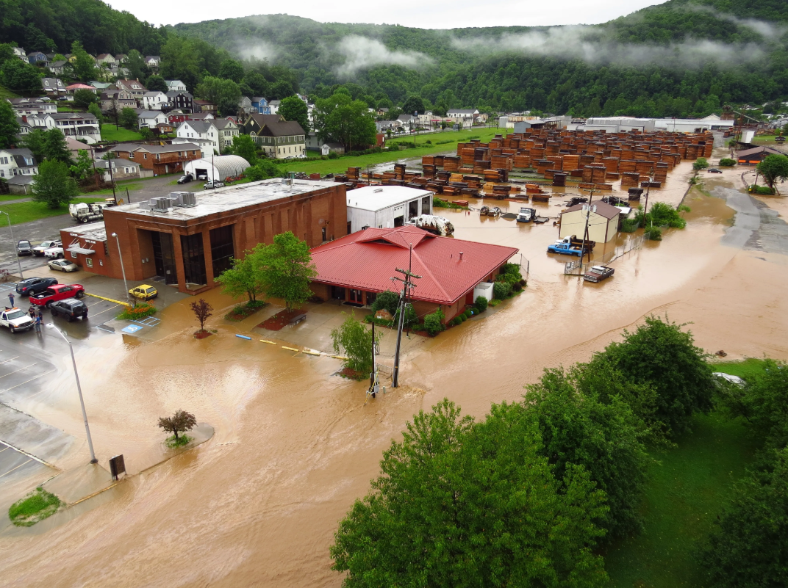
--------------------------------------------------------------------------------------------------------------------------------

https://www.pbs.org/newshour/nation/at-least-23-dead-in-west-virginia-floods
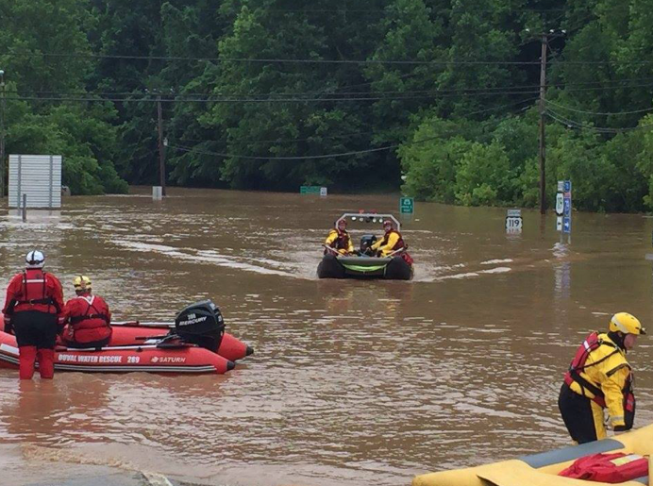
--------------------------------------------------------------------------------------------------------------------------------

https://wvmetronews.com/2016/07/08/191385/
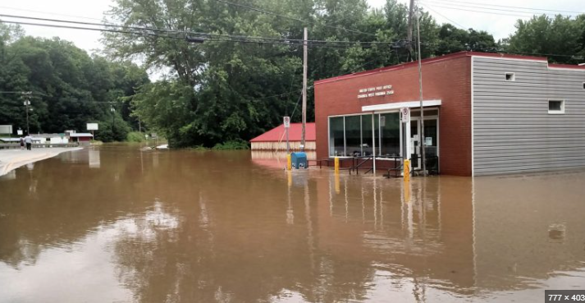
--------------------------------------------------------------------------------------------------------------------------------
https://www.cnn.com/2016/06/24/us/gallery/west-virginia-flooding
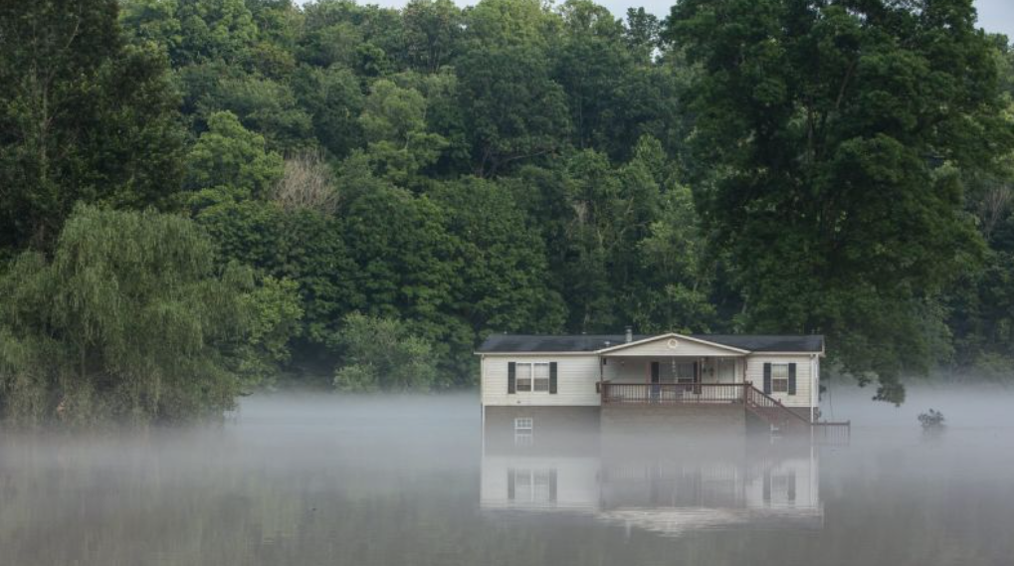
---------------------------------------------------------------------------------------------------------
Appalachian Americans on Facebook
https://www.facebook.com/groups/AppalachianAmericans/posts/10154285978733648/
In case it's hard for you to fathom the devastation that has clouded West Virginia, take a look at these pictures that Base 2 took enroute to Clendenin, WV.
We took food and lots of water to the First Responders that are working to rescue our citizens in Elkview, WV. Please remember them and all the others that are working long hours with little to no sleep.
We are down, but we are not out! We will recover better than ever because that is what we do! God Bless West Virginia!
Phot cred:Louie R. FP-C
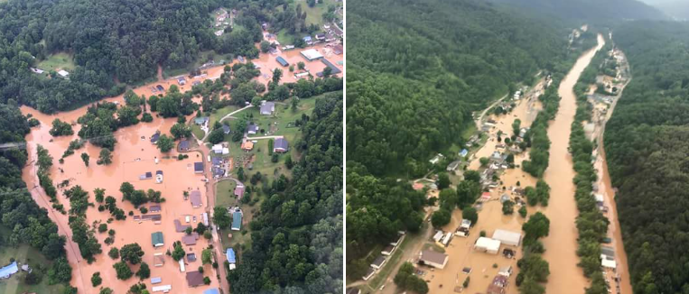
---------------------------------------------------------------------------------------------------------

https://water.noaa.gov/gauges/qusw2
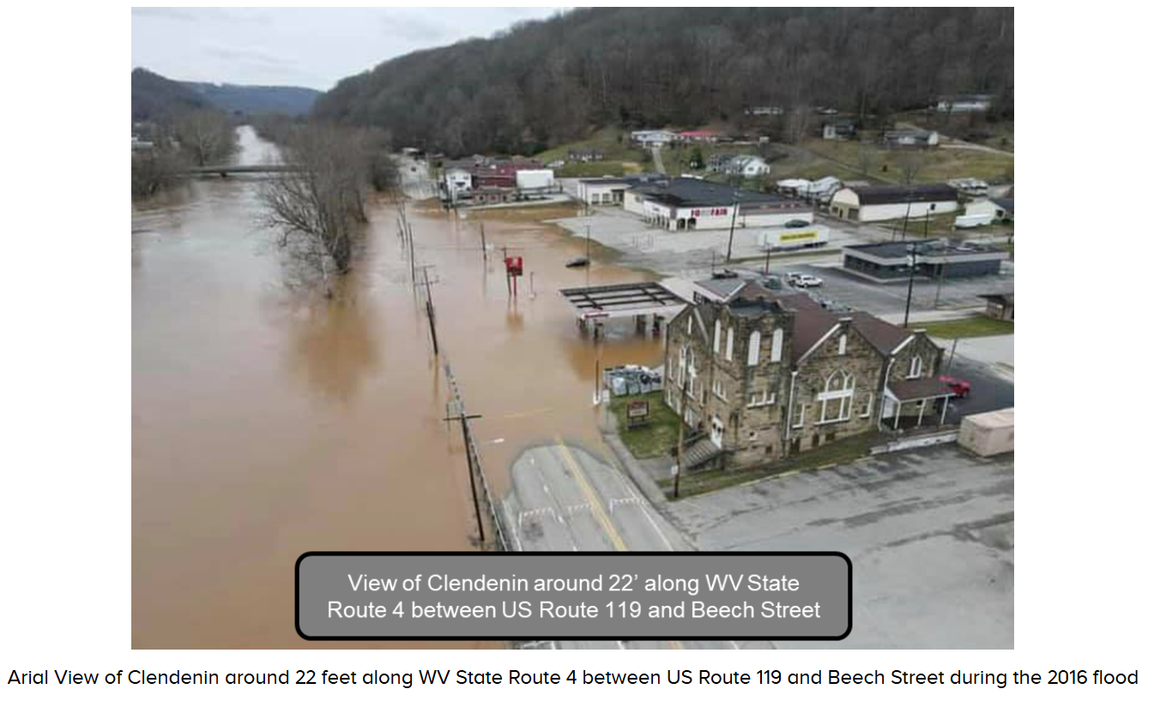
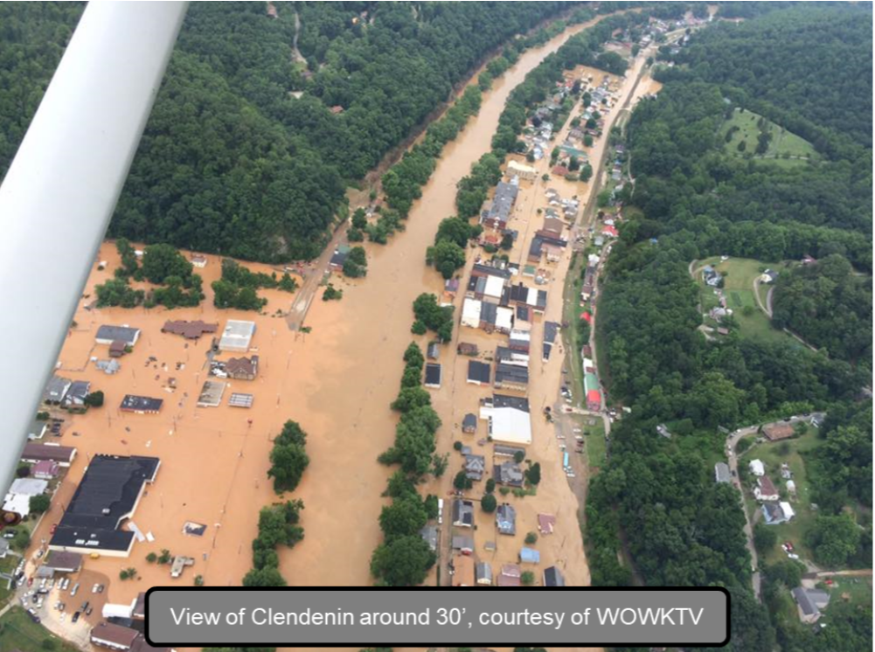
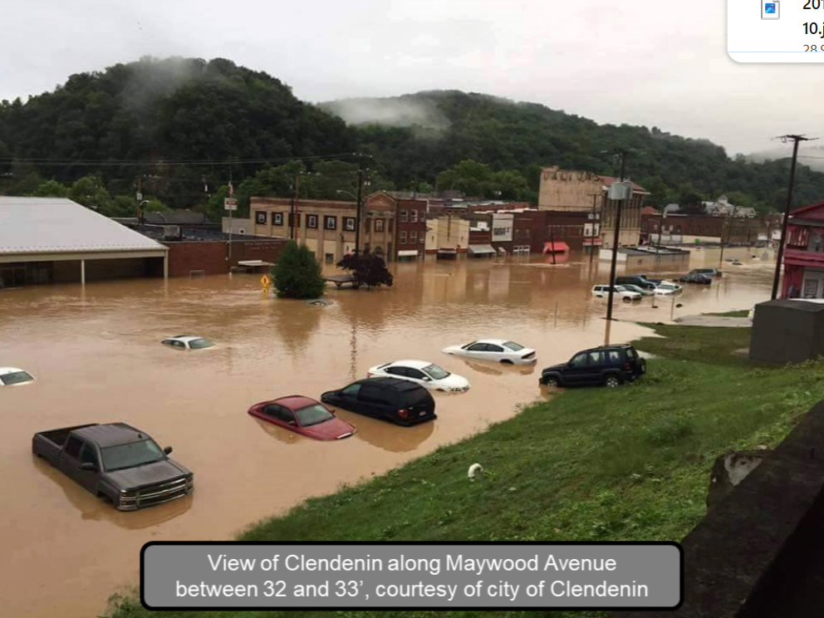
---------------------------------------------------------------------------------------------------------

https://climate.mit.edu/posts/we-have-move-wv-leaders-pushing-state-flood-risk-upward-favoring-resource-extraction-over
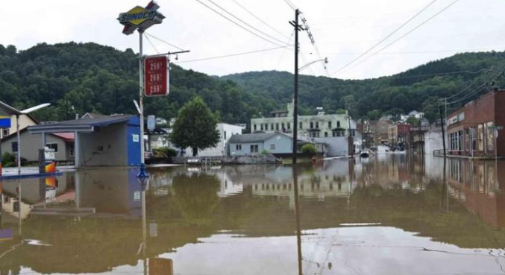
---------------------------------------------------------------------------------------------------------
On Facebook
https://www.facebook.com/photo/?fbid=1086535478078957&set=pb.100064743667219.-2207520000
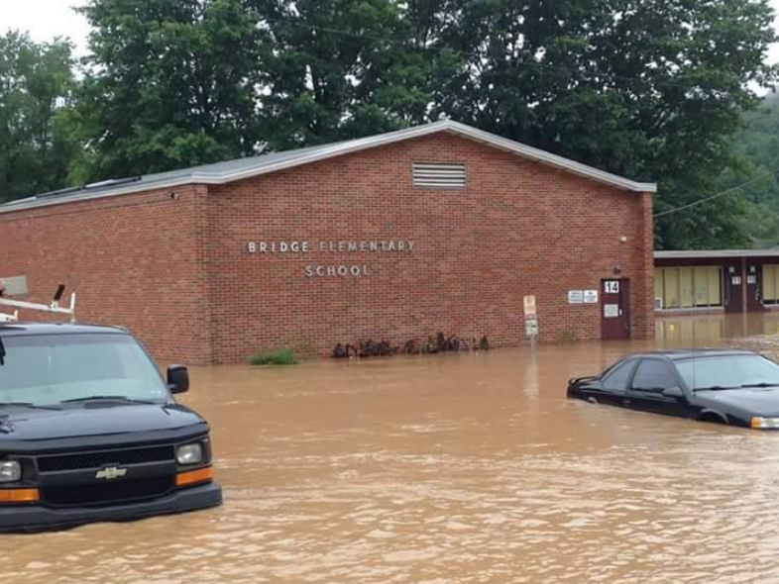
---------------------------------------------------------------------------------------------------------
 On Facebook
https://www.facebook.com/cvfdstation1/photos/pb.100064743667219.-2207520000/1076603465738825/?type=3
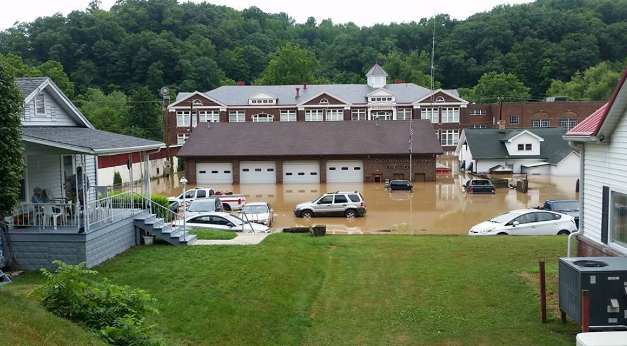
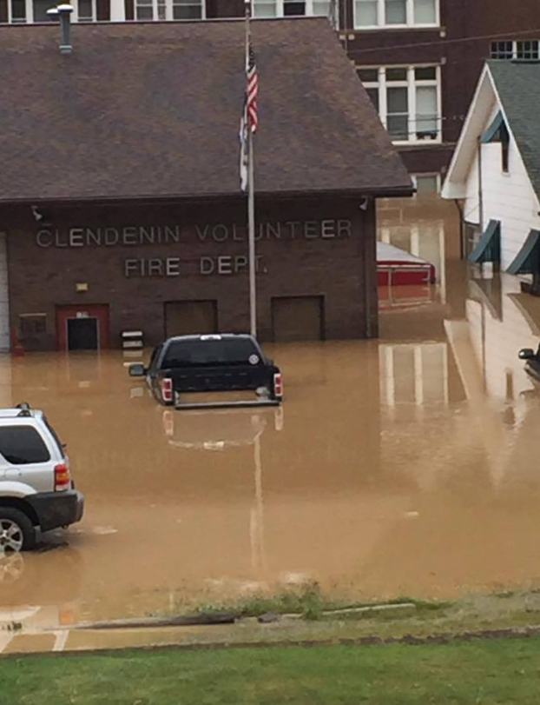
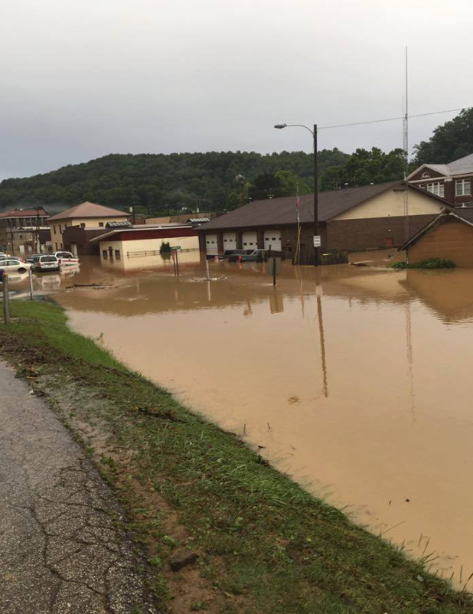
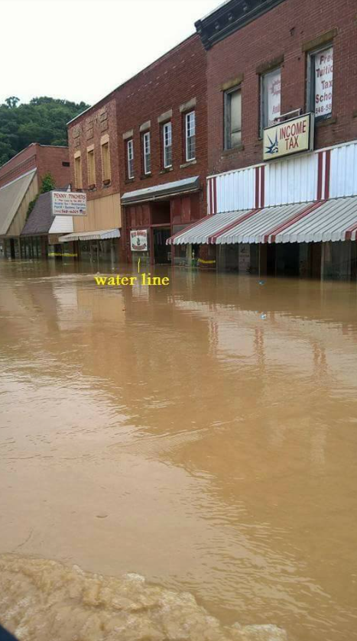
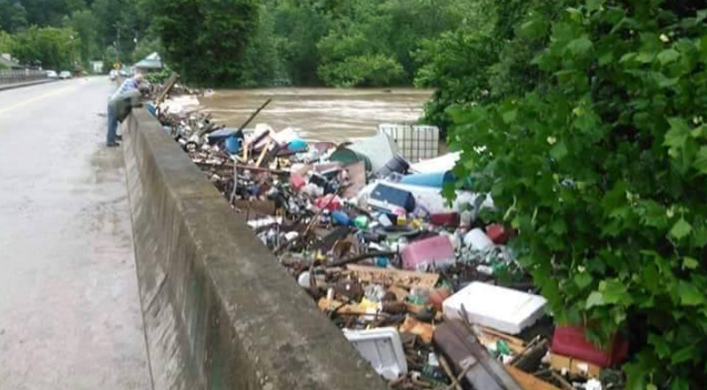
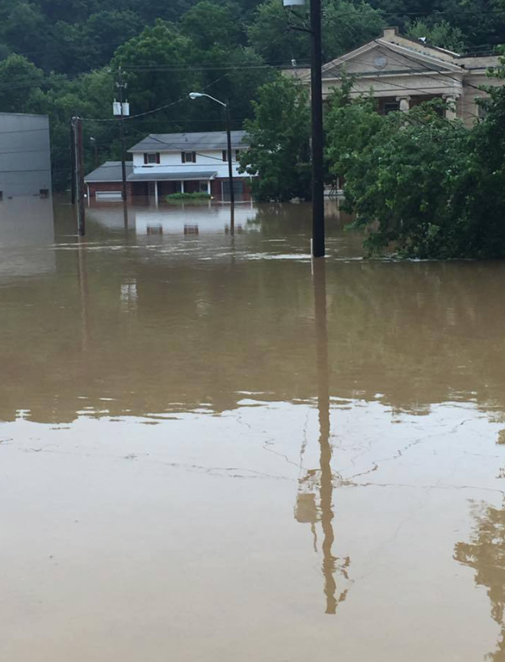
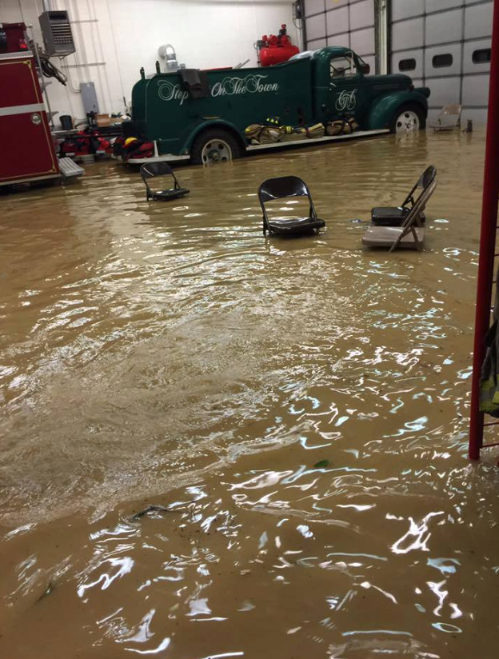
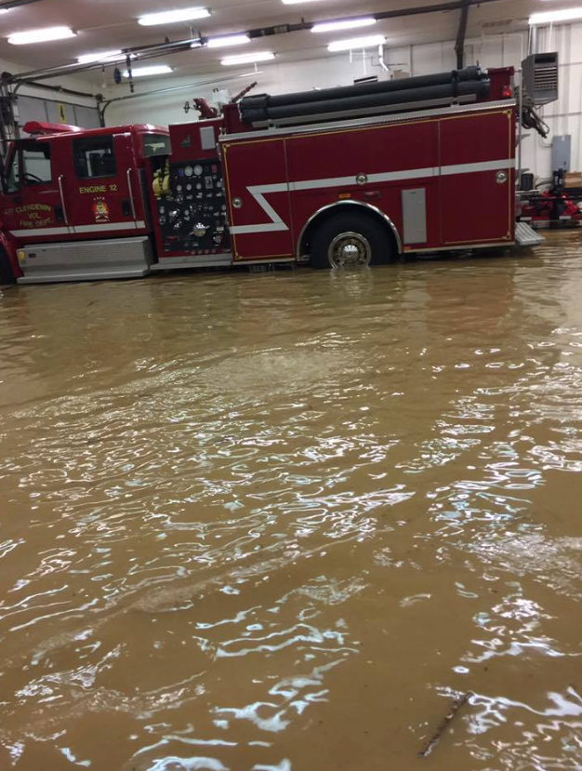
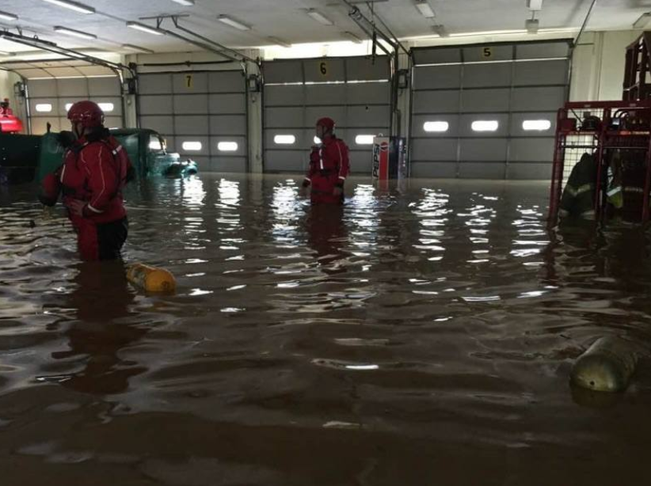
---------------------------------------------------------------------------------------------------------

https://wchstv.com/news/local/state-officials-release-some-statistical-information-on-west-virginia-flood-deaths
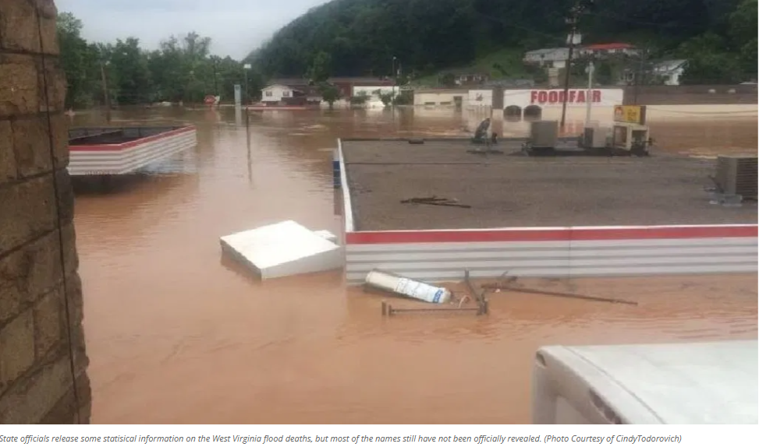
---------------------------------------------------------------------------------------------------------
on Facebook
https://www.facebook.com/Aldersonsstore/posts/here-are-more-images-of-our-hometown-during-the-historic-flood-our-store-is-okay/10153893197053264/
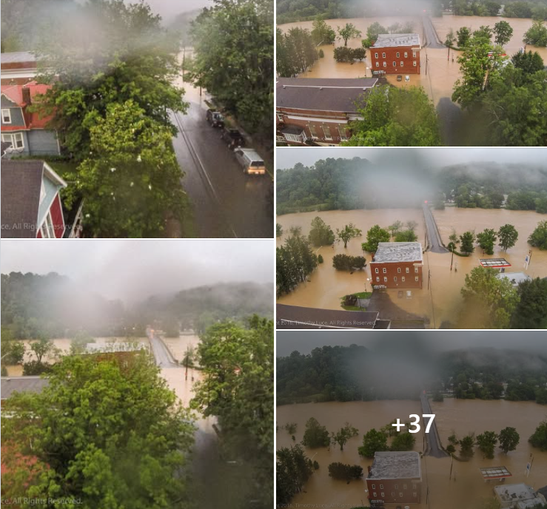
Here are more images of our hometown during the historic flood. Our store is okay and open today...and our town is cleaning up. We will still be hosting the largest 4th of July Celebration in the state starting on Friday, July 1st! But we could use your help to get ready! Please check in with Alderson City Hall, Alderson Volunteer Fire Department, or our Visitors Center to see where you can volunteer! Check out the FB pages for the Town of Alderson and Alderson Main Street. There are also funding sites that are taking donations...but you can also send a check directly to the Alderson Volunteer Fire Department and EMS, P.O. Box 647, Alderson, WV. Anything you can do and/or give will help. Thank you!
Please Like and Share. Town of Alderson, West Virginia the morning of the 2016 flood. Just after the waters had crested (photos taken within approx 6" of crest). After being out all night with the police chief Jeremy Bennett in his HUMVEE, I sent the drone up for a brief flight. It had been raining hard and then in a lull I sent it up, and it started pouring again. As I was bringing it back to land, the video feed went haywire and I looked up to see the drone fall from the sky not 10 feet from me.) Did I think I was going to lose the drone? No. Would I do it again? Yes. I feel it was important to get the shot at the crest of the flood for documentation purposes for the town. Maps are good, photos are better.
Shot with a 3DR Solo from 3DRobotics and a GoPro Hero 4 Black.
Hundreds of families were impacted. We still own a house in Alderson and it had about 2.5 feet of water inside it. But a lot of people were impacted far worse than we were. If you'd like to help our community please give here: https://www.gofundme.com/2b9usrmk ALL PROCEEDS go directly to the volunteer fire dept and the town. This page was setup by a trusted long-time former resident of Alderson Kelly Keadle Carpenter and the town has endorsed this as an authentic place to donate. You may confirm this here: Town of Alderson, West Virginia. Onward.
---------------------------------------------------------------------------------------------------------

https://www.samaritanspurse.org/article/pray-for-west-virginia-flood-victims/
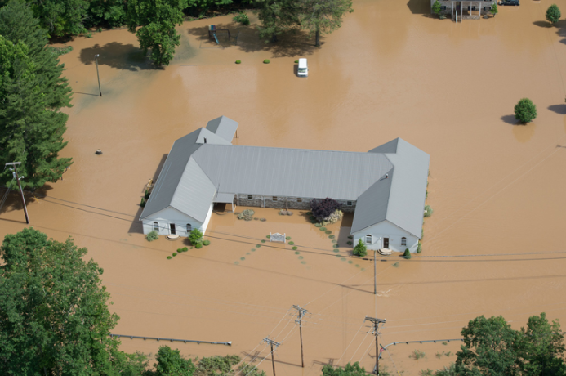
---------------------------------------------------------------------------------------------------------

https://www.syntrinity.org/featured/ronceverte-pc-helping-flood-victims-stay-on-their-feet/
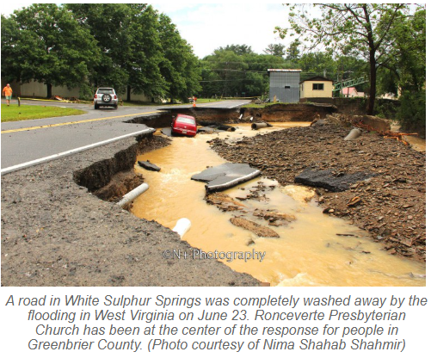
---------------------------------------------------------------------------------------------------------

https://www.google.com/imgres?q=wv%202016%20flood&imgurl=https%3A%2F%2Fmedia.cnn.com%2Fapi%2Fv1%2Fimages%2Fstellar%2Fprod%2F160626085633-west-virginia-flooding-clendenin-dairy-queen.jpg%3Fq%3Dw_4000%2Ch_2670%2Cx_0%2Cy_0%2Cc_fill&imgrefurl=https%3A%2F%2Fwww.cnn.com%2Fvideos%2Fweather%2F2016%2F06%2F25%2Fwv-flooding-deaths-valencia-nr-pkg.cnn&docid=q2IcxuS2zcuf2M&tbnid=7uTsxByydMhrWM&vet=12ahUKEwjc1KGK0dOPAxW_FFkFHbO5Kz4QM3oECGIQAA..i&w=4000&h=2670&hcb=2&ved=2ahUKEwjc1KGK0dOPAxW_FFkFHbO5Kz4QM3oECGIQAA
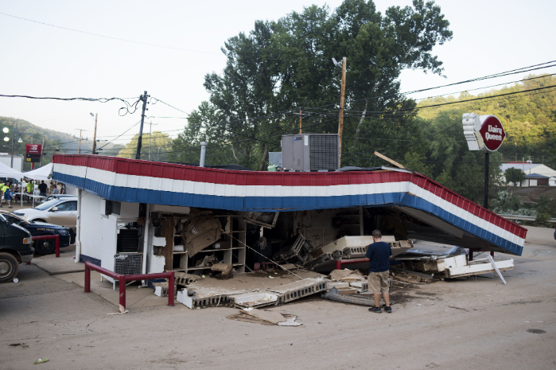
---------------------------------------------------------------------------------------------------------

https://www.cbsnews.com/news/toddler-swept-away-by-west-virginia-floods/
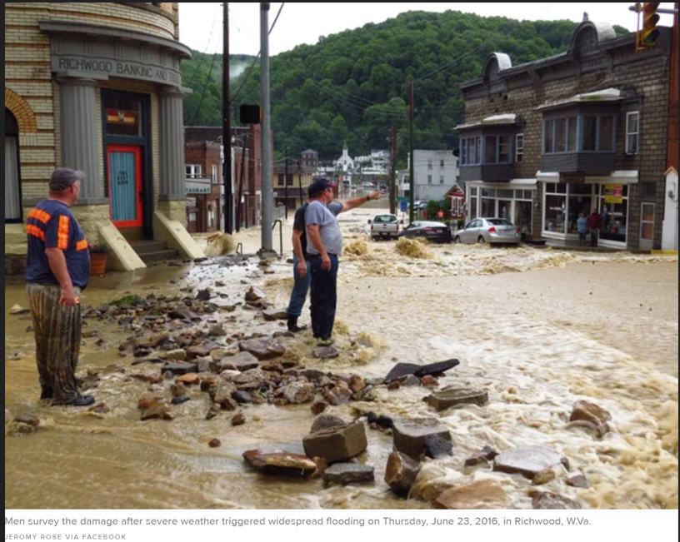
---------------------------------------------------------------------------------------------------------

https://www.wvgazettemail.com/news/kanawha_valley/were-over-this-flood-five-years-after-june-2016-flood-clendenin-looks-toward-the-future/article_7345b180-d824-5b32-baff-10cb56049de3.html
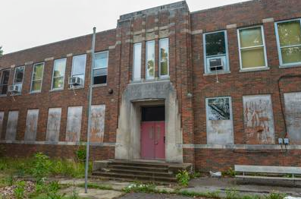
---------------------------------------------------------------------------------------------------------

https://www.google.com/imgres?q=clendenin%20elementary%20flood%202016&imgurl=https%3A%2F%2Fpbs.twimg.com%2Fmedia%2FCmm-VzmWEAASsgS%3Fformat%3Djpg%26name%3Dlarge&imgrefurl=https%3A%2F%2Fx.com%2Fclendeninelemwv%3Flang%3Dar-x-fm&docid=QdYd6IfBRq6cUM&tbnid=Vcl4EX5UWGEK7M&vet=12ahUKEwjS6b3krduPAxXIFFkFHQ22BKoQM3oECBkQAA..i&w=1950&h=1097&hcb=2&itg=1&ved=2ahUKEwjS6b3krduPAxXIFFkFHQ22BKoQM3oECBkQAA
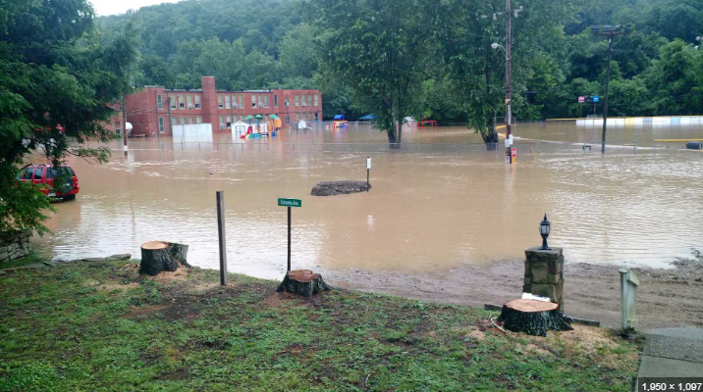
---------------------------------------------------------------------------------------------------------
https://www.google.com/imgres?q=clendenin%20high%20school%20flood%202016&imgurl=https%3A%2F%2Fbloximages.newyork1.vip.townnews.com%2Fwvgazettemail.com%2Fcontent%2Ftncms%2Fassets%2Fv3%2Feditorial%2F5%2F15%2F515747ae-6919-5b7f-b7d2-a5e2d00bc01e%2F59f75ab19fab4.image.jpg%3Fresize%3D750%252C500&imgrefurl=https%3A%2F%2Fwww.wvgazettemail.com%2Fnews%2Feducation%2F25-wv-schools-reportedly-damaged-by-flood-storm%2Farticle_83039921-7429-5c82-963c-a5365b2fb3cd.html&docid=Xb61mhoKP7vMlM&tbnid=lewCzNrwZQQp1M&vet=12ahUKEwji5s30stuPAxXOGVkFHTEWBC4QM3oECCUQAA..i&w=750&h=500&hcb=2&itg=1&ved=2ahUKEwji5s30stuPAxXOGVkFHTEWBC4QM3oECCUQAA
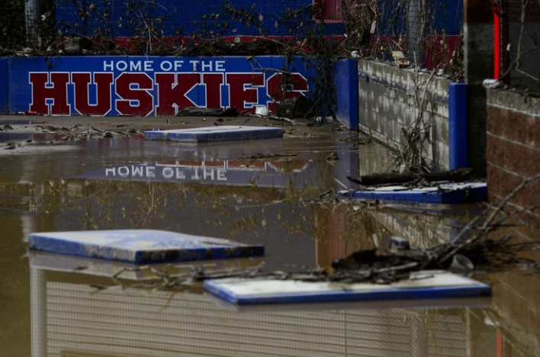
---------------------------------------------------------------------------------------------------------

https://www.facebook.com/photo/?fbid=1295423783804450&set=a.1299729193373909



