Video Sources:

Rainelle WV flood damage

https://www.youtube.com/watch?v=rtn6VBWcXGU
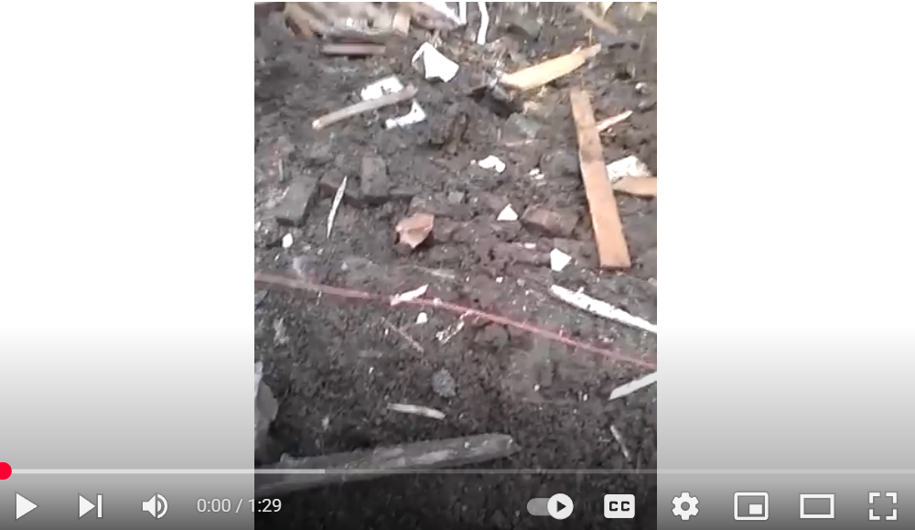
Dec 12, 2016
Home demolished after June 27-2016 flood
---------------------------------------------------------------------------------------------------------
West Virginia Floods: Burning Building Swept Away

https://www.youtube.com/watch?v=2d32zLCSjLE
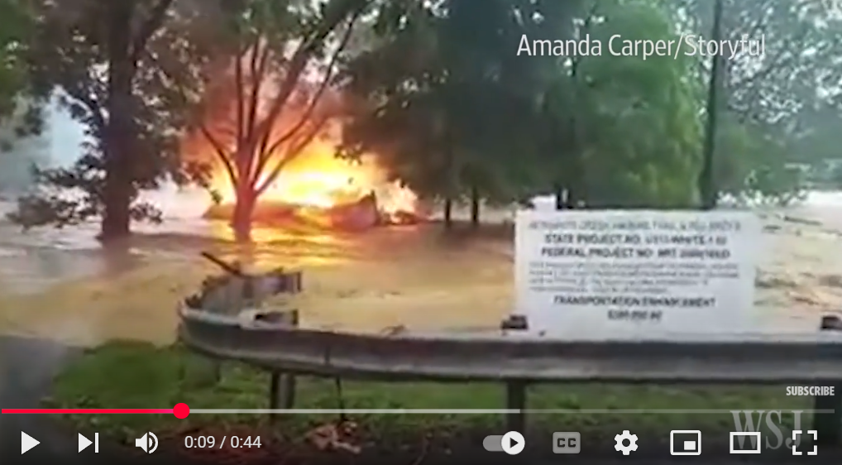
A video shows a burning building swept away by deadly flooding in the West Virginia city of White Sulphur Springs on June 23. Photo/Video: Amanda Carper/Storyful
---------------------------------------------------------------------------------------------------------
The Flood of June 2016, Rainelle, WV

https://www.youtube.com/watch?v=FmZBWNUwms8
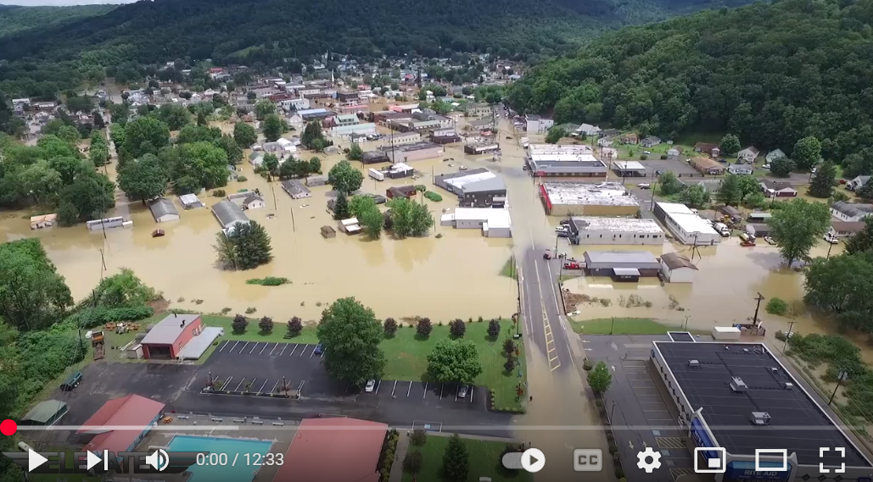
---------------------------------------------------------------------------------------------------------
West Virginia Flood 2016 - Richwood

https://www.youtube.com/watch?v=pXqZj4B-Dl8
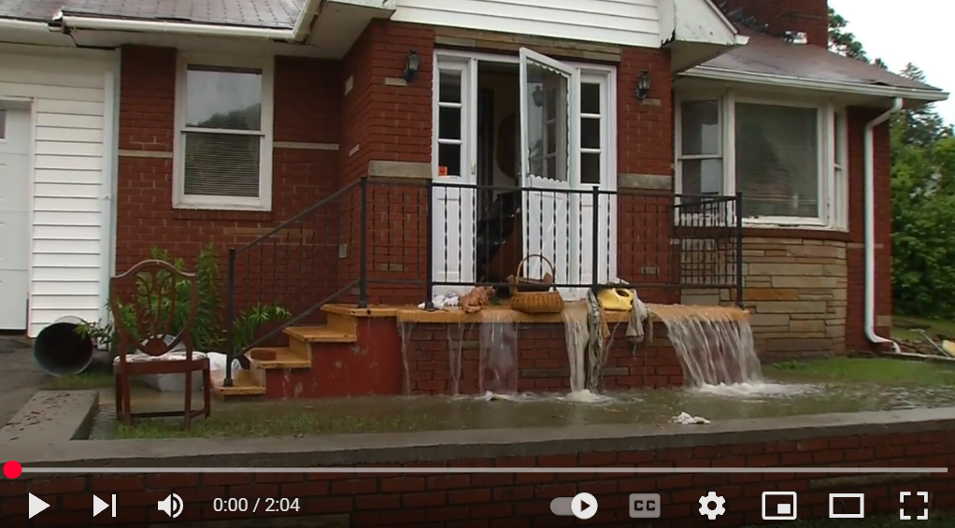
Jun 28, 2016
Day one of flooding in Richwood, West Virginia.
---------------------------------------------------------------------------------------------------------
WV Flood of 2016

https://www.youtube.com/watch?v=PhaeQonM78w
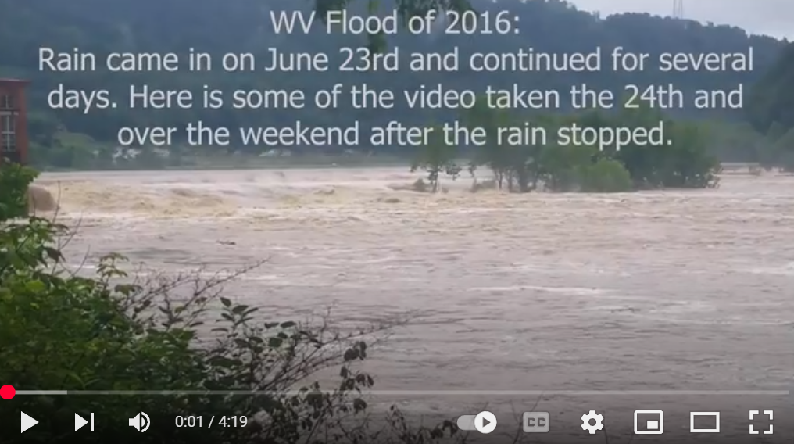
Jan 22, 2017
I put together some clips I had from the WV Flood in 2016.
---------------------------------------------------------------------------------------------------------
2016 Richwood Flood - Inside Appalachia

https://www.youtube.com/watch?v=wC7Jj110xnQ
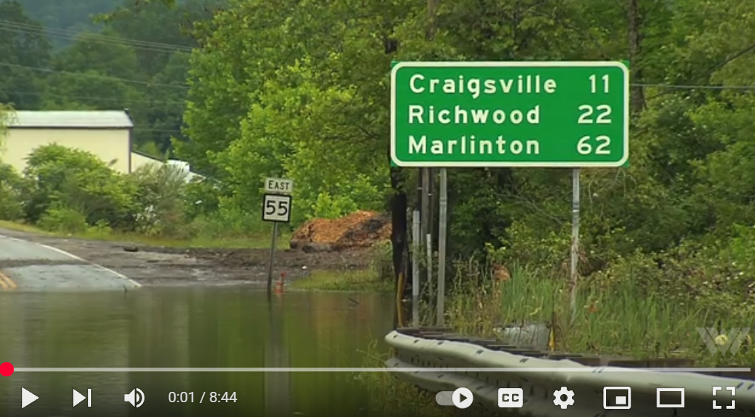
Jun 30, 2016
On Friday, June 30, Inside Appalachia host Jessica Lilly visited Richwood to speak with residents about the devastating flooding that began the previous day. She recorded the stories of two men who worked to get the residents out alive. On June 23, massive flooding swept across most of West Virginia. It began with a rare event- a tornado touched down in Nicholas County, West Virginia on the afternoon of Tuesday, June 21. Regional rain storms followed but nothing like what started to fall throughout a 22-county region on Thursday, June 23. By 7 p.m., the governor had declared a state of emergency in 44 counties. Within a tragic 24-36 hour period, at least 23 people had perished. Thousands of homes were flooded, many of them destroyed. There were stories of terror and heroism that came out of this flood. In Richwood, workers and volunteers rescued almost 100 people from the Nicholas County Nursing and Rehabilitation Center on Thursday afternoon.
---------------------------------------------------------------------------------------------------------
At least 23 dead in historic West Virginia flooding

https://www.youtube.com/watch?v=07uVmGg7GOQ

Jun 25, 2016
The death toll from the deadly flooding in West Virginia has climbed to 23 and is expected to increase. The governor has called in hundreds of national guardsmen to help with search and rescue efforts. The trouble began Thursday from heavy rains, destroying several homes. The body of a missing four-year-old boy was recovered Friday after he was swept away in floodwaters outside his home, and many more are missing. Kris Van Cleave reports from the hard-hit community of White Sulphur Springs.
---------------------------------------------------------------------------------------------------------
Nicholas County Schools moving forward after 2016 floods, construction underway in Summersville

https://www.wowktv.com/video/nicholas-county-schools-moving-forward-after-2016-floods-construction-underway-in-summersville/9934328/
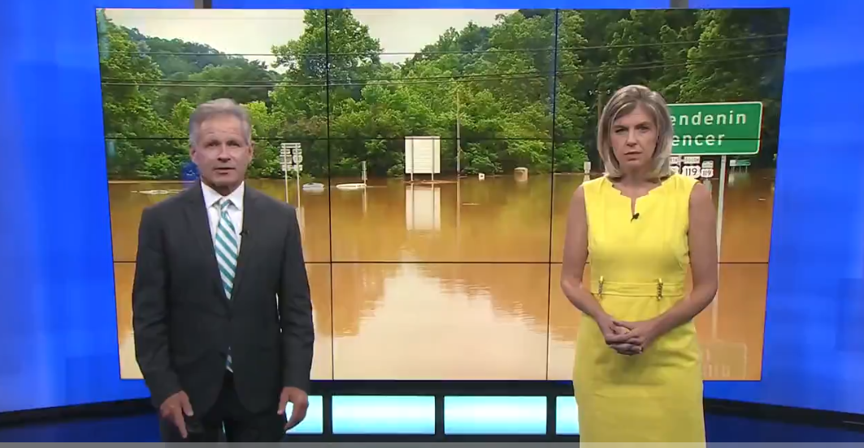
Aug 7, 2024 / 09:37 PM EDT
Back to school looks different for students and staff in Nicholas County, where the aftermath of the 2016 floods still lingers.
---------------------------------------------------------------------------------------------------------
Massive Flooding in Richwood, West Virginia

https://weather.com/news/weather/video/massive-flooding-in-richwood-west-virginia
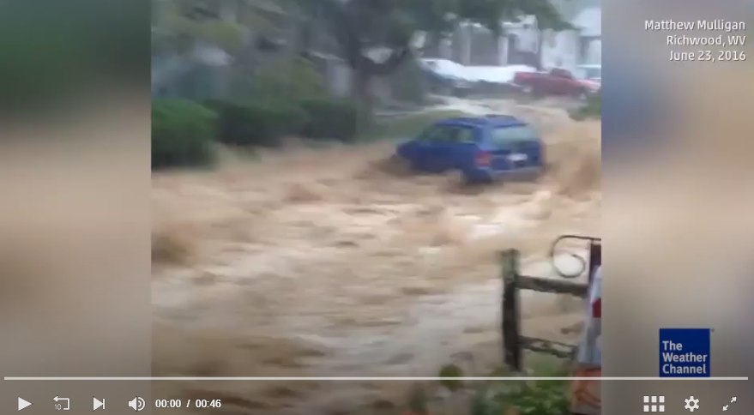
June 24, 2016
Take a look at the impact flash flooding is having on the town of Richwood, West Virginia.
---------------------------------------------------------------------------------------------------------
Sen. Capito tours Clendenin flood recovery effort

By WSAZ News Staff and Brendan Tierney
Published: May 4, 2021 at 2:00 PM EDT
https://www.wsaz.com/2021/05/04/sen-capito-tours-clendenin-for-flood-recovery-update/
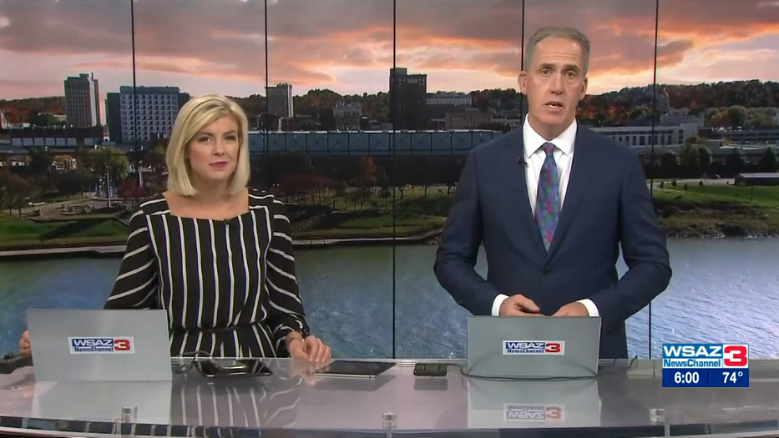
Notes: Mayor Summers said there is still a lot of work to be done to get the town back to where it was before the flood. They are trying to invest in a flood wall to prevent future damage to buildings and improve broadband internet access.
“I think this time next year, Clendenin is going to be a little Fayetteville,”
---------------------------------------------------------------------------------------------------------
Say What?! "Clendenin Flood Recovery"
Library Television Network
https://www.youtube.com/watch?v=qKvLnFWRmgY

---------------------------------------------------------------------------------------------------------

New Herbert Hoover High opens seven years after devastating flood
https://www.youtube.com/watch?v=cvWmiqttrK8

Aug 18, 2023
For seven years, students and staff at Herbert Hoover High have not had a building to call their own. Now a $100 million project culminates as campus opens its doors to students. FULL STORY: https://bit.ly/3qAHch4
---------------------------------------------------------------------------------------------------------
New Clendenin Elementary School opens its doors for a tour of the construction site
Published: Sep. 19, 2023 at 6:20 PM EDT
https://kcs.kana.k12.wv.us/news/elk_river_schools_update
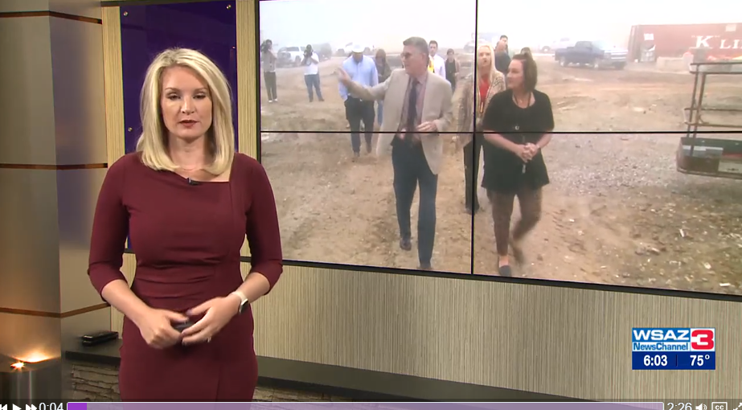
---------------------------------------------------------------------------------------------------------
Demolition underway on old Clendenin Elementary
By WSAZ News Staff
Published: Aug. 18, 2021 at 11:44 PM EDT
https://www.wsaz.com/2021/08/19/demolition-underway-old-clendenin-elementary/
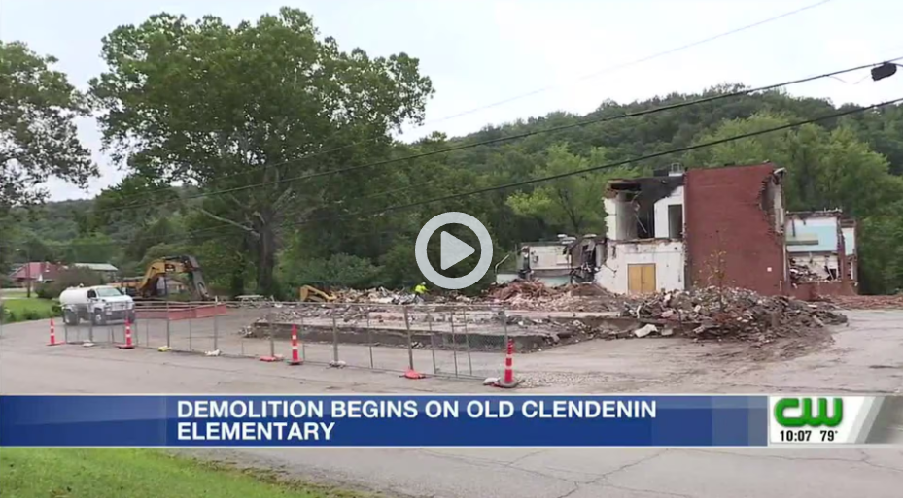
---------------------------------------------------------------------------------------------------------
Combined these three in 2016-06-Kanawha_Clendenin_Jordan-Creek-Flooding_Video:


2016 Flood Jordan Creek Clendenin WV
https://www.youtube.com/shorts/_xDvW9cJDNc


June 23 2016 WV flooding Kanawha county Clendenin WV Jordan creek
https://www.youtube.com/shorts/lJd8tkhXvG0


6-23-16 flood Jordan Creek RD in Elkview WV
https://www.youtube.com/watch?v=EdWWD5FVxL8
---------------------------------------------------------------------------------------------------------

