Picture Sources:


https://www.theintelligencer.net/news/top-headlines/2024/12/top-stories-of-2024-april-storms-had-many-struggling-to-keep-heads-above-water/
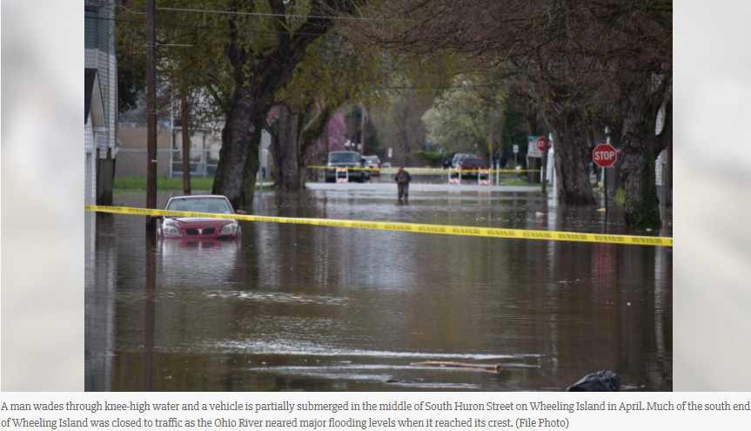
--------------------------------------------------------------------------------------------------------------------------------
https://www.theintelligencer.net/news/top-headlines/2024/04/many-wheeling-island-residents-mobilized-but-unfazed-by-flood-waters/
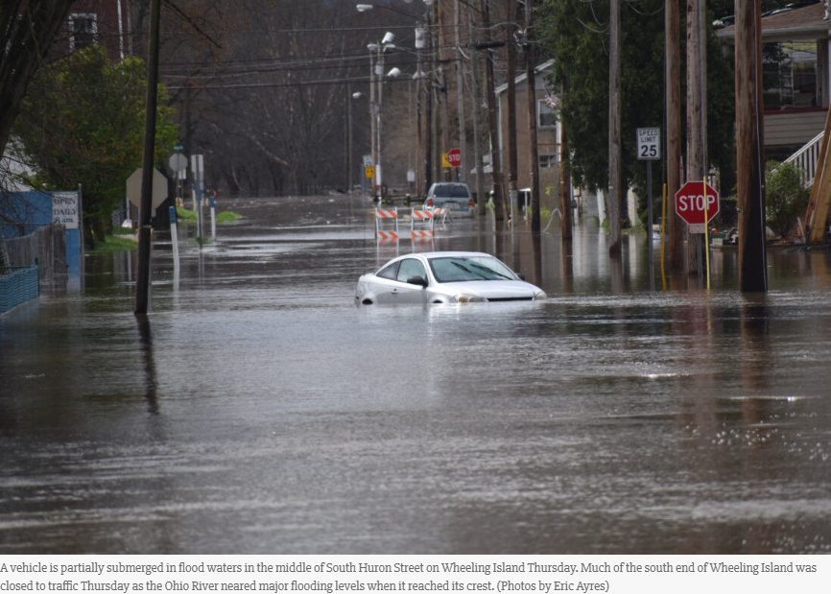

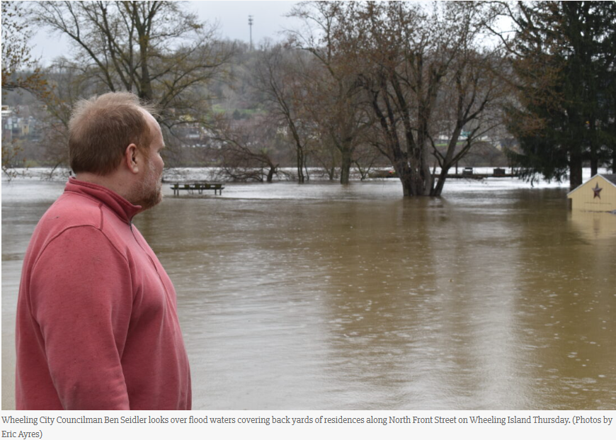

--------------------------------------------------------------------------------------------------------------------------------
 Wheeling Fire Department
https://www.wheelingwv.gov/media/Fire%20Department/ABOUT%20US/QUARTERLY%20REPORT/2nd%20Quarter%202024%20Report.pdf
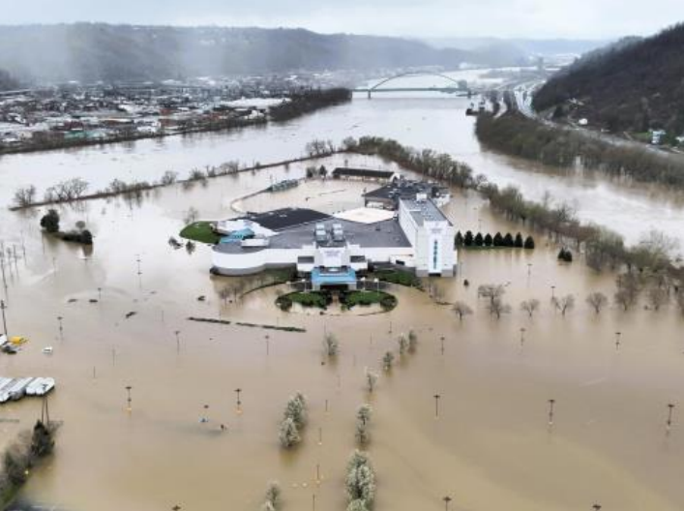
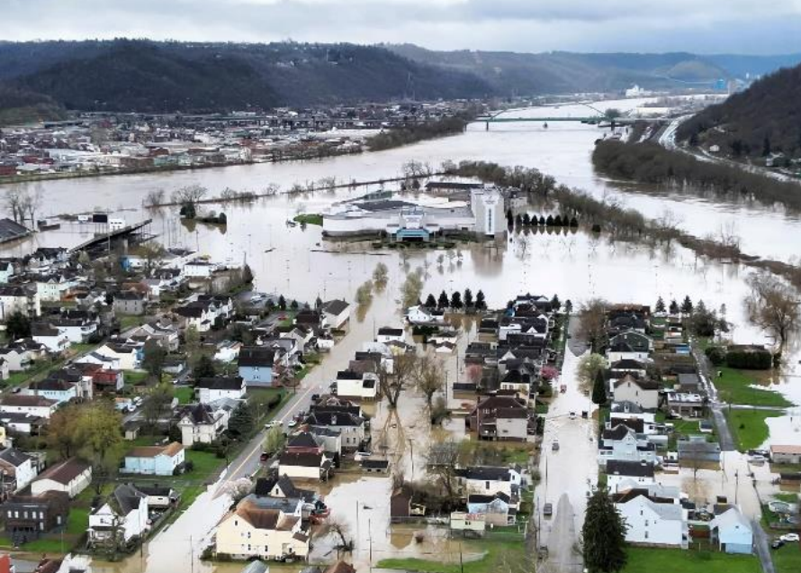
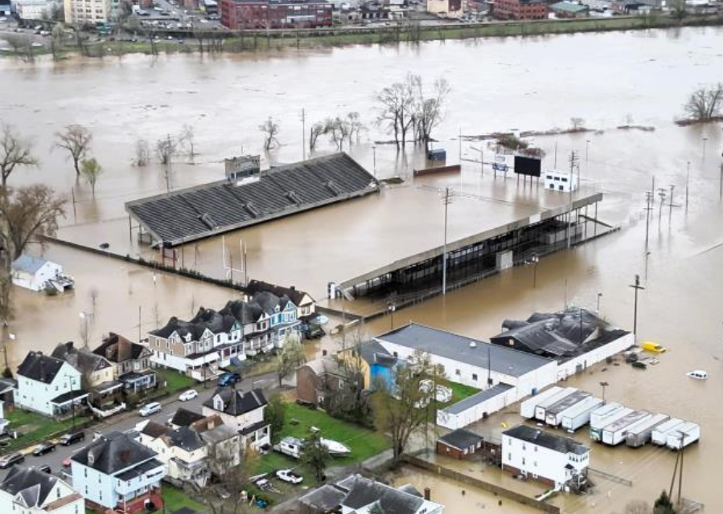
--------------------------------------------------------------------------------------------------------------------------------

https://x.com/TonyCaridi/status/1775988460785971368/photo/1
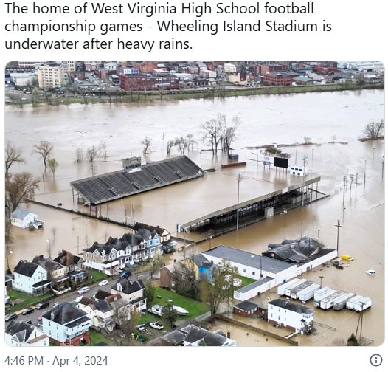
--------------------------------------------------------------------------------------------------------------------------------

https://wvmetronews.com/2024/04/04/wheeling-island-flooding-elliott-says-the-last-time-ohio-river-was-this-high-was-2004/
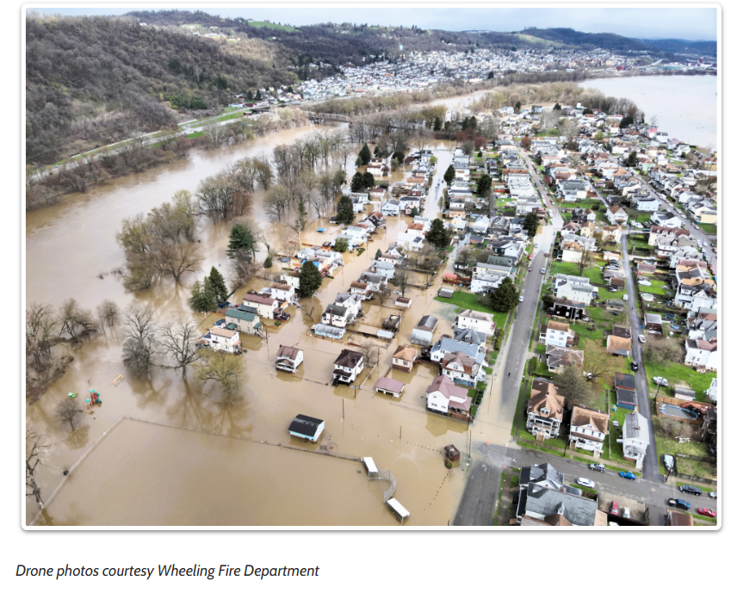
------------------------------------------------------------------------------------------------------------------------------

https://www.wtrf.com/new-cumberland/avoid-downtown-new-cumberland-due-to-flooding/
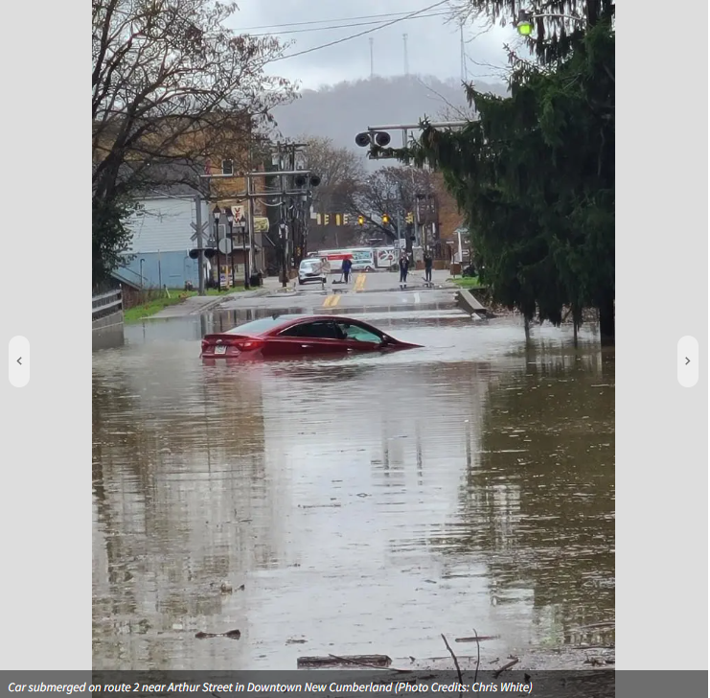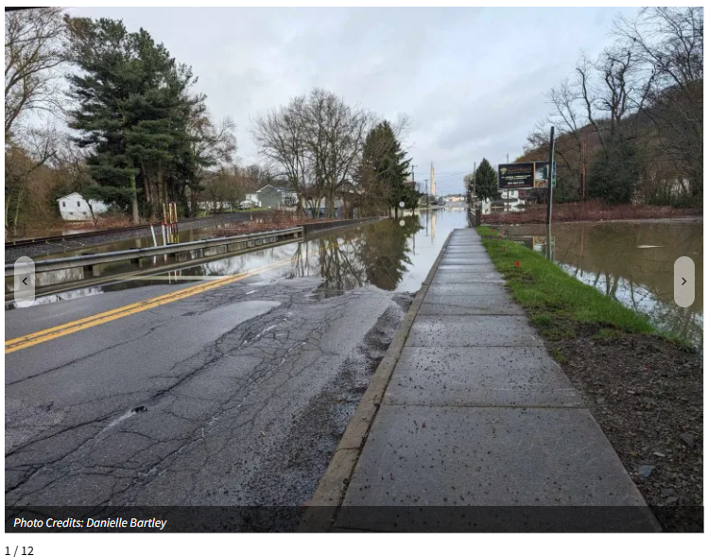
------------------------------------------------------------------------------------------------------------------------------

https://www.newsandsentinel.com/news/local-news/2024/04/wood-county-declares-emergency-as-rising-water-floods-roadways/
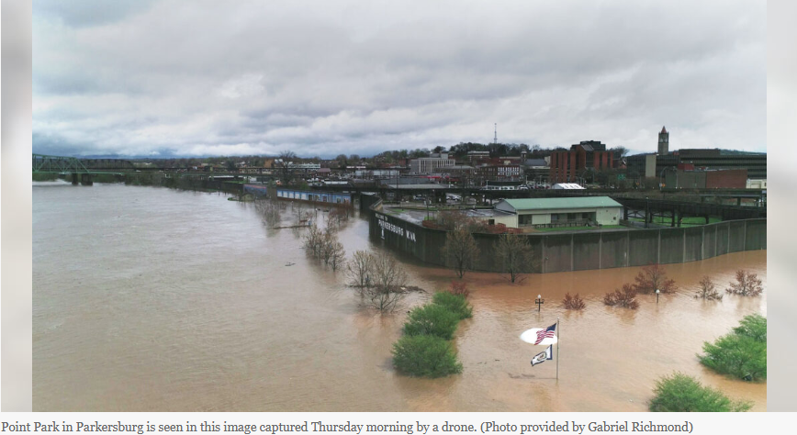
------------------------------------------------------------------------------------------------------------------------------
https://wvmetronews.com/2024/04/04/mudslide-damages-historic-wheeling-cemetery-where-many-veterans-are-buried/
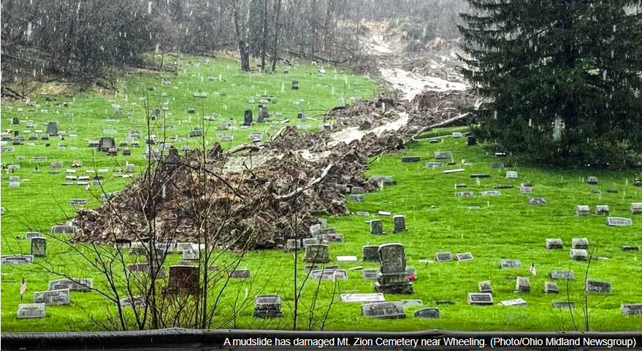
------------------------------------------------------------------------------------------------------------------------------

https://www.google.com/imgres?q=ohio%20river%20flood%20wv%202024&imgurl=https%3A%2F%2Fwww.wtap.com%2Fresizer%2FrZAa1UvsQGXnzJ7_RqsjrAj2e6U%3D%2Farc-photo-gray%2Farc3-prod%2Fpublic%2FZX6TYLW5ZFBZFO7UGQDNC4VVJA.bmp&imgrefurl=https%3A%2F%2Fwww.wtap.com%2F2024%2F04%2F05%2Fflooding-impacts-businesses-homes-along-river-williamstown%2F&docid=fZ3djqmJ7gzmlM&tbnid=48idql-1qxWLwM&vet=12ahUKEwifydH8zpqQAxViMlkFHbgkFyE4ChAzegQILBAA..i&w=1920&h=1080&hcb=2&ved=2ahUKEwifydH8zpqQAxViMlkFHbgkFyE4ChAzegQILBAA



