Video Sources:
on Facebook
https://www.facebook.com/watch/?v=875511514378946
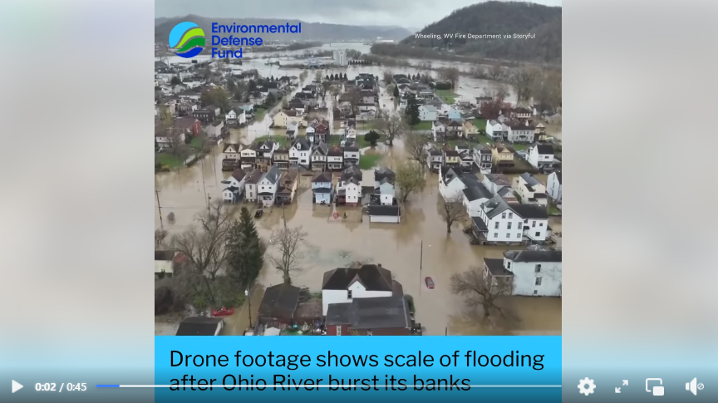
Drone footage shows scale of flooding after Ohio River burst its banks
------------------------------------------------------------------------------------------------------------------------------------------


https://www.youtube.com/watch?v=h3WpokI7XvQ
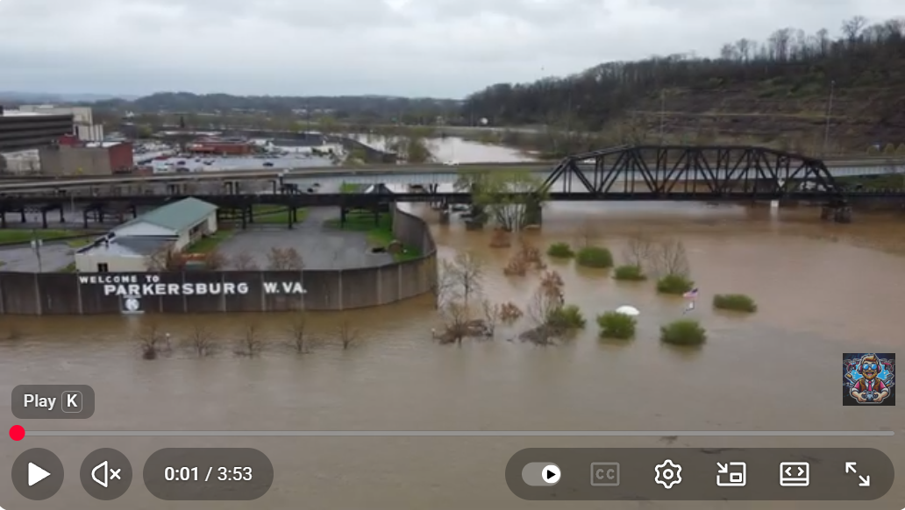
Ohio River Flooding - April 2024 - Mid-Ohio Valley
Apr 5, 2024
Footage from various locations around the Mid-Ohio Valley documenting the historic levels of flooding currently happening along the Ohio River.
Locations: Little Kanawha River & Ohio River, Parkersburg, WV Worthington Golf Club, Parkersburg, WV Belpre Soccer Club, Belpre, OH Blennerhassett Island Historical State Park, Parkersburg, WV Muskingum River & Ohio River, Marietta, OH
Footage taken over the course of two days: April 4 & 5, 2024
Music Credit: Music: bensound.com License code: SIEZ54SRHG1EVSKY
------------------------------------------------------------------------------------------------------------------------------------------

https://www.youtube.com/watch?v=NM6AC1XJKRg
Ohio River Flooding at Wheeling Island, WV on April 4 2024
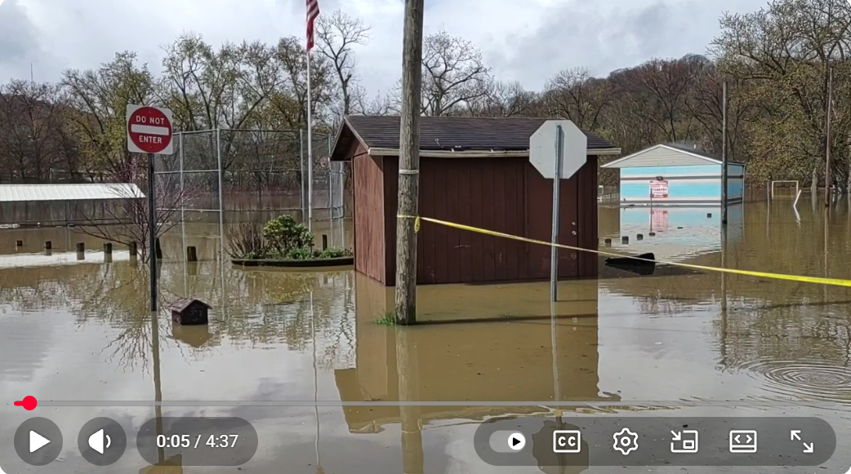
------------------------------------------------------------------------------------------------------------------------------------------

https://www.wtap.com/2024/04/05/flooding-impacts-businesses-homes-along-river-williamstown/
Flooding impacts businesses and homes along the river in Williamstown


------------------------------------------------------------------------------------------------------------------------------------------

https://wtov9.com/news/local/ohio-river-set-to-crest-after-biggest-flood-in-nearly-20-years
Ohio River set to crest after biggest flood in nearly 20 years

------------------------------------------------------------------------------------------------------------------------------------------

