Picture Sources:


https://www.foxweather.com/weather-news/west-virginia-flooding-wheeling-mid-atlantic-severe-weather
----------------------------------------------------------------------------
Montani Semper Liberi's post on Facebook:
https://www.facebook.com/story.php?story_fbid=752090810487750&id=100070605124350&rdid=EMqmkwOSbFgUWhRG#
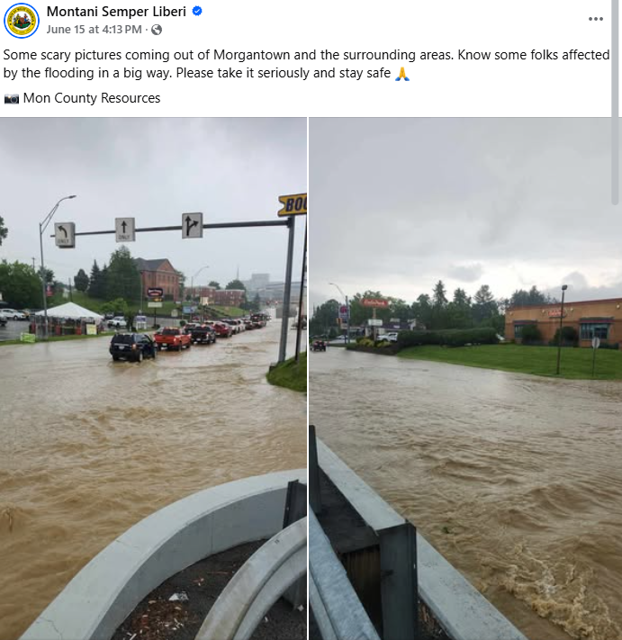
--------------------------------------------------------------------------------------------------------
Allegheny Mountains Weather's post on Facebook:
https://www.facebook.com/100069173240160/posts/1016184224030676/?rdid=IlOl4yY5AofAOUaG#
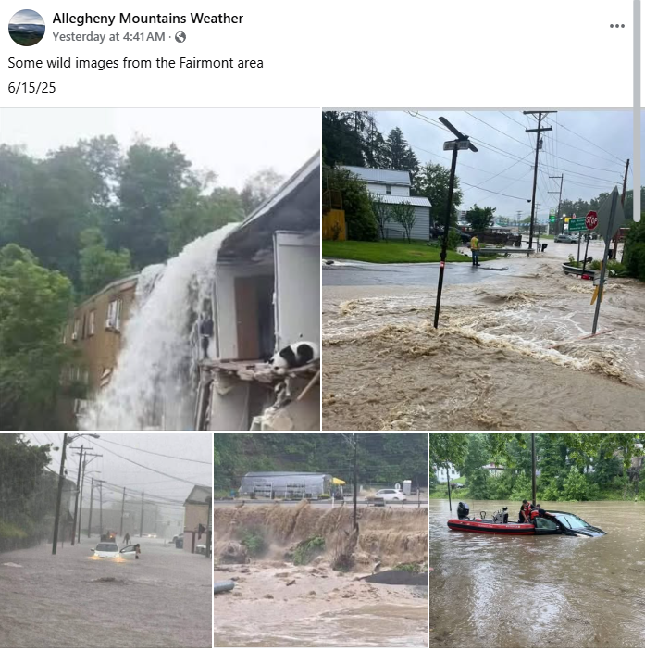
---------------------------------------------------------------------------------------------------------------
Southern West Virginia Online's post on Facebook:
https://www.facebook.com/story.php?story_fbid=701072592679079&id=100083290333464&post_id=100083290333464_701072592679079&rdid=jiOjMBVgOmzNfFVj#
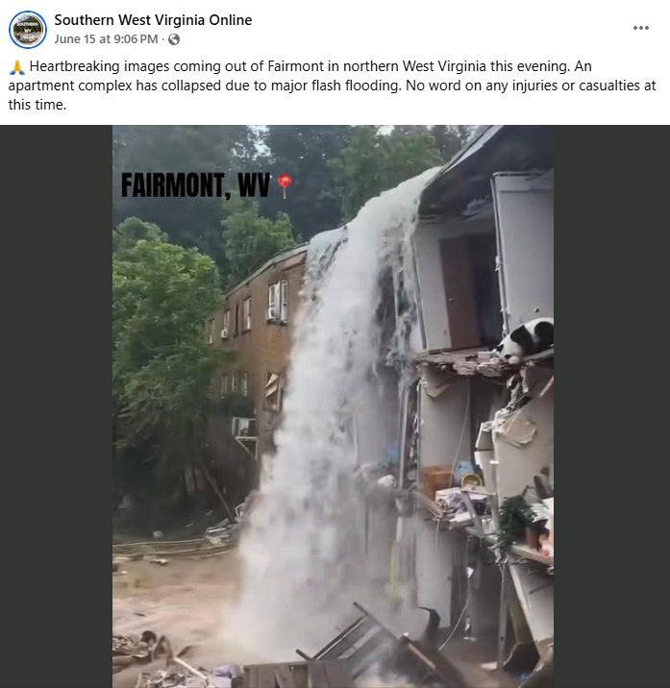
https://www.facebook.com/1479723162/posts/10229283249573988/?rdid=qPpJgQoIk7WiacnD#
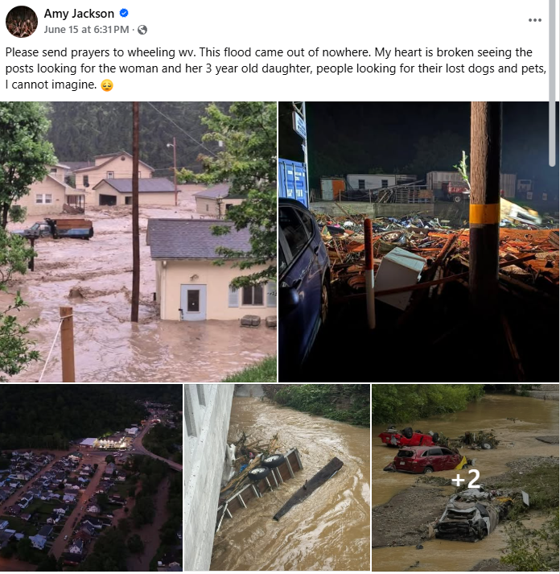
------------------------------------------------------------------------------------------------------------
Tri-Cities Weather & Alert Crew's post on Facebook:
https://www.facebook.com/100042985459450/posts/1525654328877401/?rdid=NsyuHOXkcjEkTBMW#
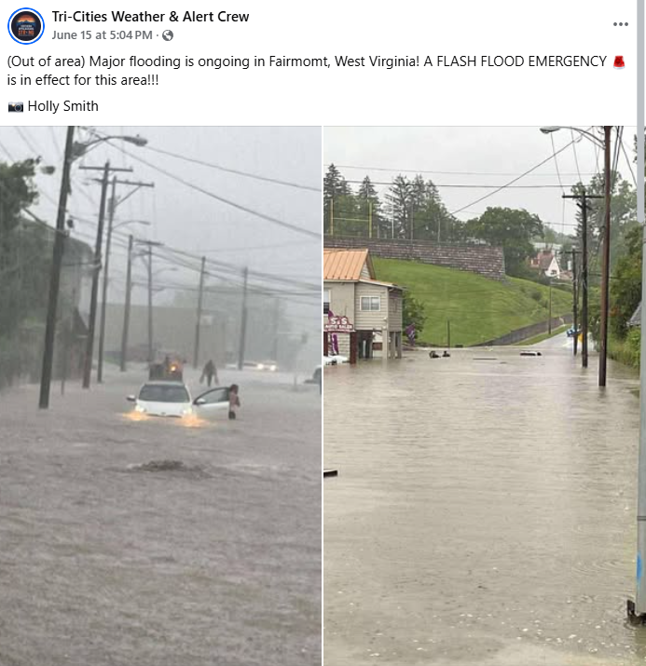
https://www.facebook.com/100002096327562/posts/9958373870909058/?rdid=qIum6r1bBjDhRNOi#
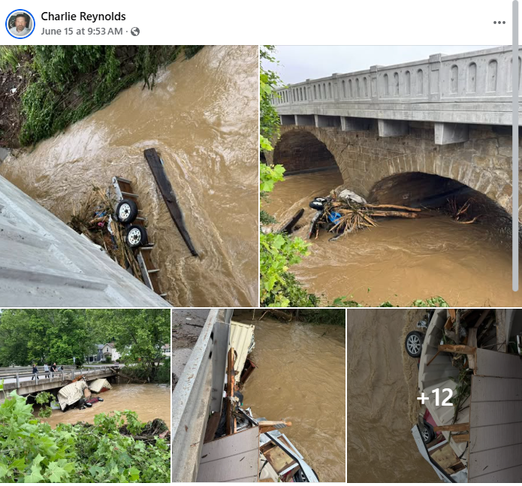
----------------------------------------------------------------------------------------------------------------
https://www.facebook.com/story.php?story_fbid=707547565337935&id=100082480943085&post_id=100082480943085_707547565337935&rdid=Y7zhCbl3mObh55J2#
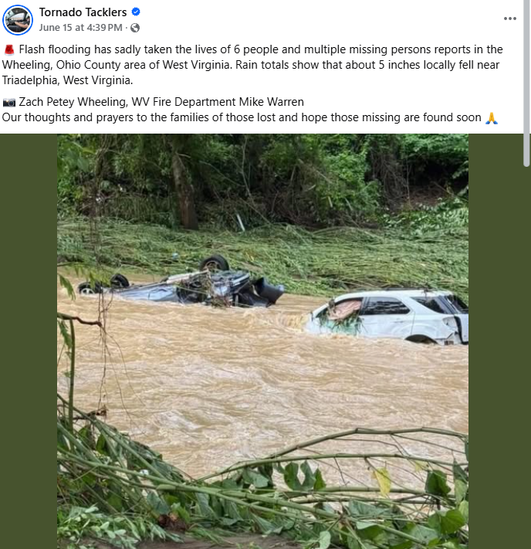
---------------------------------------------------------------------------------------------------------------
PLEASANT VALLEY WV COMMUNITY on Facebook:
https://www.facebook.com/groups/340345139887384/permalink/1761207257801158/?rdid=J7iYhCywV1Z3cXWU#
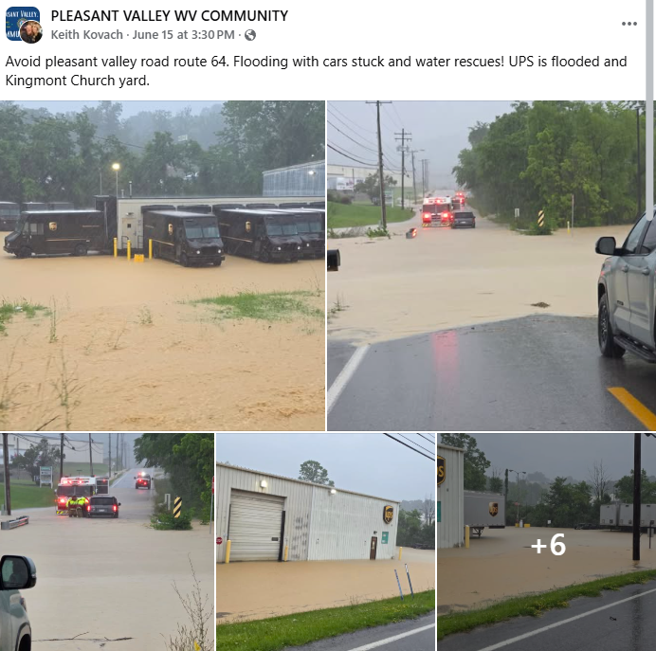
-----------------------------------------------------------------------------------------------------------------------
Valley Volunteer Fire Department's post on Facebook:
https://www.facebook.com/100064843686407/posts/1135855115252601/?rdid=w817JQWzoZOyY1g3#
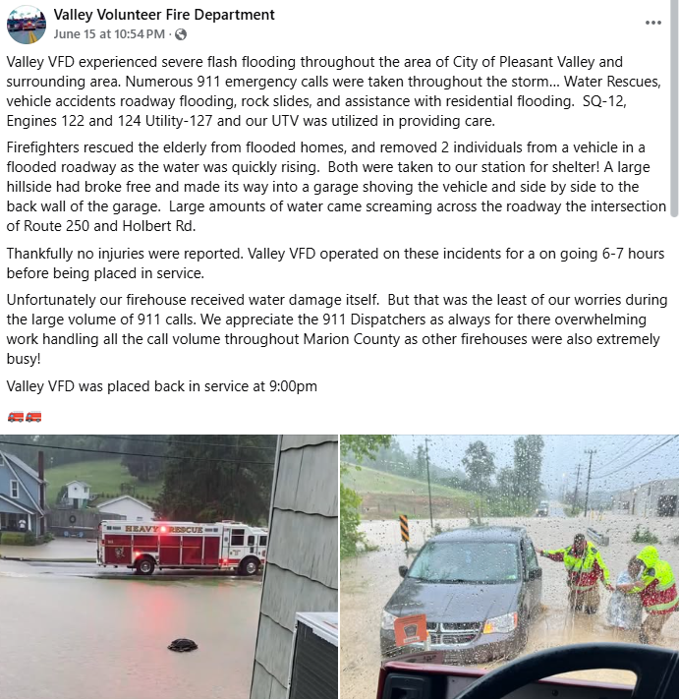
-----------------------------------------------------------------------------------------------------------
https://www.facebook.com/100075994727867/posts/737189242157560/?rdid=NK8fgvCxeGEf4MLY#
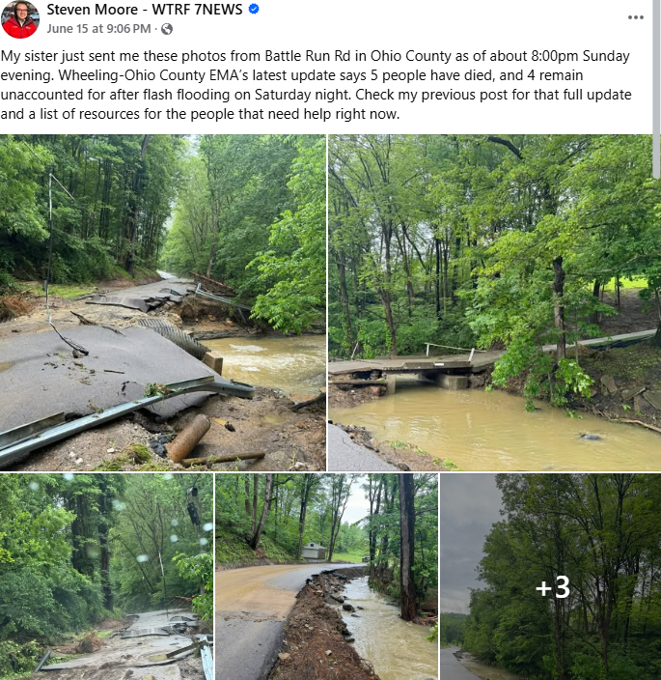
------------------------------------------------------------------------------------------------------------
https://www.facebook.com/100064330316365/posts/1123910106429989/?rdid=Or9TBJpDw0IddXXT#
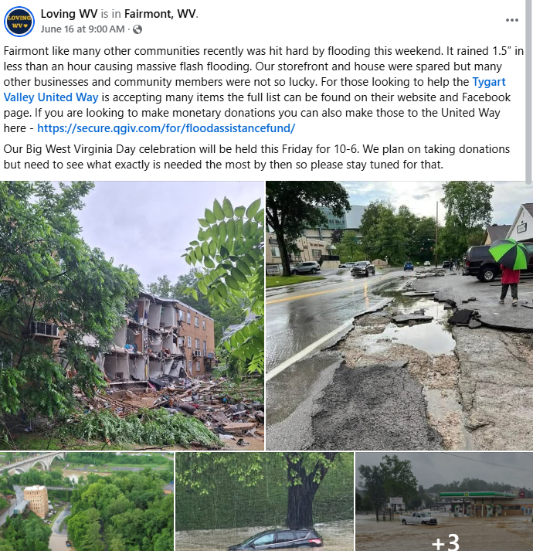
----------------------------------------------------------------------------------------
https://www.facebook.com/groups/510838175613835/permalink/24219653200972333/?rdid=zgV0uAc2iUsPkkZw#
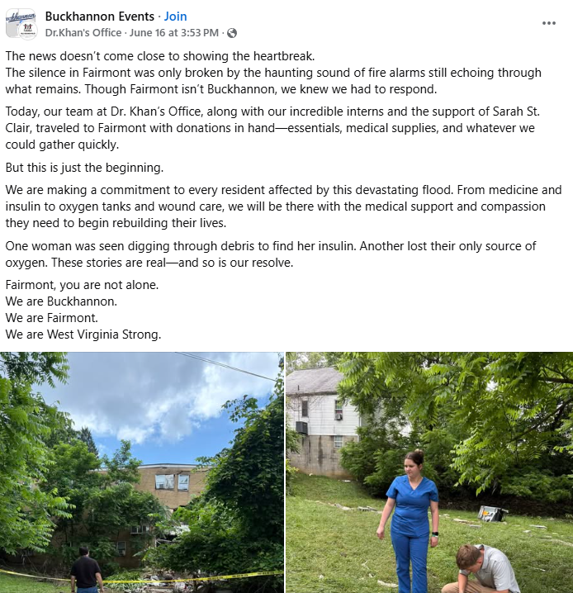
-----------------------------------------------------------------------------------------------------------------
https://www.facebook.com/1105775190/posts/10235504225002021/?rdid=jB7EgNZ0PQUQ6GnA#
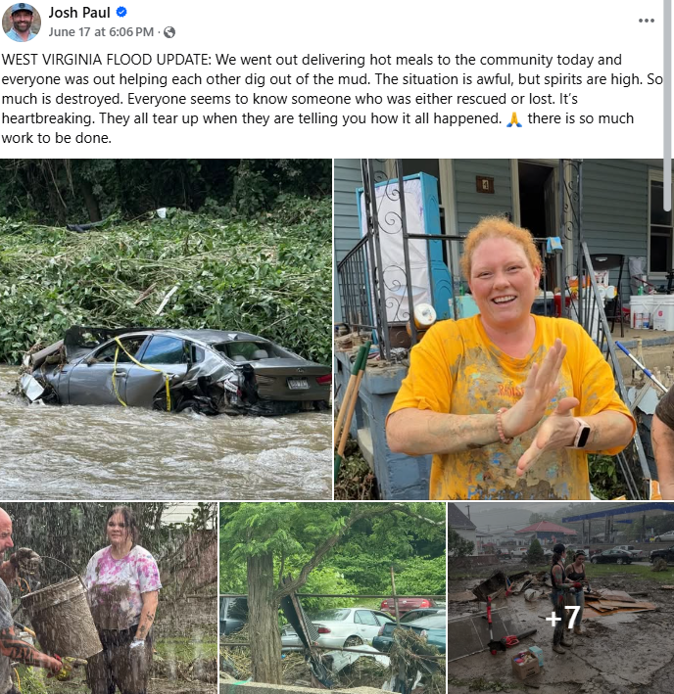
----------------------------------------------------------------------------------------
WTAP Television's post on Facebook:
https://www.facebook.com/100064052048769/posts/1151181057026952/?rdid=5iZq4C9N115qOS56#
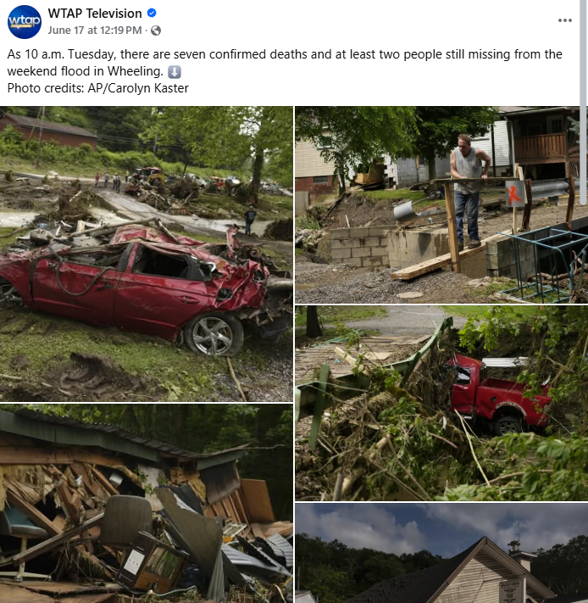
-----------------------------------------------------------------------------------------------------------------------
https://www.facebook.com/reel/1050839943259640
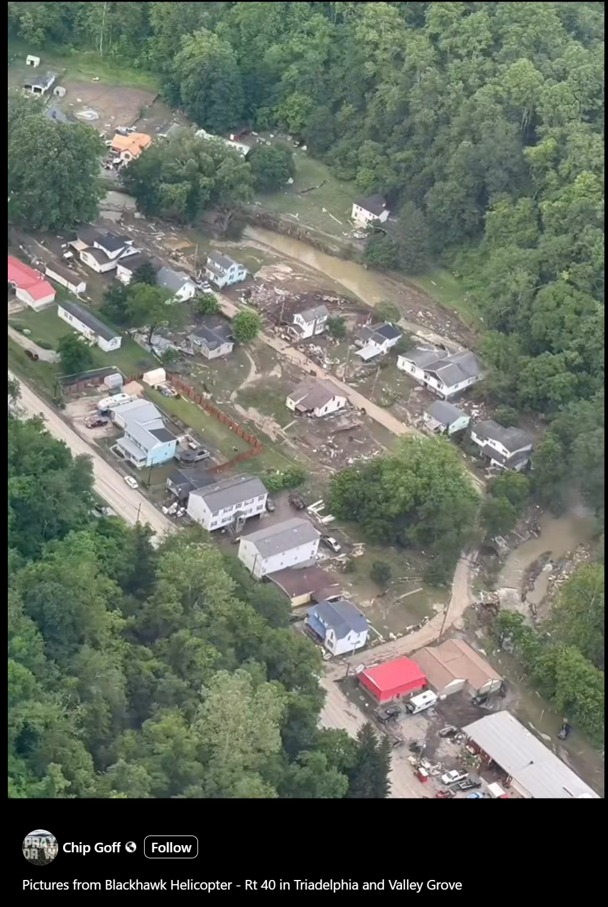
-------------------------------------------------------------------------------------------------

https://www.facebook.com/1105775190/posts/10235520194961260/?rdid=LT0KCGPgOq3nwXnf#
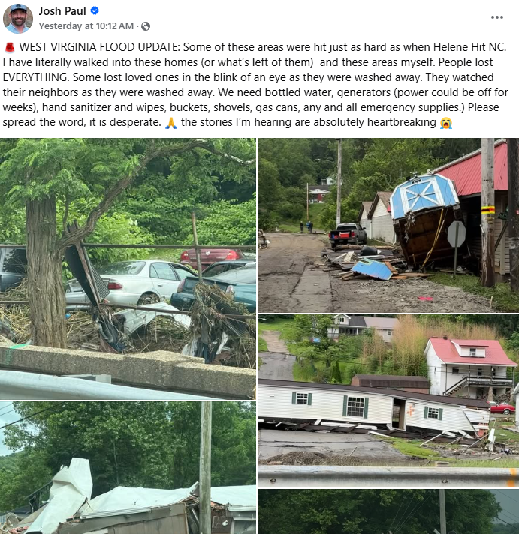
---------------------------------------------------------------------------------------------------------------------------------

https://ledenews.com/the-realities-of-a-natural-disaster-in-ohio-county/?fbclid=IwY2xjawLPudZleHRuA2FlbQIxMQBicmlkETFwV25RSXE3M2RQRzlwc0R3AR4kBe_YFuDt2VOUMhkitAVyyMeMm0c54atGt6C3_WTw9Kz_W9YIlj_pJl_E7g_aem_jfOyPTfIFP2KaL-5hW5k3g
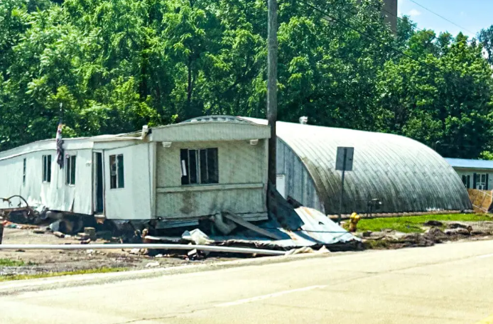
------------------------------------------------------------------------------------------------------------------------------
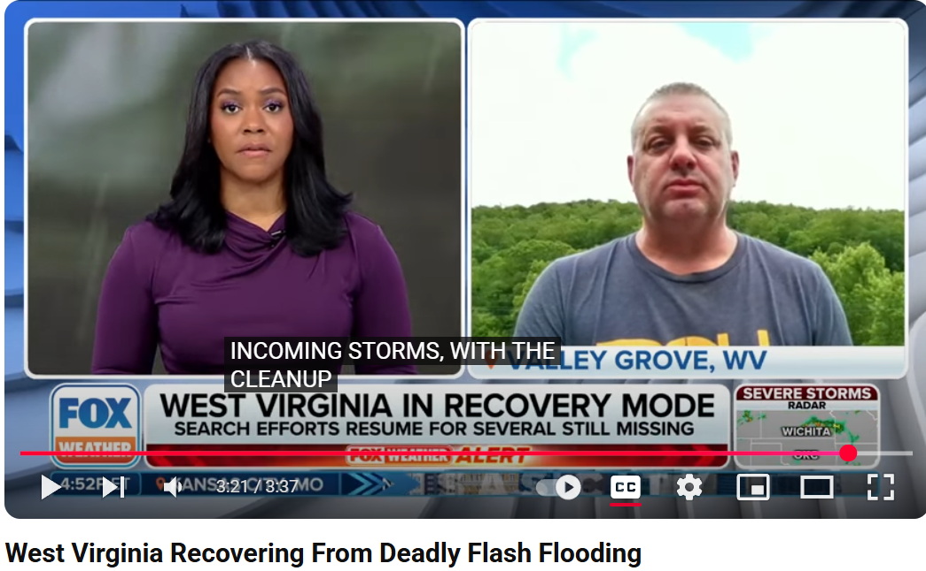
---------------------------------------------------------------------------------------------------------------------
https://www.facebook.com/reel/1086341353355853
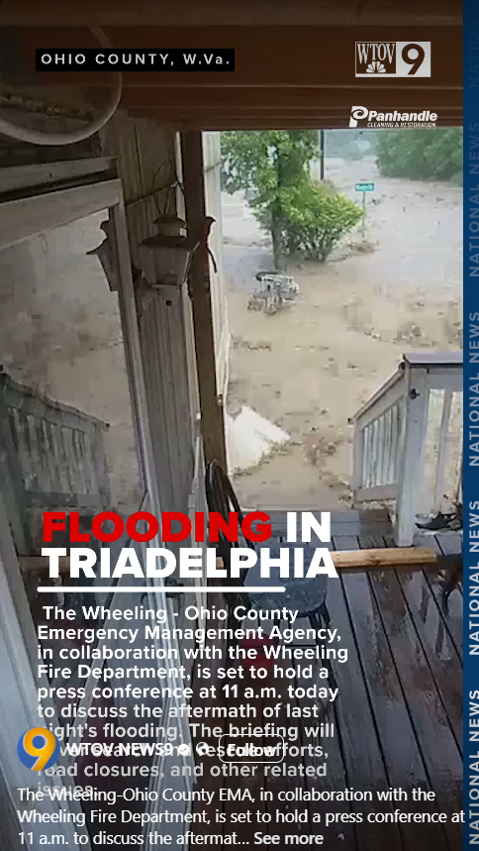
---------------------------------------------------------------------------------------------------------------------
https://www.youtube.com/watch?v=Mhd8hug7zVc


(Screenshots)
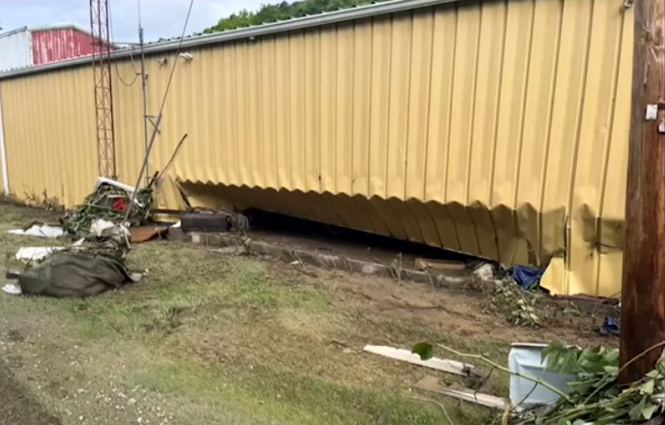
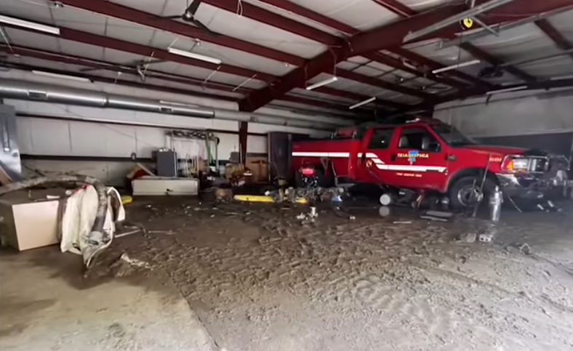
---------------------------------------------------------------------------------------------------------------------
https://www.youtube.com/watch?v=CfOcJYJKDwg

(Screenshots)



