Video Sources:
Daniel Burbank TV on Facebook:
https://www.facebook.com/watch/?v=684832434324004&rdid=2HPaKEtqIGwOD3bL
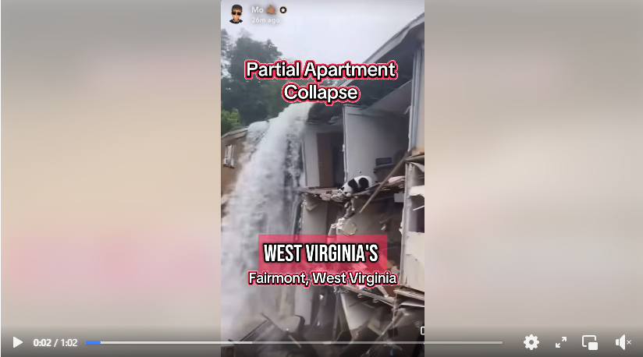
------------------------------------------------------------------------------------------------------------
Allegheny Mountains Weather on Facebook:
https://www.facebook.com/watch/?v=757449196713920&rdid=GSQPBDCC1JtAi6pn
Video by Colyn Jones from Fairmont WV of the significant flash flooding this afternoon. 6/15/25
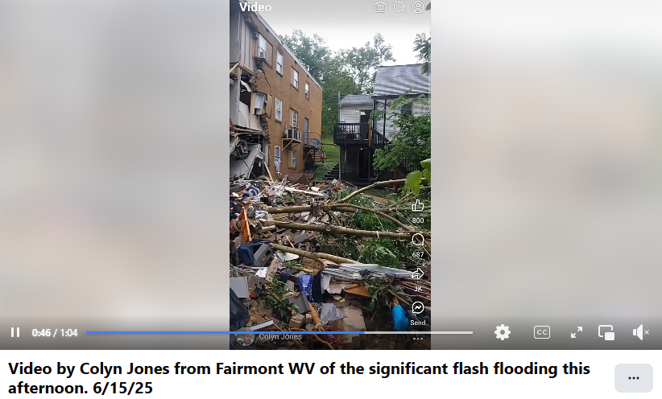
--------------------------------------------------------------------------------------------------------
WDTV 5 News's post on Facebook:
https://www.facebook.com/100064942954333/posts/1119586793549409/?rdid=KAkWsnodEezXqMQ8#

https://www.facebook.com/100064942954333/videos/pcb.1119586793549409/1046678294198397
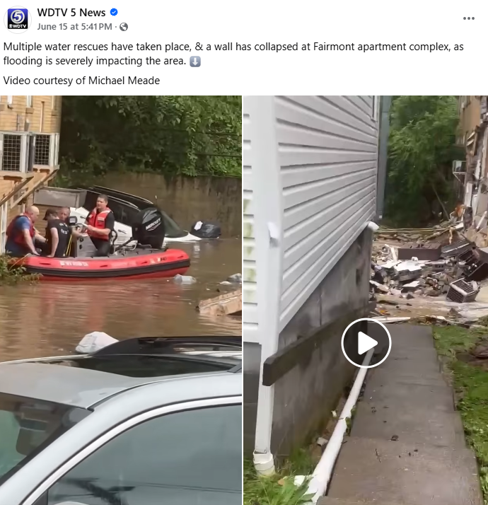
--------------------------------------------------------------------------------------------------------------

https://www.cbsnews.com/news/west-virginia-flash-flooding-deaths/
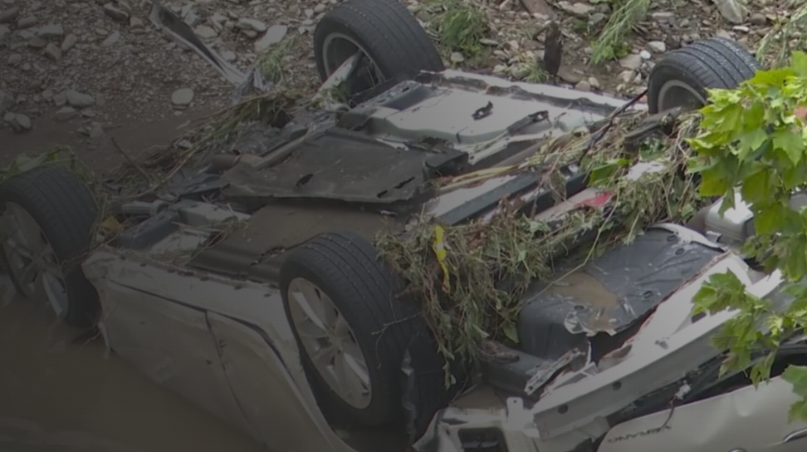
--------------------------------------------------------------------------------------


https://www.foxweather.com/weather-news/west-virginia-flooding-wheeling-mid-atlantic-severe-weather
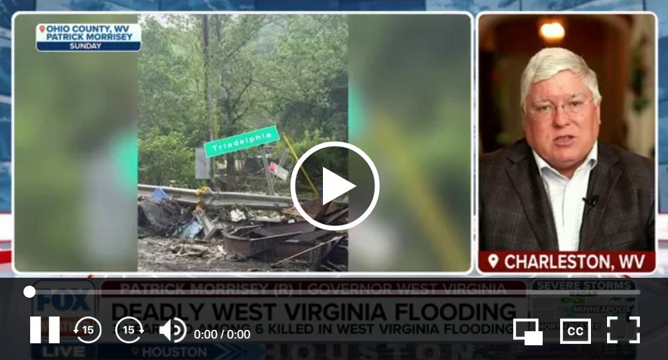
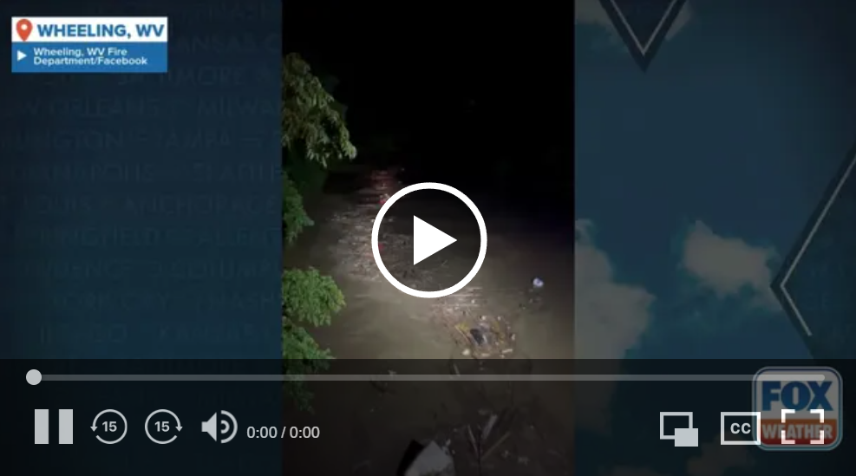
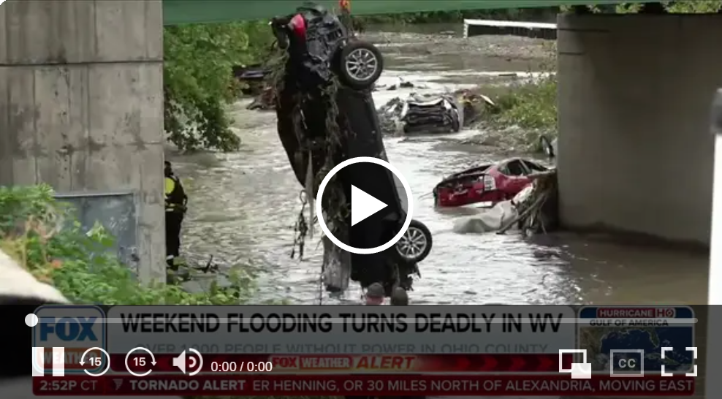
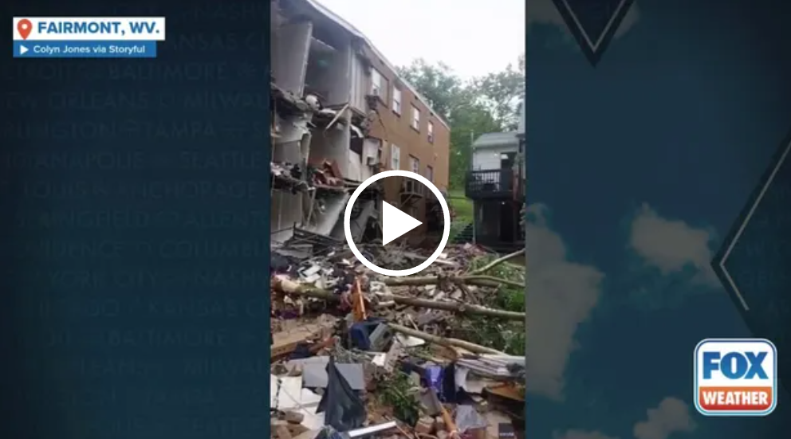
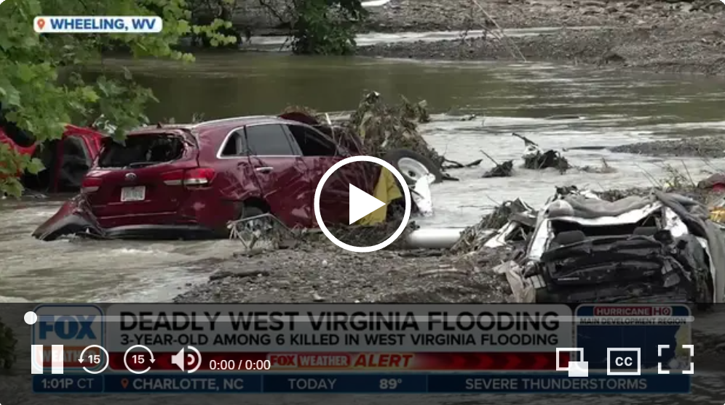
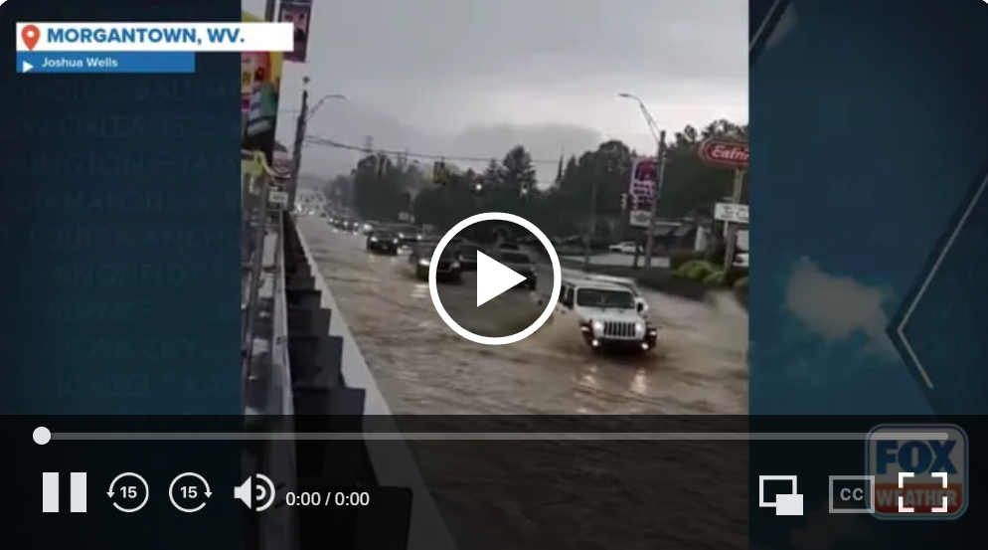
------------------------------------------------------------------------------------------------------------------------

https://www.wboy.com/emergencies/fathers-day-flood-west-virginia-2025/fairmont-village-apartments-owner-releases-statement-following-partial-collapse/
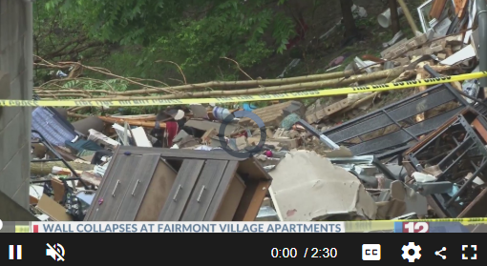
-------------------------------------------------------------------------------------------------------------
https://www.wboy.com/emergencies/fathers-day-flood-west-virginia-2025/we-were-trapped-man-details-experience-as-fairmont-apartment-building-flooded-collapsed/?ipid=promo-link-block1
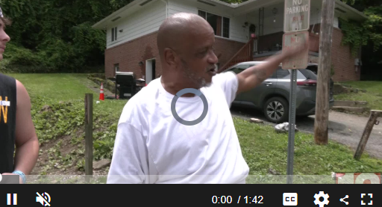
---------------------------------------------------------------------------------------------------------------

PA Weather Plus, LLC on Facebook:
https://www.facebook.com/reel/1868175390391825
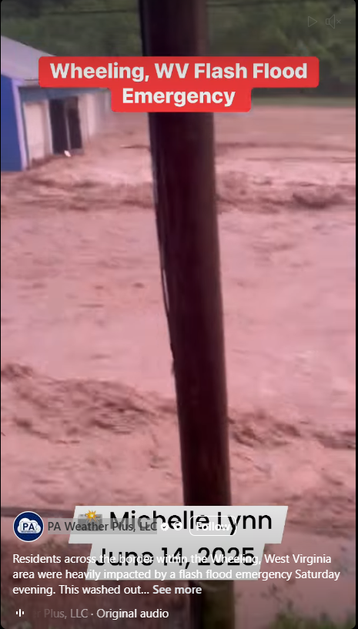
-------------------------------------------------------------------------------------------------
WTAE-TV Pittsburgh
https://www.facebook.com/watch/?v=30906338988965382&rdid=YxWywW6DhO6QqaLN
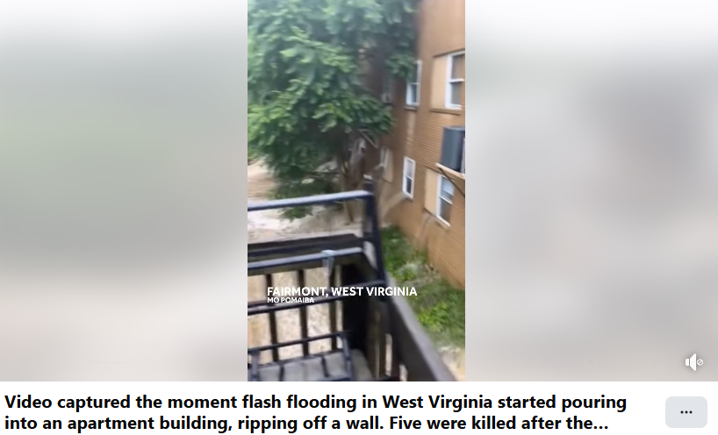
---------------------------------------------------------------------------------------------------
WTOV NEWS9
https://www.facebook.com/watch/?v=537675656092420&rdid=hSOSit9X1uMhy8Q7
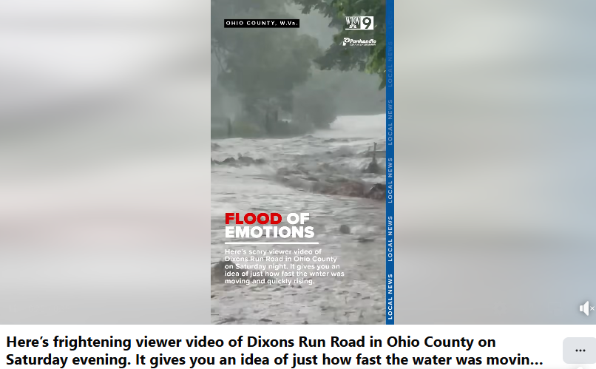
-----------------------------------------------------------------------------------------------------------------------------
FOX Weather
https://www.facebook.com/watch/?v=704403275512002&rdid=sQvrFDBEJqzBduKi
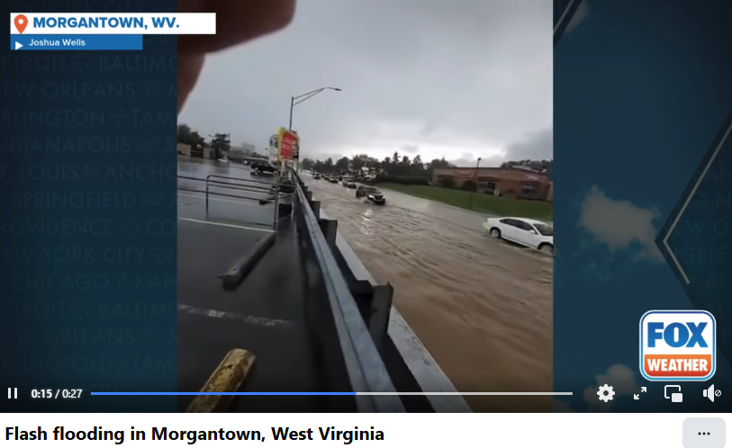
-----------------------------------------------------------------------------------------------------------------------------

WeatherNation
https://www.facebook.com/watch/?v=704366942341094&rdid=nxFotu3ptl6sxdRG
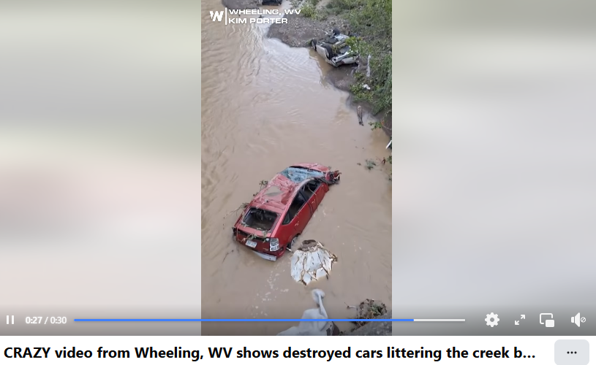
-----------------------------------------------------------------------------------------------------------------------------
Tri-Cities Weather & Alert Crew's post on Facebook:
https://www.facebook.com/100042985459450/posts/1525652008877633/?rdid=n9UG6XEU6Tf0EkYn#

https://www.facebook.com/reel/1285608816490348

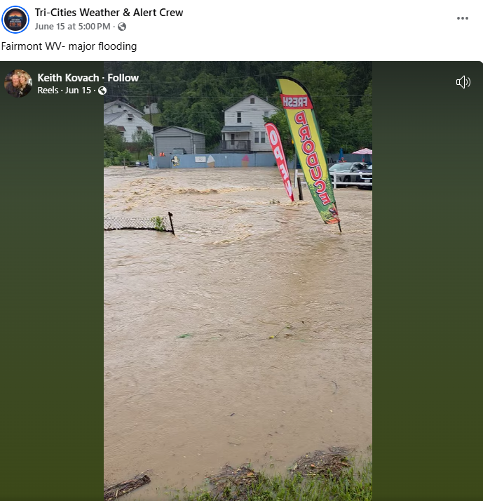
------------------------------------------------------------------------------------------------------
WDTV 5 News on Facebook:
https://www.facebook.com/watch/?v=1244698027376348&rdid=cc8dB0SNMgX927HM
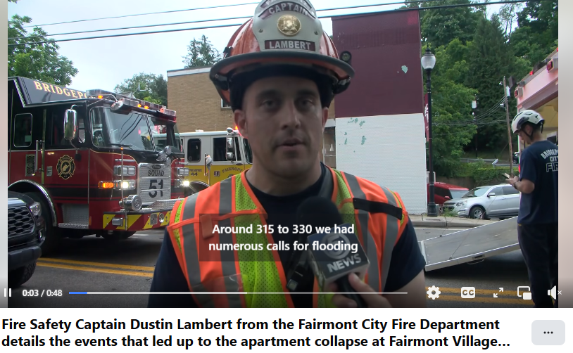
--------------------------------------------------------------------------------------------------------
https://www.facebook.com/watch/?v=1241575894302908&rdid=KR5hnEyLaxGLOy0u
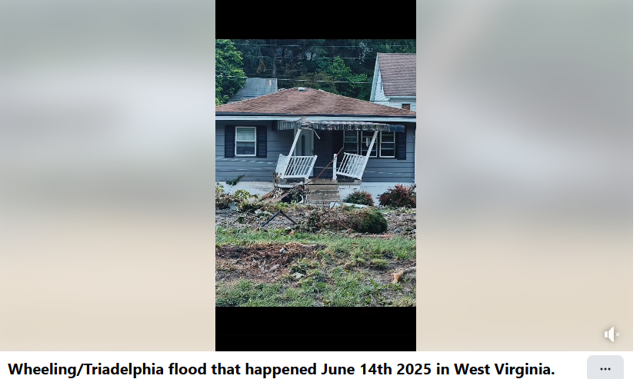
---------------------------------------------------------------------------------------------------------------------------
WTOV NEWS9 on Facebook:
https://www.facebook.com/watch/?v=718152657588256&rdid=q7GPzkAOCoyM1CkB
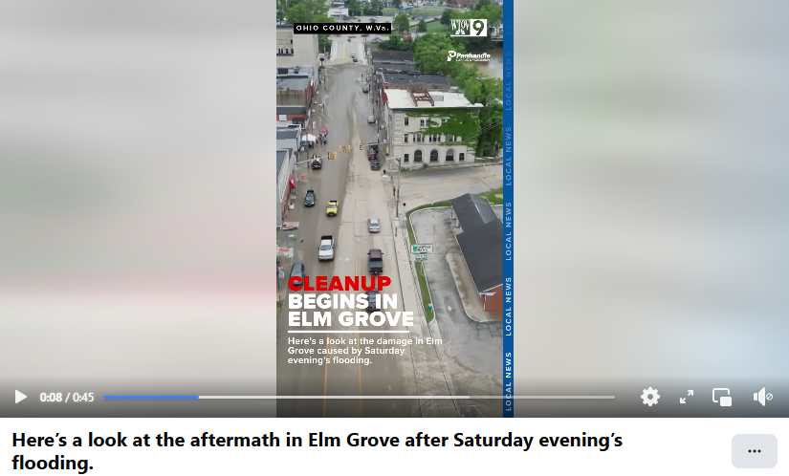
-----------------------------------------------------------------------------------------------------------------------------

WTOV NEWS9 on Facebook:
https://www.facebook.com/watch/?v=1572464334140598&rdid=1o9XRC5EKzHQiLSn
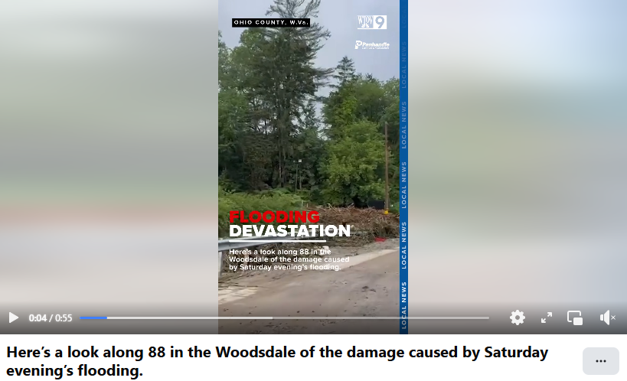
----------------------------------------------------------------------------------------------------------------------------
https://www.facebook.com/watch/?v=590573920745769&rdid=WisQ5BBaKPuSPClx
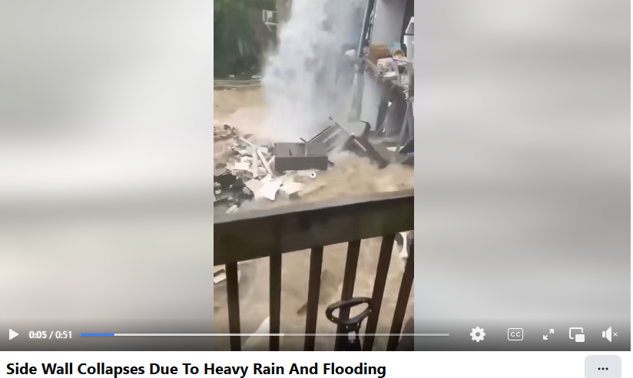
-------------------------------------------------------------------------------------------------------------------------

ABC News on Facebook:
https://www.facebook.com/watch/?v=2483092965378993&rdid=yQUdotNvUaAcqByZ
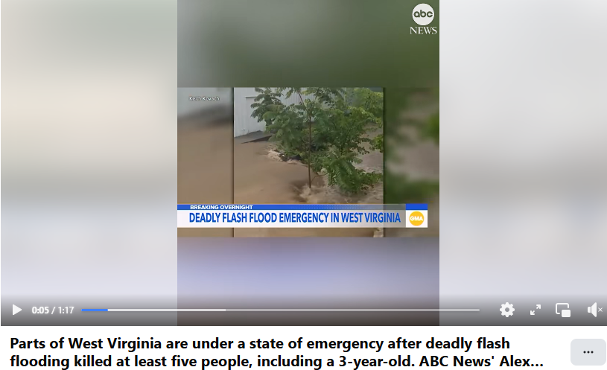
-------------------------------------------------------------------------------------------------------------------------
WTOV NEWS9 on Facebook:
https://www.facebook.com/watch/?v=1266751015043802&rdid=4vYm4mLFumS7rW1P
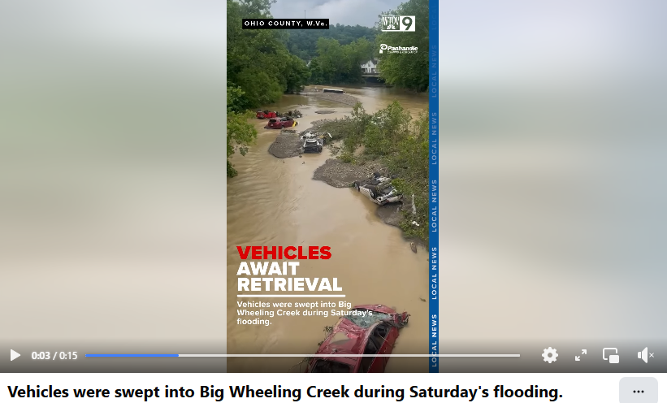
----------------------------------------------------------------------------------------------------------------------

WTOV NEWS9 on Facebook:
https://www.facebook.com/watch/?v=1490415725702598&rdid=l90iKkB70FHLHFPH
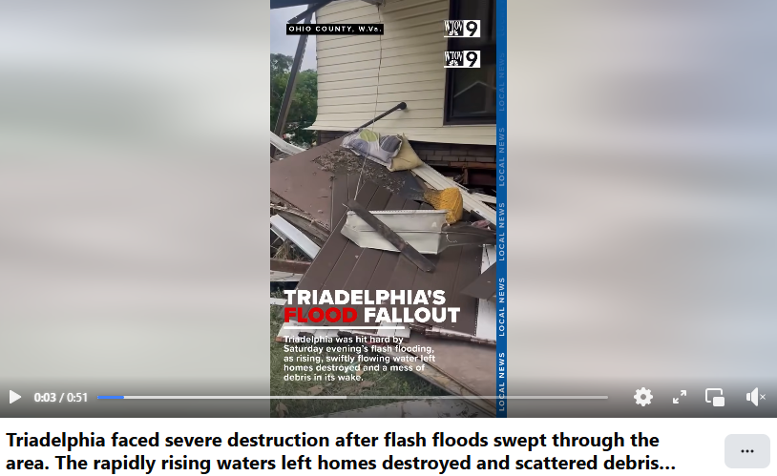
----------------------------------------------------------------------------------------------------------------------
Ohio Valley Spotlight on Facebook:
https://www.facebook.com/reel/1382958609656001
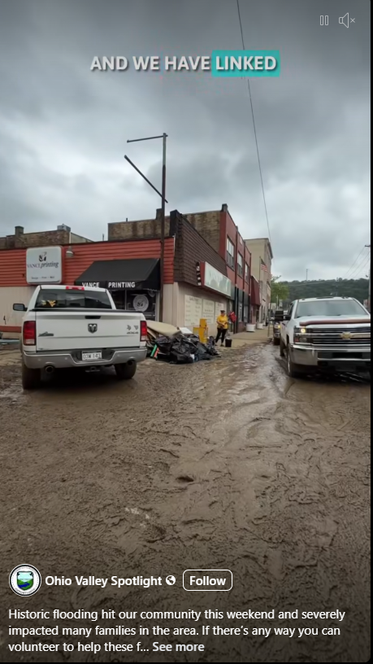
----------------------------------------------------------------------------------------------

https://www.facebook.com/reel/1233517798263486
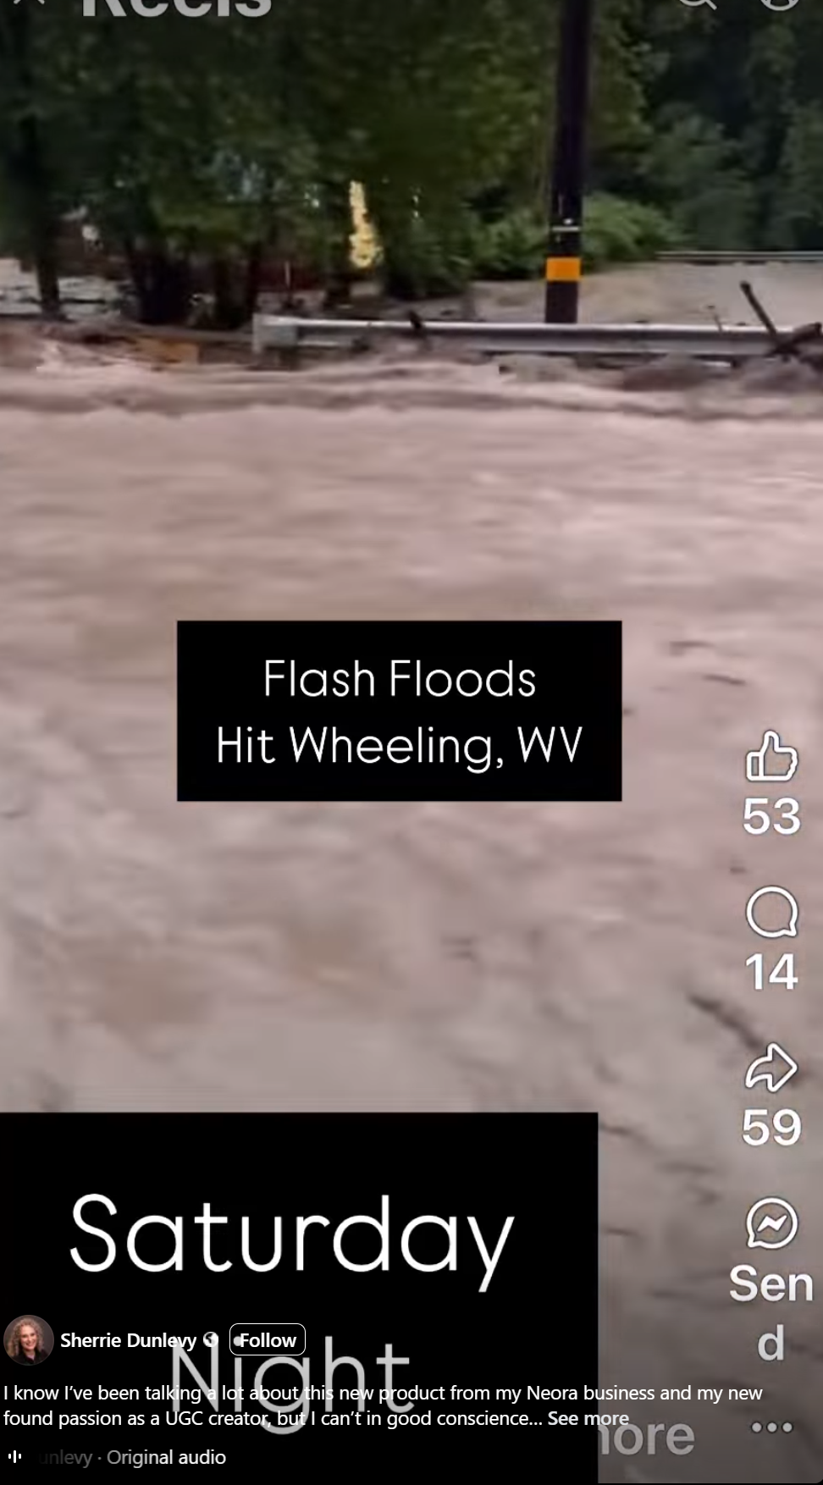
------------------------------------------------------------------------------------------
https://www.facebook.com/reel/1836765006888072
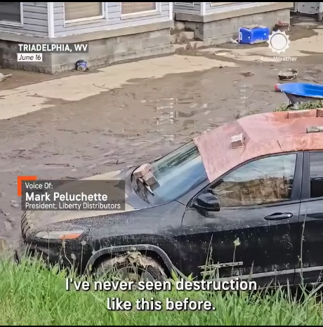
--------------------------------------------------------------------------------

https://www.facebook.com/watch/?v=1094208182577711&rdid=TqiL1E2BE9JQUKvD
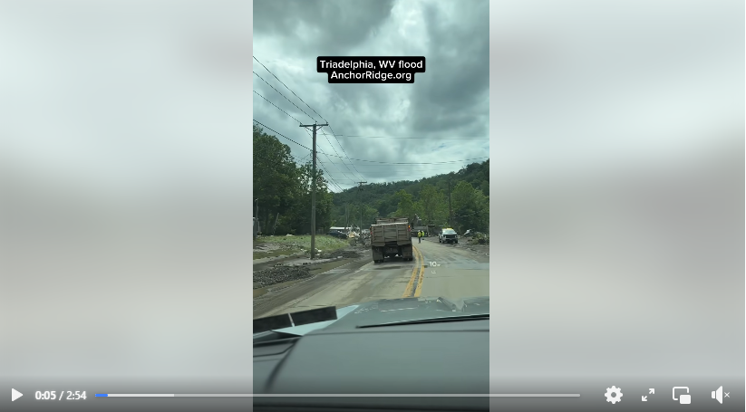
--------------------------------------------------------------------------------------------------------------------

https://www.wboy.com/news/monongalia/west-virginia-university/west-virginia-flood-resiliency-framework-offers-to-tools-for-preparing-and-recovering-from-floods/
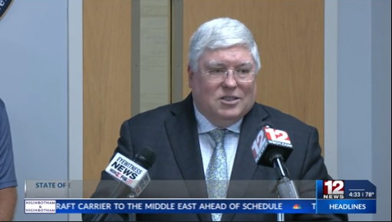
------------------------------------------------------------------------------------------------------------------------
https://www.youtube.com/watch?v=dTGJk-luNw4


AP Archive

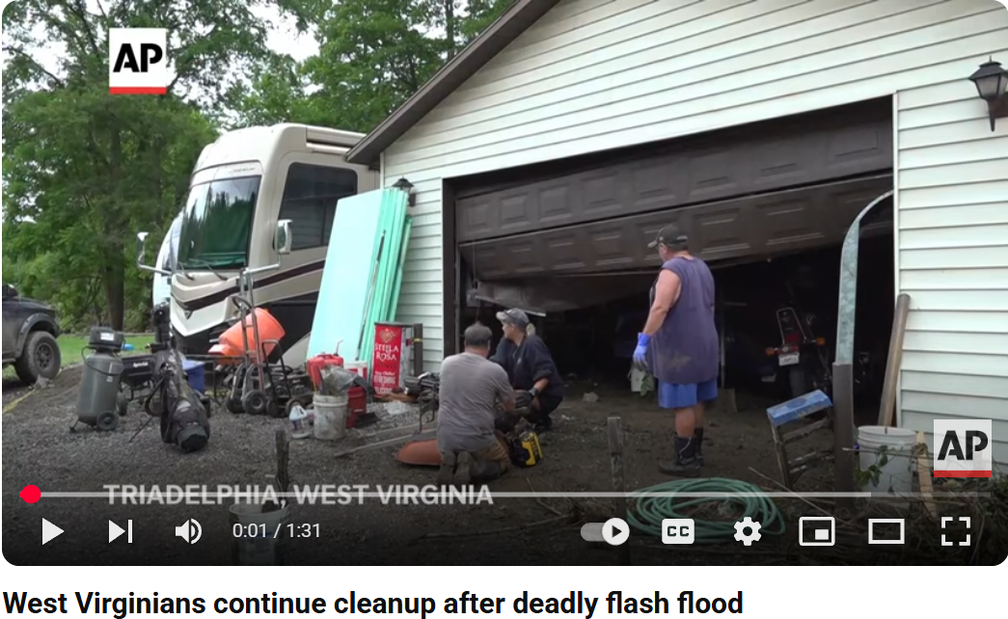
-----------------------------------------------------------------------------------------------------------------------------
https://www.youtube.com/watch?v=aVcarM0xMlo

FOX Weather
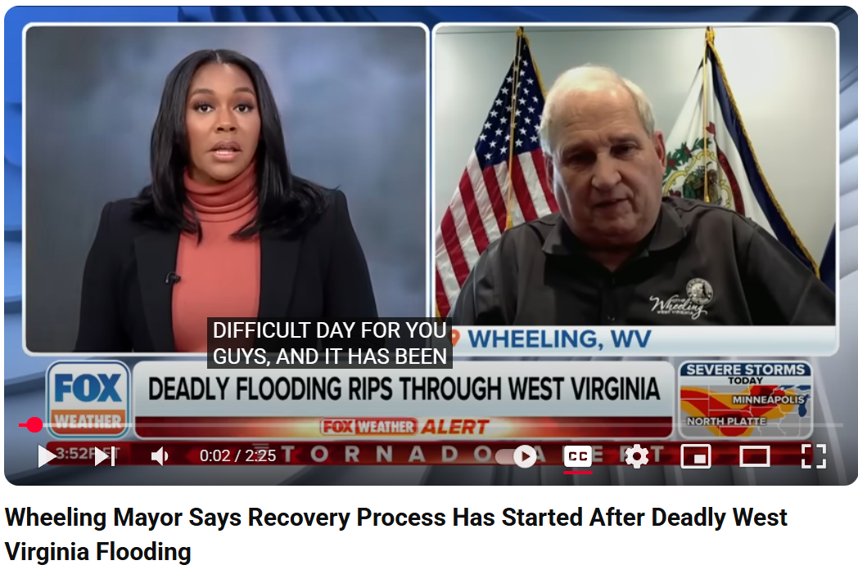
---------------------------------------------------------------------------------------------------------------------

https://www.youtube.com/watch?v=VKq79y7AqkU

ABC News

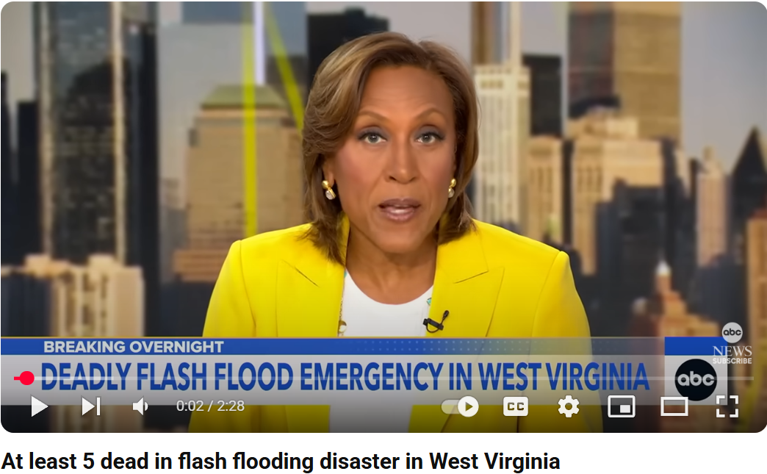
---------------------------------------------------------------------------------------------------------------------
https://www.youtube.com/watch?v=SS-Nzf9ehIY
FOX Weather
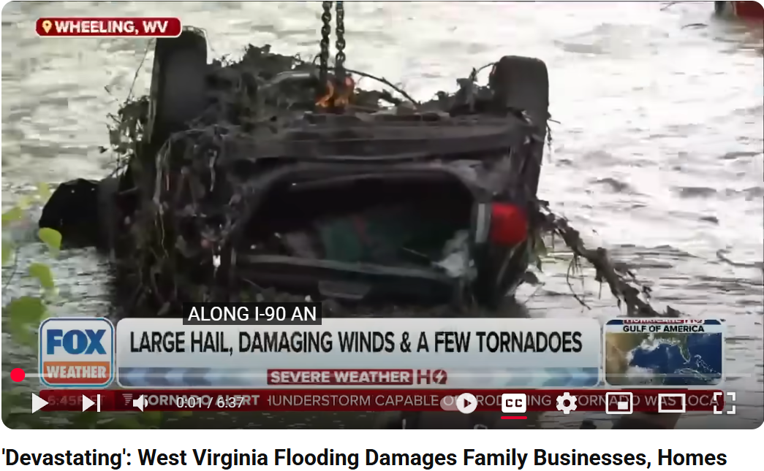
---------------------------------------------------------------------------------------------------------------------
https://www.youtube.com/watch?v=etYgVGeQRA0

WBOY 12 News
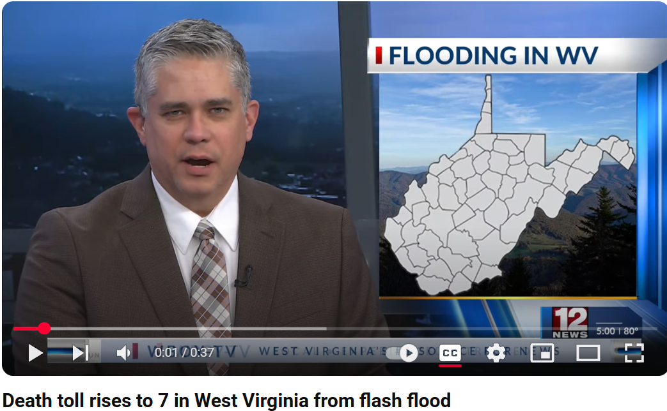
---------------------------------------------------------------------------------------------------------------------
https://www.youtube.com/watch?v=X6-AIKfepZs

The Weather Channel
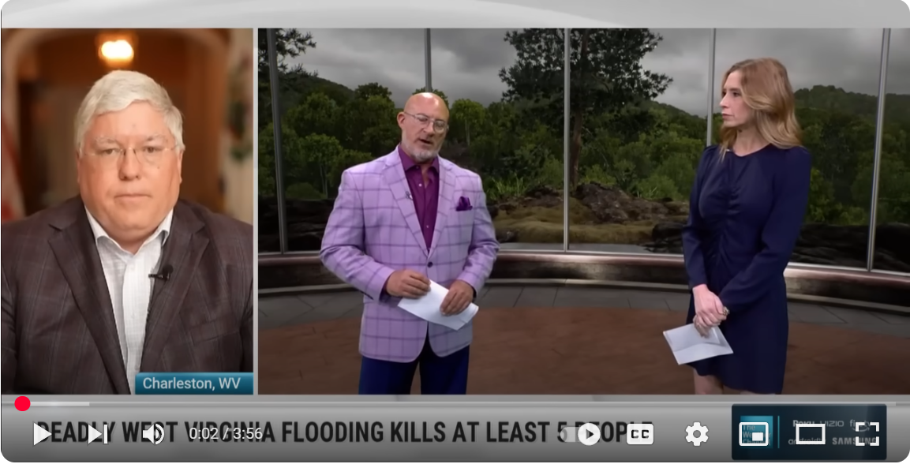
---------------------------------------------------------------------------------------------------------------------
https://www.youtube.com/watch?v=BxaIFq2eUpQ
FOX Weather
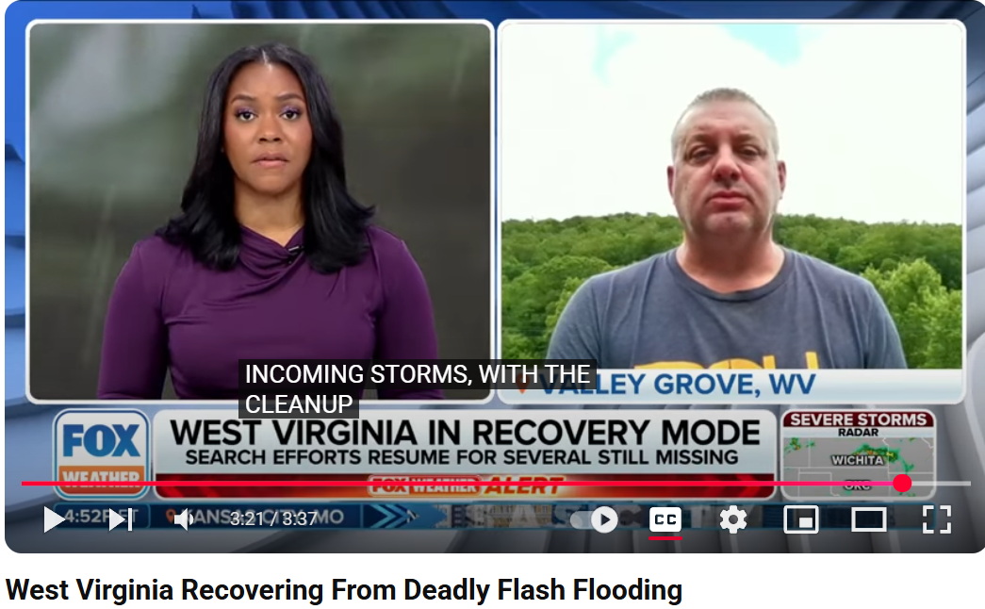
---------------------------------------------------------------------------------------------------------------------
https://www.facebook.com/reel/1086341353355853
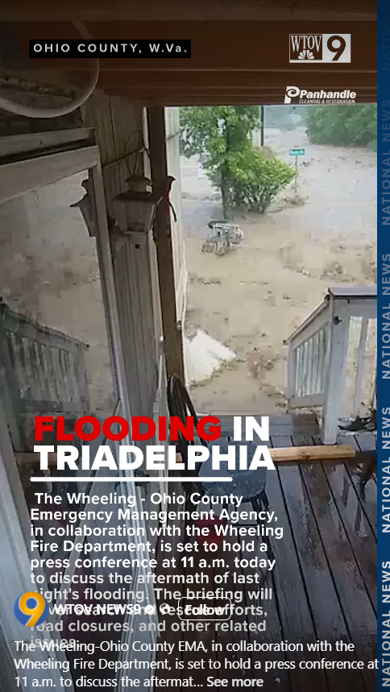
---------------------------------------------------------------------------------------------------------------------

https://www.youtube.com/watch?v=Mhd8hug7zVc

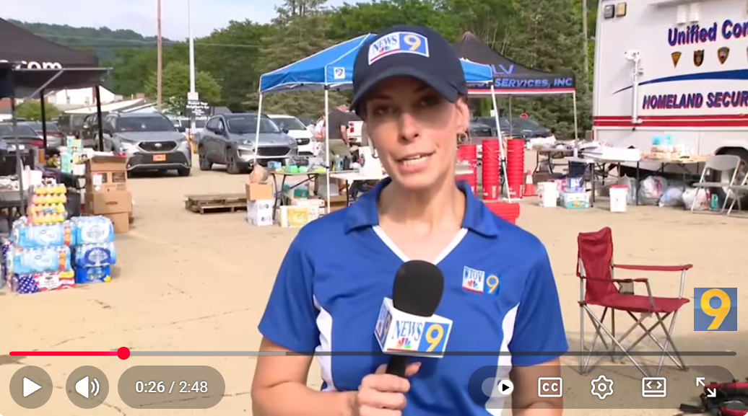
Triadelphia fire department battles floods and personal losses
---------------------------------------------------------------------------------------------------------------------

