Picture Sources:
April Tipton’s post on Facebook:
https://www.facebook.com/photo?fbid=27313569468283198&set=pcb.27313597808280364
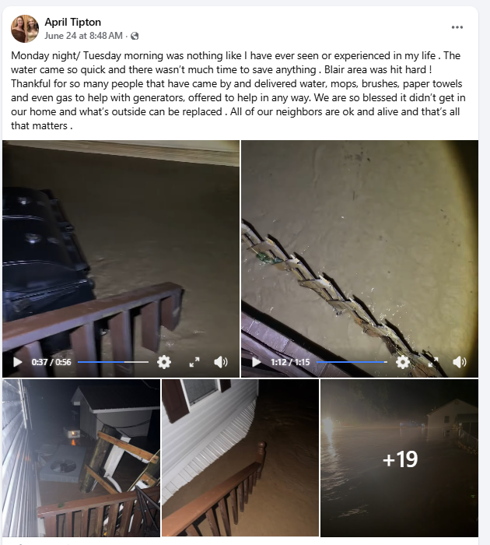

--------------------------------------------------------------------------------------------------------
Michelle Leigh Woodrum’s post on Facebook, 03-02-0004-0020-0000
https://www.facebook.com/photo.php?fbid=36754304177547223&set=p.36754304177547223&type=3
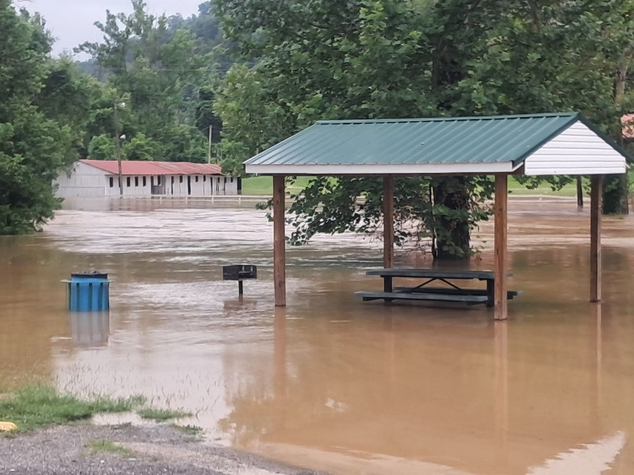

Meanwhile in Delco’s Facebook post:
https://www.facebook.com/photo/?fbid=1347140994181308&set=a.431928752369208
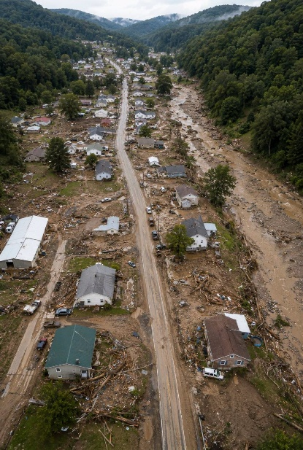

--------------------------------------------------------------------------------------------------------
Josh Fitzpatrick’s Facebook post:
https://www.facebook.com/photo/?fbid=10230592467891684&set=a.2022953649756
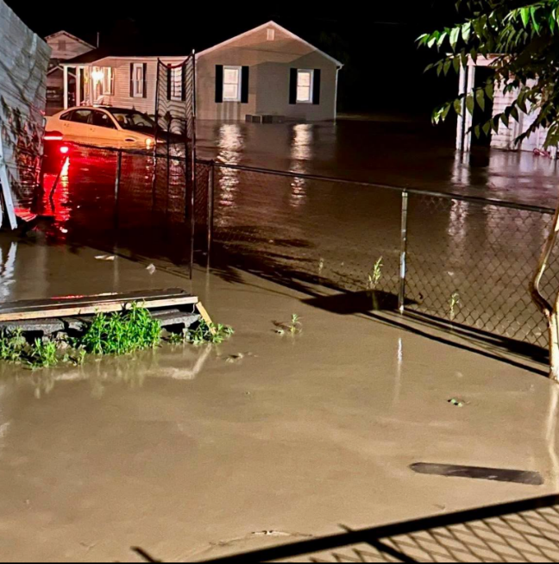

Flooding along Pond Fork leaves long trail of mud and damage along Route 85 in Boone County
https://wvmetronews.com/2026/06/23/flooding-along-pond-fork-leaves-a-long-trail-of-mud-and-damage-along-route-85-in-boone-county/
