Video Sources:
Overnight flooding in Boone County, West Virginia
https://www.facebook.com/watch/?v=684832434324004&rdid=2HPaKEtqIGwOD3bL
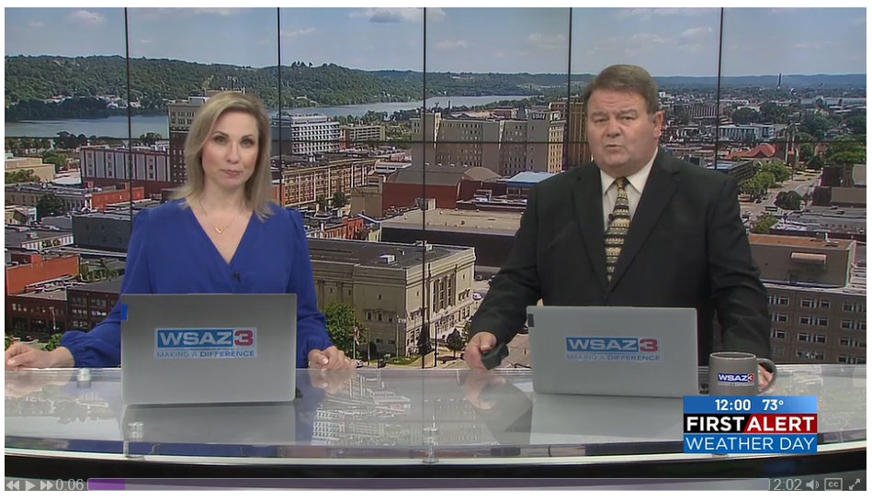

-------------------------------------------------------------------------------------------------------------------
Flooding time-lapse from 7 pm to 3 am in Wharton, WV.
Video by Aaron Dickerson on Facebook:
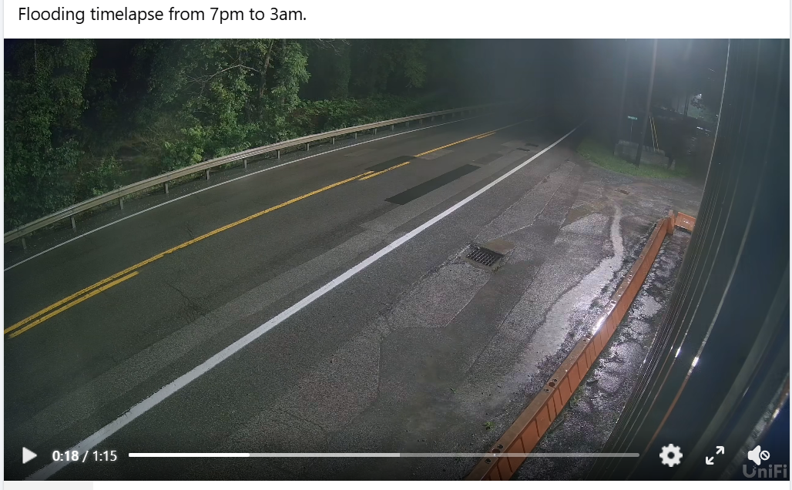
https://www.facebook.com/share/v/17r5cHBgsB/

Runoff and flooded Interstate 64 in Kanawha County.
Video by WCHS Eyewitness News on Facebook:
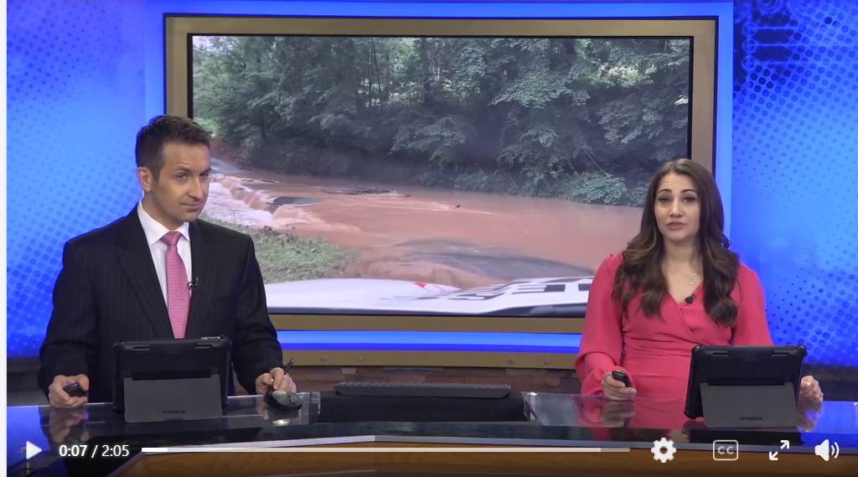
https://www.facebook.com/reel/1427270535829414

--------------------------------------------------------------------------------------------------------------------
Flash Flooding overnight at an apartment complex in the Mount Gay area of Logan County
Video by Weather with Justin Lung on Facebook:
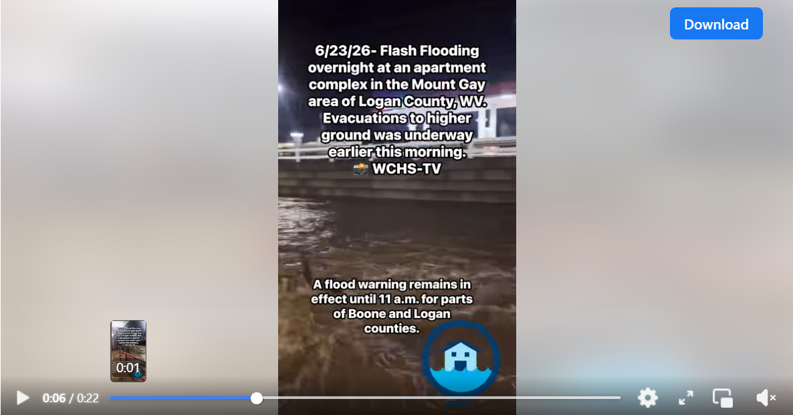
https://www.facebook.com/watch/?ref=search&v=999977136079885&external_log_id=13be31cf-f497-4535-ac1f-c290a3e50d28&q=flood%20West%20virginia%202026

Flooding response continues in Southern West Virginia
Video by wowktv:
https://www.wowktv.com/video/flooding-response-continues-in-southern-west-virginia/11907239/
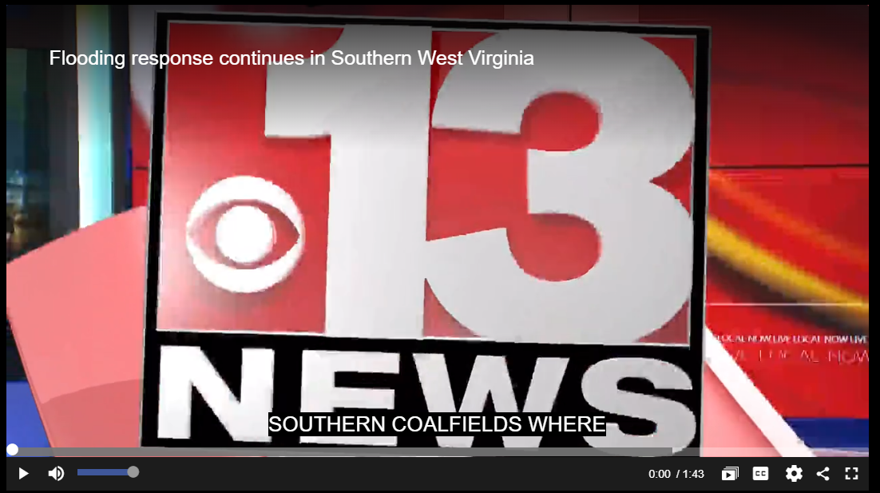

Logan County, WV after overnight flooding
Video by Anthony Conn - WCHS on Facebook:
https://www.facebook.com/reel/1590183542819838
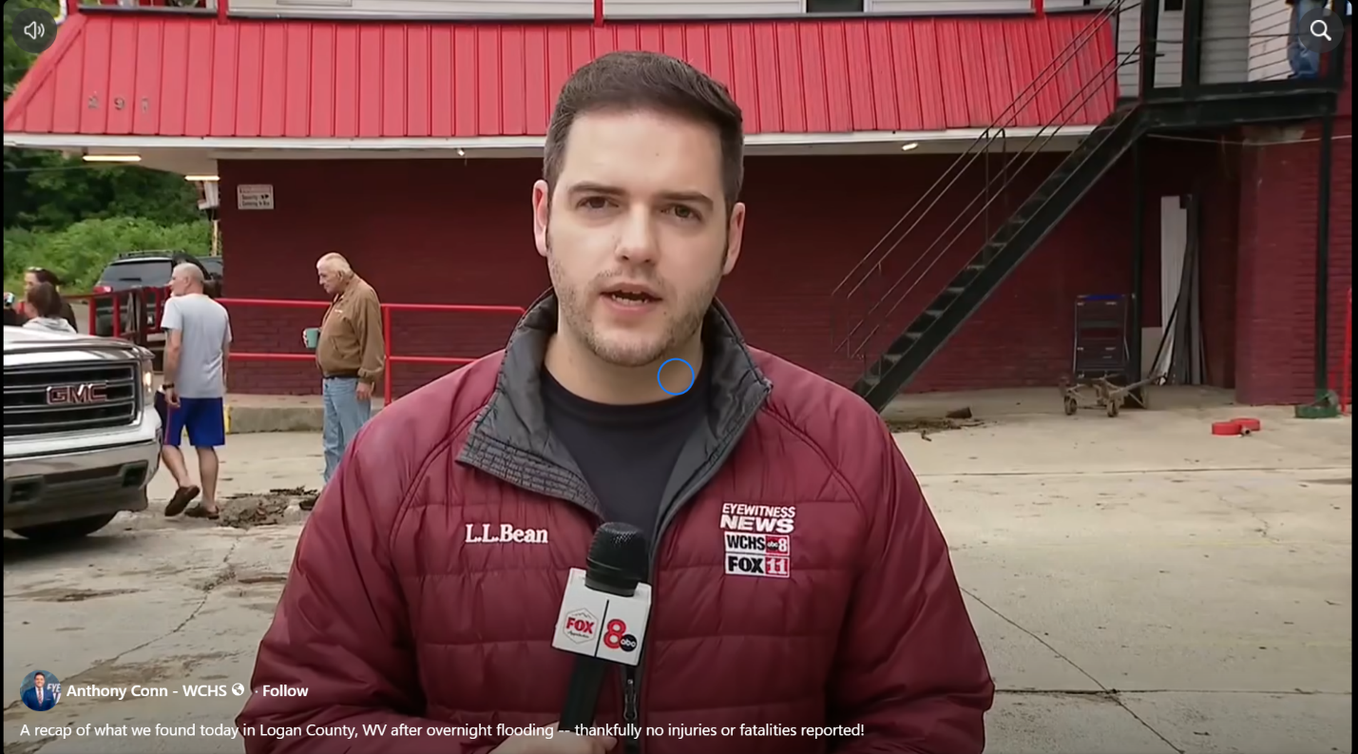
West Virginia Flood Aftermath: Boone & Raleigh Residents Face Cleanup Effort
Video by WCHS-TV:
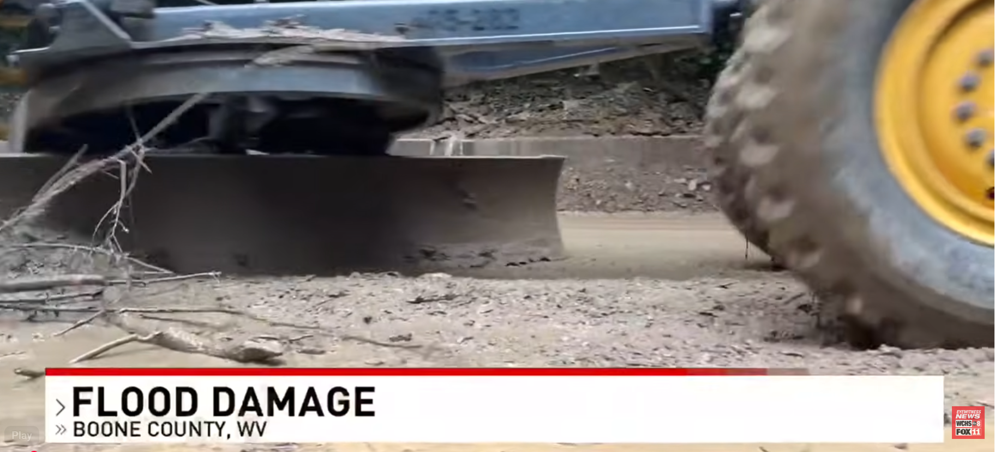
https://www.youtube.com/watch?v=dEpby03uomo

April Tipton’s post on Facebook 23-04-0077-0020-0000_11341:
https://www.facebook.com/photo?fbid=27313569468283198&set=pcb.27313597808280364
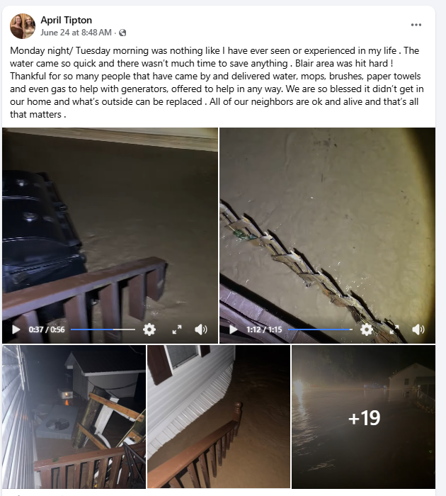

Tom Brown’s post on Facebook: 03-01-018A-0091-0000_19977:
https://www.facebook.com/100000768215067/videos/pcb.27273708822238024/1053524427150066
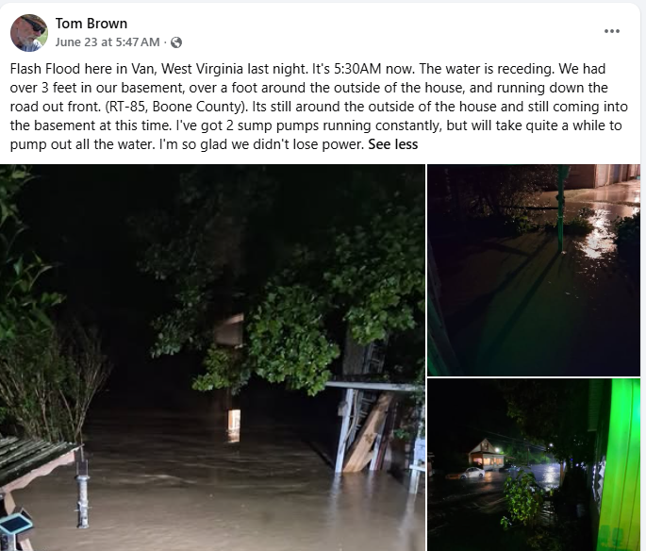

Boone County flood relief underway after heavy rainfall
(03-01-018A-0092-0000_19881)
https://www.wowktv.com/news/west-virginia/boone-county-wv/boone-county-flood-relief-underway-after-heavy-rainfall/

