Picture Sources:
The Weston Democrat post on Facebook:
https://www.facebook.com/photo/?fbid=1610909224375784&set=a.472211674912217
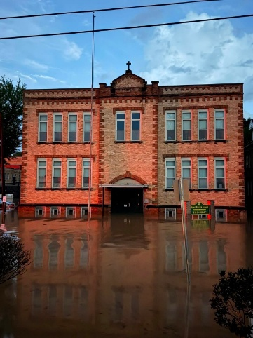

--------------------------------------------------------------------------------------------------------
The Weston Democrat post on Facebook:
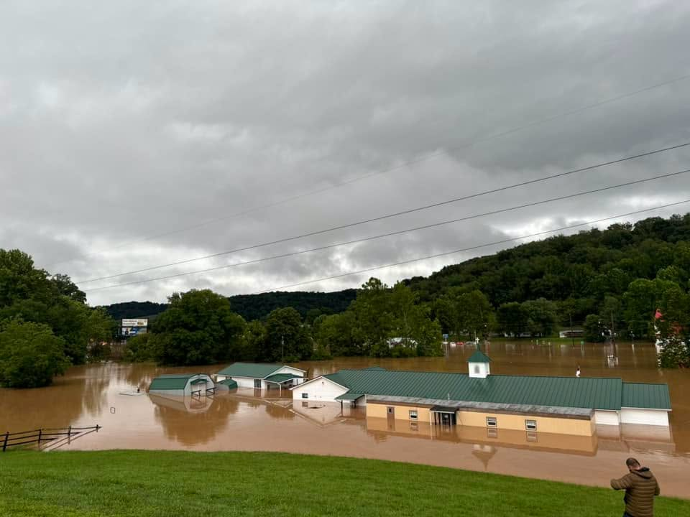
https://www.facebook.com/photo/?fbid=1610909201042453&set=a.472211674912217

--------------------------------------------------------------------------------------------------------
The Weston Democrat post on Facebook:
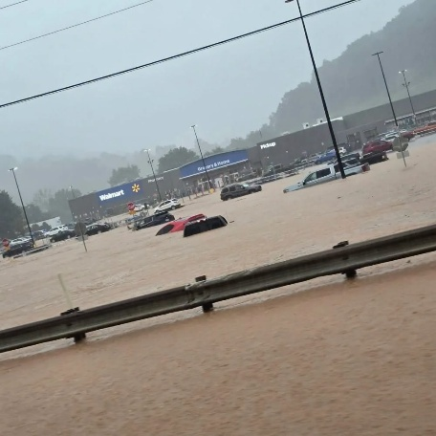
https://www.facebook.com/photo/?fbid=1347140994181308&set=a.431928752369208

The Weston Democrat post on Facebook:
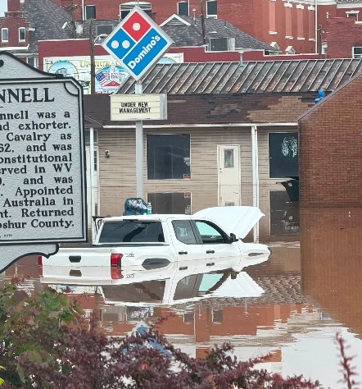
https://www.facebook.com/photo/?fbid=1610925401040833&set=a.472211674912217

--------------------------------------------------------------------------------------------------------
WDTV 5 News
﻿https://www.facebook.com/photo/?fbid=1457425656432186&set=pcb.1457426636432088
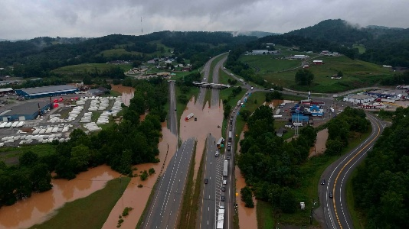

--------------------------------------------------------------------------------------------------------
WDTV 5 News
https://www.facebook.com/photo?fbid=1457425676432184&set=pcb.1457426636432088
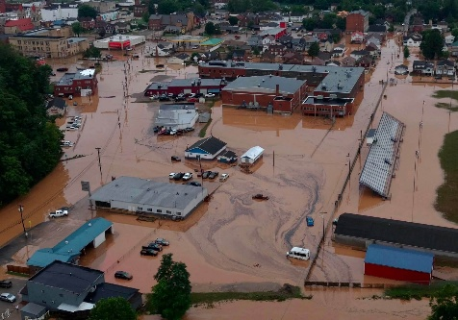

WV News
https://www.facebook.com/photo?fbid=1457425676432184&set=pcb.1457426636432088
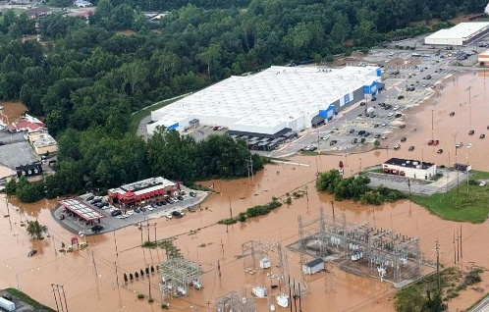

--------------------------------------------------------------------------------------------------------
The Warrior’s Chapel
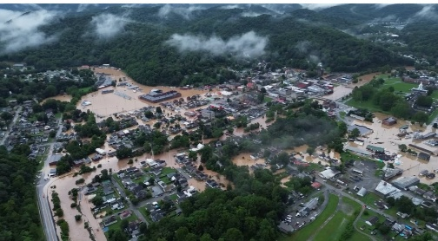
https://www.facebook.com/photo?fbid=985892791105133&set=a.120468870980867

--------------------------------------------------------------------------------------------------------
Barbara McVaney's Post
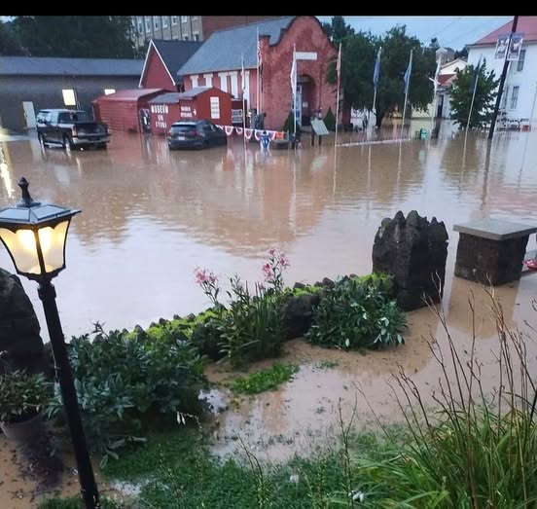
https://www.facebook.com/groups/120810177977515/permalink/28007573738874451/?rdid=JAnPk6cR0SLVkVji#

--------------------------------------------------------------------------------------------------------

D.j. Corley's Post
https://www.facebook.com/photo?fbid=10226139697078911&set=pcb.10226139712719302
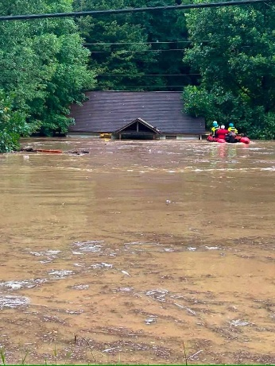

--------------------------------------------------------------------------------------------------------
Jim Jimbo Rohr II's Posts
https://www.facebook.com/photo?fbid=10226139697078911&set=pcb.10226139712719302
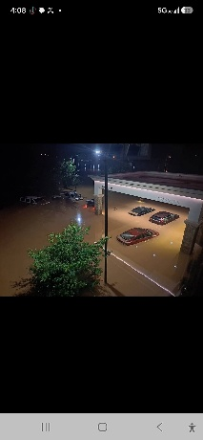
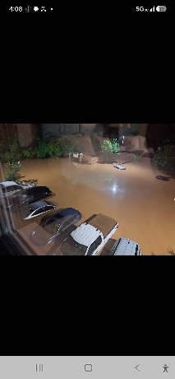
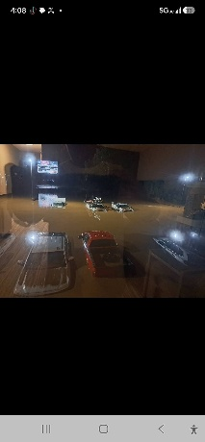
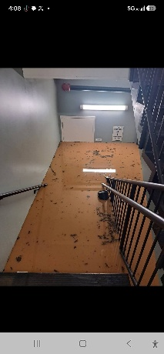
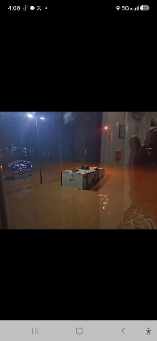

--------------------------------------------------------------------------------------------------------
Morgantown News' Post
https://www.facebook.com/photo?fbid=10226139697078911&set=pcb.10226139712719302
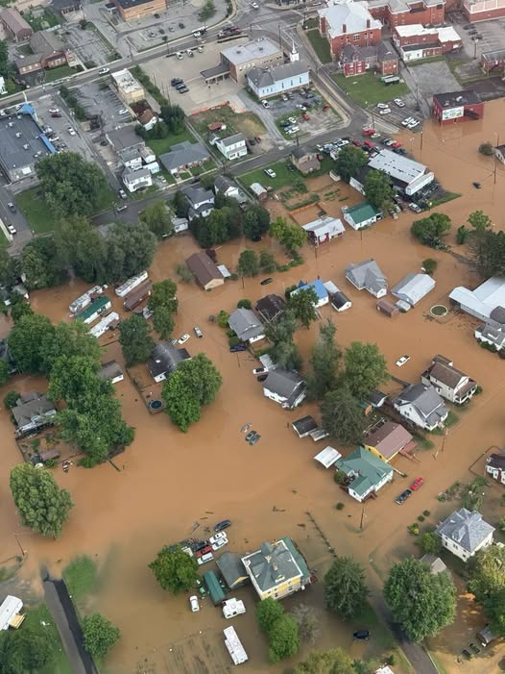

21-05-0002-0148-0000_72 Jane Lew Town Hall’s Post on Facebook
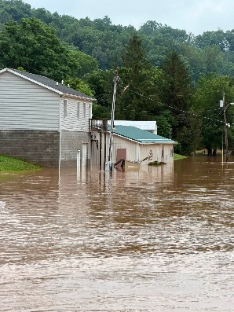
https://www.facebook.com/photo/?fbid=1465565012274783&set=pcb.1465571878940763

--------------------------------------------------------------------------------------------------------
The Bicentennial Inn: 49-03-0004-0346-0000_90 Dale Hawkins’s Post on Facebook
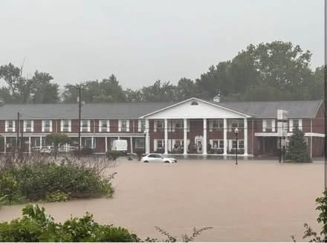
https://www.facebook.com/share/p/19JdspDV3V/

--------------------------------------------------------------------------------------------------------

