Video Sources:
WDTV 5 News
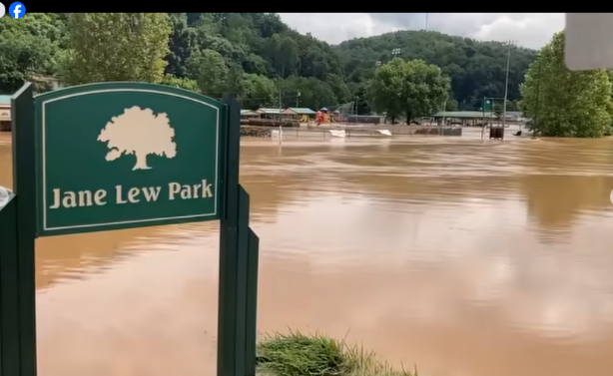
https://www.facebook.com/100064942954333/videos/pcb.1457403423101076/2249721369198181

WDTV 5 News
https://www.facebook.com/100064942954333/videos/pcb.1457403423101076/2249721369198181
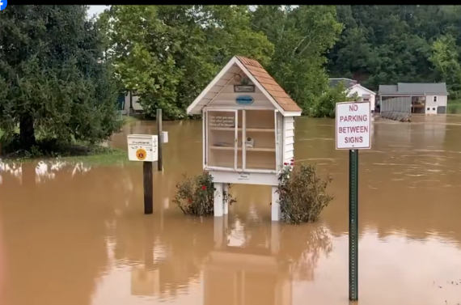

-----------------------------------------------------------------------------------------------------------------------------
Governor Patrick Morrisey’s Post on Facebook
https://www.facebook.com/share/r/14k7d6ftGgh/
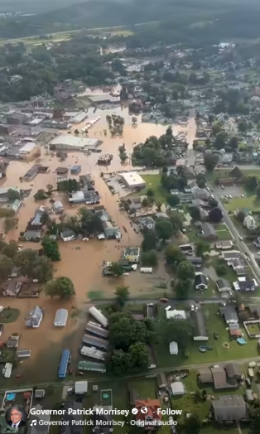

WTRF 7News Post on Facebook
https://www.facebook.com/reel/1054743320232006
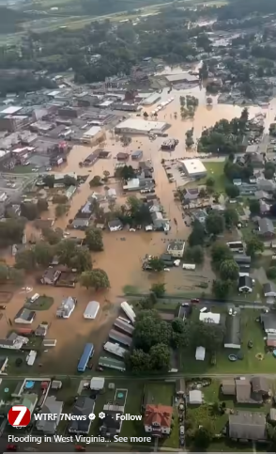

-----------------------------------------------------------------------------------------------------------------------------
MetroNews Post on Facebook
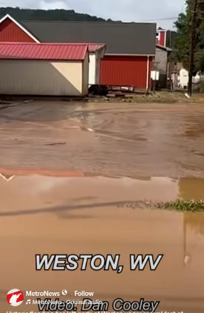
https://www.facebook.com/reel/2073689413525950

-----------------------------------------------------------------------------------------------------------------------------
49-03-0004-0214-0000_17 Robie Messenger’s Post on Facebook
https://www.facebook.com/reel/2680102559058283
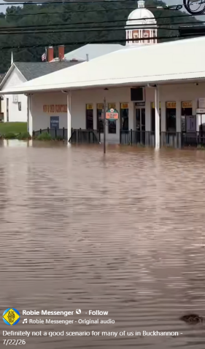

21-05-0002-0119-0000_6064 Robie Messenger’s Post on Facebook
https://www.facebook.com/photo?fbid=1465564928941458&set=pcb.1465571878940763
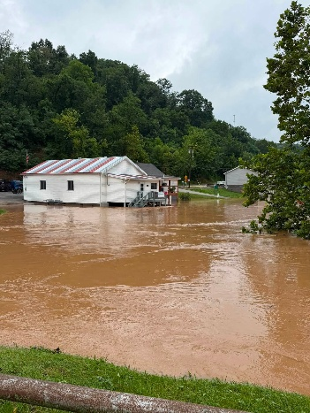

-----------------------------------------------------------------------------------------------------------------------------
49-03-0004-0214-0000_17 Robie Messenger’s Post on Facebook
https://www.facebook.com/reel/2680102559058283

-----------------------------------------------------------------------------------------------------------------------------
CNN Post on Facebook
https://www.facebook.com/reel/2680102559058283

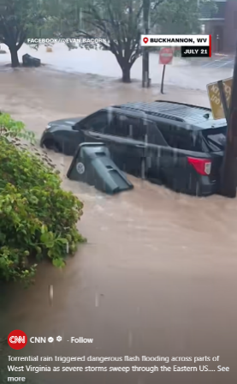

WDTV 5 News Post on Facebook
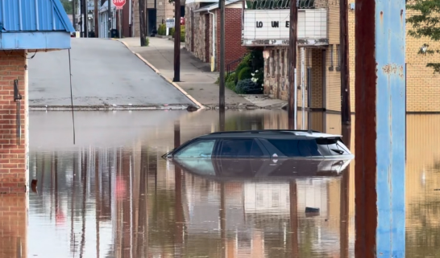
https://www.facebook.com/share/v/17K3jAxYcC/

----------------------------------------------------------------------------------------------------------------------------
WDTV 5 News Post on Facebook
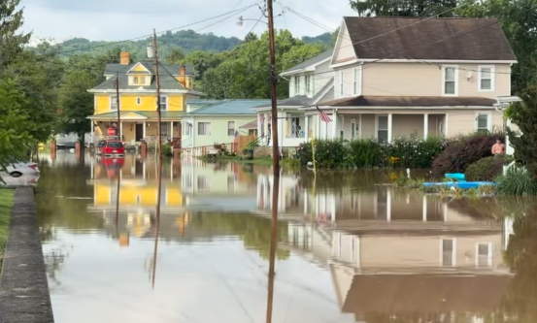
https://www.facebook.com/share/v/17K3jAxYcC/

----------------------------------------------------------------------------------------------------------------------------
Longspur Tracking Post on Facebook
https://www.facebook.com/reel/1057131070337117

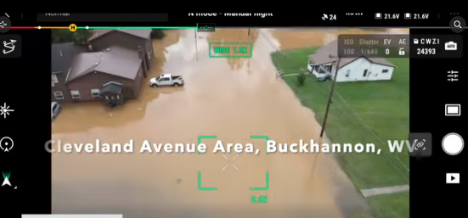

----------------------------------------------------------------------------------------------------------------------------
21-04-008G-0045-0000_1955 Nathan Rohrbough’s Post on Facebook
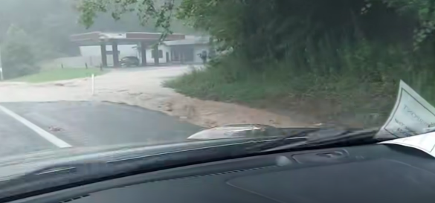
https://www.facebook.com/reel/1057131070337117

WDTV 5 News
https://www.wdtv.com/2026/07/22/heres-all-footage-photos-we-have-yesterdays-flooding-ncwv/?fbclid=IwY2xjawTVwsVleHRuA2FlbQIxMQBicmlkETFERGNsbXpuWjFlQmpUekswc3J0YwZhcHBfaWQQMjIyMDM5MTc4ODIwMDg5MgABHnQNF_KpkgLfQZj573JlrqWpol1zUUTUqRjmL3wbnA3lJwtYqA9UI1sTm_q7_aem_t7hRnbp5dLHBVLFOOcNVlw
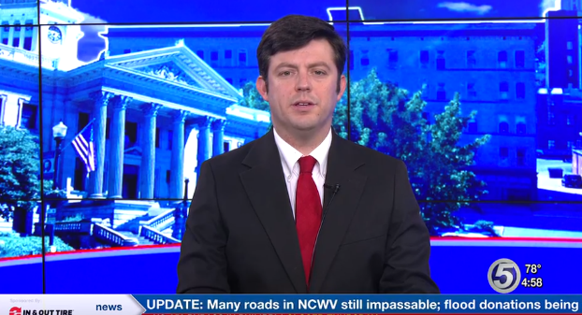

----------------------------------------------------------------------------------------------------------------------------
WCHS Eyewitness News on Facebook
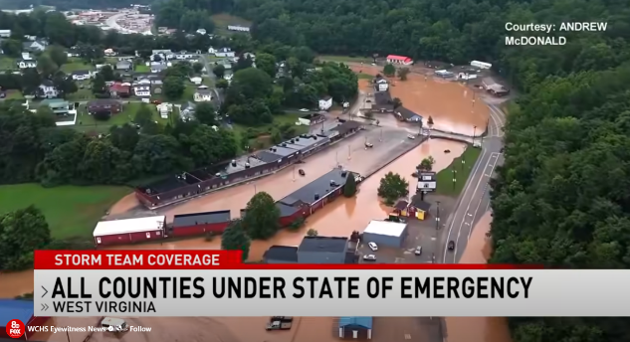
https://www.facebook.com/reel/1737416213927102

----------------------------------------------------------------------------------------------------------------------------
Mindy Chad Hayes’s Post on Facebook
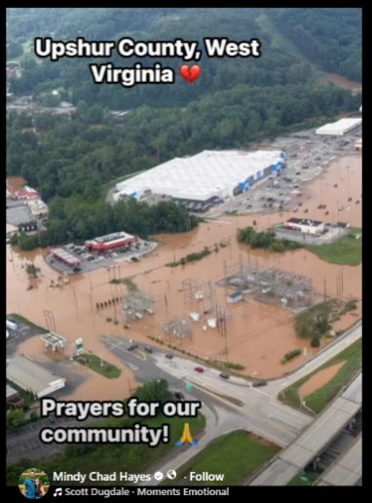
https://www.facebook.com/reel/1399234358714980

Shardinae Adams Post on Facebook
https://www.facebook.com/ShardinaeA/videos/1073000438389243
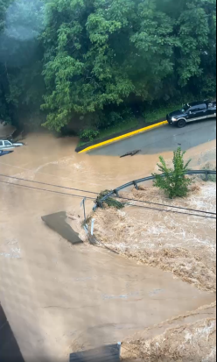

----------------------------------------------------------------------------------------------------------------------------
The Bicentennial Inn: 49-03-0004-0346-0000_90 abc news tiktok
https://www.tiktok.com/@abcnews/video/7665916984848026911?_r=1&_t=ZP-98JWXL312Q3
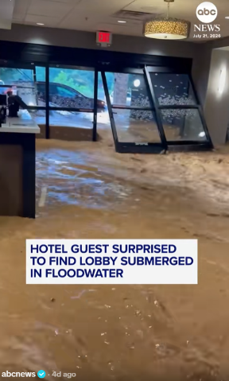

--------------------------------------------------------------------------------------------------------
Alisha Dawn’s Post on Facebook
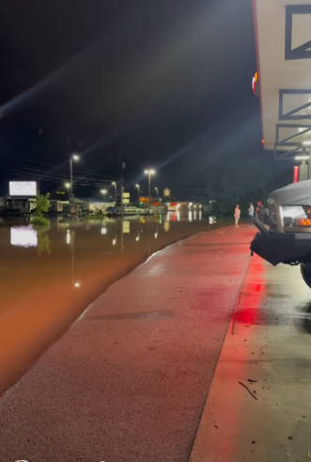
https://www.facebook.com/reel/1287674729921681

Jim Jimbo Rohr II Post on Facebook
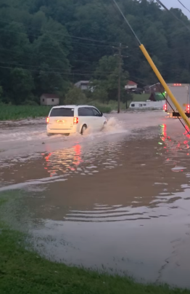
https://www.facebook.com/reel/1586251789688015

--------------------------------------------------------------------------------------------------------
NBC Washington Post on Facebook
https://www.facebook.com/reel/1657814121958702

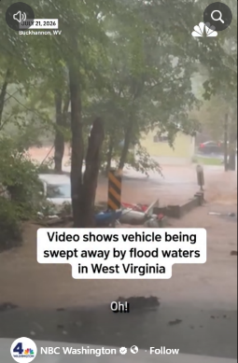

--------------------------------------------------------------------------------------------------------
Terry Crowl’s Post on Facebook
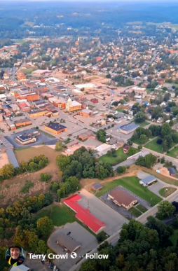
https://www.facebook.com/reel/1581297163606719

--------------------------------------------------------------------------------------------------------

W.Va. (WBOY) Website
https://www.wboy.com/emergencies/cooridor-h-flood/lewis-county-schools-look-to-reopen-on-schedule-amid-flood-cleanup-effort/
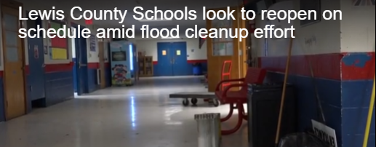

--------------------------------------------------------------------------------------------------------
43-01-0003-0021-0000_12026: Chester Osborne Jr’s Post on Facebook
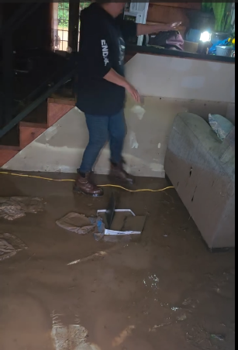
https://www.facebook.com/reel/2114903256048972

--------------------------------------------------------------------------------------------------------
Homes washed away, flooding in Weston and Buckhannon
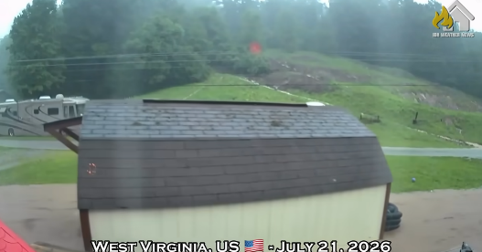
https://www.youtube.com/watch?v=yBYm025QrEQ

--------------------------------------------------------------------------------------------------------

