Elevation Certificate File Naming Conventions for WV Flood Tool
9/30/2019

Use the Building Identifier to name Elevation Certificates with the Full GIS Parcel ID + underscore + address building number. Once can copy all this information from the Flood Tool Results Query Panel.

<< Example >>
Parcel ID: 01-08-0011-0069-0000
Address: 604 S Main St, Philippi, West Virginia, 26416
Building ID: 01-08-0011-0069-0000_604

For the scanned elevation certificates, the “finished” elevation certificates and the building pictures in color are preferred. An FTP service can be employed to exchange the scanned certificates.

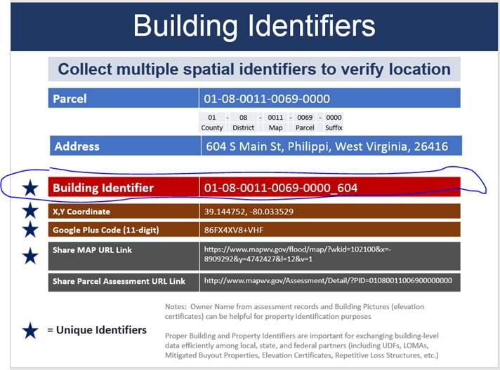

If there is no building number then use the value 9999 instead. If there is no parcel number, then use the County Code_ District Code_Map Number_9999-9999.

Here are some more examples for buildings located in Jefferson County:

19-10-0003-0034-0000_206
19-04-010A-0002-0001_33
19-02-0013-0007-0006_223
19-05-0004-0025-0000_744
19-05-0004-0025-0000_744A (Building Unit A in same parcel)
19-05-0004-0025-0000_744B (Building Unit B in same parcel)
19-10-003A-0019-0000_115
19-09-005B-0028-0000_267
19-05-0004-0025-0000_780
19-02-0016-0017-0002_656
19-05-0004-0025-0000_9999 (no building number scenario; if more than one building in parcel missing address number then sequence 9999, 9998, 9997, etc.)
19-10-0003-0048-0000_111
19-05-0004-0025-0000_723
19-09-005A-0040-0000_34
19-09-005A-9999-9999_34 (no parcel number scenario; include county code, district code, and map number; parcel number and parcel suffix all 9’s)
19-05-0004-0025-0000_754
19-09-005B-0026-0000_270
19-06-0004-0001-0000_141
19-09-005A-0041-0000_48
19-07-022B-0027-0000_7198
19-07-0018-0129-0000_1183
19-07-0011-0006-0004_11070
19-06-0010-0008-0001_199
19-07-0011-0009-0000_344
19-03-0005-0041-0003_191
19-07-0011-0002-0000_64
19-02-0016-0139-0000_229
19-02-0016-0093-0000_86
19-10-0003-0033-0000_204
19-10-0003-0021-0000_207
19-06-0014-0010-0000_4490

