Community Rating System (CRS) Credit Calculations:
Case Study of Mount Hope, Fayette County, WV
West Virginia GIS Technical Center
May 2020

Goals and Objectives
The project applied a selection of the activities described in the coordinator’s manual of National Flood Insurance Program Community Rating System (CRS), published by FEMA in 2017, to investigate the achievable credits in Mount Hope, WV. The main goal of the CRS is to reward communities for flood mitigation activities that are beyond the minimum national requirements regulating construction of new buildings.
With the purpose of supporting the National Flood Insurance program (NFIP), the CRS provides communities with reductions in the flood insurance premium rate for implementing such activities. Benefiting from the CRS activities, communities can collect credit points that are applicable to the NFIP. Every 500 credit points can change a class in the NFIP that will reward the community with a discount equal to 5% of the flood insurance premium rate.
This study investigated two types of activities. The first group was under Open Space Preservation (OSP) coded as 420 in the manual. The objective of such activities is to reduce flood damages in areas that are prone to inundation by keeping them free of development including buildings and infrastructure. Consequently, the lands located in those areas will continue or resume their natural functions for flood and erosion control while protecting the biological resources. The second group was relevant to building Acquisition and Relocation (AR) under class 520 in the manual with the objective of encouraging communities to clear the existing structures from the floodplains. Acquiring, relocating or demolishing the buildings can remove the population and assets from the floodplains and mitigate the potential flood losses and damages. It will have effects on reduction of flood response and recovery costs for communities.
Assumptions and Conditions
- The “OSP” (CRS-422.a) credits can be given for the preserved open spaces located in the community’s regulatory floodplains including the SFHA as shown on the community’s Flood Insurance Rate Map (FIRM) or another floodplain with similar development regulations. In West Virginia, it can be considered just the same as the Special Flood Hazard Area (SFHA) because there is no other regulatory floodplain.
- The impact adjusted SFHA must be used in the base maps and area calculations. That means refining the SFHA by eliminating the areas without any potential for development or out of the community’s authority. It can be translated to exclusion of the large waterbodies (larger than 10 acres) in addition to the federally owned lands from the SFHA area. A state land is a special situation. Although a community does not have any regulation authority over it, if it helps the community receive more credit it can be included in the maps and area calculations.
- Coordinate systems of the GIS environments can have effects on the dimensions and areas on maps. The projected coordinate system of NAD 1983, UTM Zone 17N is applied in the GIS files used in all area calculations of the CRS credits in West Virginia to have more accurate results.
- To be considered as “open space”, it is assumed that there are no buildings or structures, filling, large pavement, or other encroachment to flood flows in the parcels.
- To be qualified as “preserved” open space, all of the parcels included in the calculations are assumed to be attached with a signed statement by a public or creditable private owner or some regulations on the parcel preventing from construction, fillings, or other encroachments on flood flows in the future.
- All of the OSP parcels are assumed to be vacant at the time of application for the CRS credits.
- The calculations of “deed restrictions (DR)” (CRS-422.b) only apply to the areas qualified for the OSP, as a prerequisite. It is assumed that there is a deed for the parcels with the explicit language indicating the following restrictions:
(a) No new buildings may be allowed on the property;
(b) The restriction runs with the land; and
(c) The restriction cannot be changed by a future owner; rather, it can only be amended by a court for just cause.
- To be eligible for the “Natural Functions Open Space (NFOS)” (CRS-422.c), the properties are assumed to be managed to keep the undeveloped natural state (for NFOS1) or designation as critical habitat for threatened or endangered species (for NFOS3).
- For the calculations of “Freeboard (FRB)” (CRS-432.b), a 2-foot freeboard is assumed in West Virginia. The areas previously calculated in the open space preservation credit (cOSP) are excluded from the freeboard area.
- In the calculations of “Acquisition and Relocation (AR)” (CRS-520), the assumption is that all the buyout properties had buildings that have been acquired or relocated from the regulatory floodplain since the FIRM effective date.
- No “Repetitive Loss” structures were included in the calculations of Acquisition and Relocation.
- As there is no other regulatory floodplain in West Virginia, in the AR calculations of step 2 of the option 2 (c520-2.2), the number of buildings acquired or relocated out of the SFHA (bARSF) is the same as the number of buildings acquired or relocated from the regulatory floodplain (bAR).
Study Area
We worked on Mount Hope in Fayette County as a pilot study for investigating the achievable credit points by some of the CRS activities in West Virginia. The vast area of buyout by the county or the city as a part of the Dunloup Creek Voluntary Floodplain Buyout Program had made that community a proper study area for our purpose.
Base Map Preparation
In this study, we used the data of Natural Resources Conservation Service (NRCS) to identify the buyout parcels with floodplain easements in the community (75 parcels). Then, 23 other parcels owned by the county or city were added as “unverified” parcels by observations on the WV Flood Tool. The above parcels were mapped along with the updated regulatory floodplains (SFHA) (Figure 1).

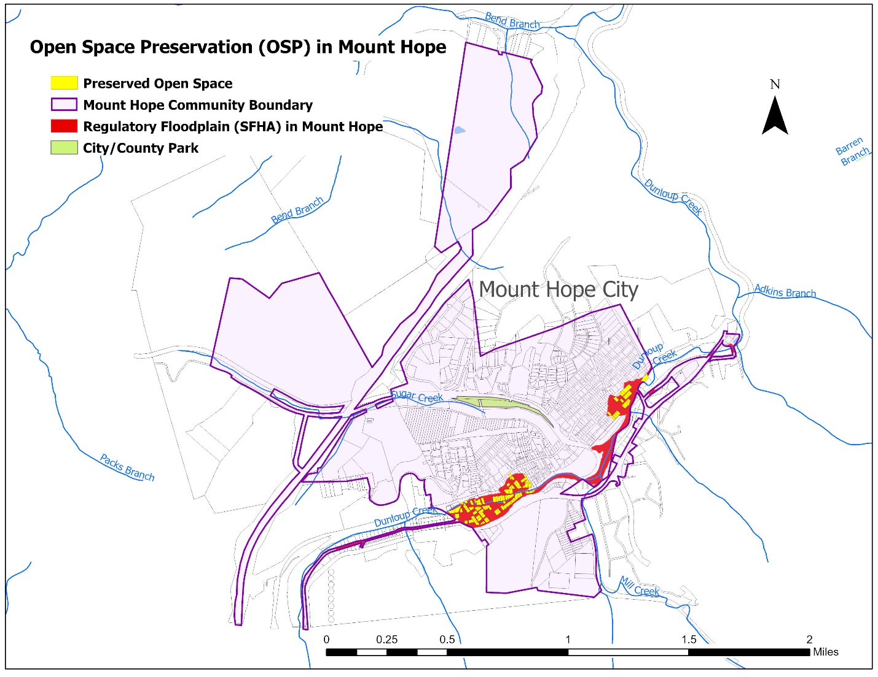
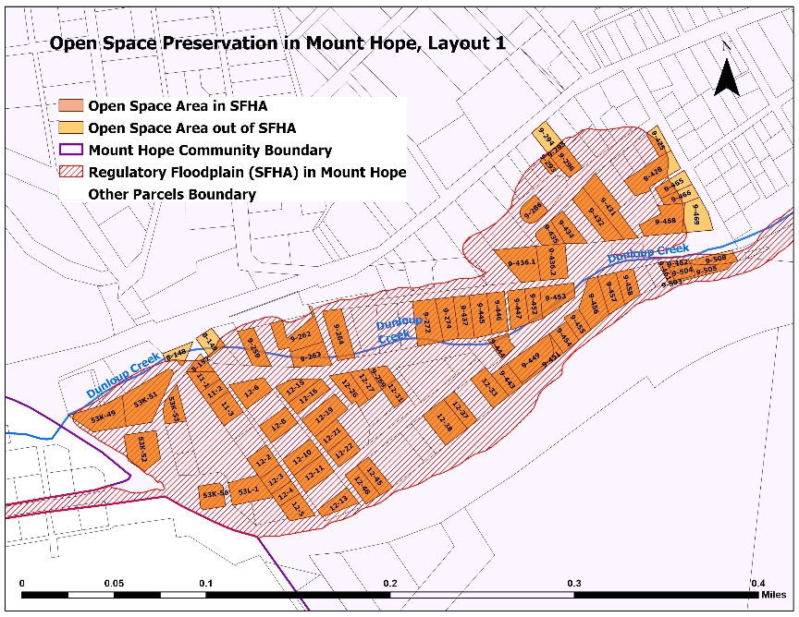
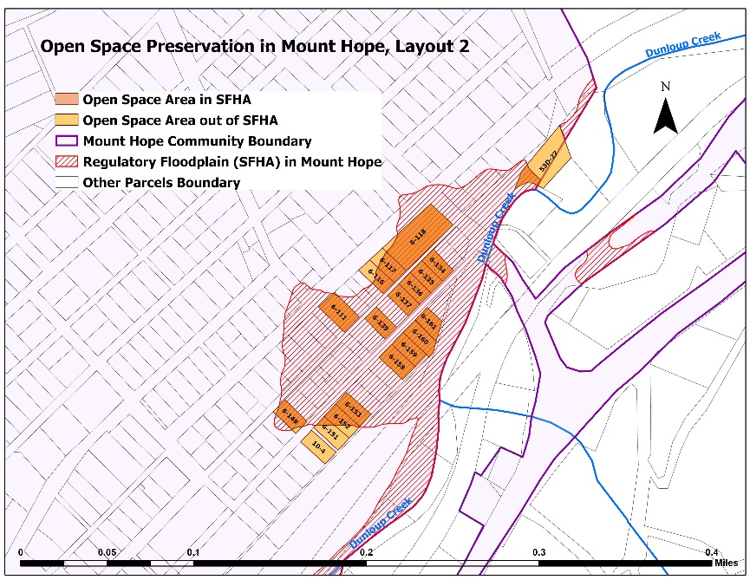

Figure 1: The prepared base maps of Mount Hope

The study considered the described parcels as the preserved open spaces in Mount Hope. It means that those lands were assumed not to be subject to any construction or encroachments on flood flows. In addition, all of the above parcels were assumed to be attached with relevant legal documents (deeds) indicating the restrictions of sale and development in the future.
Calculated Activity Elements
The first group of the CRS activities (under CRS-400) studied in Mount Hope included Open Space Preservation (OSP), Deed Restrictions (DR), Natural Functions Open Space (NFOS), and Freeboard (FRB). These activities were based on the impact adjusted special flood hazard area (mSFHA). As there was no large waterbody or federal land in Mount Hope, the area of impact adjusted regulated floodplains (mSFHA) could be considered the same as the special flood hazard area (aSFHA).
The GIS measurements indicated 41 acres of the lands as the total area of the regulatory floodplains or aSFHA in Mount Hope. The parcels described as the study area were intersected with the regulatory floodplain to extract the open space area in the SFHA (Figure 1).
Open Space Preservation (OSP), CRS-422.a
The maximum achievable credit for this activity is 1,450 points for keeping flood-prone lands vacant. OSP credit (cOSP) is calculated by the ratio of the preserved open space area located in the regulatory floodplain (aOSP) to the impact adjusted area of the special flood hazard (here, aSFHA).
The area of open spaces owned by the county or city of Mount Hope located in the regulatory floodplains (aOSP) was measured as 12 acres. According to the following calculations, the OSP credit for Mount Hope was equal to 424.
$$aOSP=12 acres$$
$$aSFHA=41 acres$$
$$rOSP=\frac{aOSP}{aSFHA}=\frac{12}{41}=0.293$$
$$cOSP=rOSP×1450=0.293×1450=424$$
* Reference: CRS Coordinator's Manual 2017, 422.a, page 420-3
Deed Restrictions (DR), CRS-422.b
This element, with the maximum points of 50, can provide communities with extra credit for assuring that the parcels in the regulatory floodplain will always remain open spaces. This element only applies to the areas qualified for the OSP, as a prerequisite.
The DR credit (cDR) is calculated based on the ratio of the preserved open space areas with deed restrictions (aDR) to the area of the SFHA (aSFHA). Assuming that all of the OSP areas in Mount Hope can be attached with the proper deeds, the aDR was equal to the aOSP. Consequently, the DR credit was calculated as 15.
$$aDR=12 acres$$
$$aSFHA=41 acres$$
$$rDR=\frac{aDR}{aSFHA}=\frac{12}{41}=0.293$$
$$cDR=rDR×50=0.293 ×50=15$$
* Reference: CRS Coordinator's Manual 2017, 422.b, page 420-12
Natural Functions Open Space (NFOS), CRS-422.c
If the natural functions of the qualified preserved open spaces (OSP) are preserved, communities can be rewarded with the NFOS credit with the maximum of 350 points. The logic is that the natural open spaces can play an important role in flood controlling with lower costs compared to the man-made systems. The credit for Natural Functions Open Space (cNFOS) is adjusted based on the ratio of the preserved open space areas qualifying for each of the following sub-elements to the area of the SFHA.
NFOS1: 190 points (Max.), for having parcels that qualify as OSP in an undeveloped natural state or restored to a similar natural state
NFOS2: 50 points (Max.), for having parcels that qualify as NFOS1 designated in a natural floodplain functions protection plan
NFOS3: 50 points (Max.), for having parcels that qualify as NFOS1 designated as critical habitat for threatened or endangered species
NFOS4: 60 points (Max.), for having parcels that qualify as NFOS1 also in a designated open space corridor
The activities of NFOS1 and NFOS3 were applied to this study. According to the results, 70 credit points could be achieved as the total cNFOS in Mount Hope.
$$aNFOS1=12 acres$$
$$aNFOS3=12 acres$$
$$aSFHA=41 acres$$
$$rNFOS1=\frac{aNFOS1}{aSFHA}=\frac{12}{41}=0.293$$
$$rNFOS3=\frac{aNFOS3}{aSFHA}=\frac{12}{41}=0.293$$
$$cNFOS1=rNFOS1×190= 0.293 ×190=55.7$$
$$cNFOS3=rNFOS3×50= 0.293 ×50=14.7$$
$$cNFOS=cNFOS1+cNFOS3=55.7+14.7≅70$$
* Reference: CRS Coordinator's Manual 2017, 422.c, page 420-14
Freeboard (FRB), CRS-432.b
According to the NFIP, the lowest floor of residential buildings must be elevated to or above the base flood elevation (BFE). Non-residential buildings can also be floodproofed to the same level, as an alternative. A freeboard requirement assures the above conditions by considering an extra height margin over the BFE to protect structures from waves, debris, miscalculations or lack of data, and changing weather patterns.
Assuming a 2-foot freeboard in Mount Hope, the maximum credit points could be 225. It was adjusted based on the area where the freeboard could be effective (aFRB) to the area of the SFHA. As mentioned in the CRS manual, the areas previously calculated in the open space preservation credit (cOSP) must be excluded from the freeboard area. As shown in the calculations, the credit of freeboard (cFRB) in Mount Hope was equal to 159 points.
$$aSFHA=41 acres$$
$$aOSP=12 acres$$
$$aFRB=aSFHA-aOSP=41-12=29 acres$$
$$rFRB=\frac{aFRB}{aSFHA}=\frac{29}{41}=0.707$$
$$cFRB=rFRB×225=0.707×225=159$$
* Reference: CRS Coordinator's Manual 2017, 432.b, page 430-11
Acquisition and Relocation (AR), CRS-520
The other type of activity applied to the study area was Acquisition and Relocation (CRS-c520) that dealt with the number of buildings in the community's special flood hazard area (bSF). The credit of this element depends on the number of primary buildings in the regulatory floodplain acquired or relocated since the effective date of the Flood Insurance Rate Map (FIRM).
Two options of calculation can be applied to this activity. The first one is easier to apply but has the limitation of 190 points as the maximum. It can be more useful in large communities or a community with a small percentage of relocated buildings in the floodplains. The second option, with the maximum points of 2,250, can be a better alternative in communities that have cleared a large percentage of the structures.
The buyout parcels with centroids within the community boundary and in the SFHA were considered for this part of the study. We assumed that, in all of those properties, there had been buildings acquired or relocated from the regulatory floodplain since the FIRM effective date. Consequently, 88 buildings were identified as acquired or relocated (bAR) and 38 structures were identified as the remaining buildings in the floodplain (bSF). No “repetitive loss” structures were included in the calculations of Acquisition and Relocation. We used both options of calculation in the study area to compare the results.
Option 1, calculated as below, could provide 264 points for the community.
$$bAR=88$$
$$c520_1=bAR×3=88×3=264$$
The first step of option 2 was based on the ratio of the relocated or demolished buildings (bAR) to all the buildings located in the regulatory floodplains before the acquisition and relocation including the relocated buildings in addition to the remaining buildings in the SFHA. After adjusting the maximum points (1900) with this ratio, 1327 points could be achieved for this step.
Step1 of option 2:
$$bAR=88$$
$$bSF=38$$
$$c520_2.1=1900×\frac{bAR}{bSF+bAR}=1900×\frac{88}{38+88}=1327$$
As the above ratio was larger than 30%, the second step of option 2 could be applied to add to the collected points. As there is no other regulatory floodplain in West Virginia, in this step, the number of buildings acquired or relocated out of the SFHA (bARSF) was the same as the number of buildings acquired or relocated from the regulatory floodplain (bAR). As the result, 199 bonus points were calculated according to the following formula.
Step2 of option 2:
$$rAR=\frac{bAR}{bSF+bAR}=\frac{88}{38+88}=0.698>0.3$$
$$bARSF=bAR=88$$
$$bSF=38$$
$$c520_2.2=\left(\frac{\left(bARSF×100\right)}{bSF+bARSF}-30\right)×5=\left(\frac{\left(88×100\right)}{38+88}-30\right)×5=199$$
The total acquisition and relocation credit for Mount Hope, as the sum of the steps of option 2, was equal to 1526 points that was much higher compared to the result of the first option.
$$c520_2=c520_2.1+c520_2.2=1327+199=1526$$

* Reference: CRS Coordinator's Manual 2017, 523.b, page 520-8
Conclusion
Of the total community area of 996 acres, regulatory floodplains cover an area of 41 acres (4%) in Mount Hope. The parcels owned by the county or city, as the result of the Dunloup Creek Voluntary Floodplain Buyout Program, that intersected the floodplains were investigated in this study. The area of the preserved open spaces located in the regulated flood zones of the community provided by those parcels is equal to 12 acres. With the assumptions mentioned in the process, the total credit of the applied CRS activities in Mount Hope can be equal to 2194 points. It can be translated to four classes of enhancement in the NFIP and, consequently, a discount equal to 20% of flood insurance premium rates. The credit may be increased by application of some other elements described in the CRS manual. The study showed that the activities under open space preservation can provide the communities in West Virginia with more flood resilience while potential benefits of discounts in the National Flood Insurance Program. The following table summarizes the results of the study.
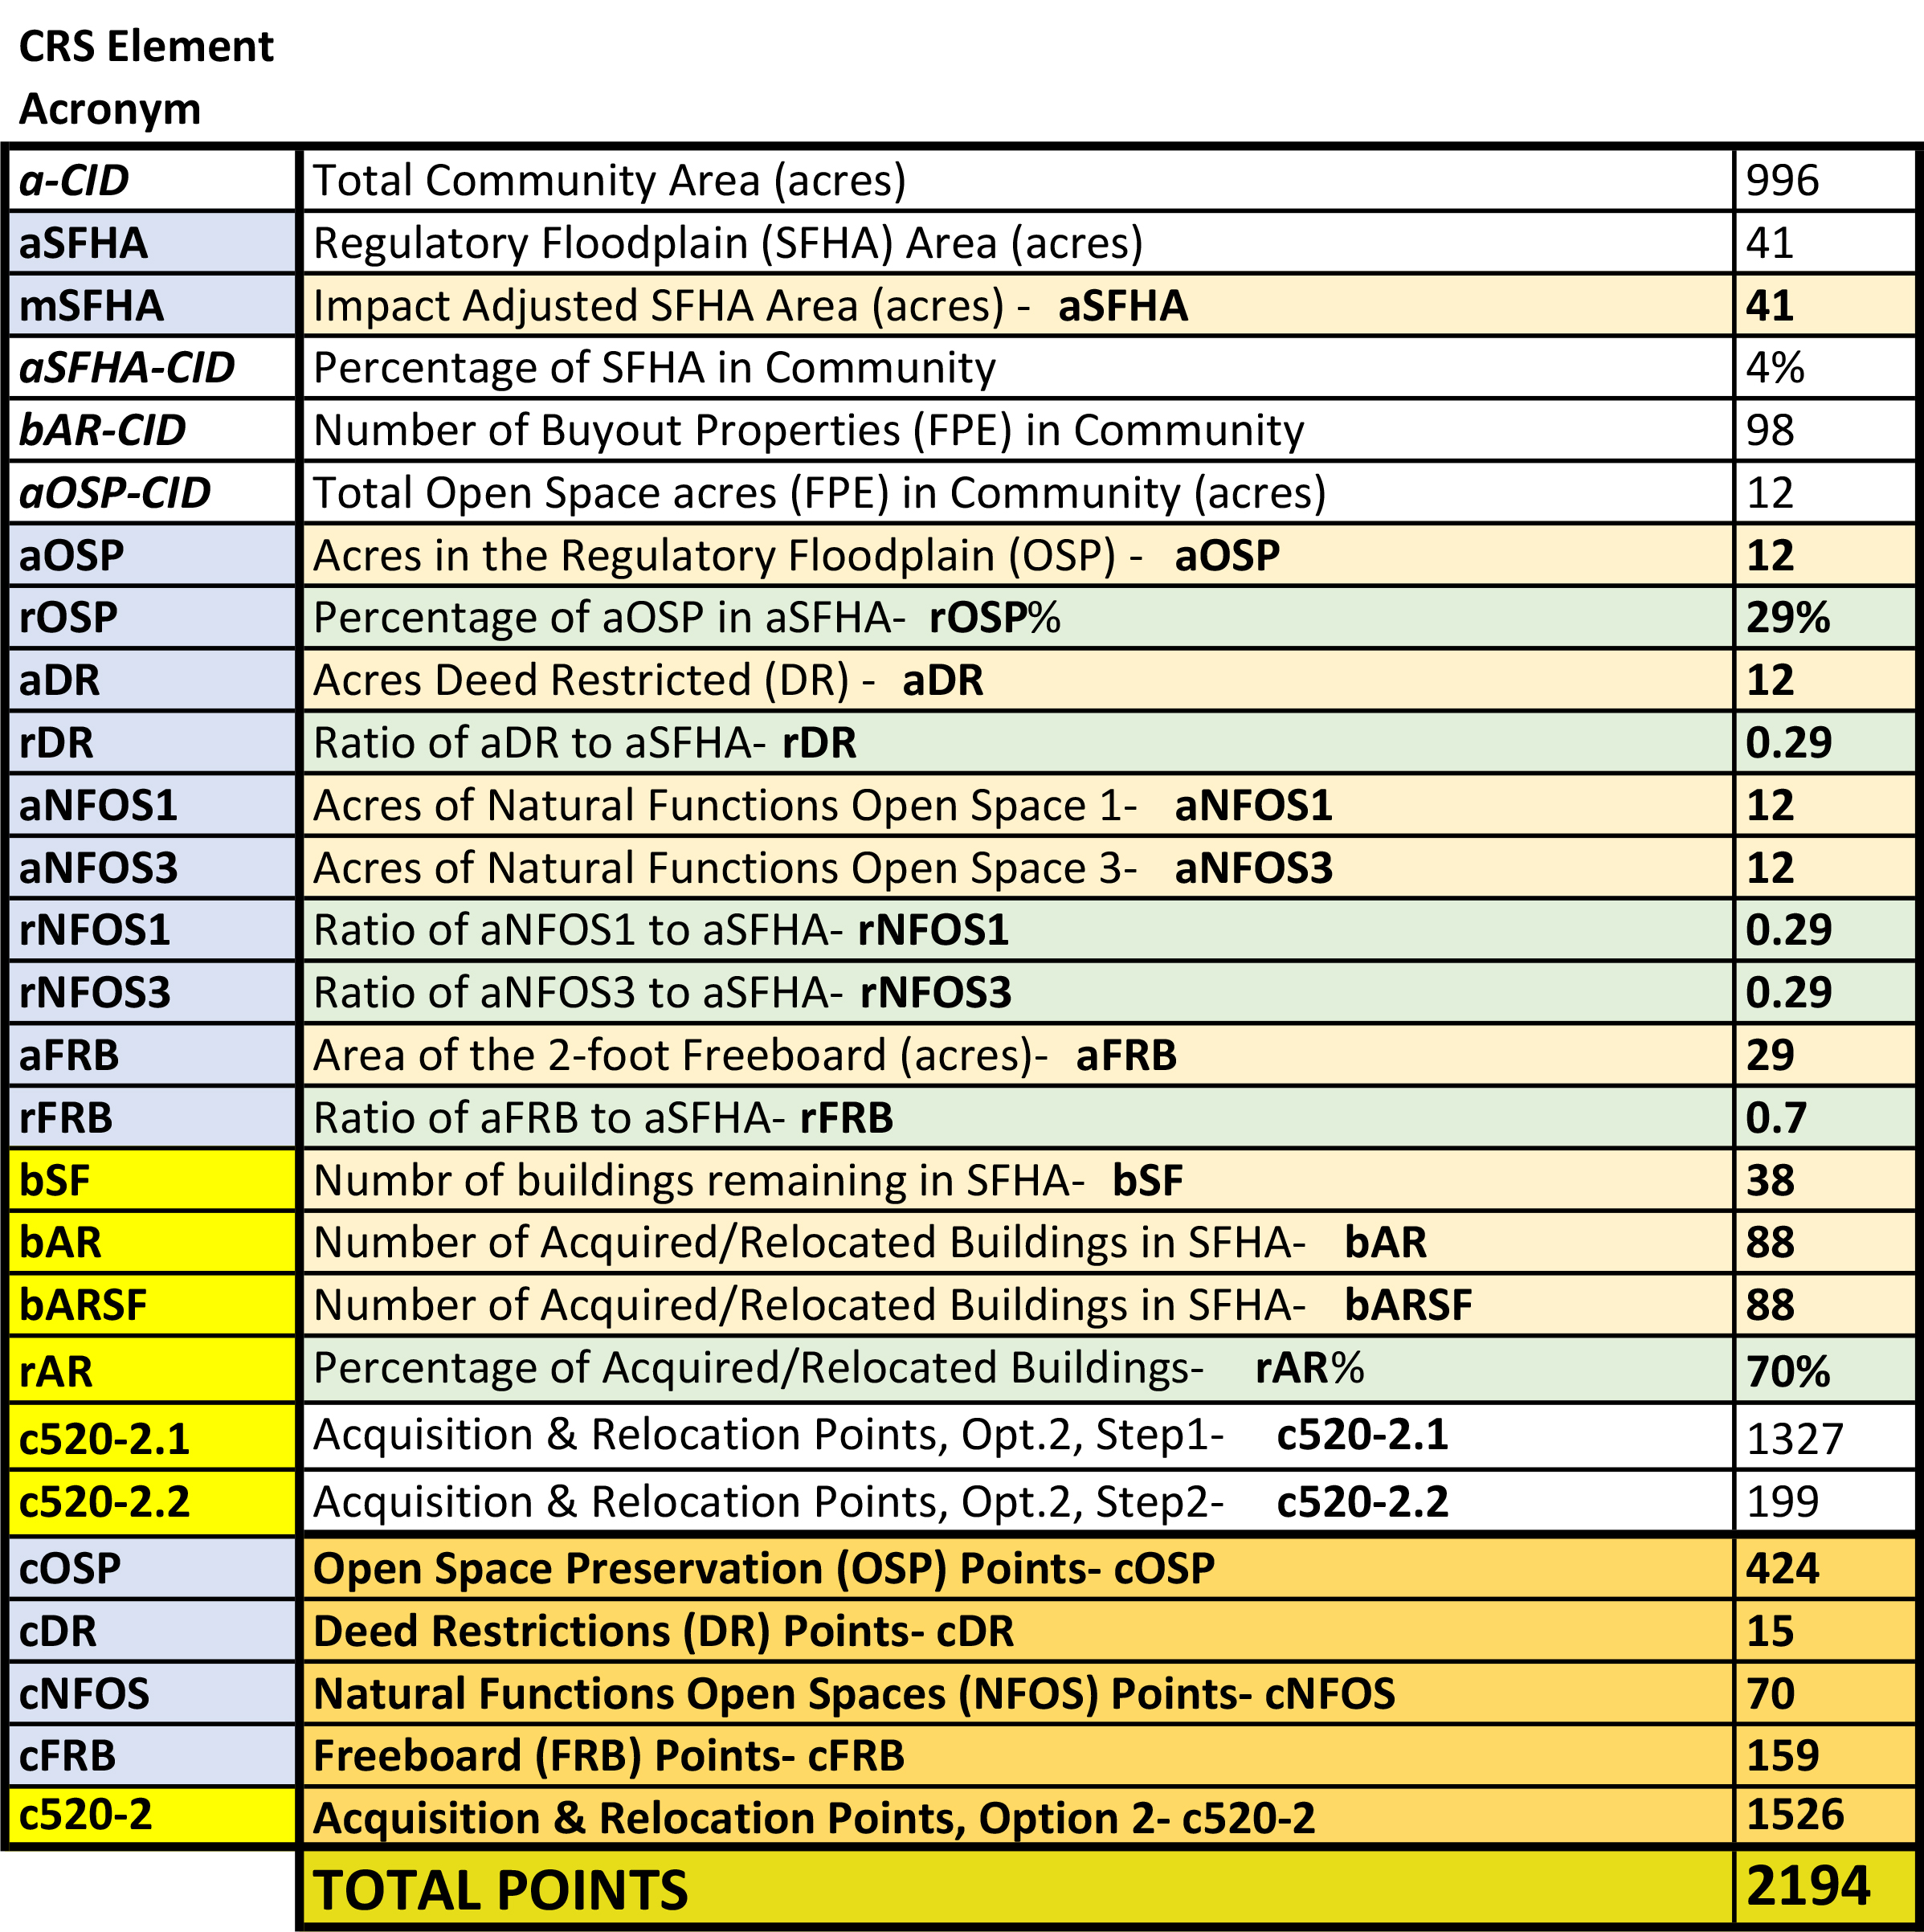

Reference:
Federal Emergency Management Agency (FEMA). (2017). National flood insurance program community rating system: Coordinator’s manual.

