Spatial Cluster Analysis of Structures in Approximate A Zones at Varying Flood Depths
2/21/2022
Kurt Donaldson, WV GIS Technical Center, WVU

Objective: Evaluate potential Approximate A Zone rivers/streams for more comprehensive Detailed Flood Studies where clusters of buildings with high damage potential exist. Building-level risk assessment data from the TEIF/TEAL Statewide Risk Assessment project and the best available flood depth grids were utilized to perform a spatial cluster analysis of structures in the A Zones based on high (1) building counts, (2) building dollar exposure, (3) building damage dollar exposure estimates, and (4) substantially damaged estimates. The cluster analysis identifies a higher density (or higher development) of structures located in the Approximate A Zone.

Methodology: Spatial Cluster Analysis of structures in Approximate A Zones was performed for flood depths of ≥ 5 Feet, ≥ 10 Feet, and ≥ 15 Feet. The structure density per stream mile was not calculated except for visual viewing on the WV Flood Tool. The building-level risk assessment factors below were utilized for ranking clusters of Approximate A Zone structures as candidates for Detailed Flood Studies.
- Building Count
- Building Dollar ($) Exposure
- Building Damage Dollar ($) Loss Estimates
- Substantially Damaged Loss (%) Estimates

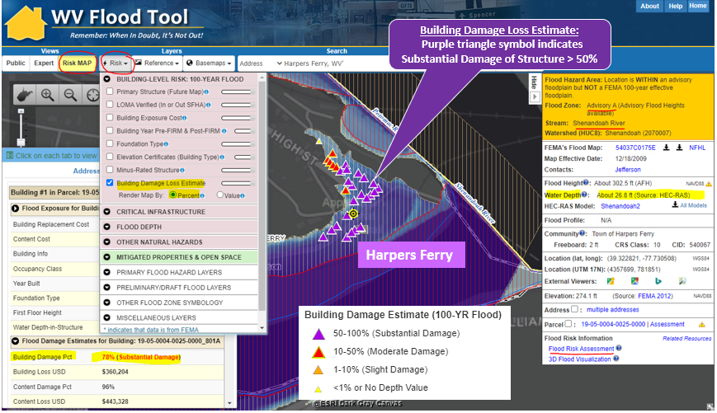
WV Flood Tool’s Risk MAP View – Building Damage Loss Estimate Percent Layer: In the Risk MAP View of the WV Flood Tool, the risk assessment layer, Building Damage Loss Estimate (%), provides a relationship between high flood depths and flood loss estimates of substantially damaged structures
(> 50% damage). High building-level damage percentages typically correlate to structures in Approximate A Zones with high base flood depths for a 1% annual chance flood.
Depth Grids: Where no model-backed HEC-RAS depth grids existed for Approximate A Zones, the less accurate Hazus depth grid was used. Refer to Advisory A Zone status graphic.

A Zone Structure Cluster Analysis: Zone A structure vulnerability and spatial density analyses were performed for three flood depths at ≥ 5 feet, ≥ 10 feet, and ≥ 15 feet.

- Zone A Cluster Analysis Graphics: Flood Depths for ≥ 5 feet, ≥ 10 feet, and ≥ 15 feet
- Spreadsheet Flood Source Tables: Summary Building-Level Risk Assessment Factors per River/Stream Cluster and Top Building Flood Depths per River/Stream
- Report: Methodology and map links to potential candidates for AE Zone Detailed Studies
- BLRA: Statewide Building-Level Risk Assessment (BLRA) source geodatabase for cluster analysis

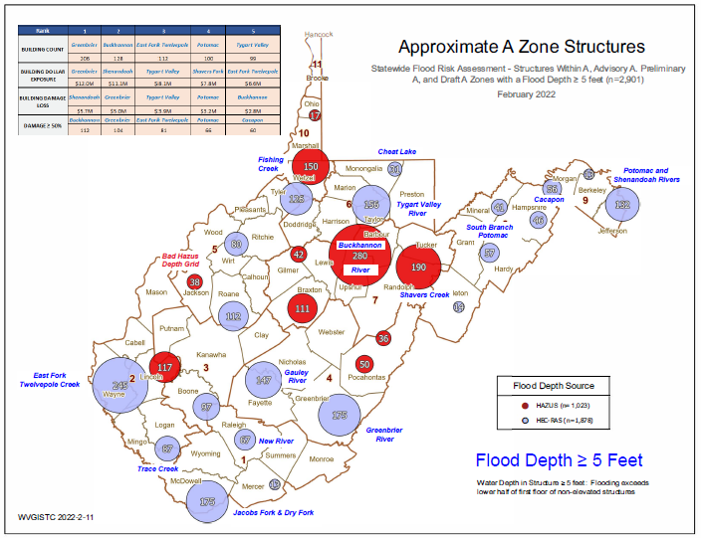

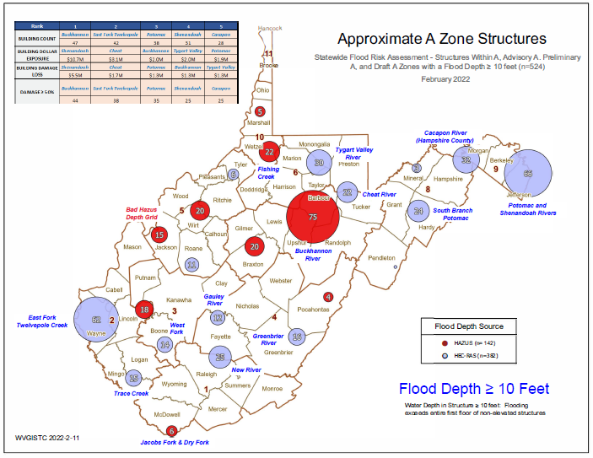

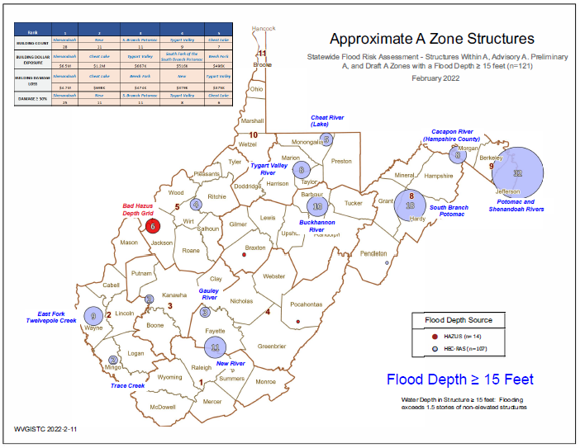

Findings: Refer to the graphics, spreadsheet table, and WV Flood Tool when evaluating the TEIF data for this analysis.

Flood Depth ≥ 5 Feet
Approximate A Zone Structures with Flood Depth ≥ 5 Feet. Water Depth in Structure ≥ 5 feet: Flooding exceeds lower half of first floor of non-elevated structures.
- Greenbrier River: Greenbrier River in Greenbrier County is ranked first as having the highest Building Count (206) and Building Dollar Exposure ($12M). Greenbrier River is ranked second for Building Damage Loss Estimate ($5.0M) and Substantially Damaged Structures Estimate (104)
- Other Rivers/Streams of Interest: Buckhannon, East Fork Twelvepole, Potomac, Tygart Valley, Shenandoah, Shavers Fork, Cacapon, and West Fork.

Flood Depth ≥ 10 Feet
Approximate A Zone Structures with Flood Depth ≥ 10 Feet. Water Depth in Structure ≥ 10 feet: Flooding exceeds entire first floor of non-elevated structures.
- Buckhannon River: Buckhannon River in Barbour and Upshur counties is ranked first with the highest Building Count (47) and Substantially Damaged Loss Estimate (44).
- Shenandoah River (Harpers Ferry): Shenandoah River is ranked first in Building Dollar Exposure ($10.7M) and Building Damage Loss Estimate ($5.5M).
- Other Rivers/Streams of Interest: East Fork Twelvepole, Potomac, Cacapon, Cheat, Tygart Valley, and West Fork.

Flood Depth ≥ 15 Feet
Approximate A Zone Structures with Flood Depth ≥ 15 Feet. Water Depth in Structure ≥ 15 feet: Flooding exceeds 1.5 stories of non-elevated structures.
- Shenandoah River (Harpers Ferry): Shenandoah River is ranked first in all risk factors: Building County (28), Building Dollar Exposure ($6.5M), Building Damage Loss Estimate ($4.7M), and Substantially Damaged Loss Estimate (25).
- Other Rivers/Streams of Interest: New, South Branch Potomac, Tygart Valley, Cheat Lake, South Fork of the South Branch Potomac, and Beech Fork.

Zone A Candidates for Detailed Studies. Using spatial cluster and building-level risk analyses, below is a list of A Zones with map links to the WV Flood Tool to consider for detailed flood studies.

- Beech Fork Lake Dam backwater
- Buckhannon River
- Cacapon River
- Cheat Lake Dam backwater
- Cheat River
- Dry Fork
- East Fork Twelvepole Creek
- Fishing Creek
- Gauley River
- Greenbrier River
- Jacobs Fork
- New River
- Patteson Creek
- Potomac River
- Shavers Fork
- Shenandoah River
- South Branch Potomac River
- South Fork of the South Branch Potomac
- Trace Creek
- Tygart Valley River
- West Fork

Greenbrier River (Greenbrier County) Approximate A Zone Cluster of High Damaged Structures
High building county for Depth > 5 feet. High damage loss structures are located over a long distance of the Greenbrier River in Greenbrier County.
https://www.mapwv.gov/flood/map/?wkid=102100&x=-8943985&y=4572143&l=5&v=2
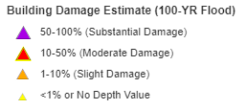
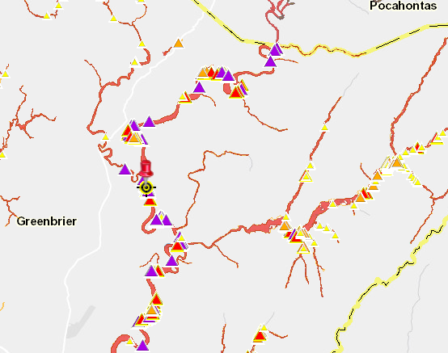

Shenandoah River (Harpers Ferry) Zone A Cluster
A high-value wastewater treatment plant is associated with the high building exposure values of this Zone A cluster. Building 19-05-0004-0025-0000_744 has high-water marks on building side.
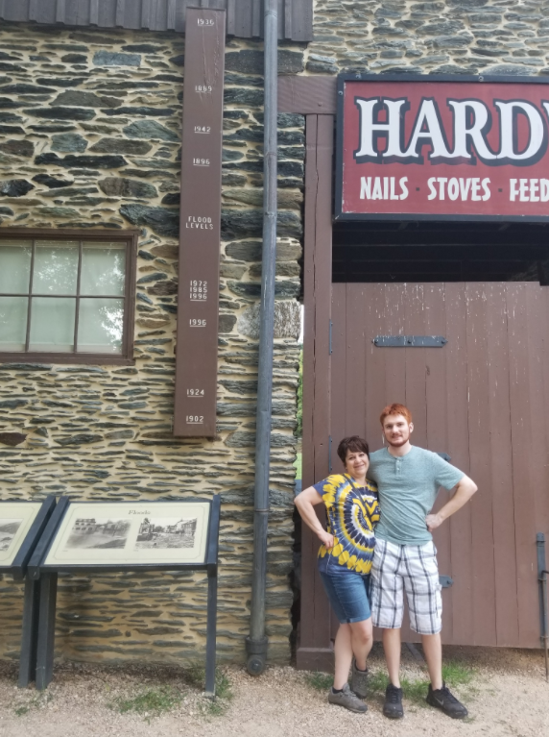
https://www.mapwv.gov/flood/map/?wkid=102100&x=-8652936&y=4767965&l=11&v=2
High Water Marks
Building Damage Loss Estimate:
Purple triangle symbol indicates Substantial Damage of Structure > 50%
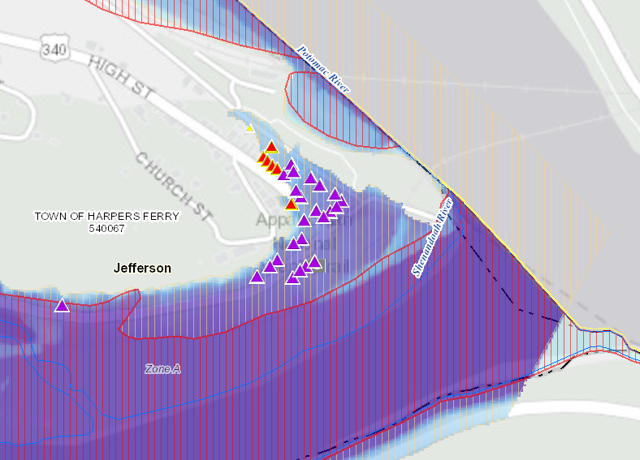
Buckhannon River (Barbour / Upshur Counties) Zone A Cluster of High Damaged Structure Estimates
https://www.mapwv.gov/flood/map/?wkid=102100&x=-8919535&y=4727392&l=6&v=2
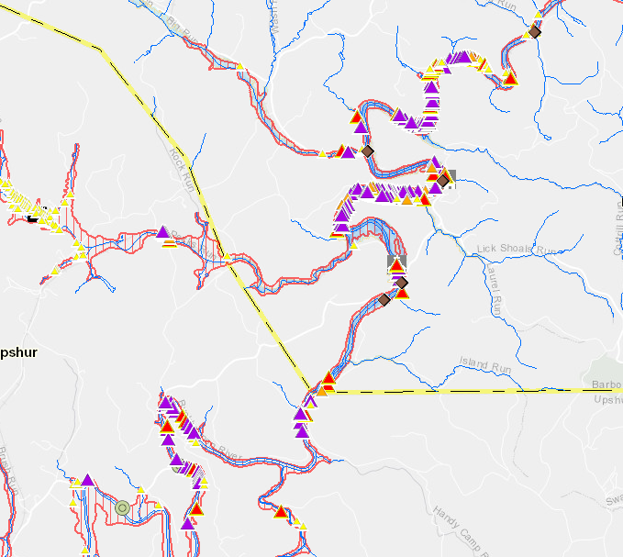
Building Damage Loss Estimate:
Purple triangle symbol indicates Substantial Damage of Structure > 50%

Potomac River Zone A Cluster in Jefferson County between Shepherdstown and Harpers Ferry
https://www.mapwv.gov/flood/map/?wkid=102100&x=-8919535&y=4727392&l=6&v=2
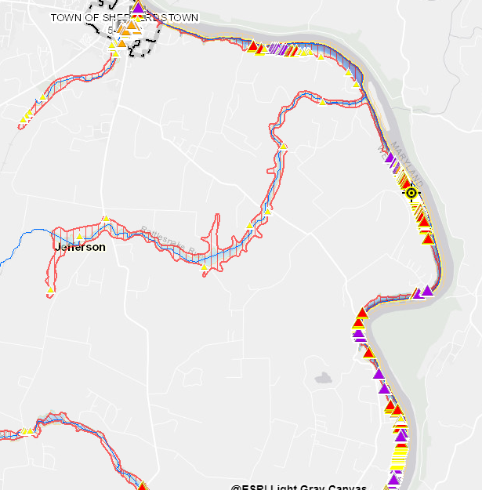
Building Damage Loss Estimate:
Purple triangle symbol indicates Substantial Damage of Structure > 50%

Cacapon River Zone A Cluster at Hampshire-Morgan County border. Detailed AE in Morgan County but not Hampshire County where density of vulnerable structures located in Zone A. Extend detailed study on Cacapon at Morgan-Hampshire county border south into Hardy County.
https://www.mapwv.gov/flood/map/?wkid=102100&x=-8726461&y=4790357&l=8&v=2
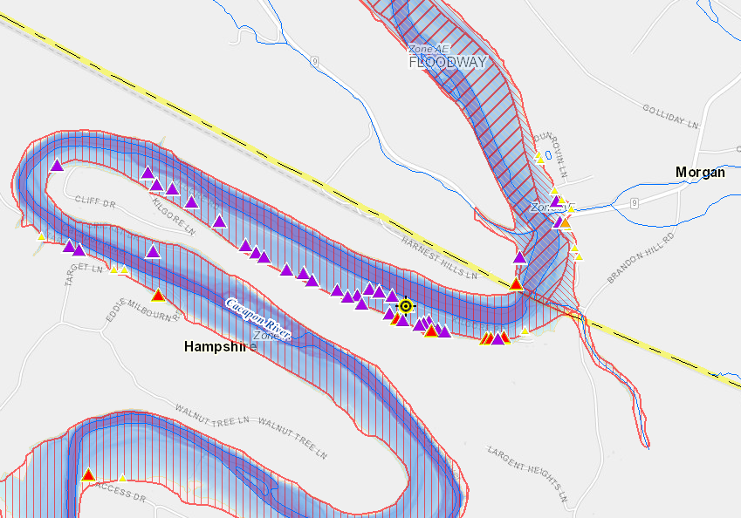
Building Damage Loss Estimate:
Purple triangle symbol indicates Substantial Damage of Structure > 50%

Cacapon River (Bubbling Spring - Hampshire County)
https://www.mapwv.gov/flood/map/?wkid=102100&x=-8733549&y=4758133&l=8&v=2
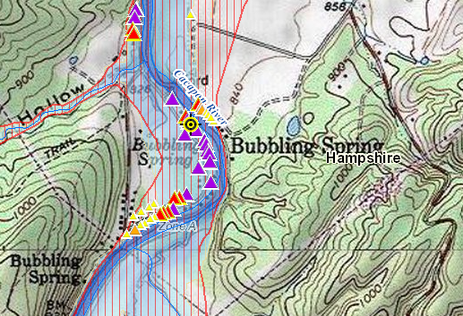

East Fork Twelvepole Creek (Wayne County) Zone A Cluster
https://www.mapwv.gov/flood/map/?wkid=102100&x=-9172551&y=4605140&l=7&v=2
Google Street View: https://goo.gl/maps/VdmcqvGhgFkfWWCo9
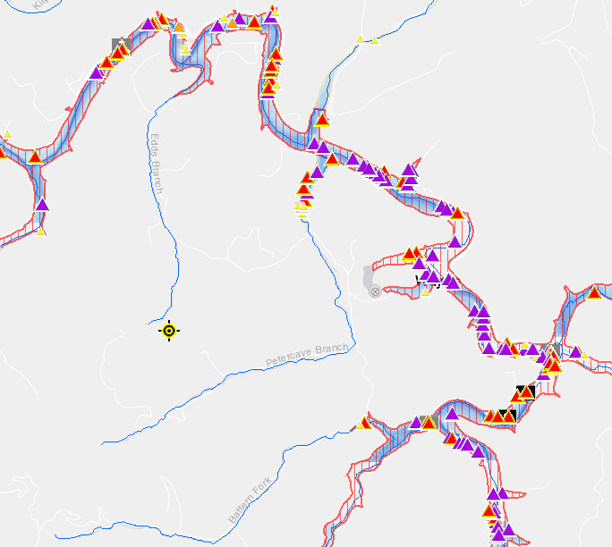
Building Damage Loss Estimate:
Purple triangle symbol indicates Substantial Damage of Structure > 50%

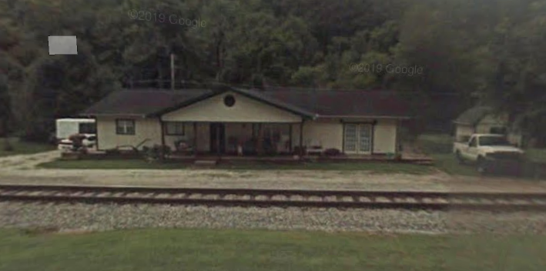

Tygart Valley River (Marion County) Zone A Cluster
https://www.mapwv.gov/flood/map/?wkid=102100&x=-8921129&y=4783263&l=7&v=2
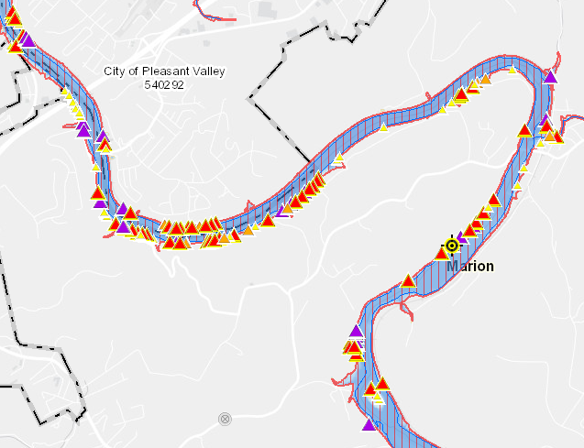
Building Damage Loss Estimate:
Purple triangle symbol indicates Substantial Damage of Structure > 50%

New River (Fayette-Raleigh County Border) Zone A Cluster
Location 1: https://www.mapwv.gov/flood/map/?wkid=102100&x=-9026921&y=4558340&l=8&v=2
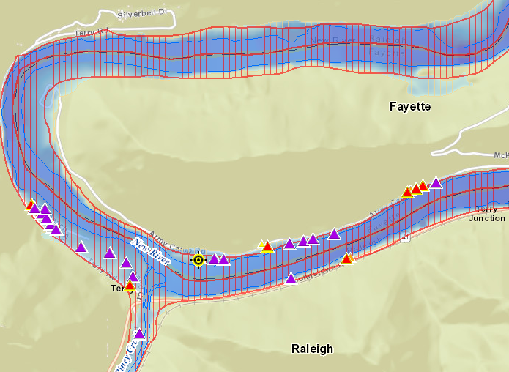

Location 2: https://www.mapwv.gov/flood/map/?wkid=102100&x=-9024733&y=4572211&l=9&v=2
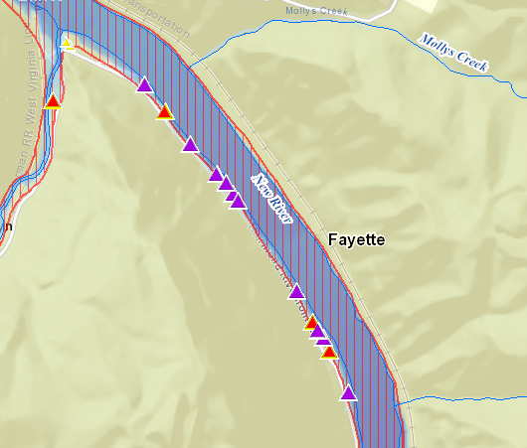
Building Damage Loss Estimate:
Purple triangle symbol indicates Substantial Damage of Structure > 50%

Cheat River (Tucker County). Extend detailed study of Cheat River in Preston County southward into Tucker County.
https://www.mapwv.gov/flood/map/?wkid=102100&x=-8874572&y=4754020&l=5&v=2

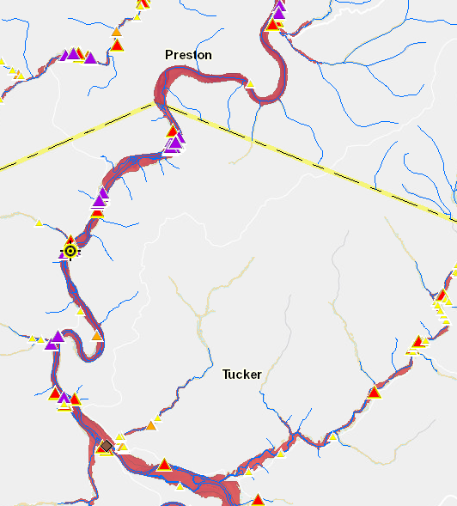
Building Damage Loss Estimate:
Purple triangle symbol indicates Substantial Damage of Structure > 50%

Gauley River (Nicholas-Fayette County Border) Zone A Cluster
https://www.mapwv.gov/flood/map/?wkid=102100&x=-9036214&y=4612356&l=7&v=2
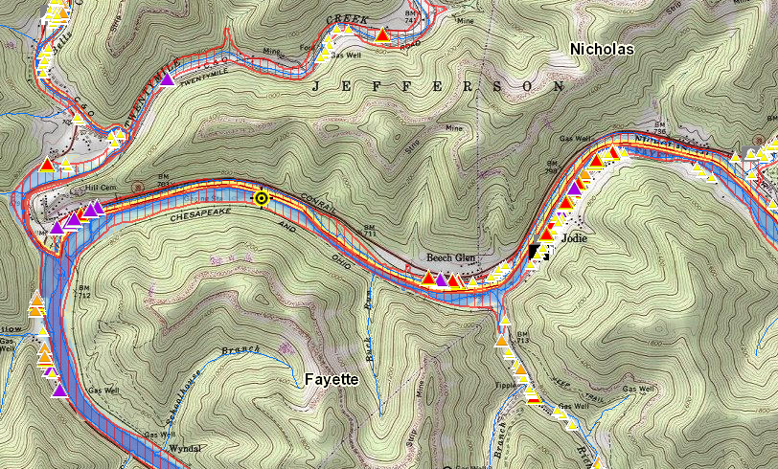

Building Damage Loss Estimate:
Purple triangle symbol indicates Substantial Damage of Structure > 50%

Patteson Creek (Mineral County) Zone A Cluster. Extend AE Zone northward
https://www.mapwv.gov/flood/map/?wkid=102100&x=-8782165&y=4772918&l=7&v=2

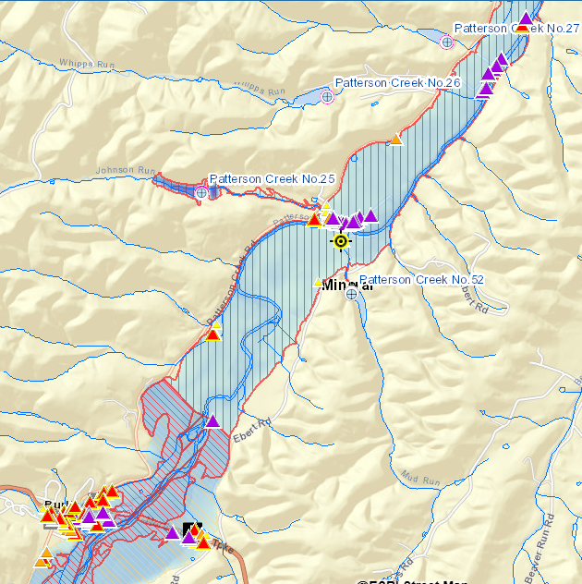
Building Damage Loss Estimate:
Purple triangle symbol indicates Substantial Damage of Structure > 50%

South Branch Potomac (Hampshire County) Zone A Cluster
Extend Detailed AE Zone south of Romney
https://www.mapwv.gov/flood/map/?wkid=102100&x=-8773513&y=4763240&l=6&v=2
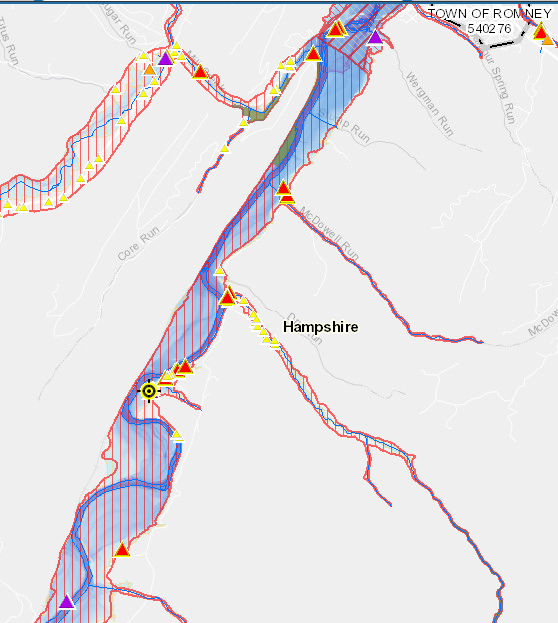
Building Damage Loss Estimate:
Purple triangle symbol indicates Substantial Damage of Structure > 50%

South Branch Potomac Zone A Cluster
Location 2: Hardy County (north of Moorefield)
https://www.mapwv.gov/flood/map/?wkid=102100&x=-8785721&y=4741525&l=7&v=2
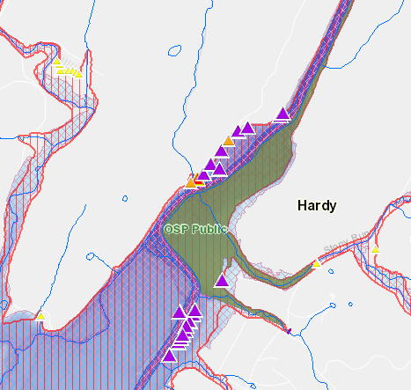
Building Damage Loss Estimate:
Purple triangle symbol indicates Substantial Damage of Structure > 50%
South Fork of the South Branch Potomac River (Hardy County) Zone A Cluster. Unfinished Draft NFHL study south of Moorefield because of certification of levees.
https://www.mapwv.gov/flood/map/?wkid=102100&x=-8790188&y=4721848&l=8&v=2
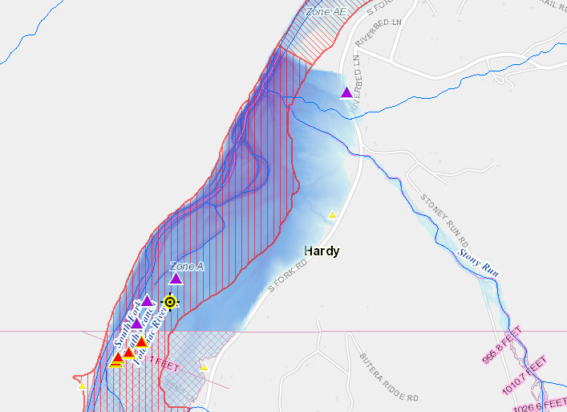
Building Damage Loss Estimate:
Purple triangle symbol indicates Substantial Damage of Structure > 50%

Trace Creek (Mingo County) Zone A Cluster
https://www.mapwv.gov/flood/map/?wkid=102100&x=-9148646&y=4547355&l=9&v=2
Google Street View: https://goo.gl/maps/6chE1k5XsTFLyg22A
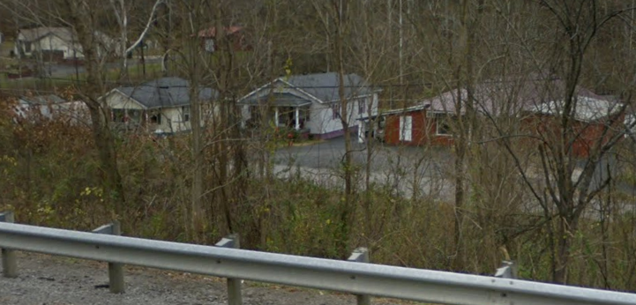
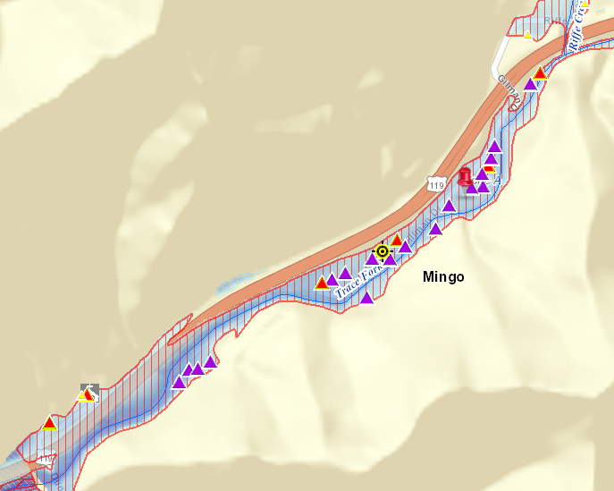
Building Damage Loss Estimate:
Purple triangle symbol indicates Substantial Damage of Structure > 50%

Fishing Creek (Pine Grove, Wetzel County) Zone A Cluster
https://www.mapwv.gov/flood/map/?wkid=102100&x=-8981728&y=4802636&l=9&v=2
Google Street View: https://goo.gl/maps/V9FgQH5bWcD9LQCZ6
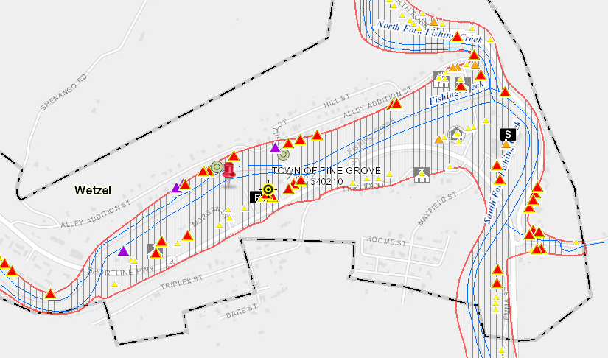
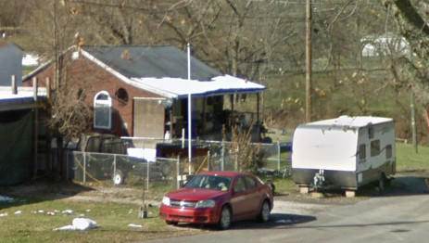

Shavers Fork (Randolph County) Zone A Cluster
https://www.mapwv.gov/flood/map/?wkid=102100&x=-8875471&y=4708853&l=7&v=2
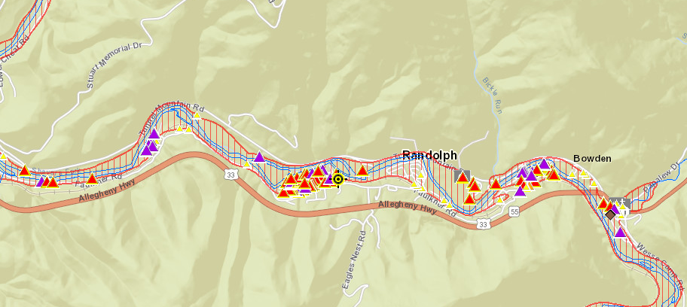
Building Damage Loss Estimate:
Purple triangle symbol indicates Substantial Damage of Structure > 50%

Jacobs Fork (McDowell County) Zone A Cluster
https://www.mapwv.gov/flood/map/?wkid=102100&x=-9085812&y=4476043&l=9&v=2
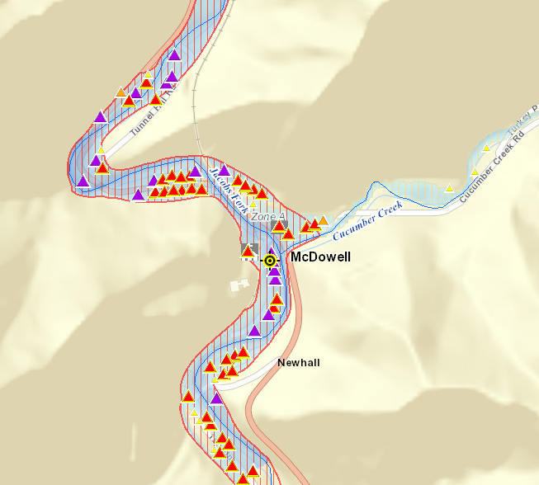
Building Damage Loss Estimate:
Purple triangle symbol indicates Substantial Damage of Structure > 50%

Dry Fork (McDowell County) Zone A Cluster
https://www.mapwv.gov/flood/map/?wkid=102100&x=-9090459&y=4476268&l=9&v=2
Google Street View: https://goo.gl/maps/vMRBvDh14TeA1YXEA
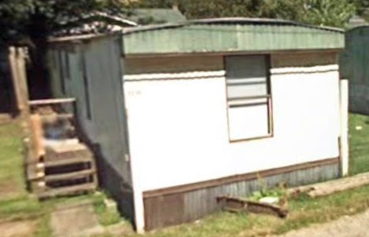
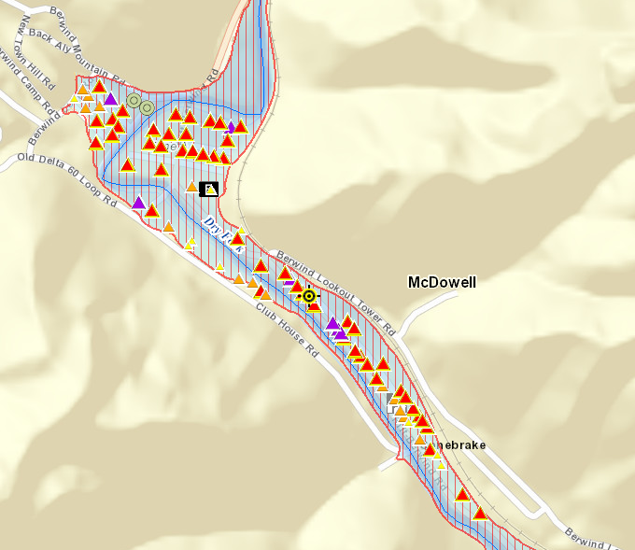
West Fork (Boone County) Zone A Cluster
https://www.mapwv.gov/flood/map/?wkid=102100&x=-9094902&y=4575960&l=9&v=2
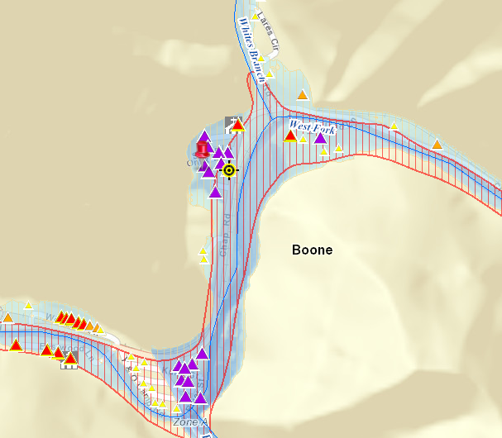
Building Damage Loss Estimate:
Purple triangle symbol indicates Substantial Damage of Structure > 50%

Cheat Lake (Monongalia County) Zone A Cluster. Expensive homes and businesses surrounding Cheat Lake backwater showing risk in Effective/Advisory A flood zones. Flood source is the Cheat River.
Location 1: https://mapwv.gov/flood/map/?wkid=102100&x=-8888987&y=4816745&l=9&v=2
Google Picture: https://goo.gl/maps/gJLfo8dse7aqBNRJ6
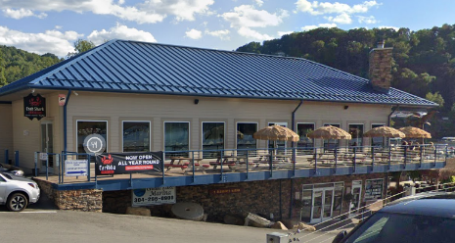
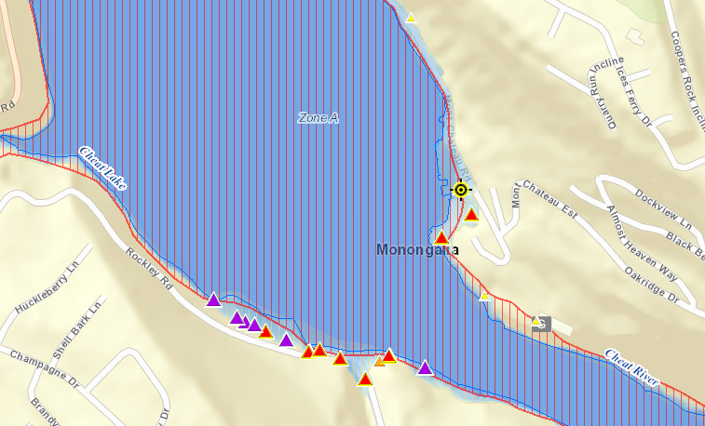
Building Damage Loss Estimate:
Purple triangle symbol indicates Substantial Damage of Structure > 50%

Cheat Lake (Monongalia County) Zone A Cluster. Structure in backwater of Lake Lynn Dam.
Location 2: https://mapwv.gov/flood/map/?wkid=102100&x=-8889823&y=4819241&l=10&v=2
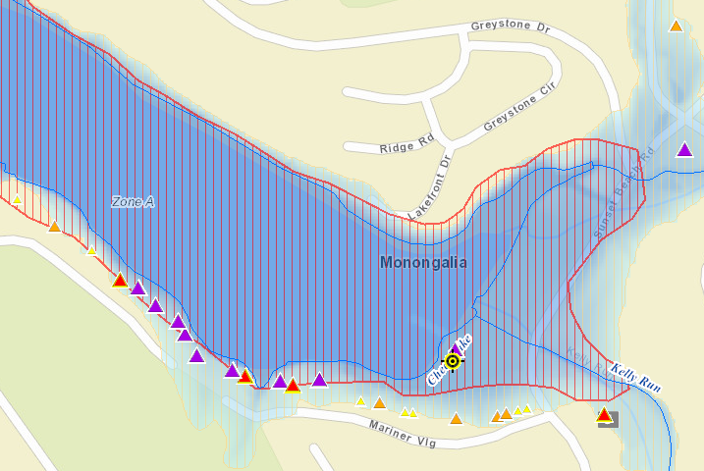
Beech Fork Lake (Wayne County). High water flood depth in the A Zone backwater of Beech Fork Lake Dam for high-valued structure in State Park.
https://mapwv.gov/flood/map/?wkid=102100&x=-9166766&y=4623020&l=9&v=2

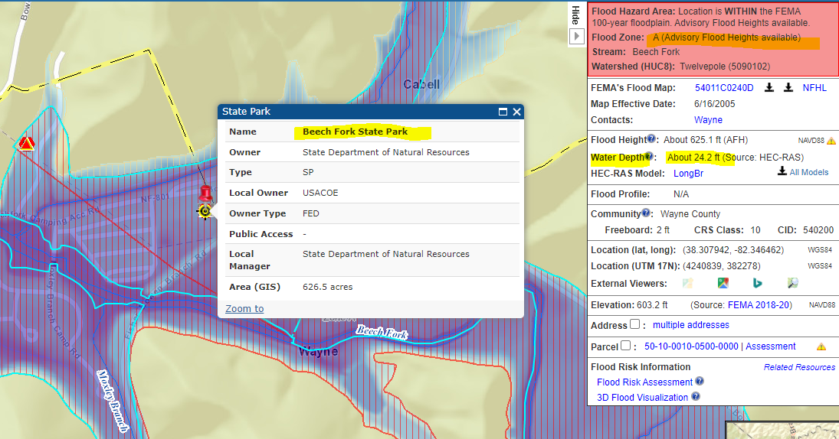

Highest Building Flood Depth for Approximate A Zone Rivers/Streams. Sorted on building flood depth. Click on Flood Tool map link to view location.

River/Stream Name | Flood Depth Value (ft.) | Web Link | County | Flood Depth Source | Hazard Occupancy Code | Building Exposure ($) | Notes
Shenandoah River | 33.0 | FT | JEFFERSON COUNTY | HEC-RAS | COM8 | 532,300
South Branch Potomac | 28.5 | FT | HARDY COUNTY | HEC-RAS | RES2 | 1,710 | Low value. May not be a primary structure
Gauley River | 24.3 | FT | FAYETTE COUNTY | HEC-RAS | RES1 | 9,000 | Vacant building? Major building value drop from 2016 flood. See Assessment History.
Beech Fork | 24.2 | FT | WAYNE COUNTY | HEC-RAS | GOV1 | 496,266 | Mapping issue?
New River | 20.6 | FT | FAYETTE COUNTY | HEC-RAS | RES1 | 18,100
Cedar Run | 20.0 | FT | JACKSON COUNTY | HAZUS | RES1 | 31,700 | Mapping Issue (Hazus Depth Grid removed)
Tygart Valley River | 20.0 | FT | TAYLOR COUNTY | HEC-RAS | GOV1 | 35,000 | Pumping Station?
South Fork of the South Branch Potomac River | 20.0 | FT | HARDY COUNTY | HEC-RAS | RES1 | 34,500 | Cabin (elevated?)
Lower Right Fork | 19.5 | FT | WAYNE COUNTY | HEC-RAS | RES1 | 7,700
Cheat River | 19.3 | FT | TUCKER COUNTY | HEC-RAS | RES2 | 13,000
Trace Fork | 18.3 | FT | MINGO COUNTY | HEC-RAS | RES1 | 106,100
Pole Run | 18.0 | FT | JACKSON COUNTY | HAZUS | RES1 | 46,100 | Mapping Issue (Hazus Depth Grid removed)
Hughes River | 18.0 | FT | WIRT COUNTY | HAZUS | RES1 | 33,400 | Elevated?
Potomac River | 17.8 | FT | JEFFERSON COUNTY | HEC-RAS | RES1 | 59,600
Coles Run | 17.7 | FT | MONONGALIA COUNTY | HEC-RAS | COM8 | 305,810
East Fork Twelvepole Creek | 17.5 | FT | WAYNE COUNTY | HEC-RAS | RES2 | 12,000 | Inhabitable?
Sandy Creek | 17.4 | FT | TAYLOR COUNTY | HEC-RAS | RES1 | 216,600
Crooked Creek | 17.1 | FT | KANAWHA COUNTY | HEC-RAS | RES1 | 91,400 | https://goo.gl/maps/ntR9DvwtEHnhcgDJ6
Little Otter Creek | 17.0 | FT | BRAXTON COUNTY | HAZUS | RES1 | 58,500 | Hazus depth grid mapping issue
Hawes Run | 17.0 | FT | PENDLETON COUNTY | HEC-RAS | RES1 | 158,100
Cacapon River | 16.4 | FT | HAMPSHIRE COUNTY | HEC-RAS | RES1 | 42,000
Middle Fork River | 16.0 | FT | UPSHUR COUNTY | HAZUS | RES2 | 52,100 | Carport. Hazus depth grid
Laurel Run | 15.9 | FT | RITCHIE COUNTY | HEC-RAS | RES1 | 1,400 | Low value. May not be a primary structure.
Lynn Creek | 15.6 | FT | WAYNE COUNTY | HEC-RAS | RES1 | 31,700
Buckhannon River | 15.4 | FT | BARBOUR COUNTY | HEC-RAS | REL1 | 118,920
South Fork Hughes River | 15.2 | FT | RITCHIE COUNTY | HEC-RAS | RES2 | 7,200 | Carport
Turkey Run | 15.0 | FT | JACKSON COUNTY | HAZUS | RES1 | 82,500 | Hazus depth grid mapping issue
Greenbrier River (Lower Reach) | 15.0 | FT | POCAHONTAS COUNTY | HAZUS | RES1 | 76,100 | Farm

