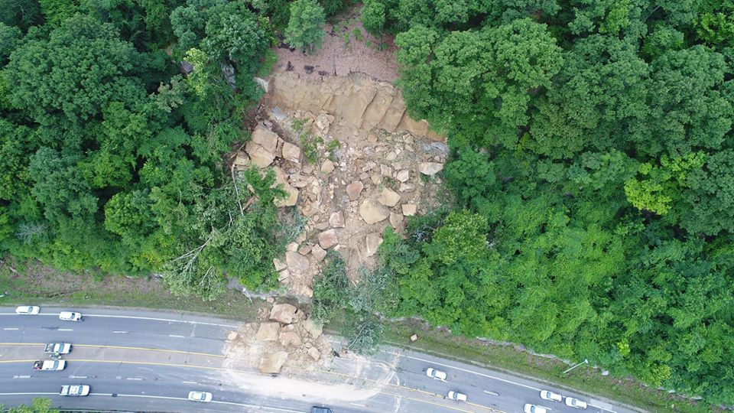
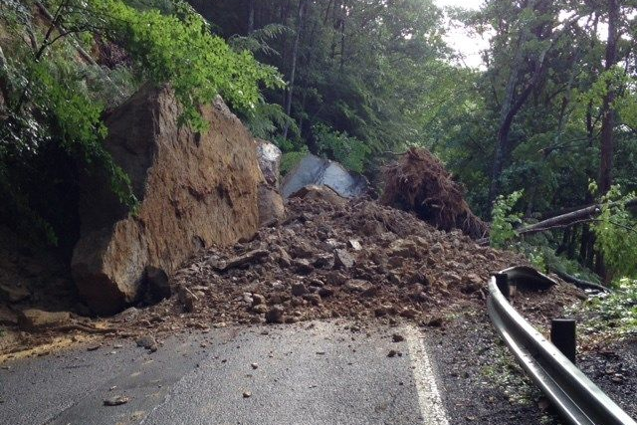
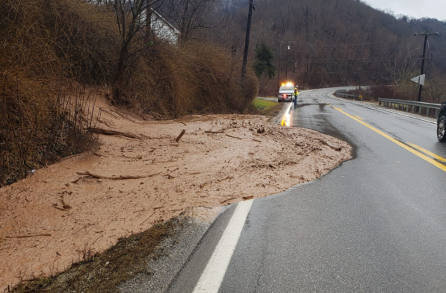
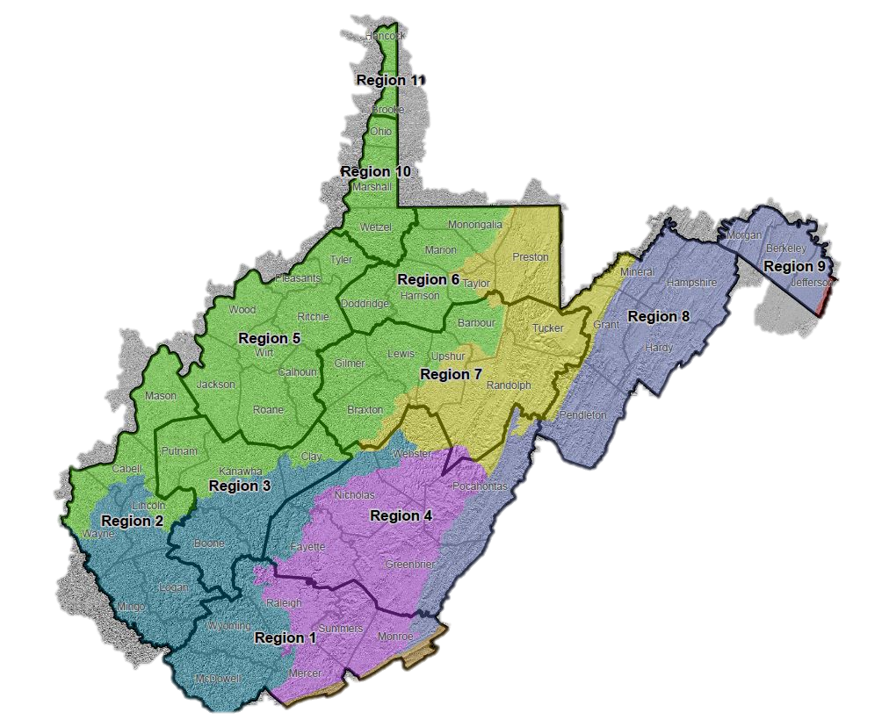

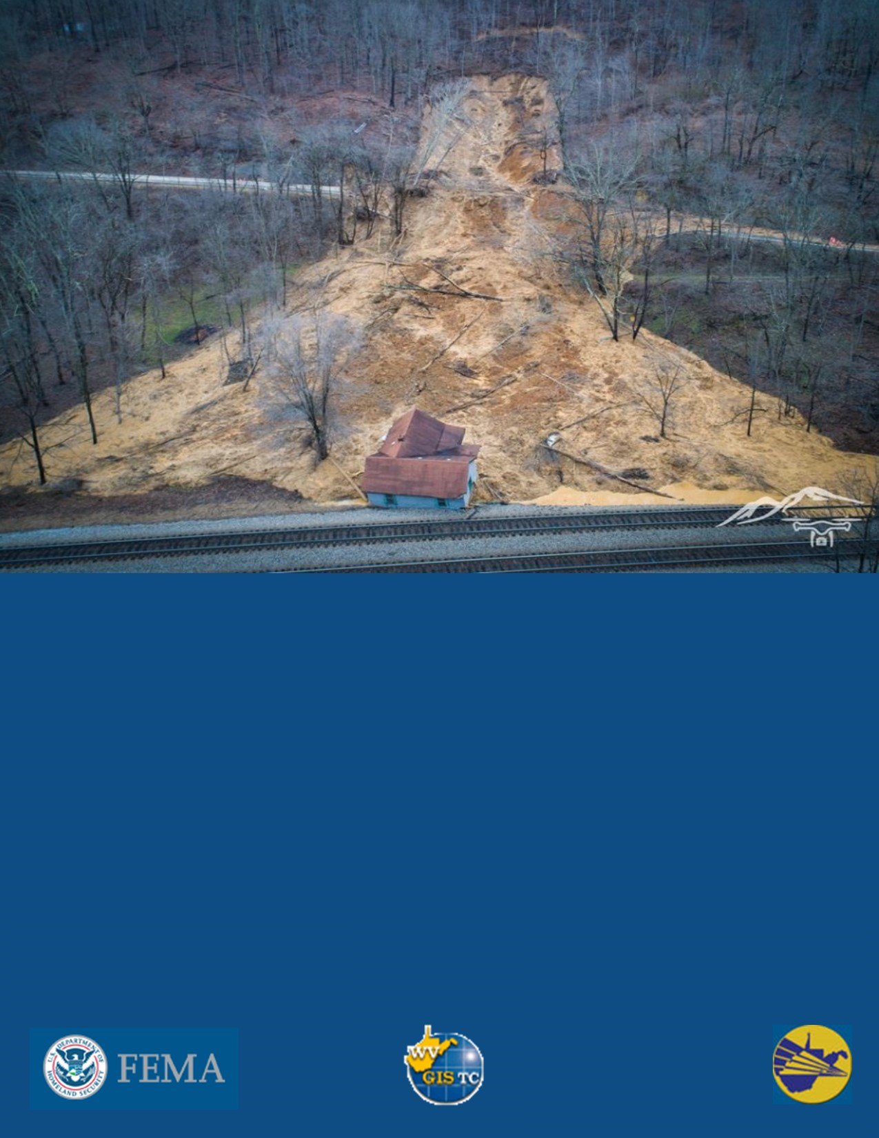


April 21, 2022

In support of FEMA HMGP Project
West Virginia Landslide Risk Assessment
Table of Contents
Executive Summary 2
Key Takeaways 4
1.0 Introduction 6
2.0 About Landslide Risk 6
2.1 Calculating Landslide Risk 7
2.2 Sources of Data for Landslide Risk Assessments 7
3.0 Landslide Susceptibility Modeling 9
3.1 Major Land Resource Areas 10
3.1.1 Central Allegheny Plateau MLRA 12
3.1.2 Cumberland Plateau and Mountains MLRA 14
3.1.3 Eastern Allegheny Plateau and Mountains (North) MLRA 15
3.1.4 Eastern Allegheny Plateau and Mountains (South) MLRA 16
3.1.5 Northern Appalachian Ridges and Valleys MLRA 17
4.0 Risk Assessment Data 19
5.0 Landslide Risk Analysis 19
5.1 Road Risk Analysis 19
5.1.1 Results 19
5.2 Structure/Parcel Risk Analysis 23
5.2.1 Results 23
5.3 Essential Facilities Risk Analysis 29
5.3.1 Results 29
5.4 Total Area Risk Analysis 32
5.4.1 Results 32
6.0 Limitations and Expert Consultation 34
7.0 Outreach Materials 35

Executive Summary
The West Virginia Emergency Management Division (WVEMD), Department of Homeland Security (DHS), and Federal Emergency Management Agency (FEMA) have facilitated landslide susceptibility studies and community-based risk assessments in support of local and state hazard mitigation plans. Landslide susceptibility was modeled using a random forest machine learning method. The model used LiDAR-identified landslide locations, topography, soil type, and proximity to roads and streams among many input variables to produce landslide susceptibility grids. Overall, 65,086 landslide points were identified using LiDAR in the state. Risk assessment was performed at the sub-county scale and includes results on roads, structures/parcels, essential facilities, and total area. This report summarizes risk assessment results by West Virginia Planning and Development Council regions. Results can be integrated into hazard mitigation plans to enhance resilience and protect communities from landslide hazards.
This landslide risk report provides non-regulatory landslide risk information to help local and state officials, planners, emergency managers, and stakeholders to better understand their landslide risk, take steps to mitigate those risks, and communicate those risks to citizens and businesses.
Roads, parcels, and essential facilities were analyzed for landslide susceptibility and risk.
Road risk analysis – Statewide, 11% of total road miles are located in high/medium landslide susceptibility areas. Region 7 ranks 1st for total at-risk road miles, with almost 794 miles in high/medium landslide susceptibility areas, while Region 11 ranks last with about 44 miles. Region 1 has about 556 miles, Region 2 has almost 340 miles, Region 3 has about 318 miles, Region 4 has almost 476 miles, Region 5 has almost 600 miles, Region 6 has about 697 miles, Region 8 has about 247 miles, Region 9 has almost 47 miles, and Region 10 has about 228 miles of road prone to high/medium risk for landslides.
Structure/Parcel analysis – Statewide, 4% of total primary structures/parcels are in high/medium landslide susceptibility areas, representing 2% of the total appraisal value of structures in the state. Region 3 ranks 1st for total number of structures located in high/medium susceptibility areas, but Region 6 ranks 1st for total replacement cost of structures in high/medium susceptibility areas. Region 11 ranks last in both categories. Region 1 has a total of 3,489 primary structures with a total appraisal value of $76,729,607 that are in high/medium landslide susceptibility areas. Region 2 has 3,130 primary structures with an appraisal value of $95,832,732; Region 3 has 6,956 primary structures with an appraisal value of $455,472,095; Region 4 has 1,301 primary structures with an appraisal value of $104,555,980; Region 5 has 1,476 primary structures with an appraisal value of $49,211,106; Region 6 has 5,805 primary structures with an appraisal value of $725,657,563; Region 7 has 2,327 primary structures with an appraisal value of $80,007,169; Region 8 has 1,597 primary structures with an appraisal value of $111,771,975; Region 9 has 1,195 primary structures with an appraisal value of $142,031,474; Region 10 has 1,650 primary structures with an appraisal value of $119,190,690; and Region 11 has 692 primary structures with an appraisal value of $18,932,281 in high/medium susceptibility areas.
Essential Facilities analysis – Statewide, 1% of essential facilities are located in high/medium landslide susceptibility areas, representing 4% of the total appraisal value of essential facilities in the state. Region 6 ranks 1st for total number of at-risk essential facilities and total replacement cost of at-risk facilities, with 4 facilities worth $236,413,800 located in high/medium susceptibility areas. Region 4, Region 7, Region 8, and Region 11 have no essential facilities in high/medium susceptibility areas. Region 1 has 3 essential facilities with a total appraisal value of $1,125,700 in high/medium susceptibility areas. Region 2 has 3 essential facilities with a total appraisal value of $1,371,400; Region 3 has 1 essential facility with an appraisal value of $554,100; Region 5 has 1 essential facility with an appraisal value of $0; Region 9 has 1 essential facility with an appraisal value of $1,951,400; and Region 10 has 1 essential facility with an appraisal value of $15,900 in high/medium susceptibility areas.
Total Area analysis – Statewide, 53% of total land area is classified as having high/medium landslide susceptibility. Region 8 ranks 1st in the area analysis, with about 61% of total land area classified as high/medium susceptibility for landslides, while Region 9 ranks last, with about 20% of total area classified as high/medium susceptibility. In Region 1, about 56% of total land area is classified as high/medium risk for landslides. Region 2 has about 59%; Region 3 has about 59%; Region 4 has almost 60%; Region 5 has about 46%; Region 6 has almost 47%; Region 7 has about 51%; Region 10 has about 37%; and Region 11 has about 29% of total area classified as high/medium risk for landslides.
Region Rankings - The table below presents the Region rankings for each analysis category. Region 11 consistently ranks last in the different road and structure categories, suggesting that the relative risk to humans and related infrastructure is lowest in this Region. Region 6 ranks 1st or 2nd in all of the road and structure categories, suggesting that the relative risk to humans and related infrastructure is highest in this Region.
 | REGION RANKINGS
Region | Road Miles in High/Medium Risk Areas | Number of Structures in High/Medium Risk Areas | Total Replacement Costs for Structures in High/Medium Risk Areas | Number of Essential Facilities in High/Medium Risk Areas | Total Replacement Costs for Essential Facilities in High/Medium Risk Areas | Percent of Land Area Classified as High/Medium Risk
1 | 4 | 3 | 9 | 3 | 3 | 5
2 | 6 | 4 | 7 | 2 | 4 | 4
3 | 7 | 1 | 2 | 3 | 5 | 3
4 | 5 | 9 | 6 | - | - | 2
5 | 3 | 8 | 10 | 3 | - | 8
6 | 2 | 2 | 1 | 1 | 1 | 7
7 | 1 | 5 | 8 | - | - | 6
8 | 8 | 7 | 5 | - | - | 1
9 | 10 | 10 | 3 | 3 | 2 | 11
10 | 9 | 6 | 4 | 3 | 6 | 9
11 | 11 | 11 | 11 | - | - | 10

This report is for informational purposes related to general emergency services planning. It has not been prepared for, and may not be suitable for legal, design, engineering, or site-preparation purposes. This report cannot substitute for site-specific investigations by qualified practitioners. Landslide risk is complex and continually changing. Although other existing studies or reports may provide more precise and comprehensive information, detailed original site investigations are normally an essential best practice for public safety, sustainability, and financial viability. These other data sources may give results that differ from those in this report.

Key Takeaways

Data Inventory
- A total of 159,247 landslide features were inventoried for the WV Landslide Risk Assessment.
- 66,151 landslide initiation points were mapped statewide using high resolution (1- or 2-m) LiDAR.
- 46,330 landslide polygons were digitized based on a 1976 study by the WVGES.
- 41,307 landslide polygons were digitized based on a USGS study completed between 1975 and 1985.
- Slides and slumps are the most common landslide types in West Virginia.
- Future work includes landslide mapping in areas where LiDAR coverage was incomplete; LiDAR for remaining areas was delivered by FEMA in December 2021.

Modeling
- Landslide susceptibility modeling was performed using a random forest machine learning method for various Major Land Resource Area to minimize heterogeneity in physiographic conditions that may influence landslide susceptibility.
- Slope, soil type, and geology are the main variables contributing to landslide risk. Generally, steeper slopes, unconsolidated soils, and less resistant rock units like shale and siltstone will increase landslide susceptibility.
- Anthropogenic disturbance contributes heavily to landslide risk.
- Future work includes re-running models after new LiDAR-based landslide mapping is complete.

Risk Assessment Results
- The WVGISTC Landslide Risk Assessment provides landslide risk information at the sub-county scale.
- Statewide, 4,346 road miles are located in high/medium landslide susceptibility areas; 29,618 primary structures/parcels worth $1,979,392,672 are in high/medium risk areas; 14 essential facilities worth $241,432,300 are in high/medium susceptibility areas; and 8,261,236 acres of land are classified as having high/medium landslide susceptibility.
- The majority of buildings located in high/medium landslide susceptibility areas are Residential structures. Residential buildings also account for the majority of total asset value in these areas.
- Kanawha and Monongalia counties rank 1st or 2nd for Residential structure counts, Residential asset values, and Commercial structure counts located in high/medium landslide susceptibility areas statewide. Harrison and Ohio counties rank 1st and 2nd for Commercial asset values.
- Fourteen essential facilities (police departments, fire departments, 911 centers, nursing homes, hospitals, and K-12 schools) are located in high/medium landslide susceptibility areas statewide.
- More than 50% of the total land area in Regions 1, 2, 3, 4, 7, and 8 is classified as having high/medium landslide susceptibility.
- Relative risk to humans and related infrastructure is highest in Region 6, which ranks either 1st or 2nd in all five road and structure risk analysis categories.

Risk Assessment Limitations
- Rock fall susceptibility is not well represented by the landslide inventory because rock falls are unlikely to be caught on LiDAR surveys.
- High/medium susceptibility areas are based on the locations of landslide initiation points and may not encompass the full extent of area vulnerable to landslide damage.
- Missing or incorrect structure values may exist in the “Other” property class category and in Essential Facilities.

Communication
- The West Virginia Landslide Tool (http://mapwv.gov/landslide) is an interactive landslide web mapping application that displays landslide incidence data and modeling results.
- Educational brochures were developed to provide general information about identifying signs of slope instability and mitigation measures that may help reduce landslide risk at the community and individual property levels.
- Landslide Susceptibility Maps for all 55 counties can be viewed and downloaded here.
- Story Maps have been developed to discuss the causes of landslides in WV and to explain the 1976 landslide risk assessment performed by the WV Geological and Economic Survey.
- Regional Landslide Reports for all 11 Planning and Development Council Regions with landslide risk assessment results presented at the sub-county level can be viewed and downloaded here.
- Site-specific evaluations for landslide susceptibility can only be provided by performing detailed geotechnical studies, including bedrock and soil analyses, core description, physical testing, and slope-stability analyses.

1.0 Introduction
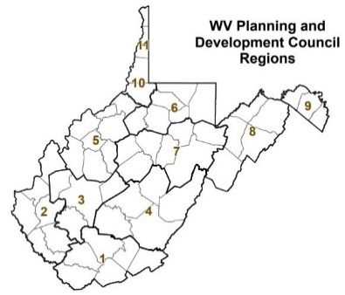
West Virginia has been divided into 11 regional and planning development councils to more effectively utilize funding, plan development, and aid cooperation. Landslide risk assessment has been performed for roads, structures/parcels, and essential facilities in all 11 regions. Roads provide critical service to communities. FEMA recently developed the community lifelines to enhance their effectiveness in disaster operations and better position themselves to respond to catastrophic incidents. Community lifelines cover seven sectors: Safety and Security; Food, Water, Shelter; Health and Medical; Energy; Communications; Transportation; and Hazardous Material. Roads are classified under Transportation in FEMA community lifelines.
Figure 1. Planning and Development Council regions in West Virginia
Landslide risk assessment has been performed to assess high and medium risk road segments and structures/parcels. This study is suitable for planning-level analysis. The risk analysis for roads should be used in conjunction with site-specific risk analysis performed by WV Department of Transportation. FEMA’s goal is to ensure that communities address natural hazards. A comprehensive plan should acknowledge all hazards that pose a risk and identify steps to avoid these hazards altogether or incrementally reduce a community’s exposure to them.

Community Engagement and Verification:
Review Landslide points identified using LiDAR data in the WV Landslide Tool. Add any missing major landslide points in the web application. A photo of the landslide incident can also be uploaded to the Landslide Tool. Review the susceptibility grid in WV Landslide or WV Flood Tool. Report any major discrepancies in high/medium landslide susceptible zones.

2.0 About Landslide Risk
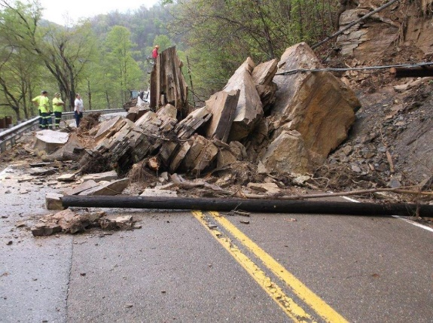
Landslides are naturally occurring phenomena that can happen almost everywhere in West Virginia, especially on steep slopes. In its most basic form, a landslide is the movement of soil or rock down a slope. Landslides become hazardous to people and property when they happen in an area where development has occurred, causing losses. Many landslides have relatively little impact on people or property, such as minor road damage, tree throws, or tilting of fences and walls. However, severe landslide damage can topple buildings, destroy roads, disrupt utilities, and cause critical injuries or death.
Figure 2. Landslides present a risk to critical infrastructure and public safety (Photo by WVDOT)

2.1 Calculating Landslide Risk
It is not enough to simply identify where landslides may occur. Knowing approximately where a landslide may occur is not the same as understanding the risk posed by landslides. The most common method for determining landslide risk, also referred to as vulnerability (the exposure of a given population to harmful effects from a hazard), is to identify the susceptibility of landslide occurrence and then determine the subsequent consequences. In other words:

Landslide Risk = Susceptibility x Consequences
Figure 3. The consequences of a landslide are often higher in populated areas due to resulting property damage and injury to citizens (Photo by WVDOT)

Where,
Susceptibility = the likelihood of occurrence
Consequences = the estimated impacts associated with the occurrence
An area’s landslide susceptibility is the likelihood that a landslide will occur. The likelihood of a landslide occurring can change based on physical, environmental, or contributing human factors. Factors affecting the likelihood of landslide occurrence in an area include seasonality, weather, climate, slope, human disturbance, and the existence of mitigation structures. The ability to assess the likelihood of landslide occurrence and the level of accuracy for that assessment are enhanced by landslide modeling methodology advancements and more widespread reporting or mapping of landslide occurrence.
The consequences of a landslide are the estimated impacts related to the landslide occurrence. Consequences relate to human activities within an area and how a landslide impacts natural and manmade infrastructures.

2.2 Sources of Data for Landslide Risk Assessments
To assess potential community losses or the consequences portion of the “risk equation”, the following data is typically collected for analysis and inclusion in a landslide risk project:
- Locations of past landslide occurrence
- Areas susceptible to landslide occurrence
- Information about local assets or resources at risk from landslide occurrence
- Information about where the risk is most severe
The following sources of incidence information were compiled for the statewide Landslide Risk Project and can be viewed on the West Virginia Landslide Tool. A detailed table showing landslide points and polygons collected in the state can be reviewed here. However, only high-resolution LiDAR-identified landslide incidence points were used for susceptibility modeling.

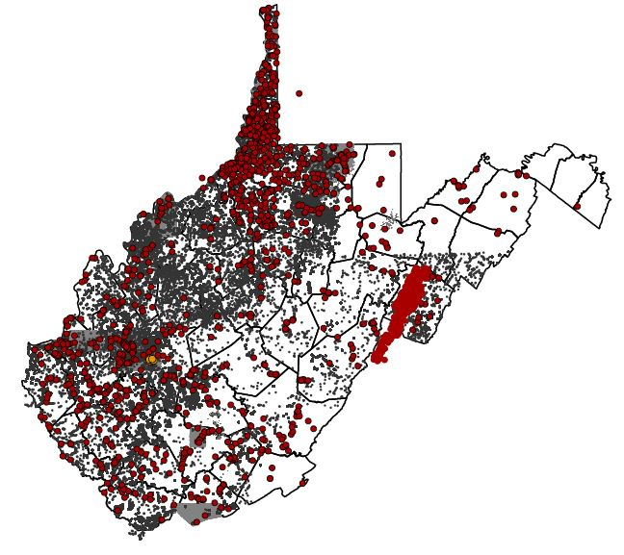
- WVGES Study - A study by West Virginia Geological and Economic Survey in the 1970s led to a report by Lessing et al. (1976) published as WVGES Environmental Geology Bulletin no. 15. The study mapped 46,330 landslide polygons in 39 7.5-minute quadrangles throughout West Virginia. The study was largely based on air photos taken in the 1960s and 1970s. The West Virginia GIS Technical Center (WVGISTC) digitized many of these polygons in 2018. Failures were categorized into three broad categories based on original map symbology: older landslides, recent landslides, and rock falls.
Figure 4. Historical landslides were compiled from several studies to create a comprehensive landslide dataset (Image adapted from the West Virginia Landslide Tool)
- USGS Study - The United States Geological Survey completed a multiple-author study between 1975 and 1985 that mapped various failures over 382 7.5-minute quadrangles. The WVGISTC digitized 41,307 “active or recently active” slope failure polygons in 2018.
- Landers and Smosna (1973) evaluated the damage caused by flooding and slope failure during a 1973 storm event in Kanawha City. From this study, ten landslide points were mapped in the Charleston area.
- Jacobson et al. (1993) mapped 3,571 slope failures near the Wills Mountain anticline to evaluate the effects of the November 1985 flood in the upper Potomac and Cheat basins.
- Kory Konsoer (2008) and Beau Downing (2008), as part of their M.S. theses, performed a landslide study in the Horseshoe Run watershed in Tucker County, WV. This research mapped 149 landslide polygons within the watershed and included a statistical analysis to quantitatively assess risk. In 2014, Yates and Kite created a landslide inventory in the Bluestone National Scenic River and vicinity, resulting in 12 landslide polygons. Following this analysis, an inventory of 212 polygons was created for the New River Gorge National River area by the same authors (Yates and Kite, 2016).
- West Virginia Department of Highways (WVDOH) database of landslide locations – The road landslide Inventory (2016) contains 1,406 points where landslides have occurred along roadways. Many of these incident points are no longer visible with LiDAR data, even at the 1-meter scale, either because they are small enough to escape visibility or because the WVDOT has repaired the damage.
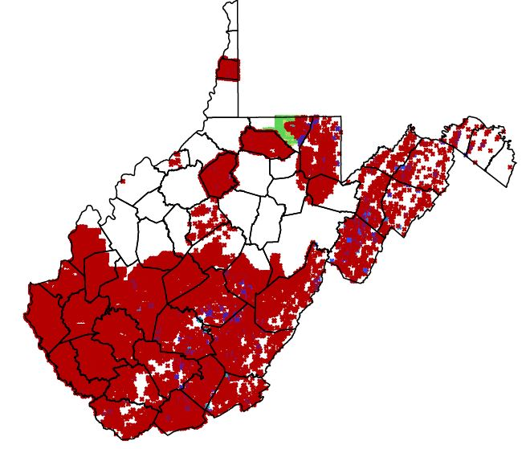
- High-resolution LiDAR-identified landslide incidence points - Landslide initiation points were identified and mapped specifically for this project on DEMs created from recent high resolution (1- or 2-m) LiDAR. Trained technicians placed points at the approximate center of the landslide headscarp and classified the failures into one of six general slope failure categories: slide, debris flow, lateral spread, multiple failures, fall, or undetermined. The details of classification can be found here. The nature of the West Virginia landscape and the LiDAR imagery limited mapping to landslides at least 33 feet wide. This approach undercounts small, shallow landslides and slope failures that human agents may have mitigated or removed. Rock falls and debris flows, major landslide risks along roadways, are considerably undercounted in this approach. Overall, 66,151 landslide points were identified in the state.
Figure 5. LiDAR-mapped landslide points are dependent upon the presence of 1- or 2-meter LiDAR data (Image from the West Virginia Landslide Tool)


3.0 Landslide Susceptibility Modeling
Figure 6. Simplified diagram showing machine learning process for generating landslide susceptibility grid
Landslide susceptibility has been generated as a raster grid dataset for the state. Much like the pixels in a photo or graphic, a grid is made up of square cells, where each grid cell stores a value representing a landslide susceptibility value. Using Random Forest machine learning methods, landslide incidence was modelled and rendered as a raster grid dataset. In machine learning, a model is generated by learning from examples. Figure 6 shows a simplified diagram of the machine learning model. Modeling starts with two basic variables:
1) Response variable you want to predict (example: landslide susceptibility) and,
2) Predictor variables you think might help you predict the new response variable (for example: prior locations of landslide, geology, soil, slope, etc.). Then, these predictor variables are run through a machine learning algorithm to train a model. This trained model is used for making predictions. In the end, a new prediction grid is generated (in this case, landslide susceptibility grid).
Following is the methodology for landslide susceptibility grids generated using the Random Forest machine learning model:
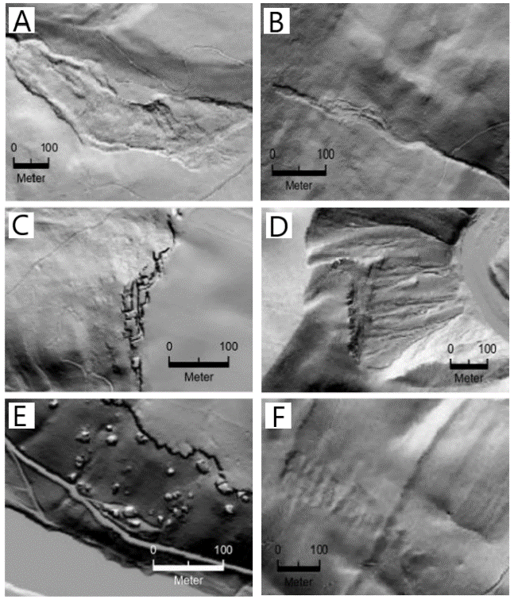
Landslide locations were mapped throughout West Virginia using light detection and ranging (LiDAR) elevation data products, including hillshades and slopeshades. Mapped failure types include slide, debris flow, lateral spread, multiple failures (when several failures were present in a small area, but were too small or close together to map separately), fall, and undetermined failure type (Figure 7). Site characteristics and terrain variables, such as slope, lithology, soil type, and distance to roads and streams, were extracted from the mapped landslide locations. Using a random forest machine learning algorithm, these variables were used as inputs to calculate a probabilistic landslide susceptibility grid. A majority of the mapped landslide locations were used to train the model, and the remaining locations were used to validate the model’s accuracy. The resulting grid cells were classified into low, medium, and high susceptibility areas using professional judgement and model statistics. On average, over 95% of known failure locations were found to occur within the modeled high susceptibility areas (Maxwell et al., 2020).
Figure 7. A) Slide B) Debris Flow C) Lateral Spread D) Multiple Failures E) Fall F) Undetermined

3.1 Major Land Resource Areas
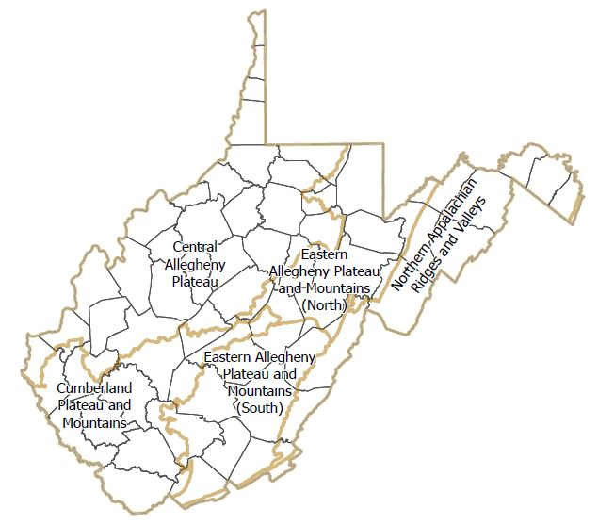
Landslide susceptibility modeling was performed at the Major Land Resource Area (MLRA) scale. MLRAs are geographic areas defined by the Natural Resources Conservation Service based upon shared characteristics, such as lithology, climate, soils, land uses, and water resources. There are four major MLRAs in West Virginia: the Central Allegheny Plateau, the Cumberland Plateau and Mountains, the Eastern Allegheny Plateau and Mountains, and the Northern Appalachian Ridges and Valleys. For the purposes of landslide susceptibility modeling, the Eastern Allegheny Plateau and Mountains MLRA was divided into a Northern and a Southern segment (see Figure 8). Additionally, tiny portions of the Southern Appalachian Ridges and Valleys MLRA and the Northern Blue Ridge MLRA were incorporated into the Northern Appalachian Ridges and Valleys MLRA because these areas were too small to model individually. Models were generated for each MLRA to minimize heterogeneity in physiographic conditions that may influence landslide susceptibility.
Figure 8. Major land resource areas in West Virginia
Many local factors contribute to landslides and their related losses. Contributing factors can be natural or human induced, but slope and local bedrock geology strongly influences county and community scale landslide incidence. Bedrock control on landslides is relatively consistent throughout individual MLRAs, which are geographically associated with Land Resource Units (LRUs).
Table 1 provides a summary of MLRAs present in each Planning and Development Council Region.
Table 1. Major Land Resource Areas present in each Planning and Development Council Region
Region | Primary MLRA | Secondary MLRA | Tertiary MLRA
1 | Eastern Allegheny Plateau and Mountains (South) | Cumberland Plateau and Mountains
2 | Cumberland Plateau and Mountains | Central Allegheny Plateau
3 | Cumberland Plateau and Mountains | Central Allegheny Plateau
4 | Eastern Allegheny Plateau and Mountains (North & South) | Northern Appalachian Ridges and Valleys | Cumberland Plateau and Mountains
5 | Central Allegheny Plateau
6 | Central Allegheny Plateau | Eastern Allegheny Plateau and Mountains (North)
7 | Eastern Allegheny Plateau and Mountains (North) | Central Allegheny Plateau | Eastern Allegheny Plateau and Mountains (South)
8 | Northern Appalachian Ridges and Valleys | Eastern Allegheny Plateau and Mountains (North)
9 | Northern Appalachian Ridges and Valleys
10 | Central Allegheny Plateau
11 | Central Allegheny Plateau

The following section presents MLRA characteristics and a summary of the critical underlying variables that affect landslide susceptibility. A detailed report on these variables can be found here. Slope, soil type, and geology are the main variables contributing to landslide risk in each MLRA. Generally, steeper slopes, unconsolidated soils, and less resistant rock units like shale and siltstone will increase landslide susceptibility. However, the details of these contributing factors can vary by MLRA. Table 2 presents a summary of landslide-related characteristics and contributing factors for each MLRA.

Table 2. Summary of MLRA Landslide Characteristics
MLRA | No. LiDAR-Mapped Landslides | Types of Landslides | Slope | Geology | Soil | Other Landslide Factors
Central Allegheny Plateau | Total: 30,915*  Per sq. mile:  3.6* | Most Common:  - Slides  - Slumps  Less Common:  - Rock falls  - Debris flows  - Lateral spreads | Majority of landslides on slopes greater than 14° | - Shale and siltstone dominated units most prone to landslides  - Conemaugh Group most susceptible | Acid clastic residuum and mining regolith are the most slide-prone materials | - Urban/rural development  - Timber harvesting
Cumberland Plateau and Mountains | Total: 20,714  Per sq. mile:  4.6 | Most Common:  - Slides  - Slumps  Less Common:  - Rock falls  - Debris flows  - Lateral spreads | Majority of landslides on slopes greater than 21° | - Shale and siltstone dominated units most prone to landslides  - Kanawha Formation most susceptible | Mining regolith is the most slide-prone material | - Unreclaimed mine sites  - Timber harvesting
Eastern Allegheny Plateau and Mountains (North) | Total:  2,228*  Per sq. mile:  0.66* | Most Common:  - Slides  - Slumps  Less Common:  - Rock falls  - Debris flows | Majority of landslides on slopes greater than 17° | - Shale and siltstone dominated units most prone to landslides  - Chemung and Mauch Chunk Groups most susceptible | Mining regolith and calcareous clastic residuum are the most slide-prone materials | - Urban/rural development  - Unreclaimed mine sites  - Timber harvesting
Eastern Allegheny Plateau and Mountains (South) | Total:  10,297  Per sq. mile:  2.8 | Most Common:  - Slides  - Slumps  Less Common:  - Rock falls  - Debris flows | Majority of landslides on slopes greater than 20° | - Shale and siltstone dominated units most prone to landslides  - Allegheny and Hinton Formations most susceptible | Mining regolith is the most slide-prone material | - Unreclaimed mine sites  - Timber harvesting
Northern Appalachian Ridges and Valleys | Total:  1,997  Per sq. mile:  0.48 | Most Common:  - Slides  - Slumps  Less Common:  - Rock falls  - Debris flows  - Lateral spreads | Majority of landslides on slopes greater than 20° | - Sandstone and shale dominated units most prone to landslides  - McKenzie Fm. and Clinton Group most susceptible | Acid clastic residuum is the most slide-prone material | - Limestone quarries  - Timber harvesting
*Underrepresented due to incomplete LiDAR coverage

3.1.1 Central Allegheny Plateau MLRA
Landscape Characteristics
The Central Allegheny Plateau is an extensive MLRA situated in an area dominated by rugged topography, nearly flat-lying clastic sedimentary bedrock (siltstone, shale, and sandstone), and well-drained soils formed in residuum and colluvium. River valleys have significant alluvial deposits ranging from coarse gravel in steep upland river channels to fine silt and clay on broad low-gradient river bottoms. Results of LiDAR-based mapping suggest landslide abundance is greater in the Central Allegheny Plateau than in any other MLRA within West Virginia.
Landslide Characteristics and Contributing Factors
Slides and slumps are the most common landslide types in the Central Allegheny Plateau, as is the case for all MLRAs in West Virginia. They tend to develop when soil moisture and pore pressure are highest. They are most problematic after prolonged wet seasons, particularly in late winter and early spring when soils are saturated and ground-water tables usually are high throughout the region. Debris flows can initiate as slumps or slides in residuum (material weathered in place or nearly in place) or colluvium (material transported some distance by gravitational processes) on upper slopes, but may run long distances downslope from their source. The most frequent cause of Appalachian debris flows is heavy rain associated with intense spring and early summer storms or late summer and early autumn remnants of tropical cyclones. Fortunately, Appalachian debris flows are infrequent, with recurrence intervals at the most vulnerable sites estimated to be hundreds or thousands of years. Rock fall failures are commonly reported in the MLRA, especially on disturbed slopes such as road cuts along transportation corridors and mine highwalls, but the scope of rock fall susceptibility is not well shown by this landslide inventory. Less common landslide types in the MLRA include multiple failures (tight clusters of small landslides and debris flows that tend to occur during debris flow events) and lateral spreads (clusters of large rock blocks that appear to move rarely).
Slope: Analysis of LiDAR-based landslide data from West Virginia reveals that slope steepness may be the most important control over where landslides develop, especially in steep hillslope hollows that allow subsurface moisture, surface-water runoff, and unconsolidated material to accumulate. The slopes on upland surfaces where slides (including slumps) and debris flows initiate are significantly steeper than most of the nearby landscape. Eighty percent of slides and slumps initiated on slopes between 17° to 39° and eighty percent of debris flows initiated on slopes between 14° to 40°.
Geology: Geology is a universally cited factor in landslide distribution. The influence of geology on landslides may be complex, indirect, and somewhat counter-intuitive. Bedrock units heavily dominated by sandstone, the hardest and most resistant rock type in the region, generally are responsible for the highest-elevation topography in the MLRA. The inherent strength of thick sandstones makes them more stable than other rocks at any given slope angle. Across the Central Allegheny Plateau, weaker bedrock units containing significant amounts of shale and siltstone tend to be more deeply incised and more prone to failure than resistant units, even if the weaker units contain some sandstone beds.
Soil: Analysis of mapped landslides and the digital NRCS Soil Survey Geographic database (SSURGO) indicate soil parent material and drainage class correlate with landslide susceptibility in the Central Allegheny Plateau. Almost 98 percent of slides were mapped in residuum developed from clastic sedimentary bedrock or in colluvium, parent materials that cover almost 87 percent of the MLRA. Acid clastic residuum, in particular, has a mapped landslide density that is significantly greater than the average for the entire MLRA. However, mining regolith is the most slide-prone parent material. Most of the mining regolith slides mapped in this MLRA lie within the Conemaugh and Monongahela group bedrock units, most likely associated with materials produced by extensive mining of the Pittsburgh Coal, which lies immediately above the contact boundary between the two groups.
Soil polygons assigned as “well drained” cover over 90 percent of mapped portions of the Central Allegheny Plateau MLRA, account for almost 97 percent of slide initiation points, and have the highest slide susceptibility. This drainage class commonly occurs on steep slopes, so its over-representation in number of slides may reflect a key role of slope as a control of both soil drainage and landslide initiation.
Other Landslide Factors: Although many factors influencing slope stability are universal, some aspects of slope stability in the Central Allegheny Plateau differ from other areas in West Virginia. Anthropogenic disturbance is significant, especially in urban areas and landscapes underlain by or adjacent to coal-bearing bedrock. Urban and rural development has long been known to enhance landslide susceptibility in West Virginia. Hillslopes underlain by weak bedrock or soil may obtain a significant fraction of their shear strength from tree roots, so intensive clearing for timber harvesting or real estate development may lessen slope strength. Ill-designed or poorly constructed roadways, commercial sites, and housing developments may lead to surface drainage disruptions that cause unprecedented soil saturation and abnormal slope destabilization. The importance of good engineering design, based on slope-stability site analysis by professional geologists and certified civil engineers, cannot be over-emphasized. Neither can the importance of long-term monitoring and maintenance of constructed drainage and retaining structures.

3.1.2 Cumberland Plateau and Mountains MLRA
Landscape Characteristics
The Cumberland Plateau and Mountains MLRA is dominated by rugged topography, relatively flat-lying clastic sedimentary bedrock (sandstone, siltstone, claystone, shale, coal), and well-drained soils developed in colluvium, mining regolith, and residuum. Limestone occurs only in geologic units in the lower and upper parts of the stratigraphic column. Mining regolith is widely distributed and locally thick in the coal-bearing geologic settings that encompass over 90 percent of the area. LiDAR-based mapping reveals the abundance of landslides in the Cumberland Plateau and Mountains is virtually the same as in the Eastern Allegheny Plateau and Mountains (South), but over five times more abundant than in the Appalachian Ridges and Valleys.
Landslide Characteristics and Contributing Factors
As with all MLRAs in West Virginia, slides and slumps are the most common landslide types in the Cumberland Plateau and Mountains, often developing after prolonged wet seasons when soil moisture and pore pressure are highest. Rock fall failures are commonly reported in the MLRA, especially on disturbed slopes such as rock cuts along transportation corridors and mine highwalls. Less common landslides types include multiple failures and debris flows. Only one lateral spread was identified from LiDAR-based DEMs from the Cumberland Plateau and Mountains.
Slope: About 90 percent of mapped slope failures in the MLRA occurred on slopes greater than 21 degrees.
Geology: Bedrock units heavily dominated by sandstone, the hardest and most resistant rock type in the region, are generally responsible for the highest-elevation topography in the area and numerous cliffs along major river valleys. Away from river valleys, upland landscapes associated with heavily sandstone-dominated units tend to be less rugged than landscapes dominated by weaker shale, claystone, or siltstone. On the almost ubiquitous steep slopes that extend across most of the Cumberland Plateau and Mountains, weaker bedrock units tend to be more deeply incised and more prone to failure than resistant sandstone units, even if the weak units contain some significant sandstone beds.
Soil: The two most common soil parent materials in the MLRA, colluvium and acid clastic residuum, have moderately high landslide susceptibility and cover 85 percent of the area. However, the highest density of mapped landslides occurs in mining regolith and disturbed areas. Young, unconsolidated parent materials, like mining regolith, have low inherent strength and may not have been in place long enough to reach equilibrium. Conversely, unless disturbed by human activities or exceptional natural events, colluvium and residuum have developed over thousands of years or more, providing more opportunity to adjust to conditions on the steep rugged landscape. The parent material data convey a clear message that human disturbance, especially coal mining, contributes heavily to landslide susceptibility.
Soil polygons assigned as “well drained” cover about 96 percent of the Cumberland Plateau and Mountains landscape and account for almost 99 percent of landslide initiation points. The overwhelming preponderance of well drained soils dominates the overall MLRA statistics, leaving other classes with such small areas and numbers of landslides that the validity of landslide statistics in these classes may not be robust.
Other Landslide Factors: Anthropogenic disturbance is particularly significant in landscapes underlain by coal-bearing bedrock. Unreclaimed mine high walls have local rock-fall susceptibility, but falls elsewhere in the area are most commonly associated with over-steepened road and railroad cuts. Forest products are part of the economy of most counties in the Cumberland Plateau and Mountains. Hillslopes underlain by weak bedrock or soil may obtain a significant fraction of their shear strength from tree roots, so intensive timber clearing may lessen slope strength for decades until new root systems develop. Ill-designed or poorly constructed haul roads and skidder trails may lead to surface drainage disruptions that causes unprecedented soil saturation and abnormal slope destabilization.

3.1.3 Eastern Allegheny Plateau and Mountains (North) MLRA
Landscape Characteristics
The northern segment of the Eastern Allegheny Plateau and Mountains MLRA is dominated by rugged topography, clastic sedimentary bedrock, and well-drained soils developed in residuum and colluvium. Over two-thirds of the MLRA in West Virginia is underlain by substantially folded bedrock with gently to steeply dipping beds at many locations, including much of the Cheat and Tygart Valley river basins and the Allegheny Front along the eastern border of the MLRA. Two non-coal bearing bedrock units have the highest landslide susceptibility, but unconsolidated material produced by mining is locally significant and associated with landslides.
Landslide Characteristics and Contributing Factors
Slides and slumps are the most common landslide types in the MLRA, often developing after prolonged wet seasons when soil moisture and pore pressure are highest. Rock fall failures are commonly reported, especially on disturbed slopes such as rock cuts along transportation corridors and mine highwalls. Less common landslides types include multiple failures and debris flows.
Slope: About 80 percent of slides and slumps initiated on slopes of 21° to 40°, while about 80 percent of debris flows initiated on slopes of 17° to 46°.
Geology: Bedrock units heavily dominated by sandstone are generally responsible for the highest-elevation topography in the area and cliffs along waterways. Except for steep narrow canyons, topography formed on sandstone-dominated units tends to be less rugged than landscapes dominated by weaker shale or siltstone. On the steep uplands across the MLRA, weaker bedrock units, like shale and siltstone, tend to be more deeply incised and more prone to failure than resistant sandstone units, even where the weaker units contain some significant sandstone beds.
Soil: Over 90 percent of landslides were mapped in either residuum developed from acid clastic sedimentary bedrock or from colluvium, two units that cover almost 90 percent of the MLRA. However, the highest mapped landslide densities occur in mining regolith and calcareous clastic residuum.
Soil polygons assigned as “well drained” cover about 67 percent of the MLRA, account for almost 82 percent of landslide initiation points, and have the second highest landslide susceptibility. “Excessively drained” soils cover 10 percent of the area, contain the second highest number of landslides, and have the highest landslide susceptibility of any class. Both of these drainage classes commonly occur on steep slopes, so their over-representation in landslides may reflect the important role of slope as a control of both soil drainage and landslide initiation.
Other Landslide Factors: Anthropogenic disturbance is significant in the MLRA, especially in landscapes underlain by coal-bearing bedrock. Unreclaimed mine high walls have local rock-fall susceptibility, but falls elsewhere in the area are most commonly associated with over-steepened road and railroad cuts. Forest products are part of the economy of most counties in the MLRA. Intensive timber clearing may lessen slope strength for decades until new root systems develop. Ill-designed or poorly constructed haul roads and skidder trails may lead to surface drainage disruptions, causing unprecedented soil saturation and abnormal slope destabilization. Urban, suburban, and rural development share many of the landslide issues characteristic of timber operations. Foundation excavations and inadequate retaining walls can contribute to slope failure on developed land, sometimes including farm land. The intensity of property development in the Northern Allegheny Mountains is increasing, so the importance of good engineering design, based on slope-stability site analysis by professional geologists and certified civil engineers, cannot be over-emphasized.

3.1.4 Eastern Allegheny Plateau and Mountains (South) MLRA
Landscape Characteristics
The southern portion of the Eastern Allegheny Plateau and Mountains MLRA is dominated by rugged topography, clastic sedimentary bedrock, and well-drained soils developed in residuum and colluvium. Unconsolidated material produced by mining is locally significant in coal-bearing settings. Mining landslides are widespread and abundant. LiDAR-based mapping reveals that landslides are over five times more abundant in the MLRA than in the Appalachian Ridges and Valleys, which lies to the east.
Landslide Characteristics and Contributing Factors
Slides and slumps are the most common landslide types in the MLRA, often developing after prolonged wet seasons when soil moisture and pore pressure are highest. Rock fall failures are commonly reported, especially on disturbed slopes such as rock cuts along transportation corridors and mine highwalls. Less common landslides types include multiple failures and debris flows. A few landslides could not be classified due to their unusual topographic features.
Slope: About 90 percent of mapped landslides occurred on slopes greater than 20 degrees.
Geology: Bedrock units heavily dominated by sandstone are generally responsible for the highest-elevation topography in the area and numerous cliffs along major river valleys. On the almost ubiquitous steep slopes that extend across most of the MLRA, weaker bedrock units, like shale and siltstone, tend to be more deeply incised and more prone to failure than resistant sandstone units, even if the weak units contain some significant sandstone beds.
Soil: Soils formed from acid clastic residuum, colluvium, and calcareous clastic residuum parent materials across the MLRA are highly prone to landslides. Collectively, these three parent materials cover almost 90 percent of the area, so they contribute significantly to the high regional landslide density. However, the mapped landslide density of mining regolith is nearly three times higher than the MLRA average. Previous studies in the New River Gorge identified many landslides associated with old unreclaimed coal strip mine benches and haul roads, but landslides have also occurred on reclaimed mines that postdate the 1977 Surface Mining Control and Reclamation Act.
Soil polygons assigned as “well drained” cover about 83 percent of the Southern Alleghenies landscape and account for almost 94 percent of landslide initiation points. However, the small sample of “somewhat excessively drained” soils has the highest landslide susceptibility, a trend consistent with the fact that excessively drained soils are common in mining regolith but uncommon in other soil parent materials. Both of these drainage classes commonly occur on steep slopes, so the over-representation of landslides in these two classes is correlated with the important role of slope as a control of both soil drainage and landslide initiation.
Other Landslide Factors: Anthropogenic disturbance is significant, especially in landscapes underlain by coal-bearing bedrock. Unreclaimed mine high walls have local rock-fall susceptibility, but falls elsewhere in the area are most commonly associated with over-steepened road and railroad cuts. Forest products are part of the economy of most counties in the MLRA. Intensive timber clearing may lessen slope strength for decades until new root systems develop. Poorly designed haul roads and skidder trails may lead to surface drainage disruptions, causing increased soil saturation and slope destabilization.

3.1.5 Northern Appalachian Ridges and Valleys MLRA
Landscape Characteristics
The Northern Appalachian Ridges and Valleys MLRA has very diverse topography, geology, and soils. It is an erosional landscape underlain by folded and faulted bedrock with varied resistance to weathering and erosion. These factors contribute to higher variability in landslide distribution and a wider variety of landslide types than in any other MLRA in West Virginia. This MLRA encompasses most of the gentle topography in the state, and LiDAR-based mapping reveals the MLRA has fewer landslides.

Landslide Characteristics and Contributing Factors
Slides and slumps are the most common landslide types in the MLRA, often developing after prolonged wet seasons when soil moisture and pore pressure are highest. Less common landslide types include multiple failures, debris flows, and lateral spreads.
Slope: Almost 90 percent of mapped landslides occurred on slopes greater than 20 degrees.
Geology: Shale is the primary rock type in geological units covering over 45 percent of the Ridges and Valleys MLRA, providing initiation sites for 51 percent of landslides. Siltstone, sandstone, and limestone are the primary rock types in about 1/6th of the MLRA, but sandstone units are more strongly associated with landslides. Mapped landslide density in sandstone-dominated units is 36 percent higher than the average for the entire MLRA. Shale unit landslide densities are 12 percent above the overall MLRA.
Soil: Over 75 percent of soils in the MLRA are developed predominantly in residuum parent material and over 90 percent of landslides are initiated in these residual soils. Acid clastic residuum, the most widespread parent material category, has significantly more landslides than would be expected based on the extent of this parent material.
Soil polygons assigned as “somewhat excessively drained” cover about 85 percent of the Ridges and Valleys landscape and account for almost 95 percent of landslide initiation points; this over-representation reflects the importance of slope to soil drainage class and landslide initiation.
Other Landslide Factors: Anthropogenic disturbance is locally significant but generally not as problematic as in more densely populated areas or coalfields farther west. Limestone quarries present local rock fall susceptibility, but elsewhere in the area, falls are most commonly associated with over-steepened road cuts, particularly where dipping bedrock layers have been undercut. Forest products are a major part of the economy of most counties in the MLRA. Intensive timber clearing may lessen slope strength for decades until new root systems develop. Poorly designed skidder trails and timber haul roads may lead to surface drainage disruptions, causing increased soil saturation and slope destabilization.

Landslide Susceptibility E-size maps for every county in West Virginia can be viewed here.

4.0 Risk Assessment Data
The following datasets have been used in the risk assessment study for roads and structures/parcels:
- Landslide susceptibility analyses using random forest machine learning algorithms and landslide occurrence locations (Maxwell et al., 2020)
- E-911 site address points inside the floodplain
- Parcel centroids for areas outside the floodplain
- Roads (accessed from WV DOH website)
- Essential Facilities

5.0 Landslide Risk Analysis

5.1 Road Risk Analysis
Road risk analysis provides an assessment of landslide risk along roads in West Virginia. This analysis is suitable only for planning level analysis and should be used in conjunction with site-specific risk analysis performed by WV Department of Transportation. This “big picture” perspective will benefit the planning of route improvements and lead to more effective landslide risk mitigation for West Virginia roads. The analysis classifies roads into high, medium, and low risk areas. The following methodology was used to assess landslide risk to roads in the state.
The statewide landslide susceptibility grid was classified as High (1-0.7), Medium (< 0.7-0.3), and Low (0.3-0) susceptibility. This raster grid was then converted to a vector feature class. Road data from WV Department of Transportation was used for analysis. Risk analysis was performed for Interstates, US Roads, State, and Other roads (county roads, N/A, state parks, and forests road, FANS, HARP, and Others). Municipal non-state roads, railroads, and trail features were not included in the analysis. Since the road feature class is a line, a buffer of four meters was created for the road feature class. A buffer was created to adequately capture the risk for the road feature class as most landslides initiate on the side slopes of roads. An intersection between the buffered road layer and the susceptibility feature class was performed to capture risk information for road segments that overlapped with high and medium susceptibility areas. Finally, the road layer was clipped using the buffer layer to identify high and medium risk road segments for each community.

5.1.1 Results
Roads were analyzed at two scales. An overview level analysis was performed on all of the roads without any distinction between road types to get the total risk to roads in each Planning Region. This result was used to rank Regions based on the total length of susceptible road segments. The second set of analyses contains susceptibility details relating to Interstates, US Roads, State Roads, and Others. Railroads and trails were not part of the analysis.
Table 3 shows the total miles of road in each Region that are prone to high/medium slope failure risk. The table also shows the rank of landslide susceptibility within the state. Statewide, 4,346 miles, or 11% of total road miles are at risk. The Regions most at risk, based on total road miles in high/medium susceptibility areas, are Region 7, which ranks 1st and Region 6, which ranks 2nd. The Regions with the lowest risk are Region 9 and Region 11, ranking 10th and 11th, respectively.
Table 3. Road length susceptible to High/Medium Risk of Landslide
Region | Roads Total (miles) | Roads Total (miles)- High/Medium Risk | Percent of Roads in High/Medium Risk Areas | Rank¹
1 | 4975.6 | 556.4 | 11.2% | 4
2 | 4471 | 339.6 | 7.6% | 6
3 | 3441.8 | 318.2 | 9.2% | 7
4 | 4148.6 | 475.6 | 11.5% | 5
5 | 5287.5 | 599.5 | 11.3% | 3
6 | 5227.2 | 696.7 | 13.3% | 2
7 | 5170.2 | 793.6 | 15.3% | 1
8 | 2835.4 | 247.1 | 8.7% | 8
9 | 1658.2 | 46.9 | 2.8% | 10
10 | 1591.9 | 228.3 | 14.3% | 9
11 | 479.4 | 44.2 | 9.2% | 11
¹Rank based on total road miles at risk
Table 4 identifies the county in each Region with the highest number of road miles in high/medium landslide risk areas. The table shows the percentage of at-risk roads within the county and also the percentage of roads at risk in the Region accounted for by its highest ranked county.
Table 4. Highest ranked county in each Region by road miles in High/Medium Susceptibility Areas
Region | County | Roads Total (miles) | Roads Total (miles)- High/Medium Risk | Percent of Roads in High/Medium Risk Areas in the County | Percent of Total Roads in High/Medium Risk Areas in the Region
1 | Summers | 633.4 | 150.1 | 23.7% | 27%
2 | Wayne | 999.3 | 103.8 | 10.4% | 31%
3 | Kanawha | 1725.1 | 152.5 | 8.8% | 48%
4 | Greenbrier | 1145.6 | 109.9 | 9.6% | 23%
5 | Roane | 903.2 | 123.5 | 13.7% | 21%
6 | Preston | 1312.3 | 172.8 | 13.2% | 25%
7 | Randolph | 998.9 | 181.1 | 18.1% | 23%
8 | Pendleton | 641.4 | 85.5 | 13.3% | 35%
9 | Morgan | 431.1 | 21.3 | 4.9% | 45%
10 | Wetzel | 644.2 | 105.1 | 16.3% | 46%
11 | Brooke | 244.9 | 22.9 | 9.4% | 52%

Table 5 shows the Top 10 counties in the state with the highest number of road miles in High/Medium susceptibility areas. Three of the Top 10 counties are in Region 7 and three are in Region 6, indicating a high risk to roads in these Regions.
Table 5. Top 10 counties statewide by road miles in High/Medium Susceptibility Areas
Region | County | Roads Total (miles) | Roads Total (miles)- High/Medium Risk | Percent of Roads in High/Medium Risk Areas
7 | Randolph | 998.9 | 181.1 | 18.1%
6 | Preston | 1312.3 | 172.8 | 13.2%
7 | Braxton | 896.2 | 165.7 | 18.5%
3 | Kanawha | 1725.1 | 152.5 | 8.8%
1 | Summers | 633.4 | 150.1 | 23.7%
1 | Mercer | 1127.7 | 138.1 | 12.2%
6 | Marion | 854.5 | 136.7 | 16.0%
6 | Monongalia | 1001 | 132 | 13.2%
7 | Tucker | 526.3 | 131.7 | 25.0%
5 | Roane | 903.2 | 123.5 | 13.7%

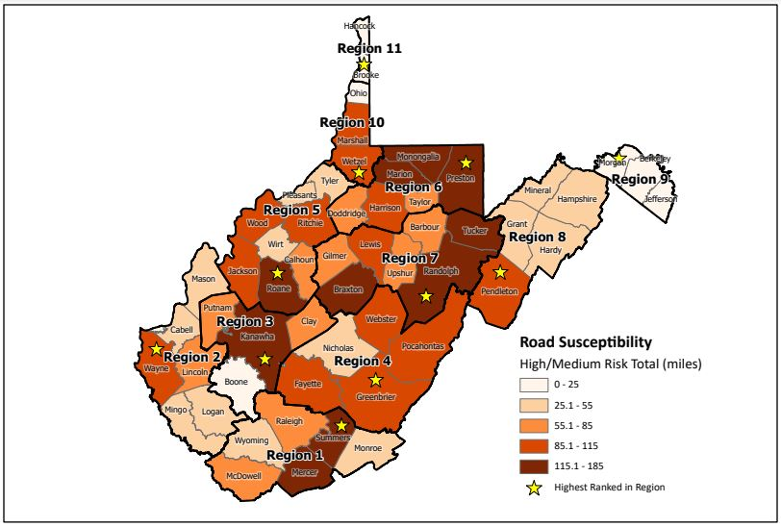
The map in Figure 9 shows the total road miles in high/medium susceptibility areas in each county and the highest ranked county in each Region.
Figure 9. Total road miles in High/Medium Susceptibility Areas

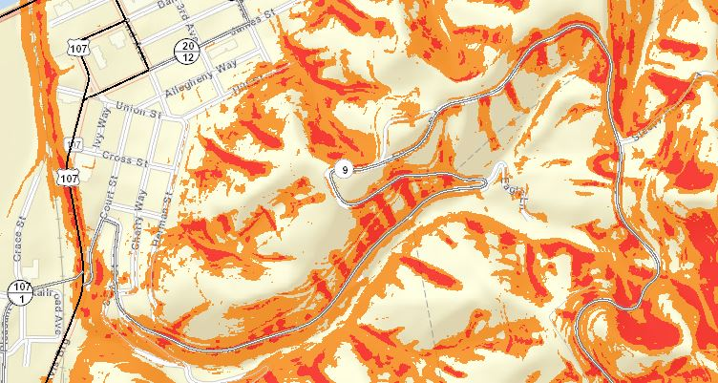
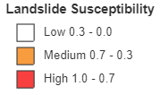
Figure 10 shows an example of landslide risk near Hinton, WV in Summers County. The road segments susceptible to landslide can be viewed on the Landslide Tool.
Figure 10. Landslide Susceptibility near Hinton, WV in Summers County. Notice high and medium susceptibility landslide areas along roads leading into the city. Data can be accessed on WV Flood Tool
The second set of risk analyses was performed to evaluate the total length of different types of roads in high/medium susceptibility areas in each Region. Table 6 shows the details of different road types in high/medium risk zones for each Region. The majority of at-risk roads in all Regions fall in the “Other” road type category. Of all eleven Regions, Region 6 has the most Interstate road miles at risk, closely followed by Region 5. Region 8 and Region 11 have no Interstate roads at risk. Region 7 has the most U.S. roads at risk and Region 1 has the most state roads at risk.
Table 6. Different road type and length susceptible to High/Medium Risk of Landslide
Region | Roads Total (miles) | Roads Total (miles)- High/Medium Risk | Interstate Roads High/Medium Risk | US Roads High/Medium Risk | State Roads High/Medium Risk | Other Roads
1 | 4975.6 | 556.4 | 6.2 | 42.7 | 89.3 | 418.4
2 | 4471 | 339.6 | 2.3 | 50.8 | 27.4 | 258.8
3 | 3441.8 | 318.2 | 9.1 | 12.8 | 24.8 | 271.3
4 | 4148.6 | 475.6 | 5.4 | 52.1 | 61.9 | 356.1
5 | 5287.5 | 599.5 | 11.2 | 23.9 | 48.3 | 515.9
6 | 5227.2 | 696.7 | 12.3 | 83.6 | 43.1 | 557.5
7 | 5170.2 | 793.6 | 6.3 | 125 | 61.2 | 600.9
8 | 2835.4 | 247.1 | 0 | 59.9 | 30.8 | 156.4
9 | 1658.2 | 46.9 | 1.9 | 5.3 | 8 | 31.8
10 | 1591.9 | 228.3 | 3.4 | 28.2 | 19.2 | 177.3
11 | 479.4 | 44.2 | 0 | 1.5 | 11.6 | 30.9

5.2 Structure/Parcel Risk Analysis
Land use risk analysis provides an assessment of landslide risk to structures/parcels in West Virginia. This study is not intended for site-specific analysis or remediation measures and is only suitable for planning-level analysis. This “big picture” perspective will benefit planning and lead to more effective landslide risk mitigation for West Virginia. The following methodology was used to assess landslide risk to structures/parcels.
Primary structures were extracted for each parcel both inside and outside of 1% annual chance floodplains in each community. Verified primary structures located inside 1% annual chance floodplains were used as a point to assess landslide risk within a parcel. For primary structures in the area outside of the floodplain, the following methodology was applied to extract primary structures. This method was used to avoid overestimating the values for each parcel. A spatial join was performed between the site address point and property tax assessment record. To avoid overestimating the appraisal value, the average was calculated by dividing the building appraisal value of the tax assessment record by the number of points located in the parcel. A spatial join was performed between the site addresses and parcels with the average building appraisal value. The output resulted in a site address point feature class representing primary structures attributed to the building appraisal value. These processing steps avoided adding the same building appraisal value multiple times to more than one site address point within a tax parcel.
One notable limitation of this method was that parcels containing no addressing points are assigned a building value of zero ($0). In addition, the building values for some structures are less than the values recorded in the community-wide building dollar exposure report because, for specific parcels, the appraisal values may be in neighboring parcels instead of the parcel where the structure is located. This results in building values not being assigned to site address points. Also, some government and other property values do not get pulled in from the statewide assessment database, resulting in a lower value of at-risk structures.

5.2.1 Results
Structures were analyzed at two scales for each Region. An initial overview-level analysis was performed for all of the structures without any distinction to occupancy type. A second analysis was performed for different types of occupancy at high/medium risk of landslide.
Table 7 shows the total count of primary structures in high/medium landslide susceptibility areas. Total asset values were derived from the 2021 tax assessment database. Statewide, 29,618 structures (4% of total structures in the state) worth $1,979,392,672 are at risk. Each Region was ranked for the number of primary structures and the total asset values in high/medium susceptibility areas. For total count of buildings in high/medium risk areas, Region 3 ranks 1st and Region 6 ranks 2nd, but these positions are reversed for total asset value ranking. The lowest ranked Regions for building count are Region 9 (10th) and Region 11 (11th). It should be noted that although Region 9 ranks in the bottom for building count, it ranks 3rd for total asset value, indicating that high-value structures are at risk in the Region. The lowest ranked Regions for total asset value are Region 5, in 10th place, and Region 11, which is once again ranked last.

Table 7. Structures with High/Medium Risk Landslide Susceptibility
Region | Total Count | Total Value | Ranking (Count) | Ranking (Value)
1 | 3,489 | $76,729,607 | 3 | 9
2 | 3,130 | $95,832,732 | 4 | 7
3 | 6,956 | $455,472,095 | 1 | 2
4 | 1,301 | $104,555,980 | 9 | 6
5 | 1,476 | $49,211,106 | 8 | 10
6 | 5,805 | $725,657,563 | 2 | 1
7 | 2,327 | $80,007,169 | 5 | 8
8 | 1,597 | $111,771,975 | 7 | 5
9 | 1,195 | $142,031,474 | 10 | 3
10 | 1,650 | $119,190,690 | 6 | 4
11 | 692 | $18,932,281 | 11 | 11

Table 8 identifies the county in each Region that ranks first for highest building count and first for highest building exposure value in high/medium landslide risk areas. In most Regions, the highest ranking county is the same for both categories, except for Regions 1, 4, 7, and 8. In Region 1, McDowell ranks 1st for total building count, while Mercer ranks 1st for total asset value, which is mostly due to building values in McDowell County being below average for the Region. In Region 4, Fayette ranks 1st for total count and Greenbrier ranks 1st for total value, which is due to above average building values in Greenbrier. In Region 7, Lewis ranks 1st for total count and Randolph ranks 1st for total value, which is caused by Lewis County asset values being slightly below average for the Region and Randolph County values being slightly above average. In Region 8, Hampshire ranks 1st for count and Mineral ranks 1st for value, largely due to above average asset values in Mineral County.

Table 8. Highest ranked county in each Region by structure count & by value in High/Medium Susceptibility Areas
Region | HIGHEST RANK BY COUNT |  | HIGHEST RANK BY VALUE
 | County | Total Count | County | Total Value
1 | McDowell | 1,205 | Mercer | $29,675,908
2 | Cabell | 772 | Cabell | $54,280,453
3 | Kanawha | 5,751 | Kanawha | $399,596,198
4 | Fayette | 305 | Greenbrier | $61,943,791
5 | Wood | 392 | Wood | $20,735,403
6 | Monongalia | 2,967 | Monongalia | $344,409,948
7 | Lewis | 757 | Randolph | $25,428,143
8 | Hampshire | 402 | Mineral | $34,302,956
9 | Berkeley | 516 | Berkeley | $57,360,557
10 | Ohio | 887 | Ohio | $90,742,380
11 | Hancock | 381 | Hancock | $11,926,699

Table 9 identifies the Top 10 counties in the state with the highest structure counts and total asset values in High/Medium landslide susceptibility areas. Kanawha County ranks 1st for both structure count and total value in the state. Three of the Top 10 counties by count and by asset value are from Region 6, indicating a high risk to structures in this Region.

Table 9. Top 10 counties statewide by structure count & by value in High/Medium Susceptibility Areas
HIGHEST RANK BY COUNT |  |  | HIGHEST RANK BY VALUE
Region | County | Total Count | Region | County | Total Value
3 | Kanawha | 5,751 | 3 | Kanawha | $399,596,198
6 | Monongalia | 2,967 | 6 | Monongalia | $344,409,948
1 | McDowell | 1,205 | 6 | Harrison | $256,888,640
6 | Harrison | 1,069 | 10 | Ohio | $90,742,380
1 | Mercer | 992 | 6 | Marion | $71,733,187
6 | Marion | 941 | 4 | Greenbrier | $61,943,791
10 | Ohio | 887 | 9 | Berkeley | $57,360,557
2 | Cabell | 772 | 2 | Cabell | $54,280,453
7 | Lewis | 757 | 9 | Jefferson | $52,730,494
2 | Wayne | 728 | 3 | Putnam | $38,146,493

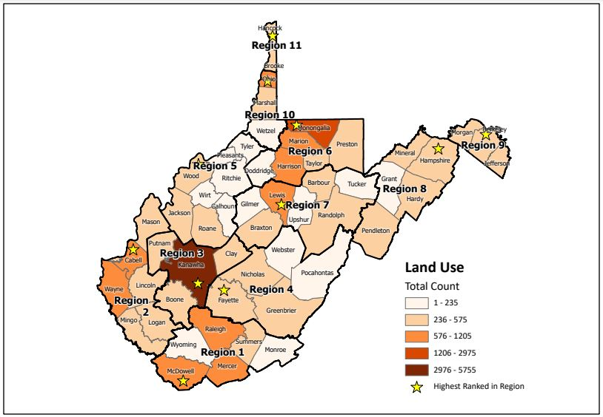
The map in Figure 11 shows the total structure count in high/medium landslide susceptibility areas in each county and the map in Figure 12 shows the total value of structures in high/medium susceptibility areas. The maps also show the highest ranked county in each Region for each category.
Figure 11. Number of structures in High/Medium Susceptibility Areas
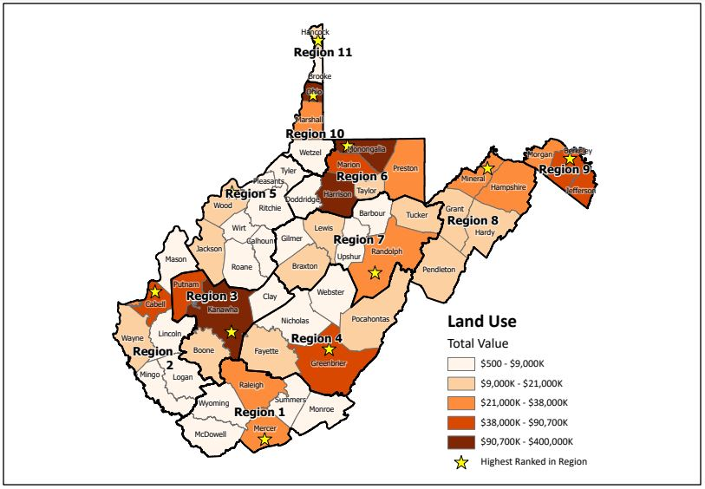
Table 10 shows detailed risk of slope failure based on different occupancy classes. In all Regions, the Residential occupancy class has the highest structure count and total asset value in high/medium landslide susceptibility areas. Asset values for the Other occupancy class should be ignored as some government and other property values do not get incorporated into the statewide assessment database, resulting in a lower value of at-risk structures. Of all eleven Regions, Region 3 has the highest structure count and total asset value in the Residential class, while Region 6 has the highest count and total value in the Commercial class. Region 6 also has the highest structure count in the Other class.
Figure 12. Total value of structures in High/Medium Susceptibility Areas

Table 10. Types of Structures with High/Medium Risk Landslide Susceptibility
Region | RESIDENTIAL OCCUPANCY CLASS |  | COMMERCIAL OCCUPANCY CLASS |  | OTHER OCCUPANCY CLASS
 | High/Medium Susceptibility |  | High/Medium Susceptibility |  | High/Medium Susceptibility
 | Residential count | Residential value | Commercial count | Commercial value | Other count | Other value*
1 | 2,505 | $55,503,732 | 136 | $7,965,814 | 848 | $13,260,061
2 | 2,361 | $88,364,234 | 70 | $3,319,749 | 699 | $4,148,749
3 | 6,078 | $434,650,059 | 92 | $13,186,915 | 786 | $7,635,121
4 | 908 | $88,559,063 | 64 | $13,632,260 | 329 | $2,364,657
5 | 995 | $36,959,021 | 25 | $4,502,481 | 456 | $7,749,604
6 | 4,637 | $367,411,909 | 238 | $249,458,309 | 930 | $108,787,345
7 | 1,584 | $65,434,268 | 66 | $6,196,583 | 677 | $8,376,318
8 | 1,094 | $73,979,675 | 47 | $17,548,728 | 456 | $20,243,572
9 | 1,025 | $123,716,003 | 50 | $11,915,477 | 120 | $6,399,994
10 | 1,279 | $65,328,886 | 56 | $47,069,379 | 315 | $6,792,425
11 | 586 | $16,289,633 | 19 | $2,213,049 | 87 | $429,600
*Other occupancy class value is underreported as assessment value may be absent in assessment database

Table 11 identifies the county in each Region that ranks first for highest Residential building count and highest Residential asset value in high/medium landslide risk areas. In most Regions, the highest ranking county is the same for both categories. But, in Regions 1, 4, and 7 this is not the case. In Region 1, McDowell ranks 1st for Residential building count, while Mercer ranks 1st for total asset value. In Region 4, Fayette ranks 1st for count and Greenbrier ranks 1st for value. In Region 7, Lewis ranks 1st for count and Randolph ranks 1st for total value.

Table 11. Highest ranked county in each Region by Residential structure count and asset value in High/Medium Susceptibility Areas
Region | RESIDENTIAL  HIGHEST RANK BY COUNT |  | RESIDENTIAL  HIGHEST RANK BY VALUE
 | County | Count | County | Value
1 | McDowell | 866 | Mercer | $23,011,817
2 | Cabell | 688 | Cabell | $52,838,441
3 | Kanawha | 5,204 | Kanawha | $389,742,542
4 | Fayette | 210 | Greenbrier | $59,810,011
5 | Wood | 316 | Wood | $18,696,745
6 | Monongalia | 2,438 | Monongalia | $231,493,444
7 | Lewis | 442 | Randolph | $19,738,554
8 | Hampshire | 316 | Hampshire | $23,612,212
9 | Berkeley | 456 | Berkeley | $53,183,807
10 | Ohio | 760 | Ohio | $43,202,862
11 | Hancock | 325 | Hancock | $9,915,983

Table 12 identifies the Top 10 counties in the state with the highest Residential structure counts and total asset values in High/Medium landslide susceptibility areas. Kanawha ranks 1st for Residential structure count and for Residential asset value. Three of the Top 10 counties by both structure count and asset value are from Region 6. Three of the Top 10 counties by structure count are from Region 1, although no Region 1 counties rank in the Top 10 for asset value.

Table 12. Top 10 counties statewide by Residential structure count and asset value in High/Medium Susceptibility Areas
RESIDENTIAL HIGHEST RANK BY COUNT |  |  | RESIDENTIAL HIGHEST RANK BY VALUE
Region | County | Count | Region | County | Value
3 | Kanawha | 5,204 | 3 | Kanawha | $389,742,542
6 | Monongalia | 2,438 | 6 | Monongalia | $231,493,444
1 | McDowell | 866 | 6 | Harrison | $68,026,655
6 | Harrison | 827 | 4 | Greenbrier | $59,810,011
6 | Marion | 791 | 9 | Berkeley | $53,183,807
1 | Mercer | 767 | 2 | Cabell | $52,838,441
10 | Ohio | 760 | 6 | Marion | $44,799,820
2 | Cabell | 688 | 10 | Ohio | $43,202,862
2 | Wayne | 551 | 9 | Jefferson | $39,628,571
1 | Raleigh | 457 | 3 | Putnam | $36,862,999

Table 13 identifies the county in each Region that ranks first for highest Commercial building count and highest Commercial building exposure value in high/medium landslide risk areas. In most Regions, the highest ranking county is the same for both categories. But, in Regions 3, 6, and 11 this is not the case. In Region 3, Kanawha ranks 1st for Commercial building count, while Boone ranks 1st for total asset value. In Region 6, Monongalia ranks 1st for count and Harrison ranks 1st for value. In Region 11, Brooke ranks 1st for count and Hancock ranks 1st for total value.

Table 13. Highest ranked county in each Region by Commercial structure count and asset value in High/Medium Susceptibility Areas
Region | COMMERCIAL  HIGHEST RANK BY COUNT |  | COMMERCIAL  HIGHEST RANK BY VALUE
 | County | Count | County | Value
1 | Raleigh | 46 | Raleigh | $3,199,777
2 | Logan | 20 | Logan | $1,305,234
3 | Kanawha | 59 | Boone | $8,439,787
4 | Fayette | 33 | Fayette | $10,257,782
5 | Ritchie & Jackson | 7 | Ritchie | $2,910,600
6 | Monongalia | 141 | Harrison | $185,197,580
7 | Randolph | 21 | Randolph | $4,116,952
8 | Mineral | 16 | Mineral | $12,813,638
9 | Jefferson | 33 | Jefferson | $8,628,019
10 | Ohio | 39 | Ohio | $46,511,201
11 | Brooke | 10 | Hancock | $2,003,267

Table 14 identifies the Top 10 counties in the state with the highest Commercial structure counts and total asset values in High/Medium landslide susceptibility areas. Monongalia County ranks 1st for Commercial structure count, but Harrison County ranks 1st for Commercial asset value. Three of the Top 10 counties by both structure count and asset value are from Region 6. Three of the Top 10 counties by structure count are from Region 1, although no Region 1 counties rank in the Top 10 for asset value.
Table 14. Top 10 counties statewide by Commercial structure count and asset value in High/Medium Susceptibility Areas
COMMERCIAL HIGHEST RANK BY COUNT |  |  | COMMERCIAL HIGHEST RANK BY VALUE
Region | County | Count | Region | County | Total Value
6 | Monongalia | 141 | 6 | Harrison | $185,197,580
3 | Kanawha | 59 | 10 | Ohio | $46,511,201
1 | Raleigh | 46 | 6 | Monongalia | $37,165,612
6 | Harrison | 43 | 6 | Marion | $24,469,400
10 | Ohio | 39 | 8 | Mineral | $12,813,638
1 | Mercer | 37 | 4 | Fayette | $10,257,782
9 | Jefferson | 33 | 9 | Jefferson | $8,628,019
4 | Fayette | 33 | 3 | Boone | $8,439,787
1 | McDowell | 33 | 3 | Kanawha | $4,371,328
6 | Marion | 26 | 7 | Randolph | $4,116,952

5.3 Essential Facilities Risk Analysis
Essential facilities risk analysis provides an assessment of landslide risk to essential facilities in West Virginia. Essential facilities, in the context of this assessment, are structures that provide vital emergency response activities or are critical to public health and safety, before, during, or after a landslide. Facilities included in this analysis include: police departments, fire departments, 911 centers, nursing homes, hospitals, and K-12 schools. This study is not intended for site-specific analysis or remediation measures and is only suitable for planning-level analysis. This “big picture” perspective will benefit planning and lead to more effective landslide risk mitigation for West Virginia.

5.3.1 Results
Structures were analyzed at two scales for each Region. An initial overview-level analysis was performed for all of the structures without any distinction to facility type. A second analysis was performed for different types of essential facilities at high/medium risk of landslide.
Table 15 shows the total count of essential facilities in high/medium landslide susceptibility areas. Total asset values were derived from the 2021 tax assessment database. For structures inside the 0.2% annual chance floodplain, if tax assessment data was missing, asset values were derived using BRIM data, RSMeans calculations, or other sources. For structures outside the 0.2% annual chance floodplain, missing tax assessment data will result in a value of $0 being assigned to the facility. Statewide, 14 essential facilities (1% of essential facilities in the state) worth $241,432,300 are at risk. Each Region was ranked for the number of essential facilities and the total asset values in high/medium susceptibility areas. Region 6 ranks 1st for both total number of essential facilities and total value of essential facilities in high/medium landslide risk areas. Region 4, Region 7, Region 8, and Region 11 have no essential facilities in high/medium risk areas.

Table 15. Essential facilities with High/Medium Risk Landslide Susceptibility
Region | Total Count | Total Value | Ranking (Count) | Ranking (Value)
1 | 3 | $1,125,700 | 2 | 4
2 | 3 | $1,371,400 | 2 | 3
3 | 1 | $554,100 | 3 | 5
4 | 0 | - | - | -
5 | 1 | - | 3 | -
6 | 4 | $236,413,800 | 1 | 1
7 | 0 | - | - | -
8 | 0 | - | - | -
9 | 1 | $1,951,400 | 3 | 2
10 | 1 | $15,900 | 3 | 6
11 | 0 | - | - | -

Table 16 shows details for the types of essential facilities in high/medium landslide susceptibility areas in each Region. Figure 13 shows the location of all essential facilities located in high/medium susceptibility areas in the state.

Table 16. Types of essential facilities in High/Medium Risk Areas
Region | 911 Centers | Police Departments | Fire Departments | Hospitals | Nursing Homes | Schools (K-12)
1 | 0 | 1 | 2 | 0 | 0 | 0
2 | 1 | 0 | 1 | 1 | 0 | 0
3 | 0 | 0 | 0 | 0 | 0 | 1
4 | 0 | 0 | 0 | 0 | 0 | 0
5 | 0 | 0 | 0 | 0 | 0 | 1
6 | 0 | 1 | 0 | 1 | 2 | 0
7 | 0 | 0 | 0 | 0 | 0 | 0
8 | 0 | 0 | 0 | 0 | 0 | 0
9 | 0 | 0 | 0 | 0 | 1 | 0
10 | 0 | 0 | 1 | 0 | 0 | 0
11 | 0 | 0 | 0 | 0 | 0 | 0

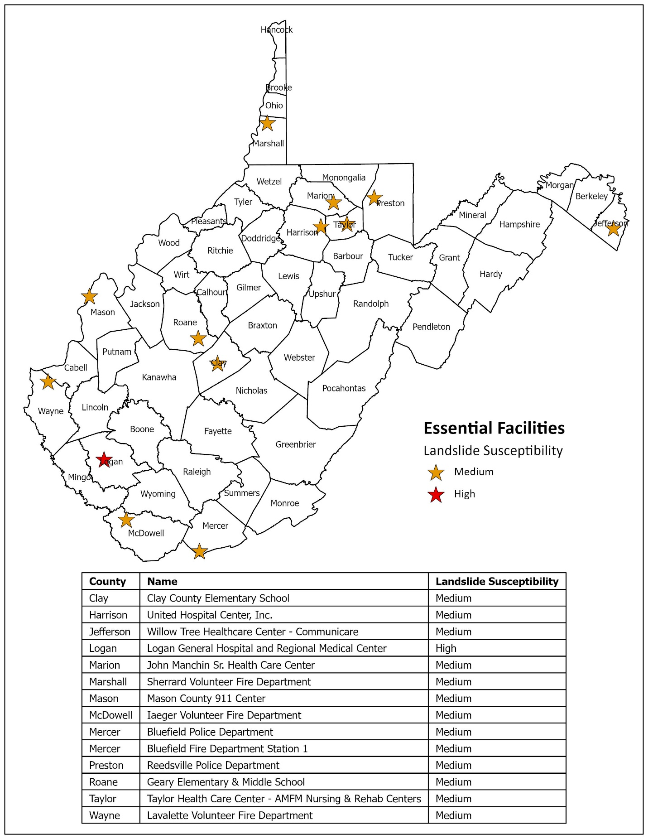
Figure 13. Essential facilities located in High/Medium Landslide Susceptibility Areas

5.4 Total Area Risk Analysis
Total area risk analysis assesses the total area of land classified as high/medium risk of landslide susceptibility in West Virginia. This study is not intended for site-specific analysis or remediation measures and is only suitable for planning-level analysis. This “big picture” perspective will benefit planning and lead to more effective landslide risk mitigation for West Virginia.

5.4.1 Results
Table 17 shows the total area of land in each Region that is classified as having high/medium risk of landslides. Statewide, 8,261,236 acres, or 53% of total land area, are classified as having high/medium landslide susceptibility. Regions were ranked based on the percent of total area classified as having a high/medium risk of landslide. Region 8 ranks 1st, with 61.5% of total area classified as high/medium risk for landslides, but Regions 1, 2, 3, 4, and 7 all have more than half of their total area classified as high/medium risk. Region 9 ranks last, with only 20.3% of area classified as high/medium risk.
Table 17. Total area of land classified as High/Medium Landslide Susceptibility
Region | Area Total  (acres) | Area Total (acres)- High/Medium Risk | Percent of Area Classified as High/Medium Risk | Rank¹
1 | 1,859,569 | 1,042,500 | 56.1% | 5
2 | 1,640,167 | 969,248 | 59.1% | 4
3 | 1,348,345 | 799,345 | 59.3% | 3
4 | 2,459,430 | 1,468,436 | 59.7% | 2
5 | 1,724,768 | 786,722 | 45.6% | 8
6 | 1,433,742 | 672,012 | 46.9% | 7
7 | 2,177,502 | 1,120,046 | 51.4% | 6
8 | 1,751,413 | 1,076,990 | 61.5% | 1
9 | 488,638 | 99,211 | 20.3% | 11
10 | 500,188 | 187,382 | 37.5% | 9
11 | 115,743 | 33,661 | 29.1% | 10
¹Rank based on percent of area classified as high/medium risk
Table 18 shows the county in each Region with the highest percent of area classified as having high/medium risk of landslides. The table presents the percent of area classified as high/medium susceptibility within the county as well as the percentage of area at risk in the Region accounted for by its highest ranked county.
Table 18. Highest ranked county in each Region by percent of area classified as High/Medium Susceptibility
Region | County | Total Area (acres) | Total Area (acres)- High/Medium Risk | Percent of County Area Classified as High/Medium Risk | Percent of High/Medium Risk Area in Region
1 | Summers | 235,138 | 169,495 | 72.1% | 16%
2 | Mingo | 271,217 | 188,202 | 69.4% | 19%
3 | Kanawha | 582,509 | 373,549 | 64.1% | 47%
4 | Pocahontas | 602,346 | 417,884 | 69.4% | 28%
5 | Roane | 309,396 | 173,100 | 55.9% | 22%
6 | Marion | 199,219 | 109,559 | 55.0% | 16%
7 | Braxton | 330,400 | 224,049 | 67.8% | 20%
8 | Pendleton | 446,660 | 401,531 | 89.9% | 37%
9 | Morgan | 147,140 | 57,403 | 39.0% | 58%
10 | Wetzel | 231,050 | 114,114 | 49.4% | 61%
11 | Brooke | 59,353 | 18,047 | 30.4% | 54%

Table 19 identifies the Top 10 counties in the state by percent of land area classified as having high/medium landslide susceptibility. Pendleton County ranks 1st, with almost 90% of its total area being classified as high/medium risk. Three of the Top 10 counties are from Region 2.
Table 19. Top 10 counties statewide by percent of area classified as High/Medium Susceptibility
Region | County | Total Area (acres) | Total Area (acres) - High/Medium Risk | Percent of County Area Classified as High/Medium Risk
8 | Pendleton | 446,660 | 401,531 | 89.9%
1 | Summers | 235,138 | 169,495 | 72.1%
2 | Mingo | 271,217 | 188,202 | 69.4%
4 | Pocahontas | 602,346 | 417,884 | 69.4%
7 | Braxton | 330,400 | 224,049 | 67.8%
2 | Logan | 291,411 | 194,254 | 66.7%
4 | Webster | 355,723 | 231,396 | 65.0%
8 | Hardy | 374,055 | 239,996 | 64.2%
3 | Kanawha | 582,509 | 373,549 | 64.1%
2 | Lincoln | 280,780 | 175,372 | 62.5%

The map in Figure 14 shows the percent of land area classified as having high/medium susceptibility for landslides and the highest ranked county in each Region.
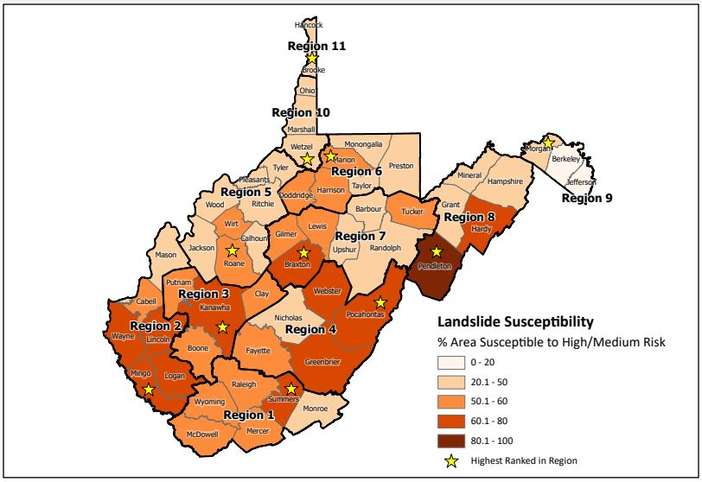
Figure 14. Percent of total land area classified as high/medium susceptibility for landslides

6.0 Limitations and Expert Consultation
Landslide susceptibility classifications are based on physical characteristics associated with landslide locations mapped using LiDAR data. The nature of the West Virginia landscape and the LiDAR imagery limited mapping to landslides at least 33 feet wide. This approach undercounts small, shallow landslides and slope failures that may have been mitigated or removed by human agents. LiDAR-mapped landslide locations and landslide susceptibility maps derived from this data are inherently biased against these areas. Additionally, it is not feasible to thoroughly verify the accuracy of each dataset used for mapping and modeling. However, every effort has been made to ensure the integrity of this data.
Landslide risk is complex and continually changing. Future mitigation projects or alterations to topography, land use, and climate may render these results inaccurate. Other models, maps, reports, and future site-specific analyses may provide results that differ from those included here.

This study is NOT intended for regulatory use and is NOT the final authoritative source of all landslide risk data in the community. It should be used in conjunction with other data sources to provide a comprehensive picture of general landslide risk. This report is for informational and planning purposes regarding landslide susceptibility and risk at the county scale. It may not be used to identify susceptibility at site-specific locations.

To address landslide susceptibility at a sub-county scale, geotechnical evaluations should be performed by professional engineers or geologists. For site-specific investigations, local officials, developers, and property owners should consult slope-stability experts, such as certified professional engineers and qualified geologists. Site-specific evaluations for landslide susceptibility can only be provided by performing detailed site-specific geotechnical studies, including bedrock and soil analyses, core description, physical testing, and slope-stability analyses.

7.0 Outreach Materials
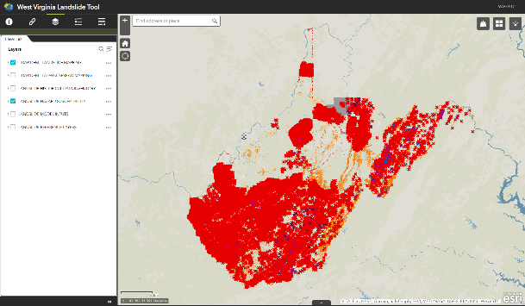
- The West Virginia Landslide Tool (http://mapwv.gov/landslide) is a landslide web mapping application showing landslide incidence data and modeling results. The West Virginia GIS Technical Center created an ArcGIS online map that provides information about landslide susceptibility and landslides mapped throughout West Virginia. The map allows users to display landslide locations mapped by the West Virginia Department of Transportation (WV DOT), West Virginia Geological and Economic Survey (WVGES), United States Geological Survey (USGS), several independent research projects, and landslides mapped using high-resolution elevation data. The public can also add landslide locations to the West Virginia Landslide Tool (http://www.mapwv.gov/landslide) by taking a photo of the landslide and uploading it to the application.
Figure 15. West Virginia Landslide Tool

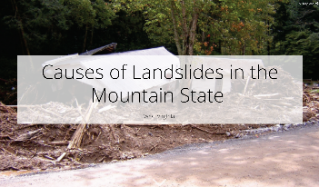
- Story Maps
Figure 16. Story Map showing causes of landslide
- Causes of Landslides in Mountain State, West Virginia https://arcg.is/1SW0Sn discusses different causes of landslides in the state.

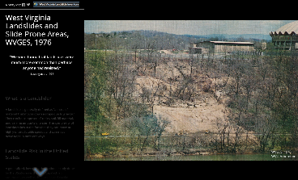
Figure 17. WVGES 1976 Study details in Story Map
- West Virginia Landslides and Slide Prone Areas, WVGES 1976 https://arcg.is/1KDnvq discusses landslide risk assessment published in 1976 by the WV Geological and Economic Survey that was funded by the Appalachian Regional Commission.

- Regional Landslide Reports for all 11 Planning and Development Council Regions with landslide risk assessment results presented at the sub-county level can be viewed and downloaded here.

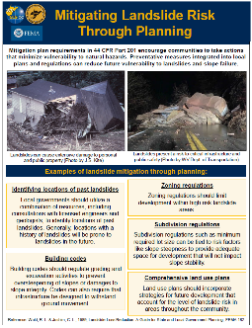
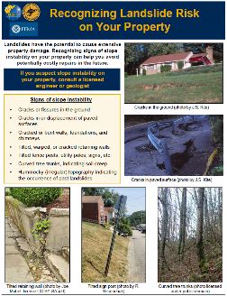
- Educational brochures were developed to provide general information about identifying signs of slope instability and mitigation measures that may help reduce landslide risk at the community and individual property levels.
Figure 18. Mitigation brochure for community and property owners

- Landslide susceptibility modelling publications- Three peer reviewed modelling papers have been published in refereed journals
  - Slope Failure Prediction Using Random Forest Machine Learning and LiDAR in an Eroded Folded Mountain Belt – Published in the journal Remote Sensing
  - Assessing the Generalization of Machine Learning-Based Slope Failure Prediction to New Geographic Extents – Published in the International Journal of Geo-Information
  - Explainable Boosting Machines for Slope Failure Spatial Predictive Modeling – Published in the journal Remote Sensing

- County Landslide Susceptibility Maps – Landslide susceptibility maps for all 55 counties can be viewed and downloaded here.

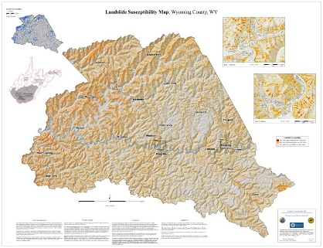
Figure 19. Example of landslide susceptibility map for Wyoming County

Statewide Risk Assessment Contacts

Statewide Risk Assessment Technical Support, WVU GIS Technical Center
- Kurt Donaldson (kurt.donaldson@mail.wvu.edu)
- Maneesh Sharma (maneesh.sharma@mail.wvu.edu)
- Eric Hopkins (Eric.Hopkins@mail.wvu.edu)
WV Emergency Management Division
- Brian Penix, State Hazard Mitigation Project Officer (Brian.M.Penix@wv.gov)
- Tim Keaton, State Hazard Mitigation Planner (Tim.W.Keaton@wv.gov)
- Kevin Sneed, CTP Coordinator (Kevin.L.Sneed@wv.gov)
- Nuvia E. Villamizar, GIS Manager (nuvia.e.villamizar@wv.gov)

State NFIP Coordinator, WV Office of the Insurance Commissioner
- Chuck Grishaber (Charles.C.Grishaber@wv.gov)

