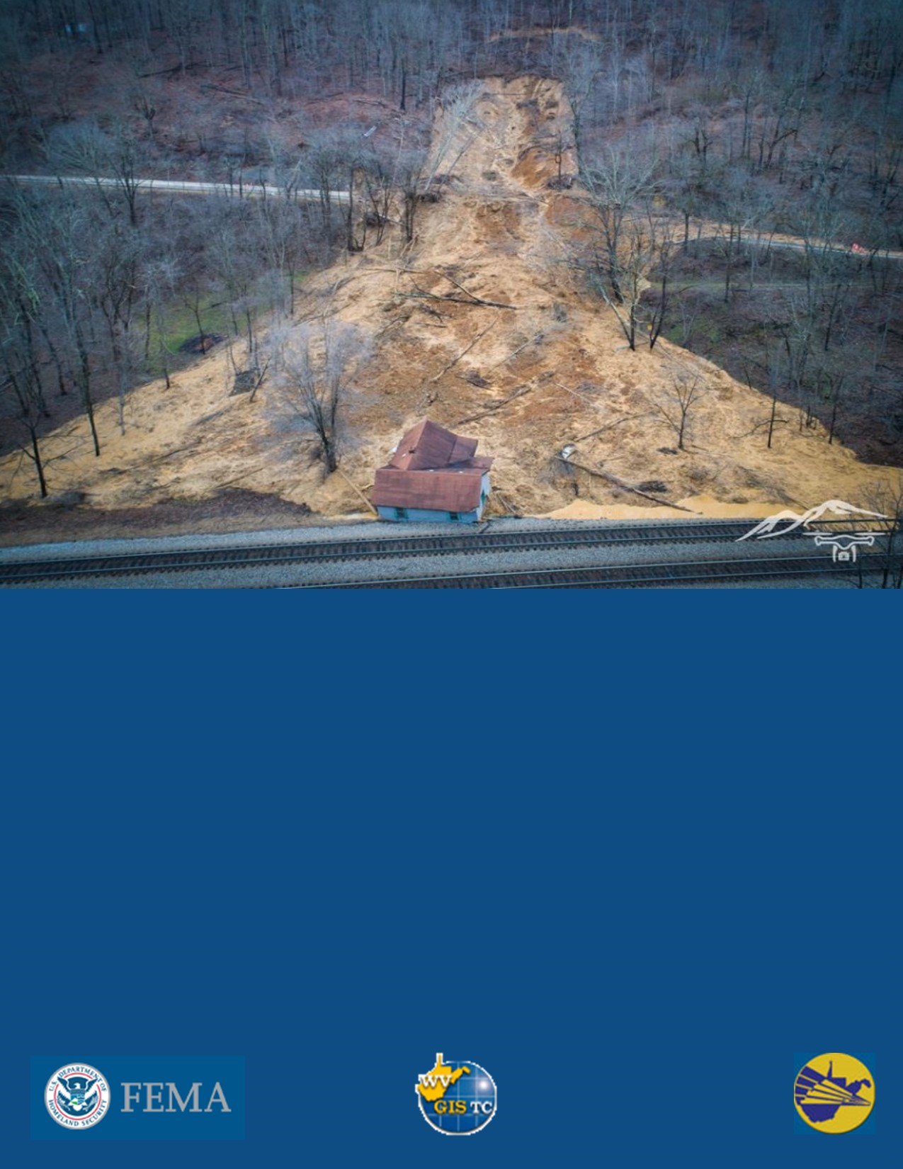


August 2023
West Virginia Landslide Risk Assessment: Climate Change Susceptibility
Landslide along Old US-19 in Mercer County
Climate Change and Landslide Susceptibility in West Virginia
Slope failures in the United States cause millions of dollars in damage and deaths every year (USGS). In the Appalachian Mountains, shallow landslides are a constant threat to life and infrastructure. Due to the significant influence of climate on slope failure, it is anticipated that human-induced climate change will unpredictably affect slope stability in the future (Crozier, 2010).
Predicting the impact of Anthropocene climate change on slope failure into the long-term future is difficult given the coarse spatial and temporal resolution of climate simulations (Crozier, 2010; Garianno and Guzzetti, 2016). Numerous studies have been unsuccessful in devising a universally applicable method to comprehend the implications of climate change on slope stability (Garianno and Guzzetti, 2016). This does not reflect a flaw in these studies; instead, it serves as evidence of the uncertainty and intricacy of feedback systems in slope stability and climate science. Sidle and Ochiai (2006) evaluated the usefulness of climate projection data on predicting slope stability and found that on larger timescales, i.e > 10 years, annual mean temperature and precipitation serve as the most relevant climate variables for modeling studies. Coe and Godt (2012) found that predicting slope failure using coarser annual precipitation and temperature data resulted in lower levels of uncertainty than predicting slope failure with down sampled climate data due to the stochastic nature of storm events. Consequently, we employed NASA BioClim climate simulations (2010 – 2100) for annual mean temperature and precipitation projections. After analyzing these data for statistical trends, we utilized the slope stability grid from Maxwell et al. (2020) to pinpoint regions within West Virginia that exhibit both a high probability of slope failure and exceptional susceptibly to changes in climate variables.

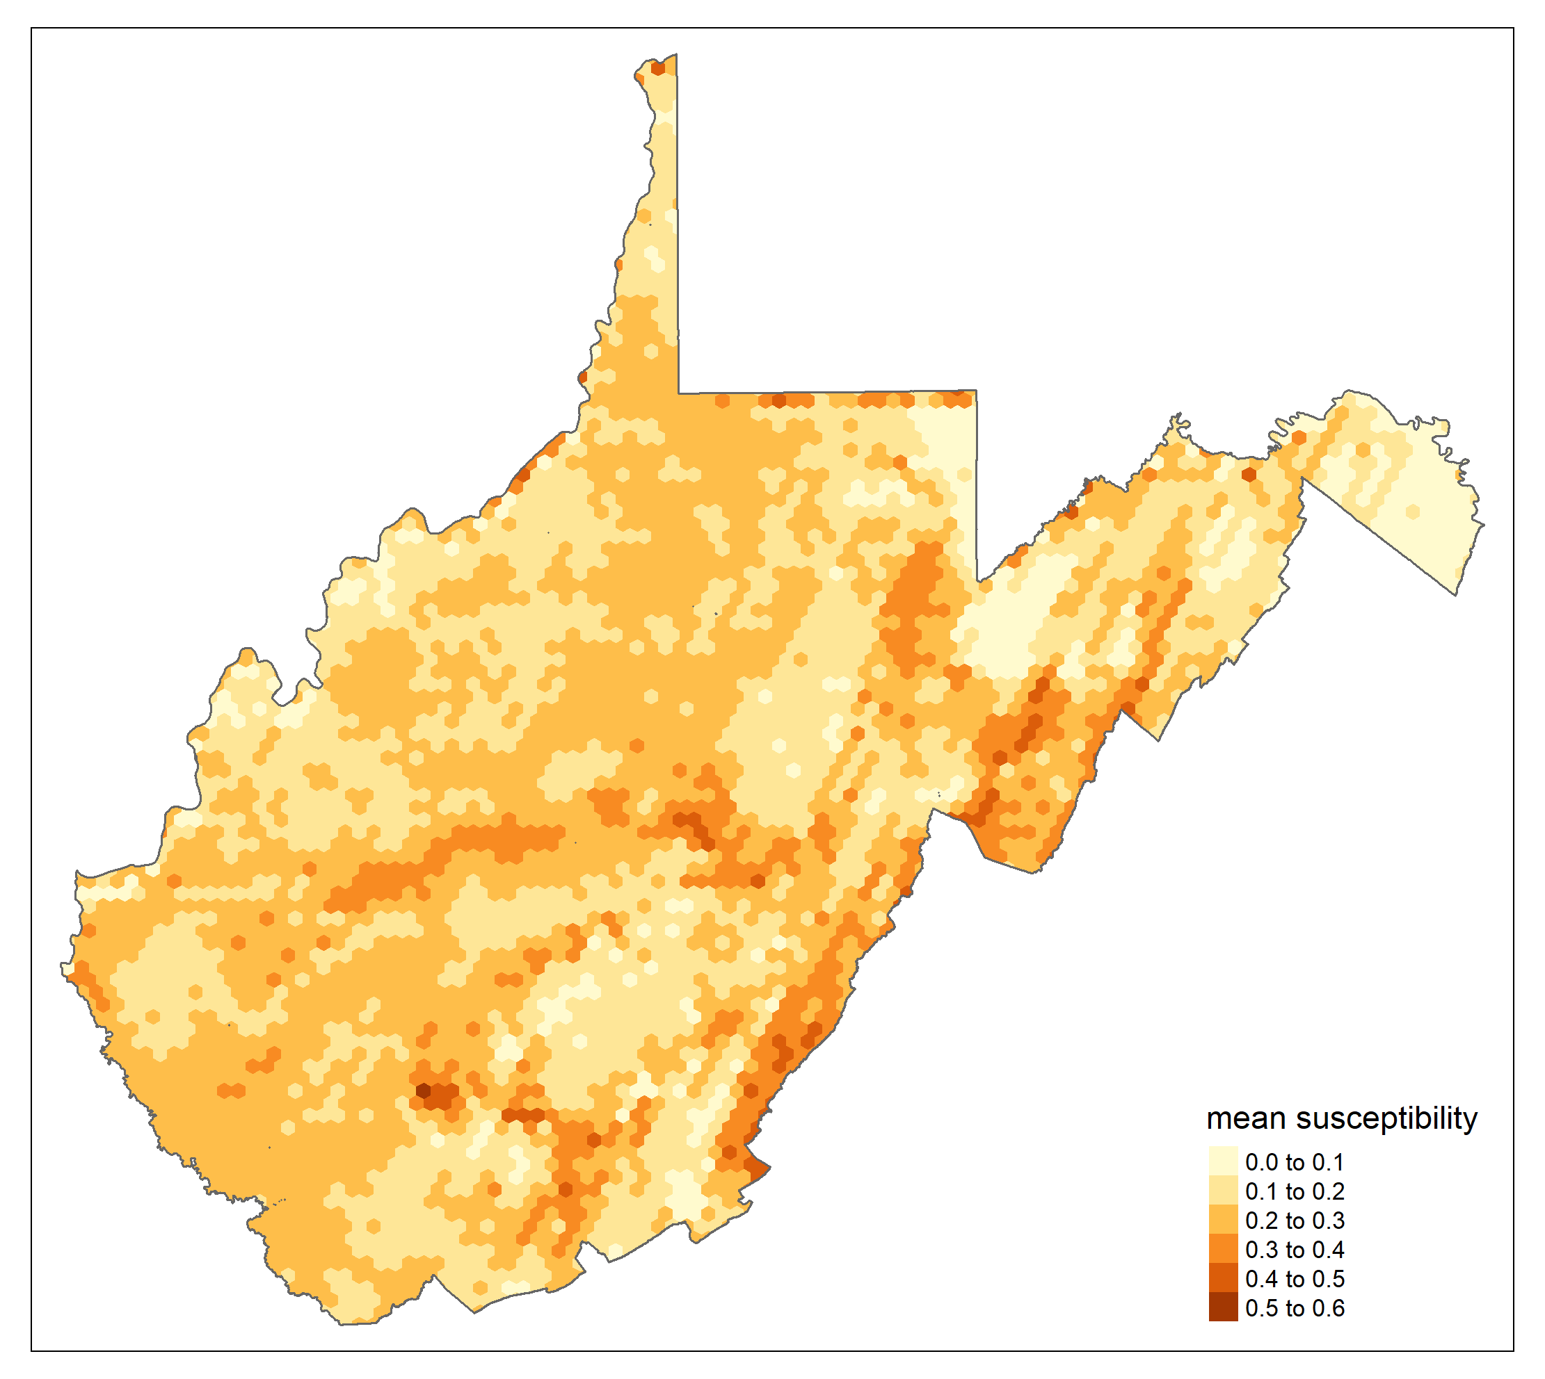
Figure 1: Landslide susceptibility grid from Maxwell et al. (2020). Deeper red colors represent a higher probability of slope failure. This data is available at 1-meter resolution on the WV Landslide Tool; here, it is aggregated to match the climate data grid size.
Mapwv.gov/landslide
Landslide susceptibility

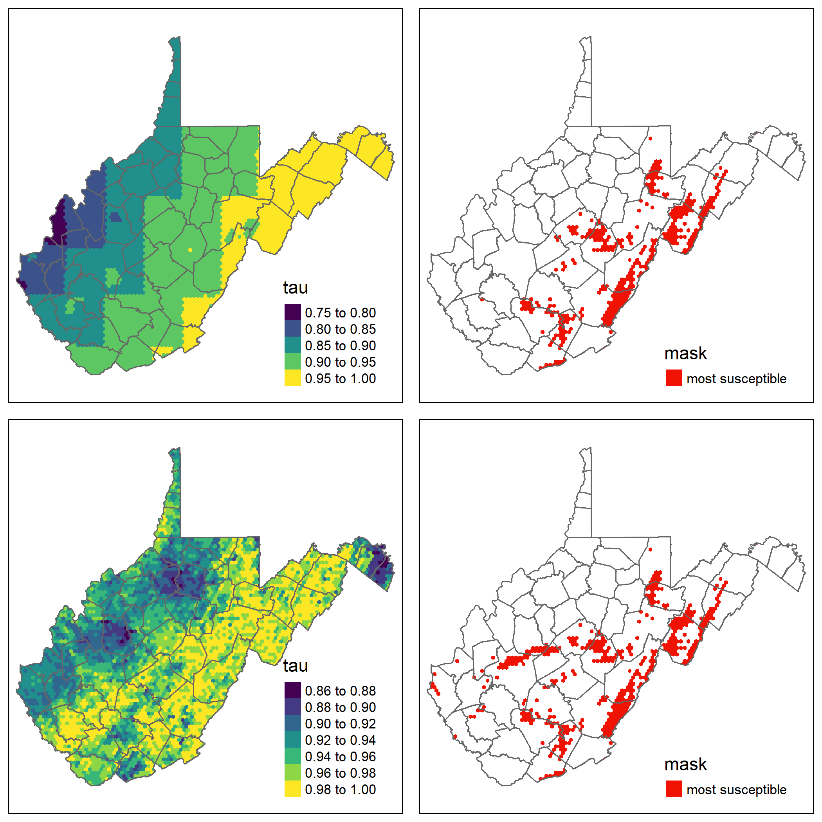
Figure 2: We used a Mann-Kendall statistical test to look for trends in climate data in every hexagon in the grid. We show the test statistic from. In basic terms, a tau value of 1 shows the strongest possible evidence for an increasing trend. Areas that are increasingly yellow in panel A represent regions where mean annual precipitation is most likely to increase until 2100. Areas that are increasingly yellow in panel B represent regions where mean annual temperature is most likely to increase until 2100. The red areas in panel C represent where a high probability of precipitation increase (tau greater than 0.90) overlaps with a high probability of slope failure (landslide probability greater than 30%); the red area in panel D shows where a high probability of temperature increase overlaps with a high probability of slope failure.
NASA BioClim. ADCP US
D.
C.
B.
A.
Trends in annual mean temperature
Trends in annual mean precipitation
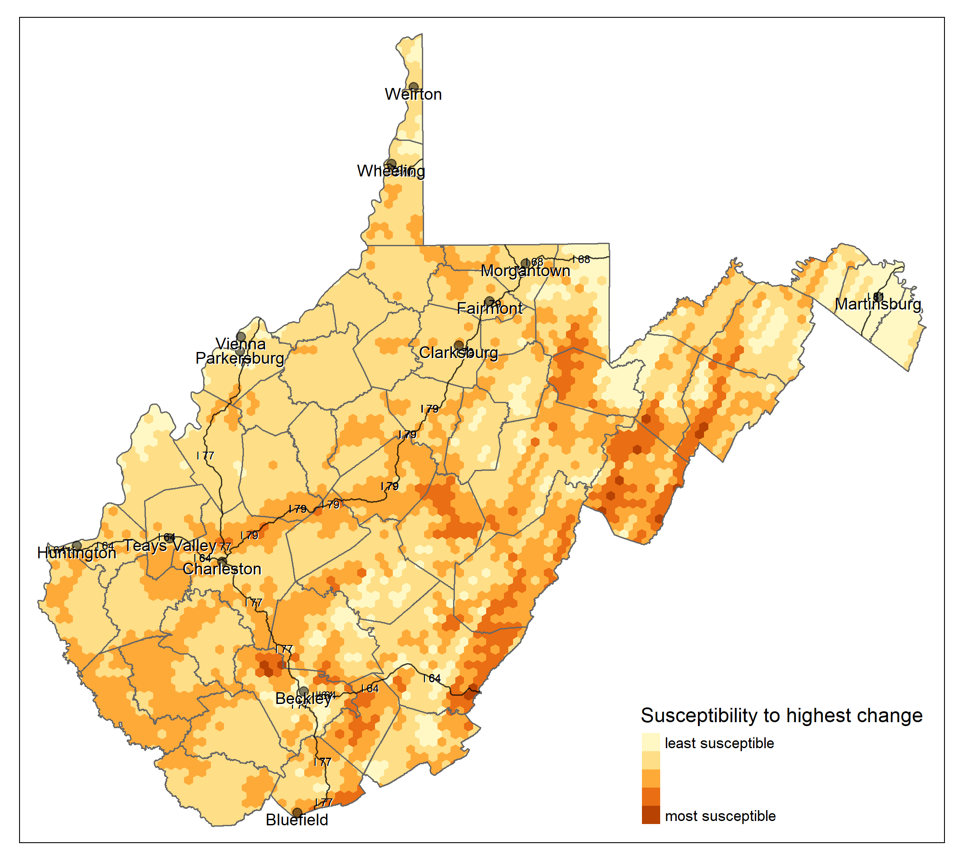
Figure 3: This map shows a model that combines landslide susceptibility, susceptibility to precipitation, and temperature increase. In this map, darker colors represent cells that have the highest combination of all three susceptibility models. Dark red cells are highly susceptible to slope failure as well as changes in precipitation and temperature.
There are several areas in the state where a high risk of slope failure might be exacerbated by climate change. The southern I-79 corridor which passes through Kanawha County, Roane County, Clay County, and Braxton County shows moderate susceptibility. Considerable susceptibility is present in the mountainous regions of Webster County, Greenbrier County, Pocahontas County, Pendleton County, Hardy County, and Grant County. Western Tucker County and southern Preston County also display areas of high susceptibility.

These models allow for a wide range of interpretation. Those using them for management practices should take the following into account:
- Climate simulations are inherently unpredictable as they depend on human behavior and decisions in the coming decades.
- It is difficult to link annual mean precipitation and temperature to increases or decreases in slope failure; increasing precipitation and temperature can have varying effects on slope stability. Increased annual precipitation can raise the probability of slope failure by increasing river discharge, water antecedent conditions, and water table levels. However, a wetter climate can also increase vegetation which adds cohesion to soil on slopes (Crozier, 2010). Increasing mean temperature can cause more rapid snowmelt and increased slope failure (Crozier, 2010). Conversely, higher annual temperatures can increase vegetation growth and evapotranspiration, which can decrease antecedent water conditions and lead to less slope failure. These are all feedback systems to keep in mind when interpreting these results.

This report is for informational purposes related to general emergency services planning. It has not been prepared for, and may not be suitable for legal, design, engineering, or site-preparation purposes. This report cannot substitute for site-specific investigations by qualified practitioners. Landslide risk is complex and continually changing. Although other existing studies or reports may provide more precise and comprehensive information, detailed original site investigations are normally an essential best practice for public safety, sustainability, and financial viability. Other data sources may present results that differ from those in this report.
References:
Crozier, M.J., (2010). Deciphering the effect of climate change on landslide activity/: A review. Geomorphology. Vol. 124, Issues 3-4.
Donald W. Meals, Jean Spooner, Steven A. Dressing, and Jon B. Harcum. 2011. Statistical analysis for monotonic trends, Tech Notes 6,November 2011. Developed for U.S. Environmental Protection Agency by Tetra Tech, Inc., Fairfax, VA, 23 p. Available online at https://www.epa. gov/polluted-runoff-nonpoint-source-pollution/nonpoint-source-monitoring- technical-notes.
Gariano, S.L., Guzzetti, F. (2016). Landslides in a changing climate. Geomorphology. Vol. 162.
Kendall, M. (1938). "A New Measure of Rank Correlation". Biometrika. 30 (1–2): 81–89. doi:10.1093/biomet/30.1-2.81. JSTOR 2332226.
Maxwell, A.E.; Sharma, M.; Kite, J.S.; Donaldson, K.A.; Thompson, J.A.; Bell, M.L.; Maynard, S.M. Slope Failure Prediction Using Random Forest Machine Learning and LiDAR in an Eroded Folded Mountain Belt. Remote Sens. 2020, 12, 486. https://doi.org/10.3390/rs12030486
Panék, Tomáš. (2019). "Landslides and Quaternary Climate Changes - State of the Art. Earth-Science Reviews. Vol 196. https://doi.org/10.1016/j.earscirev.2019.05.015.
https://www.usgs.gov/programs/landslide-hazards/landslides-101

