Supplemental Risk MAP resources for Berkeley County CCO Meeting/Preliminary Floodplains:
WV Flood Tool & WV Risk Explorer
10/2/2025

- Refined Building Counts. Please remember that we inventory only "primary structures" and no outbuildings, so our counts will be less than the counts on FEMA's Community Risk Dashboards.
County Summary: There are more buildings expected to be mapped in the SFHA than mapped out. +228 / -172

 | Remaining in SFHA | No Change Floodway | Mapped In SFHA | Mapped In Floodway | Newly Mapped in SFHA | SFHA to Floodway | Total Floodway | Newly Mapped Out of SFHA | Net Change | Total Structures in New SFHA
Berkeley County* (Unincorporated) | 381 | 1 | 206 | 1 | 207 | - | 2 | 153 | +54 | 589
Martinsburg, City of | 39 | 6 | 21 | - | 21 | - | 6 | 19 | +2 | 66
Total | 420 | 7 | 227 | 1 | 228 | 0 | 8 | 172 | +56 | 655

(2) Building-Level Risk Tools. We have deployed new Building Risk Tools which allow users to query and download which structures have been mapped in or mapped out of the SFHA. The SFHA building change query links are below:

<< Mapped In Structures - about 228 >>
https://www.wvfrf.org/wvre/blra/?sortfield=Depth_Grid&sorttype=desc&statement=County%2520%253D%2520Berkeley%253BSymbol_FloodRiskZone%2520IN%2520%28Mapped%2520in%2520Floodway-Commercial%252CMapped%2520In%2520Floodway-Residential%252CMAPPED%2520IN-Commercial%252CMAPPED%2520IN-Other%252CMAPPED%2520IN-Residential%29&from=1&perPage=10&hiddenFields=2,5,7,8,10,15,16,17,18,19,20,23,25,29,31,33,34,35,36,37

Mapped in Structure with highest Flood Depth: Top structure 02-01-0021-0006-0012_292, flood source Opequon Creek, is mapped in at a 7.1-foot flood depth. Fortunately, the lowest floor of this 2015 structure is elevated at a high enough flood protection level.

<< Building 02-01-0021-0006-0012_292 - 292 SPIRAL LN, Inwood, WV, 25428 - Mapped in SFHA Structure >>
Building Level Risk Tool: https://www.wvfrf.org/wvre/blra/?statement=Building_ID%2520LIKE%252002-01-0021-0006-0012_292&type=blra&hiddenFields=default
WV Flood Tool: https://mapwv.gov/flood/map/?wkid=102100&x=-8679231&y=4773902&l=13&v=2
Photo: https://data.wvgis.wvu.edu/pub/Clearinghouse/hazards/BldgPhotos/02-01-0021-0006-0012_292.jpg


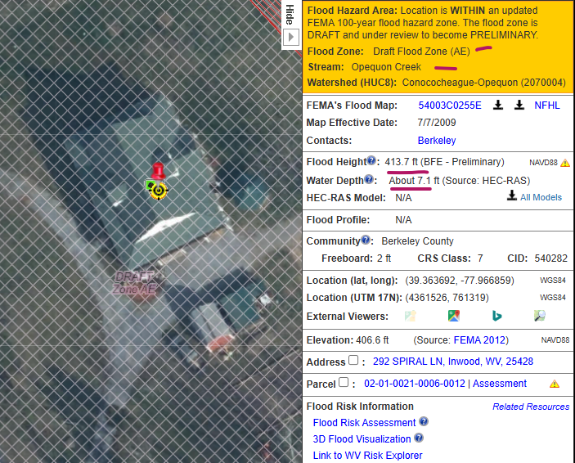

<< Mapped Out Structures - about 172 >>
https://www.wvfrf.org/wvre/blra/?sortfield=Depth_Grid&sorttype=desc&statement=County%2520%253D%2520Berkeley%253BSymbol_FloodRiskZone%2520IN%2520%28MAPPED%2520OUT-Commercial%252CMAPPED%2520OUT-Other%252CMAPPED%2520OUT-Residential%29&from=1&perPage=10&hiddenFields=2,5,7,8,10,15,16,17,18,19,20,23,25,29,31,33,34,35,36,37

Note that the top four records are "mapped out" LOMAs that have a Preliminary Flood Depth value (greater than zero) and thus will be changed or superseded when the new flood maps are published.
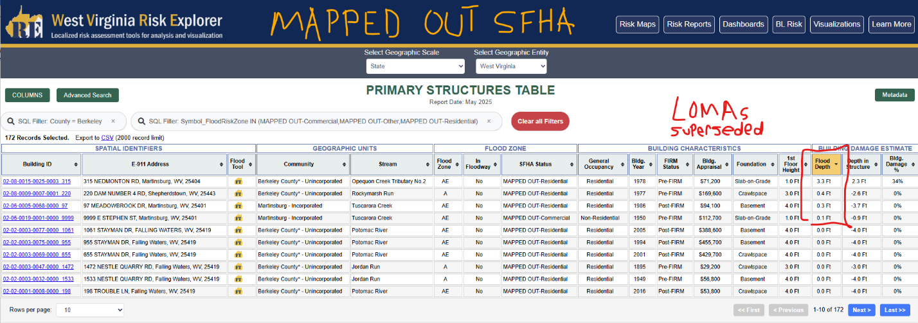

If the superseded LOMAs are dropped (Mapped Out SFHA Status but Preliminary Flood Depth > 0 feet), then a minimum of four LOMAs with "removal" status will be superseded. For example, the structure at 315 NEDMONTON RD, Martinsburg, WV, 25404 is in the Mapped-Out list because of a 2017 LOMA but will be superseded with the new FEMA maps.
https://www.wvfrf.org/wvre/blra/?statement=Building_ID%2520LIKE%252002-08-0015-0025-0003_315&type=blra&hiddenFields=default
https://mapwv.gov/flood/map/?wkid=102100&x=-8673360&y=4788073&l=14&v=1
LOMA 17-03-0518A-540282 "Removal Status" will be superseded: https://map1.msc.fema.gov/data/54/L/17-03-0518A-540282.pdf?LOC=af5014a6eb8e1bfb7121f121d73b9d3f

(3) Berkeley County Risk Assessment (Top 20% Risk Factors)
https://www.wvfrf.org/wvre/report/?scaleid=3&entityid=2&type=all
https://www.wvfrf.org/wvre/report/?scaleid=3&entityid=2&type=top20

Online Report of Top 20% Risk Factors
- Median Building Value
- Building Damage Loss (mostly due to unelevated structures along Potomac River)

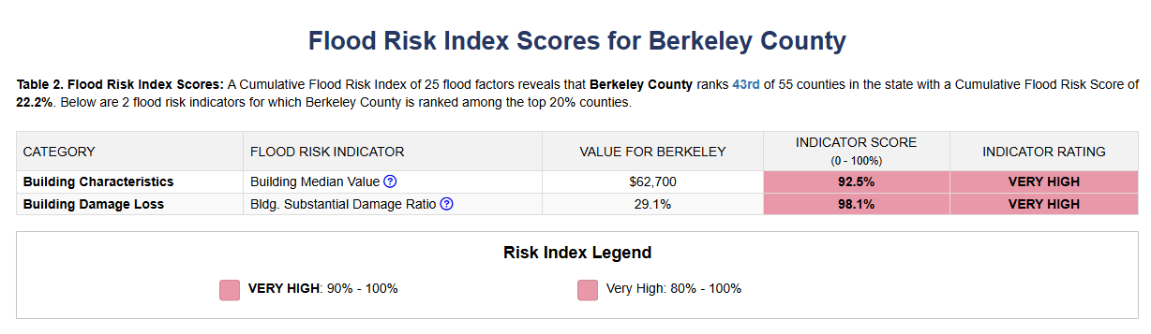

(4) Viewing Preliminary Floodplains & Changes Since Last FIRM (CSLFM) on WV Flood Tool. The preliminary vector data for Berkeley County has been published to the WV Flood Tool in preparation for tomorrow's CCO meeting.

Along with the preliminary XS and floodplain layers, FEMA's Change Since Last FIRM service is also available via the Flood Tool. This layer works well in conjunction with the primary structure points and is an easy way to verify Mapped In/Mapped Out status. We recommend turning off the effective floodplain and depth layers when viewing this service on the Flood Tool, as it can get quite busy otherwise.
<< WV Flood Tool Risk MAP View showing SFHA floodplain boundary and structure changes >>
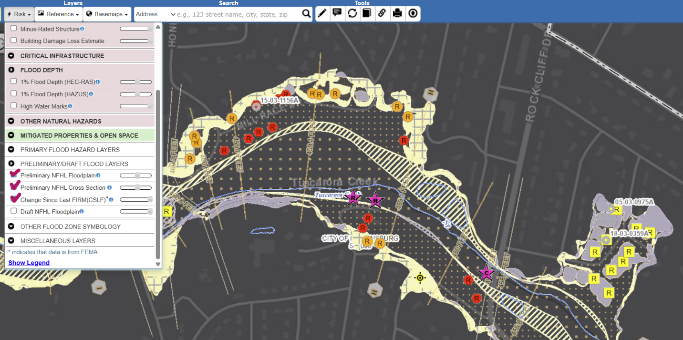

You can also navigate straight to FEMA's Map Changes Viewer from the Flood Tool via the link in the query panel:

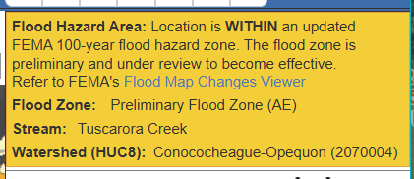

<< Legend for Primary Structures Inventoried in Preliminary Floodplain >>
