West Virginia Flood Resiliency Framework Symposium Summary | Olson Harris Ltd.
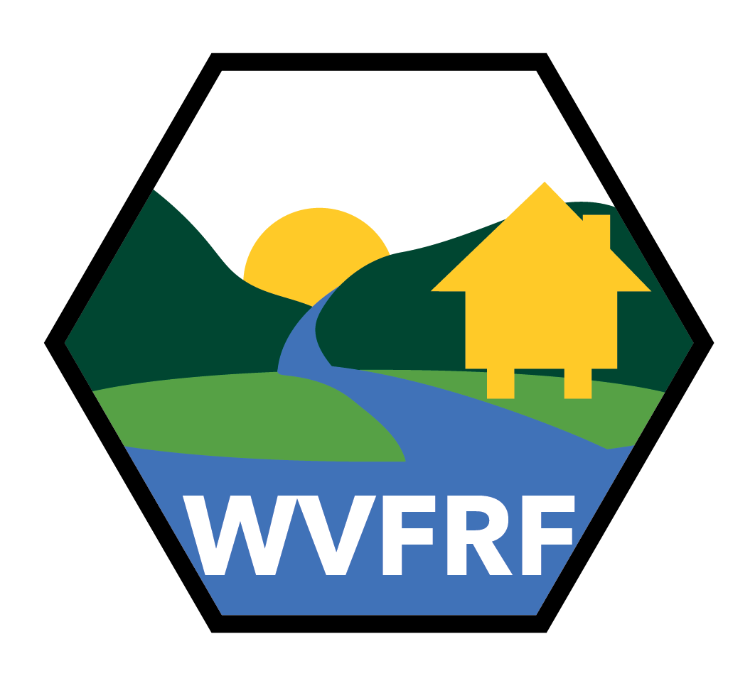
MARCH 2024
Created as part of the West Virginia Flood Resiliency Framework

TABLE OF

CONTENTS
Table of Contents
OPENING REMARKS 3
SENATOR JOE MANCHIN III 3
SENATOR SHELLEY MOORE CAPITO 4
CONGRESSWOMAN CAROL MILLER 5
SYMPOSIUM SUMMARY 6
INTERACTIVE QUESTIONS & RESPONSES – BREAKOUT SESSIONS 10
POST SYMPOSIUM SURVEY SUMMARY 14
APPENDIX I: LINKS TO RESOURCES 17
APPENDIX II: AGENDA 18
APPENDIX III: ATTENDEES 29

  - oPENING rEMARKS
  - sENATOR jOE mANCHIN iii

sENATOR sHELLEY mOORE CAPITO

cONGRESSWOMAN cAROL mILLER

  - sYMPOSIUM sUMMARY
The Building Flooding Resiliency in West Virginia Communities Symposium was held on March 12-13, 2024 in Charleston, WV. This event brought together 117 members of the network of people working on flood-related issues at all levels in WV, from local community organizations to state and federal agencies. Over the course of two days, symposium attendees took part in a scenario-based tabletop exercise and other activities in order to meet four goals:
- Gain a common understanding of who the main players are and the capabilities they provide before, during, and after a flood;
- Have a better understanding of how participants and their organizations can coordinate their efforts in each phase of a disaster;
- Identify barriers to coordination between agencies and organizations; and
- Identify those considerations that contribute to or detract from individual and/or community resiliency.

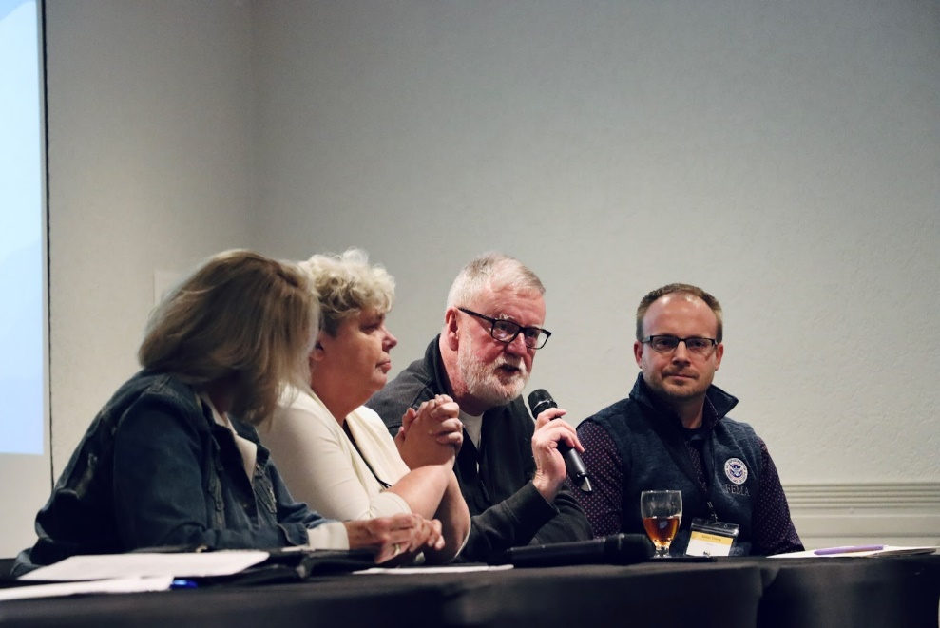
On the first day of the symposium, attendees learned about the research project, state resiliency plan, flood risk assessments, and visualizations. Attendees also participated in a “How to Plan for Everything” activity that provided participants with a simple, step-by-step approach to prepare themselves and their neighbors for emergencies and accidents. In the afternoon, they attended three different concurrent sessions on the National Flood Insurance Program (NFIP), tools for comprehensive flood planning, and lessons from the Williamsburg Area Response Team (WART). Panel discussions included planning for the disaster response cycle and building community resiliency.
During the second day of the symposium, attendees also participated in a disaster simulation activity. The Cross-Sector Disaster Simulation Game simulates cross-sector collaboration and coordination before, during, and after such disasters (Day, n.d.). Each person was assigned a role, such as government, for-profit company, non-profit organization, or community member. They coordinated on the local, state, and national level prior to the disaster. Once the disaster happened, everyone needed to work together to ship food, water, and medicine within three days. Each "day" was just a few minutes long, creating a high-stress, chaotic environment. Afterward, participants debriefed and analyzed outcomes.
After the simulation, attendees were divided into tables with 6 to 7 people per table. Each table was asked to discuss the following questions:
- Who are the main players and what are their capabilities before, during, and after a flood?
- What are the barriers to coordination between agencies and organizations in each phase of a disaster?
- How can we overcome these barriers?
- What are key attributes of individual and/or community flood resiliency?
- How can we build these attributes?
- What do you want to see included in the West Virginia Flood Resiliency Framework?

When asked who the main players are and what their capabilities are, most attendees frequently brought up the same organizations and individuals. For example, government entities and individuals, like county commissions, mayors, city managers, floodplain managers, code enforcement officers, state/house representatives, and the federal emergency management association (FEMA) played a major role in leadership throughout the disaster cycle. On the emergency management side, coordination, response, relief, and communication were key capabilities. Other players included citizens, non-governmental organizations, faith–based organizations, and private entities, including media companies. Each of these entities had different capabilities, ranging from materially oriented ones, such as medicine, food, and shelter, to immaterial capacities like spiritual services and providing directives.
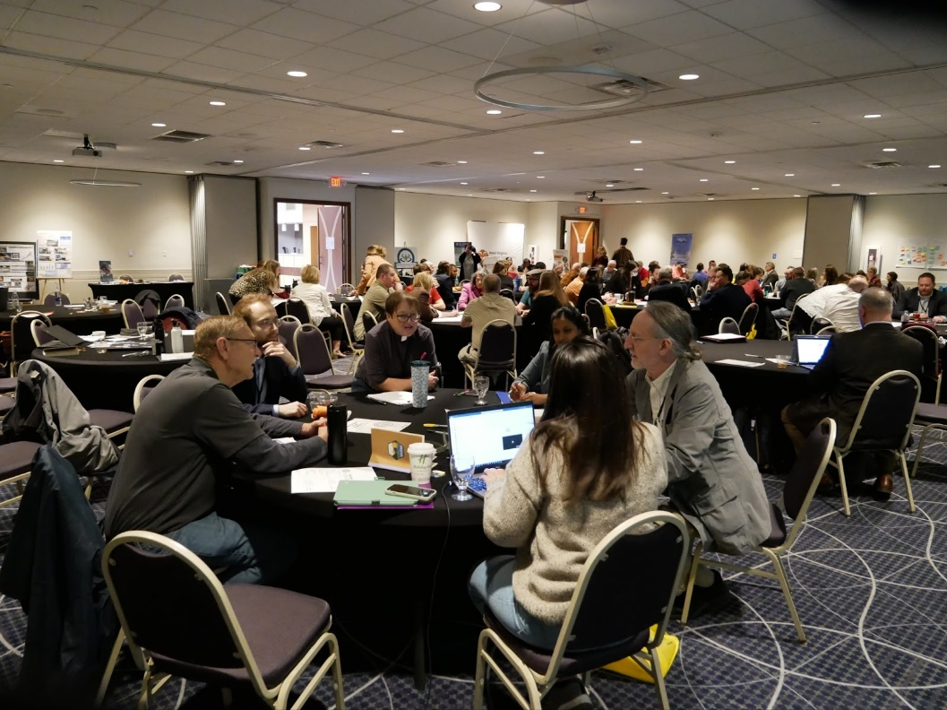
When assessing the barriers to coordination between agencies and organizations in each phase of a disaster, communication was the most frequently mentioned barrier. Other commonly mentioned barriers included communication, funding/resources, turnover, ego, training/education, roles/responsibilities, planning/preparedness, and cultural limitations. Solutions to improving communication included marketing, networking (especially before emergencies), direct communication during crises, and improved coordination through Emergency Operations Centers (EOCs). Regular training sessions and exercises and education about roles and responsibilities within organizations also would help to overcome these barriers. Memorandums of Understanding (MOU) are a key component of the planning and preparedness stage and help to integrate planning strategies.
Planning was the most commonly mentioned method for overcoming barriers. Both in respect to developing written plans, like standard operating procedures (SOPs) and comprehensive plans, but also with other planning efforts like staging resources in advance, maintaining flexibility, raising public awareness, centralizing and updating datasets, sound fiscal planning, and securing funding to support disaster preparedness. Conducting educational outreach and regular training sessions will help to improve communication and ensure transparency among stakeholders. Moreover, building relationships through these meetings and other networking opportunities before disasters occur and during “blue sky” days will improve and clarify role responsibilities.
Similar to the question before, attendees described key attributes of individual and/or community flood resiliency. While many attendees noted previously mentioned attributes like preparation, planning, education, communication, and relationships, new responses described effective leaders. Personal attributes included maintaining a positive attitude, confidence, willingness to listen, being open to change, advocating for and pushing past political barriers, and building consensus within the community. Mitigation and risk management also became a central attribute, such as elevating buildings, floodproofing, code enforcement, and understanding individual and community risks.
To build attributes for individual and community flood resiliency, education and training was mentioned among almost all groups. New insights that were not mentioned in the previous questions included conducting exercises and practice sessions for real-word scenarios, using media and outreach programs to disseminate information, and encouraging community participation to build trust and address community needs. Within media and outreach, maintaining consistency in messaging and ensuring accountability among leaders were key components.
To inform the West Virginia Flood Resiliency Framework (WVFRF), attendees suggested that the following be incorporated into the framework. This included 1) current comprehensive and accessible resources, case studies, research data, and bibliographies; 2) educational materials and guides: how-to guides and applicant guides, glossary of acronyms, lesson plans for K-12 teachers to teach disaster preparedness; 3) mitigation and planning tools: flood resiliency plans, hazard mitigation plans, comprehensive plans, and emergency action plans; 4) practical examples and templates: mitigation fact sheets, policy guides, toolkits, and templates for plans; 5) communication and outreach: contact lists, public comment section, crowdsourcing community knowledge, and educational flyers; 6) policy and governance: state and regional involvement, defined roles and responsibilities, and examples of statute language; 7) funding and support: disaster trust fund and list of available grants; and 8) technical and operational tools: stream cleaning and debris management and continuity documents for personnel turnover.
References
Day, J. (n.d.). Cross-Sector Disaster Simulation Game. http://www.aidforum.org/docs/Jamison_Day.pdf

  - Interactive Questions and Responses-
  - Post-It note activity

During the symposium, there were numerous opportunities for participants to answer interactive questions for using Post-it notes. Below are the questions and responses from the attendees.

What does community resiliency mean to you?
- The ability to come together and respond
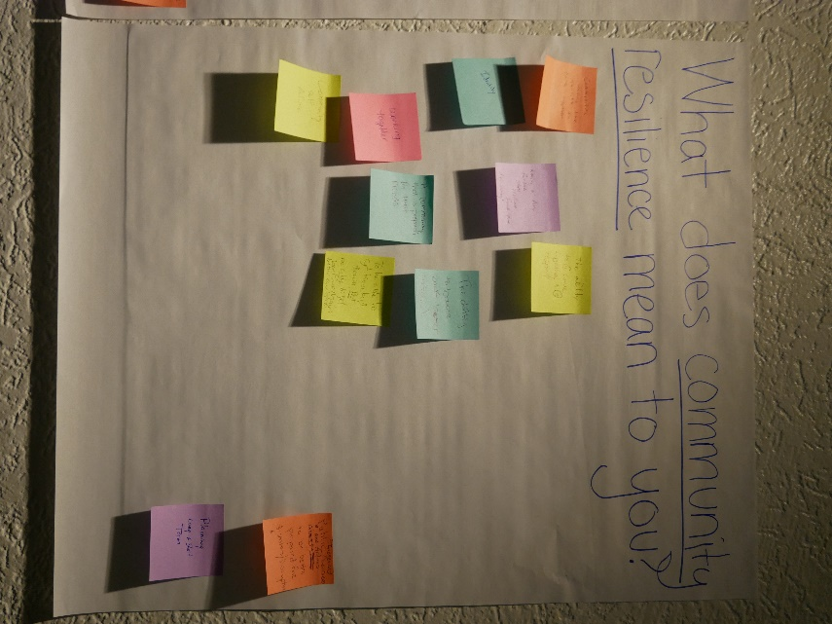
- Working together
- A community that is prepared for their floods
- To be able to get knocked down, but be able to get back up again better equipped
- Ability to get knocked down and still have the resources to get up again
- Community self-reliance
- Planning long + short term
- Increased public awareness and actions to be better prepared for disasters/disruptions
- The ability to bounce back better
- Having a fully funded state resilient fund that has money!
- Identity
- Communities having the ability to come together
- GRIT sharing resources

What gives you hope for long-term recovery efforts?
- A robust VOAD!
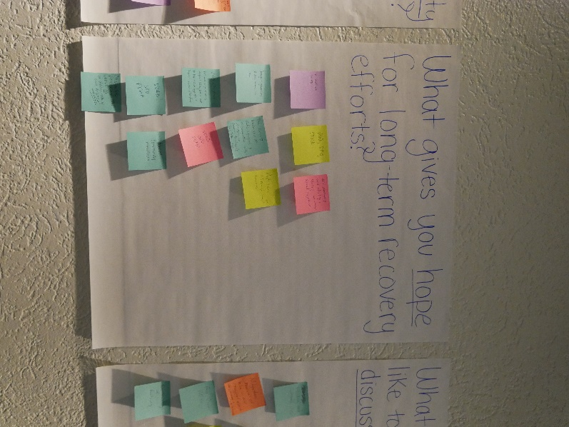
- VOAD, SRO, FEMA
- WV community and identity is strong. We always stand together
- Younger generations finding careers in EM
- The current leadership at state agencies & at communities with interest in economic development “long term” ideas
- People can change and learn
- Personal preparedness is difficult today, but we need to keep educating people to prepare themselves & families
- Events like this and improved collaboration
- Informed community members
- Collaborative partnerships that involve all in decision making and engaged

What is the main reason you came to the symposium?
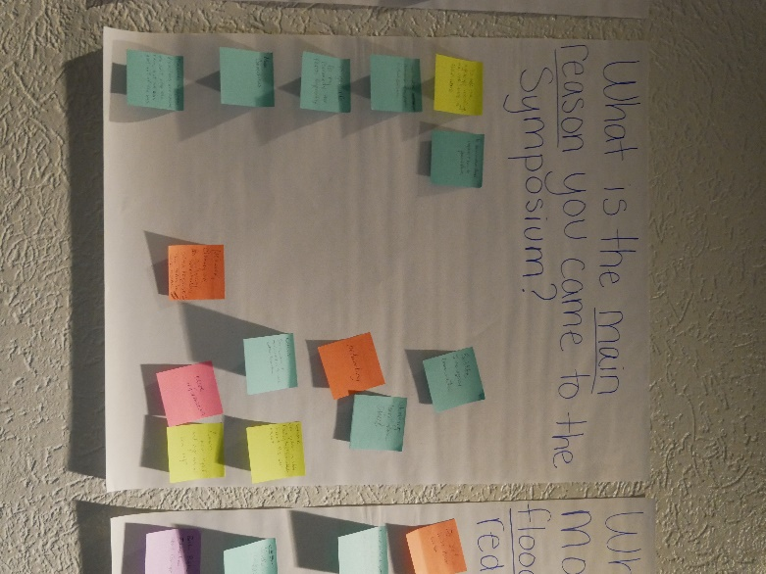
- To help the agencies working on resilience in their work
- To learn more on flood impacts & how to prevent them
- Get better partnerships w/ key people in Flood Resilience
- Make Connections
- To get info for my community that floods frequently
- Hazards happen; disasters are caused. We can’t stop the rain, but we can get out of the way
- Network, clarity on patrons/stakeholders, roles + responsibility, how better to work together.
- Networking and education
- Always learning
- Facilitate Inter-agency Communication
- Networking, Learn from others
- Learn how my network and I can help
- Network, get updates on state flooding/resiliency efforts, Support this NSF project
- Network, get counties & municipalities to work better together
- More information

What would enable more people to access flood insurance, other than reducing costs?
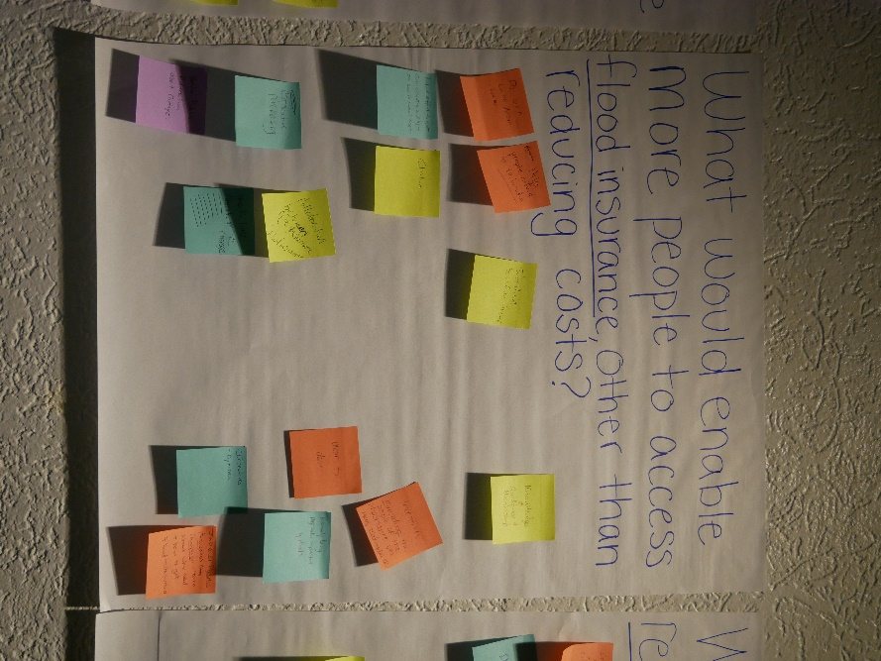
- Do not live near water ← Help people afford to relocate
- Actual effort to get cost estimates and figure out how to make it happen
- Subsidize based on income
- Knowledge and Guidance and Mentorship
- Education
- Incentives, Educating the people of the importance via news, social media, etc Door to Door
- Incorporating in Social Sciences (vulnerable populations don’t have assets)
- Collaboration between fire insurance and flood insurance
- Cooperative purchasing
- Better Public Education about coverage
- Increase Public Awareness Campaign- learn about why need and how to get Flood Insurance
- Education
- Incentives, options
- Personally, being negatively impacted by floods
- Truly understands risks and options
- Education on ICC Coverage

Post Symposium survey Summary

Out of the 117 attendees, 37 people participated in the post-symposium survey. Team members involved in planning the symposium did not take the survey (~20 people). Therefore, this data represents about 40% of the attendees’ experience. During the symposium, participants engaged in discussions and activities related to disaster preparedness, response, and recovery. One outcome of the symposium was the significant increase in participants' sense of connectedness within the disaster preparedness network. Before the event, many felt moderately connected to the network, with an average rating of 4.91 out of 10. However, this number increased to 7.87 post-symposium, reflecting a 60.28% increase in network connections among attendees as a result of the symposium.

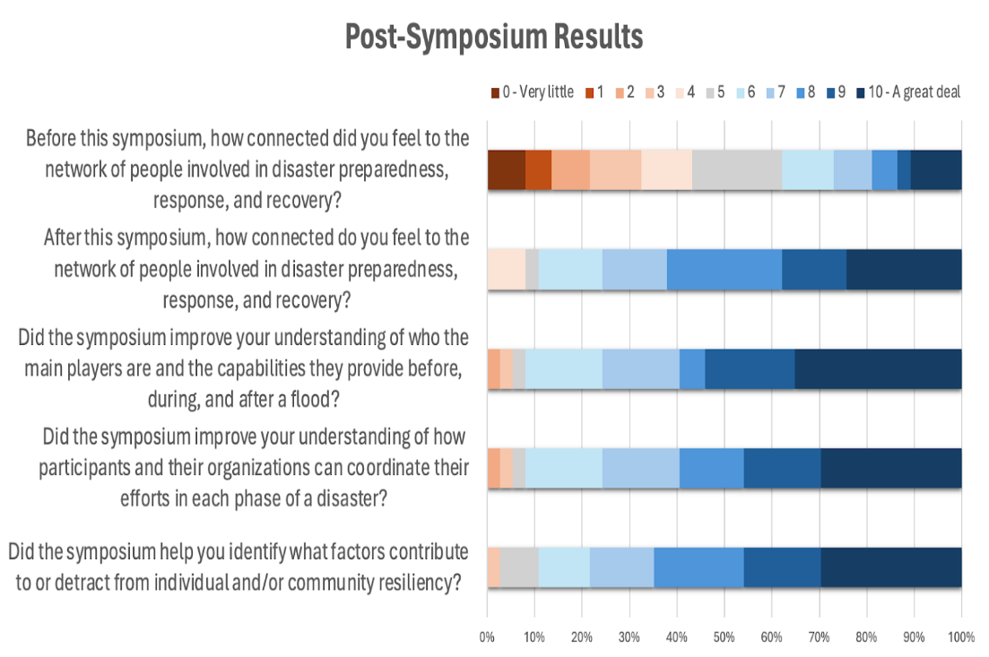
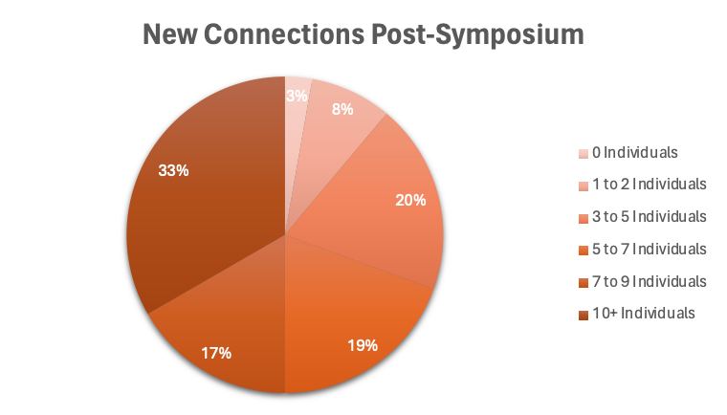
The symposium provided opportunities for attendees to share and expand their understanding of the complexity of disaster management. We asked participants if the symposium improved their understanding of the main players and their capabilities in flood preparedness, response, and recovery. On a scale from 0 to 10 (0 = Very Little to 10 = A Great Deal), the average rating stood at 7.99, demonstrating participants felt like the symposium significantly increased their understanding of the main players and their capabilities. Using the same scale, we asked participants if the symposium improved their understanding of how participants and their organizations can coordinate their efforts across different phases of a disaster. The average answer was approximately 8.84, indicating the symposium increased understanding of coordinating efforts.
Regarding identifying factors contributing to or detracting from individual and community resiliency, participants rated their understanding at approximately 7.14 out of 10 as a result of the symposium. One participant said, “Thank you, Dr. Shinn, for your point about meeting communities where they are. I don’t know that some folks in the day-to-day “work” of floodplains etc., really understand some of the issues faced at the community level concerning capacity and funds.” This anecdote captures the sentiment of resiliency at the community level.
Additionally, networking emerged as one of the most useful aspects of the symposium, with participants valuing the opportunity to interact and work with others to increase flood resiliency. The survey responses made clear that attendees were proactive in creating new relationships, with an average of seven new connections made per attendee. Notably, twelve individuals answered that they formed connections with 10 or more attendees after the symposium.
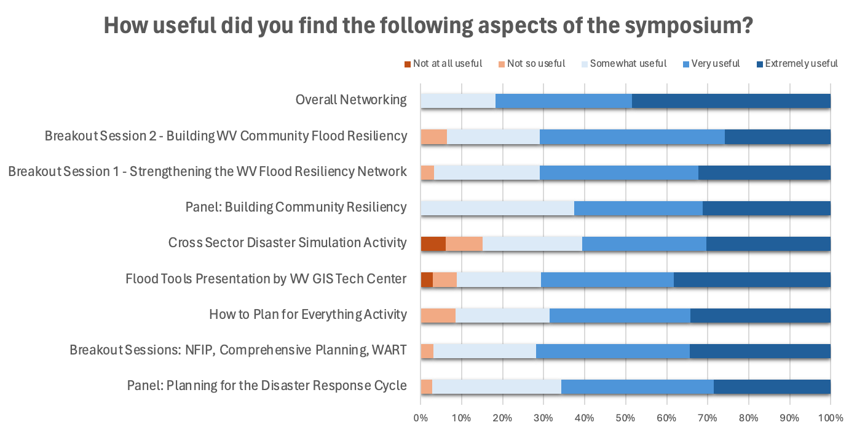
When considering the West Virginia Flood Resilience Framework (WVFRF), some attendees expressed certain changes that could be added to the framework. One attendee emphasizes the importance of incorporating information from the US Army Corps of Engineers (USACE) that can help communities. Another attendee stated that there should be an acknowledgment of the voluntary organizations’ roles in recovery. Also, there should be a strong emphasis on encouraging broader community engagement. The insights provide valuable guidance for shaping the WVFRF to address the needs of those involved. However, of those who responded to the open-response question asking if they understood how the WVFRF can benefit your work/community, all responses said yes, indicating a clear conveyance of the framework.
Following the symposium, several key topics emerged that warrant further exploration post-symposium through follow-up meetings, workshops, and discussion. One topic was that the collaboration with the WVU land clinic should focus on innovative land use planning beyond comprehensive plans. Additionally, attendees noted that collecting data on the capacity of relief organizations (asset mapping) is crucial in decision-making. Moreover, brainstorming sessions should be organized to explore collaborative opportunities to submit grants like PROTECT or HMGP grants. These follow-up initiatives can build on progress made at the symposium and help further efforts towards enhancing disaster preparedness and resilience within the community.

Appendix I: Links to Resources

- Building Flood Resiliency Symposium Welcome PowerPoint
- Building Flood Resiliency Symposium Recap Video
- West Virginia Flood Resiliency Framework Website

Appendix II:agenda

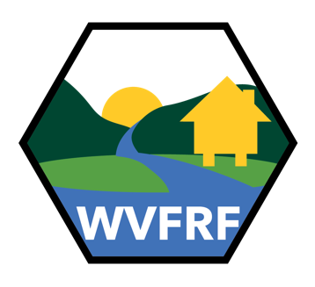
Symposium: Building Flood Resiliency in West Virginia Communities
March 12-13, 2024
Holiday Inn & Suites, 400 2d Ave SW, Charleston WV 25303
Detailed Agenda

Tuesday, March 12, 2024
Day | Time | Session | Location | Presenter(s)
Tuesday | 8:00 – 9:00 | Registration Opens
Tuesday | 9:00 – 9:15 | Welcome and Introductions | Centennial | Jamie Shinn, Assistant Professor at SUNY College of Environmental Science and Forestry (SUNY-ESF) and West Virginia Flood Resiliency Framework Project Team
Tuesday | 9:15 – 9:30 | Overview of NSF Study & Symposium Goals | Centennial | Jamie Shinn, SUNY-ESF and WVFRF Project Team
Tuesday | 9:30 – 10:00 | State Flood Resiliency Plan | Centennial | Robert Martin, Director of the West Virginia State Resiliency Office (SRO)  Edwin Martin, Deputy Director of the West Virginia State Resiliency Office (SRO)
Tuesday | 10:00 – 10:15 | Coffee & Tea Break
Tuesday | 10:15 – 12:00 | How to Plan for Everything Activity  There are an endless number of disasters to worry about. Preparing for every possible disaster leaves you with a long, disorganized list of things to buy or do, which may not match personal needs. Preparation can seem unattainable. We check off the first few items from our list, give up, and hope the zombies eat us first.  It's time to start preparing with two simple changes: First, Prepare for disruptions, not disasters. It doesn't matter whether a power outage was caused by a flood, backhoe, or someone backing into a pole. Just prepare for the power outage! Preparing for a few disruptions will prepare you for any disaster. You really can prepare for everything. Second, prepare together. We prepare better when we prepare together. How to Prepare for Everything gives you a simple, step-by-step approach to prepare yourself and your neighbors for emergencies, accidents, adventures, and life's ups and downs. | Centennial | Aaron Titus, Executive Director of Crisis Cleanup
Tuesday | 12:00 – 1:00 | Lunch (provided) | Reception Hall
Tuesday | 1:00 – 2:00 | Panel: Planning for the Disaster Response Cycle  Panelists:  Debbie Sizemore, President of Williamsburg Area Emergency Response Team (WART)  Paula Brown, Deputy Director of Greenbrier County Homeland Security and Emergency Management  Dave Lumsden, Disaster Response Coordinator for Episcopal Diocese of West Virginia  Cathy Rennard, Former Disaster Case Management Supervisor for West Virginia Voluntary Organizations Active in Disaster (WV VOAD)  James Young, Disaster Field Coordinator for the Federal Emergency Management Agency,  Tim Keaton, NFIP/CTP Coordinator at West Virginia Emergency Management Division  Tammy Tincher, President County Commissioner for Greenbrier County | Centennial | Julian Levine (moderator), Director of Population Health & Community Engagement at West Virginia School of Osteopathic Medicine, Center for Rural and Community Health (WVSOM CRCH) and WVFRF Project Team
Day | Time | Concurrent Sessions (3) | Location | Presenter(s)
Tuesday | 2:00 – 3:00 | National Flood Insurance Program (NFIP) | Montgomery | Tim Keaton, National Flood Insurance Program (NFIP)/Cooperating Technical Partner (CTP) Coordinator at West Virginia Emergency Management Division (WVEMD)
Tuesday | 2:00 – 3:00 | Tools for comprehensive flood planning  This session will briefly introduce legal and planning tools effective at reducing impacts from flooding. Tools include floodplain overlays, setbacks, floodplain ordinances, and non-regulatory tools such as deed restrictions. After introducing a variety of tools, hypotheticals will be discussed covering common questions. In addition, the panel will discuss HB 171 impacting the regulation of agriculture with flood regulation as an example. | Capitol | Katherine Garvey, Director of Land Use Law Clinic at West Virginia University (WVU)  Jared Anderson, Land Use Attorney, Land Use Law Clinic at West Virginia University (WVU)
Tuesday | 2:00 – 3:00 | Williamsburg Area Response Team (WART)  Nominated for two awards in the area of disaster response, the Williamsburg Area Emergency Response Team model is a program designed to help rural communities establish a local emergency crisis team. This nuts-and-bolts session aimed specifically at small towns and communities, will help participants think through what is needed before, during, and after a disaster. The session will describe one very rural community’s effort to build and sustain capacity in the area of emergency response and will provide practical tips on how participants can build their own teams prior to a catastrophic event. | Centennial | Debbie Sizemore, President of Williamsburg Area Emergency Response Team (WART)
Tuesday | 3:00 – 3:15 | Coffee & Tea Break
Day | Time | Session | Location | Presenter(s)
Tuesday | 3:15 – 4:15 | WV Flood Risk Assessment and Visualization Tools  The West Virginia GIS Technical Center will provide background on flood-related tools, such as the West Virginia Flood Tool, and in-progress data, mapping efforts, and application development as part of the West Virginia Flood Resiliency Framework. The Center hopes to encourage feedback and discussion on existing tools and needs for landowners, flood mitigation professionals, and community leaders to understand risk and resiliency to flooding and plan for mitigation. They will generally discuss their contributions to the West Virginia Food Resiliency Framework and work moving forward. | Centennial | Kurt Donaldson Director of the West Virginia GIS Technical Center (WVGISTC)  Aaron Maxwell Faculty Director for the WVGISTC, faculty member in the Department of Geology and Geography at WVU, and WVFRF Project Team  Behrang Bidadian, Research Associate and GIS Analyst at the WVGISTC  Annie Mahmoudi, Graduate Research Assistant and PhD student funded by the WVGISTC
Tuesday | 4:15 – 4:45 | National Weather Service Flood Inundation Mapping Service  The longstanding demand for event-driven flood inundation mapping (FIM) has increased dramatically in recent years as a high value source of actionable information for emergency and water resource managers to prepare, mitigate, and respond to flood impacts. In response, the National Water Center of the National Weather Service has developed and demonstrated high-resolution inundation modeling capabilities which complement and expand upon existing static FIM libraries providing geo-referenced visualizations of forecast flooding extent at the continental scale. These new inundation mapping capabilities translate analysis and forecasts of streamflow into operational maps that communicate impact by showing where flooding may occur. | Centennial | Nicholas Webb, Senior Service Hydrologist/Meteorologist National Weather Service
Tuesday | 4:45 – 5:00 | Daily Recap, Reflections, Wednesday Agenda Preview | Centennial | Jamie Shinn, SUNY-ESF and WVFRF Project Team  Aaron Titus, Executive Director of Crisis Cleanup
Tuesday | 5:15 – 6:30 | Social Event (appetizers provided)
Wednesday, March 13, 2024
Day | Time | Session | Location | Presenter(s)
Wednesday | 9:00 – 9:15 | Day 1 Observations Summary | Centennial | Jamie Shinn, SUNY-ESF and WVFRF Project Team  Aaron Titus, Executive Director of Crisis Cleanup
Wednesday | 9:15 – 10:15 | Cross Sector Disaster Simulation  The Cross-Sector Disaster Simulation Game simulates cross-sector collaboration and coordination before, during, and after such disasters. Each person is assigned a role, such as government, for-profit company, non-profit organization, or community member. We coordinate on the local, state, and national level prior to the disaster. Once a disaster happens, everyone needs to work together to ship food, water, and medicine within three days. Each "day" is just a few minutes long. The fun (and anxiety) starts when plans, relationships, and competing priorities are challenged in a high-stress, chaotic environment. Afterward, we debrief and analyze the outcomes. | Centennial | Aaron Titus, Executive Director of Crisis Cleanup
Wednesday | 10:15 – 10:30 | Coffee & Tea Break
Wednesday | 10:30 – 11:00 | Cross Sector Disaster Simulation Debrief | Centennial | Aaron Titus, Executive Director of Crisis Cleanup
Wednesday | 11:00 – 12:00 | Panel: Building Long-term Community Resiliency  Panelists:  Sarah Riley, Executive Director of High Rocks  Brian Farkas, Federal Emergency Management Agency Interagency Recovery Coordinator with WV FEMA Integration Team Office (WVFIT)  Debbie Sizemore, WART  Jenny Gannaway, Executive Director of West Virginia Voluntary Organizations Active in Disaster (WV VOAD)  Dave Lumsden, Episcopal Diocese of WV  Robert Martin, SRO  Tim Keaton, NFIP/CTP Coordinator at WVEMD | Centennial | Julian Levine (moderator), WVSOM CRCH and WVFRF Project Team
Wednesday | 12:00 – 1:00 | Lunch (provided) | Reception Hall
Wednesday | 1:00 – 2:00 | Breakout Session 1 - Strengthening the WV Flood Resiliency Network |  | Jamie Shinn (moderator), SUNY-ESF and WVFRF Project Team  Julian Levine (moderator), WVSOM CRCH and WVFRF Project Team  Aaron Maxwell (moderator), WVGISTC, WVU, and WVFRF Project Team
Wednesday | 2:00 – 2:15 | Coffee & Tea Break
Wednesday | 2:15 – 3:15 | Breakout Session 2 - Building WV Community Flood Resiliency |  | Jamie Shinn (moderator), SUNY-ESF and WVFRF Project Team  Julian Levine (moderator), WVSOM CRCH and WVFRF Project Team  Aaron Maxwell (moderator), WVGISTC, WVU, and WVFRF Project Team
Wednesday | 3:15 – 3:45 | Presentation with Q&A: Building & Maintaining the West Virginia Flood Resiliency Framework | Centennial | Jamie Shinn, SUNY-ESF and WVFRF Project Team  Robert Martin, SRO  Aaron Maxwell, WVGISTC, WVU, and WVFRF Project Team
Wednesday | 3:45 – 4:00 | Closing Remarks | Centennial | Jamie Shinn, SUNY-ESF and WVFRF Project Team


Thank you for coming! Please take our post-symposium survey by scanning the QR code or visiting https://tinyurl.com/WVFRFsymposium.


Appendix III: ATTENDEEs

Name Affiliation
Aaron Maxwell………………………………West Virginia GIS Technical Center (WVGISTC)
Aaron Titus……………………………………………………….……………………………..Crisis Cleanup
Adam Stollings …………………..………………………………………….USDA Rural Development
Alan Harris………………………………………………………….………….USDA Rural Development
Albert Ray Perry…………………………….West Virginia Floodplain Managers Association
Alex Ellis…………………………………………………………………..…………..Wyoming County 911
Allison Hoosier……………………………………………………………………..Wyoming County 911
Amanda Smarr………………………………….Region 4 Planning and Development Council
Amberlea Perks…………….West Virginia Emergency Management Division (WVEMD)
Amy Clark……………………………………State of West Virginia Department of Commerce
Andrea Cass…………………………....SUNY College of Environmental Science & Forestry
Annalee Posey………………………………………………………….…..Appalachia Service Project
Annie Mahmoudi…………………………..………………………………………………………. WVGISTC
April Knight………………………………………………………………………………….West Virginia 211
Behrang Bidadian………………..…………………………… West Virginia GIS Technical Center
Betsy Morris………………………………………Region 4 Planning and Development Council
Bo Belshee……………………………………………………………..…City of White Sulphur Springs
Bob Martin…………………………………..….West Virginia State Resiliency Office (WVSRO)
Brady Shrader……………………………………………….……….West Virginia University (WVU)
Brandon Moore………………..………..West Virginia Department of Highways (WVDOH)
Brendan Muckian-Bates………………………………………Appalachian Citizens’ Law Center
Brian Aluise………………………………………………………….………….Senator Manchin’s Office
Brian Farkas………………………..……..Federal Emergency Management Agency (FEMA)
Cameron Boggs……….…………………….West Virginia Voluntary Organizations Active in Disaster (WV VOAD)
Cathy Colby……………………………………………West Virginia Housing Development Fund
Cathy Rennard………………………………………………………………………………………..WV VOAD
Chris Schroeder……………………………………………..……………Appalachian Service Project
Christi Hicks………………………..USDA Natural Resources Conservation Service (NRCS)
Chuck Grishaber……………………………………………………….………..CFM City of Charleston
Clayton Scott……………………………………..…………………………………………………USDA NRCS
Cory Clay……………………………………………………………………………………………………WVEMD
Dale McEwuen…………………………………………………………………..Wood County, WV E911
Dara Vance………..……………West Virginia School of Osteopathic Medicine (WVSOM)
Darian David……………………………………………….Congresswoman Carol D. Miller Office
Dave Lumsden…………………………………………………..Episcopal Diocese of West Virginia
Debbie Sizemore………………Williamsburg Area Emergency Response Team (WARTS)
Direl Baker………………………………………………………………………..Lincoln County 911/OES
DJ Morgan………………………………………………………………………….WV House of Delegates
Douglas Kirk……………………………………………………………………………………………….WVDOH
Ed Martin……………………………………………………………………………………………………WVSRO
Emily Brammer……………………………………………………………………………………………….WVU
Eric Hopkins……………………………………………………………………………………………. WVGISTC
Eric S. Duff…………………………………………………………………………………. Town of Alderson
Forrest Palmer…………………………….. Presbyterian Disaster Assistance and WV VOAD
Francis Holton……………………….... Lincoln County Office of Emergency Services(OES)
Gabriel Reed………………………………………………………………………………………..……WVEMD
George Eidel…………………………………………………………..Doddridge County Commission
Gina Namay………………………………………………………………………………………Volunteer WV
Ginger Barnett…………………………………………………………………………………………..WVEMD
Haidyn DePinho………….…….WV Department of Environmental Protection (WVDEP)
Hannah Thacker……………………………………….Natural Resources Conversation Service
Jacob Kravetz……………………………………………………National Science Foundation (NSF)
James Young………………………………………………………………………………………………….FEMA
Jamie Shinn……………………………………………………………………………………………..SUNY ESF
Jamie Wolfe………………………………………………Resiliency Center at Marshall University
Jared Anderson………………………………………………..WVU College of Law, Land Use and Sustainable Development Law Clinic (LULC)
Jennifer Berryman…………………………………National Weather Service Charleston, WV
Jenny Gannaway……………………………………………………………………………………..WV VOAD
Jim McCune…………………………………………………………………….United Methodist Church
Judith Lyons…………………………………………………………………….WV Conservation Agency
Julian Levine……………………………….WVSOM Center for Rural and Community Health
Julie Alston…………………US Department of Housing and Urban Development (HUD)
Julie Sears……………………………………………………………………………………State of WV NFIP
Kase Poling……………………………………………………………………………………………..WVU Tech
Katherine Garvey…………………………………………………………………….WVU College of Law
Kate Cruickshank………………………………………………………………………………………..WVDEP
Keith A. Gunnoe……………………………………………………………………………..Mercer County
Kelly Banton………………………………………………………………………………Greenbrier County
Kevin King……………………………………………………………………Mennonite Disaster Service
Khristina Jones………………………………………………………………………………………..WV VOAD
Kurt Donaldson………………………………………………………………………………………..WVGISTC
Lexi Browning……………………………………………………………..WV Grant Resource Centers
Lindsey Hanks…………………………………………………………………………………………….WV SRO
Lora Pierce…………………………………………………………….................Catholic Charities WV
Mark Lambert……………………………………………………….WV State Fire Training Academy
Mark Swiger…………………………………………………………………………………...WVU Extension
Mary Poke………………………………………………………………………………………………WV VOAD
Mary Saunders………………………………………………………..Community Lutheran Partners
Marilyn Lynch……………………………………………………………………………………………WVEMD
Matthew Blackwood…………………………………………………………………………………WVEMD
Matthew Williams………………………………………………………………………………….…WVSOM
Megan Frampton……………..WV Community Advancement and Development (CAD)
Megan Kruger………………………………………………………………………………..WVU Extension
Melanie Boothe………………………………………………………………………………………….WVCAD
Melanie Neal………………………………………………………………US Army Corps of Engineers
Melisa Winburn………………………………………………………….…Appalachia Service Project
Melynda Sampson…………………………………………………………………………….……….WV 211
Morgan A. Saunders………………………….….The West Virginia Grant Resource Centers
Nazma Ahmed………………………………………………………………………………………………..WVU
Nick Webb………………………………..…………..National Weather Service Charleston, WV
Nico Zegre………………………………………………………………Mountain Hydrology Lab WVU
Olivia Hensley…………………………………………………………………….US Department of HUD
Paula Brown…………………….……Greenbrier County Homeland Security & Emergency Management
Rebecca Chestnutt…………………………………………………………………..The Salvation Army
Richard Begley……………………………………………………………………..….Marshall University
Ruthana Beezley……………….Greenbrier Valley Economic Development Corporation
Ruthie Maniscalchi……………………………………………………………………………..…….WVEMD
Ryan Halsey………………………………………………………………………………………..……..WVCAD
Sandy Keener……………………………………………………………………………….………..WV VOAD
Sara Dyer……………………………………………………………………….….WV House of Delegates
Sara Hambrick………………………………………………………………………………………………….SBP
Sarah Woody…………………………………..……..….Greenbrier County Health Department
Scott Smith………………………………………..….West Virginia Housing Development Fund
Senator Chandler Swope………………………………………………………………WV State Senate
Sherry Risk………………………………………………………………………………………………………..SBP
Tammy Tincher…………………………………………………………………………Greenbrier County
Taryn Moser…………………………..…………………………WV Geological & Economic Survey
Terri Jo Bennett…………………………………………………………….……….County Government
Thomas Smith………………………………………………………………..…..Senator Capito's Office
Tigra Yang……………………………………….…Department of Civil Engineering, WVU TECH
Tim Ellison…………………………………………………………………………….Wyoming County 911
Tim Keaton………………………………………………………………………………………………..WVEMD
Tom Hansen………………………………………………………………………………………………….FEMA
Ty Smith………………………………………………………………………………….……City of Princeton
Wesley A. Smith………………………………………………….…..Kanawha County Commission
William Kuhn…………………………………………………………………………………………………FEMA
Vivian Wood……………………………………………………………………………………..………WVEMD
Xzavier Morgan…………………………………………………………………………………………WVEMD

