A Best practices guide to building resiliency in west Virginia communities before, during, and after FLOOD disasters | Olson Harris Ltd.
Establishing Community Organizations Active in Disasters (COADS)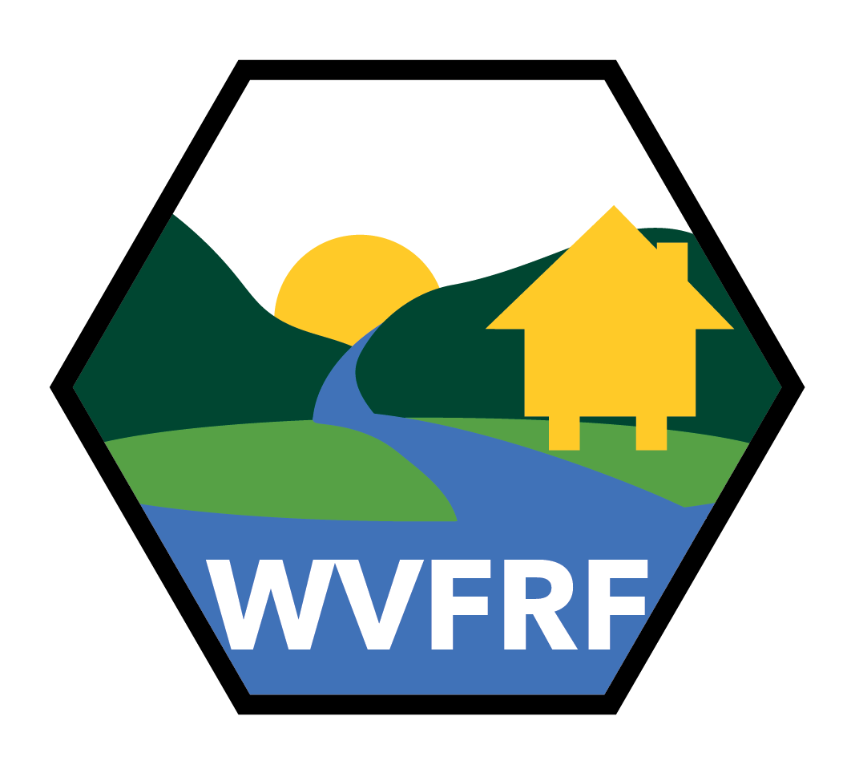
December 2024
Created as part of the West Virginia Flood Resiliency Framework (wvfrf.org)

TABLE OF

CONTENTS
Table of Contents
Executive Summary 3
CHAPTER 1 BUILDING RESILIENCY BEFORE A DISASTER STRIKES 4
STEP 1: CREATE AN EMERGENCY COMMUNICATION PLAN 6
STEP 2: CREATE AN EMERGENCY RESPONSE PLAN 7
STEP 3: PLAN FOR SHELTER & FOOD 10
CHAPTER 2 EFFECTIVE RESPONSE DURING A DISASTER 11
CHAPTER 3 BUILDING RESILIENCY AFTER A DISASTER 13
CHAPTER 4 SPECIAL CONSIDERATIONS FOR UNINCORPORATED AREAS 15
APPENDIX 1: KEY CONTACTS FOR DISASTER RESPONSE & RECOVERY 17
APPENDIX 2: THRESHOLDS FOR DISASTER DECLARATIONS 20

Suggested Citation: A Best Practices Guide to Building Resiliency in West Virginia Communities Before, During, and After Flood Disasters: Establishing Community Organizations Active in Disasters (COADS). (2024). The West Virginia Flood Resiliency Framework. URL: wvfrf.org, Date of Access:

Executive
  - summary
Community resiliency is the ability to withstand and mitigate the effects of a disaster. An essential component of community resiliency is effective pre-disaster coordination of the complex network of actors involved in response and recovery. Easily one of the most important players in such networks is a community group organized to address disasters, either formally or informally. Captured in this guide as Community Organizations Active in Disaster (COADs), these groups can be part of planning councils, local governments, voluntary organizations, or any number of like bodies. Whatever title or name they use, the key is that these COADs are groups of like-minded individuals, organizations, and agencies working toward the common purpose of increasing their community’s disaster resiliency through robust cooperation, communication, coordination, and collaboration before, during, and after a disaster.
“All disasters begin and end locally.”

This guide is intended to assist communities across West Virginia establish and strengthen their COADs. COADs can play a critical role in meeting unmet needs in their communities in the event of a disaster, but they can also do much more. Permanently established COADs can encompass all phases of disaster management: mitigation, prevention, preparedness, response, and recovery. COADs use community disaster education, hazard analysis, training exercises, community leadership classes, local emergency management plans, and the expertise of community members to bring holistic disaster awareness to their communities.
This guide is part of the West Virginia Flood Resiliency Framework (WVFRF), funded by the National Science Foundation’s Civic Innovation Challenge Program (CIVIC), and was created based on research about and with the West Virginia disaster response and recovery network. The framework, including this guide, is designed to support resiliency in communities across West Virginia. You can also find the guide, along with other information relevant to disaster response in West Virginia, in the Hazards Library section of the Framework.

Chapter 1
  - BUILDING RESILIENCY BEFORE A DISASTER
Developing a disaster-response plan prior to an event is critical to help West Virginia communities respond to and recover from disasters. The insights included in this guide can help communities identify the steps necessary to formulate a plan, so they are ready in the event of a disaster.

Ultimately, resiliency comes down to two factors: relationships and resources. The more you can invest in building relationships and identifying resources prior to a disaster event, the easier it is to access them when you need them.

Relationships
Resources
Resiliency
FOSTERING RELATIONSHIPS THROUGH LEPCs
Throughout the country and in every West Virginia county there is a local emergency planning committee (LEPC). LEPCs are federally mandated entities intended to form a partnership between local governments and industry to enhance hazardous materials preparedness efforts. LEPCs can be composed of state and local officials; professionals representing sectors such as environment, transportation, fire, civil defense, and hospital and public health; and representatives from community groups and the media. They are meant to “develop emergency response plans, review those plans at least annually, and provide information … to citizens.”

From a community resiliency perspective, LEPCs provide a solid starting point for building COADs. While generally focused on the emergency phase of a disaster (e.g., rescues, relief, etc.), an expanded membership includes voluntary, faith-based, nonprofit organizations and other community partners. The relationships built through LEPCs lend themselves to disaster response scenarios requiring extensive long-term recovery.
During “blue skies” (i.e., before-a-disaster) exercises, community leadership should work with LEPC leadership to develop an expanded membership and to ensure LEPC training includes post-emergency/recovery operations. LEPC’s are encouraged to reach out to the organizations who will have a role in recovery operations and invite them to participate in LEPC events.

ASSESSING RISK & EDUCATION
One of the most frequent disasters encountered in West Virginia is flooding. The first step for individual residents, local leadership, and anyone in the LEPC and COAD communities is assessing their area’s risk of flooding. The WV Flood Resiliency Framework can assist with this effort and the Risk Explorer it includes is recommended as a first stop for assessing risk at any scale, from state down to building levels. Once risk is understood, education of the community is a critical next step. In a statewide survey conducted by the WVFRF project, over 40% of respondents who report being previously impacted by a flood did not know their residence was in a floodplain before the event.

ASSET MAPPING– IDENTIFYING YOUR AVAILBLE RESOURCES
Related to risk assessment is understanding what resources a community has and what resources it needs. Most counties have a good understanding of what resources are needed during an emergency (e.g., first responders and their equipment, medical resources, shelters, etc.). For emergency operations if they do not have those resources they typically know where to get them. But for post-emergency operations– particularly long-term recovery operations– understanding what is needed is less certain. For example, in the case of a flood communities may need:
- People to write grants to apply for funding
- Foundation funders to fill gaps in state and federal funding
- Temporary housing for displaced survivors
- A system for post-flood case management
- Volunteer recruitment, coordination, and housing

In the pages that follow, recommendations are offered that will help you foster the relationships and develop the resources needed to respond to a disaster when it occurs– in other words, how to increase your community’s resiliency through pre-disaster planning.
STEP 1: CREATE AN EMERGENCY COMMUNICATION PLAN
- MONITOR: Stay up to date with the National Weather Service and Emergency Management.
- EMERGENCY CALL LIST: Create a digital and paper copy of an emergency call list. Cell phones may not work in a disaster, so include landlines when possible. See Appendix 1 to get started.
- RESOURCE LIST: Create a digital and paper copy of emergency resources available in the community.
- INSURANCE INFO: Create a digital and paper file with insurance policy information for your town or community, including policy numbers and phone numbers for claims.
- MEET REGULARLY: Establish quarterly meetings to review and revise emergency planning documents. Consider working with local LEPC.
- BLUE SKIES TRAINING: Consider implementing “blue skies” training exercises to practice emergency response.
  - 211: If a 211 system is not already in place, consider contracting with a call center to receive requests for assistance. You can find more info at: https://www.211.org/
- PLAN FOR INFORMATION DISSEMINATION: Determine how you will disseminate information in a disaster. Social media may be an effective way to disseminate useful information, but it can also be the source of bad information.
- PLAN FOR A PIO: Determine who will be a Public Information Officer to be the point person to spread essential information quickly and efficiently during a disaster.
- INTEGRATE EARLY WARNING SYSTEMS: Consider incorporating early warning systems into city and county websites. 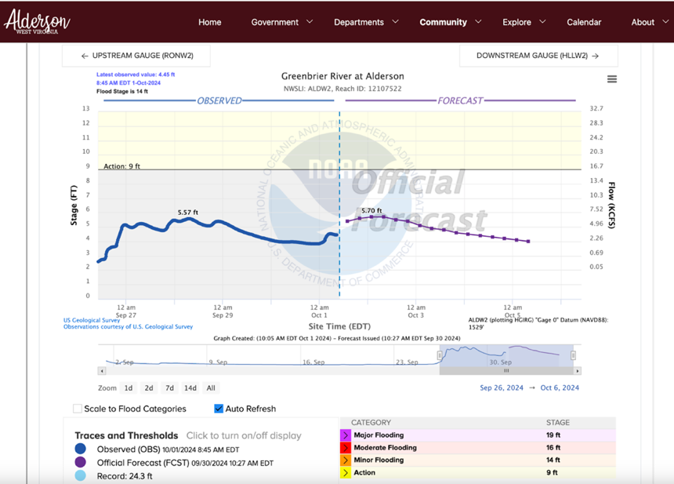
Example of early warning system from the website of Alderson, WV (https://www.aldersonwv.org/riverstatus)
STEP 2: CREATE AN EMERGENCY RESPONSE PLAN
- EMERGENCY RESOURCES MAP: Create an emergency resources map including things like shelters, distribution sites, higher ground areas, etc.
- FEMA PUBLIC ASSISTANCE: Connect with a FEMA Public Assistance consultant who can assist with pre-disaster training related to eligible spending and reimbursement.
- FIND A RELIABLE CONSULTANT: Municipalities and counties will be bombarded with solicitations from disaster services consultants, and they are not all reliable. Do not wait until the disaster to find a reliable consultant, from FEMA or elsewhere.
- VEHICLES AND EQUIPMENT: Make sure each town supervisor or plant operator is assigned to get vehicles and other equipment to higher ground as soon as a flood is expected.
- CENTRAL SUPPLY LOGISTICS: Establish a central supply point for receiving and disseminating supplies and donations.
- PLAN FOR UNSOLICITED VOLUNTEERS: Have a plan in place for managing unsolicited volunteers. They will require supervision to put their skills to use appropriately.
- RECOVERY COMMITTEES: Consider creating a county level disaster Recovery Committee to coordinate beyond typical functions of LEPCs.

How and Why to form recovery committees in Rural Communities

Purpose of Recovery Committees

Recovery committees enable small, rural communities to responds to disasters effectively through collaboration, coordination, and communication. They provide a structured yet adaptable framework that harness unique community strengths, build resilience, and help communities respond to and prepare for disasters.

LEPCs and/or COADs are a good starting point for a Recovery Committee

Convening a Recovery Committee After a Disaster Occurs
1. Call an open meeting (in person or virtual) and invite key community members and groups, such as emergency management, the county school system, healthcare and home health organizations, hospitals, the health department, nonprofit organizations, the community of faith, the business community, and economic development organizations.

2. State that the goal of convening the Committee is to coordinate, collaborate, and communicate during a disaster situation.

3. Meet regularly. Ideally the Committee should meet multiple times a week directly following a disaster. Meeting frequency should match disaster severity.

4. Agree on one person or a small team to organize the Committee meetings. Take good notes and send them out after the meeting to Committee members.

5. Be clear during Committee meetings on what information should and should not be shared outside the meeting participants. Proactively build relationships with local media and ask them to share Committee updates that are open to the public, and to refrain from sharing updates that are not meant for the public.

6. When the critical phase of a disaster is over, it is time to end the Committee but find a way to continue the relationships built, including through establishment of Long-Term Recovery Committees (LTRCs).

Why Create a Recovery Committee?
1. Efficient Resource Sharing: Small communities often have limited resources.
A Recovery Committee coordinates these resources, ensuring they are utilized effectively and equitably.

2. Rapid Response to Emergencies: In crises like natural disasters or pandemics,
a Recovery Committee can quickly mobilize local resources, make joint decisions, and communicate with the public.

3. Strengthened Partnerships: Establishing a Recovery Committee fosters relationships across sectors, creating a network of trust and collaboration that can be activated for future initiatives.

4. Improved Community Outcomes: A Recovery Committee helps communities address complex issues, pooling resources for greater impact.

Example of Recovery Committee Success

In many small rural communities, Recovery Committees have proven essential. For example, after severe flooding in 2016, Greenbrier County, WV, formed a Long-Term Recovery Committee to organize recovery efforts. Later, this Committee helped coordinate COVID-19 responses, facilitating rapid vaccination and information dissemination to protect vulnerable populations.

STEP 3: PLAN FOR FOOD & SHELTER
- SHELTER LOCATIONS: Confirm where shelter(s) will be located. Using the WVFRF tools, make sure they are safely out of the possible flood zones.
- SHELTER POWER: Plan for how to power the shelter. In the event of a power outage, how will the shelter operate? By generator? How large? Who will pay for it? Plan for routine maintenance of any generators.
- SHELTER SUPPLIES: What supplies will be needed at a shelter? Consider cots, blankets, sheets, pillows, comfort kits, etc. Where will supplies come from? Who will pay for them? Who will re-stock?
- GENERATORS: Have a plan for generators. The WV Army National Guard has emergency generators for critical sites in disasters, but an electrician is needed for generator hookup. Critical sites should have a transfer switch sized for the facility pre-disaster. Have local emergency management conduct a prime power survey for all potential generator locations.
- FEEDING: Plan for how you will feed people. Where will the food come from? Who will prepare meals? Consider independent feeding trailers that come in to help. You will need to ask the Health Department to oversee and certify them. Plan specifically for how to feed first responders.
- SHOWER AND LAUNDRY: WV VOAD (https://www.wvvoad.org/) can provide shower and laundry trailers. Plan in advance for where they will go and contact VOAD as soon as you may need them.
- SENIORS/PEOPLE WITH DISABILITIES: Make a specific plan for seniors and residents with disabilities, including where they can sleep. Cots will not work for everyone.
- PETS: Plan to shelter pets. Expect large numbers, including strays, lost pets, and families with pets. Also, plan for pet food donations.
A survey by the WVFRF project found that if there was a severe flood, only 13% of West Virginian pet owners would go to a shelter if pets were not allowed at that shelter.

CHAPter 2
  - Effective response during a disaster

- CONTACT LOCAL EMS: Start by contacting your county Emergency Management office.
- CONTACT WV VOAD: Contact WV VOAD immediately for advice and assistance.
“Substantial damage assessments impact the rebuilding phase significantly!” – Local Leader
- ASSIGN A PIO: Assign your Public Information Officer to manage communications and answer calls.
- CONVENE THE DISASTER RECOVERY COMMITTEE: Convene your county level Recovery Committee. If you do not have one, start one. Meet as often as needed to collaborate, communicate, and coordinate activities. Invite all relevant public and private organizations.
- REGISTER DAMAGE: Encourage affected families and businesses to register their damage in the Survey 123 system.
- TAKE PICTURES: Pictures of damage incurred are essential in getting federal disaster declarations.
- COORDINATE SUBSTANTIAL DAMAGE ASSESSMENTS: Coordinate with whoever is doing the “boots on the ground” Substantial Damage Assessments, which are to be done by Floodplain Managers or FEMA.
- CONTACT VOLUNTEER WV: Coordinate with Volunteer WV for assistance organizing volunteers. Track all volunteer hours.
“Document, document, document from the very beginning, even before [a disaster] actually gets declared.” – Local Leader

- PREPARE FOR UNSOLICITED DONATIONS: Coordinate unsolicited (unasked for) donations. Clarify what you will take and what you will not take.
- ORGANIZE DONATIONS: Determine where you can accept, house, sort, and warehouse the donations. Have enough people at the donation site for loading and unloading.
- PLAN FOR PETS: For managing pets during disasters, coordinate with the WV Department of Agriculture and ask FEMA to assign a pet specialist.
- DOCUMENT ALL DATA: Confirm with local, state, and federal partners what data you should collect. Keep good records and data. Decide how data will be kept and stored and stick to the plan.
- CONSIDER DISASTER DECLARATION: If a federal disaster declaration is warranted, work with the appropriate state and federal agencies to build the application for assistance. Consider declaring a disaster at the county or municipality level. See Appendix 2 to get started.

Chapter 3
  - Building Resiliency After a Disaster
- EDUCATE FIRST TIME HOMEOWNERS: Educate first-time homeowners on repairing and maintaining homes that were built by non-profit organizations.
- PRIORITIZE MITIGATION OVER DEMOLITION: Prioritize mitigation over demolition of homes to maintain the tax base.
- IDENTIFY A FISCAL AGENT: Identify a fiscal agent to receive and disburse donated funds (e.g., a local community foundation). Before filing for non-profit status with the IRS consider carefully the challenges of administering a non-profit. Do not one if you do not have to.
- FIND CRISIS COUNSELORS: Contact WV Behavioral Disaster Coordinator for crisis counselors.
A survey by the WVFRF project found that 24% of respondents reported new or worsened fear of large storms, 19% reported new or worsened anxiety, and 11% reported new or worsened depression.

- COORDINATE WITH DISASTER CASE MANAGERS: Having and using teams of disaster case-managers to support disaster survivors is a best–case practice, but it’s not always clear how to access and organize them. For more about disaster case management see: https://www.fema.gov/emergency-managers/practitioners/recovery-resilience-resource-library/disaster-case-management
- IDENTIFY VOLUNTEERS WHO CAN LISTEN TO SURVIVORS: Almost without exception, disaster survivors need to tell their story—it’s part of their healing process. It is important to find volunteers (e.g., clergy, pastoral care, counselors, etc.) who can sit with survivors and listen. For example:
  - West Virginia Bureau for Behavioral Health, Disaster Behavioral Health: https://dhhr.wv.gov/BBH/getconnected/Pages/Disaster%20Behavioral%20Health.aspx
  - West Virginia Council of Churches: https://wvcc.org/disaster-response/.

Telling their story is cathartic for survivors.

- IDENTIFY GROUPS WHO WORK WITH TRAUMATIZED CHILDREN: Find groups that can work specifically with traumatized children.
- FORM LONG-TERM RECOVERY NETWORKS: Identify groups that can be pulled together to form a Long-Term Recovery Committee, ideally managed by an existing organization. To learn about Long-Term Recovery Committees, see:
  - https://disasterphilanthropy.org/resources/long-term-recovery-groups/
  - https://www.fema.gov/pdf/rebuild/ltrc/selfhelp.pdf

Chapter 4
  - SPECIAL CONSIDERATIONS FOR UNINCORPORATED AREAS

- FORM A COMMUNITY DISASTER RESPONSE & RECOVERY COMMITTEE: Form a community disaster Response & Recovery Committee (also see Chapter 1). The first step is to look at your community and determine what people and organizations can come together in an emergency. Reach out to these organizations and individuals (e.g., fire department, rescue squad, community action groups, food pantry, medical clinic, etc.)
- DEVELOP MOUs: Develop memoranda of understanding (MOUs) between and among the parties. MOUs will determine each organization’s role in the response plan (e.g., the local fire department may oversee shelter security, and the local community center may agree to be the emergency shelter), including how the organization leaves the response team if it no longer wants to participate, etc.)
- CONDUCT A SHORT SURVEY: Develop a one-page comprehensive community survey. This can be done by a direct-mail campaign, through social media, via an electronic survey or any other method used to communicate with the community at large. The survey should include all following points: 1) Assets people are willing to lend in the event of a disaster; 2) Volunteers who are willing to assist in an emergency; 3) Persons who may be particularly vulnerable during a disaster; 4) Persons who need a check-in phone call during an event. Each of these items is discussed in greater detail below:
  - ASSETS TO BE LOANED can include things like chainsaws, ATVs, tractors, tools, boats, dump trailers, etc. Make sure to develop both the list of resources and their location in the community as some areas may be inaccessible in an emergency.
  - VOLUNTEERS who are willing to work and assist during a disaster. The call for volunteers should also determine if the volunteer has specific skills that can be used during the crisis (e.g., tree removal, physician, nurse, EMT, cook, electrician, firefighter, sign language interpreter, clergy, mental health counselor, etc.)
  - INDIVIDUALS WITH SPECIAL NEEDS can include anyone who is wheelchair bound, has a disability, is homebound, uses home oxygen, is deaf or blind, etc.
  - A CALL LIST FOR THOSE WHO NEED A VERBAL CHECK is useful for people who are NOT likely to use shelter services even if available, as is common in rural areas. However, some would still like to be checked on in an emergency. These people tend to be senior citizens who are seeking information and reassurance but who are reluctant to leave their homes.
  - COMPILE DATABASES: Once survey responses are received, develop specific databases to determine volunteers and any specific skills they possess, assets and their location, individuals with special needs, and the list to call for reassurance.
Key message: Disaster preparation in rural, unincorporated areas can present unique challenges. In most cases, there are no local systems or municipalities to coordinate a response, and often there is no infrastructure in place to aid in responding to and/or mitigating the effects of a disaster.

Appendix 1: Key Contacts for Disaster Response & Recovery

This template is intended to be a starting point that you can adapt to best meet the needs of your community. We provided some initial contacts and blank spaces at the end to get you started. Once it is completed, be sure to print and laminate it, so it can be easily grabbed in a disaster. It should also be updated regularly to ensure it is up to date in a disaster.

Organization | Website | Phone Number  (cell and landline) | Email
County 911 Center | https://www.wvapco.com/west-virginia-911-centers
County Health Department-Clinical (for vaccinations and other health concerns) | https://wv.accessgov.com/localhealth/Forms/Page/contact-localhealth/contact-localhealth/0 | 304-352-5259
County Health Department-Sanitarians (for water and septic issues) | https://wv.accessgov.com/localhealth/Forms/Page/contact-localhealth/contact-localhealth/0 | 304-352-5259
County Emergency Management
EPA spill line for chemical releases in floods) |  | (800) 424-8802
FEMA Disaster Recovery Center (if established) |  | (800) 621-3362 | AskIA@fema.dhs.gov
Local Public Information Officer
Municipal Emergency Services
National Flood Insurance Program (NFIP) |  | (877) 336-2627 | FEMA-FMIX@fema.dhs.gov
National Weather Service
Town/Municipality Insurance providers (flood, vehicle, property)
Utility/power companies
Volunteer WV |  | (304) 558-0111
West Virginia Homeland Security and Emergency Management |  | (304) 558-2930
WV Army National Guard | https://www.wv.ng.mil/About-Us/Contact-Us/ | (304) 561-6689 | ng.wv.wvarng.mbx.public-affairs@army.mil
WV Behavioral Disaster Coordinator/Mental Health Support |  | (304) 558-0627
WV Dept of Agriculture (for pet/animal sheltering) |  | (304) 558-2227 | wvfeedreg@wvda.us
WV Emergency Management Division | https://wv.accessgov.com/emd/Forms/Page/emd-contactus/contact-emd/1
WV Voluntary Organizations Active in Disaster (VOAD) |  | (304) 553-0927 | disaster.assistance@wvvoad.org

Appendix 2: THRESHOLDS FOR DISASTER DECLARATIONS

FEMA sets thresholds that the state and counties must meet to apply for a federal disaster declaration. This is 2024 data and will be updated annually. Below are the Federal Register Notices announcing the annual Consumer Price Index (CPI) adjustment of the statewide and countywide per capita impact indicators and the increase of the maximum amount of Small Project Grants and minimum amount that will be approved for any Project Worksheet under the Public Assistance program.

The following indicators and project thresholds are adjusted annually to reflect changes in the CPI for All Urban Consumers published by the Department of Labor:
- Statewide per capita impact indicator (under 44 C.F.R. § 206.48)
  - Increases from $1.77 to $1.84
- Countywide per capita impact indicator (under 44 C.F.R. § 206.40(b))
  - Increases from $4.44 to $4.60
- Maximum Public Assistance Small Project Grant amount (under Section 422 of the Sandy Recovery Improvement Act, Public Law 113-2)
  - Increases from $1,000,000 to $1,037,000
- Minimum Public Assistance Project Worksheet (PW) amount (under 44 C.F.R. § 206.202(d)(2))
  - Increases from $3,800 to $3,900

These changes reflect an increase in the CPI of 3.7 percent for the 12-month period that ended August 2023. These changes to the statewide and countywide per capita impact indicators will apply to disasters with an incident start date on or after October 1, 2023. The changes to the maximum amount of Small Project Grants and minimum amount that will be approved for any Project Worksheet under the Public Assistance program will apply to major disasters declared on or after October 1, 2023.

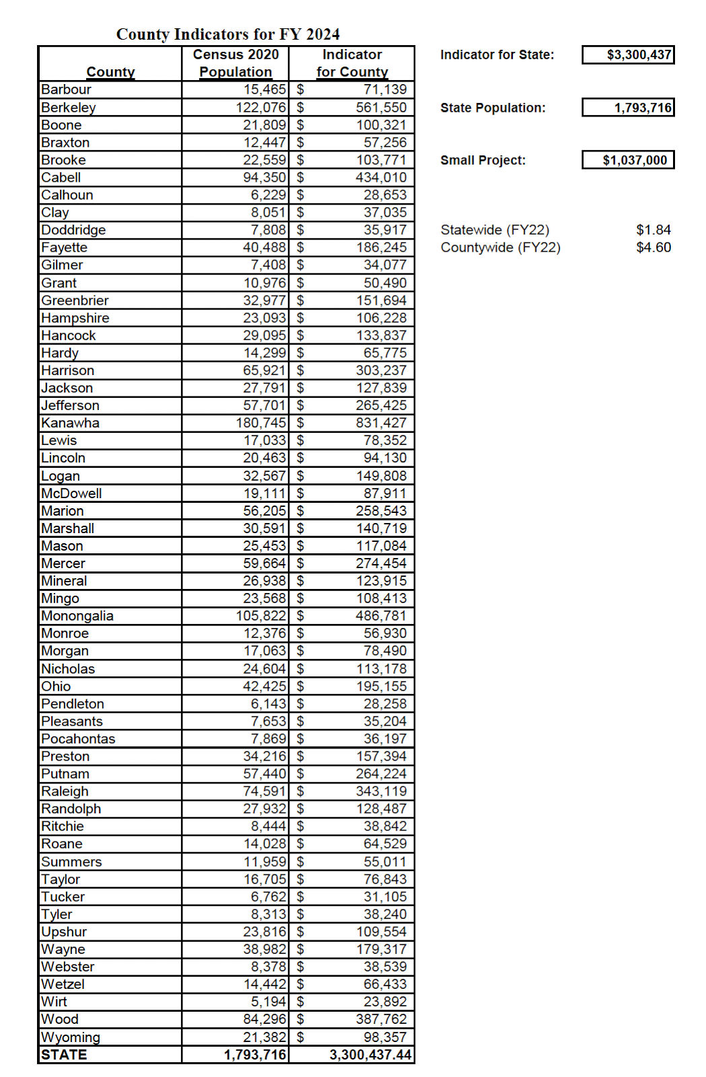

National Voluntary Agencies Active in Disasters (NVOAD) Communication, Coordination, Collaboration and Cooperation four C’s.
P.3, COMMUNITY ORGANIZATIONS ACTIVE IN DISASTER, Indiana COAD Guidance Manual Developed by Steve Cain of Purdue University In cooperation with the State of Missouri & University of Missouri Extension Reviewed by Eric Evans, University of Missouri Extension; Lucinda Nord, United Way of Indiana; Kevin Cox, Hope Crisis Response Network; Revised January 2012. Acknowledgement is made here that this language was drawn and slightly modified from the manual’s original language.
Creating the West Virginia Flood Resiliency Framework for Comprehensive Disaster Response and Long-Term Community Recovery
Paraphrased from https://www.epa.gov/epcra/emergency-planning.

