State of West Virginia
SENTRY Project BCA
BRIC Grant Application
7-22-2026

Contents
Total Project Benefit: BCR 8.03 2
Flood Fatality Avoidance: BCR 6.27 3
Property Loss Avoidance: BCR 1.76 5
Vehicle Loss Avoidance 6
Building and Content Damage Loss Avoidance 7
Companion Pets Loss Avoidance 8
Risk Assessment of Study Area 9
Risk Assessment 9
Risk Rankings 10
Project Study Map 12
Supplemental Information 13
Flood Fatality Research (Fatality Loss Avoidance) 13
FEMA Hazus Building-Level Risk Assessments (Property Loss Avoidance) 15
Vehicle Property Loss Avoidance (July 2026 Flooding) 16

Acknowledgements

Support for the Flood Risk tools and data for generating the BCA originated from CTP and HMGP grants sponsored by FEMA and the WV Emergency Management Division (WVEMD). The BCA data and analysis were compiled by the WV GIS Technical Center (Kurt Donaldson, Behrang Bidadian, and Isabella Barger) using the WV Flood Resiliency Framework, a virtual hub of risk assessment, visualization, planning, and training resources for building community flood resiliency in West Virginia.

Total Project Benefit: BCR 8.03

BCA Overview. The Benefit-Cost Analysis (BCA) or Benefit-Cost Ratio (BCR) is a financial metric used in cost-benefit analysis to evaluate the viability of the River SENTRY (Smart Environmental Notification and Threat Response System) project for a major flash flood event in West Virginia. The Flood Fatality Avoidance BCA was computed from historical flood victim data (looking backward at past events), while the Property Loss Avoidance BCA was calculated using FEMA’s software and standardized Depth-Damage Functions (looking forward using expert engineering estimates) for a 1% annual chance (100-yr) flood. Project Loss Avoidance was calculated to be 8.03. A ratio higher than 1.0 means a project is a good investment in that every $1 spent on the project, $8.03 will be returned in value.



Study Area. The principal targeted area for River SENTRY is the 1% annual chance (100=-yr) floodplain area of 255,195 acres with an exposed total population of 143,632 people that spans 25 counties. (See Figure 1 in Supplemental Information section).
WV Risk Explorer. The following sections explain Flood Fatality and Property loss avoidance calculations and rationale using the WV Flood Risk Explorer, a suite of tools for quantifying flood risk at multiple scales, from individual properties to communities, counties, regions, watersheds, and streams.

Flood Fatality Avoidance: BCR 6.27

WV Flood Fatality Research. Limited research and mapping have been done of flood fatalities from riverine flood disasters and post-disaster mitigation in West Virginia. As part of the WV Risk Explorer (www.wvfrf.org/WVRE), the WV GIS Technical Center has mapped specific locations of over 500 flood fatalities along with post-mitigation measures implemented for the 12 deadliest flood events (1870 to 2016) in the state. The focus of this research has been to quantify flood fatalities and associated flood characteristics, demographic variables, and behavioral patterns of flood victims in shared dashboards, story maps, and reports. This mapping research also reviews the circumstances of mass casualties<< where three or more victims died at the same location or were related. This research confirms that flash floods are the leading cause of flood-related fatalities, younger and older populations are more vulnerable, and behavioral factors like overconfidence and underestimating risk significantly increase mortality.

WV Flood Fatalities Per Year. Flood fatality research for the past 10 years since the major 2016 flood recorded 36 flood fatalities, or 3.6 fatalities per year. Known flood deaths recorded and mapped from 1870 to present are 501 deaths. Data Source: WV Flood Fatality Dashboard.

Weighted Early Evacuation Rate. Unpublished flood risk research of the 2016 WV Flood (23 deaths) indicates that 40% of flood fatalities resulted from engaging in risky behaviors, while 60% of deaths occur due to delayed evacuations. The latter group could have survived if they had received and acted on earlier flood warnings such as the River SENTRY. See Figure 2 in Supplemental Information section associated with flood fatality research.

Value of Statistical Life (VSL). The monetary value of preventing one statistical death is $13.7 Million per fatality. Source: FEMA’s National Risk Index Data Methodology and Hazards Overview, 2025.

Annualized Projected Benefits of SENTRY Project. The base flood fatality rate of 3.6 lives/year is reduced to 1.5 lives/year by a 70% West Virginia geographic weight and a 60% early evacuation reduction. At FEMA’s $13.7M Value of a Statistical Life (VSL), this adjusted rate yields $20.7M in SENTRY projected benefits.
Adjusted Rate = Base Rate (3.6) x Geographic Area Rate (0.70) x Evacuation Rate (0.60) = 1.5

Table 1. BCA Calculation of Projected Benefits per year.
VARIABLE | VALUE | NOTES
Base Flood Fatality Rate per year for West Virginia | 3.6 fatalities per year | See flood fatality research text above.
Geographic Weight: Adjusted to Geographic Area of 25 Counties | 2.5 fatalities per year | 3.6 flood fatalities/year x 70% geographic weight (percentage of primary structures in FEMA’s high-risk floodplains of 25-county geographic area) = estimated 2.52 flood fatalities/year for defined project area.
Early Evacuation Rate: Adjusted to the public who heed early warnings and evacuate safely, avoiding loss of life. | 1.5 fatalities per year | 2.52 flood fatalities/year x 60% early evacuation rate = estimated 1.51 fatalities/year saved by River SENTRY. Note: Flood fatality research dictates that not all the public will heed River SENTRY warnings. Effective flood risk communications are vital to lower mortality by correcting the public's tendency to underestimate risk or make poor decisions.
FEMA Value of Statistical Life (VSL) | $13.7M | Monetized River SENTRY advanced warning system in lives saved
SENTRY Project Benefits per year | $20.7M | $13.7M VSL multiplied by 1.51 fatalities/year

Annualized Project Costs of SENTRY Project.
The cost of the project is $10M over 3 years; or an Annualized Cost of $3.3 million.

Flood Fatality Avoidance Benefit-Cost Ratio (BCR).
A Flood Fatality Avoidance benefit-cost ratio (BCR) of 6.27 will be achieved by implementing the River SENTRY project. A ratio higher than 1.0 means a project is a good investment in that every $1 spent on the project, $6.27 will be returned in value.

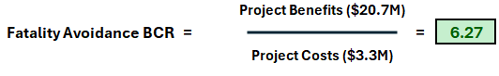

Property Loss Avoidance: BCR 1.76

Property Loss Avoidance Methodology was calculated using FEMA’s Depth-Damage Functions (DDFs) that look forward using expert engineering estimates. More information.
- Software: Hazus (FEMA’s GIS-based natural hazard software).
- Recurrence Interval. Riverine 1% annual-chance (100-yr) flood. Data for other flood frequencies (10-, 20-, 50-, 500-yr) or recurrence intervals does not exist statewide.
Property Loss Avoidance Savings associated with the SENTRY project provides a BCR that sums to $5.8 million in benefits of vehicles, property, and pets.
- Vehicle Loss Avoidance - $5.0 Million
- Advanced lead time to move vehicles out of flood inundation zone to avoid property loss (Figures 5 & 6).
- Property Loss Avoidance - $562K
- Building Loss: Advanced lead time to prepare barriers, check flood events, protect utilities, etc. to avoid damage loss to the structure.
- Content Loss: Advanced lead time to move valuables and other personal belongings in structure to avoid content loss.
- Pets Loss Avoidance - $220K
  - Advanced lead time to move pets out of flood inundation zone to avoid property loss. In West Virginia, pets are legally classified as personal property.

Annualized Project Costs of SENTRY Project.
The cost of the project is $10M over 3 years; or an Annualized Cost of $3.3 million.
Property Loss Avoidance Benefit-Cost Ratio (BCR).
The Property Loss Avoidance benefit-cost ratio (BCR) of 1.76 will be achieved by implementing the River SENTRY project. A ratio higher than 1.0 means a project is a good investment in that every $1 spent on the project, $1.76 will be returned in value.


The following subsections break down the Property Loss Avoidance BCA by vehicle loss, building damage loss, building content loss, and loss of pets (personal property).

Vehicle Loss Avoidance
Vehicular Flood Loss Model. Primary residential structures (n=61,540) in FEMA’s high-risk flood zones for the 25-county study area with a base flood depth >= 3 feet.
Predictive Flood Loss Avoidance Data Sources. Data sources are the Building Level Risk Assessment (BLRA) database, 1% annual chance flood depths, Census vehicular counts, used car values, and hazard risk research of historical flood events.
Annualized Vehicles Lost. 1% of the 61,540 primary residences in FEMA high-risk flood zones with a base flood depth ≥ 3 feet annualizes to 158 vehicles / year.
Flood Depth. While 3 feet of water will permanently ruin most vehicles, it only takes 1 foot of moving water to sweep a car away (Source: NWS).
Vehicles Per Unit. Because West Virginia is mountainous and highly rural, reliable personal transportation is essential for everyday life. According to Census (ACS 5-year Estimates, 2024), the average number of vehicles for the 25-county study area is 1.7 vehicles per residential unit.
Weighted Early Evacuation Rate. Flood behavioral research of historic flood events reveals that 60% of the public will heed the early flood warnings and take immediate actions to avoid damage loss to vehicles or before shelter in place orders take effect. See Figure 2 of Flood Fatality Research section.
Vehicle Property Loss Avoidance. Advanced flood warning notifications of the RIVER Sentry allow drivers to move their vehicles out of the flood inundation zone and avoid property loss.
# Vehicles Loss (158) x Vehicles/Unit (1.7) x Dollar Value ($8.3M) x Early Evacuation (0.60) = $5.0M

Table 2. Vehicle Loss Avoidance annualized from a 1% annual chance flood event. Property loss avoidance = $5 Million.
Residential Primary Structures in 1% Annual Chance floodplains (25 counties) | Vehicles Lost (Base Flood Depth >= 3 ft. | Annualized Number of Vehicles Lost | Vehicles per Residential Unit | Cost per Used Vehicle | Annualized Vehicle Damage Dollar Loss | Early Evacuation Rate (60%) | SENTRY Project Loss Avoidance for Vehicles
61,540 | 15,772 | 158 | 1.7 | $31,131 | $8.3 M | 60% | $5.0 M
DATA SOURCES:  BLRA | BLRA | Residential Structures * 1% | U.S. Census ACS 5-Yr Estimates, 2024 | iSeeCars.com  2021 adjusted for inflation | # Vehicles Lost x Unit Cost/Vehicle | Flood Risk Research

Building and Content Damage Loss Avoidance
Building/Content Flood Loss Model. Total primary structure (n=68,978) in the 1% annual chance floodplain for the 25-county study area, using FEMA’s Hazus riverine DDFs for Building and Content Damage Losses.
Predictive Flood Loss Avoidance Data Sources. Data sources are the 2026 Building Level Risk Assessment (BLRA) database, base flood depths, and research of historical flood events.
Building and Content Dollar Exposures. The total dollar value exposures for building and content are $6.6 and $5.2 billion, respectively.
Building and Content Dollar Damage Loss. Hazus riverine flood damage estimates for a 1% annual chance event reveal total damage losses are $396M and $540M for building and content, respectively. The annualized damage losses are $4M and $5.4M, respectively.
Loss Avoidance Measures. Benefits of River SENTRY in reducing building and content damages.
Building Loss: Early warning systems provide crucial lead time for property owners to minimize building damage by deploying barriers, protecting utilities, and tracking flood progression.
Content Loss: These advance warnings also protect personal belongings by giving residents the time to relocate valuables and other content to upper floors or safer locations.
Weighted Measures for Property Loss Avoidance. Early flood warnings conservatively allow property owners to reduce building and content damage losses by at least 10%, giving individuals vital time to elevate valuables and implement temporary structural protections. Based on flood risk behavioral research of historical events, it is estimated that 60% (Figure 2) of the public will heed the early warnings of SENTRY to take active protective measures to minimize building and content damage loss.
Building /Content Losses x Loss Avoidance Savings (10%) x Early Warning Action (60%) = $562K

Table 3. Estimated Building/Content Loss Avoidance annualized from a 1% annual chance flood event. Building ($238K) and Content ($324) = $562K property damage loss avoidance from SENTRY Project.
 | Building Appraisal Cost (USD) | Building Loss (USD) | Content Cost (USD) | Content Loss (USD)
Total Value and Losses | $6,620.4 M | $395.9 M | $5,250.9 M | $540.8 M
Annualized (* 1%) | $66.2 M | $4.0 M | $52.5 M | $5.4 M
Loss Avoidance Savings (* 10%) | N/A | $0.4 M | N/A | $0.5 M
Early Warning Protective Measures taken (* 60%) to secure Loss Avoidance Savings | N/A | $0.238 M | N/A | $0.324 M

Companion Pets Loss Avoidance
Companion Pets Loss Avoidance Model. Pet loss models monetize the savings from the advanced lead time notification of the River SENTRY to allow owners to evacuate their pets away from flood dangers. In West Virginia, pets are legally classified as personal property. Other pets or livestock are not calculated in this model.
Value of Statistical Lives of Dogs and Cats. According to a 2026 research paper, the Value Statistical Life of a Dog (VSDL) and Cat (VSCL) are $8,000 and $7,100, respectively.
Pet Ownership Percentage Statistics. According to U.S. pet ownership statistics, the percentage of households owning dogs is 42.6% and cats 32.6%.
Weighted Measures for Property Loss Avoidance. Based on flood risk behavioral research of historical events, it is estimated that 60% (Figure 2) of the public will heed the early warnings of SENTRY to take active protective measures to safely evacuate their pets.
Predictive Shelter Methodology, Data Sources, Pet Value Loss Avoidance. The loss avoidance analysis employs the Hazus methodology for a 1% annual chance flood event, utilizing the 2024 Building Level Risk Assessment (BLRA) database and U.S. Census data as primary inputs. Population displacement and short-term shelter models (shelters used up to 3 weeks) for humans and companion pets are based on building-level tax assessment records (building characteristics), U.S. Census community-level demographic data (population & household size, income, age), and for primary residential structures in the 1% annual floodplains where the base flood depth >= 1 foot. See more information about how shelter methodology is completed.
Pet Loss Avoidance Algorithm:
- Short Term Population (17,142) / Avg. Household Size * Pet Ownership % = Total Pet Value ($36.7M)
- Annualized Pet Value Displaced ($367,360) x Early Evacuation Rate (60%) = Loss Avoidance ($220,246)

Table 4. Estimated Pet Loss Avoidance ($220,246) annualized for a 1% annual chance flood event saved by River SENTRY project.
Short-Term Shelter Population | Short-Term Shelter for Dogs | VSDL | Total Dogs Personal Property Value | Short-Term Shelter of Cats | VSCL | Total Cats Personal Property Value
17,142 | 3,030 | $8,000 | $24.2 M | 1,760 | $7,100 | $12.5 M
Total Companion Pets Displaced Value for 1% Annual Chance Flood | Annualized Pet Value Displaced  (* 0.01) | Early Evacuation Rate (60%) | SENTRY Project Benefits for Pets
$36.7 M | $367,360 | 60% | $220,416

Risk Assessment of Study Area

Risk Assessment
Table 5. Risk Assessment of 25-county project study area. The targeted area for SENTRY is the 1% floodplain area of 255,195 acres with an exposed total population of 143,632 people. View Data Access and Learn More of WV Risk Explorer Tool.
Variable Name | Value | Notes
GENERAL INFORMATION
Total Area | 7,064,789 acres | Total 25-County Area
Total Structures | 625,406 structures | WV E-911 Database
Total Population | 1,011,190 people | Census 2021 ACS 5-yr estimates
Households Number | 401,980 | Census 2021 ACS 5-yr estimates
Average Household Size | 2.5 | Census 2021 ACS 5-yr estimates
FLOODPLAIN CHARACTERISTICS
Floodplain Area | 255,195 acres | 1% Floodplain
Floodplain Length | 8,590 miles | 1% Floodplain
Flood Depth Median | 2.1 feet | 1% Flood Event
BUILDING EXPOSURE
Building Floodplain Count | 68,978 | 1% Floodplain. View BL Table.
Building Floodway Count | 6,164 | 1% Floodplain
Building Value | $6,6B | 1% Floodplain
Building Content Value | $5.3B | 1% Floodplain
BUILDING CHARACTERISTICS
Building Median Value | $41,600 | 1% Floodplain
Residential Structures | 61,540 (90%) | 1% Floodplain. View BL Table.
Mobile Home Ratio | 27% | 1% Floodplain
Building Year Pre-FIRM | 15,725 | 1% Floodplain
CRITICAL INFRASTRUCTURE
Essential Facilities | 354 | 0.2% Flood Event. View BL Table.
Highway Bridges Inundated | 108 bridges | 1% Flood Event
Road Inundated | 4,173 road miles | 1% Flood Event
Railroads Inundated | 373 RR miles | 1% Flood Event
COMMUNITY ASSETS
Historical | 2,258 | 1% Floodplain. View BL Table.
Non-Historical | 1,425 | 1% Floodplain. View BL Table
BUILDING DAMAGE
Building Loss | $396M | 1% Flood Event
Contents Loss | $541M | 1% Flood Event
Substantial Damage Estimates | 4,636 | 1% Flood Event
Building Previous Paid Losses | $233M
Repetitive Loss Structures | 6,588
PEOPLE/SOCIAL VULNERABILITIES
Population in Floodplain | 143,632 people | 1% Flood Event
Population Displaced | 88,468 people | 1% Flood Event
Short-Term Shelter Population | 17,142 people | 1% Flood Event
Short-Term Shelter Companion Dogs | 3,030 dogs | 1% Flood Event
Short-Term Shelter Companion Cats | 1,760 cats | 1% Flood Event

Risk Rankings
Table 6. Top rankings of vulnerable counties and communities of 25-county study area to a major riverine flood storm.
Ranking | Value | Source
CUMULATIVE FLOOD RISK
Top 10 County Rankings | - Kanawha  - Boone  - McDowell  - Logan  - Mingo  - Wyoming  - Wayne  - Lincoln  - Ohio  - Mason | Risk Comparison Report
Top 10 Communitive Rankings  - Incorporated Places  - Unincorporated Area* | - Boone County*  - Clendenin  - Wheeling  - McDowell County*  - Wayne County*  - Kanawha County*  - Madison  - Kimball  - Lincoln County*  - Milton | Risk Comparison Report
SOCIAL VULNERABILITY
People / Social Vulnerabilities County Rankings | - McDowell  - Mingo  - Wyoming  - Logan  - Boone | Risk Comparison Report  Select People / Social Vulnerabilities Category

Table 7. Building Level Risk Assessment. The online table reveals that the Top 10 structures of the SENTRY Project study area are in FEMA’s AE Zones with model-backed flood depths greater than 20 feet. These structures are in the Upper Kanawha, Tug, South Branch Potomac, Lower Kanawha, and Upper Ohio-Wheeling watersheds.

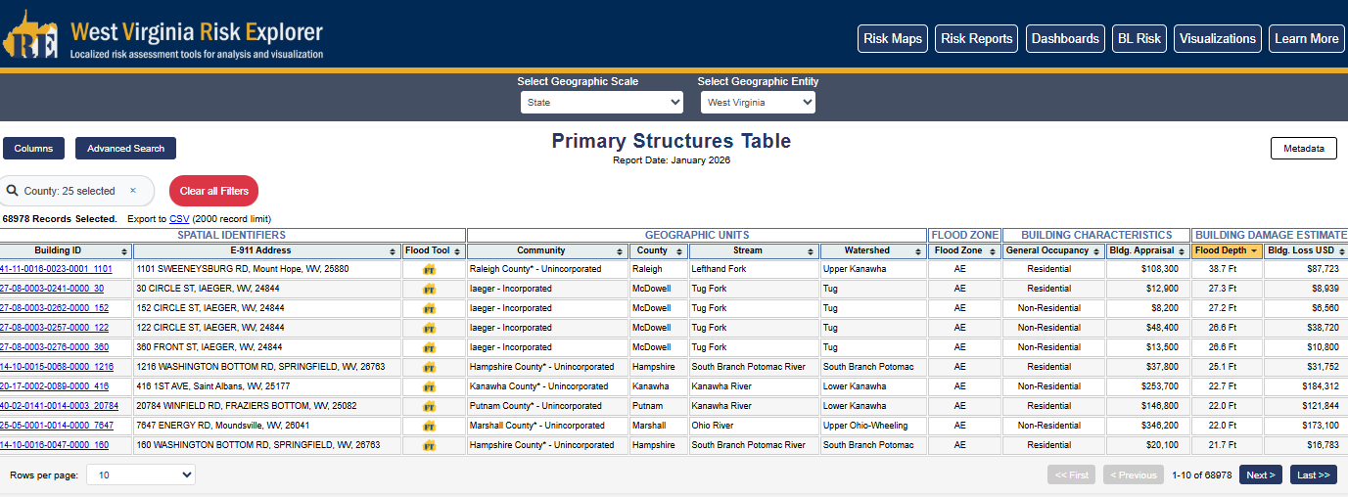

- View online Building-Level Risk assessment (BLRA) table of primary structures of SENTRY Project study area. Structures are sorted from highest to lowest base flood depths.
https://www.wvfrf.org/wvre/blra/?s=V93PeO

Project Study Map

Figure 1. Project study area graphic of the 25 counties with the HUC-8 watersheds overlain. 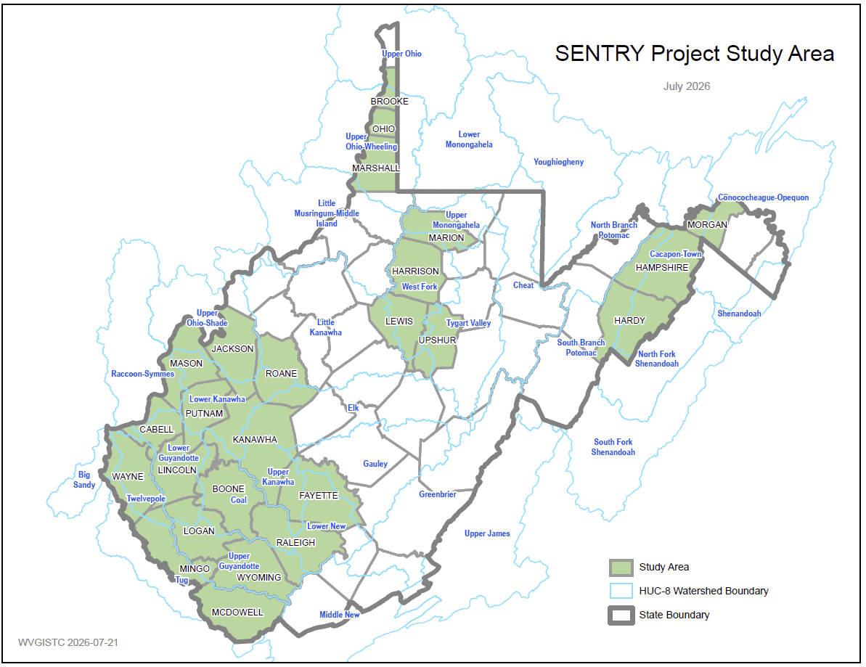
Download PDF map.

Supplemental Information

Flood Fatality Research (Fatality Loss Avoidance)
Flood Fatality Research data provides statistics for the flood fatality loss avoidance calculations. Sources for flood fatality data include death certificates, newspaper archives, social media, and published reports and books.
Figure 2. Unpublished Flood Fatality Research. The 2016 WV Flood (23 deaths) revealed that 40% of flood fatalities resulted from engaging in risky behaviors, while 60% of deaths occurred due to delayed evacuations. The latter group could have survived if they had received and acted on earlier flood warnings such as the River SENTRY. View research slides.
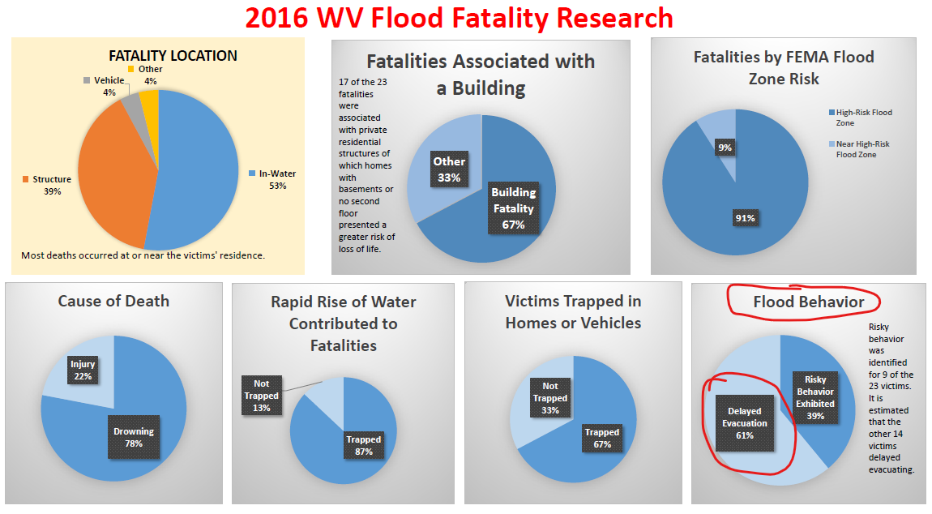

Figure 3. Flood Fatality Dashboards. The flood fatality dashboards show mapped geographic locations of lives lost to riverine floods and known circumstances: cause of death, location (in structures, vehicle, or water), age, gender, and other flood fatality characteristics. Flood deaths are also categorized as mass casualty events if three or more victims died as the same location or have the same last name. In West Virginia's 12 deadliest flood events, mass casualty incidents accounted for approximately 60% of the fatalities.
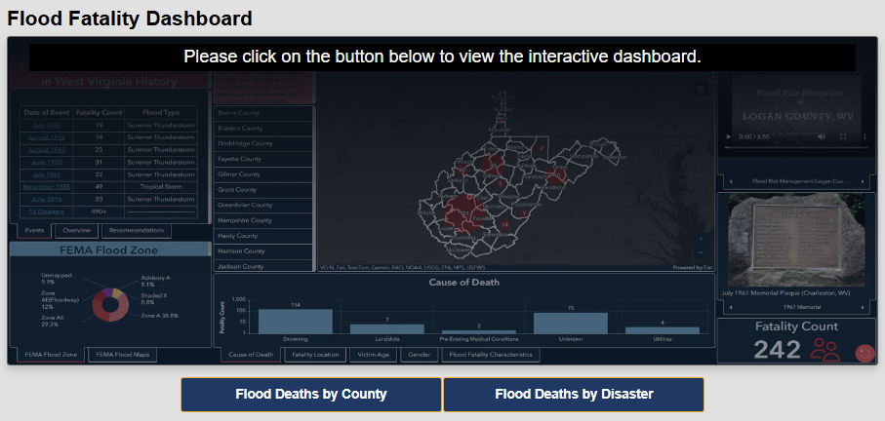

FEMA Hazus Building-Level Risk Assessments (Property Loss Avoidance)

The Property Loss Avoidance BCA is calculated using FEMA’s standardized Hazus methodology. A detailed riverine Hazus loss assessment for a major 1% annual chance (100-yr) event is applied to every high-risk floodplain building (n = 98,076) inventoried in the State. To assess flood risk across targeted areas like the SENTRY Project, these property-level assessments can be aggregated to broader scales, including communities, counties, regions, watersheds, and streams.

Figure 4. Building-level Hazus loss estimates are viewed on the WV Flood Tool or Primary Structures Table.
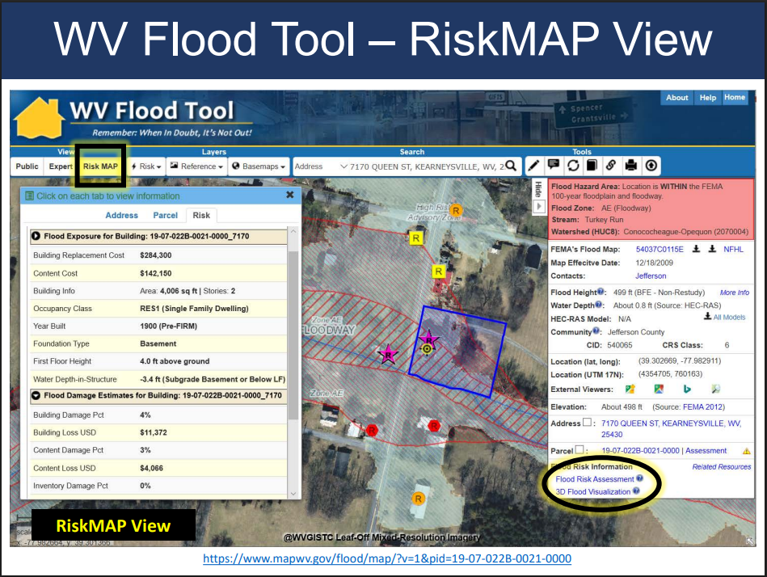

Vehicle Property Loss Avoidance (July 2026 Flooding)
The Property Loss analysis reveals that vehicle loss avoidance generated the highest savings from implementing the River SENTRY project for major flash flood events.
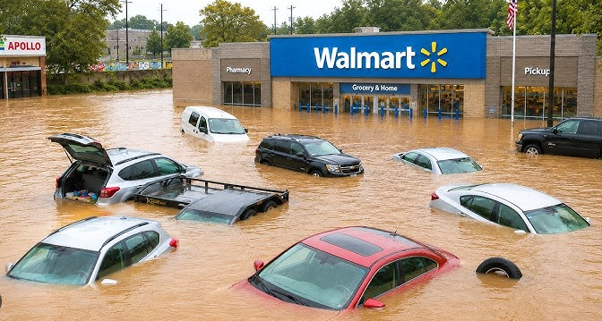

Figure 5. Multiple Submerged Vehicles (Weston Walmart), 22 July 2026 Flash Flood
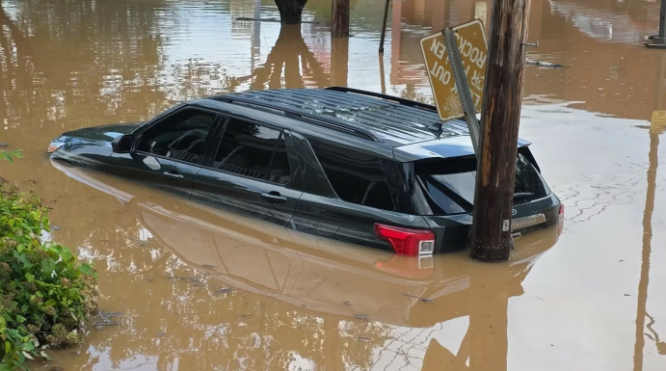

Figure 6. Submerged Vehicle (Buckhannon, WV), 22 July 2026 Flash Flood

