Bramwell, Mercer County Study (by Behrang, sent to Dennis Marcello on 3/30/2026)
Tools used:
Flood Tool, BL Primary Structures, BL Significant Structures, Risk Reports tool, Hazard Library, Data Download (BLRA), WV SHPO

Risk Assessment:
In total, there are 56 primary structures located within either the effective or advisory (draft) high-risk 1%-annual-chance (100-year) floodplains in Bramwell.
You can access the detailed list of these structures using the BL Primary Structures tool, we’ve already filtered it for Bramwell using the link below.
https://wvfrf.org/wvre/blra/?sortfield=Flood_Depth_Value&sorttype=desc&statement=COMMUNITY%2520%253D%2520Bramwell%2520-%2520Incorporated&from=1&perPage=100&hiddenFields=Owner_Name_s%2CFull_Owner_Address

If you need to download the table, click on “CSV” above the table: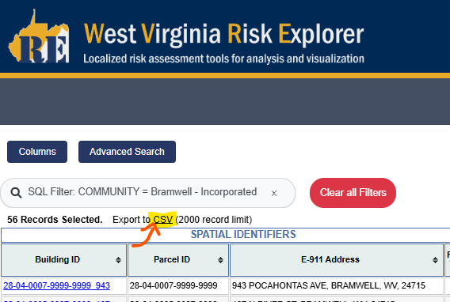

Based on the 2024 E-911 address dataset, there are approximately 275 primary structures in Bramwell. Assuming this, we can translate the floodplain exposure (56 structures) as about 20% of the community’s primary structures in the high-risk 100-year flood zones. According to our datasets, the average of this ratio (structures in the 100-year floodplain relative to total community-wide addresses) for incorporated places in West Virginia is 15.5%. Therefore, Bramwell appears to be above average in terms of the Floodplain Building Ratio risk indicator.

Of the above structures only 21 are already in the effective floodplain while the 35 others are mapped in according to the draft map.
Here’s the link to the list of the 21 structures already in the effective floodplain (remain the same): https://wvfrf.org/wvre/blra/?sortfield=Flood_Depth_Value&sorttype=desc&from=1&perPage=100&statement=COMMUNITY%2520%253D%2520Bramwell%2520-%2520Incorporated%253BSymbol_FloodRiskZone%2520IN%2520%28Remains%2520Same%2520Floodway-Commercial%252CRemains%2520Same%2520Floodway-Other%252CRemains%2520Same%2520Floodway-Residential%252CRemains%2520Same-Commercial%252CRemains%2520Same-Other%252CRemains%2520Same-Residential%252CSFHA%2520New%2520Floodway-Commercial%252CSFHA%2520New%2520Floodway-Other%252CSFHA%2520New%2520Floodway-Residential%29&hiddenFields=Owner_Name_s%2CFull_Owner_Address

And here’s the link to the list of the 35 newly mapped in structures: https://wvfrf.org/wvre/blra/?sortfield=Flood_Depth_Value&sorttype=desc&statement=COMMUNITY%2520%253D%2520Bramwell%2520-%2520Incorporated%253BSymbol_FloodRiskZone%2520IN%2520%28Mapped%2520In%2520Floodway-Commercial%252CMapped%2520In%2520Floodway-Other%252CMapped%2520In%2520Floodway-Residential%252CMAPPED%2520IN-Commercial%252CMAPPED%2520IN-Other%252CMAPPED%2520IN-Residential%29&from=1&perPage=100&hiddenFields=Owner_Name_s%2CFull_Owner_Address

Of the total 56 exposed primary structures (in either the effective or draft flood zones), 38 are considered historical community assets. We define these assets as flood-prone primary structures (residential or non-residential) located within National Register areas or within registered historic districts and constructed before 1930.
This means that approximately 68% of the buildings in Bramwell’s high-risk floodplains are historical structures, which is a notably high ratio.
Here’s a link to the list of these historical community assets in Bramwell on the Significant Structures tool: https://wvfrf.org/wvre/blra/?type=sigstruct&sortfield=Depth_Grid&sorttype=desc&from=1&perPage=50&statement=COMMUNITY%2520%253D%2520Bramwell%2520-%2520Incorporated%253BSignificant_Structure_Category%2520IN%2520%28Community%2520Asset%2520Historical%29%253BSignificant_Structure_Category%2520NOT_IN%2520%28Community%2520Asset%2520Non-Historical%29%253BSignificant_Structure_Category%2520NOT_IN%2520%28Essential%2520Facility%29&hiddenFields=Owner_Name_s%2CFull_Owner_Address

Of the 38 at-risk historical community assets in Bramwell, 27 are newly mapped in the floodplain according to the draft flood maps. Here’s the link to the list of these historical community assets on the Significant Structures tool: https://wvfrf.org/wvre/blra/?type=sigstruct&sortfield=Depth_Grid&sorttype=desc&from=1&perPage=50&statement=COMMUNITY%2520%253D%2520Bramwell%2520-%2520Incorporated%253BSignificant_Structure_Category%2520IN%2520%28Community%2520Asset%2520Historical%29%253BSignificant_Structure_Category%2520NOT_IN%2520%28Community%2520Asset%2520Non-Historical%29%253BSignificant_Structure_Category%2520NOT_IN%2520%28Essential%2520Facility%29%253BFloodplain_Type%2520IN%2520%28Advisory%2520High%2520Risk%29&hiddenFields=Owner_Name_s%2CFull_Owner_Address

Additionally, one non-historical community asset, Wesleyan Church of Bramwell, is located within the designated high-risk 100-year floodway, the main channel of the river or stream where floodwaters are typically deepest, velocities are highest, and debris potential is greatest.
Here’s the Flood Tool link for this structure:
https://mapwv.gov/flood/map/?wkid=102100&x=-9051656&y=4484600&l=13&v=2
And here’s the link to it on the Significant Structures tool:
https://wvfrf.org/wvre/blra/?sortfield=Depth_Grid&sorttype=desc&type=sigstruct&statement=Building_ID%2520LIKE%252028-04-0005-0087-0000_107%253BSignificant_Structure_Category%2520NOT_IN%2520%28Community%2520Asset%2520Historical%29%253BSignificant_Structure_Category%2520NOT_IN%2520%28Essential%2520Facility%29&from=1&hiddenFields=default

Moreover, an essential facility, the Bramwell Police Department, is among the newly mapped structures in Bramwell, near your area of interest. Such facilities are expected to remain operational during disaster events; therefore, their location within the floodplain may pose additional risk to the community.
Here’s the Flood Tool link for this structure:
https://mapwv.gov/flood/map/?wkid=102100&x=-9051739&y=4484588&l=13&v=2
And here’s the link to it on the Significant Structures tool:
https://wvfrf.org/wvre/blra/?sortfield=Depth_Grid&sorttype=desc&type=sigstruct&statement=Building_ID%2520LIKE%252028-04-0005-0006-0000_100%253BSignificant_Structure_Category%2520NOT_IN%2520%28Community%2520Asset%2520Historical%29%253BSignificant_Structure_Category%2520NOT_IN%2520%28Community%2520Asset%2520Non-Historical%29&from=1&hiddenFields=default

--------------------------------------------------------
In total, based on the 2025 tax assessment data, the appraised value of the 56 at-risk primary structures in the high-risk floodplain sums to about $4.9M ($4,854,204). As we discussed, there may be additional cultural or market value associated with the 38 buildings identified as historical community assets among these.

For the community-level risk assessment, based on the latest updates of the Risk Reports tool (August 2024), Bramwell ranks among the higher-risk incorporated places for several indicators.

Even based on the previous data (not including the draft flood zones), Bramwell was among the top 10% of incorporated places for the number of historical community assets (ranked 19th among 229 incorporated places statewide). With the additional historical structures mapped into the floodplain under the draft maps, this ranking could increase to approximately 5th.

Due to the concentration of older buildings within the floodplain, Bramwell also ranks high for two other risk indicators: Pre-FIRM buildings and buildings with subgrade basements in the floodplain. These indicators can be considered physical vulnerability factors that make the community more susceptible to flood impacts.

From a social perspective, Bramwell also shows relatively high estimated ratios of population residing in the floodplain, population requiring evacuation during a 100-year flood event, and overall social vulnerability.

You can view the community-level risk report for Bramwell using the link below:
https://wvfrf.org/wvre/report/?scaleid=5&entityid=151&type=all

Again, these indicators were calculated in August 2024, prior to the release of the draft floodplain. With additional structures now mapped into the high-risk floodplain, risk indicator values which will be reflected in future updates of the Risk Reports tool may be significantly higher.
--------------------------------------------------------
I’ve attached a Building-Level Risk Assessment (BLRA) table for Bramwell, which you can use as an alternative (BLRA_Bramwell_20251204_Modified_20260325.xlsx). I’ve hidden the fields that may not be needed and highlighted the key fields, including Building ID (Parcel ID with Address Number at the end), Parcel ID, E-911 Address, WV Flood Tool Link, Owner(s) Name(s), Owner(s) Address(es), Building Appraisal, Historical Structure, Flood Zone Status (showing mapped-in/out or remain the same), and General Occupancy (Residential or Non-Residential).

For complete metadata on the data fields included in the table, you can use this link: https://data.wvgis.wvu.edu/pub/RA/HL/Data/RA-BL/2a_BL-BLRA/3_Metadata/Full_BLRA_Metadata.pdf
In this table, the 38 historical community assets are marked as “Yes” in column BE (Historical_Structure).

While you can filter the full table using the available data fields, I’ve also attached a subset as a separate spreadsheet (Historical_Bramwell_20260325) which includes the historical buildings in floodplain, and another one (Mapped-in_Historical_Bramwell_20260325.xlsx) which includes only the 27 historical structures that are newly mapped into the floodplain under the draft maps.

Here’s the link to your area of interest in Bramwell on the WV Flood Tool (Risk Map view):
https://mapwv.gov/flood/map/?wkid=102100&x=-9051523&y=4484546&l=11&v=2
If you check the “Historic Structures” layer under Critical Infrastructure, you can see the historical structures marked as NR on the map. You may also want to turn off the “Primary Structure” layer to view them more clearly.
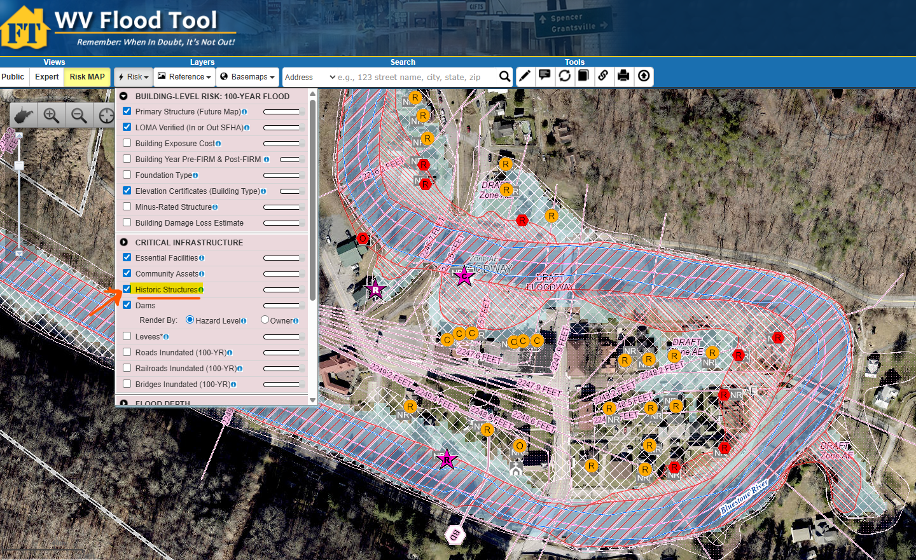

In addition, here’s the link to the tool we’ve developed for the WV State Historic Preservation Office (SHPO). You can search for Bramwell in the address box to zoom to the area:
https://mapwv.gov/shpo/viewer/index.html

Mitigation:

Insurance:
The community-wide FEMA NFIP report (2024) shows only two policies in place for Bramwell. We do not have access to individual NFIP policy data, as those are not publicly available. You may contact Julie Sears to see if she can provide that information.

Historical Structures Flood Protection:
Here’s a link to the WV Hazard Library, where I’ve filtered guides related to flood protection and adaptation of historical buildings:
https://wvfrf.org/library/?freeText=historic&typeID=5&view=advanced&sortfield=Title&sorttype=asc
You can click on the titles to view or download the documents.

Flood Barriers:
Regarding the flood barrier, I would recommend consulting with a specialized engineering firm to obtain more accurate estimates of requirements such as the elevation and specifications of the barrier, in addition to cost.

Given the land limitations associated with the historic areas, at a planning level, a simple urban floodwall would likely be more realistic than an earthen levee, as levees require a substantially larger footprint. However, floodwalls are typically more expensive but space-efficient, which is why they are commonly used in historic areas. Additionally, a floodwall is a more complex system due to factors such as gates, interior drainage, utility relocation, and aesthetic considerations.

Regarding elevation, the minimum floodwall elevation should be estimated as the difference between the ground elevation and the modeled base flood elevation, plus required freeboard, with localized increases near bridges or other constrictions. In practice, the required wall elevation will vary by segment rather than remain constant across the full length.

Based on the base flood estimates available on the Flood Tool, water depths in the historic area you’re looking to protect may range from a couple of feet up to approximately 14 feet. These depth values do not directly translate to wall height but indicate the range of protection needed when combined with ground elevations and freeboard. Therefore, different wall elevations would be required depending on depth values derived from engineering analysis and freeboard requirements.

In terms of cost estimation, here’s the link to a 2023 summary brochure by the US Army Corps of Engineers (USACE) on the costs of levee-related activities:
https://data.wvgis.wvu.edu/pub/RA/HL/MIT/STRUCTURAL/Levee/USACE_NLSP_Levee-Cost-Brochure_202311.pdf

Technical requirements, particularly the level of protection (e.g., 100-year vs. 500-year flood) and the complexity of interior drainage systems, are major drivers of floodwall and levee construction costs. These requirements are typically determined through detailed hydraulic and engineering studies and can significantly influence both design and total project cost.
For example, the Milton Floodwall Project, which is approximately 1.5 miles in length, is estimated to cost around $200 million due to its high level of protection, inclusion of pump stations, channel modifications, and urban constraints. In contrast, a simpler flood protection project of similar length, such as a rural levee system with minimal structural components and limited interior drainage requirements, may cost on the order of $5 to $20+ million based on USACE estimates.

I used the USACE guides and consulted with AI about the cost and got the following planning-level estimations. Again, for a more detailed and accurate cost analysis, you should consult with specialized engineers. Also, please note that these values are based on 2023 estimates.

Based on USACE screening-cost guidance, a 5-foot floodwall is roughly $3,000–$6,600 per linear foot, while a 15-foot floodwall is roughly $12,900–$22,400 per linear foot. For a quick, engineer-ready approximation, you can express this as a simple planning table for floodwalls:

- 5 ft wall: about $3,000–$6,600 per linear foot
- 8 ft wall: about $6,000–$11,300 per linear foot
- 10 ft wall: about $8,000–$14,500 per linear foot
- 12 ft wall: about $10,000–$17,600 per linear foot
- 15 ft wall: about $12,900–$22,400 per linear foot

These intermediate values are interpolated from the USACE 5-foot and 15-foot benchmarks, so they are useful for screening purposes only, not final cost-benefit analysis or design. USACE also notes that taller walls often require deep foundations or piles, and local soil conditions can significantly affect costs.

It is also important to note that a “simple wall” is rarely just a wall. If roads, alleys, rail crossings, or access points intersect the line of protection, the project will require closure structures. USACE screening costs for closure openings can range roughly from $1,600 to over $20,000 per square foot of opening, depending on the type and complexity of the system. Interior drainage features are another major cost component; USACE provides representative costs of approximately $696,000–$862,000 for a 48-inch system and $1.209M–$1.367M for a 72-inch system.

I’d also like to mention a couple of potential challenges that could make the project more complex and costly. The area of interest in Bramwell would likely require at least three openings (flood gates) in the floodwall, unless the bridges could be elevated above the wall elevation. However, given the historic nature and size of the area, such modifications may be more challenging to implement.
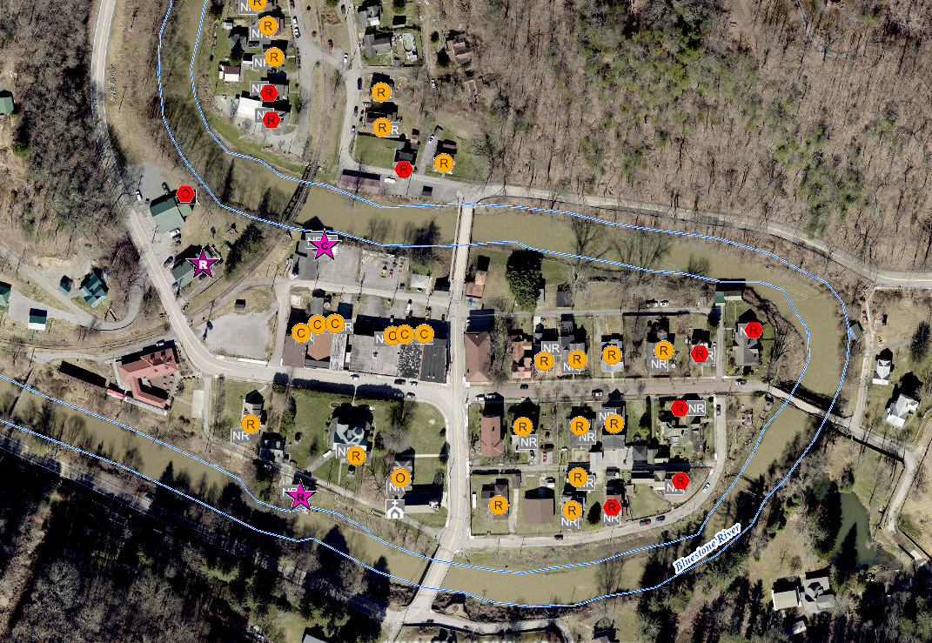

Here’s an example of such gates in Matewan:
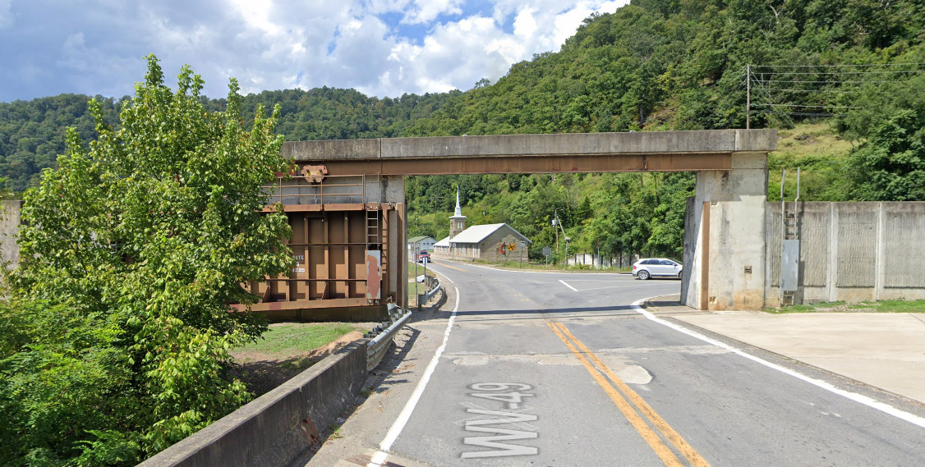

And here’s an example of elevating a bridge above the levee elevation in Moorefield:
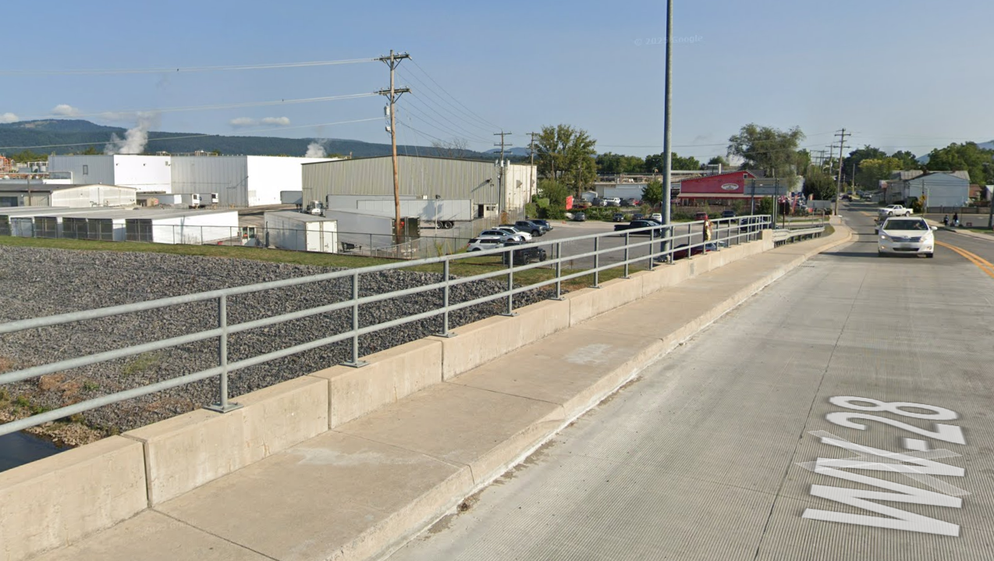

Another challenge you may face could be related to the aesthetic aspects associated with the historic area. If a high floodwall is constructed, depending on its height, views from the houses to the stream, as well as views from the surrounding area into the district, may be impacted. This may lead to some objections from the community.

Now, I’d like to mention a potential opportunity for your project. The U.S. Army Corps of Engineers, Huntington District, is partnering with the State of West Virginia to explore flood risk management options for the Kanawha River Basin. This study was authorized by Congress in 2016, received federal appropriations in 2021, and obtained state funding in July 2025.
Mercer County is also included in this study (see the map below). Here’s the link to documents related to this project on the WV Hazard Library:
https://wvfrf.org/library/?freeText=Basin&authorID=26&view=advanced&sortfield=Title&sorttype=asc

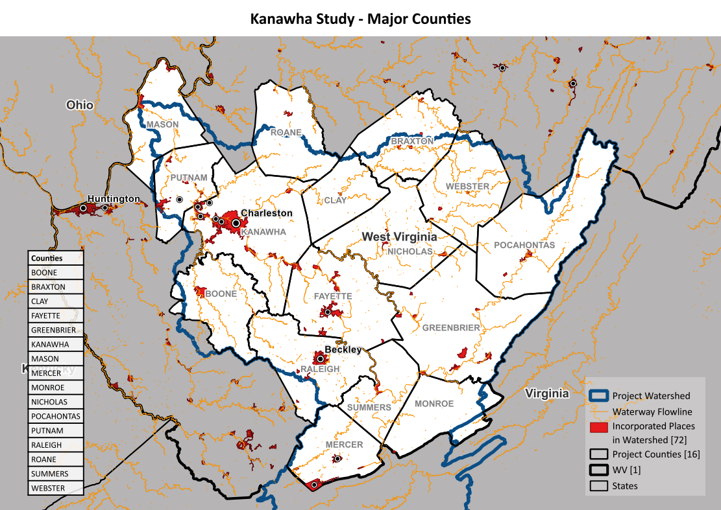
You may consider reaching out to the U.S. Army Corps of Engineers to share information about the risks to your historic district and your plans for a mitigation project, and explore opportunities for technical, and potentially financial, support. If you’re interested, you may want to contact Hannah Parlock who might be able to help at:
Hannah.G.Parlock@usace.army.mil

