McDowell County Risk Assessment:
Mitigation Prioritization of Dilapidated Structures
4/17/2026

A risk assessment prioritization of dilapidated structures in McDowell County for flood buyout mitigation was performed by the WVU GIS Technical Center. Findings of the risk assessment are below along with a spreadsheet and online web map for viewing the results of the prioritization assessment. The primary flood risk factor of the risk assessment was the model-backed flood depth from the 2024 FEMA Draft flood maps. Other variables such as the Floodway and Adjacency to Existing Buyout Parcel were also examined.

<< RISK FINDINGS >>
Structure Counts and Data Quality:
- Structure Counts. The dataset provided by McDowell County included 73 dilapidated structures in McDowell County proposed for open-space mitigation. Of these, 61 structures are in the high-risk floodplain, 8 are outside the floodplain, and 4 could not be identified.
- Structures Not Mappable. The x/y decimal coordinates provided only have 4 significant digits and thus could not be utilized to pinpoint the site location. The Latitude/Longitude coordinates in Decimal Degrees should always be reported in 6 decimal places of precision to accurately locate the structures. In addition to Latitude/Longitude coordinates, the GIS Parcel Identifier, Building ID, and other supplemental spatial identifiers like Owner Name captured from the WV Flood Tool should be included to ensure accurate location of the structure.
- Data Inconsistencies. The source attributes (e.g., building year, appraisal value) do not always match Tax Year 2025 tax assessment attributes. Users of this data and findings should ensure the dilapidated structures are pinpointed to the correct geographic locations.

Risk Assessment Map Layers
- Flood Depth. The primary risk factor utilized for prioritizing dilapidated structures is Flood Depth of a 1% annual chance flood event from the recently released 2024 FEMA Draft Floodplains. Floodwater depth is widely considered the most critical element in planning and designing flood mitigation because it dictates the magnitude of hydrostatic pressure on a structure and is the primary factor in determining the cost and extent of potential damage. Symbolized on web map as proportional circles (red-orange-yellow-tan).
  - Flood depths for the top 10 high-priority structures ranges from 4.1 to 8.0 feet. (column M: Flood Depth (Ranking Variable) in the spreadsheet table)
  - Flood depths of the mapped dilapidated structures range from 0 to 8 feet, with seven flood depths that exceed 5 feet, of which four of these structures are in the Regulatory Floodway.
  - The structure (Building ID 27-15-0002-0249-0000_60) with the highest flood depth is not in the Floodway but located along Browns Creek and affected by the backwater flooding of the Tug Fork.
  - Regarding the distribution, as shown on the web map tool, the dilapidated structures with the recommended highest mitigation priority are dispersed across different parts of McDowell County and with unique flood sources.
- Floodway. Thirty percent (30%) or 18 of the mapped structures are in the Regulatory Floodway, the most hazardous, high-velocity, and deep-flooding portions of a riverine floodplain mapped in a detailed AE Zone. Symbolized on web map as a small black circle or dot.
- Adjacent to Existing Buyout Parcels. 13 dilapidated structures are within 100 feet of existing mitigated deed-restricted open-space parcels. Contiguous community-owned vacant, open-space parcels can be linked to form a connected network of parks and conserved lands. These assembled sites enhance ecological connectivity, provide recreational opportunities, improve quality of life, and protect local environmental assets. Symbolized on the web map as a green circle.
Other Risk Assessment Notes
- Flood Source. The most common flood source of the mapped dilapidated structures is Dry Fork (24.6%), followed by Tug Fork (19.6%) and Elkhorn Creek (16.4%).
- Flood Zone Types. Of the 61 structures mapped in the high-risk effective and advisory floodplains, 72% of the dilapidated structures are in the detailed Zone AE flood zone which includes a Regulatory Floodway, while 28% are in the Zone A Approximate flood zone which does not have a mapped Floodway.
- Basement Foundations. It is estimated that 40% of the structures have basement foundations which if are subgrade (not-walk-out basement) foundations are more susceptible to flood damage.
- Occupancy Class: 95% of the dilapidated structures are residential and 5% non-residential.
<< WEB MAP APPLICATION for VIEWING RISK ASSESSMENT >>
https://www.mapwv.gov/McDowell-RA-buyouts
A simple interactive web map application was created of the 61 structures located in the high-risk floodplain to further spatial analysis and collaboration.

Operational Map Layers:
- Flood Depths. The proportional circles (red-orange-yellow-tan) represent model-backed base flood depths, the primary flood risk factor.
- Floodway. The small solid black circle indicates the structure in the Regulatory Floodway.
- Adjacent Mitigated Parcel. A green circle indicates dilapidated structure is near an existing buyout parcel and thus aggregated into a larger park or conservation area.

<< Figure 1. Risk Assessment Map of McDowell County’s Dilapidated Structures >>
<< Base Map is Street Map >>
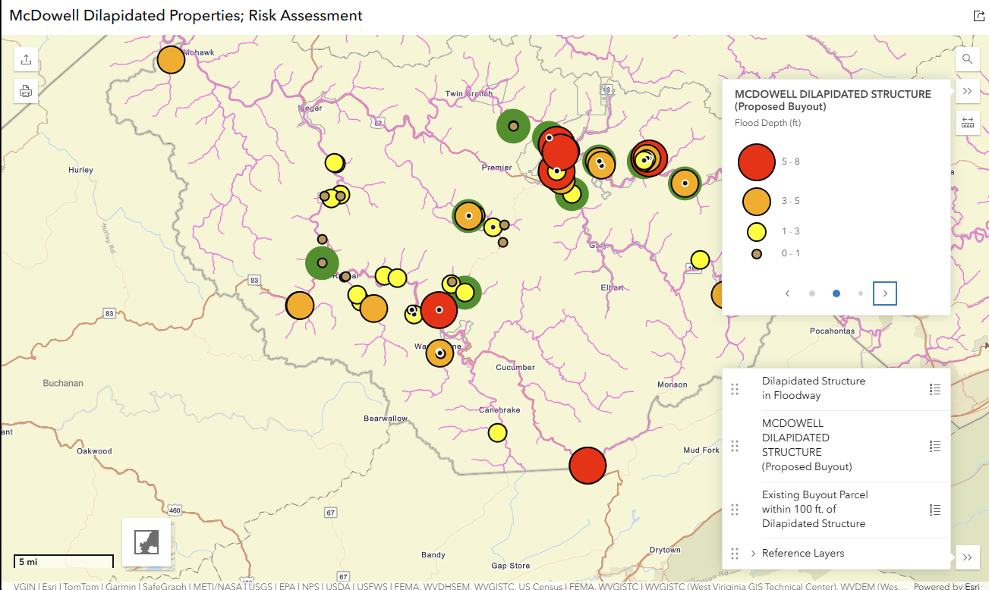
Map Functions:
- Print/Export Function
- Map Layers (and legend)
- Base Layers
  - Topo Map View (default) - lower left of map frame
  - Street Map - lower left of map frame
  - Aerial Imagery (WV Best Leaf Off) – make visible in reference layers
- Measure Tool
- Shared Link Tool
- Legend List
- Address Finder
- Pop-up Attributes of Dilapidated Structures (click on circle in map frame) including links to the WV Flood Tool

<< Figure 2. Zoomed-in Risk Assessment Map of Kimball’s Dilapidated Structures >>
<< Base Map is Topographic Map >>
<< Many of the dilapidated structures in Kimball are close to existing buyout properties >>
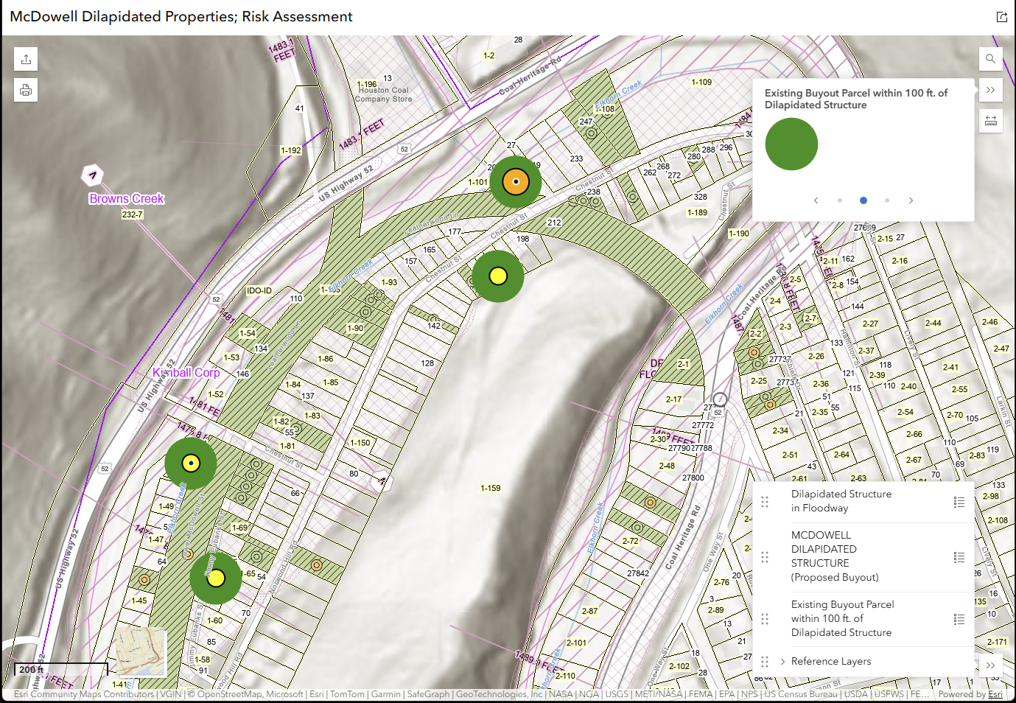

<< Figure 3. Zoomed-in Risk Assessment Map of Kimball’s Dilapidated Structures >>
<< Base Map is Aerial Imagery >>
<< Many of the dilapidated structures in Kimball are close to existing buyout properties >>

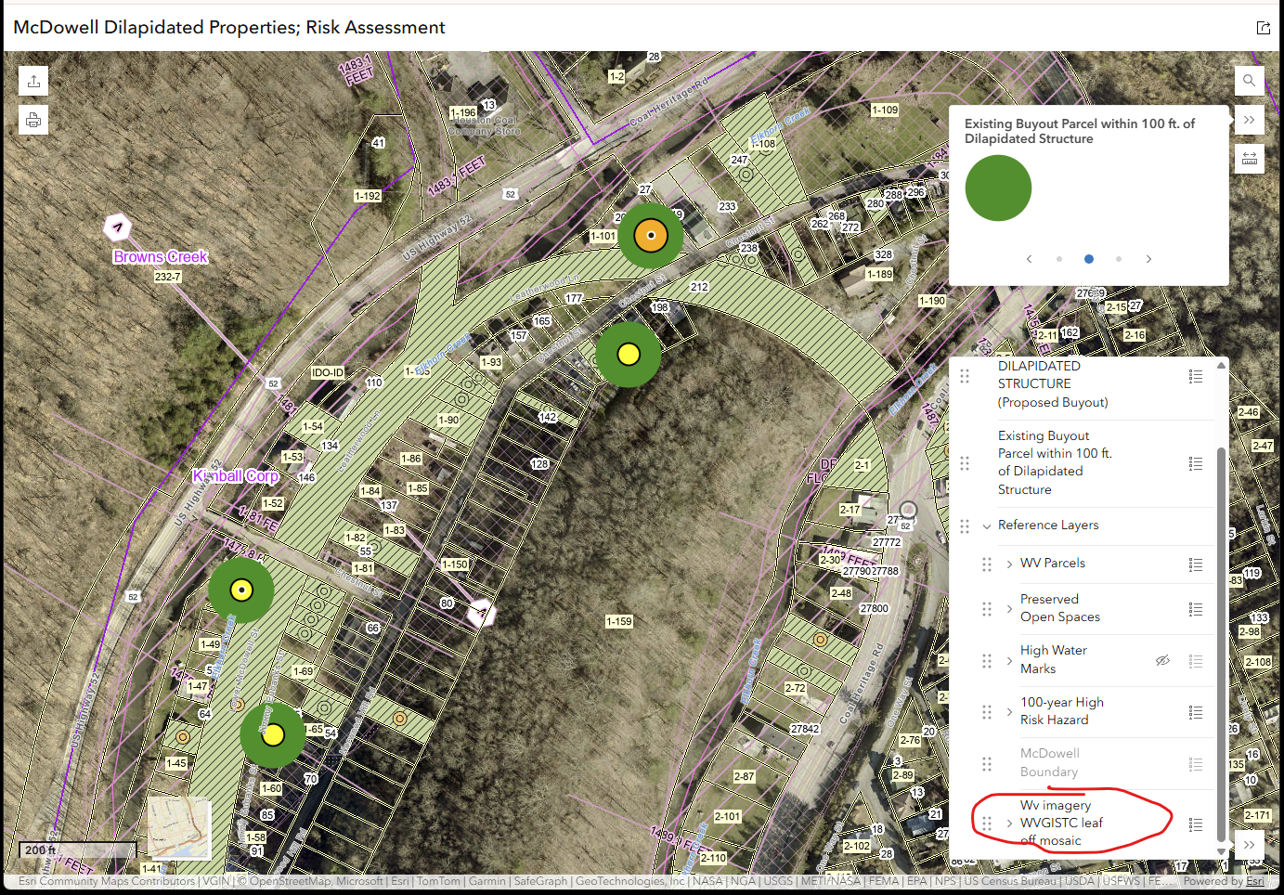

Contributors: Risk assessment and mapping performed by the WV GIS Technical Center at West Virginia University.
- Annie Mahmoudi
- Behrang Bidadian
- Kurt Donaldson

