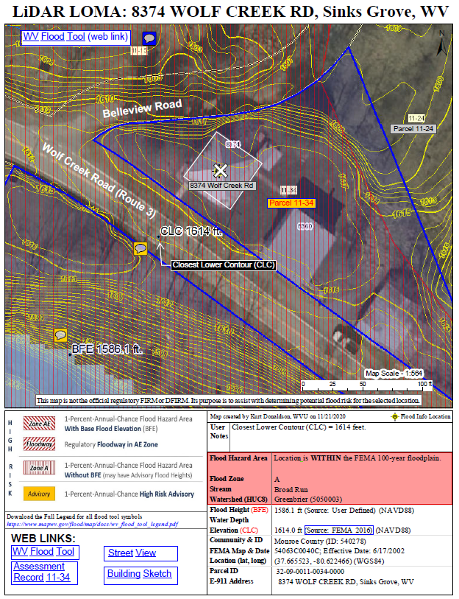
Example LIDAR LOMA Exhibit
LOMA LIDAR CANDIDATE
For this property the difference between the BFE and LAG is nearly 30 feet.

WV FLOOD TOOL: LIDAR FOR LOMA INSTRUCTIONS
Drafted by Kurt Donaldson 11/29/2020
Contents
BACKGROUND INFORMATION 1
STEP-BY-STEP INSTRUCTIONS 4
NEED MORE HELP? 14
RESOURCES 15
APPENDIX A: Studied Zone A and Unstudied Zone A 16
APPENDIX B: FEMA Processing of Contour or LiDAR Point Submittals 19
APPENDIX C: Incomplete Submission 20
APPENDIX D: eLOMA Tool versus Online LOMC Tool 21
APPENDIX E: WV Flood Tool’s LOMA implementation compared to Region V Counties (Minnesota) 22

BACKGROUND INFORMATION

WHAT IS THE PURPOSE OF A LOMA?
Occasionally, a small area is inadvertently shown to be within the SFHA on a FIRM, even though the ground is at or above the BFE. If this occurs, an individual property owner may submit survey information to FEMA and request that FEMA issue a document that officially removes a property from the SFHA, called a Letter of Map Amendment (LOMA).
HOW DO I CHANGE MY FLOOD ZONE DESIGNATION?
Letters of Map Amendment enable property owners to request changes or updates to their property’s flood risk status to FEMA. Learn more about how to request a change to your flood zone designation at FEMA’s website. Typically, this flood zone change request using the WV Flood Tool applies to property owners at the floodplain boundary fringe (not in the floodway) of high-risk AE or Approximate A Flood Zones, for existing buildings or lots not elevated on fill (natural grade), and where there is more than two feet difference between the Base Flood Elevation (BFE) and Lowest Adjacent Grade (LAG).
LiDAR FOR MAP AMENDMENTS
LiDAR data can replace the requirement to submit elevation information certified by a licensed land surveyor or professional engineer, which can create a cost savings for property owners. However, when the LAG is close to the BFE, LiDAR data may not be accurate enough and require certified elevations to capture the full risk of the building. The WV Flood Tool can be used to submit LOMAs where accurate LIDAR-derived elevation contours and point data are available. Generally, if there is two feet or more difference between the BFE and LAG, then the homeowner or community should investigate using the WV Flood Tool’s Print LOMA Map function to generate a LOMA for submission to FEMA at no charge.
DOES MY COMMUNITY HAVE LIDAR?
Not all communities have LiDAR data available. Talk to your floodplain administrator to find out if your community has LiDAR data. To be used in a LOMA request, LiDAR data must meet or exceed the U.S. Geological Survey (USGS) Quality Level 3 accuracy requirement. To learn more about this requirement, view the WV LiDAR Quality Level Map and Elevation Source Metadata for the WV Flood Tool.
ONLINE LOMC
The Online LOMC web application allows homeowners or their designated representatives to easily request a Letter of Map Change (LOMC). Use this site if your property was inadvertently included in a flood zone, or if the addition of fill elevated your property so that it is above the flood zone. The Online LOMC tool is an alternative to the MT-1 and MT-2 paper forms and/or MT-EZ paper form. Anyone, including communities, home or property owners, their representatives, and professional surveyors and engineers, may submit a LiDAR LOMA request using the Online LOMC if the application meets the LOMA submission requirements listed in the next section.

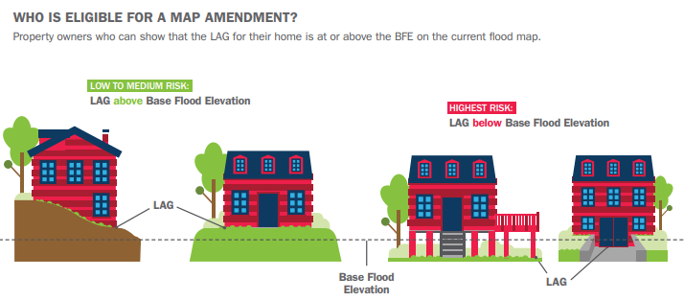
WHO IS ELIGIBLE FOR A MAP AMENDMENT?
Property owners who can the show the LAG of their home is at or above the BFE on the current flood map.
Source: How to Request a Map Amendment (Nov. 2018)
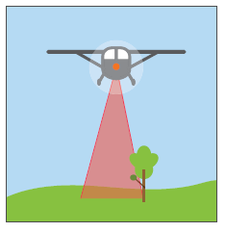
WHAT IS LIDAR?
Light Detection and Ranging (LiDAR) is defined as a laser system that is used to acquire x, y, and z coordinates of terrain and terrain features that are both manmade and naturally occurring.

IS THERE A COST SAVINGS USING LIDAR ELEVATION DATA?
LiDAR data can replace the requirement to submit elevation information certified by a licensed land surveyor or professional engineer, which can create a cost savings for property owners. However, LiDAR data may be less accurate than certified elevations and may not capture the full risk for the building or lot.

WHEN CAN LIDAR NOT BE USED
There are situations when LiDAR cannot be used in a LOMA request. These include applications involving the following:
- Buildings or lots elevated using fill
- Buildings or lots in the regulatory floodway or Zone AO
  - FEMA is only concerned that the subject of review is outside the floodway
  - The location of the closest lower contour can be within the floodway
- Buildings under construction. LiDAR would need to show that the lot or portion of the lot on which building will be located is above the Base Flood Elevation (BFE)
- Conditional determinations
- Electronic LOMAs (eLOMAs)
- Potential violations identified through the LOMA process
- Physical changes to the flooding source/Special Flood Hazard Area that require revisions to the Flood Insurance Rate Map
- Requests to supersede previously issued LOMAs based on certified elevation data
WHAT IS REQUIRED IN THE SUBMISSION?
When requesting a LOMA using LiDAR data, you can use the WV Flood Tool to submit a digital PDF that displays:
- an overlay of the LiDAR contours (lines of equal elevation), or
- an overlay of the LiDAR points (points with specific elevations).
Either application submission must include an aerial image of the building or lot with at least one street intersection shown on the map. Your floodplain administrator or a mapping professional can help you develop the map exhibit for your application. For other requirements, please refer to FEMA's online resources about Letters of Map Change (LOMC).
# | Map Elements Required
1 | Name, organization, and contact information for the map creator
2 | E-911 Address of property
3 | Road or street intersection reference
4 | Assessor’s Parcel Number (APN) for the building/lot
5 | Clearly identified building and/or lot boundaries
6 | Aerial imagery that shows building footprint
7 | Date, Source, and Accuracy of the LiDAR collected (must meet Quality Level 3 standards)
8 | Vertical Datum of elevation data (e.g., NAVD 88, NGVD 29)
9 | Scale Bar and North Arrow
10 | WV Flood Tool Location web link

STEP-BY-STEP INSTRUCTIONS

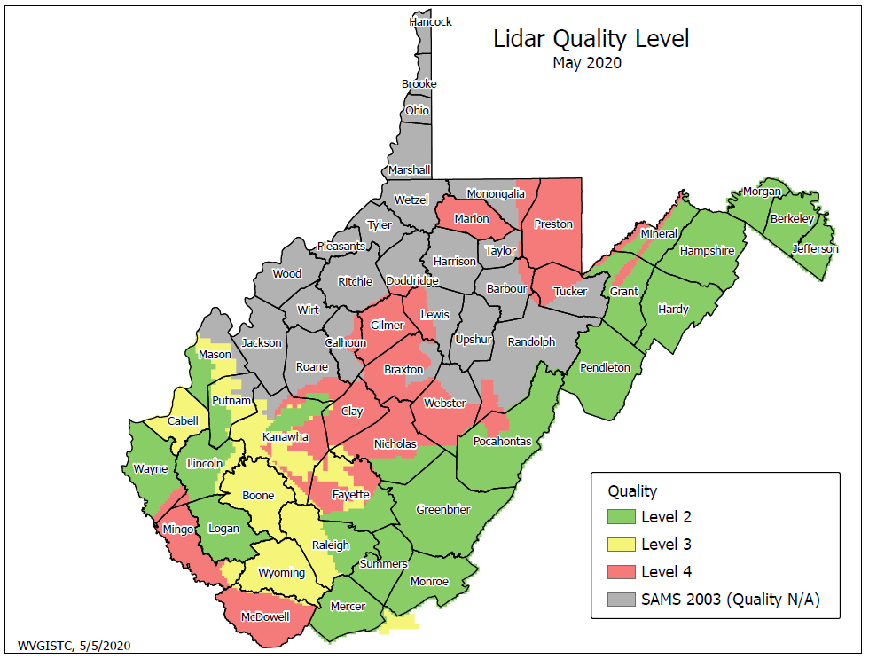
- Determine LiDAR Coverage: Determine if your community has LiDAR of Quality 3 (QL3) accuracy or better. Refer to the WV LiDAR Quality Level Map that show QL3 or QL2 coverage. All the LiDAR QL2 areas in West Virginia except for Logan County have high-resolution 1-foot or 2-foot contours displayed at the 1:564 and 1:282 map scales. When a user queries a location in the WV Flood Tool, the LiDAR Elevation Source Metadata project name and acquisition year are displayed to the right of the elevation value in the Flood Query Results Panel from which the LiDAR source, accuracy, and date can be identified. In 2021, FEMA-purchased QL2 LiDAR should be available for the entire State.
- Select WV Flood Tool’s Print LOMA Tool: Select the Print Function on the toolbar of the WV Flood Tool and then the FEMA Floodplain LOMA Map option. Refer to the LiDAR for LOMA Guide for more illustrations and depictions.
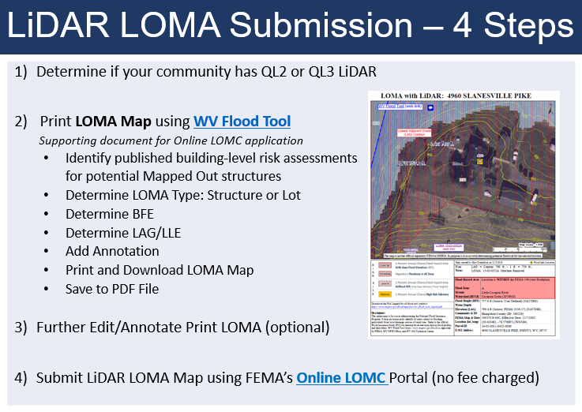

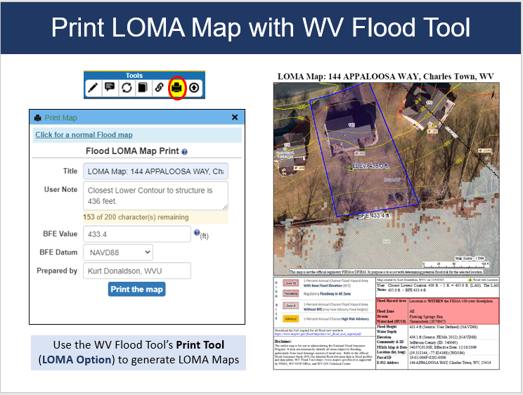
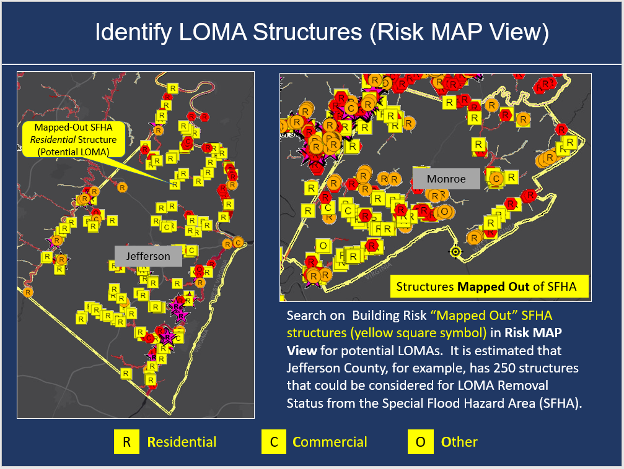
  - Identify Potential Mapped Out Structures: Use the EXPERT or RISKMAP Views. Remember that changing between views in the WV Flood Tool resets all the default layers. Ensure the Best Leaf-Off Aerial Imagery is selected as the base map. Look for areas where the model-backed 1% annual chance Water Depth (blue shaded raster) is not near a mapped structure. In the RISKMAP View, for potential LOMAs, consider the “Mapped Out SFHA” (yellow square symbol) structures which indicate Building Risk for Future Map Conditions (or changes to future flood zone designations). The Mapped-Out SFHA structures are only calculated with model-backed depth grids and not Hazus-derived depth grids. Do not consider mapped-out structures that have a Verified LOMA with certified elevation data.

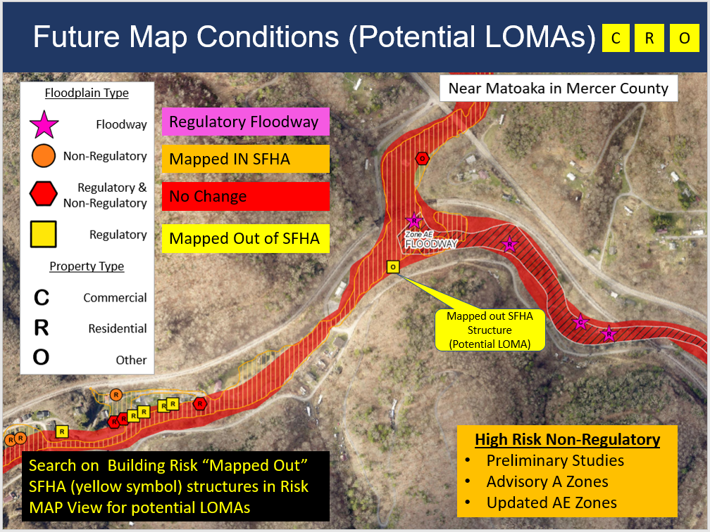

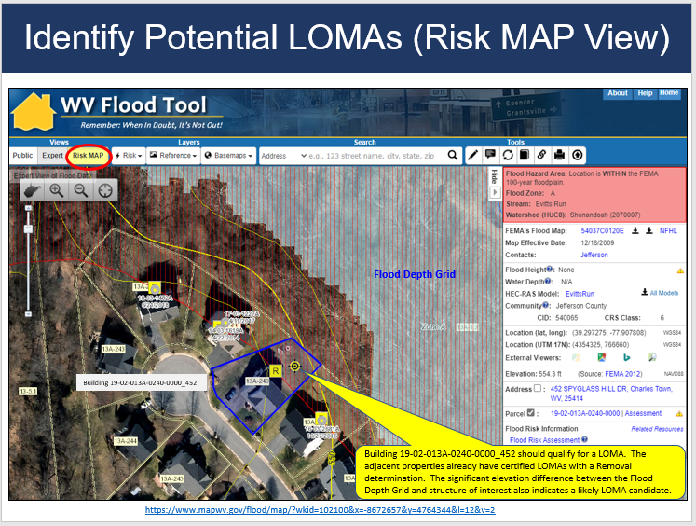

  - Determine LOMA type: Identify the existing structure or lot type for subject of review. Remember that LiDAR LOMAs cannot be submitted for structures or lots elevated on fill – only for natural grade properties. LOMAs on Fill require a different application process. LOMA requests involving one or more structures, the LAG must be at or above the BFE. LOMA requests involving one or more lots, the lowest point on each lot must be at or above the BFE.

  - Determine BFE: Determine the Base Flood Elevation (BFE) of the flooding source closest to the structure. If the property is in an AE Zone, then make sure the X-Sections and BFEs are visible. Identify the BFE value from the Flood Height of the Flood Query Results Panel or the Cross-Sections. In the Print LOMA popup window, enter the BFE Value to the nearest tenth of a foot (0.01). Next enter the Vertical Datum (NAVD88 or NGVD29) which is displayed to the right of the Flood Height value in the Flood Results Query Panel. Use the Text Markup tool to annotate the BFE value on the map. A NAVD88 Ground Elevation is converted to a match a NGVD29 BFE so the ground elevation and flood height elevations are the same for the LOMA submission. IMPORTANT: When submitting LOMA applications, the BFE and LAG Vertical Datums must be the same! See WV Vertical Datum Conversions for more information.
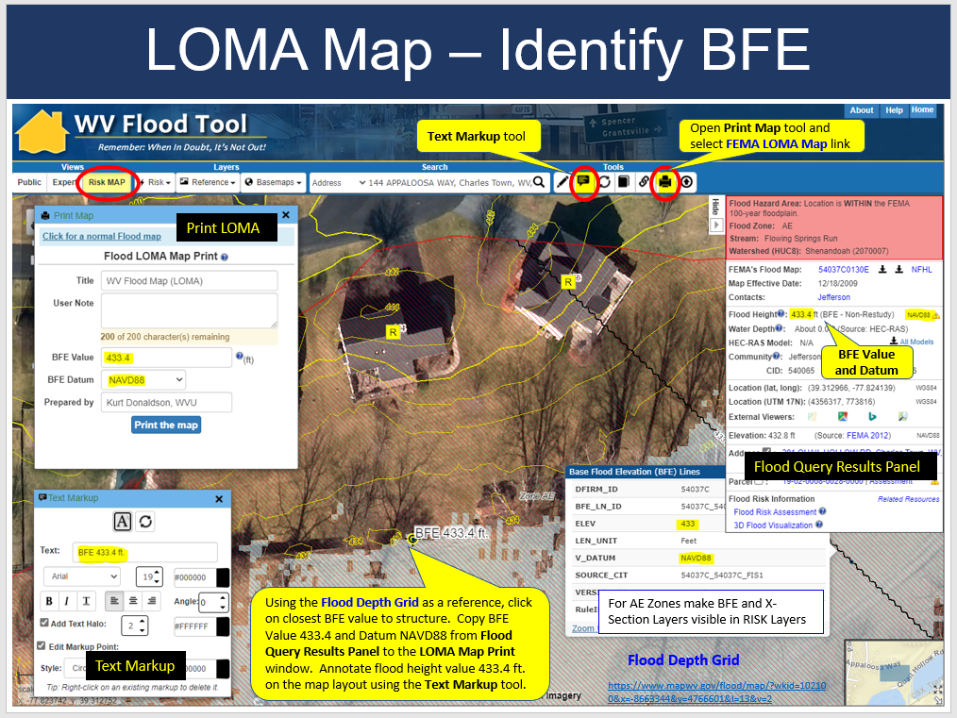
  - Determine LAG/LLE: The lowest adjacent grade (LAG) for a building, or the lowest lot elevation (LLE) for a lot, will be compared to the Base Flood Elevation (BFE) to determine the flood zone designation (e.g., A, AE, X shaded). If the LAG/LLE is at or above the BFE on the current flood map, FEMA can issue a removal determination. For buildings or lots that cannot be removed from the high-risk flood zone using LiDAR, certified elevation data will be required for a standard LOMA determination.
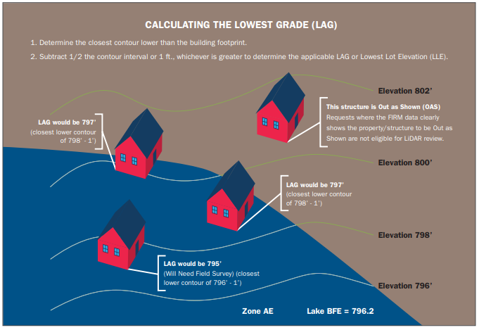
    - Using LiDAR Contours: For LOMA submittals that include LiDAR data contours, FEMA will subtract half the contour interval or 1 foot, whichever is greater, from the lowest contour closest to (but not going through) the building (to determine the LAG) or the lot (to determine the LLE)¹. Determine the Lowest Adjacent Grade (LAG) or Lowest Lot Elevation (LLE) using the 1-ft. or 2-ft. LiDAR-Derived Contours. Ensure the Contours Layer in the Reference Layers is visible. High-resolution contours are displayed only at the highest two zoom levels of 1:564 and 1:282 map scales. Use the Text Markup tool to annotate the Closest Lower Contour on the map. Submit the LAG/LLE elevation values to the nearest tenth of the foot (0.1). If high-resolution contours do not exist, then use the LiDAR Point Data method described in the following section to determine the LAG.
Calculating Lowest Adjacent Grade (LAG) – Contours
¹ Note: For West Virginia, users will always subtract 1 foot from the Closest Lower Contour to determine the LAG
    - Using LiDAR Point Data: For submittals that include LiDAR point data, FEMA will subtract 2 feet from the lowest point closest to the building (to determine the LAG) or the lowest point on the lot (to determine the LLE). Multiple points must cover the building/lot for this method. Use the Text Markup tool to annotate the Lowest Adjacent Point value on the map. Submit the LAG/LLE elevation values to the nearest tenth of the foot (0.1).
Where LiDAR contours are not available, in lieu of the LiDAR contours noted above, the overlay exhibit may depict the point cloud, with elevations labeled, that would be used to determine the LAG or LLE. The point density must be sufficient, and the labeled elevations need to be uniformly spaced throughout the subject property to adequately portray changes in elevations.
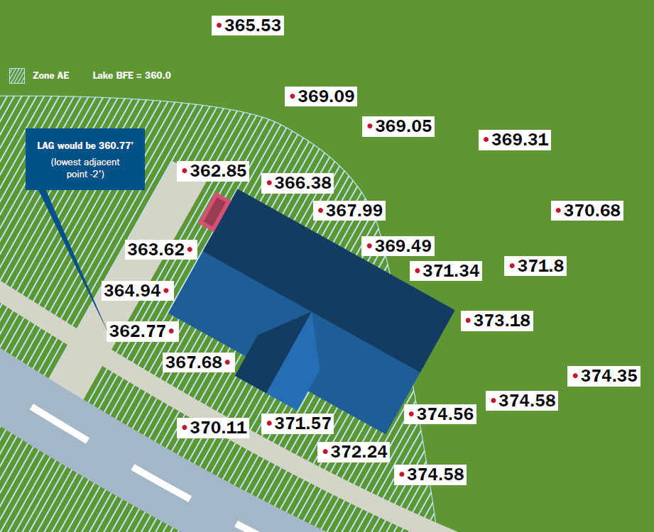
Calculating Lowest Adjacent Grade (LAG) – Point Data

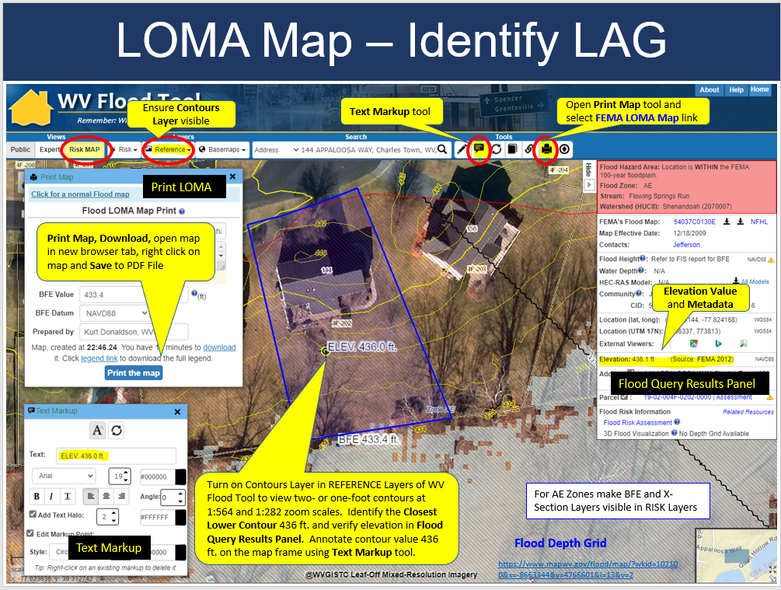

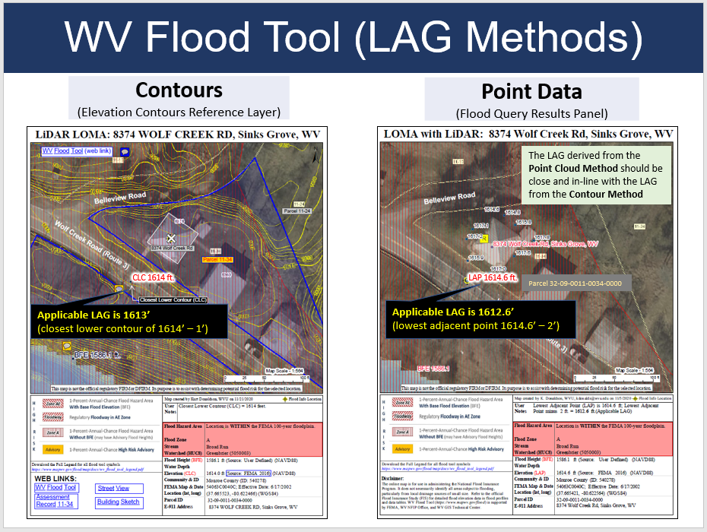

  - Add Annotation: Users can add a customized title and user notes in the Print LOMA popup window to display on the PDF LOMA map. Use the Text Markup tool for annotation on the map; ant the Text Markup tool to annotate the BFE value on the map. To erase all text markups, select the Clear tool. To erase single features, right click on the annotation to delete; however, the delete function will not work if the parcel selection is on.
  - Print and Download LOMA Map: Select the “Print Button” to generate and download the online PDF LiDAR LOMA Map. Review and make corrections. Download the PDF LOMA Map to view in your web browser. Follow the same procedures each time of printing and downloading the map after an edit or format change has been made to the layout.
  - Save to PDF LOMA File: Right click on the LiDAR LOMA Map in your web browser and Save the LOMA Map to a file. For the LiDAR LOMA PDF file name, include the unique Building Identifier for a structure LOMA and the unique Parcel Identifier for the lot LOMA. This information can be copied from the WV Flood Tool.
- Further Edit/Annotate Print LOMA (optional): Import the Print LOMA file into Adobe Acrobat (preferred) or other editing software to add or edit annotation. Ensure the property information is correctly identified on the Print LOMA.
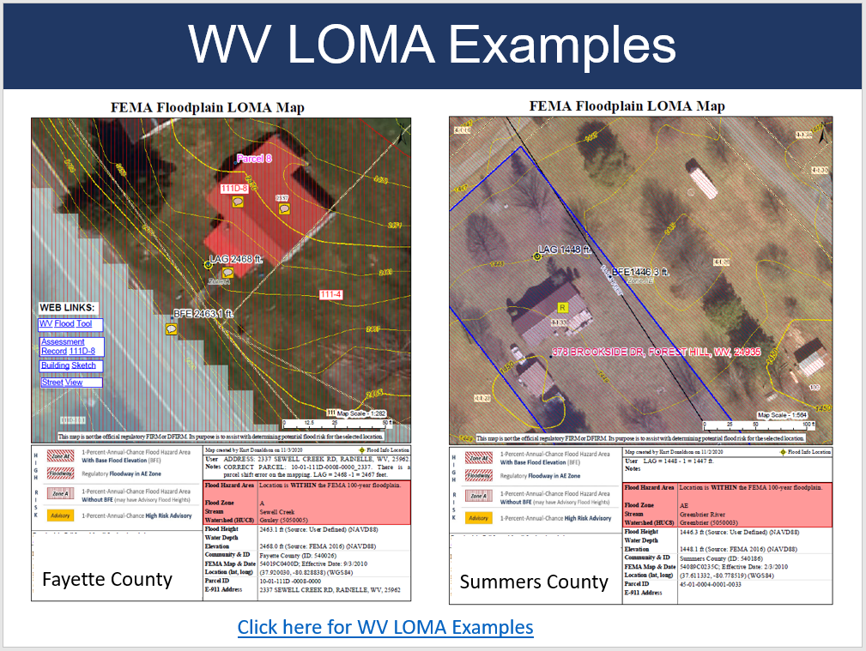
LIDAR LOMA map examples
- Submit LiDAR LOMA Map: Submit the Print LOMA file and elevation information using FEMA’s Online Letter of Map Change submission process. Process multiple maps to ensure all the required elements and parcel/street information are captured. Below are the major processing steps:
  - Flood Determination Details (Single Structure, Single Lot, Multiple Structures, Multiple Lots; a survey is required for portions of lots).
  - Community Details
  - E-911 Street Address & Legal Description of Property. Make sure the authoritative E-911 address is utilized and not the Assessor’s Parcel Address (which is often incomplete or inaccurate). In the property description, ensure the full building identifier or parcel identifier are the complete spatial identifiers prescribed for West Virginia properties.
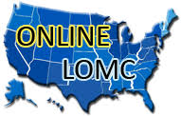
  - Fill Information (Choose No)
  - LOMC Type (Choose LOMA)
  - Processing Fee (Choose No Fee Required)
  - Applicant Name, Mailing Address, Contact Information
  - Upload Supporting Documents. If you do not upload the appropriate supporting documents, you will not be able to continue the LOMC application process.
    - Map Documents (click links for examples)
      - PDF LOMA Map with BFE and LAG
      - Street Reference Map for property location
    - Tax Assessor's Map or suitable map document (WV Flood Tool parcel map should suffice)Property Deed or Plat Map: Upload either a Copy of the Property Deed (with recordation data and stamp of the Recorder's Office) OR a Copy of the Subdivision Plat Map for property (with recordation data and stamp of the Recorder's Office) as separate files.
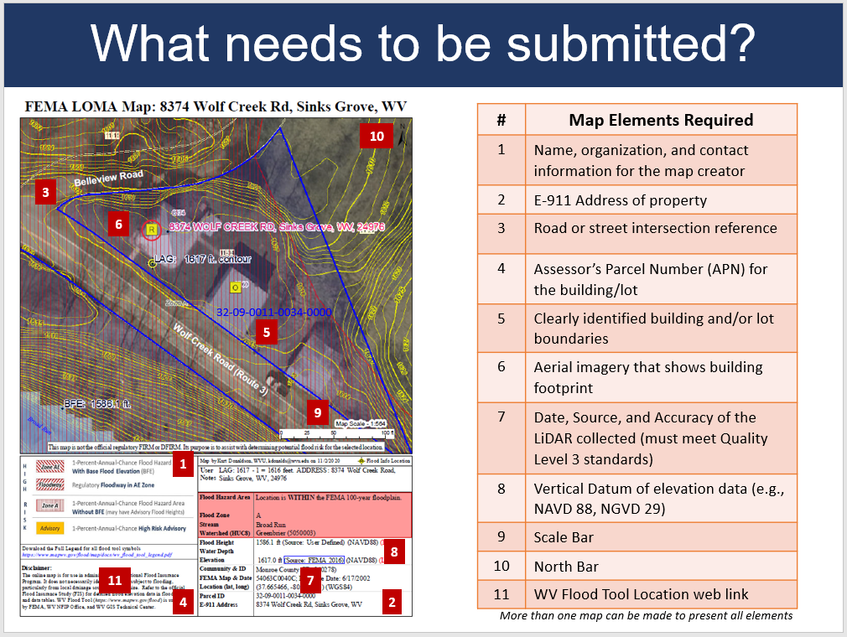

NEED MORE HELP?

Need more help? Refer to FEMA’s Online Letter of Map Change Tutorial (2018). In addition, as a guide, refer to LIDAR LOMA map examples created using the WV Flood Tool.
Processing Time: Determinations will be made within 60 days of a completed Amendments request.
Approval for Letter of Map Amendment (LOMA): If the LOMA is approved, the submitter of the application will receive a letter from DHS-FEMA stating that an existing structure or parcel of land that has not been elevated by fill (natural ground) would not be inundated by the base flood. Approval time
* * *
Assistance: As a guide, refer to LIDAR LOMA map examples created using the WV Flood Tool.
Local Floodplain Manager: Your floodplain administrator or a mapping professional can help you develop the map exhibit for your online application. Refer to the State Directory for the contact information of your local floodplain manager.

FEMA: To speak with a Map Specialist about the amendment process, contact the FEMA Map Information eXchange (FMIX) at 877-FEMA-MAP (877-336-2627) or FEMAMapSpecialist@riskmapcds.com

WV Flood Tool (www.mapwv.gov/flood)
WVU GIS Technical Center, West Virginia University
Kurt Donaldson, GIS Manager
kurt.donaldson@mail.wvu.edu, phone: (304) 293-9467
Maneesh Sharma, GIS Analyst
Maneesh.Sharma@mail.wvu.edu, phone (304) 293-9466
Eric Hopkins, GIS Analyst
Eric.Hopkins@mail.wvu.edu, phone: (304) 293-9463

RESOURCES

- West Virginia
- WV Flood Tool LiDAR for LOMA Guide | Instructions
- WV LiDAR for LOMA Examples
- WV LiDAR Quality Level Map
- WV Elevation Source Metadata
- WV FEMA-Purchased LiDAR Status Map
- WV Advisory A / AFH Status Map
- WV Building and Property Identifiers
- WV Vertical Datums

- FEMA
- FEMA Online Letter of Map Change (LOMC) Website
- Online Letter of Map Change Tutorial (2018)
- How to Request a Letter of Map Amendment (LOMA) or Letter of Map Revision Based on Fill (LOMR-F)
- Region V LiDAR LOMA Fact Sheet (2018)
- Guidance for Flood Risk Analysis and Mapping MT-1 Technical Guidance (November 2019), Light Detection and Ranging (LiDAR) Letter of Map Amendment (page 44)

APPENDIX A: Studied Zone A and Unstudied Zone A

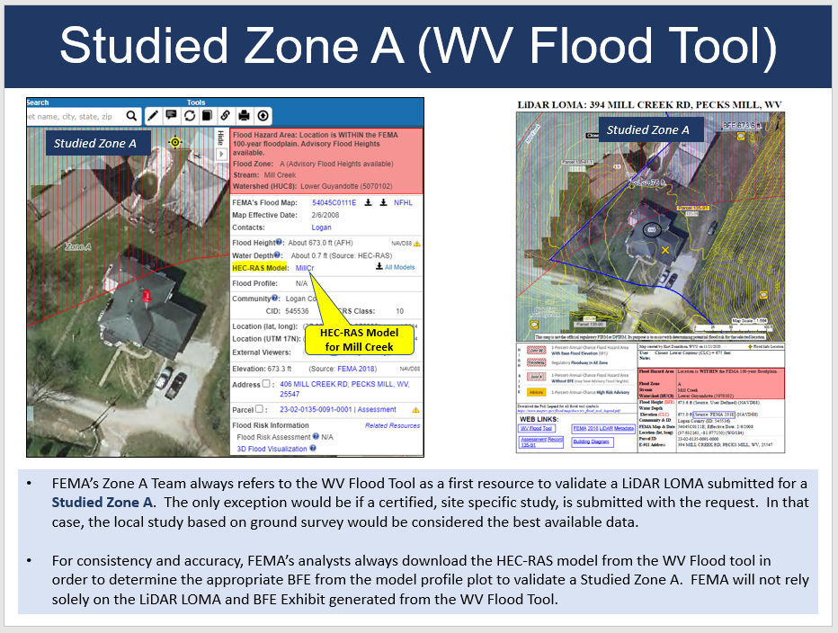
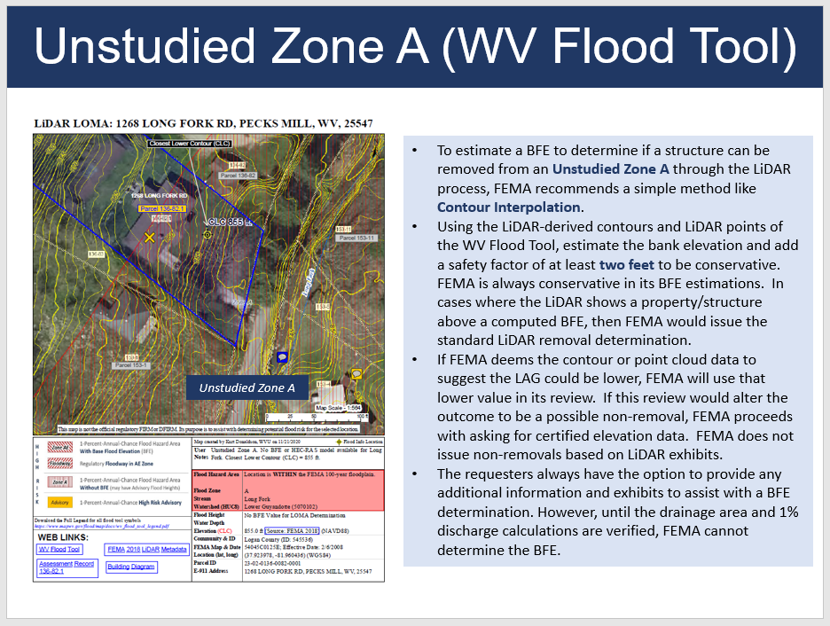
- To estimate a BFE to determine if a structure can be removed from an Unstudied Zone A through the LiDAR process, FEMA recommends a simple method like Contour Interpolation.
- Using the LiDAR-derived contours and LiDAR points of the WV Flood Tool, estimate the bank elevation and add a safety factor of at least two feet to be conservative. FEMA is always conservative in its BFE estimations. In cases where the LiDAR shows a property/structure above a computed BFE, then FEMA would issue the standard LiDAR removal determination.
- If FEMA deems the contour or point cloud data to suggest the LAG could be lower, FEMA will use that lower value in its review. If this review would alter the outcome to be a possible non-removal, FEMA proceeds with asking for certified elevation data. FEMA does not issue non-removals based on LiDAR exhibits.
- The requesters always have the option to provide any additional information and exhibits to assist with a BFE determination. However, until the drainage area and 1% discharge calculations are verified, FEMA cannot determine the BFE.

Unstudied Zone A

- FEMA will attempt to calculate the BFE when a LOMA application is submitted for properties of less than 50 lots or 5 acres.
- FEMA uses the best available topography to approximately model the BFEs. For areas where there is not a BFE tied to model backing that FEMA can download from the WV Flood Tool, FEMA will use whatever data is submitted or available to determine an applicable BFE for a request. FEMA will use the LiDAR available in the WV Flood Tool to capture the necessary extent to compute BFE determinations where there is no model backing. The availability of LiDAR provides FEMA with more confidence in the outcomes of these reviews and to complete a reasonable BFE determination.
- For riverine flooding, FEMA measure a cross section at the upstream limit of the structure and use FEMAs Quick 2 software to apply Manning’s flow equation.
- Where available, FEMA uses gage data or regional regression equations to determine the discharge for the model.
- If the drainage area is too small for the parameter range FEMA may use the rational method.
- If the source is a lake or depressed area, FEMA would apply stage-storage calculations or rectangular weir flow pending the identification of outlet or not.
- FEMA follows the detailed methods of FEMA 256 Managing Floodplain Development in Approximate Zone A Areas that provides guidance for obtaining and developing base (100-Year) flood elevations.
- Once that BFE is determined in-house, FEMA will know if the LiDAR results in a removal or will send a data request letter asking for certified elevations.
- FEMA never discourages users from submitting a LiDAR LOMA because the BFE for an Unstudied Zone A is unknown. The LiDAR-derived ground elevation information submitted in the LiDAR LOMA Exhibit will be enough for FEMA to make an in-house determination.

APPENDIX B: FEMA Processing of Contour or LiDAR Point Submittals

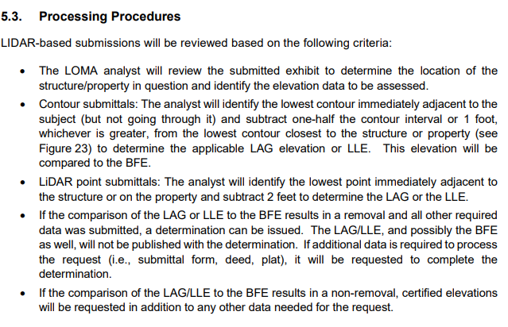
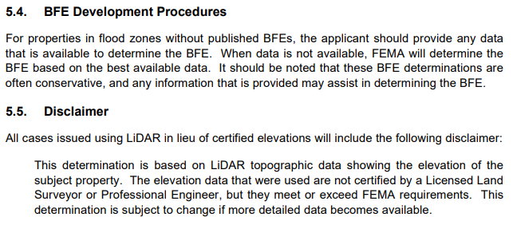

Guidance for Flood Risk Analysis and Mapping MT-1 Technical Guidance (November 2019), LiDAR LOMA Section 5.0, pages 47-48

APPENDIX C: Incomplete Submission

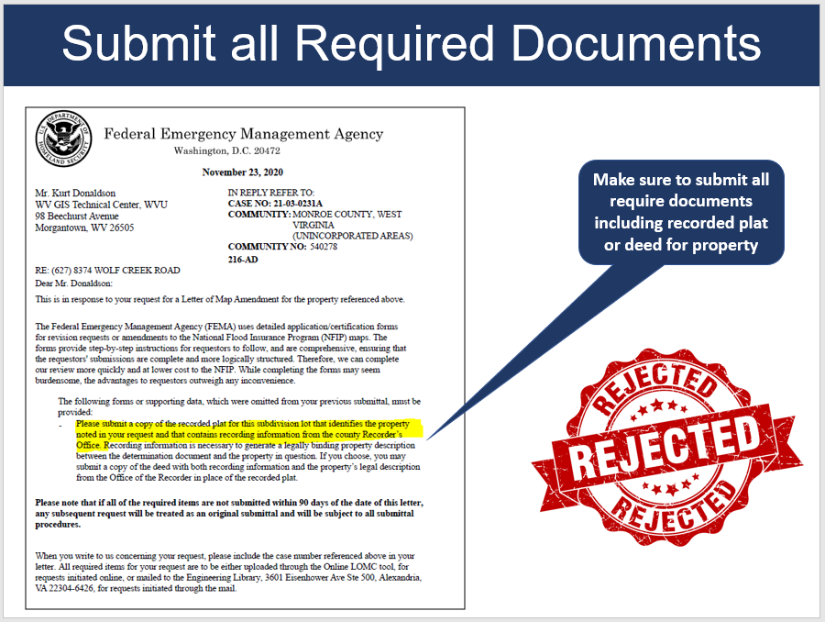

APPENDIX D: eLOMA Tool versus Online LOMC Tool

eLOMA
The Federal Emergency Management Agency (FEMA) has designed a web-based tool specifically for licensed land surveyors and professional engineers (referred to as Licensed Professionals or LPs) and FEMA approved National Flood Determination Association (NFDA) Certified Professionals (CPs) to submit selected Letter of Map Amendment (LOMA) requests, known as an electronic Letter of Map Amendment (eLOMA). A LOMA is an official amendment to an effective Flood Insurance Rate Map (FIRM), typically issued to remove a property and/or structure from a Special Flood Hazard Area (SFHA).

Differences Between Online Letter of Map Change (LOMC) and Traditional LOMA Paper Form Processes
An eLOMA determination serves the same function as a standard LOMA that was completed via the Online LOMC tool or the MT-EZ or MT-1 paper forms submitted by mail. The Online LOMC tool is available to any applicant, including home or property owners who wish to submit a LOMC request online, whereas eLOMA can only be used by a selected group. All LOMC requests may be processed through Online LOMC, including amendment and revision requests, whereas eLOMA is for a selected LOMA (amendment) requests.
A LOMA determination via Online LOMC or the paper forms may take up to 60 days to process, compared to a potentially instant eLOMA determination. The eLOMA tool allows for less mailing and printing of supporting data forms and expedites the electronic transfer and tracking of data.

eLOMA Criteria
The tool accepts LOMA requests that are not considered to be within a coastal zone (Zone V), an alluvial fan, or modified by fill to raise the elevation of the structure.
Determine if the eLOMA tool is right for your LOMA request by answering the following pre-qualifying questions:
Has fill been placed, or will fill be placed, to raise the elevation for the subject of the request?
Is the request for a proposed structure, a proposed portion of property, or a proposed legally recorded parcel of land?
Is the subject of the request located on an alluvial fan or coastal flood hazard area (V Zone)?
Is there a LOMA application currently being processed by FEMA for the subject of the request?
If answered “No” to each question, the request qualifies for an eLOMA determination.
If the request does not meet eLOMA criteria, you will need to use Online LOMC tool or the MT-1 paper form.

APPENDIX E: WV Flood Tool’s LOMA implementation compared to Region V Counties (Minnesota)
The WV Flood Tool’s LIDAR for LOMA implementation is similar to select Minnesota counties in FEMA Region V but with additional enhancements:
- Statewide Geographic Extent: A statewide, standardized implementation of the LiDAR for LOMA TOOL. The tool can be used by all counties in West Virginia when complete FEMA-purchased QL2 LiDAR coverage is attained and processed for the WV Flood Tool.
- LAG Determination Methods: Supports both Contour and Point LiDAR methods for determining the Lowest Adjacent Grade. In the WV Flood Tool, one or two-foot contours are displayed in the REFERENCE Layers at the highest zoom scales (1:564 and 1:282 map scales) and LiDAR points are presented on the FLOOD QUERY RESULTS PANEL. Leaf-off aerial imagery typically at 4-inch cell resolution is also available at the highest zoom scales.
- NGVD29 Base Flood Elevation Datum Conversion: The LOMA Map Print Tool converts the Ground Elevation NAVD88 to NGVD29 so the BFE and LAG/LLE are the same vertical datum.
- Model-Backed A Zones: For Studied A Zones, HEC-RAS models for the flood studies can be downloaded from the WV Flood Tool’s Query Results Panel.
- LOMA Candidate Identification: The building-level risk assessments and base flood depth grid provide easy references for users to identify potential LOMAs.
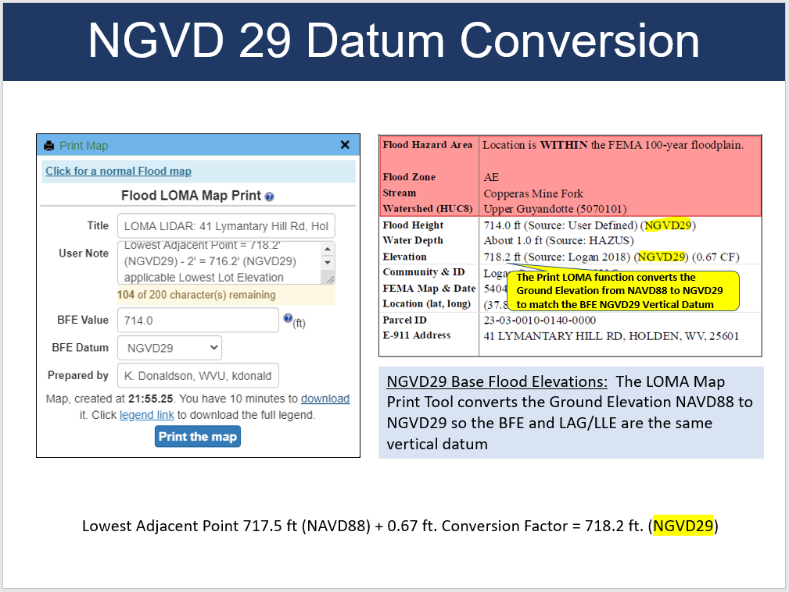

RESOURCES:
- FEMA Region V Fact Sheet https://greatlakescoast.org/pubs/factSheets/Region_V_LiDAR_LOMA_FS_v3_012219_FINAL.pdf
- Examples of Minnesota web application Print LOMA Tool features:
- Anoka County, Minnesota:
http://gis.anokacountymn.gov/flood/
- Hennepin County Natural Resources Interactive Map
- https://gis.hennepin.us/naturalresources/map/
- https://gis.hennepin.us/NaturalResources/map/default.aspx?C=440980.63442474947,4979864.386330494&L=9&T=road&D=true&IMG=2015&LID=2&PID=0611724410004&VIS=5,27,24,8&I=440972.142523,4979872.800097321

