
West Virginia Statewide Imagery Contract
Prepared by Kurt Donaldson 8/12/2026

INFORMATION SHEET
West Virginia Statewide Imagery Program
A statewide contract through the WV GIS Technical Center at West Virginia University is available for the acquisition of digital orthoimagery in West Virginia. As part of the Statewide Imagery Program (WVSIP), the imagery is unit priced so that participants can budget for imagery years in advance as well as pay over multiple budget cycles. To meet the needs of the largest number of potential participants, a variety of product options are available through the WVSIP program to include countywide unit pricing for 12-inch, 6-inch, 4-inch, and 3-inch spatial resolutions. This contract allows for municipalities, counties, state agencies, and the federal government to tap into an existing contract to acquire imagery at a known unit price that is usable until June 30, 2027.

Pixel Resolution  (Detail Level) | 3-inch | 4-inch | 6-inch | 12-inch
Cost per square mile | $111 | $81 | $65 | $44
Map Scale | 1” = 50’ | 1” = 67’ | 1” = 100’ | 1” = 200’
Horizontal Accuracy  (ASPRS 1) | 0.5 feet | 0.66 feet | 1.0 feet | 2.0 feet
Note: 4-band stacked imagery that includes color infrared can be added at 25% of the acquisition cost

A target spatial resolution of 6 inches is recommended for counties that can afford this level of detail. The horizontal accuracy standard is ASPRS Class 1. The original state contract was awarded to Blue Mountain Inc. which is now part of The Thrasher Group, Inc. The state contact and county unit prices can be viewed at the following links: Amendment #3 (7/1/2025 to 6/30/2027) | Amendment #2 (7/1/2024-6/30/2025) | Amendment #1 (current price list) | 2019 Contract

Performance Period
The total contracting period of this contract has been extended from 1 January 2026 through 30 June 2027 to include the spring 2027 leaf-off season.

How can you participate?
Any organization can participate in the Statewide Imagery Program. A signed MOU that states the specifications and costs is all that is needed to participate in the program. The MOU must be signed by March 15 of the flight season. For more information, contact one of the following program representatives:

Kurt Donaldson, GISP, CFM Craig Fry, CP
WVU GIS Technical Center The Thrasher Group, Inc.
304.293.9467 724.485.7060
kdonalds@wvu.edu CFry@thethrashergroup.com

View Aerial Imagery Examples
You can review the aerial imagery acquired via the State Contract by linking to the statewide aerial imagery web service below. Refer to counties of the vendor acquisition map by The Thrasher Group, Inc.
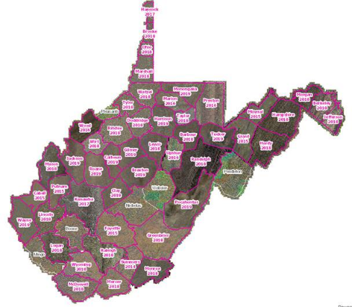
  - County Aerial Imagery Year Acquired
  - County Aerial Imagery Resolution
  - County Aerial Imagery Vendor
  - Resolution Comparison – Baseball Fence
  - Resolution Comparison – WVU Coliseum
  - Statewide Leaf-Off imagery web map service
  - Download County Aerial Imagery

Detailed Imagery Resolution
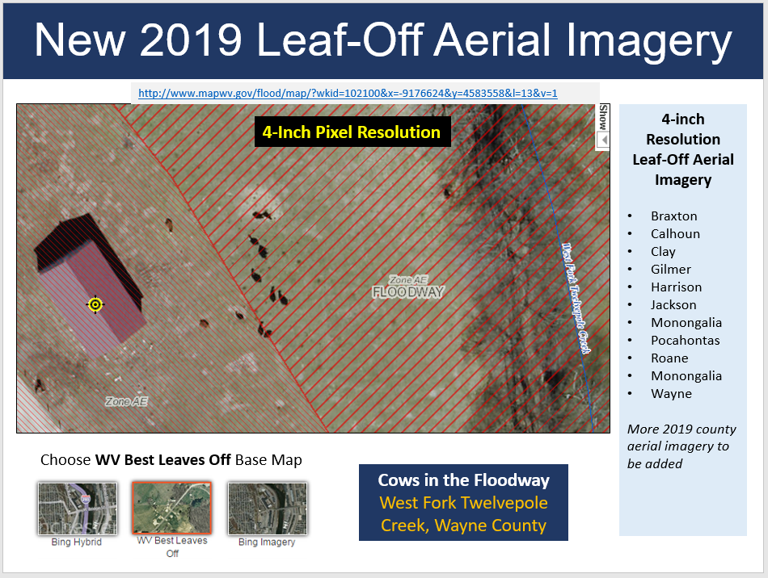
The four-inch resolution imagery is high enough resolution to count cows on the imagery.

State Contract Aerial Imagery Pricing

AERIAL IMAGERY PRICING Effective July 1, 2026 – June 30, 2027

Pixel Resolution  (Detail Level) | 3-inch | 4-inch | 6-inch | 12-inch
Cost per square mile | $111 | $81 | $65 | $44
Map Scale | 1” = 50’ | 1” = 67’ | 1” = 100’ | 1” = 200’
Horizontal Accuracy  (ASPRS 1) | 0.5 feet | 0.66 feet | 1.0 feet | 2.0 feet
Notes:
4-band stacked imagery that includes color infrared can be added at 25% of the acquisition cost.
The county border buffer is 1000 feet unless otherwise noted.

County | Square Miles | 12" @ $44 per square mile | 6" @ $65 per square mile | 4" @ $81 per square mile | 3" @ $111 per square mile
BARBOUR COUNTY | 343 | $15,092 | $22,295 | $27,783 | $38,073
BERKELEY COUNTY | 322 | $14,168 | $20,930 | $26,082 | $35,742
BOONE COUNTY | 503 | $22,132 | $32,695 | $40,743 | $55,833
BRAXTON COUNTY | 516 | $22,704 | $33,540 | $41,796 | $57,276
BROOKE COUNTY | 93 | $4,092 | $6,045 | $7,533 | $10,323
CABELL COUNTY | 288 | $12,672 | $18,720 | $23,328 | $31,968
CALHOUN COUNTY | 280 | $12,320 | $18,200 | $22,680 | $31,080
CLAY COUNTY | 344 | $15,136 | $22,360 | $27,864 | $38,184
DODDRIDGE COUNTY | 320 | $14,080 | $20,800 | $25,920 | $35,520
FAYETTE COUNTY | 668 | $29,392 | $43,420 | $54,108 | $74,148
GILMER COUNTY | 339 | $14,916 | $22,035 | $27,459 | $37,629
GRANT COUNTY | 480 | $21,120 | $31,200 | $38,880 | $53,280
GREENBRIER COUNTY | 1024 | $45,056 | $66,560 | $82,944 | $113,664
HAMPSHIRE COUNTY | 645 | $28,380 | $41,925 | $52,245 | $71,595
HANCOCK COUNTY | 88 | $3,872 | $5,720 | $7,128 | $9,768
HARDY COUNTY | 584 | $25,696 | $37,960 | $47,304 | $64,824
HARRISON COUNTY | 416 | $18,304 | $27,040 | $33,696 | $46,176
JACKSON COUNTY | 471 | $20,724 | $30,615 | $38,151 | $52,281
JEFFERSON COUNTY | 212 | $9,328 | $13,780 | $17,172 | $23,532
KANAWHA COUNTY | 910 | $40,040 | $59,150 | $73,710 | $101,010
LEWIS COUNTY | 389 | $17,116 | $25,285 | $31,509 | $43,179
LINCOLN COUNTY | 439 | $19,316 | $28,535 | $35,559 | $48,729
LOGAN COUNTY | 455 | $20,020 | $29,575 | $36,855 | $50,505
MARION COUNTY | 311 | $13,684 | $20,215 | $25,191 | $34,521
MARSHALL COUNTY | 312 | $13,728 | $20,280 | $25,272 | $34,632
MASON COUNTY | 445 | $19,580 | $28,925 | $36,045 | $49,395
MCDOWELL COUNTY | 535 | $23,540 | $34,775 | $43,335 | $59,385
MERCER COUNTY | 420 | $18,480 | $27,300 | $34,020 | $46,620
MINERAL COUNTY | 329 | $14,476 | $21,385 | $26,649 | $36,519
MINGO COUNTY | 424 | $18,656 | $27,560 | $34,344 | $47,064
MONONGALIA COUNTY | 366 | $16,104 | $23,790 | $29,646 | $40,626
MONROE COUNTY | 473 | $20,812 | $30,745 | $38,313 | $52,503
MORGAN COUNTY | 230 | $10,120 | $14,950 | $18,630 | $25,530
NICHOLAS COUNTY | 654 | $28,776 | $42,510 | $52,974 | $72,594
OHIO COUNTY | 109 | $4,796 | $7,085 | $8,829 | $12,099
PENDLETON COUNTY | 698 | $30,712 | $45,370 | $56,538 | $77,478
PLEASANTS COUNTY | 134 | $5,896 | $8,710 | $10,854 | $14,874
POCAHONTAS COUNTY | 941 | $41,404 | $61,165 | $76,221 | $104,451
PRESTON COUNTY | 651 | $28,644 | $42,315 | $52,731 | $72,261
PUTNAM COUNTY | 350 | $15,400 | $22,750 | $28,350 | $38,850
RALEIGH COUNTY | 609 | $26,796 | $39,585 | $49,329 | $67,599
RANDOLPH COUNTY | 1039 | $45,716 | $67,535 | $84,159 | $115,329
RITCHIE COUNTY | 454 | $19,976 | $29,510 | $36,774 | $50,394
ROANE COUNTY | 483 | $21,252 | $31,395 | $39,123 | $53,613
SUMMERS COUNTY | 367 | $16,148 | $23,855 | $29,727 | $40,737
TAYLOR COUNTY | 176 | $7,744 | $11,440 | $14,256 | $19,536
TUCKER COUNTY | 421 | $18,524 | $27,365 | $34,101 | $46,731
TYLER COUNTY | 261 | $11,484 | $16,965 | $21,141 | $28,971
UPSHUR COUNTY | 355 | $15,620 | $23,075 | $28,755 | $39,405
WAYNE COUNTY | 512 | $22,528 | $33,280 | $41,472 | $56,832
WEBSTER COUNTY | 556 | $24,464 | $36,140 | $45,036 | $61,716
WETZEL COUNTY | 361 | $15,884 | $23,465 | $29,241 | $40,071
WIRT COUNTY | 235 | $10,340 | $15,275 | $19,035 | $26,085
WOOD COUNTY | 377 | $16,588 | $24,505 | $30,537 | $41,847
WYOMING COUNTY | 502 | $22,088 | $32,630 | $40,662 | $55,722
Note: A countywide buffer of 1000 feet is flown beyond the county border.

Vendor agrees to not exceed the countywide unit rates or price schedule listed for the services rendered:

FAQs
FREQUENTLY ASKED QUESTIONS
What is Aerial Imagery?
Aerial imagery refers to digital pictures taken from the air. These pictures are normally taken from a vertical perspective looking straight down from the airplane onto the rooftops. Digital aerial imagery requires bright sunlight and cloud free conditions for good results. Digital orthoimagery is the foundation for GIS, forming the base layer from which many additional data layers are created. It combines the characteristics of an aerial image with the geometric qualities of a map. This allows GIS and CAD software to accurately measure all visible ground features in their true geographic position and lets users:
- Make accurate distance and area calculations across the entire image mosaic
- Measure the true position of any feature observed in the orthoimagery

What is the best resolution for your needs?
Your organization should capture aerial imagery at the smallest feature and highest positional accuracy that you require, while not to paying for more than you need if there is no benefit. Refer to the table below to choose the best resolution. Digital aerial imagery can vary greatly in accuracy and pixel resolution. Pixel resolution (a single point in a graphic image) refers to the actual distance on the ground each pixel represents in the orthoimagery. For example, one-foot pixel resolution means each pixel in the image covers one foot on the ground.
Table 1. Comparison of Aerial Imagery Resolution
Resolution | 3-inch | 4-inch | 6-inch | 12-inch
Cost per square mile | $111 | $81 | $65 | $44
Mapping of: | Utilities and public works | Utilities and public works | Urban and more developed areas | Rural and less developed areas
Mapping Scale | 1:600 Map Scale  1” = 50’ | 1:800 Map Scale  1” = 67’ | 1:1200 Map Scale  1” = 100’ | 1:2400 Map Scale  1” = 200’ or 1” = 400’
Positional Accuracy | Very High | Higher than 6”  Lower than 3” | Higher than 12”  Lower than 4” | Lowest
Key Features Visible | Very Small Infrastructure  - Fire Hydrants  - Manhole Covers  - Individual people and animals  - Finer details on roads including markings and skid marks | Smaller Infrastructure  - Clearer Road Markings  - Power Lines | Infrastructure  - Property line fences  - Utility Poles  - Individual Trees  - Vehicle Types  - Road markings | Large Infrastructure  - Buildings  - Paved Roads  - Railroads  - Vehicles  - Tree/shrub line
Tax Parcel Conversion Projects or Re-mapping | Identifiability of small features somewhat improved over 4”. Lower cost-to-benefit ratio | Ideal for mapping fences and other survey features at a higher positional accuracy than 6” | Ideal for mapping fences, survey features, and land divisions (e.g., fences, walls, tree lines, roads) | Satisfactory for conversion projects
Other Notes | More building lean may be noticeable at 3” resolution for taller structures | 2-foot contours for engineering grade maps generated at this resolution

What is Uncorrected versus Corrected (Ortho) Aerial Imagery?
If you are planning to measure ground features or to create maps from your aerial images, then orthorectified imagery is necessary. Orthorectification corrects for tip or tilt of the aircraft and displacement in the photograph caused by changes in the ground elevation.

How often should aerial imagery be purchased by your organization?
We would like to see all counties flown once every five years at a minimum resolution of 12 inches. Rapidly growing counties or developing areas may choose to fly every year.

How is a client billed for the imagery?
Clients are billed upon the complete delivery of the imagery products. Organizations may be able to pay the aerial imagery company over more than one budget cycle.

When is leaf-off aerial imagery flown in West Virginia?
Leaf-off aerial imagery is flown during late February to early April when there is neither no snow on the ground nor flooding. Leaf-on conditions occur about April 10 of every year, depending on the location in the state.

When will the aerial imagery be delivered?
For spring flights, all ensuing deliverables must be completed before the end of the calendar year, and preferably before October 1.
What is color-infrared imagery?
Color-infrared imagery is a false-color image that includes the near-infrared spectral band. Color infrared imagery is good at penetrating atmospheric haze and for determining the health of vegetation.

What is oblique imagery?
Oblique imagery is aerial photography that is captured at approximately a 45-degree angle with the ground and thus allows viewers to see and measure not only the top of objects but the sides as well. Typically, oblique imagery requires proprietary software to view.

What are Benefits of a Statewide Imagery Program?
A coordinated statewide imagery program employs a collective approach where partners share imagery acquisition costs in an equitable manner and based on the available funding of organizations.
- Excellent value through:
- economy of scale
- partner funding
- efficiency in implementation
- Data-sharing among members
- Specifications and QA/QC support
- RFP and contract administrative support

Business Case for Aerial Imagery. What is it used for?
- Aerial imagery is used throughout West Virginia to meet daily business needs. Imagery has many uses, including providing a common operating picture and accurately mapping the locations of natural and man-made features.
- Access to current imagery improves business efficiency and informs decision making.

What is the MrSID compression ratio?
MrSID (Multi-resolution Seamless Image Database) is a highly compressed format used to store images of photographs. The MrSIDs by default are compressed to a 20 to 1 ratio generation 4.

What is the defaults county border buffer?
The county border buffer is 1000 feet unless otherwise noted. The county can expand the buffer by adding the additional specifications in the Memorandum of Understanding.

What does The Thrasher Group offer a 4-inch resolution product?
The 4-inch resolution allows for two-foot contour accuracy, provides a spatial resolution that is slightly better than Google Earth, and captures slightly more detail than the 6-inch resolution product.

