
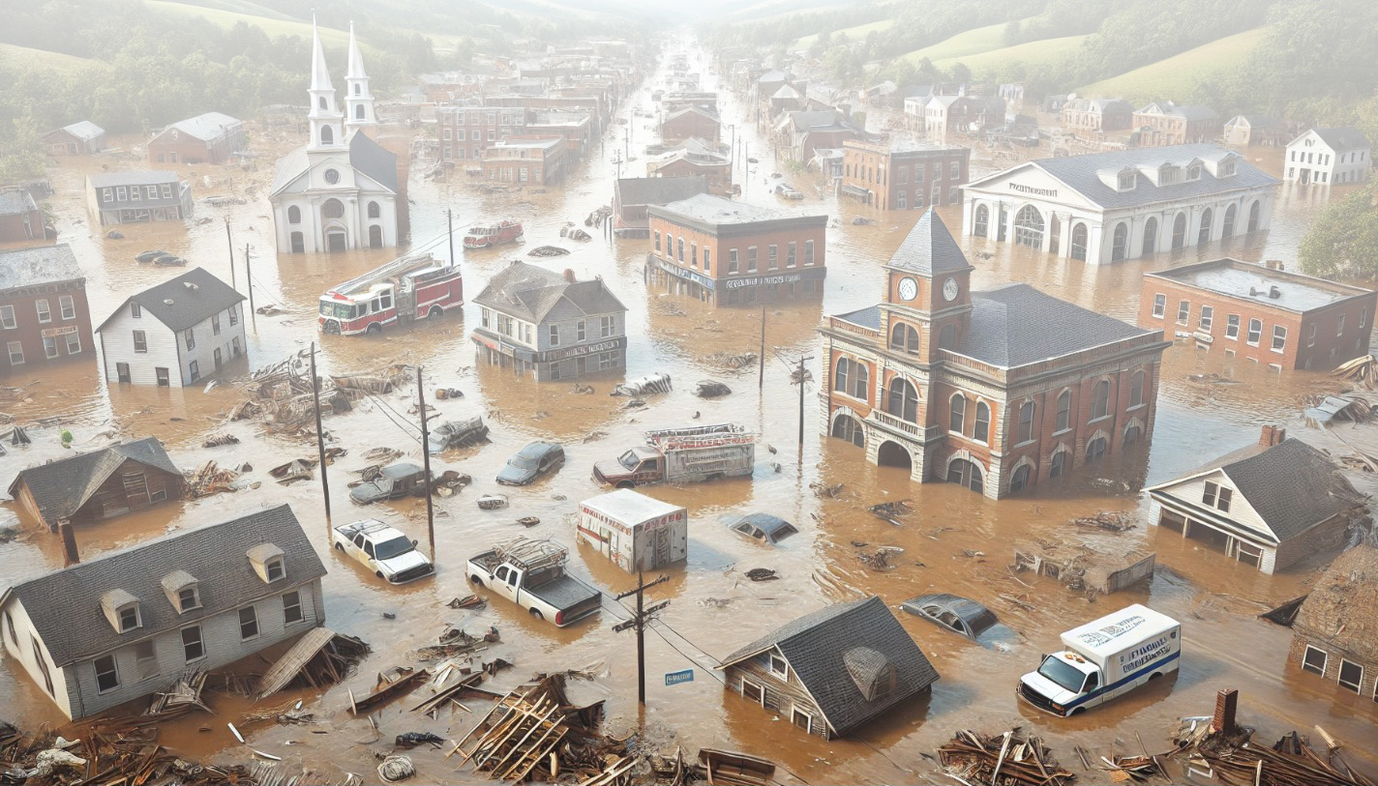


30 Fast Facts about Flooding
in West Virginia



April 2025


WV GIS Technical Center

FLOODPLAIN CHARACTERISTICS
- Floodplain Area:
- The total modified area of regulatory floodplains (aSFHA) in West Virginia, excluding large open water lakes (> 10 acres), large rivers (bank-to-bank > 500 ft.), and federal lands (> 10 acres), amounts to 528,635 acres which constitutes 3.4% of the state’s total land area. Hampshire County has the largest floodplain area in the state (26,607 acres) while Hancock County has the smallest (1,528 acres).

- Although only 31% of the state has mapped Detailed Flood Zones with advanced engineering studies including inundation depth analysis, the Detailed Flood Zones contain 65% of the Building Stock located in the Special Flood Hazard Area (SFHA).

- The median ratio of modified area of regulatory floodplain (aSFHA) to community area for all incorporated places statewide is 13.8%. The Town of Sylvester, in Boone County, has the highest floodplain ratio in the state, with 79.4% of its area located within the floodplain, followed by the Town of Friendly, in Tyler County (58.5%).

- Federally-Declared Flood Disasters:
64 flood disasters (incident subcategories of “flood,” “severe storms,” or “hurricanes”) have been federally declared in West Virginia between 1953 and 2024. Mingo County has the highest number of declared disasters in that period (28) while Brooke, Hancock, and Pleasants counties have the lowest (9 each).

- Flood Depth (FEMA Models):
- The median flood depth at structure locations across the state is 1.8 feet.

- The maximum estimated flood depth at structure locations statewide is 38.8 feet, estimated at a single-family residential building in the Raleigh Unincorporated Area.

- Within the statewide high-risk 1%-annual-chance (100-year) floodplain, a total of 2,088 primary buildings are located in areas where the estimated flood depths exceed 10 feet.

BUILDING EXPOSURE
- Buildings in Floodplain:
Of the state’s 1,118,761 primary (insurable) buildings, 82,408 are located within the 1%-annual-chance Special Flood Hazard Area (SFHA), accounting for 7.4% of all structures. Kanawha County has the highest number of structures in the state’s floodplain (13,452) while Grant County has the lowest (300). Boone County has the highest floodplain building ratio in the state, with 24.5% of its primary structures exposed, while Berkeley County has the lowest, at 0.8%.

- Buildings in Floodway:
Of the primary buildings located in the state’s Special Flood Hazard Area (SFHA), 8,237 (10%) are situated in floodways—the main channels of rivers or streams—where floodwaters are typically deepest, velocities are highest, and debris potential is greatest. Kanawha County has the highest number of primary structures in the state’s floodways (1,462), followed by Logan County (961).

BUILDING CHARACTERISTICS
- Building Value in Floodplain:
- The total estimated value of primary structures exposed to a high-risk 1%-annual-chance (100-year) flood is approximately $10 billion.

- The median value of buildings located in the high-risk floodplain is $38,200. Jefferson County has the highest median building value in the floodplain ($97,450), while McDowell County has the lowest ($14,000).

- Residential Building Values in Floodplain:
Within the statewide high-risk 1%-annual-chance (100-year) floodplain, 43.5% of the total exposed building value ($4.34 billion) is attributed to residential structures with one to four units, including mobile homes.

- High-Value Residential Structures in Floodplain:
Among the residential buildings with one to four units exposed to a high-risk 1%-annual-chance (100-year) flood in the state, there are 17 structures with appraised values exceeding one million dollars. The majority of these structures are located in Greenbrier and Kanawha counties.

- Manufactured (Mobile) Homes in Floodplain:
14.0% of all occupied residential units in West Virginia are mobile homes (120,734 out of 859,437), more than twice the national percentage of 5.9%. Of these mobile homes, 19.3% (23,315) are located within the High-Risk 1%-annual-chance (100-year) floodplain, also known as the Special Flood Hazard Area (SFHA). Mobile homes (23,315) account for 26.8% of all one-to four-unit residential buildings in the state’s SFHA (86,732 total) and 27.5% of single-family dwellings in the SFHA (84,778 total). Such structures are not designed to withstand extreme weather conditions or flooding and are particularly more vulnerable to flooding compared to conventional dwellings. Mercer County has the highest ratio of mobile homes among single-family dwellings in the floodplain (53.3%), followed by Mingo County (49.8%).

- Structures with Subgrade Basements in Floodplain:
Of the total buildings exposed to high-risk floods in the state, 24.8% (24,323 structures) have either full or partial basements, rendering them more susceptible at greater risk of physical damage. Ohio County has the highest ratio of buildings with basements in the floodplain (71.7%), while Lincoln County has the lowest (10.4%).

- One-Story Buildings in Floodplain:
Of the total buildings in the high-risk floodplains statewide, 84% (82,201 structures) are one-story which can be more vulnerable to flooding. During a flood event, residents in single-story buildings face limited options for seeking higher elevations within their premises, and given the typical exposure of the entire one-story structure to floodwaters, these buildings often experience a higher ratio of flood damage to replacement cost. While this ratio is considerable for the majority of counties in the state, Clay County has the highest ratio of one-story buildings in the floodplain (94.9%) and Ohio County has the lowest (39.4%).

- Low-Value Structures in Floodplain:
Among the total buildings exposed to high-risk floods in the state, 8.5% (7,167 structures) have appraised values less than $10,000. Generally, these structures are considered more physically vulnerable due to their condition.

- Building Year & FIRM Status:
The Flood Insurance Rate Map (FIRM) date marks when a community’s initial flood maps became effective and floodplain development standards were adopted. A Pre-FIRM building, for floodplain management purposes, is defined as: (1) a building constructed before December 31, 1974; (2) a building constructed before the effective date of the community’s initial FIRM; or (3) a newly identified Post-FIRM structure mapped into an expanded Special Flood Hazard Area due to a restudy.
Among the total primary buildings in the statewide high-risk 1%-annual-chance (100-year) floodplains, 77.5% are classified as Pre-FIRM (75,804 structures). In contrast, 22.5% are categorized as Post-FIRM structures or new developments, which must comply with the floodplain development standards outlined in the local floodplain management ordinance. While the Pre-FIRM building ratio in the state’s floodplain is considerable for most counties, Ohio and McDowell counties have the highest ratio (92.9%), while Mingo County has the lowest (57.3%).

- Minus-Rated Post-FIRM Structures:
Statewide, 5.8% of the floodplain buildings (4,740 structures) are constructed or substantially improved after December 31, 1974, or after the effective date of an initial Flood Insurance Rate Map (FIRM), with their first floor still positioned more than one foot below the base flood elevation (BFE) of a 100-year event. Mason County has the highest ratio of minus-rated Post-FIRM structures in the state (23.0%) while Braxton County has the lowest (1.0%).
CRITICAL INFRASTRUCTURE
- Essential Facilities in Floodplains:
In the high-risk (1%-annual-chance or 100-year) and moderate-risk (0.2%-annual-chance or 500-year) floodplains statewide, there are a total of 489 essential facilities. These include 187 fire departments, 170 schools, 88 police stations, 19 nursing homes, 15 hospitals, and 10 E-911 emergency operations centers. Among the above essential facilities, 262 are identified as the most vulnerable. This subset comprises all schools, hospitals, and nursing homes in addition to other essential facilities situated either in the floodway or in areas with estimated flood depths equal to or exceeding three feet. Kanawha County has the highest count of essential facilities in the floodplain (80), followed by McDowell County (32).

- Transportation Inundation Estimates:
Out of West Virginia’s 109,052 miles of roads, 6,503 miles (6%) are susceptible to inundation by a high-risk 1%-annual-chance (100-year) flood. Additionally, 2,603 of the state’s 7,349 public bridges (35%) and 617 miles (19%) of its 3,284 miles of railroads are at risk of flooding during such an event. Boone County has the highest ratio of estimated inundated roads (19.2%), while Berkeley and Grant counties have the lowest (2.6%). McDowell County has the highest number of public bridges susceptible to inundation (188), followed by Fayette County (159). Among the counties, Hardy County has the highest estimated ratio of inundated railroads (74.1%), followed by Tyler County (64.3%).

COMMUNITY ASSETS
- Non-historical Community Assets in Floodplain:
In the high-risk (1%-annual-chance or 100-year) floodplains statewide, there are 2,092 structures classified as non-historical community assets. These include 1,450 structures affiliated with religious organizations, 423 federal, state, or local government facilities, 166 utilities (water, sewage, gas, electric, or phone), 24 emergency medical response (EMS) facilities, 21 postsecondary educational facilities, and 8 other significant buildings contributing to the built environment of the community. Among these community assets, 616 are identified as the most vulnerable, comprising structures situated in the floodway or in areas with estimated flood depths equal to or exceeding three feet. Kanawha County has the highest count of non-historical community assets in the floodplain (261), followed by McDowell County (116).

- Historical Community Assets in Floodplain:
There are 2,758 historical community assets in the high-risk (1%-annual-chance or 100-year) floodplains statewide. These include flood-prone buildings identified within National Register Areas (94 structures) or structures in registered historic districts constructed before 1930 (2,664 structures). Among these historical community assets, 1,493 are identified as the most vulnerable, comprising structures situated in the floodway or in areas with estimated flood depths equal to or exceeding three feet. Ohio County has the highest number of historical community assets in the floodplain (1,263), followed by Brooke County (507).
BUILDING DAMAGE LOSS
- Flood Building Damage Estimates:
- The cumulative estimated building loss resulting from a high-risk (1%-annual-chance or 100-year) flood in the state amounts to 858 million dollars, equivalent to 8.6% of the total building value exposed to such a flood statewide.

- Overall, 6,493 primary structures in the state are estimated to incur substantial damage, amounting to 50% or more of their appraised value, due to a high-risk (1%-annual-chance or 100-year) flood. This figure represents 7.9% of the buildings exposed to such a flood event statewide. Kanawha County is estimated to have the highest number of substantially damaged buildings (975) in the state, followed by Boone County (439).

- Flood Debris Removal Estimates:
The total estimated debris resulting from a high-risk (1%-annual-chance or 100-year) flood in the state amounts to 521,283 tons. Kanawha County is estimated to have the largest amount of debris (90,280 tons), followed by Ohio County (71,161 tons).
PEOPLE / SOCIAL VULNERABILITIES
- Population in Floodplain:
Overall, 198,888 persons are estimated to reside in the high-risk (1%-annual-chance or 100-year) floodplain statewide, constituting 11% of the state’s population according to the Census Bureau’s 2021 American Community Survey (ACS). McDowell County has the highest percentage of population residing in the floodplain (45.0%), followed by Boone County (37.5%), while Berkeley County has the lowest (1.0%).

- Population Displaced by Flooding:
In the event of a statewide high-risk (1%-annual-chance or 100-year) flood, it is anticipated that 119,350 individuals will be temporarily displaced from their residences. This displacement represents approximately 6.6% of the state’s population, based on data from the Census Bureau’s 2021 American Community Survey (ACS). Kanawha County is estimated to have the highest number of displaced people (20,393), followed by Logan County (7,531). However, McDowell County has the highest percentage of the total population estimated to be displaced (30.4%), followed by Boone County (26.6%).

- Short-Term Shelter Needs:
In the event of a statewide high-risk (1%-annual-chance or 100-year) flood, it is projected that 23,003 individuals, along with 6,411 companion pets (4,057 dogs and 2,354 cats), are anticipated to require short-term shelters for up to two weeks. The highest number of people estimated to be in need of short-term shelters is in Kanawha County (3,719 people with 1,092 pets), followed by Logan County (1,570 people with 425 pets).

- WV Social Vulnerability Index:
Communities with higher social vulnerability are less able to prepare for, respond to, and recover from flood disasters quickly and fully. The WV Social Vulnerability Index integrates eight social and economic indicators to assess a population’s susceptibility to flood hazards using a localized approach. These indicators include economic factors (Poverty Rate, Unemployment Rate), population characteristics (Vulnerable Ages Rate, Disability Rate, Population without a High School Education, Population Change), and housing factors (Median Housing Unit Value, Mobile Homes as a Percentage of Housing).
In the state, McDowell County has the highest vulnerability score (100%), followed by Wyoming County (98.1%), while Jefferson County has the lowest (0%).

- Flood Fatalities over Time:
According to the analysis of flood fatalities in the 48 contiguous United States between 1959 and 2019, West Virginia has the third highest ranking in the nation when flood fatalities are standardized as the average annual number of fatalities per million inhabitants.

Reference: Han, Z., & Sharif, H. O. (2021). Analysis of flood fatalities in the United States, 1959–2019. Water, 13(13), 1871.

- 2016 Flood Fatalities & Flood Maps:
Of the fatalities by the 2016 flood, 91% occurred in the high-risk (100-year) flood zones mapped by FEMA, while the remaining fatalities occurred in close proximity to the high-risk flood zones.

- 2016 Flood Fatalities & Flood Characteristics:
It is estimated that the rapid rise of water contributed to the death of 87% (20 of 23) of the victims by the 2016 flood because they did not evacuate to higher ground or a higher floor in time. Eighteen of the 23 or 78% fatalities were contributed to high flood velocities and flood depths in which the victims drowned, while the remaining five flood fatalities occurred from injuries related to flooding (e.g., respiratory or heart failure, electrocution, severe burns).

- 2016 Flood Fatalities & Building Type:
Seventeen of the 23 or 74% of fatalities by the 2016 flood were associated with private residential structures of which homes with basements or no second floor presented a greater risk to loss of life.

- 2016 Flood Fatalities & Behavior:
Risky behavior, such as attempting to rescue pets, retrieve memorabilia from basements, playing near flooded creeks, driving into floodwaters, and crossing or viewing from bridges, was identified for nine of the 23 victims or 39% of the fatalities by the 2016 flood. It is estimated that the other 14 victims or 61% of the fatalities delayed evacuations of which three victims had had major health issues and required special assistance for evacuation.

- Demographics of the 2016 Flood Victims:
- Of the total victims of the 2016 flood, nine were aged over 65, accounting for 39.1% of the total fatalities. This proportion is significantly higher than the ratio of this age group in the state population, which was 19.9% in 2016. Additionally, eleven victims were between 15 to 64 years old, while three were younger than 15.

- A minimum of five victims of the 2016 flood (22%) had pre-existing health conditions (cancer, Alzheimer’s, respiratory disease, etc.) and disabilities while living with care givers who were unable to seek medical attention or evacuate persons of need in a timely manner. The 2016 fatalities exceeded the statewide disabled population percentage of 20% in 2016.

------------------------------------------------------------------------------------------------------------------------------------------

