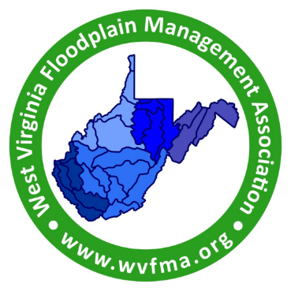
West Virginia Floodplain Management Association
2024 Conference Agenda
Chief Logan Lodge and Conference Center
June 10-12, 2024

BUILDING BACK BETTER
Conference presented by the WV Floodplain Management Association (WVFMA),
the Office of the National Flood Insurance Program (NFIP) and the State Resilience Office (SRO)

Monday, June 10, 2024

8:00 to 8:30 Registration

8:30 to 8:45 Welcome and Introductions
Ray Perry, CFM, Chairman, WVFMA and Diana Barnett, President, Logan County Commission

8:45 to 9:30 Keynote Speaker - Hazard Resistant Building Codes
Charles Baker, Program Analyst, Regional and Field Support Branch, Floodplain Management Division, FEMA Region III

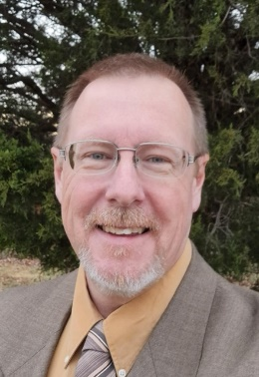 Charles Baker is a Program Analyst for FEMA Headquarters, Floodplain Management Division, Regional and Field Support Branch. Charlie’s duties include being support for FEMA Regions I, III, and IX and being the liaison between Floodplain Management and Building Science. Current Building Code initiatives include sitting on the committee for ASCE 24-24 development and a Headquarters subgroup targeting Select Flood Hazard Resilient Standards in the Codes and development of a training emphasizing the cross connections of the 2021 International Codes and the NFIP. Charlie is also the lead for the National Violation Tracker (NVT) and Potential Violations.

Charlie was previously employed as a Floodplain Specialist with FEMA Region III for five years. Prior to his employment with FEMA he served as a local floodplain administrator, building code official, planning director, and historic landmarks director at the local level. Charlie has received awards from the DHS Administrator for work associated with the Substantial Damage Administrative Procedures while at FEMA Region III.

Monday, June 10, 2024 – continued

9:30 to 9:45 Break

9:45 to 10:15 WV Flood Resiliency Plan
Bob Martin, Director, State Resilience Office (SRO) and Ed Martin, Deputy Director, State Resilience Office (SRO)

10:30 to 10:45 Break

10:45 to 11:30 Enhancing Floodplain Management: Adopting, Enforcing Ordinances and Educating Officials
Bobby Cobelli, Floodplain Management Section Supervisor: State Support, Mitigation, FEMA Region III

11:30 to 12:00 WV DEP Dilapidated Properties Program in the Special Flood Hazard Area
John King, Environmental Resources Analyst, West Virigina Department of Environmental Protection

12:00 to 1:30 Lunch

1:30 to 2:00 WV Flood Insurance Round Table Discussion
William Bradfield, CFM, Flood Insurance Outreach Specialist, Mitigation, FEMA Reion III

2:00 to 2:45 National Weather Service (NWS) - Flood Inundation Mapping Services
Nicholas Webb, Senior Service Hydrologist, Department of Commerce/National Oceanic & Atmospheric Administration/National Weather Service

2:45 to 3:00 Break

3:00 to 3:45 WV Flood Resiliency Research Project
Behrang Bidadian, PhD, CFM ; Annie Mahmoudi, CFM; Kurt Donaldson, GISP, CFM, Senior Project Manager; Eric Hopkins, CFM, GIS Specialist; Shannon Maynard, CFM, GIS Specialist; and Sara Lusher, Graduate Research Assistant; West Virginia GIS Technical Center, West Virginia University

3:45 to 4:00 Wrap-up and Announcements
Ray Perry, CFM, Chairman, WVFMA

7:00-8:00 Special Evening Activity - The History and the Return of Elk in West Virginia
Lauren Cole, Assistant Superintendent, Chief Logan State Park

Tuesday, June 11, 2024

8:30 to 8:45 Recap and Announcements – Ray Perry, CFM, Chairman, WVFMA

8:45 to 9:30 Legal Tools for Floodplain Management
Katherine Garvey, Director, Land Use Law Clinic, West Virginia University College of Law

9:30 to 9:45 Break

9:45 to 10:30 Enhancing Flood Resilience: The Redesigned NFIP Compliance Audit Program
Joshua Lippert, CFM, Floodplain Management Sector Supervisor, FEMA Region III

10:30 to 10:45 Break

10:45 to 11:00. Conference Sponsors - Introductions and Overview of Services

11:00 to 11:30 Election of 2024-2025 WV Floodplain Management Association Board of Directors
Ray Perry, CFM, WVFMA Chairman

11:30 to 12:00 Presentation of Floodplain Manager of the Year
Timothy W. Keaton, CFM, NFIP/CTP Coordinator, WV Emergency Management Division
12:00 to 1:30 Lunch

1:30 to 3:00 Multi-Hazard Extreme Flood Event (interactive)
Timothy W. Keaton, CFM, NFIP/CTP Coordinator, WV Emergency Management Division and Hannah Parlock, CFM, Interdisciplinary Planner, Huntington District, US Army Corps of Engineers

3:00 to 3:15 Break

3:15 to 4:00 Updates on the WV Flood Tool
Eric Hopkins, CFM, GIS Specialist; Kurt Donaldson, GISP, CFM, Senior Project Manager; Shannon Maynard, CFM, GIS Specialist; and Sara Lusher, Graduate Research Assistant; West Virginia GIS Technical Center, West Virginia University

4:00 to 4:45 2024 Hazard Mitigation Plan - Overview, Funding and Application Process
Tammy Sneed, Project Officer, Cory Clay, Project Officer, Xzavier Morgan, Project Officer and Vivian Wood, Planner, WV Emergency Management Division

4:45 to 5:00 Wrap-up and Announcements
Ray Perry, CFM, Chairman, WVFMA

8:30 to 10:00 Special Evening Activity – Blacklight Nite Hike
Lauren Cole, Assistant Superintendent, Chief Logan State Park

Wednesday, June 12, 2024

8:30 to 8:45 Recap and Announcements
Ray Perry, CFM, Chairman, WVFMA

8:45 to 9:30 WVFMA Sponsorship Presentations (15 minutes each)

Kurt Luecke, CFM, Regional Manager, Flood Mitigation Specialist, Floodproofing.com

Kenneth Kinder, P.E., CFM, Project Manager, E.L. Robinson Engineering

Matthew Breen, Senior Associate/Service Line Lead and Jenna McGee, PE, CFM, GISP, Assistant Vice President/Water Resources Engineer, WSP USA Environment and Infrastructure Inc.

9:30 to 9:45 Break

9:45 to 10:30 CRS and West Virginia: You are closer to becoming a CRS community than you May Think
Melissa Mitchell, CFM, Floodplain Management Analyst, Tetra Tech

One-on-One: Tetra Tech will be available to visit with you directly!
If you would like to discuss floodplain management, NFIP, and the CRS program, Tetra Tech will be available to meet with you. Please reach out to Melissa Mitchell to schedule a day and time to connect during conference week. Melissa.Mitchell@tetratech.com.

10:30 to 10:45 Break

10:45 to 11:30 NFIP – Yesterday and Tomorrow
Elizabeth Ranson, Floodplain Specialist, WV FIT (Field Integration Team), FEMA Region III and Timothy W. Keaton, CFM, NFIP/CTP Coordinator, WV Emergency Management Division

11:30 to 12:00 Open Discussion – Floodplain Management Opportunities
FEMA and WV NFIP Staff

12:00 Conference adjourns

Special thanks to this year’s sponsors!







