
Heather Maxey, Annaka Exley, Darren Aguilera, Behrang Bidadian, and Jim Schindling
Microsoft
Wv Division of Highways Plan Scanning PROJECT
October 6, 2025
West Virginia GIS Technical Center
Operational MANUAL
CONTENTS
PROJECT OVERVIEW 1
SEVEN MAJOR PROCEDURAL TASKS: 1
VOCABULARY PRIMER 3
FILE PATHS AND PINNING TO YOUR FILE VIEWER’S QUICK ACCESS 3
(1) PROJECT BOOK PREPARATION 5
ACQUISITION AND SCANNING 5
NAMING PROJECT BOOKS 5
SCANNING FILE NAME CONVENTION 6
ENTERING PROJECT BOOKS 13
CODES / DATA DOMAIN VALUES 14
(2) SHEET SCANNING 19
SCANNER SETUP 19
FOLDER, FILE AND PAGE NAMING 20
SCANNING PROCEDURES FOR 22x34 AND 12x18 SHEETS 20
SCANNING PROCEDURES FOR 8.5x11 REPORTS 21
SCANNER CLEANING AND MAINTENANCE 22
SCANNING QUALITY ISSUES 22
SCANNER CLEANING 22
SCANNER CALIBRATION 22
(3) IMAGE PROCESSING 23
ACTION CREATION PROCEDURES 23
IMAGE PROCESSING PROCEDURES 23
IMAGE SETTINGS AND ENHANCEMENTS 25
COLOR MODE 25
AUTOMATED ACTIONS 25
(4) PDF BOOK 27
PDF CREATION PROCEDURES 27
PDF RESOURCE NOTES 29
(5) GEOREFERENCING HIGHWAY INDEX MAP 30
ARCGIS PRO SETUP 30
GEOREFERENCE PROCEDURES 31
(6) QUALITY CONTROL & FILE RENAMING 37
QUALITY CONTROL PROCEDURES 37
FILE RENAMING TO PROJECT KEY 38
SET UP PROCEDURES 38
RENAMING PROCEDURES 39
POSSIBLE ISSUES WITH RENAMING: 40
(7) PUBLISHING (includes WEB QC & BACKUPS) 41
DOT GEODATABASE OVERVIEW 41
PUBLISHING GEOTIFFS 43
ADD RASTERS 44
BUILD FOOTPRINTS 47
UPDATE FOOTPRINT EXTENT 48
PUBLICATION STATUS 49
FINAL WEBSITE QC 49
WEBSITE TROUBLESHOOTING 49
BACKUP PROCEDURES 50
EXTERNAL DRIVE 50
DIGITAL PLAN PROCEDURES 50
APPENDIX A: Page Number FAQ 52
APPENDIX B: Image Processing Keyboard Shortcuts 53
APPENDIX C: Procedure Hardware, Software, and Documents 54
APPENDIX D: Transmittal Sheet 55

This is a step by step guide intended for internal use by the WV GIS Technical Center to explain the procedures of the DOT Scanning Project. All work progress should be recorded in the proper Performance Tracking Database.

PROJECT OVERVIEW

The West Virginia GIS Technical Center (WVGISTC) is working with the West Virginia Department of Transportation (DOT) to scan large format highway plan sheets into digital raster images. For every highway Project Book, a single Adobe PDF file of all the sheets is created along with an index map that is spatially referenced. The WV Division of Highways Plan Scanning Project is fulfilled through a series of steps and processes that are described throughout this documentation. Records are kept to document time spent on each process and are used to calculate estimations of time and cost for future evaluation. Technicians are expected to keep correct records of time spent on each process and record their activity in the DOT_Operator_64 access table and the DOT Performance Tracker Google Sheet.

SEVEN MAJOR PROCEDURAL TASKS:
The scanning project consists of seven major work tasks which are described in more detail below.
(1) Book Preparation and File Naming: Once the Tech Center receives a batch of Project Books from the DOT, book preparation can begin. This process consists of placing each Project Book in the designated location in the Tech Center, keeping them separate from books that have been completed or ones that are file-named and still in progress. Every WV DOT Project Book scanned by the WVGISTC will have an entry in the WV DOT Scanning (dbo_Scanning) Database. This database consists of key transportation fields for identifying the highway book, unique scan order and project key identifiers, scan information for tracking project progress and work tasks, index map coordinates, and useful online links for the PDF Book, geographic location, ProjectWise location, etc. After they are placed in their proper location, the technician will select a Project Book and enter description information about the Project Book in the dbo_Scanning table. Each DOT Project Book gets an entry in this table during the first intake of the plan. This consists of recording the information on the transmittal sheet (found on top of the map (in the folder/rolled map)) and the Project Book cover sheet. Once all information is documented, the technician will then create and record a Scan Order Number on the transmittal sheet and move the Project Book and transmittal to the location designated for the named documents that are to be scanned. During this, the technician also needs to make sure pages are as neat and organized as possible to speed up the scanning step. This might include repairing pages or replacing binder clips.
(2) Sheet Scanning: The technician will begin this process by selecting a Project Book from the named books area and bringing it to the scanner workstation. The scanner must be set to specific settings before the Project Book can be scanned, which ensures that the image is in the proper format and is named correctly. Additionally, a new folder at the scanner workstation must be created and should be named according to the Scan Order Number on the transmittal sheet. After these are completed, each page of the document is to be wiped off with the cleaning products supplied to protect the scanners from dirt and any other potentially damaging debris. If the technician finds that the Project Book is especially dirty or is in bad condition, document protectors must be used. These are found on the first two shelves of the filling cabinet worktable, which are labelled. Once the technician is sure that the document is clean and the file location and scanner settings are correct, the document can be scanned. After the entire Project Book is scanned, the file must be moved from the local workstation to the IncompleteBooks folder. The physical Project Book should then be noted that it has been scanned and then placed in designated location. It is important to be sure that all Scanner components are maintained and kept clean.
(3) Image Processing: This action uses tools created in Photoshop to make image adjustments. The files will be loaded into Photoshop and, with the use of an autocontrast tool, which is detailed in Chapter 3 will be cleaned up, cropped, and rotated, if necessary. After processing, upload the TIFF files into the server folder in the IncompleteBooks folder.
(4) PDF Creation: After image processing has been completed, the edited TIFFs are to be compiled into a PDF document. To do this, the technician uses Adobe Acrobat Pro to reduce file size and recognize text (using Optical Character Recognition). This process is detailed in Chapter 4. After this is completed, the PDF is moved to the PDF folder created on the technicians’ local workstation. The document must then be checked and corrected for any rotation or other errors. Once the PDF is correct, rename the document using the Scanning ID Number and put the finished PDF into the server folder in IncompleteBooks.
(5) Georeference Plan Index Map: The technician will use ArcGIS Pro, and Google Maps if needed, to find and georeference each cover sheet of the Project Book. This sheet is typically found on the first page and is contained in the index map, but it can be found in various places throughout the Project Book. The page that has the object to be georeferenced must be copied from the TIFF folder and then pasted into the GeoTIFF folder. Once it is in the proper location, the technician must open the TIFF and ensure the correct projection (Universal Transverse Mercator Zone 17N) is applied. After this is complete, the object’s location needs to be found on the map. By using spatial information found throughout the Project Book, the technician can find the location with Google Maps and ArcGIS Pro. Once found, the image is to be georeferenced based off at least four (4) control points set by the technician but must not exceed ten (10) control points. The georeferenced image will then need to be named according to the DOT naming conventions. The GeoTIFF folder is to be moved from the local workstation to the Project Book’s file in IncompleteBooks.
(6) Quality Control & File Renaming: Due to the complexity in the several earlier processes, a special emphasis is placed on quality control and assurance to confirm that the technicians are providing the best possible product. The technician will check for accuracy and completion of Database entry, filename, image processing, PDF, and GeoTIFF. Upon completion, the technician will use the file renaming tool to rename the quality assured folder in the IncompleteBooks folder. Once renamed, it will be moved to the ProjectBooksFolders folder. Technicians cannot Quality Control their own work.
(7) Publishing to Web Map: The final process to the WV Division of Highways Plan Scanning Project is uploading the TIFFs, PDF, and GeoTIFFs to the website. These tasks are performed primarily using a set of ArcGIS Python scripts which are contained within an ArcPro Toolbox.
The basic steps in the process are:
- Copy GeoTIFFs into a folder that is used to add scan rasters to the mosaic
- Create footprint polygons for each georeferenced image.
- Calculate footprint extents that are used to support searching
- Update the status of each scan project to indicate that it is available on the website
- Perform a final QC check of the website.

VOCABULARY PRIMER

- Project Book: One individual project or plan. This term is interchangeable with ‘plan’, ‘project’, or ‘book’. These are separated by their transmittal sheets within a folder of projects. Can be from one page to hundreds of pages.
- Project Book Folder: The large manila folders of individual Project Books. Folders can have anywhere from one Project Book to many. They need to be kept together and in order of their Scan Order Number. When we return plans to the DOT they are kept in this folder.
- Transmittal Sheet: The physical copy of the Project Book information, usually partially filled by the DOT when they are sent to us. Every Project Book gets one. The information on the sheet includes things such as the title of the project and route information which is entered into the DOT Access Database.
- Scan Order Number: This is the ID assigned to every individual Project Book and is found on the transmittal sheet. We assign this number based on the order we enter them into the DOT Access database during the naming process.
- Artifact: Byproduct produced when there is dirt or other unwanted material on the scanner lens when scanning a page. Usually forms in a streak like line in the direction the page is scanned.
- TIFF: The file type the pages of a Project Book are digitally stored as. Stands for Tag Image File Format and is a handy way to store high quality images for editing.
- Georeferencing: The process of scaling a plan’s map to its real-world location in ArcGIS Pro.
- GeoTIFF: The georeferenced index page of a plan. Not all project plans will have the geoinformation to have a GeoTIFF. Usually uses the cover page of a Project Book’s map.
- OCR: Optical Character Recognition. Part of the process of building the individual TIFF files into a single PDF book when we run text recognition on the pages to turn the text printed on the plan into a digitally recognized version for document searching.

FILE PATHS AND PINNING TO YOUR FILE VIEWER’S QUICK ACCESS

- IncompleteBooks: (\\gistc-infilesrv1-22\DOTScanning\Scanning\IncompleteBooks)
- This is the network drive where all in progress Project Books go.
- ProjectBookFolders: (\\gistc-infilesrv1-22\DOTScanning\Scanning\ProjectBookFolders)
- This is the network drive where all complete Project Books go.
- wvDOT: (R:\DOT\wvDOT_planROW_scanning)
- This folder holds the data and management documents for the scanning project.
- DOT.accdb is the overall database for the project. Do not open or edit anything in this Access sheet without permission.
- The Documents folder holds the manuals.
To pin the folders to your quick access bar on your file viewer, right click the folder itself and select ‘Pin to Quick Access’. It will now be on the left pane of the file viewer.

- DOT Performance Tracker Google Sheet
- This is for logging your activity.
- DOT_Operator_64.accdb: (\\gistc-infilesrv1-22\Projects\DOT\wvDOT_planROW_scanning\DOT_Operator_64.accdb)
- This is for logging your activity.






LOCATION OF WORK
SOFTWARE UTILIZED
PROJECT WORKFLOW
- Access Database
- Adobe Photoshop
- Adobe Acrobat DC
- ArcGIS Pro
- Script Based

(1) PROJECT BOOK PREPARATION

The following section explains the overall acquisition process, breaks down the components to the naming system, and outlines the steps taken to enter each plan into the access database.

ACQUISITION AND SCANNING

Project plans to be scanned are delivered to the WV GIS Technical Center by DOT personnel. The frequency of delivery varies and is based upon operational backlog.

PROJECT BOOK INTAKE
- Receive shipment of Project Book Folder(s) from the WV DOT with their respective transmittal sheet(s).
  - Leave plans in the designated location within the WVGISTC for unnamed plans.
- Physically move a folder of Project Books to a scanning workstation.
  - Enter transmittal sheet information into the dbo_Scanning database. Refer to the section on naming for details.
- Ensure the plan is organized and well bound.
  - Remove debris, replace damaged clips, and bind unbound plans to keep them together.
  - This is to minimize repairs, transportation, and organization further on.
- Physically move the Project Book(s) to the location with other named books that are ready for scanning.
  - Keep Project Books together with the plans they came with, in their folder of origin.

NAMING PROJECT BOOKS
Check to see if you have access to Microsoft Access database. If an error window pops up saying you cannot use the application, then go to this location "\SysAdm\Software\ESRI\SQL Server Client-Side Tool Kit.msi" and run the toolkit. After it is finished running, you should have access.
Every WV DOT Project Book scanned by the WVGISTC will have an entry in the WV DOT Project Database named dbo_Scanning. Before a book can be scanned its information needs to be entered into the DOT Access database. This database provides a means for tracking work completed along with published information for the Highway Plans Locator web application (www.mapwv.gov/dotplans).
The information needed to fill out the field column of the database can be found on the Project Book’s transmittal sheet and/or the cover page. Copy the key transportation fields for finding the highway book to the dbo_Scanning table. Most of the information needed to fill out this table (with a few important exceptions described below) can be found on the first page of the Project Book.
Occasionally pieces of information will be missing from the cover page, such as a title, bridge number, or fiscal year. This information can often be found on other pages within the Project Book. If the information cannot be found anywhere within the Project Book, it should be noted in the comments field of the dbo_Scanning table.
Not all Project Books will have a transmittal sheet, and not all cover pages have all pertinent information, so the database should be filled out as much as is possible, but there will be times when information is missing, and columns will remain blank. Contact Hussein Elkhansa of WV DOT for aid with missing transmittal information.

SCANNING FILE NAME CONVENTION

The following section explains the file naming convention, a fixed-length alpha-numeric name of 30 digits that describes the project being named. The first 18 characters follow the WV DOT County Route ID naming convention. Folder structures and scanned files will adopt this convention for file organization. All the files will be complete to include leading zeroes and null values so that all Project Key Numbers have the same fixed length format. Fields are separated by underscores within the file name for readability.
1 | 2 | 3 | 4 | 5 | 6 | 7 | 8 | 9 | 10 | 11 | 12 | 13 | 14 | 15 | 16 | 17 | 18 | 19 | 20 | 21 | 22 | 23 | 24 | 25 | 26
_ | _ | _ | _ | _ | _ | _ | _ | _ | _ | _ | _ | _ | _ | _ | _ | _ | S | _ | _ | _ | _ | _ | _ | _ | _
Type | County ID |  | Sign System | Route Number |  |  |  | Sub Route |  | Begin Milepost |  |  | Fiscal Year |  |  |  | Unique  Scan ID |  |  |  |  |  | Sheet Number

PROJECT KEY NUMBER: The unique ID number generated for each project book. The first 8 fields are concatenated and separated with underscores to create this Project Key Number which is also the file folder name. The last two fields are for the sheet names of the individual scanned TIFF files; total file name characters of Project Key Number (23 characters and 7 underscores) and Sheet Number and Suffix (5 characters) sums to 28 possible characters.
EXAMPLE FILE NAMES: Boldfaced text represents the Project Key Number; regular text represents sheet number and file extension.
B_06_1_0064_00_011_2012_S00149 (Folder name)
B_02_3_0081_08_000_2008_S00150.pdf (PDF highway plan set)
B_52_4_0036_00_002_2010_S00151_0010.tif (TIF file of individual scanned sheet)
P_47_2_0048_00_073_2005_S00152_0002.tif (TIF file of individual scanned sheet)
B_23_3_0010_00_013_2012_S00153_0157.tif (TIF file of individual scanned sheet)
R_17_1_0079_00_132_1971_S00156_001_UTM17N83.zip (Compressed Geo-Referenced Tiff)

The following image shows the 19 primary columns the technician will interact with when naming a Project Book. (We have minimized the columns you will not be entering the information in for at this time). Each number corresponds to the # column of table 1:
Reminder: Mandatory columns that MUST be filled out to generate a project key are PlanType, CountyID, SignSystemID, RouteNumber, SubRoute, BeginMile, and FiscalYear. These columns cannot be more than the provided number length, noted in Table 1. Ex. RouteNumber can only be four numbers long.

Table 1: Data fields of dbo_Scanning database. Boldfaced elements form 30-character Project Key.

# | FIELD NAME | DESCRIPTION | NOTES
1 | ID | Unique 6-character Scan Order Number. | Single digit location (S, D, X) character plus a 5-digit number. The number is automatically generated by the database when adding a new line. Plans processed by the WVGISTC use the letter S.
2 | ProjectTitle | Name of the project that the plan represents. | Generally located on the top center of the Project Book. If no title is given on the transmittal sheet nor can be found, name the project after something relevant, such as the county it is in and the route it is on.
3 | FederalProject | Federal Project number. | Found in the notes section on the transmittal sheet. Make sure to enter it exactly as written on the physical Project Book (generally in the top right corner or top center of the plan).
4 | StateProject | State Project number. | Found in the notes section on the transmittal sheet. Make sure to enter it exactly as written on the physical Project Book (generally in the top right corner or top center of the plan).
5 | PlanType | The type of the plan, categorized as one of 5 values. | Corresponds to “Type” field on transmittal sheet. Must be one of the five letter options. See table 2 for more information.
6 | CountyID (2 # spaces) | Name of county where the project is located. | Referred to by County ID number on transmittal sheet. Check physical book for county name (generally in the top right corner or top center of the plan). See table 3 for more information.
7 | County2ID | Name of second county, if project crosses county borders. | Not listed on the transmittal sheet. Check physical book for county name (generally in the top right corner or top center of the plan). If there are more than two counties, add the first two listed.
8 | SignSystemID (1 # space) | Denotes sign system. Code specified by WV DOT. | Numbers on transmittal sheet correspond to a dropdown box in access. If no ID can be found or determined, mark as N/A. Refer to table 4 for more information.
9 | RouteNumber (4 # spaces) | Denotes the project primary route number. | Corresponds to transmittal sheet. If no route can be found mark as 0. The middle portion of the State Project ID generally contains the route number. You can also frequently locate the route on the top center portion of the cover page.
10 | SubRoute (2 # spaces) | Denotes the primary sub-route number. | Corresponds to transmittal sheet. The sub-route number generally follows the route number after a backslash. If no sub route can be found mark as 0.
11 | BeginMile (3 # spaces) | Denotes the project’s beginning milepost, as stated on the project cover/index sheet. | Corresponds to the “Begin Milepost” field on the transmittal sheet. If no begin milepost can be found, mark as 0. The end portion of the State Project ID generally contains the begin mile value.
12 | FiscalYear (4 # spaces) | Year the project was commissioned. | Check physical book for its fiscal year (generally in the top right corner of the plan). If no year can be found mark as 9999. Cannot be 0.
13 | District | District in which the county of the plan is located. | Corresponds to transmittal sheet. Check physical book for its district (generally in the top right corner of the plan). West Virginia separates its counties into 10 districts. If you can find the county and no district is listed, you can use the county name to find the district number. If no county or district is found, ask the project leader for assistance.
14 | BridgeNumbers | Denotes relevant bridge numbers for the project. | List all bridge numbers for the Project Book, found in the “Bridge No.” section of the transmittal sheet. If there are multiple bridge design or structure identifiers, then list in order from lowest to highest. These are frequently found under the district map on the cover sheet but can also be found on the plan map itself.
15 | SpecialCodeID | Denotes a special code. Code to be specified by WV DOT. | Corresponds to “Special Code ID” on transmittal sheet. If no ID is listed mark as 00. This code is intended to differentiate between multiple contracts or projects that fall within the same route and milepost. Refer to table 5 for more information.
16 | ProjectStatusID | Denotes Project Book Status ID. | Corresponds to the “Status ID” field on the transmittal sheet. Refer to table 6 for more information.
17 | BookLocationID | Location book was scanned | Mark as “Tech Center.” Change status to “DOT” when returned.
18 | PublicationStatusID | Indicates if book has been published on the website. | Drop down menu. Corresponds to a binary status of “Not Published” and “Published.” Leave as “Not Published” when entering new plans.
19 | Comments | Comments on Project Book | Add if necessary. Relevant information could include if a plan has no geo-information, the state of the plan, and supplemental pages, etc.
 | ScanCount | Number of sheets scanned in the project book. | Leave blank. This will be added before the publishing process.
 | GeoTIFFSheet | The page number of the sheet used to create the GeoTIFF. | Leave blank. This will be added before the publishing process.
 | SupplementalCodeID | Denotes a supplementary code identifier which refers to a key provided by WV DOT. | Leave as default (00) unless provided by the WV DOT on the transmittal sheet.
 | XMax | The latitude of the top corner used to hold the GeoTIFF in correct location on map. | Leave blank. This is generated by the publishing script.
 | XMin | The latitude of the bottom corner used to hold the GeoTIFF in correct location on map. | Leave blank. This is generated by the publishing script.
 | YMax | The longitude of the top corner used to hold the GeoTIFF in correct location on map. | Leave blank. This is generated by the publishing script.
 | YMin | The longitude of the bottom corner used to hold the GeoTIFF in correct location on map. | Leave blank. This is generated by the publishing script.

The following images notes each of the primary columns, where to find them on the transmittal sheet, and where they can most likely be found on the cover page of the project.

ENTERING PROJECT BOOKS

- After you open DOT.accdb, open the tab by double clicking it on the left side pane.
  - The database is found in R:\DOT\wvDOT_planROW_scanning\DOT.accdb
  - Go to the last record in the dbo_Scanning tab.
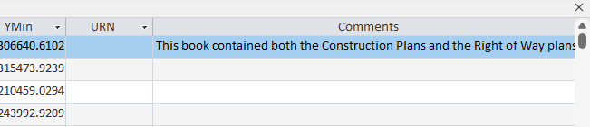
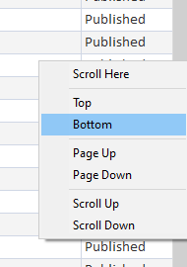
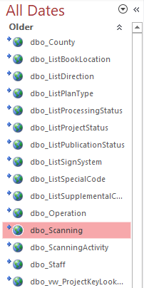
    - Right click the scroll bar and select ‘Bottom’ on the pop-up menu to quickly reach the last record.
Right click

  - If necessary, right click the “ID” column and click sort by smallest to largest. The “ID” column corresponds with the “S00000” number assigned to every book.
- Assure the Project Books in the folder are together.
  - Sometimes plans will be unorganized and will need to be reunited with the rest of the project. Check that all loose plans are not part of a different plan in the folder.
- Fill out the any missing information on the transmittal sheet provided by the WV DOT.
  - Check the information on the sheet is correct.
- Find and copy the Scan Order Number from the ID field in the dbo_Scanning database.
  - For example, copy Scan Order Number 2115 from the dbo_Scanning table to the transmittal sheets as S02115.
- Copy transportation field information from the transmittal sheet to the corresponding fields in the dbo_Scanning table.
  - This information is used to generate the Project Key file name (e.g., B_06_3_0094_00_000_1964_S02115) which is used to rename all the files during the QC/File Renaming process and needed to identify the file name of the Project Book.
- Once the Project Book has been entered, move it to its designated location so it can begin being processed.
  - Keep the individual Project Books in order of their Scan Order Number in their original folder.

CODES / DATA DOMAIN VALUES

HIGHWAY PLAN TYPES
Several types of highway plans are scanned, processed, and published by technicians. The code must be one of the 5 single letter options in the following table.

Table 2: Descriptions of several types of highway plans.

PLAN TYPE | CODE | DESCRIPTION
ROW Plans | R | Right of way plans show the land obtained by WV DOT to complete highway projects. The right of way portion of the plan set is used to convey information about the right of way boundaries and adjacent property lines, the property ownerships and acreage involved in the takes and the overall impact the improvement will have to the particular property owners. Appraisers, negotiators and attorneys all use the right of way plans to aid them with their work when determining fair market value, negotiating with the property owner or explaining a condemnation case to a jury.
Bridge Plans | B | Bridge plans show construction and location of a specifics of a bridge (e.g., type of girders, type of span, soils).
Construction Design Plans | P | The construction part of the plan set is used to convey information about the design of the roadway itself, the amount and type of construction materials used for the project and the types of construction methods used to complete the work. Designers, estimators and construction workers all use the construction plans to help them with their work when determining current standards, estimating the cost of the project or constructing the improvement. Important for maintenance of existing highways. The construction plans are important for maintaining current highways such as re-pavement projects. The bridge and shop drawings are tied to the planning sheets.
Shop Drawings | S | Shows the way materials were fabricated. A shop drawing is a drawing or set of drawings produced by the contractor, supplier, manufacturer, subcontractor, or fabricator. Shop drawings are typically needed for prefabricated components such as the structural steel, trusses, etc.
Half-Sized Plans | H | Half-sized plans show exactly what the contractors were told to build or as plans were let to the contractors.
As Built | A | Revised set of drawing given by a contractor upon completion of a project or a job. They reflect all changes made in the specifications and working drawings during the construction process, and show the exact dimensions, geometry, and location of all elements of the work completed under the contract. Also called record drawings or just as-builts. Typically, the as-built plans found in the District Offices and not kept in a consistent and orderly manner.

COUNTY CODES
On the transmittal sheet the county is expressed as a 2-digit code corresponding to one of the 55 counties in West Virginia. This reflects the county of origin of the project. This code is the numeric equivalent of the alphabetized county name list. When entered in the database the county is referred to by name.
Table 3: Codes corresponding to each county in the state.
COUNTY NAME | CODE
Barbour | 01
Berkeley | 02
Boone | 03
Braxton | 04
Brooke | 05
Cabell | 06
Calhoun | 07
Clay | 08
Doddridge | 09
Fayette | 10
Gilmer | 11
Grant | 12
Greenbrier | 13
Hampshire | 14
Hancock | 15
Hardy | 16
Harrison | 17
Jackson | 18
Jefferson | 19
Kanawha | 20
Lewis | 21
Lincoln | 22
Logan | 23
McDowell | 24
Marion | 25
Marshall | 26
Mason | 27
Mercer | 28
Mineral | 29
Mingo | 30
Monongalia | 31
Monroe | 32
Morgan | 33
Nicholas | 34
Ohio | 35
Pendleton | 36
Pleasants | 37
Pocahontas | 38
Preston | 39
Putnam | 40
Raleigh | 41
Randolph | 42
Ritchie | 43
Roane | 44
Summers | 45
Taylor | 46
Tucker | 47
Tyler | 48
Upshur | 49
Wayne | 50
Webster | 51
Wetzel | 52
Wirt | 53
Wood | 54
Wyoming | 55
Reserved for Other Statewide Continuous features | 99

SIGN SYSTEM CODES
The sign system corresponds to the type of roadway the main route of the plan is. Most often we use codes 1-4. On the transmittal sheet, the corresponding code is used. When entered into the database the long name is used.

Table 4: The several types of sign systems and their codes.

SIGN SYSTEM CODE | LONG NAME | SHORT NAME
0 | Municipal Non-State | MNS
1 | Interstate | Interstate
2 | U.S. Highways | U.S.
3 | WV State Routes | State
4 | County Routes | County
5 | N/A
6 | State Parks and Forest | State Parks and Forest
7 | FANS | FANS
8 | HARP | HARP
U | US Forest Road | US Forest
R | WV State Rail Authority | Railroads
T | Trails | Trails
9 | Other | Other

SPECIAL CODES
The DOT sets special codes. If one is not provided, we use “Archived Set.”
Table 5: The various special designations and their codes.

CODE | NAME
AA | Archived Set
C(#) | Contract 1 (C1), Contract 2 (C2), Contract 6 (C6), etc.
P(#) | Phase 3 (P3), Phase 4 (P4), Phase 5 (P5), etc.
R(#) | R1, R2, R3, R4 (Right of way submissions 1-4)
S(#) | Submission 1 (S1), Submission 2 (S2), etc.

STATUS CODES
The DOT sets status codes. If one is not provided, we use “Final Design.”
Table 6: The various plan status designations and their codes.

CODE | STATUS NAME
1 | Initial Design
2 | Preliminary Design
3 | Final Design

SUPPLEMENTAL CODES
The DOT sets supplemental codes. If one is not provided, we use “Not Applicable.”
Table 7: The various supplemental designations and their codes.

SUPPLEMENTAL CODE | NAME
0 | Not Applicable
1 | Alternate
2 | Wye
3 | Spur
4 | North
5 | South
6 | East
7 | West
8 | business
9 | North Bound (Business)
10 | South Bound (Business)
11 | East Bound (Business)
12 | West Bound (Business)
13 | Truck Route
14 | Bypass
15 | Loop
16 | Toll
17 | Ramp
18 | Other
19 | City Streets Non-State
20 | Construction
21 | Footbridges
22 | Historical Bridges
23 | Connector
24 | New/Proposed
25 | Crossover (between dual geometry)
26 | Emergency Crossover
27 | Left Turn Lane
28 | Right Turn Lane
51 | Rail Trail
99 | Abandoned

(2) SHEET SCANNING
Each Project Book will be unbound, and each sheet individually scanned, following all best scanning practices as determined by WVGISTC staff, the scanner’s user manual, and the specifications described below.

Each page of a Project Book will be numbered sequentially, scanned in the order it is in the book with the auto naming feature on. This is to aid WVGISTC technicians and staff during the scanning and QC process. Double sided scans will have both sides scanned individually, while trying to remove all visible information from the reverse side if possible. This can be aided by placing black construction paper behind the sheet inside of a protective cover before scanning.

The document-protection scanning sheath is to be used whenever necessary to protect the document and/or scanner. Conditions when this protective sheath is to be used include:
- The document is very dirty and might leave dirt in the scanner
- The document has a waxy coating that may leave residue on the scanner lens
- The edges of the document are torn.
- The document is brittle and could be damaged by the scanner.
- The document is made of a material that is difficult for the sensors in the scanner to properly detect, resulting in some scanning errors/inconveniences
- Any other reason as determined by the scanning technician
Older sheets tend to need the protective sheath more. Newer sheets are often made of clean, sturdy materials that do not require added protection.

SCANNER SETUP
The scanning software used is SmartWorks Pro for both ColorTrac SmartLF SC 42e Xpress Scanners. Turn on the scanner and open SmartWorks Pro scanning software. Ensure the scanner settings are correct.
SCANNING SETTINGS
Size | 22 x 34 Sheets: Full Auto Size  12 x 18 Sheets: Manual Width with Auto Length
Width | 22 x 34 Sheets: N/A  12 x 18 Sheets: 480mm
Auto BW points | Off
Color Mode | 256 Colors with auto palette (8-bit or indexed color)
Resolution | 300 dpi
Quality | 1
Auto Naming | Off or Add Numerical Suffix
Auto Overwrite | Type new name if file exists
File Name | S1XXXX-XXXX.tif
File Type | TIFF LZW
Folder | E:\DOT\Imagery\Original Scans\S1XXXX

FOLDER, FILE AND PAGE NAMING
Folder Name: On the scanning computer create a folder named after the Scan Order ID for the Project Book being scanned using the computer pathway listed in the above table.
Scan File Name: The naming convention for individual TIFF digital scans is the Scan Order Number followed by the page or sheet number. Example: Sheet number 25 from Project Book S12345 should have a file name of S12345-0025.tif. Only numbers should be used in the page number, using the auto naming feature of the scanning software.
Sheet/Page Naming: Use the Add Numerical Suffix of the scanning software to name the sheets (or pages) in sequential order automatically.
SCANNING PROCEDURES FOR 22x34 AND 12x18 SHEETS

- Select the top Project Book Folder from the named books area (from the most recent shipment) and bring it to your assigned working pile inside the scanning room.
  - If there are many Project Books in the folder, it is recommended to move the Project Books in smaller sections while preserving the order to the top of the working pile assigned to you. This way you can take the Project Books from there to the scanner workstation and back without having to move the whole folder from the scanning workstation if you cannot finish the whole folder in this session.
- Move a Project Book to the scanner workstation.
- Write the Scan Order Number (e.g. S12345) with a Sharpie marker on the supplied colored paper.
  - The Scan Order Number is found on the Project Book’s transmittal sheet.
  - There will be one piece of colored paper per individual Project Book.
- Remove clips/tape/staples/sharp objects from sheets and unlatch the binder.
- Clean the scanner lens.
  - Refer to the cleaning section below for more details.
- Check that scanner settings are correct.
  - Refer to the settings table above. Once you set them for the first time you should not have to change them again but do confirm each time you start scanning.
  - On the scanning computer create a folder named using the Scan Order Number from the transmittal sheets. Use the computer path name listed in the table above.
- Scan sheet.
  - Wipe the sheets clean and remove any sharp objects or debris as you go to protect the scanner and improve the image quality of the scan.
  - Fix any tears or holes with reinforcement labels or document tape if necessary.
    - Use a “D-size” document protector found in the map case if sheets are dirty, excessively waxy or sticky, too torn, brittle or any other reason it can’t be scanned like regular sheet.
  - Check digital image: Make sure it is straight and free of any streaks or artifacts made by the scanner, folds over the neat lines or other data, no information is cut off, or that there is any other reason you will have to rescan the page for.
- Repeat step 7 until all sheets have been scanned.
- After the entire Project Book is scanned, the TIFF scans must be transferred from the local workstation to the IncompleteBooks folder.
  - The file path can be found in the Plan Overview section.
  - Mark plan as Yellow on the Performance Tracker when the file has been transferred.
- Replace prong fasteners for the Project Book.
  - Ensure the plan is as securely fastened as possible.
    - Use new prong fasteners if the old ones are too damaged or otherwise unacceptable.
    - After scanning, use document hole punch reinforcement labels to secure loose pages with broken prong holes.
- Place Project Book within large folder that it originally came from.
  - Make sure the Project Books are in order in the folder.
  - If you are not finished with a plan, keep it separated from the plans that are finished and the plans that have yet to be scanned in a manner that makes sense to you. Do not leave unfinished folders or Project Books on the center scanning cabinets.
- When all Project Books in a folder are scanned, write the Scan Order Number range of the Project Book Folder with a Sharpie marker on the colored paper provided and tape it to the large folder.
  - One sheet will be the list of all the projects in that large folder, if there are multiple projects in one folder add the first and last Scan Order Numbers to that list (e.g. S12345 – S12355)
- Clean the scanner lens when you finish scanning for the day.
- Update DOT Performance Tracker Google Sheet:
  - Find relevant Scan Order Number. Mark plan as Yellow when file has been transferred if it is not already.
    - Date of Action
    - Technician Name
    - Time worked on action (minutes) in the Scanning Time column
    - Quantity completed (total number of sheets)
    - Additional Comments
  - Complete this process after every completed action.
- Update DOT_Operator_64 Tracking Database in MS Access:
    - Technician performing action
    - Scan Order Number
    - Action taken
    - Date of Action
    - Time worked on action (minutes)
    - Quantity completed (sheets)
    - Additional Comments
  - Complete this process after every completed action or before the end of shift.

SCANNING PROCEDURES FOR 8.5x11 REPORTS

Note: Disregard scanning the 8.5 x 11 sheet unless WV DOT includes a note to scan the 8.5 x 11 reports which they consider important. Guidance from Kevin Huffman on 6/16/2017. If you are not sure ask the project lead for guidance and further instructions.

SCANNER CLEANING AND MAINTENANCE

Clean the scanner before and after scanning for the day and recalibrate scanner at least once a month. The lens should be cleaned with a lint-free cloth and specialized lens-cleaning solution. The white rollers on the lid that sit on top of the sensor when the lid is closed also need to be carefully cleaned, and any other dust, hairs, or debris under the scanner lid should be removed.
Occasionally, cleaning the scanner lens and rollers will not improve the quality of the scan, which will continue to have dark streaks, discoloration, or other issues. In these cases, it may help to recalibrate the scanner. The scanner’s online manual has detailed instructions on how to perform calibration. If this also does not improve conditions, there may be more serious maintenance issues that will require a visit from a trained technician. It will be important to carefully watch the condition of the scanner over the course of this project so that any issues can be swiftly handled.

SCANNING QUALITY ISSUES
- If images have streaks on them, this means the scanner is dirty. Delete the image, clean the scanner and rescan the sheet.
- If the scanner is unable to catch a particularly crumpled or frayed sheet either rotate the sheet before scanning and rotate it back with Photoshop or place it in a document protector, then scan.

SCANNER CLEANING
- Click in the latches found on the left and right of the base of the scanner to raise the “lid” of the scanner, the scanner must be turned off before cleaning.
- Use air duster to remove particulate material by blowing air across the flat bottom surface and around support and rubberized rollers.
- Remove all residue from all wheels. (Top two tracks of plastic wheels and bottom two tracks of rubber wheels.
- Clean the roller bar. (Distilled water on a magic eraser.)
- Clean the surfaces surrounding the wheels and roller bar to remove any transferred residue.
- Clean the lens and close the lid.
- Wipe down the top of the lid and surrounding surfaces. (Be gentle on the guideline print as it will fade.)

SCANNER CALIBRATION
- Open Smart SC Utilities. On touch screen computer, it can be found at c:\Program Filesx86\ColorTrac\SmartLFSCUtilities\SmartLFSCUtilities.exe.
- Retrieve the calibration sheet from the file cabinet.
- Click the calibration button on screen.
- Screen will prompt you to insert the calibration sheet into the scanner. Insert the sheet exactly as shown.
- Click calibrate and wait for scanner to perform the calibration.
- Close SmartLF Utilities.
- Open SmartWorks Pro.
- Scan the calibration sheet and examine the image to check lines are not skewed. Delete afterwards.

(3) IMAGE PROCESSING

Image enhancements are performed on scanned images using Adobe Photoshop software to improve image quality. Image processing tasks include manual cropping and an automated Auto Contrast function.

Auto Contrast adjusts the overall contrast of an image without affecting its color. Auto Contrast maps the lightest and darkest pixels in the image to white and black, which makes highlights appear lighter and shadows appear darker.

Scans are cropped in Adobe Photoshop to remove excess white space in the margins and to reduce file size. Technicians should crop within an estimated centimeter to the neat line. Technicians must be careful to not crop out any information or markings visible on the scan. When in doubt, do not crop.

Image enhancement procedures must be performed on the local workstation. Before copying the file over make sure to create the proper subfolder structure first.

Each WVDOT Project Book scanned will have its own project folder for holding the TIFFs, PDFs and GeoTIFFs. The folder name will be the unique Scan Order ID for that Project Book, which is generated by WVGISTC.

ACTION CREATION PROCEDURES

- Using Adobe Photoshop software, create an action for Auto Contrast and save.
  - Open the Window tab > Actions
  - In the Actions menu, click “Create new action” icon at the bottom. (Green box below)
  - Name it Auto Contrast and assign a function key (F2).
  - Press record.
  - Hold down Alt+Shift+Control keys and press L (Alt+Shift+Ctrl+L).
  - Then hold down Control+S. (Ctrl+S)
  - Click the stop icon in the action menu. (Red box below)
  - This will automate the process of using auto contrast and save the file. Use when finished.
  - This process will not need to be done again

IMAGE PROCESSING PROCEDURES

- Open File Explorer.
  - Navigate to the IncompleteBooks folder on \\gistc-infilesrv1-22\DOTScanning\Scanning\IncompleteBooks
  - Open the Project Book to be image processed.
  - Create three new folders on your desktop. You will not have to do this more than once. Name them as follows:
      - GeoTIFF
      - PDF
      - TIFF
    - For every Project Book you do, copy these folders from your desktop and paste them into the Project Book folder in the IncompleteBooks folder on the network drive.
    - Move the original scans into the TIFF folder.
- Copy the Project Book files from IncompleteBooks on to your desktop.
- Open the tif files in the TIFF folder in Photoshop by selecting them in the folder on your desktop and dragging them to the program.
- Making sure you are on the Crop tool, highlighted below.
  - Shortcut ‘C’ - see Appendix B for more shortcuts.
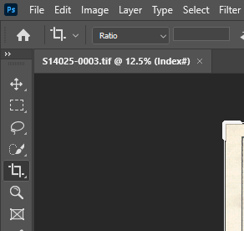
  - Align the page by holding Ctrl or clicking the “ruler” icon and dragging your mouse from one corner to another on the straightest line possible.
  - Ensure the text is as level and straight as possible.
  - If there is no neat line, use your best judgement to find the next best reference.
- Crop the image to around a centimeter (estimate it) away from the neat lines by using the crop tool while making sure to include any text, diagrams, or additional information that is outside the neat lines while minimizing whitespace and the scanner background.
  - If needed, you can use the zoom tool (Z) to get a more precise crop by zooming in closer to the edge. Ctrl + 0 will refit the image to the screen.
  - If there is no neat line, keep the cropping about a centimeter away from any information on the page while leaving no white space.
  - Keep each side of the page as consistent as possible distance wise, excluding any information outside the neat lines.
- Use the Autocontrast and Save tool by hitting the function key (F2) you assigned it to.
- Go to the next page by hitting ctrl+tab or clicking the next file at the top of the work area.
- Repeat steps 4-7 until finished with all the TIFF files.
  - As you go, make sure there are no artifacts, folds over the neat lines or other data, no information is cut off, or that there is any other reason you will have to rescan the page for.
- Upload processed images to IncompleteBooks from the folder on your desktop.
- Update DOT Performance Tracker Google Sheet:
    - Find relevant Scan Order Number.
    - Date of Action
    - Technician Name
    - Time worked on action(minutes) in the Processing Time column
    - Additional Comments
  - Complete this process after every completed action.
- Update DOT_Operator_64 Tracking Database in MS Access:
    - Technician performing action
    - Scan Order Number
    - Action taken
    - Date of Action
    - Time worked on Action (minutes)
    - Quantity completed (sheets)
    - Additional Comments
  - Complete this process after every completed action or before the end of shift.

IMAGE SETTINGS AND ENHANCEMENTS

Adjusting the image levels is also useful for removing background noise in the whitespace of a scan, and for darkening lines slightly. With proper use of keyboard shortcuts, actions, and practice, this step can be performed very quickly and may result in much higher image quality. This process can be automated for multiple images that require identical, small adjustments. Any TIFFs that might be georeferenced later need to be in Indexed color mode and not grayscale mode. They should be in the mode by default if the scanner settings were properly set up.

IMAGE QUALITY ENHANCEMENT | SETTINGS OR ENHANCEMENT TOOLS
Color Mode | Indexed Color Mode (256 colors)
Auto Image Edits | Auto Contrast or Auto Levels
Cropping | Manual

COLOR MODE
The color mode or image mode determines how colors combine based on the number of channels in a color model. To reduce file size, the color mode of the image should be Index Color mode (256 colors). Indexed Color mode produces 8-bit image files with up to 256 colors and is enough colors to match the original document.

AUTOMATED ACTIONS

An action is a series of tasks that you play back on a single file or a batch of files—menu commands, panel options, tool actions, and so on. For example, you can create an action that changes the size of an image, applies an effect to the image, and then saves the file in the desired format.

Actions can include steps that let you perform tasks that cannot be recorded (for example, using a painting tool). Actions can also include modal controls that let you enter values in a dialog box while playing an action.

Photoshop comes with predefined actions installed that help you perform common tasks. You can use these actions as is, customize them to meet your needs, or create new actions. Actions are stored in sets to help you organize them. See the Adobe Photoshop online help or YouTube videos for more information on how to create actions.

(4) PDF BOOK

After image processing has been completed, the edited TIFFs are compiled into a PDF document. To do this, an automated script created in Adobe Acrobat Pro is executed to reduce file size and create OCR.

For each WVDOT Project Book a single PDF document is created that will hold every scan in that Project Book and follows the correct page order.

PDF CREATION PROCEDURES

- Open Adobe Acrobat Pro.
- Change your display theme to dark by going to the view tab on the top left menu ribbon > Display Theme > Dark Grey.
  - You only must do this once. It is important to change this setting to see errors later in the process.
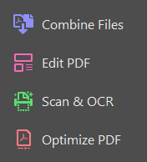
- Open the Tools tab on the top right of the window.
  - On the right side of the screen remove every tool except for Combine Files, Edit PDF, Scan & OCR, and Optimize PDF. Your tool bar will look like this:

- Open the folder with the processed images from the copy of the plan on your desktop.
  - Do NOT work out of IncompleteBooks.
- In Adobe Acrobat, click on Tools > Combine files.
  - Generally, Acrobat can handle ~50 pages of the 22x34 sheets and ~100 of the 12x18 sheets. This number can vary.
  - If it cannot handle the number of pages, split the project into however many PDFs as needed. (e.g. 400 small sheets should have four 100-page PDFs.)
- Highlight all the processed files you want to combine into a PDF in the TIFF folder.
  - Drag and drop them into Adobe Acrobat with the Combine tool open.
- Make sure all files are in the correct order, then click Combine.
  - The PDF will then be combined creating a tab entitled “Binder1.pdf”.

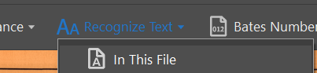
- In the OCR tools, run recognize text tool > In this File > Recognize Text (Blue button.)

- Save and name the PDF to match the number of the Project Book (e.g. S12345.)
- After that is finished, open the File Optimization tool and run Reduce File Size or Compress PDF depending on your software version.
- Save and check all the pages for errors.
  - Make sure that all the pages are the right orientation.
    - Open the thumbnail view on the left side and use the rotate arrows to correct the page’s orientation.
  - Make sure there are no OCR errors generated from the text recognition process.
    - The page will look like it has been rotated, sometimes barely noticeable and sometimes extremely obvious. These pages will either need cropped to remove the generated white space or replaced if cropping is not possible.
    - Open the thumbnail view on the left side and right click the page that has the error. Replace the page with the processed original page from the TIFF folder. You will have to change the file type in the file viewer to All or TIFFs to see the files. Press ok when prompted.
  - Make sure there are no artifacts, folds over the neat lines or other data, no information is cut off, or any other reason you will have to rescan and reprocess the page for.
    - In this case, find the page, rescan it, replacing the page in the OriginalScan Project Book folder.
    - Upload that individual file to the IncompleteBooks folder and replace the former scan.
    - Process the new page in Photoshop as usual.
    - Replace the old page in the PDF with the new page you rescanned.
- If there are multiple PDFs from too many pages, repeat steps 5-11 till all pages have been built into a PDF.
  - Combine them into one singular PDF using the Combine tool, making sure they are in the right order. There should only be one PDF in the incomplete books folder.
  - Save and name the PDF to match the number of the Project Book (e.g. S12345.)
  - Re-run the Reduce File Size or Compress PDF tool.
- Upload finished PDF to IncompleteBooks from your desktop.
- Update DOT Performance Tracker Google Sheet.
  - Find relevant Scan Order Number.
    - Date of Action
    - Technician Name
    - Time worked on action(minutes) in the PDF Time column.
    - Additional Comments
  - Complete this process after every completed action.
- Update DOT_Operator_64 Tracking Database in MS Access:
    - Technician performing action
    - Scan Order Number
    - Action taken
    - Date of Action
    - Time worked on Action (minutes)
    - Quantity completed (sheets)
    - Additional Comments
  - Complete this process after every completed action or before the end of shift.

PDF RESOURCE NOTES

OCR Sheet Rotation: The automated Recognize Text process involves a step that automatically straightens the image by rotating it so that most of the text lies perfectly horizontally. This occasionally results in errors, such as the image being rotated to match non-horizontal text so that the scan now appears crooked, or the image being rotated a full 90 degrees to match text that appears vertically. Because of this, each page of the PDF needs to be inspected after the Recognize Text tool is run, and any errors corrected. For slightly crooked images, the correction will require removing the erroneous page and inserting it into the correct place within the PDF WITHOUT running the Recognize Text tool on that page (since that will result in it being crooked again).

(5) GEOREFERENCING HIGHWAY INDEX MAP
Technician will use Photoshop, Google Maps, and ArcGIS to find and geo-reference each Project Book index map to UTM Zone 17N projection, NAD83 Datum. The target object to be georeferenced is typically found on the first page and is contained in the index map, but it can be found in various places throughout the Project Book. The page that has the object to be georeferenced must be copied from the TIFF folder and then pasted into the GeoTIFF folder.

ARCGIS PRO SETUP

- Open ArcGIS Pro and log into your account.
  - Make sure the program is up to date. You might need admin permissions to do this, so ask the project lead for help.
- On the start screen, create a new map by clicking on the first icon labeled “Map”.
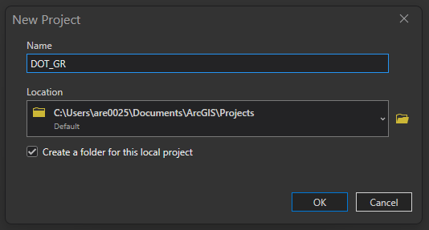
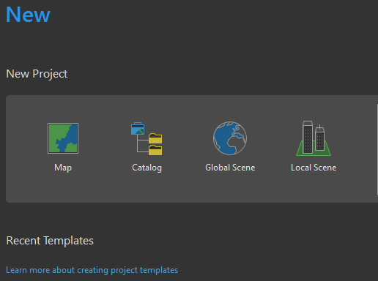
  - When prompted, name the project “DOT_GR”. This will now open the ArcGIS interface.
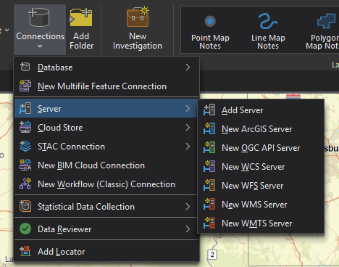
- Once the interface is loaded, click the arrow underneath “Connections” in the Insert tab, hover over the “Server” option, and click “New ArcGIS Server”
- Paste this link in beside the “https://”:
  - services.wvgis.wvu.edu/ArcGIS/services
  - Press OK.
- On the right of the screen should be the catalog pane.
  - If not, click View > Catalog Pane.
  - There, click the server folder option, and then the ArcGIS server you added. Open that and the Imagery_BaseMaps_EarthCover folder.
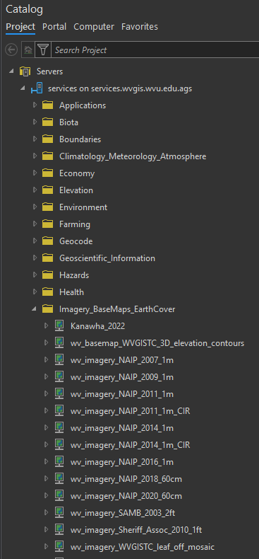
  - Drag and drop the wv_imagery_WVGISTC_leaf_off_mosaic into the contents pane on the left.
- On the contents pane on the left of your screen, right click “Map” under drawing order, and click properties.
  - Click Coordinate systems in the map properties window. Navigate to Projected Coordinate Systems > UTM > NAD1983 > NAD1983 UTM Zone 17N. Click on it and press ok.
- Once out of the properties window, change your base map to the “Streets” option on the Map tab of the tool ribbon using the Base Map button.
- Save the project and find the folder in C:\Users\YOUR USERNAME\Documents\ArcGIS.
  - Right click the “DOT_GR” folder and pin it to your quick access bar as instructed in the beginning of the manual.
- You will only need to do this set up once.

GEOREFERENCE PROCEDURES

- Select the best single TIFF file from the TIFF folder on your desktop.
  - This is preferably the cover page, but not always.
  - Open the file in photo viewer.
- Copy the selected file into the GeoTIFF folder on your desktop.
  - Exception to the cover page include:
    - Maps that are larger than 1 inch to 3 miles scale or it covers more than 3 counties.
      - If between 2-3 miles or 1 inch to 2000ft and 3000ft, crop the page down to just the map on the cover page.
    - Maps without cover pages. Find the next best page that shows as much of the plan as possible and use that.
    - Maps without any geo-information of a reasonable scale. The last resort is to crop out the inset map and georeference that.
    - Maps without any geo-information at all. Comment on the Performance Tracker that the plan has no geo-info. Move to step 15.
- Drag the TIFF into the Table of Contents from the GeoTIFF folder on your desktop.
  - A prompt will appear asking if you would like to create pyramids and statistic information. Check the boxes to have it automatically perform this. Click yes. You will only have to do this once.
  - Make sure to place it above the imagery layer so you can see the plan.
- In the Raster Layer tab and change the Transparency to ~30%.
- Use the image you opened earlier to look for spatial references to match to the image in Arc such as roads, rivers, crossroads, etc.
    - You can use Google maps to aid you in looking for the area if needed.
    - Sometimes inserting the map and orienting it properly can help you find it. Refer to step 7 on how to do this.
  - First, find the county the plan is in by referencing the top right corner map. Zoom to this county in ArcGIS.
  - Next, use the inset map to find the more precise location in the county where the project is. It will often be depicted by a line, arrow, or circle.
  - Once you have the general location, refer to project plan itself.
  - For sheets depicting little to no spatial information, use these clues to aid in georeferencing:
    - A North Arrow will aid in orienting the page correctly (Top left corner of example below.) Rarely the north arrow will be oriented incorrectly but normally it is correct.
    - Project Title often has more information corresponding to the location of the project, e.g. “Rafe Run Bridge.”
    - The scale bar can help you determine how small the plan is.
    - The DOT Access database “dbo_Scanning” can also supply more information concerning any routes/sub routes and other information. Ask the project lead for this information or consult the transmittal sheet attached to the physical Project Book.
    - Another tip for reading DOT book plans. Roads that are dashes are generally the old roads and the solid line with the circles and dashes are the proposed plan and should be georeferenced rather than the dashes, unless it does not match.
  - If the cover sheet does not supply enough spatial information, try to find a sheet in the project that does, but it should be a last resort.
    - If there are no sheets that can be used, leave an empty GeoTIFF folder in the Project Book folder. Leave a comment saying “No Geoinfo” in the Performance Tracking Sheet.
- Once you have found the area to which you plan to reference the image click Georeference from the Imagery tab and click Fit to Display.
  - Use the Rotate tool on the image to orient it using the north arrow and use the Move and Scale tools to help you get it into the general position. Do not go for perfect accuracy as that can make it more difficult to add control points.
- Once set in place, click the “Add Control Points” button and add control points as necessary.
  - Always assign control points using the imagery and not the base map.
  - When you first click to add a control point, click on the section of the map itself and then on the corresponding point on the imagery.
  - Add at least four (4) control points and make sure the main portion of the project (Usually outlined in sections of boxes) is what is being georeferenced (e.g. if the plan is an Interstate, match the Interstate road, and not the side roads.) Do not exceed ten (10) control points.
  - Sometimes a point will not work as you wanted or will need removed.
    - To do this, select the point by clicking the select tool in the review section of the Georeference tab. Once the point is selected, click on the Delete tool. These tools are highlighted in green.
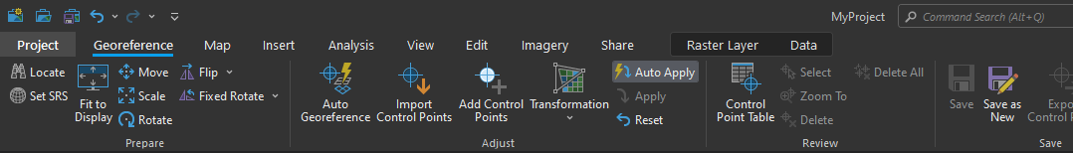
    - If you only have one other point placed, this will transform the image to make it ridiculously small. You can either reset the image and start over or try to carry on if you think you can match the point well enough. It will automatically transform the image for you.
- General Tips:
  - The north arrow is not always oriented perfectly or correctly even, if you are having difficulty finding a location, try orienting the map in different directions.
  - Check that you are trying to georeference the correct line on the map. Often the plan will be misleading and show the old part of the project in a more precise manner as the part you are most likely georeferencing had not been built yet. Generally, they will represent the new part with a bold line with dashes and circles throughout. Sometimes they will label it but not always.
  - The scale bar can give you a hint as to how small or large the plan needs to be. Using the scale of the map on the bottom of ArcGIS Pro you can tell how zoomed in you should be before you fit the map to the display.
  - Do not try to make every map as perfect as possible. Some maps are not scaled correctly. Sometimes it is the whole map, and sometimes it is part of the map. There are also times where the plan was not built as planned or perhaps not at all. Obviously, we want the best match we can get, but redoing the map over and over is a waste of your time.
  - If you cannot find the location, ask for a second opinion. This is a skill that you develop by doing and will take time to get the hang of.
- Once done, click “Save as New” in the Georeference tab
  - Set the Output Raster Dataset to your project folder that should be pinned to your quick access bar. It should default to this.
  - Make sure the coordinate system is set to NAD_1983_UTM_Zone_17N.
  - Leave Geographic Transformations, Clipping Geometry, and Cell Size as it is.
  - Change the raster size columns and rows to 6000. The cell size will change when columns and rows changes. That is fine.
  - Leave Pixel Type alone.
  - Change NoData to 0.
  - Leave everything else as it is.
  - Click Export
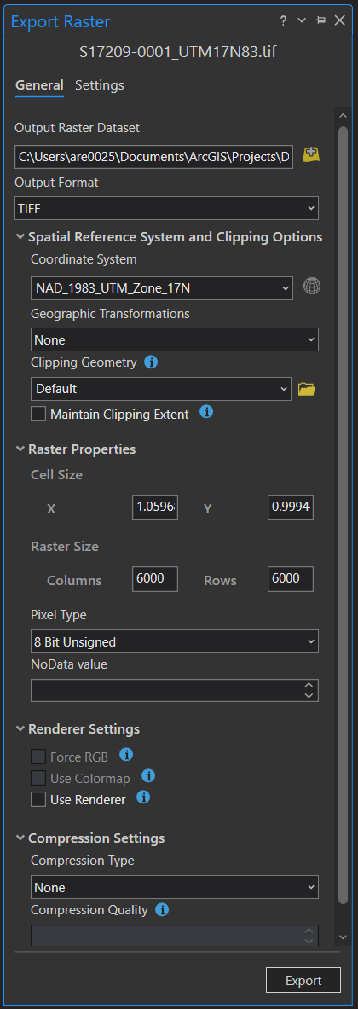
  - This image has what it should look like:
- When exported, you will find four files in the project folder pinned to your quick access bar on your file viewer.
  - Rename them all to S1XXXX-[FILENUMBER]_UTM17N83 (e.g. S10899-0001_UTM17N83).
    - The bottom two files will select the extra file extensions, make sure you keep all of them and only rename the file itself.
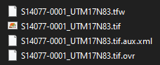
  - It is a hyphen between S1XXXX and [FILENUMBER] and an underscore between [FILENUMBER] and UTM17N83. The [FILENUMBER] is FOUR digits.
- Select all four files, right click on the .tif file with them all selected and click “Send to Compressed (Zipped) Folder”.

  - Make sure the zipped folder is named the same as files and the file type is ONLY “.zip”. (e.g. S02939-0028_UTM17N83.zip)
- Put the zipped file into the Project Book GeoTIFF folder on your desktop.
  - Delete the copy of the .tif and the two files generated in the GeoTIFF folder by ArcGIS Pro when you loaded the image into the map.
  - Delete the four tiff files and the .zip file from the DOT_GR project folder.
- Upload finished GeoTIFF to IncompleteBooks from your desktop.
- Update DOT Performance Tracker Google Sheet.
  - Find relevant Scan Order Number. Mark the number as green.
    - Date of Action
    - Technician Name
    - Time worked on action(minutes) in the Georeferencing Time column.
    - Additional Comments
      - If the plan was particularly difficult to georeference, explaining why the specific location was chosen.
      - Leave a note if the page could not be georeferenced and mark time as N/A.
  - Complete this process after every completed action.
- Update DOT_Operator_64 Tracking Database in MS Access:
  - If there was no Geoinfo, do not log anything in the Access database.
    - Technician performing action
    - Scan Order Number
    - Action taken
    - Date of Action
    - Time worked on Action (minutes)
    - Quantity completed (sheets, always one sheet for georeferencing.)
    - Additional Comments
  - Complete this process after every completed action or before the end of shift.

(6) QUALITY CONTROL & FILE RENAMING

Due to the complexity in the several earlier processes, a special emphasis is placed on quality control and assurance to confirm that the technicians are supplying the best possible product. The technician will check for accuracy and completion of the Database entry, filename, image processing, PDF, and GeoTIFF. Upon completion, the technician will use the file renaming tool to rename the quality assured folder in the IncompleteBooks folder. Once renamed, it will be moved to the ProjectBookFolders folder. Technicians cannot Quality Control their own work.

QUALITY CONTROL PROCEDURES

- Navigate to the IncompleteBooks folder and choose a folder to QC.
- Open the TIFF folder:
  - Check that all files are accounted and that the quantity listed is correct.
  - Check that there are no non-TIFF files in the folder.
- Open the PDF folder and open any PDF’s within the folder.
  - There should only be one which has the whole plan. Delete any extra PDFs.
  - Check the PDF to make sure it has the correct number of pages.
    - If there are discrepancies with the page number, flag the file on the Performance Tracker describing the problem.
  - Check that all pages have been image processed.
    - Check that no information has been cropped out or has folds over it, the page is cropped within approximately a centimeter along all neat lines and information outside the neat lines, and the page is reasonably straight.
      - If there are discrepancies, flag the file on the Performance Tracker noting which pages need processed or fixed.
  - Check that all pages face the correct direction.
    - If there are discrepancies, flag the file on the Performance Tracker noting which pages need rotated.
  - Check that no pages are askew or have OCR errors.
    - If there are discrepancies, flag the file on the Performance Tracker noting which pages need replaced.
  - Check that no pages have artifacts or other imperfections that do not come on the original plan.
    - If there are discrepancies, flag the file on the Performance Tracker noting which pages need examined or rescanned.
  - If there is an error and you are sure it needs fixed mark the whole plan section as red. If you are unsure there is an issue and need more information mark the whole plan section as orange.
- Open the GeoTIFF folder and extract all files into the GeoTIFF folder.
- Open ArcGIS Pro and your DOT_GR project.
  - Drag the TIFF file into the Table of Contents.
  - Right click that layer and click on Zoom to Layer.
  - Check that the Georeferenced index page matches the area to which it is referenced.
    - Ensure that the Georeference does not cover a large amount of a county/state. (Over 1in:3m scale or covers more than 3 counties.)
    - Ensure that the Georeference does not have a black background (No data not set to 0.)
      - Flag the file on the Performance Tracker noting the issue with the GeoTIFF.
  - After confirming that the georeference is correct, remove the GeoTIFF from ArcPro.
    - Select the extracted files that make up the GeoTIFF in the GeoTIFF folder in the IncompleteBooks folder and remove them.
      - Make sure the GeoTIFF .zip folder and the subfiles are named correctly. If not, flag this and have the technician rename them properly.
- Once the Project Book is verified as complete, move to the renaming process.

FILE RENAMING TO PROJECT KEY

SET UP PROCEDURES

- Open File Explorer:
  - In the Show/Hide section of the View ribbon, check the ‘File name extensions’ box.
  - Click the View tab > Options. A ‘Folder Options’ panel will open.
    - Click the View tab on this panel. In the Advanced settings box under Files and Folders check the ‘Always show icons, never thumbnails’ box.
    - Under Hidden files and folders check the box ‘Show hidden files, folders, or drives’
    - Uncheck the “Hide protected operating system files (Recommended)’ box.
      - A Warning will pop up, click Yes. Click Apply.
- You will now be able to see the Thumbs icons within various folders (They may not always be present, however).
  - To successfully rename a folder, you must remove all “Thumbs.db” files from the folder.
- Some of the settings for the following steps might be complete already, check to make sure they are.
- Open Start:
  - Search for ‘gpedit’ and click the top result to open the Group Policy Editor.
  - Click on User Configuration from the left pane.
  - Browser the following path: Administrative Templates > Windows Components > File Explorer.
  - Double-click the Turn off the caching of thumbnails in hidden thumbs.db files policy.
  - Select the Enabled option to disable the feature.
  - Click the Apply button. Click the Ok button.
- Open Start:
  - Search for regedit, right-click the top result, and select the Run as administrator option.
  - Browse the following path: HKEY_CURRENT_USER > Software > Policies > Microsoft > Windows
  - Right-click the Windows folder select the New submenu and click on Key.
    - Name the key Explorer and press Enter.
  - Right-click the newly created key, select the New submenu, and click on the DWORD (32-bit) Value option.
    - Name the DWORD DisableThumbsDBOnNetworkFolders and press Enter.
    - Double-click the newly created DWORD and change its value from 0 to 1.
  - Click the OK button. Restart your computer.
- You should now be able to remove “Thumbs.db” files without the “The action can’t be completed because the file is open in Windows Explorer” message.

RENAMING PROCEDURES

- Navigate to the IncompleteBooks folder and find the folder to be renamed.
- Open the folder and remove any “Thumbs.db” from the Project Book folder and its subfolders.
  - Make sure it has all three of the subfolders (GeoTIFF, PDF, TIFF) or else the tool will not run.
  - Navigate out of the folder to be renamed.
- In the DOT Access database open the dbo_vw_ProjectKeyLookup.
  - Locate the Scan Order Number of the plan you are renaming. The corresponding key is what you need.
- Open ArcGIS Pro:
  - In Arc, click the “Insert” Tab” to select the “add folder” option and connect to R:\DOT\wvDOT_planROW_scanning\Scripts.
  - Expand Pro_DOT_Tools.tbx to find the DOT File Rename for Pro Tool.
    - Open the File Rename Tool and type in the name of the folder to be renamed exactly as it appears in the IncompleteBooks in the Old Project Key box of the Rename Tool
    - Copy the ProjectKey of the folder to be renamed from Access and paste it into the New Project Key box of the Rename Tool.
    - Make sure the ProjectBook Structure box is checked.
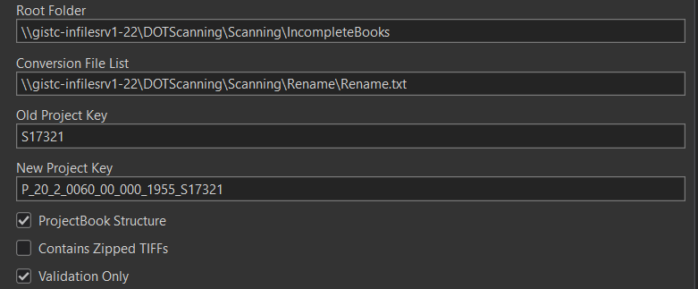
    - Run the tool with the Validation Only box checked.
  - If there are no issues with the validation, uncheck the box and run the rename tool.
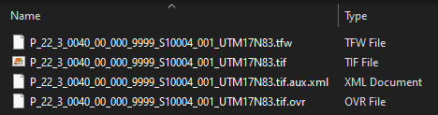
- Check to ensure the files renamed properly in all the subfolders and inside the GeoTIFF .zip file. They will look like this:
- After the file has been properly renamed, it must be moved from the IncompleteBooks folder to the ProjectBookFolders folder.
  - Drag the correctly renamed book in the IncompleteBooks folder and drop it in the ProjectBookFolders folder. Mark the plan number Blue on the Performance tracker noting it has been QC’d.
  - If there was an issue with renaming the file, mark the plan number Light Blue.
    - The most likely error is a permission error. Have the technician who processed the plan restart their PC.
- Update DOT Performance Tracker Google Sheet.
  - Find relevant Scan Order Number
    - Date of Action
    - Technician Name
    - Time worked on action(minutes) in the QC Time column.
    - Additional Comments
  - Complete this process after every completed action.
- Update DOT_Operator_64 Tracking Database in MS Access:
    - Technician performing action
    - Scan Order Number
    - Action taken
    - Date of Action
    - Time worked on Action (minutes)
    - Quantity completed (sheets)
    - Additional Comments
  - Complete this process after every completed action or before the end of shift.

Note: When running the rename tool, make sure you are outside the folders when in the Project Book. You can be inside the Project Book but not in TIFF, PDF, or GeoTIFF.
- If there are any issues with the validation, address them and run the validation again.

POSSIBLE ISSUES WITH RENAMING:

- Thumbs in the TIFF folder and GeoTIFF folder.
  - Delete the thumbs.db file.
- File Permission Error- does not rename Folder but renames sub folders and files.
  - Have the technician restart their computer and manually rename the main folder the project key. If you re-run the renaming tool it will mess up the GeoTIFF .zip.
- File type Suffix on the end of the of the compressed GeoTIFF folder.
  - Be sure that the compressed zip in the GeoTIFF folder does not include any suffixes, such as .tif /.aux or any other combination that is not just ‘.zip’ These suffixes lead to error on the website’s download GeoTIFF action.

(7) PUBLISHING (includes WEB QC & BACKUPS)

Highway Plans Locator website: www.mapwv.gov/DOTplans

The Highway Plans Locator website is one of the final products achieved in the West Virginia Division of Highways Scanning Project. The scanned images are organized in a geodatabase that houses several image and feature services to make data available to the webpage. This section of the Scanning Project Procedures outlines the scripts and databases used to manage the scanning process and publish the results.

The DOT Project Plan Scanning system is designed around two Microsoft SQL Server databases: one used for recording scanning activity (DOT) and a second enterprise geodatabase used to support web mapping and image services (GDB_DOT). The system takes advantage of the multi-user capability of Microsoft SQL Server 2022, allowing scanning information to be recorded in real-time and new scans to be published as they are created.

In addition, the use of an enterprise geodatabase streamlines the process of updating the ArcGIS feature and image services by eliminating the need to re-publish an entire ArcGIS geodatabase in order for updates to be made available on the web.

DOT GEODATABASE OVERVIEW

The ArcGIS Pro project used for feature and image service publication is named WV_DOT_Planfinder_Pro.aprx. This project defines the related feature classes, raster mosaic, and database tables. It also defines the standard symbology and related database connection information. This ArcGIS Pro project is stored on a production file server in the WV GIS Technical Center and is backed up on automated schedule.

The supporting ArcGIS enterprise geodatabase has three primary objects:

- A raster mosaic used as the source for the ArcGIS image service.
- A feature class representing map footprints of each scanned construction plan.
- A database view that is used as the underlying source for the published plans and for the web-based query interface.

These can be seen in the following screenshot taken from the ArcPro Catalog interface.
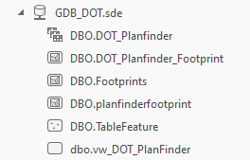
Mosaic used for image service
Feature class containing footprints
View that is published as the map service

The vw_DOT_Planfinder SQL Server view is used in ArcPro as the layer source for the Footprint map service. The DOT database, which stores scanning information and related lookup tables, is used on the website to provide this information to the user. This view links the ArcGIS feature class inform to the operational scanning data. The view is defined as follows:
vw_DOT_Planfinder view definition:

CREATE VIEW vw_DOT_Planfinder AS
SELECT OBJECTID
,Name
,[Shape]
, Scanning.*
FROM GDB_DOT.dbo.DOT_Planfinder_Footprint
JOIN DOT.dbo.vw_Scanning AS Scanning
ON Scanning.ScanOrder = DOT_Planfinder_Footprint.ScanOrder

The structure of the DOT database used to store scanning information and related lookup tables can be viewed from within ArcPro or Arc Catalog. All administration for this database is performed using Microsoft SQL Server Management Studio. Backup plans are defined from within the management interface and scheduled backups are run using the SQL Server Agent process.
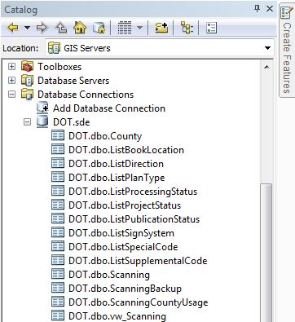

PUBLISHING GEOTIFFS

Because the Map Service and Image Service are fed from a SQL Server enterprise geodatabase (dbo_Scanning), it is not necessary to re-publish any services to add new scan rasters to the ArcGIS Services. All that is needed is to add them to the raster mosaic and update the footprint feature class. This section describes the steps involved in publication process.

The georeferenced TIFFs from each Project Book are combined into raster mosaics in ArcGIS for easy viewing. To begin the process, expand the toolbox named Pro_DOT_Tools and open the DOT Publish GeoTIFFs tool.
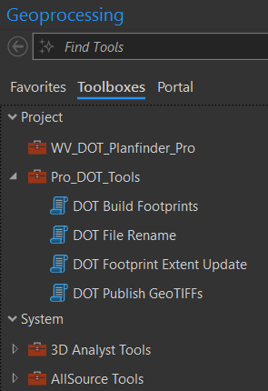
DOT GeoTIFF Publishing Tool

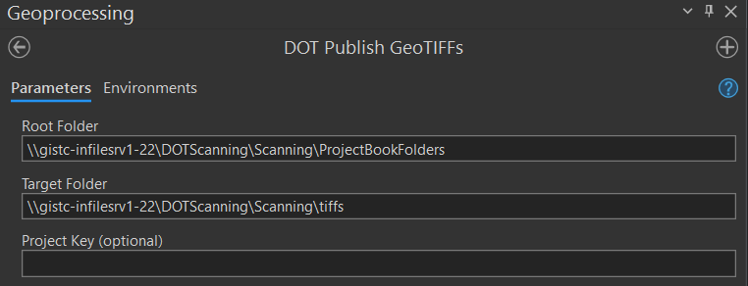
Double-Click DOT Publish GeoTIFFs Tool to open the script, the following box will appear:

The Root Folder needs to be:
\\gistc-infilesrv1-22\DOTScanning\Scanning\ProjectBookFolders
The Target Folder needs to be:
\\gistc-infilesrv1-22\DOTScanning\Scanning\tiffs

To add scan rasters to the mosaic they first need to be placed in the Target Folder. This tool extracts the GeoTIFFs from the zipped versions in the individual Project Book folders that are created during the scanning process. These zipped images are in the Root Folder specified above. The tool can process a single Project Book folder or optionally all folders. If a Project Key value (For example, “B_02_1_0081_00_012_2001_S01614”) is specified, then only the corresponding GeoTIFF will be published. If the Project Key value is left blank, then the GeoTIFF files for all projects will be extracted to the production folder. You can only do one at a time, but the process is much faster this way.

Click OK and the Tool will run, placing all the GeoTIFF folder contents from \ProjectBookFolders into \tiffs so that they can be added to the Mosaic dataset.

This step takes a long time to run if you do not individually process projects. (approximately 6 hours as of 10,000 plans), so plan accordingly.

When the process is completed, check to see the website is functioning correctly.

ADD RASTERS

The next step adds the previously extracted GeoTIFF rasters to the mosaic dataset. This is needed so we can build the footprints and display the georeference on the web map.

The first step is to use the Data Management Toolbox, click Raster, Mosaic Dataset, and the Add Rasters to Mosaic Dataset tool will appear.


Add Raster to Mosaic Dataset

Alternatively, you can type “add rasters to mosaic dataset” in the search box of the Geoprocessing tab and select the tool from the results.
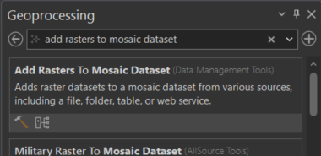
Add Raster to Mosaic Dataset

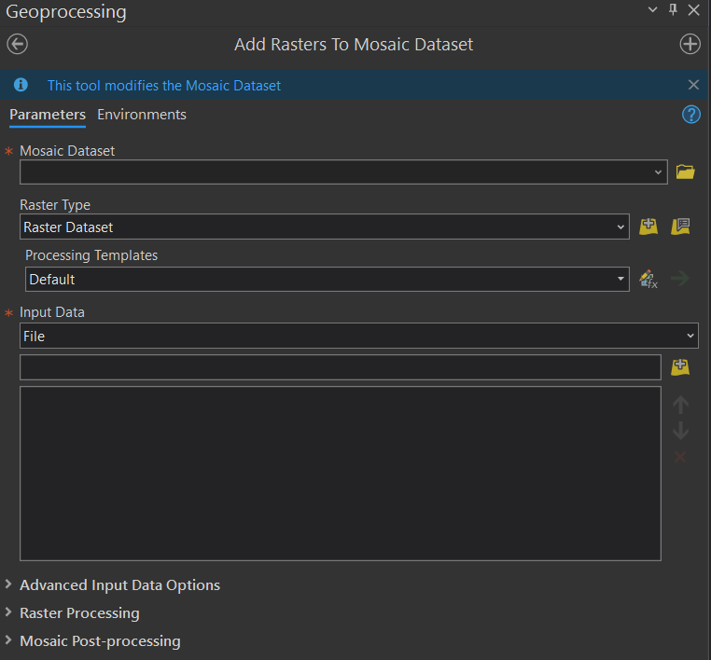
The following interface will appear:

The Mosaic Dataset needs to be:
\\gistc-infilesrv1-22\Projects\DOT\wvDOT_planROW_scanning\Scripts\GDB_DOT.sde\GDB_DOT.DBO.DOT_Planfinder
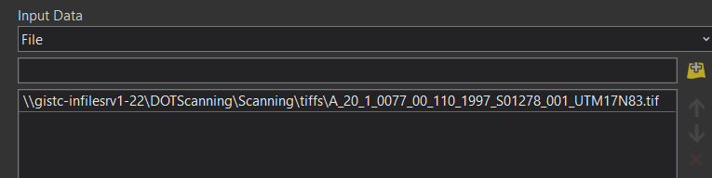
Normally, when adding rasters to the mosaic, the “File” option should be selected in the “Input Data” section of the “Add Rasters” dialog. Each raster can be selected individually and added to the “Source” list. It is important to use the full UNC pathname so that the ArcGIS server can access the images.
Insert the file path (As shown) of the GeoTIFF(s) you need to add here. They will be added to the list below.

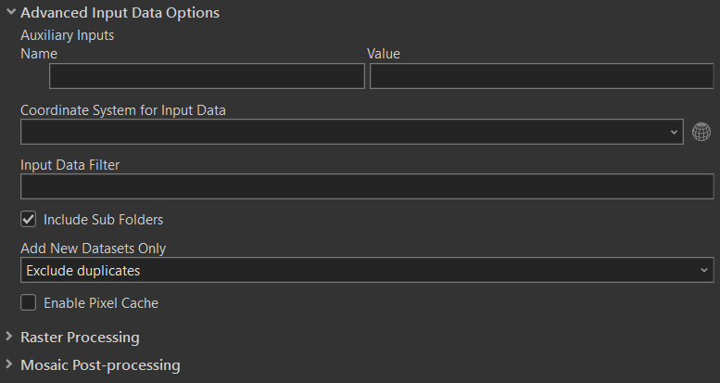
Under the Advanced Options, the “Add New Datasets Only (optional)” drop down should be set to “Exclude duplicates” for regular publishing steps or “Overwrite duplicates” for republishing during the Website QC process.

If needed, the mosaic can be loaded from scratch by selecting the Workspace option instead of Raster dataset under Input Data. The technician must enter the file path of the folder we previously extracted the GeoTIFFs to.

The Input Data Workspace needs to be:
\\gistc-infilesrv1-22\DOTScanning\Scanning\tiffs

Click OK to run the tool and add the GeoTIFFs extracted in the last step to the mosaic dataset. This process takes approximately 30 minutes for 10,000 plans. Check to see the website is running when it completes.

BUILD FOOTPRINTS

When added to a data frame in ArcGIS, each raster mosaic contains three layers, one of which is called Footprint. This is a vector layer of rectangles drawn around the extent of each raster, and attributes for each raster are stored here in the attributes table.

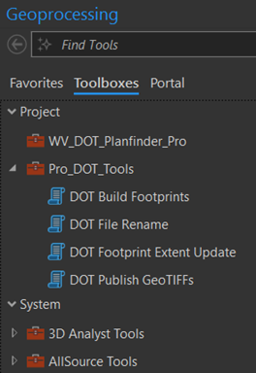
After the rasters are added to the mosaic dataset, the footprints of each georeferenced image need to be created. The next tool removes all existing footprints then rebuilds the feature class by scanning the rasters and generating new features. Expand the toolbox named Pro_DOT_Tools.pyt toolbox and open the DOT Build Footprints tool.
DOT Footprint Builder

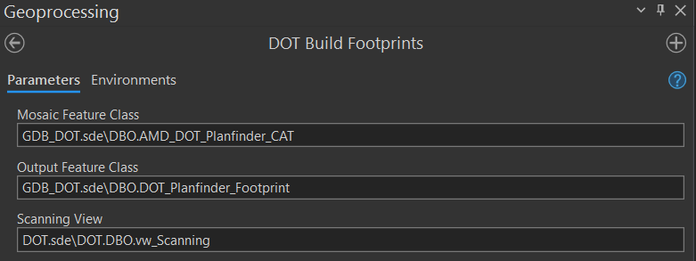
The following interface will appear:

The Mosaic Feature Class needs to be:
GDB_DOT.sde\GDB_DOT.DBO.AMD_DOT_Planfinder_CAT
The Output Feature class needs to be: GDB_DOT.sde\GDB_DOT.DBO.DOT_Planfinder_Footprint

Open the tool and click OK. Expect it to take around an hour minimum as of 10,000 plans.

Finally, verify that the website is functioning correctly when the process has completed.

UPDATE FOOTPRINT EXTENT
The footprints from each of the mosaics are merged into a single, separate, layer and stored in the geodatabase. This supplies a unique extent for every raster in each mosaic, making it much easier to search for and view data raster data. To facilitate retrieving and displaying GeoTIFF sheets and image attributes, the system requires a connection between the raster data in the geodatabase and the scanning data in the operations databases. The DOT Footprint Extent Update tool is used to create the connection.

To copy the footprint extents, the technician uses the DOT Footprint Extent Update tool in the DOT_Tools.pyt toolbox.
DOT Footprint Extent Update

It is important to note that the DOT Footprint Extent Update tool will only run on the plans that are specified in the Scan Order row. To update all Scan Orders, follow the directions in the tool and place an asterisk (*) in the Scan Order row. It is also necessary to check the “Update Database” checkbox at the bottom of the dialogue box to properly update footprint extents. If this box is left unchecked, the tool will function as a test and will not copy any information from the image service into the database.
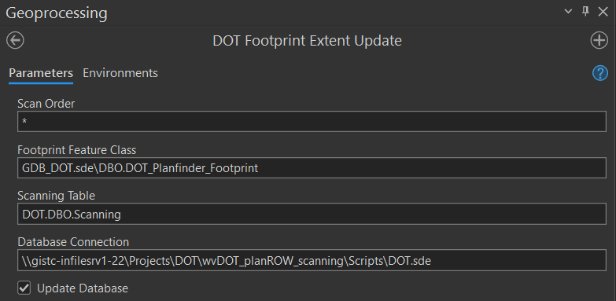
Make sure to check this box

Click OK and the tool will populate the XY coordinates in the database. This should take no more than 10 minutes as of 10,000 plans. Check to see the website is running.

PUBLICATION STATUS
The raster mosaics and the Footprints layer are currently being published as a GIS service in ArcServer and then added to a map on the ArcGIS.com map viewer. This is mostly for demonstration purposes but is also useful as a means of sharing the materials with WVDOT, tracking the project’s overall progress, and making it viewable in an interactive environment.

To publish the service, the user must have access to various server addresses on the WVGISTC network, which will likely require admin permission. The server addresses themselves are subject to occasional changes; verify which server the service should be published on before continuing.

The last step is to update the PublicationStatusID column of the Scanning table to ‘2’ or if you are using the Access interface open the table and set the PublicationStatus to ‘Published’.

Make sure the ScanCount and GeoTIFFSheet columns of the Scanning Table include the accurate page number.

At this point you should be able to see the new footprints on the website, check to see that it is running.

FINAL WEBSITE QC

After the Publication Status is changed to Published, all links on the website should working. However, there are several different scenarios that cause the links to fail. A final quality control is to be completed by the technician who has updated the website.

- Navigate to the website: http://mapwv.gov/DOTplans/
- Search for one specific plan at a time, which you published in the last batch.
  - Click and check each of the four links for each Project Book.
- Note any errors that are found in the Web QC Google Sheet.
  - Refer to Website Troubleshooting for information about errors.
- Make any corrections and continue to Backup procedures.

WEBSITE TROUBLESHOOTING

- If the PDF works and the Globe does not:
  - Look to see if book is named correctly:
    - Check to see if the GeoTIFF zip file name matches the dbo_vw_Projectkeylookup name.
    - Check to see if the Georeference page number matches the column under dbo_scanning > GeoTIFFSheet (this can only have 3 number characters.)
    - Check to see if the coordinates are properly populated.
      - If the book name matches, and the Georeference page is correct, see if the date is 0 or not populated. If so, you will need to remove the old tiffs in the tiffs folder, rename all related files to include the “9999” date (including the zipped GeoTIFF files,) and wait for republishing.
      - This can apply to any field that has specific parameters, such as the route number, sub route number, and begin mile number. Check those fields as well.
  - Look to see if there is a file or folder issue:
    - Go to the GeoTIFF folder within the problem book and check to see if the zipped file folder is within another folder. Removed zipped folder and place it inside GeoTIFF folder.
    - Check that the zipped folder has all four of the required files and is not missing any. If it is missing files, it will need georeferenced again.
- If the PDF does not work and the Globe is not there:
  - Check to see if the PDF file name matches the dbo_vw_Projectkeylookup name.
- If the download GeoTIFFs (scenic portrait button) does not work:
  - Check the GeoTIFF zip file-pathname. Make sure that the folder does not include the ending “. aux.zip”
- If footprints display but raster mosaic does not appear or the Georeference otherwise does not display properly:
  - Search the Project Book number in the \tiffs folder and remove all tiffs associated with that plan.
  - Remove any associated rasters from GDB_DOT.sde.
  - Complete the Website Publishing Procedures.

Important: To get rid of duplicate book numbers when uploading to the website go to the \tiffs and remove the TIFFs in the folder. When adding rasters, go to advanced settings in the dialog box and check “exclude duplicates”.

Record work in Web QC Status Google Sheet.

BACKUP PROCEDURES

EXTERNAL DRIVE
The external drive is to be backed up by one technician at the end of web QC process. After being backed up, a transmittal sheet should be updated and saved to the external drive DOT Scanning folder, which records the date of backup, Project Books included, and the amount of storage used. The transmittal sheet can be found on the external drive being used to back up the scan data.
INTERNAL SERVERS
The internal backup is performed along with the WVGISTC’s general server backup.

DIGITAL PLAN PROCEDURES

In case of digital plan submissions of previously scanned images from WV DOH District offices, technicians will follow the procedures as outlined below. This method is subject to change as digital plan submission formats and procedures change. Digital submissions may affect the following work tasks:

    - File Naming
    - Image Processing
    - PDF Creation
    - Georeference Plan Index Map Sheets
    - Quality Control/Quality Assurance
    - Publishing Web Map

APPENDIX A: Page Number FAQ

Page Numbering FAQ
The following Q&A’s are examples of page numbering questions/inconsistencies that have arisen during the scanning project. New questions are added to the document as problems are discovered, and answers are added as they are received.

Q: Pages are arranged out of order.
A: Rearrange the pages by the official page number as seen on the sheet. If there are pages from different projects within the same book which are numbered by a different system/sequence, retain the order in which those pages were physically found when creating the PDF document, as they were likely placed in that order intentionally by WV DOT.
Q: Two pages with different content, but same page number.
A: They might be from different projects. If so, keep the order in which they were found, keeping the same file name and allowing the scanning software to auto number the pages.
There is also a chance the pages were miss-numbered. Example: 17, 18, 20, 20… In a case like that, correct the page numbers in the file name (in the example, you would change the first 20 into 19), keeping the order which pages were found.
Q: Some pages are marked as removed with a large X crossing the entire page and text that reads “This sheet deleted, see page 81A” or the like. In this example, there was a page 81, then another page 81 that was marked as removed and referred to page 81A.
A: The deleted page does not need to be scanned (according to WVDOT), though it may be wise to scan it anyway. Make a note of it in the database either way.
Q: Some sheets have no visible page number.
A: Give them one for now, according to the sequence in which they were discovered. Keep them in the order they were discovered when creating the PDF document. Make a note in the comments field of the database describing how they were numbered.
Q: One Project Book can have sheets from multiple projects. EXAMPLE: Project 32, starting on the second page it switches to a different project in a different county for 37 pages before switching back to the original project listed on the cover sheet, beginning with page #2. Another EXAMPLE: Project 17 has two pages appended to the end from unrelated projects. Another EXAMPLE: Project 33, page 52 (there are two of them) is a seemingly random page from some unrelated project. How should we handle examples like these? Separate them? Keep them in the same folder and number them as they appear?
A: Those pages were usually put in there by WV DOT staff for a reason, so be sure they are arranged in the PDF as they were discovered. As for naming the TIFFs, they are to be auto named based on the order they are in and remain inside the project folder in which they were found. Write a descriptive note in the comments field of the database.
Q: Pages repeat, but with some revisions.
A: The original un-revised page does not need to be scanned (according to WVDOT), and the revised page should get the original page number. Scan the un-revised page anyway and note it in the comments field of the database.

APPENDIX B: Image Processing Keyboard Shortcuts

The following shortcuts can be used in Adobe Photoshop for Image Processing:

Shortcut | Action
Ctrl + C | Copy
Ctrl + V | Paste
Ctrl + X | Cut
Ctrl + S | Save
Ctrl + Zero | Zooms to Page Extent
Z | Switches to Zoom Mode
C | Switches to Crop Mode
Ctrl + Tab | Go to Next Image
Ctrl + Alt + Shift + L | Auto Contrast
Ctrl + Alt + Z | Undo Droplet Action
HOLD Ctrl | (While in Crop Mode) Use Straighten Tool
Ctrl + Z | Undo
Ctrl + Plus | Zoom in
Ctrl + Minus | Zoom out
Ctrl + L | Opens Levels Menu

Additional shortcuts may be created using the Keyboard Shortcuts menu in Photoshop (Edit<Keyboard Shortcuts… or Alt + Shift + Ctrl + K)

APPENDIX C: Procedure Hardware, Software, and Documents

Procedural tasks associated with hardware, software, management documents.
PROCESSING TASK | HARDWARE | SOFTWARE | MANAGEMENT DOCUMENTS
Book Preparation & File Naming | Scanning Computers | File Explorer  Access | dbo_scanning
Scan Document | Scanning Computers | Softworks Pro  Access  Google Sheets | dbo_scanningActivity  DOT Performance Tracking
Image Processing | Local Workstation | Adobe Photoshop  Access  Google Sheets | dbo_scanningActivity  DOT Performance Tracking
Build PDF | Local Workstation | Adobe Acrobat DC  Access  Google Sheets | dbo_scanningActivity  DOT Performance Tracking
Georeference | Local Workstation  Gistc-infilesrv1-22 | ArcGIS  Google Maps  Access  Google Sheets | dbo_scanningActivity  DOT Performance Tracking
QA/QC | Local Workstation  Gistc-infilesrv1-22 | ArcGIS  FileRename.pyt  Access  Google Sheets | dbo_scanningActivity  DOT Performance Tracking  dbo_scanning  dbo_vw_ProjectKeyLookup
Publishing & Web QC | Local Workstation  External Drive  External Server  Gistc-infilesrv1-22 | PublishGeoTIFF.pyt  BuildFootprints.pyt  UpdateFootprints.pyt  Access  Google Sheets | dbo_scanningActivity dbo_scanning  DOT Web QC Status  dbo_vw_ProjectKeyLookup

APPENDIX D: Transmittal Sheet

Project Key | Project Title:

1 | 2 | 3 | 4 | 5 | 6 | 7 | 8 | 9 | 10 | 11 | 12 | 13 | 14 | 15 | 16 | 17 |  | 18 | 19 | 20 | 21 | 22 | 23
 |  |  |  |  |  |  |  |  |  |  |  |  |  |  |  |  |  | S | 1
Type | County ID |  | Sign System | Route Number |  |  |  | Sub Route |  | Begin Milepost |  |  |  | Fiscal Year |  |  |  | Scan Order Number  S- Scanned at WVGIS TC  D- Digitally Received by District  (To be completed by scan tech.)
1 | 4 | 5 | 6 | 7 | 8
_ | _ | _ | _ | _ | _
District # | Special  ID |  | Status ID | Supplemental Code
Supplemental Information
9
Bar #
_ | _ | _ |  | _ | _ |  | _ | _ |  | _ | _ |  | _ | _ |  | _ | _ | _ |  | _
Bridge #
_ |  |  | _ |  |  | _ |  |  | _ |  |  | _ |  |  | . |  |  |  | _
_ |  |  | _ |  |  | _ |  |  | _ |  |  | _ |  |  | . |  |  |  | _
_ |  |  | _ |  |  | _ |  |  | _ |  |  | _ |  |  | . |  |  |  | _
State Project #: | Fed Project #: | ProjectWise: Y / N

