

Microsoft
Wv Division of Highways Plan Scanning PROJECT
August 23, 2020
West Virginia GIS Technical Center
PROCEDURAL MANUAL
Contents
PROJECT OVERVIEW 1
SEVEN MAJOR PROCEDURAL TASKS: 1
HIGHWAY PLAN TYPES 4
(1) BOOK PREPARATION & FILE NAMING 5
BOOK PREPARATION 5
GENERATE PROJECT KEY NAME AND CREATE SCAN ORDER # 5
(2) SHEET SCANNING 8
SCANNER SETUP 9
FOLDER, FILE AND PAGE NAMING 9
PAGE NUMBERING ISSUES 10
SCANNING PROCEDURES FOR 12x34 AND 12x18 SHEETS 10
SCANNING PROCEDURES FOR 8.5x11 REPORTS 11
SCANNER CLEANING AND MAINTENANCE 12
SCANNING QUALITY ISSUES 13
SCANNER CLEANING 13
(3) IMAGE PROCESSING 15
IMAGE PROCESSING PROCEDURES 15
IMAGE SETTINGS AND ENHANCEMENTS 16
COLOR MODE 16
AUTO IMAGE ENHANCEMENTS 17
AUTOMATED ACTIONS AND DROPLETS 17
(4) PDF BOOK 18
PDF CREATION PROCEDURES 18
PDF RESOURCE NOTES 18
ACTION CREATION 19
MANUAL PROCEDURES WITHOUT SCRIPT 19
(5) GEOREFERENCING HIGHWAY INDEX MAP 20
(6) QUALITY CONTROL & FILE RENAMING 23
QUALITY CONTROL PROCEDURES 23
FILE RENAMING TO PROJECT KEY 24
POSSIBLE ISSUES WITH RENAMING: 25
(7) PUBLISHING (includes WEB QC & BACKUPS) 26
DOT GEODATABASE OVERVIEW 26
PUBLISHING GEOTIFFS 27
ADD RASTERS 29
BUILD FOOTPRINTS 30
UPDATE FOOTPRINTS 30
PUBLICATION STATUS 31
FINAL WEBSITE QC 32
WEBSITE TROUBLESHOOTING 32
BACKUP PROCEDURES 33
EXTERNAL DRIVE 33
INTERNAL SERVERS 33
DIGITAL PLAN PROCEDURES 33
APPENDIX A: Page Number FAQ 34
APPENDIX B: Image Processing Checklist 36
APPENDIX C: Image Processing Keyboard Shortcuts 37
APPENDIX D: Planfinder Python Scripts Documentation 38
APPENDIX E: Entering a New Book into the Access Database 44
APPENDIX F: Procedures Outline 48
APPENDIX G: Transmittal Sheet 53

This is a step by step guide intended for internal use by the WV GIS Technical Center to explain the procedures of the DOT Scanning Project. All work progress should be recorded in the appropriate Performance Tracking Database.

PROJECT OVERVIEW

The West Virginia GIS Technical Center (WVGISTC) is working with the West Virginia Department of Transportation (DOT) to scan large format highway plan sheets into digital raster images. For every highway plan book, a single Adobe PDF file of all the sheets is created along with an index map that is spatially referenced. The WV Division of Highways Plan Scanning Project is fulfilled through a series of steps and processes that are described throughout this documentation. Records are kept to document time spent on each process and are used to calculate estimations of time and cost for future evaluation. Technicians are expected to keep accurate records of time spent on each process and record their activity in the DOT_Operator access table.

SEVEN MAJOR PROCEDURAL TASKS:
The scanning project consists of seven major work tasks which are described in more detail below.

(1) Book Preparation and File Naming: Once the Tech Center receives a batch of project books from the DOT, book preparation can begin. This process consists of placing each book in the designated location in the Tech Center and should be kept separate from books that have been completed or ones that are file-named and still in progress.
Every WV DOT project book scanned by the WVGISTC will have an entry in the WV DOT Scanning (dbo_Scanning) Database. This database consists of key transportation fields for identifying the highway book, unique scan order and project key identifiers, scan information for tracking project progress and work tasks, index map coordinates, and useful online links for the PDF Book, geographic location, ProjectWise location, etc.
After they are placed in their appropriate location, the technician will select a project book and enter description information about the plan book in the dbo_Scanning table. Each DOT project book gets an entry in this table, which should be filled out at the time the project book is scanned.
This consists of recording the information on the transmittal sheet (found inside the map (folder/rolled map)) and the Project Book cover sheet. Once all information is documented, the technician will then create and record a Scan Order Number on the transmittal sheet and relocate the book and transmittal to the location designated for the file named documents that are to be scanned.
(2) Sheet Scanning: The technician will begin this process by selecting a book from the file-named books area and bringing it to the scanner workstation. The scanner must be set to specific settings before the book can be scanned, which ensures that the image is in the proper format and is named correctly. Additionally, a new folder at the scanner workstation must be created and should be named according to the Scan Order Number on the transmittal sheet. After these are completed, each page of the document is to be wiped off with the cleaning products provided to protect the scanners from dirt and any other potentially damaging debris. If the technician finds that the project book is especially dirty or is in bad condition, document protectors must be used. These are found on the first two shelves of the filling cabinet work table, which are labelled. Once the technician is sure that the document is clean and the file location and scanner settings are correct, the document can be scanned. After the entire book is scanned, the file must be moved from the local workstation, to the IncompleteBooks folder on the R:\ Drive. The physical project book should then be noted that it has been scanned and then placed in designated location. It is important to be sure that all Scanner components are maintained and kept clean.
(3) Image Processing: This action utilizes tools created in Photoshop to make image adjustments. The files will be loaded into Photoshop and, with the use of an autocontrast, which is detailed below, operation, will be cleaned up, cropped, and rotated, if necessary. After processing, upload the TIFF files into the server.
(4) PDF Creation: After image processing has been completed, the edited TIFFs are to be compiled into a PDF document. To do this, an “action” needs to be created in Adobe Acrobat Pro to reduce file size and recognize text (using Optical Character Recognition, or OCR). This process will be automated with the use of commands that are detailed below. After this is completed, the PDF is relocated to the PDF folder created on the technicians’ local work station. The document must then be checked and corrected for any rotation or other errors. Once the PDF is correct, rename the document using the Scanning ID Number.
(5) Georeference Plan Index Map: The technician will use ArcGIS Pro, and Google Maps if needed, to locate and georeference each cover sheet of the project book. This sheet is typically found on the first page and is contained in the index map, but it can be found in various places throughout the project book. The page that contains the object to be georeferenced must be copied from the TIFF folder and then pasted into the GeoTIFF folder. Once it is in the proper location, the technician must open the TIFF and ensure the correct projection (Universal Transverse Mercator Zone 17N) is applied. After this is complete, the object’s location needs to be found on the map. By using spatial information found throughout the ProjectBook, the technician can find the location with Google Maps and ArcGIS Pro. Once identified, the image is to be georeferenced based off at least four (4) control points set by the technician. The georeferenced image will then need to be named according to the DOT naming conventions. The GeoTIFF folder is to be relocated from the local workstation to the book’s file in incomplete books (\\gistc-filesrv1\DOTScanning\Scanning\IncompleteBooks). Lastly, the technician must update the GeoTIFF page number on dbo_Scanning in Access if the cover sheet was not on the first page.
(6) Quality Control & File Renaming: Due to the complexity in the several previous processes, a special emphasis is placed on quality control and assurance to confirm that the technicians are providing the best possible product. The technician will check for accuracy and completion of the Database entry, file-name, image processing, PDF, and GeoTIFF. Upon completion, the technician will use the file renaming tool to rename the quality assured folder in the IncompleteBooks folder. Once renamed, it will be moved to the ProjectBooksFolders folder. Technicians should not Quality Control their own work.
(7) Publishing to Web Map: The final process to the WV Division of Highways Plan Scanning Project is uploading the TIFFs, PDF, and GeoTIFFs to the website. First, the PublishGeoTIFF.pyt script will run python to copy and replace GeoTIFF’s into a new folder that will be used to add scan rasters to the mosaic. Once relocated into a new folder and added to the mosaic, the technician will use the DOTFootprints.pyt tool to create footprints of the georeferenced image (corners of the image). Next, the footprint extents need to be copied into the dbo_Scanning table. This is done with the UpdateFootprintextents tool in ArcMap and will automatically update X and Y Min/Max fields in the dbo_scanning table. After this tool is finished, the technician must update the PublicationStatusID column in dbo_Scanning, which will publish the projectbook to the images in the ArcGIS Online Map.
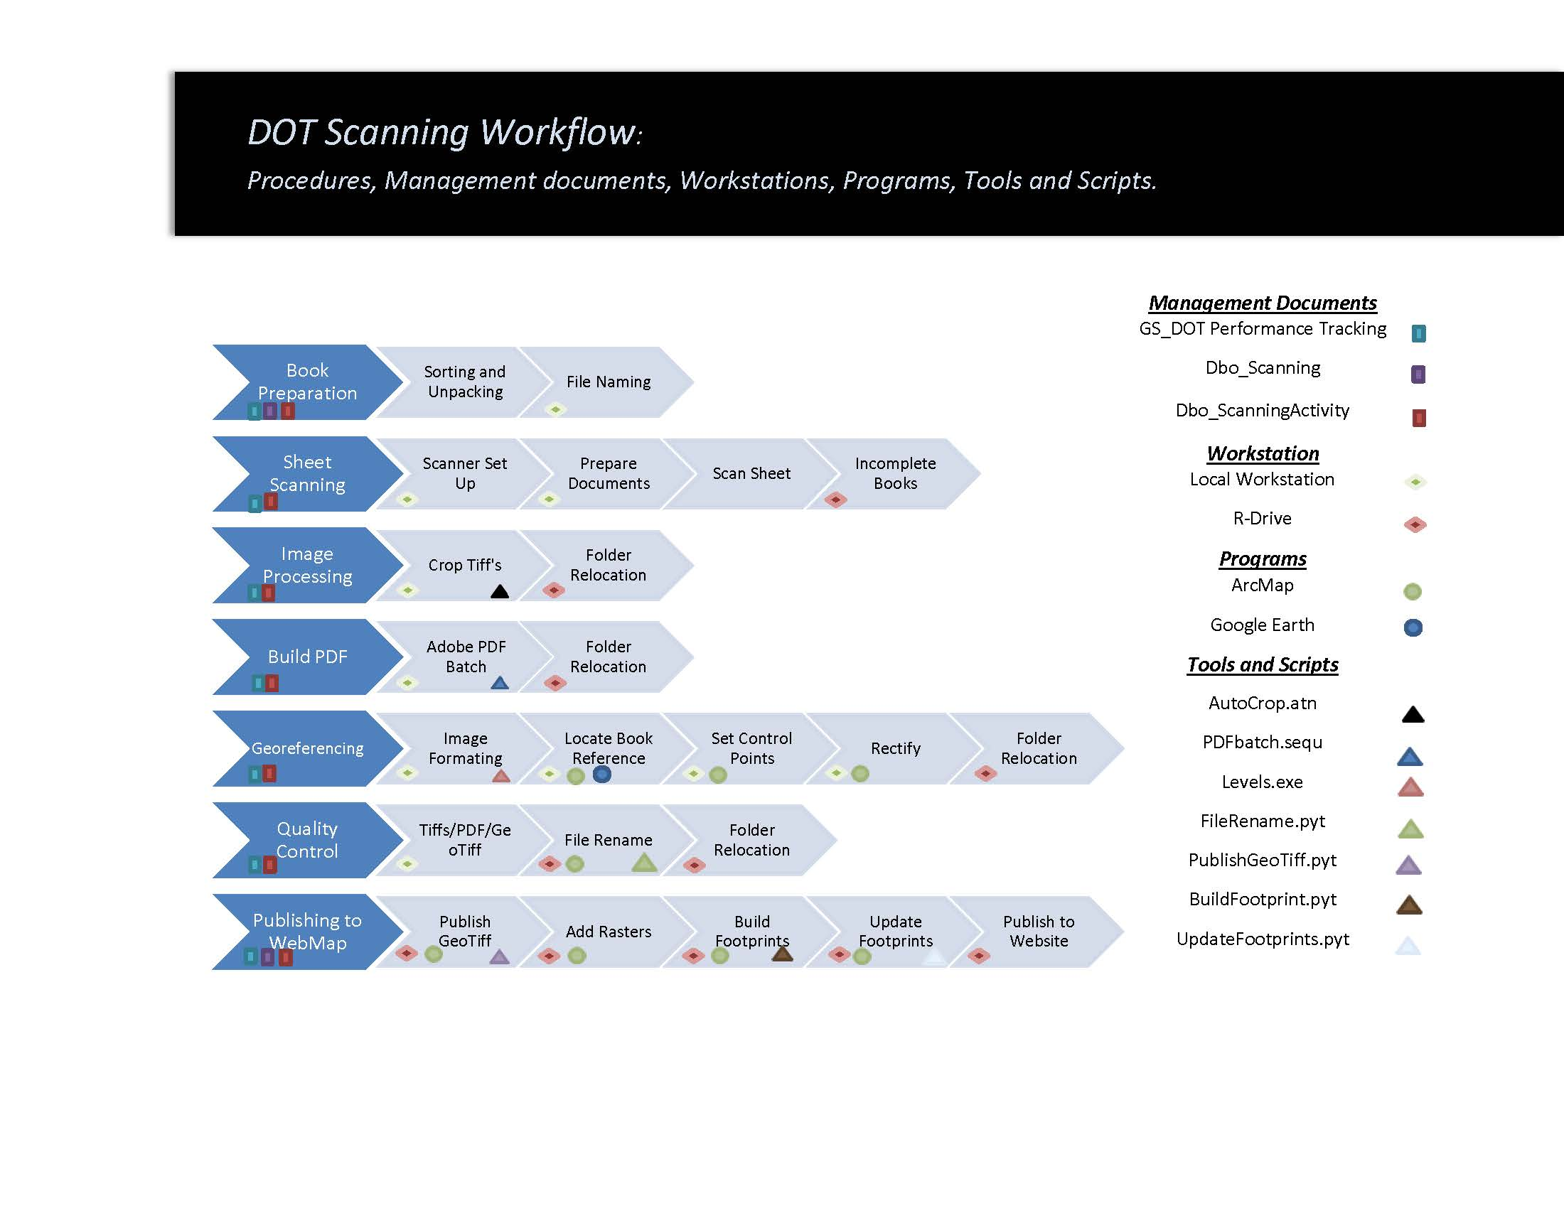

HIGHWAY PLAN TYPES

Various types of highway plans are scanned, processed, and published by technicians. The bridge and ROW plans are of the highest priority to scan.

Table 1: Descriptions of various types of highway plans.
Plan Type | Code | Description
ROW Plans | R | Right of way plans show the land obtained by WV DOT to complete highway projects. The right of way portion of the plan set is used to convey information about the right of way boundaries and adjacent property lines, the property ownerships and acreage involved in the takes and the overall impact the improvement will have to the particular property owners. Appraisers, negotiators and attorneys all use the right of way plans to assist them with their work when determining fair market value, negotiating with the property owner or explaining a condemnation case to a jury.
Bridge Plans | B | Bridge plans show construction and location of a specifics of a bridge (e.g., type of girders, type of span, soils).
Construction Design Plans | P | The construction portion of the plan set is used to convey information about the design of the roadway itself, the amount and type of construction materials used for the project and the types of construction methods used to complete the work. Designers, estimators and construction workers all use the construction plans to assist them with their work when determining current standards, estimating the cost of the project or constructing the improvement. Important for maintenance of existing highways. The construction plans are important for maintaining current highways such as re-pavement projects. The bridge and shop drawings are tied to the planning sheets.
Shop Drawings | S | Shows the way materials were fabricated. A shop drawing is a drawing or set of drawings produced by the contractor, supplier, manufacturer, subcontractor, or fabricator. Shop drawings are typically required for prefabricated components such as the structural steel, trusses, etc.
Half-Sized Plans | H | Half-sized plans show exactly what the contractors were told to build or as plans were let to the contractors.
As Built | A | Revised set of drawing submitted by a contractor upon completion of a project or a particular job. They reflect all changes made in the specifications and working drawings during the construction process, and show the exact dimensions, geometry, and location of all elements of the work completed under the contract. Also called record drawings or just as-builts. Typically the as-built plans located in the District Offices and not kept in a consistent and orderly manner.

(1) BOOK PREPARATION & FILE NAMING

Once the Tech Center receives a batch of project books from the DOT, book preparation can begin. This process consists of placing each book in the designated location in the Tech Center and should be kept separate from books that have been completed or ones that are file-named and still in progress. After they are placed in their appropriate location, the technician will select a project book and create and name the book in the dbo_Scanning table. This consists of recording the information on the transmittal sheet (found inside the map (folder/rolled map)) and the Project Book cover sheet. Once all information is documented, the technician will then create and record a Scan Order Number on the transmittal sheet and proceed to scanning.

BOOK PREPARATION
- Receive Project Book(s) from WVDOT with transmittal sheet
- Physically move Project Book to a computer workstation to enter transmittal sheet information into dbo_Scanning database.

Every WV DOT project book scanned by the WVGISTC will have an entry in the WV DOT Project Database named dbo_Scanning. This database provides a means for tracking work completed along with published information for the Highway Plans Locator web application (www.mapwv.gov/dotplans).

GENERATE PROJECT KEY NAME AND CREATE SCAN ORDER #
*Check to see if you have access to Microsoft Access database. If an error window pops up saying you cannot use the application, then go to this location "T:\SysAdm\Software\ESRI\SQL Server Client Side Tool Kit.msi" and run the toolkit. After it is finished running, you should have access.
- Open Microsoft Access dbo_Scanning database
- Go to the last record in the dbo_Scanning tab
- Copy transportation field information from transmittal sheet provided by WV DOT to dbo_Scanning table. This information is used to generate the 23-character (30 characters if underscores included) Project Key file name (e.g., B_06_3_0094_00_000_1964_S02115) which is used to rename all the files during the QC/File Renaming process needed to identify the spfile name of the project book.
- Identify Scan Order # from unique ID # field in dbo_Scanning database
- Copy new Scan Order # to transmittal sheet. For example, copy Scan Order # 2115 from the dbo_Scanning table to the transmital sheets as S02115).
- Physically move Project Book to location with other named books

The information needed to fill out the field column of the database can be found on the project book’s transmittal sheet and/or the cover page. Copy the key transportation fields for identifying the highway book to the dbo_Scanning table. Most of the information needed to fill out this table (with a few important exceptions described below) can be found on the first page of the project book.
Occasionally pieces of information will be missing from the cover page, such as a title, bridge number, or fiscal year. This information can often be found on other pages within the project book. If the information cannot be found anywhere within the project book, it should be noted in the comments field of the dbo_Scanning table.
Not all project books will have a transmittal sheet, and not all cover pages have all pertinent information, so the database should be filled out as much as is possible, but there will be times when information is missing, and columns will remain blank. Contact Hussein Elkhansa of WV DOT for assistance with missing transmittal information.
Mandatory columns that MUST be filled out to generate a project key (e.g., (e.g., B_06_3_0094_00_000_1964_S02115) are PlanType, CountyID, SignSystemID, RouteNumber, SubRoute, BeginMile, and FiscalYear

Table 2: Data fields of dbo_Scanning database. Boldfaced elements form 30-digit Project Key.
Field Name | Description | Notes
ScanID | Unique 6-digit scan order ID | 1-digit location (S, D, X) character plus 5-digit number
ProjectTitle | Name of the project that the plan represents. | If no title can be found, name the project after something relevant, such as the county it is in and the route it is on.
FederalProject | Federal Project number | Not listed on the transmittal sheet. Must be found on the physical project book (generally in the top right corner).
StateProject | State Project number | Not listed on the transmittal sheet. Must be found on the physical project book (generally in the top right corner).
PlanType | Must be a letter. Currently permitted values: R = Right of Way, P = Construction Plan, B = Bridge, S = Shop Drawings, H = 12X18 size book | Corresponds to “Type” field on transmittal sheet.
CountyID | Name of county where project is located | Referred to by County ID number on transmittal sheet. Check physical book for county name (generally in the top right corner).
County2ID | Name of second county, if project crosses county borders | Not listed on the transmittal sheet. Check physical book for county name (generally in the top right corner).
SignSystemID | Denotes sign system. Code specified by WV DOT. Example: 1 = Interstate, 2 = US Route, 3 = State, 4 = County | Numbers on transmittal sheet correspond to a dropdown box in access. If no ID can be found, mark as N/A.
RouteNumber | Denotes the project primary route number | Corresponds to transmittal sheet. If no route can be found mark as 0.
SubRoute | Denotes the primary sub-route number | Corresponds to transmittal sheet. If no sub route can be found mark as 0.
BeginMile | Denotes the project’s beginning milepost, as stated on the project cover/index sheet | Corresponds to the “Begin Milepost” field on the transmittal sheet. If no begin milepost can be found, mark as 0.
FiscalYear | Year project was commissioned | If no year can be found mark as 9999.
District | District in which the county is located | Corresponds to transmittal sheet.
SpecialCodeID | Denotes a special code. This code is intended to differentiate between multiple contracts or projects that fall within the same route and milepost. Code to be specified by WV DOT. Example: 01 = contract 1, AA = archived set | Corresponds to “Special Code ID” on transmittal sheet. If no ID is listed mark as 00.
ProjectStatus | Denotes Project book Status ID. | Corresponds to the “Status ID” field on the transmittal sheet.  1 = initial design, 2 = preliminary design, 3 = final design
BridgeNumbers | Denotes relevant bridge numbers for the project. | List all bridge numbers for the project book, found in the “Bridge No.” section of the transmittal sheet.
BookLocation | Location book was scanned | Mark as “Tech Center”
PublicationStatusID | Indicates if book has been published on website | Drop down menu
ScanDate | Date scanned | Leave blank
Scan Count | Number of Sheets in book | Leave blank
Comments | Comments on project book | Add if necessary.
SupplementalCodeID | Denotes a supplementary code identifier which refers to a key provided by WVDOT | Mark as “Not Applicable”
DirectionID | Denotes the directional heading of the roads depicted on the map | Mark as “Unspecified”
GeoTIFFSheet | The page number used to find the georeference. | Leave blank
XMax | The latitude of the top corner used to hold the geoTIFF in correct location on map. | Leave blank
XMin | The latitude of the bottom corner used to hold the geoTIFF in correct location on map. | Leave blank
YMax | The longitude of the top corner used to hold the geoTIFF in correct location on map. | Leave blank
YMin | The longitude of the bottom corner used to hold the geoTIFF in correct location on map. | Leave blank

(2) SHEET SCANNING
Each project book will be unbound, and each sheet individually scanned, following all best scanning practices as determined by WVGISTC staff, the scanner’s user manual, and the specifications described below.
Each page of a project book will be numbered sequentially, and if the page sequencing is difficult to understand, then the page number should be hand-written in pencil in the lower-left corner of each page just outside the neat line. This is to aid WVGISTC technicians and staff during the scanning and QC process.
Double sided scans will have both sides scanned individually, while attempting to remove all visible information from the reverse side if possible. This can be assisted by placing black construction paper behind the sheet inside of a protective cover before scanning.
The document-protection scanning sheath is to be used whenever necessary to protect the document and/or scanner. Conditions when this protective sheath is to be used include:
- The document is very dirty and might leave dirt in the scanner
- The document has a waxy coating that may leave residue on the scanner lens
- The edges of the document are torn.
- The document is brittle and could be damaged by the scanner.
- The document is made of a material that is difficult for the sensors in the scanner to properly detect, resulting in some scanning errors/inconveniences
- Any other reason as determined by the scanning technician
Older sheets tend to need the protective sheath more. Newer sheets are often made of clean, sturdy materials that don’t require additional protection.
The scanning software utilized is SmartWorks Pro for both Colortrac SmartLF SC 42e Xpress Scanners.

SCANNER SETUP
Turn on the scanner and open SmartWorks Pro scanning software. Ensure the scanner settings are correct.
Scanning Settings
Size | 22 x 34 Sheets: Full Auto Size  12 x 18 Sheets: Manual Width with Auto Length
Width | 22 x 34 Sheets: N/A  12 x 18 Sheets: 480mm
Auto BW points | Off
Color Mode | 256 Colors with auto palette (8-bit or indexed color)
Resolution | 300
Quality | 1
Auto Naming | Off or Add Numerical Suffix
Auto Overwrite | Type new name if file exists
File Name | S1XXXX-XXXX.tif
File Type | TIFF LZW
Folder | C:\DOT\Imagery\Original Scans\S1XXXX
FOLDER, FILE AND PAGE NAMING
Folder Name: On the scanning computer create a folder named after the Scan Order ID for the project book being scanned using the computer pathway listed in the above table.
Scan File Name: The naming convention for individual TIFF digital scans is the Scan Order Number followed by the page or sheet number. Example: Sheet number 25 from project book S12345 should have a file name of S12345-0025.tif. For duplicate pages the letters may be added after numerals as appropriate (e.g., S12345-0025A) to maintain consistency between project book page numbers and TIFF scan page numbers.
Sheet/Page Naming: Use the Add Numerical Suffix of the scanning software to name the sheets (or pages) in sequential order automatically. When sheets are out of order turn off the auto naming feature and manually name the sheets appropriately. Important Note: Ensure the page number suffix of the digital TIFF image scan corresponds to the page number of the highway plan books. Unfortunately, the scanning software is limited in auto naming pages with alphanumeric suffices (e.g., A1, A2, B3) and thus must be entered manually.

PAGE NUMBERING ISSUES

Each scan should have a unique file name based on the sheet number as it appears on the physical sheet that was scanned, however sometimes sheets will have identical sheet numbers. In these cases, the sheet number will have a 1- or 2-character suffix added to ensure each file has a unique name.
Generally, duplicate page numbers can have various combinations of alphanumeric characters (A1, A2, B2, etc.) for the page number suffix to ensure that the individual scan image file names adhere to the proper sheet order as the highway plan books. Example: Two sheets have the sheet number 20 written on them. The first TIFF will be given the sheet number 0020, and the second TIFF will be 0020A. Going further, sometimes there will be a sheet number 20, another sheet number 20, a sheet number 20A, and another sheet number 20A. Thus the sheet pages can be numbered as follows: 0020, 0020A1, 0020A2, 0020A3. It is important that the scan file names are in the proper logical order for when the individual TIFF sheets are assembled into a PDF book. Because the SmartWorks Pro Software is not very flexible for the auto generation of page number that do not follow a numerical sequence, for project books that have page gaps or duplicate pages, the scanning operator must use the scanning software to enter the page numbers manually.
There are a variety of different configurations of page numbers that can be found in WV DOH plans. Besides duplicate numbers other sheet numbering issues that may arise during this scanning project include missing numbers, clearly erroneous numbers, unreadable numbers, etc. See the appendix regarding more complex page number issues. All issues which are not addressed in this document should be sent to representatives from WV DOH.

SCANNING PROCEDURES FOR 12x34 AND 12x18 SHEETS
- Select a book from the file-named books area and bring it to the scanner workstation.
- Remove clips/tape/staples/sticky notes from sheets and unlatch the binder.
- Rearrange pages in proper sequence if necessary. Add page number suffixes if necessary for duplicate pages.
- Check that scanner settings are correct.
- On the scanning computer create a folder named using the Scan Order Number from the transmittal sheets. Use the computer path name listed in the table above.
- Use a “D-size” document protector located in the map case if sheets are dirty, excessively waxy or sticky, torn, brittle or any other reason it can’t be scanned like regular sheet
- Wipe clean the sheets to protect the scanner and improve the image quality of the scan
- Scan sheet
- Check image: Make sure it is straight and free of any streaks or artifacts made by the scanner
- Repeat steps 6-9 until all sheets have been scanned
- After the entire book is scanned, the TIFF scans must be moved from the local workstation to the IncompleteBooks folder on \\gistc-filesrv1\DOTProject\Scanning\IncompleteBooks.
- Write Scan Order Number with a Sharpie marker on colored paper provided.
  - One sheet will be the list of all the projects in that large folder, if there are multiple projects in one folder. Add number to that list.
  - The second sheet will be for the individual project.
- Replace prong fasteners for the project book. Fix any tears or holes with reinforcement labels or document tape.
- Punch holes in the individual project colored sheet and the transmittal sheet. Place these in the top prong fastener so they are the first sheets in project.
- Place project within large folder that it originally came from.
- If all projects are completed within the large folder, tape the colored sheet that contains the list of projects onto the front of the folder. Move folder to completed projects table inside the Conference Room.
- Record time in Google Performance Tracking and MS Access DOT_Operator file.

SCANNING PROCEDURES FOR 8.5x11 REPORTS

Note: Disregard scanning the other 8.5 x 11 sheet unless WV DOT includes a note to scan the 8.5 x 11 reports which they deem important. Guidance from Kevin Huffman on 6/16/2017.
Sometimes 8.5 x 11-inch letter sized reports will be located within certain 12 x 18 books. These 8.5 x 11 inch sheets must be scanned using the copier located in room 327 (faculty mail room adjacent to the Brooks Hall Administrative Office on the third floor).
These sheets will be scanned and sent via email automatically, in which the technician will then combine the 8.5 x 11 sheets at the end of the 12 x 18 project book PDF.
Important information
- Email used: dotscanning@gmail.com
- Email password: wvgisdot
- Copier password: 4415

Procedures
- Login to the copier using the password (4415).
- Press the physical button directly underneath the touch screen labeled “Fax/Scan”.
- Select the email address dotscanning@gmail.com. If this email is not present, manually add this email into the directory.
- Select the “Scan Settings” option near the bottom of the touch screen.
- On the Scan Settings screen, several parameters must be set.
  - Depending on the nature of the sheets, select either single sided or double sided
  - Leave the DPI default setting at 200x200.
  - Make sure that the PDF format is selected
- Exit the scan setting screen and prepare to scan sheets.
- Place sheets in the scanning tray, face up, with portrait orientation. Make sure the adjustable tray guider is relatively tight against the sheets.
  - Due to limitations of the copier, it is important to only scan 20 - 30 sheets at a time. Otherwise, the copier will experience a paper jam or experience an error with the data transfer. Rebooting the scanner often helps with memory issues.
- Once the sheets are ready to be scanned, press the large physical green button located beneath the touch screen.
- The sheets will begin to scan.
  - If an error occurs, you must restart the process, entering in the specific scan settings again.
  - Try to make sure that none of the sheets are stuck together or building up near the output area.
- After scanning the entire 8.5 x 11 in. book, return to WVGISTC and go to gmail.com.
- Use the email and password for (dotscanning@gmail.com, password: wvgisdot).
- The sheets you have scanned should be located at the top of the email list, corresponding to the date and time they were scanned.
- Select the appropriate email and notice that there are multiple different PDF’s that will need to be downloaded and combined using the PDF builder Adobe Acrobat.
- Download, open, and save each individual PDF to a location that is appropriate (PDF folder on the desktop, for example).
- Once saved to the computer, select all files and combine into a single PDF.
  - Remember to use the reduce file size and OCR functions with these sheets.
- Make sure that the resulting PDF has the correct number of sheets, while also deleting any that may be blank and/or rotating sheets appropriately.
- Combine the newly created PDF with the 12 x 14 in. PDF, placing the 8.5 x 11 in. sheets after the 12 x 14 in. sheets.
- Save this PDF and name it the appropriate book number (Ex. S01354).
- Record time in Google Performance Tracking and MS Access dbo_ScanningActivity

SCANNER CLEANING AND MAINTENANCE

Clean Scanner before and after scanning and recalibrate scanner every 3-6 months.

The lens should be cleaned with a lint-free cloth and specialized lens-cleaning solution. The white rollers on the lid that sit on top of the sensor when the lid is closed also need to be carefully cleaned, and any other dust, hairs, or debris under the scanner lid should be removed.
Scanned images should be inspected for signs of a dirty lens and/or rollers at the time of scanning. This could include long horizontal streaks on the image, or dots that appear repeatedly along a horizontal line, or any number of other markings that appear on the scan but are not visible on the physical sheet. Any scans with excessive visible marks as a result of dirty lens/rollers should be rescanned after the scanner is thoroughly cleaned.
Occasionally, cleaning the scanner lens and rollers will not improve the quality of the scan, which will continue to have dark streaks, discoloration, or other issues. In these cases, it may help to recalibrate the scanner. The scanner’s online manual contains detailed instructions on how to perform calibration. If this also fails to improve conditions, there may be more serious maintenance issues that will require a visit from a trained technician. It will be important to carefully monitor the condition of the scanner over the course of this project so that any issues can be swiftly handled.

SCANNING QUALITY ISSUES
- If images have streaks on them, this means the scanner is dirty. Clean the scanner, delete the image then clean the scanner and rescan the sheet.
- If the scanner is unable to catch a particularly crumpled or frayed sheet either flip the sheet before scanning then rotate it with SmartWorks or during Image Processing or place it in a document protector then scan.

SCANNER CLEANING
- Click in the latches located on the left and right of the base of the scanner to raise the “lid” of the scanner, the scanner must be turned off before cleaning.
- Use air duster to remove particulate material by blowing air across the flat bottom surface and around support and rubberized rollers
- Apply lens cleaner to microfiber rag and gently wipe away dirt from the glass of the scanner. Wipe each page cleanly with a disposable microfiber cloth in a downward/consistent direction to not spread dirt on sheet.
- Use a towel with a small amount of distilled water to clean the rollers of the scanner, if the scanner is particularly dirty use Mr. Clean Magic Eraser (use sparingly – micro abrasive particles in the eraser slowly degrade the shiny coating on the roller leading to scan image artifacts)
- Use rubbing alcohol on the glass if persistent streaks on the image scans cannot be removed.
- Lower lid of the scanner slowly until it clicks back into place.

SCANNER CALIBRATION
- Open Smart SC Utilities. On touch screen computer, it can be found at c:\Program Filesx86\ColorTrac\SmartLFSCUtilities\SmartLFSCUtilities.exe and on the non-touch screen computer, it can be found by typing in SmartLF SC Utilities in the start menu.
- Retrieve the calibration sheet from the file cabinet
- Click the calibration button on screen
- Screen will prompt you to insert the calibration sheet into the scanner. Insert the sheet exactly as shown
- Click calibrate and wait for scanner to perform the calibration
- Close SmartLF Utilities
- Open SmartWorks Pro
- Scan the calibration sheet and examine the image to check lines are not skewed

(3) IMAGE PROCESSING

Image enhancements are performed on scanned images using Adobe Photoshop software to improve image quality. Image processing tasks include the Auto Contrast and Crop functions which are automated using batch processing scripts.
Auto Contrast adjusts the overall contrast of an image without affecting its color. It is used when the image needs more contrast, but the colors look right. Auto Contrast maps the lightest and darkest pixels in the image to white and black, which makes highlights appear lighter and shadows appear darker.
Scans are cropped in Adobe Photoshop to remove excess white space in the margins and to reduce file size. Technicians should crop close to the neatline. Technicians must be careful to not crop out any information or markings visible on the scan. When in doubt, do not crop.
Image enhancement procedures can be performed on the local workstation driver or project server. In addition, the image processing can be expedited using Photoshop macros and programs called Actions or Droplets. Automated programs have been created for both the full- size and half-size scan sheets. Typically, these automated macros or scripts perform satisfactorily if the sheets are of similar design and are scanned in a uniform manner. If the cropping script does not crop the image correctly, then the operator can perform a Ctrl-Z to undo the action and then manually crop the image.
Each WVDOT project book scanned will have its own project folder for containing the TIFFs, PDFs and GeoTIFFs. The folder name will be the unique Scan Order ID for that project book, which is generated by WVGISTC.

IMAGE PROCESSING PROCEDURES
- Using Adobe Photoshop software, create an action for AutoContrast
  - Windows > Actions
  - In the Actions menu, click “Create new action” icon at the bottom. (In Green)
  - Name it Auto Contrast and assign a function key.
  - Press record.
  - Hold down Alt+Shift+Control keys and press L (Alt+Shift+Ctrl+L).
  - Click the stop icon in the action menu. (In Red)
  - This will automate the process of using auto contrast.
  - This process will not need to be done again
- Open File Explorer.
- Navigate to the IncompleteBooks folder on \\gistc-filesrv1\DOTProject\Scanning\IncompleteBooks
- Open the project book to be image processed
- Create a new folder inside the project book folder and name it TIFF.
- Copy the TIFF files from the folder and into one on your desktop.
- Open those TIFF files in Photoshop.
- Crop the image to the neatlines by using the crop tool on the left side while making sure to include any text, diagrams, or additional information that is outside the neatlines.
- Align the page if necessary by holding Ctrl and dragging your mouse from one corner to another.
- Use the AutoContrast tool by hitting the function key you assigned it to.
- Save the file after step 8 by either pressing ctrl+S or in the file tab at the top.
- Go to the next page by hitting ctrl+tab or clicking the next file at the top of the work area.
- Repeat until finished with all the TIFF files
- Record time in Google Performance Tracking and MS Access DOT_Operator file

IMAGE SETTINGS AND ENHANCEMENTS

Adjusting the image levels is also useful for eliminating background noise in the whitespace of a scan, and for darkening lines slightly. With proper use of keyboard shortcuts and practice, this step can be performed very quickly and may result in much higher image quality.
This process can be automated for multiple images that require identical, small adjustments. Create temporary backup copies of imagery before running any automated processes in case of errors.
Any TIFFs that might be georeferenced later need to be in Indexed color mode and not grayscale mode. Additionally, any GeoTIFFs that may be converted to MrSID format in the future need to contain some sort of color in them; not just shades of gray, or else the MrSID conversion process automatically converts the image to grayscale, which is incompatible with the mosaic. See the section below on Image Processing for Georeferencing and MrSID Conversion for more detailed information.
Image Qualtiy Enhancement | Settings or Enhancement Tools
Color Mode | Indexed Color Mode (256 colors)
Auto Image Edits | Auto Contrast or Auto Levels
Cropping | Crop actions or droplets (program)

COLOR MODE
The color mode or image mode determines how colors combine based on the number of channels in a color model. To reduce file size, the color mode of the image should be Index Color mode (256 colors). Indexed Color mode produces 8-bit image files with up to 256 colors and is enough colors to match the original document.

AUTO IMAGE ENHANCEMENTS
Auto Contrast adjusts the overall contrast and mixture of colors, without introducing or removing color casts. Auto Levels automatically corrects the highlights and shadows.
Auto Contrast simply darkens the darkest pixels to pure black, lightens the lightest pixels to pure white, and redistributes all the other tonal values in between. The result is an image with improved overall contrast. What's important to note here is that because it treats all three-color channels as a single composite image, Auto Contrast does not change the colors in the image. It simply boosts the overall contrast, making it a good choice for images that don't suffer from any sort of color problems and just need a bit more "pop".
Auto Levels adjusts the overall contrast of an image and may affect its color. If your image needs more contrast, and it has a color cast, try this command. Auto Levels works by individually mapping the lightest and darkest pixels in each color channel to black and white.

AUTOMATED ACTIONS AND DROPLETS

An action is a series of tasks that you play back on a single file or a batch of files—menu commands, panel options, tool actions, and so on. For example, you can create an action that changes the size of an image, applies an effect to the image, and then saves the file in the desired format.
Actions can include steps that let you perform tasks that cannot be recorded (for example, using a painting tool). Actions can also include modal controls that let you enter values in a dialog box while playing an action.
In Photoshop, actions are the basis for droplets, which are small applications that automatically process all files that are dragged onto their icon.
Photoshop comes with predefined actions installed that help you perform common tasks. You can use these actions as is, customize them to meet your needs, or create new actions. Actions are stored in sets to help you organize them.
You can record, edit, customize, and batch-process actions, and you can manage groups of actions by working with action sets.
Photoshop has the capability to create "droplets". A droplet is essentially a small application—external to Photoshop—that is attached to the hip to Photoshop. A droplet is created, by you, from an action in your actions palette.
See the Adobe Photoshop online help or YouTube videos for more information on how to create actions or droplets for batch file processing.

(4) PDF BOOK

After image processing has been completed, the edited TIFFs are compiled into a PDF document. To do this, an automated script created in Adobe Acrobat Pro is executed to reduce file size and create OCR.
For each WVDOT project book a single PDF document is created that will contain every scan in that project book and follows the correct page order.

PDF CREATION PROCEDURES
- Open Adobe Acrobat Pro
- Make a copy of the TIFF folder you intend to use (you can use the same one on your C Drive), DO NOT use the TIFF folder on \\gistc-filesrv1
- Click on Tools > Combine files.
  - Generally, Acrobat can handle ~70 pages of the large sheets and ~150 of the small sheet. This number can vary.
  - If it can not handle the amount of pages, split the project into how ever many PDFs as needed. (e.g 400 small sheets should have four 100-page PDFs)
- Click on the Action Wizard header on the right side of the window (Tools > Action Wizard)
- Click on the created action “DOT PDF”, then click next on the window that pops up
- Click Add Files
- Navigate to the location where the files you wish to make into a PDF are stored. Highlight all the files you want to combine into a PDF, then click Open
- Make sure all files are in the correct order, then click Next
- The PDF will then combined.
- In tools, click advanced file optimization and run reduce file size.
- Name the PDF to match the number of the Project Book, ex S12345.
- After that is finished, run recognize text tool.
- Save and make sure that all the pages are the right orientation and not askew.
- If there are multiple PDFs from too many pages, combine them into one singular PDF. There should only be one PDF in the incomplete books folder.
- Copy the PDF file folder of the particular project book in the “Incomplete” books folder \\gistc-filesrv1\DOTProject\Scanning\IncompleteBooks
- Record work in Google Sheet and MS Access DOT_Operator file

PDF RESOURCE NOTES

OCR Sheet Rotation: The automated Recognize Text process involves a step that automatically straightens the image by rotating it so that most of the text lies perfectly horizontally. This occasionally results in errors, such as the image being rotated to match non-horizontal text so that the scan now appears crooked, or the image being rotated a full 90 degrees to match text that appears vertically. Because of this, each page of the PDF needs to be inspected after the Recognize Text tool is run, and any errors corrected. For slightly crooked images, the correction will likely require deleting the erroneous page, converting just that TIFF into a reduced-size PDF again, and inserting it into the correct place within the PDF WITHOUT running the Recognize Text tool on that page (since that will result in it being crooked again).
Large PDF File: If Adobe Acrobat has difficulty creating a single PDF from many TIFFs, then break up the process into smaller groups and then combine all the documents.
ACTION CREATION
- Open Adobe Acrobat Pro
- Create a New Action
- Click on the Action Wizard header on the top right of the window (Tools > Action Wizard)
- Click Create New Action
- In the “Start with” dropdown menu select Combine Files into a Single PDF
- In the left sidebar expand Document Processing and click Reduce File Size
- Expand Recognize Text and click Recognize Text (using OCR)
- In the “Save to” dropdown menu select “A Folder on my Computer” and make a new folder named PDF
- Click Save and name the new action as “PDFbatch” or “DOT PDF”
- Existing PDF Action: (\\gistc-filesrv1\DOT\wvDOT_planROW_scanning\Scripts) –PDFbatch.sequ
  - Double clicking on the batch action will import it in to Adobe Acrobat if it is not loaded

MANUAL PROCEDURES WITHOUT SCRIPT
- Open Adobe Acrobat Pro
- Select Create
- Select Combine Files into a Single PDF
- Drag and drop the TIFFs into the dialog box, or click Add Files to browse to the location of the TIFFs to select them.
- Arrange them in sequential order, then click Combine Files. This may take a moment.
- Save the new file as a PDF first, then save it as a Reduced Size PDF using the default settings. (Acrobat won’t allow it to be saved as reduced size first). This may also take several minutes.
- Run the Recognize Text tool: Tools>Recognize Text>In This File. Use the default settings. This will take another several minutes. Save again after it finishes.
- Go through the PDF and correct any tilting or rotations.

(5) GEOREFERENCING HIGHWAY INDEX MAP
Technician will use Photoshop, Google Maps, and ArcGIS to locate and geo-reference each project book index map to UTM Zone 17N projection, NAD83 Datum. The target object to be georeferenced is typically found on the first page and is contained in the index map, but it can be found in various places throughout the project book. The page that contains the object to be georeferenced must be copied from the TIFF folder and then pasted into the GeoTIFF folder.
ARCGIS PRO SETUP
- Open ArcGIS Pro
- Click the Add folder icon in the Insert tab (icon is a folder with a + symbol)
- Connect to the GeoTIFF folder on the desktop.
- Click the arrow beside connections in the insert tab and click “Add ArcGIS Server”
- Paste this link in beside the https:// “services.wvgis.wvu.edu/ArcGIS/services” and press OK.
- On the right should be the catalog pane, if not, click View and then catalog pane. There, click the server folder option, and then the ArcGIS server you added. Open that and the Imagery_BaseMaps_EarthCover folder. Drag and drop the “wv_imagery_WVGISTC_leaf_off_mosaic” into the contents pane on the left.
- Right click Map on the contents pane and click properties.
- Click Coordinate systems in the map properties window. Navigate to Projected Coordinate Systems>UTM>NAD1983>NAD1983 UTM Zone 17N. Click on it and press ok.

GEOREFERENCE PROCEDURES
- Open the processed image you wish to Georeference in Photoshop
- Drag the TIFF into the Table of Contents from the desktop folder linked to your catalog
- A prompt will appear asking if you would like to create pyramids. Click Yes
- A window will appear stating Unknown Spatial Reference. Click yes.
- Open the image separately.
- Use the image to look for spatial references to match to the image in Arc such as roads, rivers, crossroads, etc. (use Google maps to aid you in looking for the area)
  - For sheets depicting little to no spatial information, use these clues to aid in georeferencing:
    - A North Arrow will assist in orienting the page correctly (Top left corner of example below).
    - For sheets depicting little to no spatial information, use these clues to aid in georeferencing:
      - Project Title often has additional information corresponding to the location of the project, i.e. “Rafe Run Bridge.” North arrow and scale bar can help, as well as the inset map can provide areas nearby.
      - The DOT Access database “dbo_Scanning” can also provide additional information concerning any routes/subroutes, as well as, begin mileage for approximate georeference.
    - If the cover sheet does not provide enough spatial information, try to find a sheet in the project that can be, but it should be a last resort.
    - If there are no sheets that can be used, leave an empty GeoTIFF folder in the project book folder. Leave a comment stating “No Spatial Information” in Access and Performance Tracking Sheet.
    - Another tip for reading DOT book plans. Roads that are dotted are old roads and the line with the circles is the proposed plan and should be georeferenced rather than the dotted, unless it doesn’t match.
- Once you have found the area to which you plan to reference the image click Georeference from the Imagery tab and click Fit to Display.
- In the Raster Layer tab and change the Transparency to ~30%
- Once set in place, click the add Control Points button and add control points as necessary. Ideally add at least four control points and make sure the main portion of the project is what is being georeferenced (e.g. if the plan is an Interstate, match the Interstate road, and not the side roads)
- Now completed, click “Save as New” in the Georeference tab
  - Set the Output Raster Dataset to GeoTIFF folder on your desktop.
  - Make sure the coordinate system is set to NAD_1983_UTM_Zone_17N.
  - Leave Geographic Transformations, Clipping geometry, and Cell Size as it is.
  - Change the raster size columns and rows to 6000. The cell size will change when columns and rows changes. That is fine.
  - Leave Pixel Type alone
  - Change NoData to 0
  - Leave everything else as it is
  - Click Export
  - If you need help the next page contains what it should look like
- When exported, you will find four files in the GeoTIFF folder on the desktop. Rename them all to S1XXXX-[FILENUMBER]_UTM17N83 (e.g. S10899-0001_UTM17N83). It is a hyphen between S1XXXX and [FILENUMBER] and an underscore between [FILENUMBER] and UTM17N83. The [FILENUMBER] is FOUR digits.
- Select all four files, right click them, and click “Send to Compressed (Zipped) Folder”. Make sure the zipped folder is named the same as files.
- Put the zipped file into the GeoTIFF folder.
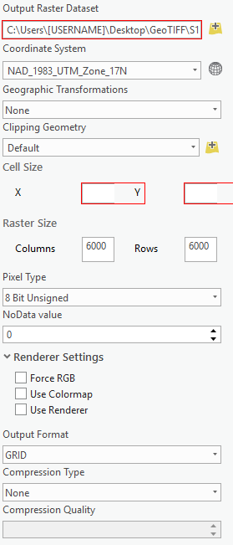
TIFF
Go to the Access database and change the GeoTIFF column with that book to the correct page number of the page that was Georeferenced. Also leave a comment in the Comment column if the plan was particularly difficult to georeference, explaining why the specific location was chosen.

Record work in Google Performance Tracking Sheet and MS Access DOT_Operator file. Leave a note if the page could not be georeferenced and mark time as N/A.

(6) QUALITY CONTROL & FILE RENAMING

Due to the complexity in the several previous processes, a special emphasis is placed on quality control and assurance to confirm that the technicians are providing the best possible product. The technician will check for accuracy and completion of the Database entry, file-name, image processing, PDF, and GeoTIFF. Upon completion, the technician will use the file renaming tool to rename the quality assured folder in the IncompleteBooks folder. Once renamed, it will be moved to the ProjectBookFolders folder. Technicians should not Quality Control their own work.

QUALITY CONTROL PROCEDURES

- Navigate to the IncompleteBooks folder on gistc-filesrv1 and choose a folder to QC
- Open the TIFF folder and check that all files are accounted for and have been image processed
- Open the PDF folder and open any PDF’s within the folder
- Check the PDF to make sure it contains the correct number of pages, all pages face the correct direction, and that no pages are askew
- Open the GeoTIFF folder and copy all files into your local GeoTIFF folder.
- Open ArcGIS Pro and the georeferencing project
- Drag the TIFF file into the Table of Contents
- Right click that layer and click on Zoom to Layer
- Check that the Georeferenced index page matches the area to which it is referenced
- After confirming that the georeference is correct and highlight the files that comprise the GeoTIFF. Ensure that the Georeference does not cover a large amount of a county/state.
- Verify that GeoTIFF files are compressed and zipped.
- Check to see if the Access column matches the Georeferenced page to create ease when uploading to the website
- Record work in Google Performance Tracking Sheet and MS Access DOT_Operator file
  - Performance Tracking Sheet: Red=fix QC, Green=last check through, White=done, Yellow=trouble with something
  - If during the QA\QC process something has not been done correctly, make a note of it and continue the process. Once the process is complete go back and correct any mistakes

FILE RENAMING TO PROJECT KEY

- Open File Explorer
- Click the Organize dropdown bar and choose ‘Folder and search options’
- Click the View tab
- In the Advanced settings box under Files and Folders check the ‘Always show icons, never thumbnails’ box
- Under Hidden files and folders check the box ‘Show hidden files, folders, or drives’
- Uncheck the “Hide protected operating system files (Recommended)’ box
- A Warning will pop up, click Yes
- Click Apply
- You will now be able to see the Thumbs icons within various folders (They may not always be present, however). In order to successfully rename a folder, you must delete all Thumbs.db files from the folder.
- Navigate to the gistc-filesrv1 and find the folder to be renamed
- Open the folder and delete the Thumbs from the ProjectBook folder, the TIFF folder, and the GeoTIFF folder. (The PDF folder will not contain a Thumbs file and there is not usually one inside the GeoTIFF)
- After deleting all the thumb files, navigate out of the folder to be renamed
- Open ArcGIS Pro
- In Access open the dbo_vw_ProjectKeyLookup
- In Arc, click “add folder” and connect to R:\DOT\wvDOT_planROW_scanning\Scripts
- Expand Pro_DOT_Tools.tbx to find the DOT File Rename for Pro Tool
- Open the File Rename Tool and type in the name of the folder to be renamed exactly as it appears on the gistc-filesrv1 in the Old Project Key box of the Rename Tool
- Copy the ProjectKey of the folder to be renamed from Access and paste it into the New Project Key box of the Rename Tool.
- Make sure the ProjectBook Structure box is checked
- Run the tool with the Validation only box checked
- If there are no issues with the validation, uncheck the box and run the rename tool
- After the file has been properly renamed, it must be relocated from the IncompleteBooks folder to the ProjectBooks folder (\\gistc-filesrv1\DOTProject\Scanning\ProjectBookFolders). 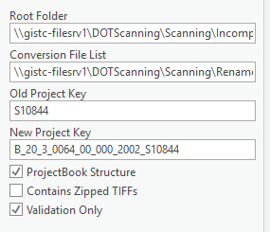
- Copy the correctly renamed book in the IncompleteBooks folder and paste it in the ProjectBookFolders folder.
- Delete the file from the IncompleteBooks folder.

Note: When running the rename tool, make sure you are outside the folders when in the project book. You can be inside the project book but not in TIFF, PDF, or GeoTIFF
• If there are any issues with the validation, address them and run the validation again

POSSIBLE ISSUES WITH RENAMING:

- Thumbs in the TIFF folder and GeoTIFF folder.
- Error and doesn’t rename Folder but Renames sub folder
  - Now that the folder has been renamed, copy and paste the folder from IncompleteBooks to ProjectBookFolders
- File type Suffix on the end of the of the compressed GeoTIFF folder
  - Be sure that the compressed zip in the GeoTIFF folder does not include any suffixes, such as .TIFF, .zip, .aux, or any other combination. These suffixes lead to error on the website’s download geoTIFF action.

(7) PUBLISHING (includes WEB QC & BACKUPS)

Highway Plans Locator website: www.mapwv.gov/DOTplans

The Highway Plans Locator website is one of the final products achieved in the West Virginia Division of Highways Scanning Project. This list details the process, steps, and scripts necessary to display the DOH plans on the highway plans locator website (www.mapwv.gov/DOTplans.php).
The files are organized in a geodatabase that houses several image and feature services to make data available to the webpage. This section of the Scanning Project Procedures will outline the use and function of the scripts and database layers that construct the web map service.
The final process to the WV Division of Highways Plan Scanning Project is uploading the TIFFs, PDF, and GeoTIFFs to the website. First, the PublishGeoTIFF.pyt script will run python to copy and replace GeoTIFF’s into a new folder that will be used to add scan rasters to the mosaic. Once relocated into a new folder and added to the mosaic, the technician will use the DOTFootprints.pyt tool to create footprints of the georeferenced image (corners of the image). Next, the footprint extents need to be copied into the dbo_Scanning table. This is done with the UpdateFootprintextents tool in ArcMap and will automatically update X and Y Min/Max fields in the dbo_scanning table. After this tool is finished, the technician must update the PublicationStatusID column in dbo_Scanning, which will publish the projectbook to the images in the ArcGIS Online Map.
It is important to note that publishing to the website now requires ArcMap 10.2. Adding raster’s to the mosaic will no longer work with previous versions.

DOT GEODATABASE OVERVIEW
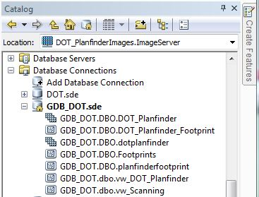
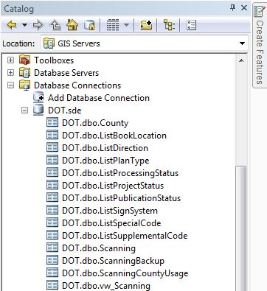
Mosaic used for image service
Feature class containing footprints
View that is published as the map service

The vw_DOT_Scanning view is used in ArcMap as the layer source for the Footprint map service. The DOT database, which stores scanning information and related lookup tables, is used on the website to provide this information to the user.
Since the Map Service and Image Service are fed from a SQL Server enterprise geodatabase (dbo_Scanning), it is not necessary to re-publish any services in order to add new scan rasters to the ArcGIS Services. All that is needed is to add them to the raster mosaic and update the footprint feature class.

PUBLISHING GEOTIFFS

The georeferenced TIFFs from each project book will be combined into raster mosaics in ArcGIS for easy viewing. To add scan rasters to the mosaic they first need to be placed in the appropriate folder, this is accomplished using the Publish GeoTIFF python tool in the R:\DOT\wvDOT_planROW_scanning\Scripts folder. Expand the tool named PublishGeoTIFF.pyt python tool.
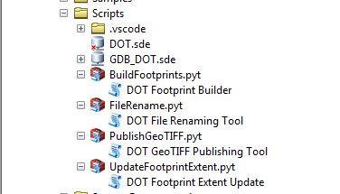
PublishGeoTIFF.pyt

Double-Click DOT GeoTIFF Publishing Tool to open the script, the following box will appear:

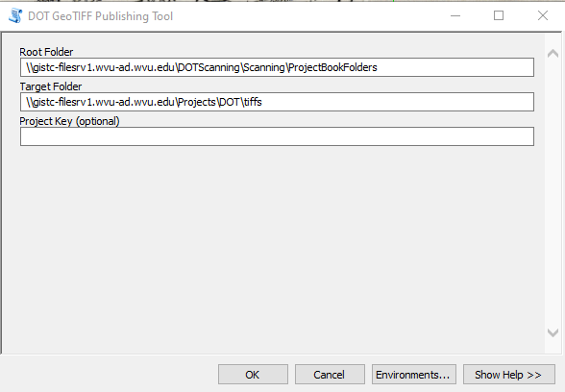

The Root Folder should be left as: ‘\\gistc-filesrv1\DOTProject\Scanning\ProjectBookFolders’
The target folder is: ‘\\gistc-filesrv1\Projects\DOT\tiffs’
Click OK and the Tool should run, this will place all the GeoTIFF folder contents from \\gistc-filesrv1 into \tiffs so that they can be added to the Mosaic dataset

ADD RASTERS

Next, add the rasters to the mosaic dataset. Right Click the feature dataset DBO_planfinder (GDB_DOT.sde\GDB_DOT.DBO.DOT_Planfinder) and select Add > Rasters. If you want to add an entire workspace filled with rasters, it is important to use a full UNC pathname so that the images can be accessed by the ArcGIS server
(\\gistc-filesrv1\Projects\DOT\wvDOT_planROW_scanning\Scripts\GDB_DOT.sde\GDB_DOT.DBO.DOT_Planfinder)
(\\gistc-filesrv1\Projects\DOT\tiffs).
Normally, when adding rasters to the mosaic, the “File” option should be selected in the “Input Data” section of the “Add Rasters” dialog. Each raster can be selected individually and added to the “Source” list.
Under the Advanced Options, the “Add New Datasets Only (optional)” drop down should be set to Exclude_Duplicates. Click OK.

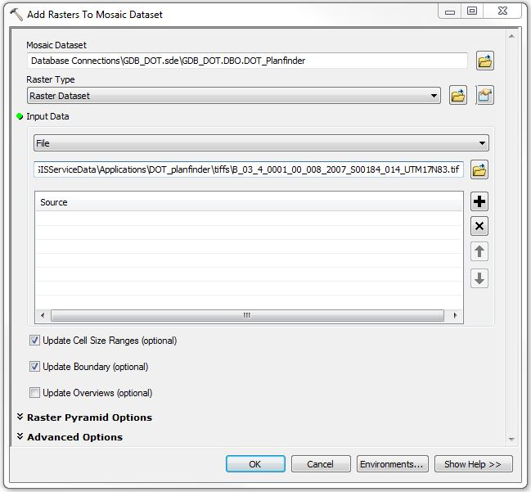

If needed, the mosaic can be loaded from scratch by selecting the Workspace option instead of Raster dataset under Input Data. The technician must enter the pathname of the TIFF folder.

BUILD FOOTPRINTS

When added to a data frame in ArcGIS, each raster mosaic contains three layers, one of which is called Footprint. This is a vector layer of rectangles drawn around the extent of each raster, and attributes for each raster are stored here in the attributes table.
So, after the rasters are added to the mosaic dataset, the Footprints of each geo-referenced image need to be created. This is done with the python tool (.pyt) DOT Footprint Builder found in the toolbox BuildFootprints.pyt in the following folder location R:\DOT\wvDOT_planROW_scanning\Scripts.

Open the tool and click OK. The tool should run and finish within 1-5 minutes for <2000 plans.
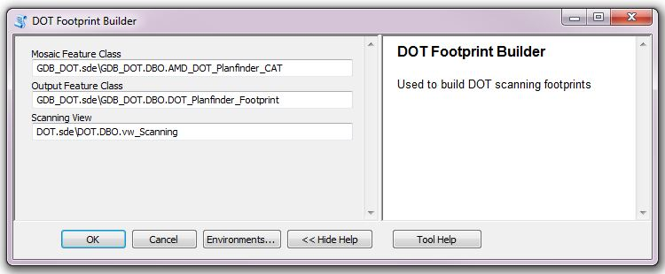

UPDATE FOOTPRINTS
Currently, the footprint layers from each of the mosaics get merged into a single, separate Footprints layer and stored in a file geodatabase. This provides a single attribute table for every raster in each mosaic, making it much easier to search for and view data relating to all the raster’s at once.
This process will call upon the Projectkey and the SheetNo. ProjectKey will contain the Project Key for each raster in the Footprints layer, and SheetNo will contain the sheet number as it appears appended to the Project Key in the filename of the raster (including the underscore). These two fields are used to create links in ArcGIS.com to our FTP server, and also facilitate joining the WV DOT Project Database to the Footprints attributes table.
The technician needs to copy the footprint extents into the dbo_Scanning table using the UpdateFootprintExtent.pyt toolbox and the associated DOT Footprint Extent Update script. It is important to note that the DOT Footprint Extent Update tool will only run on the plans that are specified in the Scan Order row, to update all Scan Orders, follow the directions in the tool and place a “*” in the Scan Order row. It is also necessary to check the “Update Database” checkbox at the bottom of the dialogue box in order to actually update footprint extents. If this box is left unchecked then the tool will function as a test and will not copy any information from the image service into the database.
Make sure to check this box
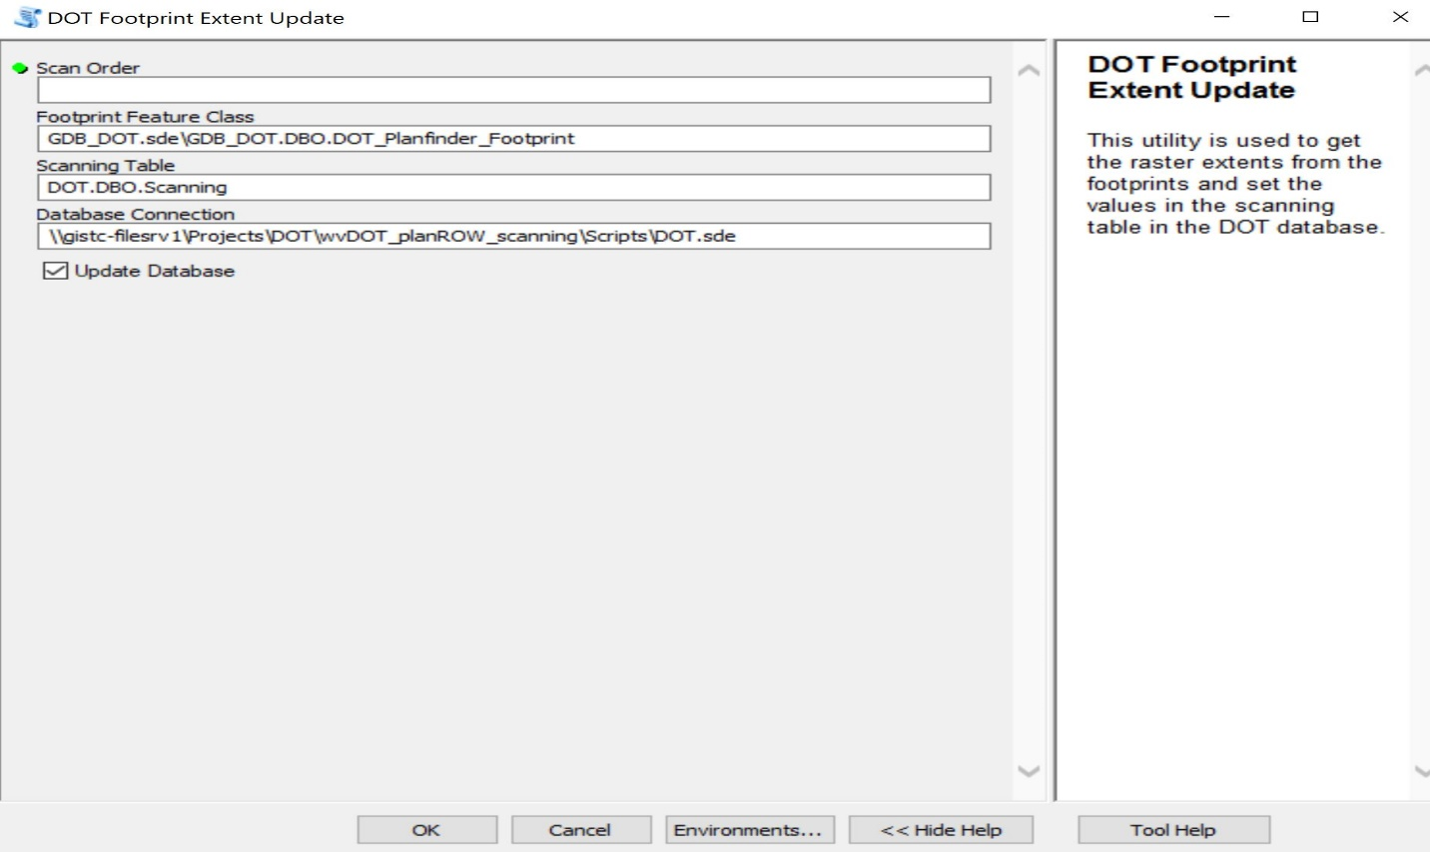
Click OK and the tool should populate the xy coordinates in the database.

PUBLICATION STATUS
The raster mosaics and the Footprints layer are currently being published as a GIS service in Arc, and then added to a map on the ArcGIS.com map viewer. This is mostly for demonstration purposes, but is also useful as a means of sharing the materials with WVDOT, tracking the project’s overall progress, and making it viewable in an interactive environment.
To publish the service, the user must have access to various server addresses on the WVGISTC network, which will likely require admin permission. The server addresses themselves are subject to occasional changes; verify which server the service should be published on before proceeding.
So, the final step is to update the PublicationStatusID column of the Scanning table to ‘2’ or if you are using the Access interface open the table and set the PublicationStatus to ‘Published’.
At this point you should be able to see the new footprints.

FINAL WEBSITE QC

After the Publication Status is changed to Published, all links on the website should working. However, there are a number of different scenarios that cause the links to fail. A final quality control is to be completed by the technician who has updated the website.
- Navigate to the website: http://mapwv.gov/DOTplans/
- Uncheck the “show first 100 matches only”
- Leave all fields blank and click search.
- Locate all project books uploaded with last publication.
- Click and check each of the four links for each project book.
- Note any errors that are found in the QC and refer to the Website troubleshooting for information regarding errors.
- Make any corrections and continue to Backup procedures.

WEBSITE TROUBLESHOOTING

- If the PDF works and the Globe does not
  - Look to see if book is named correctly:
    - Check to see if the book name matches to the dbo_vw_Projectkeylookup
    - Check to see if the Georef page number matches the column under dbo_scanning > GeoTIFFs (this can only have 3 characters)
  - A folder issue:
    - Go to the GeoTIFF folder within the problem book and check to see if the zipped file folder is within another folder. Removed zipped folder and place it inside GeoTIFF folder.
- If the PDF does not work and the Globe is not there:
  - Check to see if the Georef page number matches the column under dbo_scanning > GeoTIFFs (this can only have 3 characters)
- If the download TIFFs (scenic portrait button) do not work:
  - Check geoTIFF file-pathname. Make sure that the folder does not include the ending “. aux.zip”
- If footprints display but raster mosaic does not appear:
  - Clear TIFFs folder on externaldatasrv and remove rasters from GDB_DOT.sde
  - Complete the Website Upload Procedures.
Important: To get rid of duplicate book numbers when uploading to the website go to the externaldatasrv and delete the folder TIFFs. When adding rasters, go to advanced settings in the dialog box and check “exclude duplicates”.
Record work in Google Performance Tracking Sheet and MS Access dbo_ScanningActivity

BACKUP PROCEDURES

EXTERNAL DRIVE
The external drive is to be backed up weekly by one technician at the end of the work week. After being backed up, a transmittal sheet should be updated and saved to the external drive DOT Scanning folder, which records the date of backup, project books included, and the amount of storage used. The transmittal sheet can be found on the external drive being used to back up the scan data.
Automatic Backups are now being conducted daily, with the SyncBack program installed on the “Preston” computer. The “DOT Scanning Auto” schedule is set to run at 1:00am every night and copies all project books onto the DOT Backup A folder. As these are updated daily, it is important to remember to update the transmittal sheet weekly.

INTERNAL SERVERS
The internal backup server is to be updated at the conclusion of the final website quality control to insure that all edits are contained in the back up. The technician completing this quality control will copy all published project books from the ProjectBooks folder to the DOTBackup (\\gistc-filesrv1\DOTBackup)

DIGITAL PLAN PROCEDURES

In the event of digital plan submissions of previously scanned images from WV DOH District offices, technicians will follow the procedures as outlined below. This methodology is subject to change as digital plan submission formats and procedures change. The following work tasks may be affected by digital submissions:

    - File Naming
    - Image Processing
    - PDF Creation
    - Georeference Plan Index Map Sheets
    - Quality Control/Quality Assurance
    - Publishing Web Map

APPENDIX A: Page Number FAQ

Page Numbering FAQ
The following Q&A’s are examples of page numbering questions/inconsistencies that have arisen during the course of the scanning project. New questions are added to the document as problems are discovered, and answers are added as they are received.
Q: Pages are arranged out of order.
A: Rearrange the pages by the official page number as seen on the sheet. If there are pages from different projects within the same book which are numbered by a different system/sequence, retain the order in which those pages were physically found when creating the PDF document, as they were likely placed in that order intentionally by WV DOT.

Q: Two pages with different content, but same page number.
A: They might be from different projects. If so, retain the order in which they were found, keeping the same file name and adding a letter after the page number (starting with A) for every sheet with the repeating page number. Make a note in the project database; be sure to specify which project the page in question is from if it is from a different project.
There is also a chance the pages were miss-numbered. Example: 17, 18, 20, 20… In a case like that, correct the page numbers in the file name (in the example, you would change the first 20 into 19), retaining the order in which the pages were found.

Q: Some pages are marked as deleted with a large X crossing the entire page and text that reads “This sheet deleted, see page 81A” or the like. In this example, there was a page 81, then another page 81 that was marked as deleted and referred to page 81A.
A: The deleted page does not need to be scanned (according to WVDOT), though it may be wise to scan it anyway and add an “X” suffix to the page number. Make a note of it in the database either way.

Q: Some sheets have no visible page number.
A: Give them one for now, according to the sequence in which they were discovered. If the previous page was 0017, name the ones without a number 0017A, 0017B, etc. Keep them in the order they were discovered when creating the PDF document. Make a note in the comments field of the database describing how they were numbered.

Q: One project book can contain sheets from multiple projects. EXAMPLE: Project 32, starting on the second page it switches to a different project in a different county for 37 pages before switching back to the original project listed on the cover sheet, beginning with page #2. Another EXAMPLE: Project 17 has two pages appended to the end from unrelated projects. Another EXAMPLE: Project 33 , page 52 (there are two of them) is a seemingly random page from some unrelated project. How should we handle examples like these? Separate them? Keep them in the same folder and number them as they appear?
A: Those pages were usually put in there by WV DOT staff for a reason, so be sure they are arranged in the PDF as they were discovered. As for naming the TIFFs, they are permitted to have an entirely different key based on the project they come from and still remain inside the project folder in which they were found. This will arrange the files out of sequence in the TIFFs folder, but it will be ok as long as the correct order is maintained in the PDF, and a descriptive note is written in the comments field of the database.

Q: Pages repeat, but with some revisions.
A: The original un-revised page does not need to be scanned (according to WVDOT), and the revised page should get the original page number. It may be wise to scan the un-revised page anyway and give it a unique page number (add a letter to the page number) that should be noted in the comments field of the database. In some cases the revised page has a unique page number already visible on the sheet, usually just adding a letter to the sheet number. If so, use those numbers in the file name.

Q: The 25th project we scanned was the second part of the 32nd project we scanned. Shall we put them both in the same folder and make one PDF out of them? Or keep them separated as they are physically and give them different names?
A: Combine them. Make a note in the comments field describing which pages were found physically separated.

Q: An “addendum” sheet was discovered within a project. It is much smaller than the other sheets, and has no page number aside from “Addendum B” or some such.
A: Scan it and give it the page number ADDN, and add an additional letter to the page number as necessary if there is more than one ADDN, or if the page says something like “Addendum B” as in the example above.

Q: Project 37 is the soil profile for project 36, but has a different fiscal year and pages number 1-20. Keep separate, or combine files into one folder?
A: Combine them, giving the files different names within the folder to reflect the difference in fiscal year, and make a note in the database.

APPENDIX B: Image Processing Checklist

- Import Image Processing into Photoshop
- Open the Actions window
- Window>Actions
- Or shortcut Alt+F9
- Click the drop down menu located in upper right corner. Click “Load Actions…”
- Retrieve Actions from the following folder: R:\userFiles\Aaron\DOT\IP\Scanning
- Import TIFFs into Photoshop (PS)
- Open correct folder with scanned TIFFs in windows explorer
- Change view of TIF files to Large Icons using drop-down in upper right corner
- Select first row of images and press enter
- Crop
- In PS use crop tool to crop along all edges of scan to remove excess white space
- DO NOT crop any writing or printed info along borders of scan
- If sheet was scanned slanted, then some white space will show after being cropped
- Ctrl+z will undo any crop you make but will only work once (try it twice and you’ll see what happens)
- Take Advantage of CropContrast Shortcut
- Refer to page 17 for instructions on creating the CropContrast droplet.

- Save-n-Close Each Tab (Ctrl+s; Ctrl+w)
NOTE: Check to see if every scan has been processed correctly row by row in scan folder. Do this by looking for any scan that hasn’t been cropped via large icons. PS has tendency to not import every scan you select so always check.

APPENDIX C: Image Processing Keyboard Shortcuts

The following shortcuts can be used in Adobe Photoshop for Image Processing:

Shortcut | Action
Ctrl + C | Copy
Ctrl + V | Paste
Ctrl + X | Cut
Ctrl + S | Save
Ctrl + Zero | Zooms to Page Extent
Z | Switches to Zoom Mode
C | Switches to Crop Mode
Ctrl + Tab | Go to Next Image
Ctrl + Alt + Shift + L | Auto Contrast
Ctrl + Alt + Z | Undo Droplet Action
HOLD Ctrl | (While in Crop Mode) Use Straighten Tool
Ctrl + Z | Undo
Ctrl + Plus | Zoom in
Ctrl + Minus | Zoom out
Ctrl + L | Opens Levels Menu

Additional shortcuts may be created using the Keyboard Shortcuts menu in Photoshop (Edit<Keyboard Shortcuts… or Alt + Shift + Ctrl + K)

APPENDIX D: Planfinder Python Scripts Documentation

The DOT Project Plan Scanning system is designed around an operational database used for recording scanning activity and an enterprise geodatabase used to support web mapping and image services. The system takes advantage of the multi-user capability of Microsoft SQL Server 2012, allowing scanning information to be recorded in real-time and new scans to be published as they are created. Detailed information is recorded related to each step of the scanning process so that production performance can be monitored and metrics can be established for scheduling and cost analysis. In addition, the use of an enterprise geodatabase streamlines the process of updating the ArcGIS feature and image services by eliminating the need to re-publish an entire ArcGIS geodatabase in order for updates to be made available on the web.
The ArcMap project used for feature and image service publication is named DOT.mxd. This project defines the related feature classes, raster mosaic, and database tables. It also defines the standard symbology and related database connection information. This ArcMap project is stored on a production file server in the WV GIS Technical Center and is backed up on automated schedule (Figure 1).
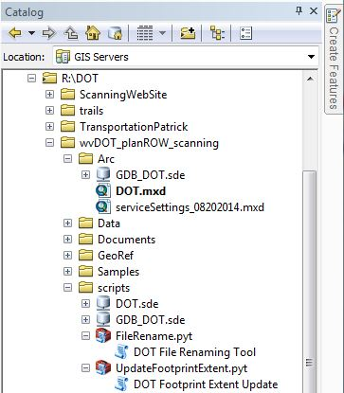
Figure 1: ArcMap / ArcCatalog Listing of the Arc Project and related toolbox items

The supporting ArcGIS enterprise geodatabase contains three primary objects: 1) a raster mosaic used as the source for the ArcGIS image service, 2) a feature class representing map foot prints of each scanned construction plan, and 3) a database view that is used as the underlying source for the published plans and for the web based query interface. These can be seen in the following screenshot taken from the ArcMap Catalog interface (Figure 2).
Mosaic used for image service
Feature class containing footprints
View that is published as the map service
Figure 2: DOT enterprise geodatabase structure.

The vw_DOT_Planfinder view is used in ArcMap as the layer source for the Footprint map service. This view links the ArcGIS feature class inform to the operational scanning data. The view is defined as follows:
vw_DOT_Planfinder view definition in ArcMap:
CREATE VIEW vw_DOT_Planfinder AS
SELECT OBJECTID
,Name
,[Shape]
, Scanning.*
FROM GDB_DOT.dbo.DOT_Planfinder_Footprint
JOIN DOT.dbo.vw_Scanning AS Scanning
ON Scanning.ScanOrder = DOT_Planfinder_Footprint.ScanOrder

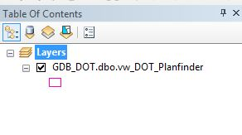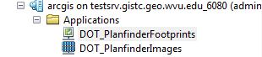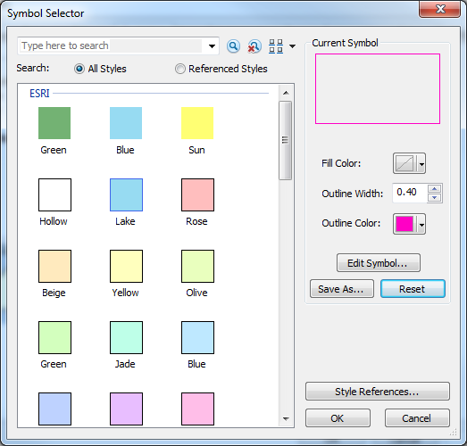
Figure 3: Feature service symbology and ArcGIS hosted services

The structure of the DOT database used to store scanning information and related lookup tables can be viewed from within ArcMap or Arc Catalog. All administration for this database is performed using Microsoft SQL Server Management Studio. Backup plans are defined from within the management interface and scheduled backups are run using the SQL Server Agent process.
Figure 4: DOT Database table listing

Since the Map Service and Image Service are fed from a SQL Server enterprise geodatabase, it is not necessary to re-publish any ArcGIS services in order to add new scan rasters. All that is needed is to add the new images to the raster mosaic and update the footprint feature class. To add scan rasters to the mosaic they first need to be placed in the folder ‘\\ExternalDatasrv\GISServiceData\Application\DOT_Planfinder\TIFFS’. This is accomplished using the Python tool “PublishGeoTIFF.pyt”. This tool extracts the GeoTIFFs from the zipped versions in the individual project book folders that are created during the scanning process. These zipped images are located under “\\gistc-filesrv1\DOTProject\Scanning\ProjectBookFolders”. The tool can process a single project book folder or optionally all folders. If a Project Key value is specified, then only the corresponding GeoTIFF will be published. If the Project Key value is left blank, then the GeoTIFF files for all projects will be extracted to the production folder.
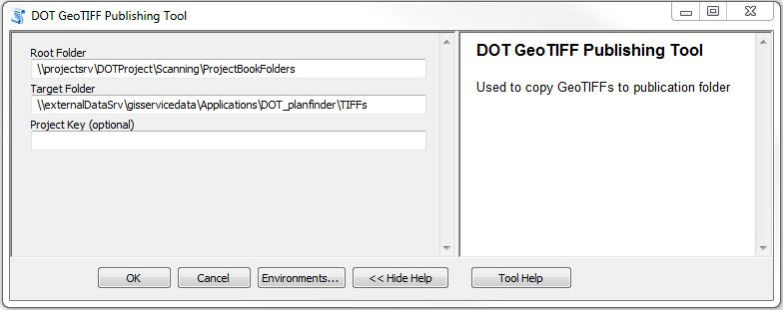
Figure 5: PublishGeoTIFF.pyt user interface

It is important to use a full UNC pathname so that the images can be accessed by the ArcGIS server. Normally when adding rasters to the mosaic, the ‘File’ option should be selected in the ‘Input Data’ section of the ‘Add Rasters’ dialog. Each raster can be selected individually and added to the ‘Source’ list.
If needed, the mosaic can be loaded from scratch by selecting the Workspace option as shown below and entering the pathname of the TIFF folder.
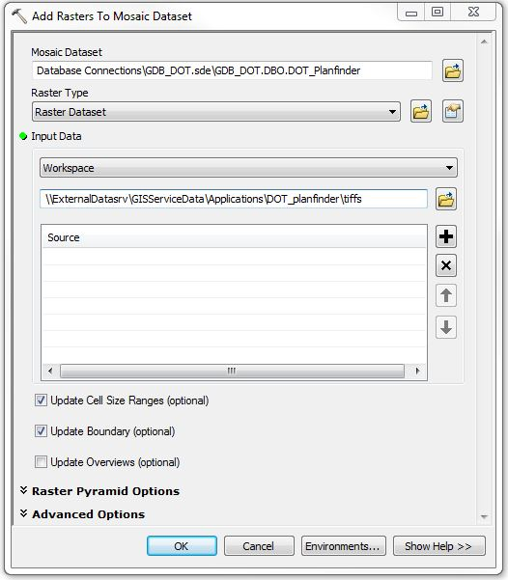
Once the new rasters have been added to the mosic, their footprints are built using the Python tool “BuildFooprints.pyt”. This tool removes all existing footprints then rebuilds the feature class by scanning the rasters and generating new features. The default location for the raster data is “GDB_DOT.sde\GDB_DOT.DBO.AMD_DOT_Planfinder_CAT” and the target footprint feature class is “GDB_DOT.sde\GDB_DOT.DBO.DOT_Planfinder_Footprint”.
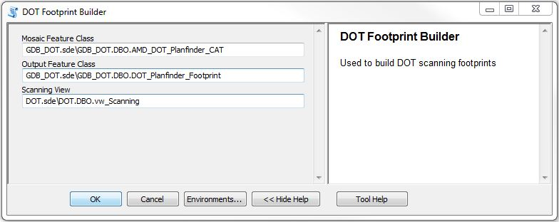
Figure 6: PublishGeoTIFF.pyt user interface

At this point, the footprints and images for all scanning table entries that have their Publication Status set appropriately will be searchable in the web query interface and visible in the ArcGIS Online map.

APPENDIX E: Entering a New Book into the Access Database

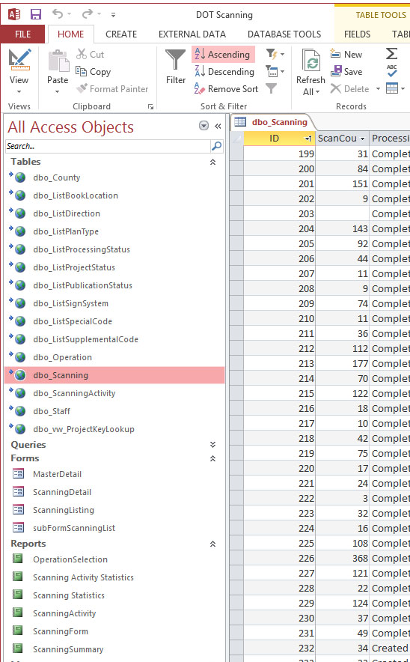
Before a book can be scanned its information needs to be entered into the DOT Access database. The Access file can be found in R:\DOT\wvDOT_planROW_scanning\DOT.accdb.
First, gather the transmittal sheet that is within the new book. Leave the book open, as there is some information that will need to be retrieved from the sheets.
Open DOT.accdb and click on dbo_Scanning under Tables on the left hand side.
This is where you will enter the information from the transmittal sheet.
If necessary right click the “ID” column and click sort by smallest to largest. Scroll to the last record (or hit skip to last record at the bottom). The “ID” column corresponds with the “S00000” number assigned to every book. The new book you are entering in will always be the next number in order.
Write this number in the top right section of the transmittal sheet, labeled “Scan Order Number.”
Now we will begin filling in the columns for this entry. Each column corresponds with information either on the transmittal sheet or the plan sheet itself (some columns are left blank until a later time).
In the following pictures I have illustrated for you where the information for each column in the database can be found in the transmittal sheet or the plans. (I have minimized the columns you will not be entering the information in for at this time). Each large bold number I have placed on the database matches the corresponding information on the transmittal and plans:

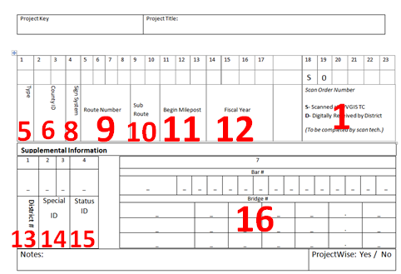
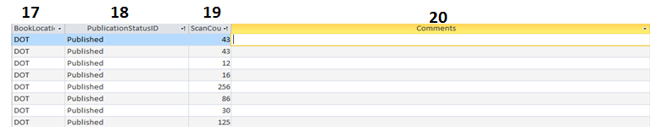
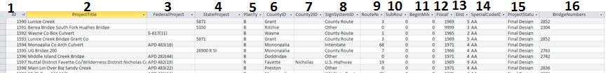

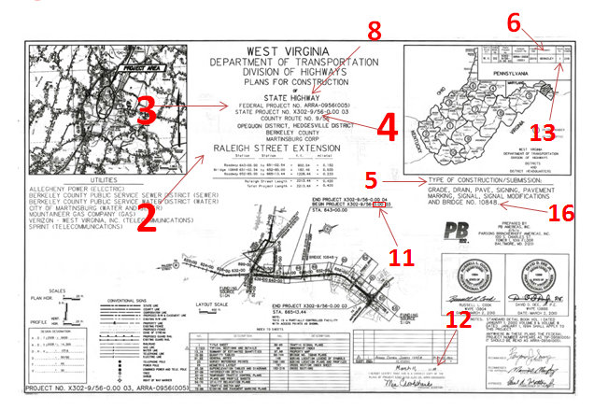
Most of these are self-explanatory, some require more explaining:
- 1 or “ID” – you do not have to type the ID number in, it will be automatically recorded
- 6 or “County2ID” – this would be used if the plans went through two counties
- 8 or “Sign SystemID” – corresponds like so:
  - 0 = Municipal Non-State
  - 1 = Interstate
  - 2 = U.S. Highway
  - 3 = WV State Route
  - 4 = County Route
  - 5 = N/A
  - 6 = State Parks and Forest
  - 7 = FANS
  - 8 = HARP
  - 9 = US Forest Road
  - 10 = WV State Rail Authority
  - 11 = Trails
  - 12 = Other
- 13 or “BookLocation” – refers to the physical location of the book at this time
- 14 or “Coments” – extra information, often not needed
- 15 or “SupplementalCodeID” – if this is 0 on the transmittal sheet select “Not Applicable” on the database
- 16 or “DirectionID” – if this is 0 on the transmittal sheet select “Unspecified”
- 18 or “ProjectStatusID” –
  - 1 = Initial Design
  - 2 = Preliminary Design
  - 3 = Final Design
- 20 or “BridgeNumbers” – enter bridge # listed on the transmittal sheet, if there are multiple bridge #s separate them with commas.

APPENDIX F: Procedures Outline

7/29/2016
- Book Preparation & File Naming
  - Receive Project Book(s) from WVDOT
    - Transmittal sheet provided by WV DOT
      - Denote if plan is located in ProjectWise
    - Project Key provided by WVDOT
    - Scan Order # designated by WVGISTC
    - Remove clips/tape/staples from sheets
    - Rearrange pages in proper sequence if necessary.
    - Review page number suffixes
    - Enter Project Book information into dbo_Scanning sheet in MS Access
    - Information found on Project Book cover sheet
    - Project Key found on transmittal sheet
    - Create project folder on scanning machines to contain scanned images:
    - Name project folder with Scan Order #

File Naming
  - File Naming
    - Designate Scan Order # on Project Key/Transmittal Sheet
    - Pull information from Project Key/Transmittal Sheet and Book to add to the DOT Scanning Database
      - Includes:
        - Processing Status
        - Publication Status
        - Project Title
        - Federal Project
        - State Project
        - County ID
        - County 2 ID
        - District
        - Sign System ID
        - Route Number
        - Sub Route Number
        - Fiscal Year
        - Sheet Count
        - Plan Type
        - Scan Date
        - Book Location
        - Comments
        - Supplemental Code ID
        - Direction ID
        - Begin Mile
        - Project Status
        - Special Code ID
        - Special ID
        - Bridge Number
        - URN (Uniform Resource Name) for ProjectWISE

- Scan Document
  - Scanner Settings:
    - Size – Full auto size
    - Auto BW points – Off
    - Color Mode – 256 Colors – auto palette
    - Resolution – 300
    - Quality – 1
    - File type – TIFF LZW
    - Folder – C:\DOT\Imagery\Original Scans\ScanOrder#
        - Change Settings to Manual Width (480) Auto Length
          - 22x34 = S#####
          - 12x18 = S#####
  - Configure scanner with Scan Order #, page number, and output location
    - Files are named by the DOH established naming convention
      - ScanOrder-PageNumber.TIF
      - Verify page number accuracy
      - Save scans in folder named with Scan Order #/TIFF
  - Scan sheets
    - Wipe each page cleanly with a disposable microfiber cloth in a downward/consistent direction to not spread dirt on sheet
    - Check each page for number changes or additional suffixes (generally letters)
    - Use the document protector in a case of sheets being dirty, excessively waxy or sticky, torn, brittle or any other reason it can’t be scanned like regular sheet
  - Scanner Maintenance: Clean Scanner daily or sooner when necessary and recalibrate scanner when necessary/weekly
  - Re-bind\replace all sheets as it was received
    - Place transmittal sheet and colored paper on top of project within prong fasteners
  - Update dbo_ScanningActivity Tracking Database in MS Access:
    - Book Number
    - Date of Action
    - Technician performing action
    - Action taken
    - Time worked on Action (minutes)
    - Quantity completed (sheets)
    - Sheet Count (finished book)
    - Scan Count (finished book)
    - Additional Comments
  - Complete this process after every completed action or before the end of shift
  - Project Book is now ready to return to WVDOT

- Image processing
  - Create Photoshop droplets for image adjustment and crop automation
  - Image Process project book folders
i) Save a copy of the incomplete book onto desktop with file name “TIFF”
ii) Drag “TIFF” through droplets
ii) Check each image and crop by hand when necessary

- PDF Creation
  - Create an action in Adobe Acrobat Pro
Action Procedure:
i) Reduce File Size
ii) Run Recognize Text (using OCR) Tool
ii) Name action “DOT PDF”
  - Run action “DOT PDF”
  - Check PDF for rotation errors resulting from Text Recognition tool and make necessary corrections.
i) Every page that has an error needs to be corrected individually without using the Text Recognition Tool by:
A) Creating a new, single page PDF
B) Reduce file size
C) Save PDF
D) Replace original page with the corrected page from the new PDF
  - Save in ProjectBookFolder/PDF
    - Naming Convention: ProjectKey.pdf

- Georeference Plan Index Map Sheets
  - Estimate 1 map sheet per project book (cover sheet)
  - Prepare TIFF for geo-referencing
    - Save a copy of TIFF to a “GEOTIFF” folder on local drive for georeferencing
    - Crop out all whitespace/margin
    - Adjust image format for Web Map Index compatibility
      - Must be in 8-bit, Indexed Color mode
      - Brighten TIFF if necessary (no pixels below RGB=’10,10,10’)
      - Create custom color index with index value ‘0’ set to black (RGB=’0,0,0’)
    - If converting to MrSID format:
      - Adjust color levels to add minor color data to TIFF if necessary
  - Georeference TIFF
    - When rectifying, set NoData as ‘0’ to set background transparency
  - Name georeferenced images according to DOT naming conventions
    - Naming conventions: ProjectKey_PageNumber_UTM17N83.tif
    - Save in local “GEOTIFF” folder
    - Paste in: ProjectBookFolder/ProjectKey/GeoTIFF
  - Update Tracking Database’s Georeferencing sheet
    - Scan order number
    - Page number
    - Amount of time to georeference
    - RMS error
    - Technician initials
    - Date
    - Additional notes
  - Enter information into dbo_ScanningActivity sheet in MS Access

- Quality Control/Quality Assurance: Procedures for each Project Book
  - Accuracy/completion of Project Database entry.
  - File-name accuracy
  - Completion/quality of image processing
  - Completion/accuracy/quality of PDF
  - Completion/accuracy of GeoTIFF
  - File renaming and editing with FileRename.pyt
    - Subfolders:
      - TIFF
      - PDF
      - GeoTIFF
  - Update Tracking Database’s QC Checklist sheet (for beginners)
  - Back-up all files onto project server FTP drive and external drive (limited personnel)
  - Update Plan location in dbo_Scanning via MS Access

- Publishing Web Map
  - PublishGeoTIFF.pyt run python tool to copy and replace GeoTIFFs
  - Add rasters to Mosaic Dataset
  - Attributes
    - Esri GIS attributes automatically created in DOT.mxd file
    - Pre-defined attributes in raster mosaic image-service
      - PDF link
      - Link to Project folder for access to all related files
      - Link to zipped GeoTIFF download
  - Execute scripts to update Web Application query and Map
    - Publish GeoTIFFs Procedure: PublishGeoTIFFs.pyt
    - Add Rasters to Mosaic Footprint creation: BuildFootprints.pyt
    - Update Footprints in dbo_Scanning MS Access: UpdateFootprints.pyt
  - Switch PublicationStatus field in dbo_Scanning to Published
  - All uploaded plans should appear on the web application <mapwv.gov/dotplans/index.php>
  - Digital Plan Submission
    - In the event of digital plan submissions of previously scanned images from WV DOH District offices, technicians will follow the procedures as outlined below. This methodology is subject to change as digital plan submission formats and procedures change.
      - File Naming
      - Image Processing
      - PDF Creation
      - Georeference Plan Index Map Sheets
      - Quality Control/Quality Assurance
      - Publishing Web Map
  - Final Website Quality Control
      - Locate all project books uploaded in the last publication.
      - Click and check each of the four links for each project book.
      - Note any errors that are found in the QC and refer to the Website troubleshooting for information regarding errors.
      - Make any corrections and continue to Backup procedures.
  - Back Up Procedures
      - External Drive (Weekly) limited access
        - Select new Project books from the R: drive
        - Copy and Paste books to WVDOT_Scans_B
        - Update Transmittal
      - Internal Servers (conclusion of website QC)
        - Select all project books
      - Copy and paste into \\gistc-filesrv1\BACKUP.

Major Procedural Tasks associated with Hardware, Software, Management Documents
Processing Task | Hardware | Software | Management Documents
Book Preparation & File Naming | Scanning Computers | File Explorer | dbo_scanning
Scan Document | Scanning Computers |  | GS_performance_tracking  dbo_scanningActivity
Image Processing | Local Workstations | Adobe PhotoShop  PDFbatch.sequ  AutoCrop.atn | GS_performance_tracking  dbo_scanningActivity  dbo_scanning
GeoReference | Local Workstation  Gistc-filesrv1 | ArcGIS  Google Maps | GS_performance_tracking  dbo_scanningActivity
QA/QC | Local Workstation  External Drive  Gistc-filesrv1  External Server | FileRename.pyt | GS_performance_tracking  dbo_scanningActivity  dbo_scanning
Publishing & Web QC |  | PublishGeoTIFF.pyt  BuildFootprints.pyt  UpdateFootprints.pyt | dbo_scanning  dbo_scanningActivity

APPENDIX G: Transmittal Sheet

Project Key | Project Title:

1 | 2 | 3 | 4 | 5 | 6 | 7 | 8 | 9 | 10 | 11 | 12 | 13 | 14 | 15 | 16 | 17 |  | 18 | 19 | 20 | 21 | 22 | 23
Type | County ID |  | Sign System | Route Number |  |  |  | Sub Route |  | Begin Milepost |  |  |  | Fiscal Year |  |  |  | Scan Order Number  S- Scanned at WVGIS TC  D- Digitally Received by District  (To be completed by scan tech.)
1 | 4 | 5 | 6 | 7 | 8
_ | _ | _ | _ | _ | _
District # | Special  ID |  | Status ID | Supplemental Code
Supplemental Information
9
Bar #
_ | _ | _ |  | _ | _ |  | _ | _ |  | _ | _ |  | _ | _ |  | _ | _ | _ |  | _
Bridge #
_ |  |  | _ |  |  | _ |  |  | _ |  |  | _ |  |  | . |  |  |  | _
_ |  |  | _ |  |  | _ |  |  | _ |  |  | _ |  |  | . |  |  |  | _
_ |  |  | _ |  |  | _ |  |  | _ |  |  | _ |  |  | . |  |  |  | _
Notes: | ProjectWise: Y / N

