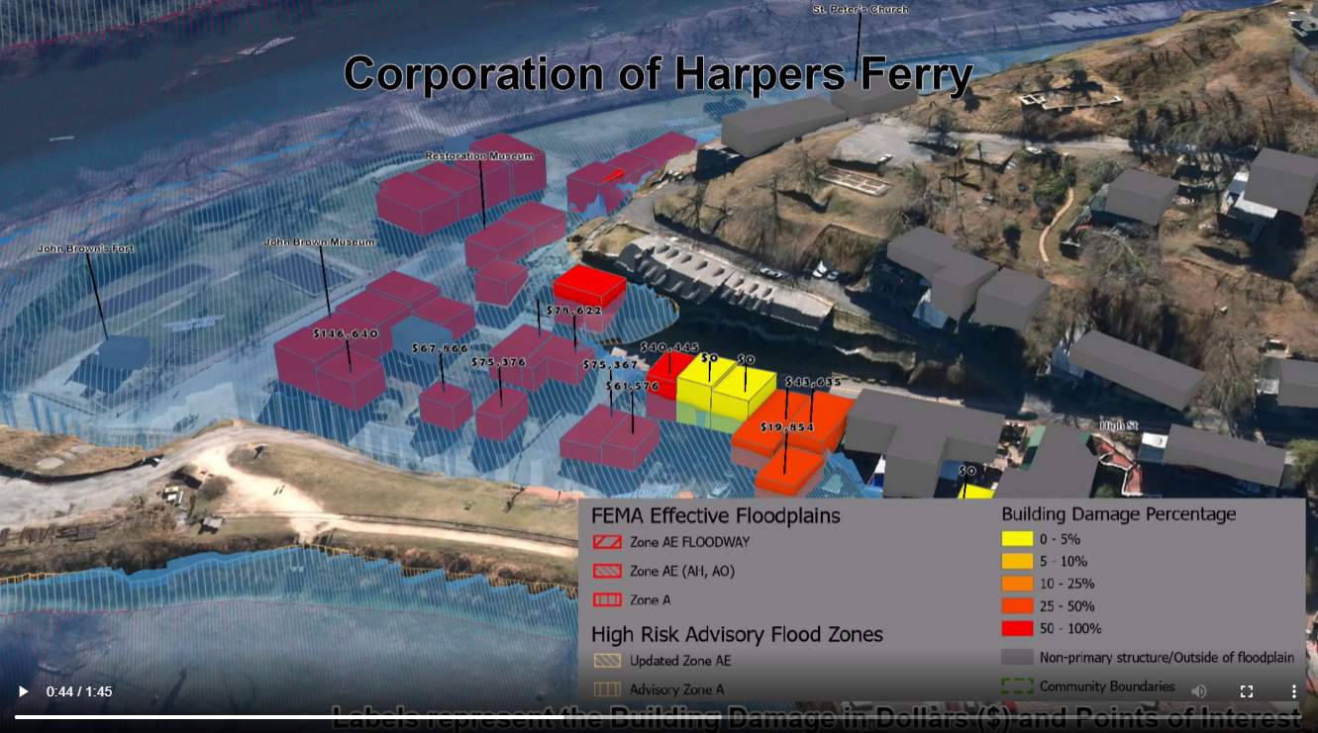
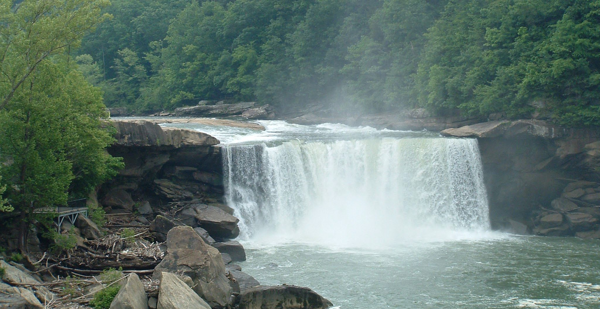


WV Emergency Management Division
COOPERATING TECHNICAL PARTNERS (CTP)
FEMA-APPROVED COMMUNITY OUTREACH AND MITIGATION STRATEGIES (COMS)
STATEMENT OF WORK (SOW)
COMS SOW No. 1

Fiscal Year 2022

This page intentionally left blank

Table of Contents
1. Part 1 – Custom Statement of Work (SOW) Information 1
1.1. Project and Point of Contact Information 1
1.2. Tasks and Deliverables to be Completed Under this SOW 2
1.3. Schedule and Performance 6
1.4. Standards 8
1.5. Use of Contractors 9
1.6. Reporting and Performance 9
1.7. Privacy and Protection of Personally Identifiable Information 10
Authorized Representative Signatures 11
APPENDIX A: Detailed Scope of COMS Activities A-1

Part 1 – Custom Statement of Work (SOW) Information

Project and Point of Contact Information

Table 1. Project and Point of Contact Information

Information Type | Insert Information
CTP Organization Name: | WV Emergency Management Division
CTP Contractor Working on the activities in this SOW:  Optional, only if contractors have already been identified; contractor support may be used for all activities except Staffing and Mentoring, which must be completed by the CTP | WVU GIS Technical Center, West Virginia University
CTP Partnership Agreement Date: | 7/2022
Period of Performance: | 10/1/2022 to 9/30/2023
CTP Project Manager: | Timothy W. Keaton, CFM
FEMA Regional Project Officer (PO):  When necessary, additional FEMA assistance should be requested through the FEMA Regional Project Officer | Robert Pierson, PMP  FEMA Region III
FEMA Funding to Complete this COMS SOW: | $100,000

Information Type Insert Information
CTP Estimated Leverage: | N/A
Project Team Coordination Activities:  Throughout the project, all members of the Project Team will coordinate, as needed, to ensure that activities, products, and deliverables meet FEMA requirements and contain accurate, up-to-date information. | - Meetings, teleconferences, and video conferences with FEMA Region III, WVEMD, and other Project Team members biannually at a minimum with additional meetings scheduled as necessary.  - Telephone conversations with FEMA and other Project Team members on a scheduled monthly basis and ad hoc basis, as required  - Email as needed

Tasks and Deliverables to be Completed Under this SOW

NARRATIVE AND AUDIENCE

Table 2. Narrative and Audience

Information Type | Insert Information
SOW Narrative: | This project focuses on three technical assistance activities in support of local and state hazard mitigation planning.  - Map riverine flood impacts of vulnerably disadvantaged communities with higher stream flow change forecast models.  - Update the WV Building Level Risk assessment (BLRA) from new data sources (e.g., flood studies, building characteristics) to enhance Hazus flood loss models and risk assessment products.  - Map landslide incidents from the new FEMA lidar for 38 counties. Correlate climate change (precipitation) to higher landslide incidents.  These activities advance community hazard mitigation actions through technical assistance that supports the Mitigation Planning Process and Risk MAP projects. See Appendix A for a more detailed statement of work.
Intended Audience: | Target Audience: Floodplain Managers, Community Planners, Emergency Preparedness Officials, and Citizens of affected communities.  Project Footprint: State of West Virginia

PROJECT TASKS AND DELIVERABLES
The following eleven tasks can be accomplished under this COMS SOW:
- COMS Engagement Plan (Required)
- Strategic Planning for Community Engagement
- Meetings and Process Facilitation
- Mitigation Support
- Communication and Outreach to Communities
- Training and Community Capability Development
- Mitigation Planning Technical Assistance
- Pilot Projects
- Internal Partner Support Activities:

These tasks and their associated deliverables are in listed in the sections below.

Task 1 – COMS Engagement Plan (Required)

Table 3. Task 1 – COMS Engagement Plan

COMS Task | Mark ‘X” if task will be done under this SOW | (A) FEMA Contribution | (B) Partner Contribution |  | (A+B) Total Project Cost
COMS Engagement Plan (required as a condition of COMS funding) (see Part 2.1) | ☒ | $0 | $0 |  | $0
Deliverable |  |  |  | Mark “X” if deliverable will be done under this task
COMS Engagement Plan (required) |  |  |  | ☒
Combined COMS Engagement and Business Plan |  |  |  | ☒
Other: {Insert additional details} |  |  |  | ☐
Custom Scope Elements
A comprehensive Business Plan will be a single deliverable for both the Community Outreach and Mitigation Strategies (COMS) Engagement Plan and PM Business Plan. Plan cost covered in PM Statement of Work.

Task 7 – Mitigation Planning Technical Assistance

Table 9. Task 7 – Mitigation Planning Technical Assistance

COMS Task | Mark ‘X” if task will be done under this SOW | (A) FEMA Contribution | (B) Partner Contribution |  | (A+B) Total Project Cost
Mitigation Planning Technical Assistance (see Part 2.7) | ☒ | $100,000 | $0 |  | $100,000
Deliverable |  |  |  | Mark “X” if deliverable will be done under this task
Copies of all technical data provided to local, state, and tribal communities |  |  |  | ☒
A report detailing the technical assistance provided, including date(s) of technical assistance, type of assistance and communities stakeholders supported |  |  |  | ☒
Other: {Insert additional details} |  |  |  | ☐
Custom Scope Elements
Special Project 1. Cost $50,000.
Map Riverine Flood Impacts of Vulnerably Disadvantaged Communities with Higher Stream Flow Change Forecast Models.
- USACE forecast models predict higher stream flows in the future for central and southern West Virginia. In addition to forecasted higher stream flows, many of the disadvantaged communities in this region have a moderate to high Social Vulnerability Index. Small, incorporated communities in which large tracts of the community are in the Special Flood Hazard Area are especially vulnerable to climate change riverine flood impacts. Many of the vulnerable communities were established in the early-20th century along narrow river valleys and steep mountainsides during the boom of coal mining and timbering extraction industries. Specifically, this project will map the riverine flood impacts of vulnerably disadvantaged communities facing higher stream flow change forecast models. The targeted five disadvantaged communities (Clendenin, Rainelle, White Sulphur Springs, Camden-on-Gauley, and Richwood) incorporate the new 2016 flood studies recently published by FEMA. All five disadvantaged communities had a negative population growth rate between the 2010 and 2020 censuses. Both 2D and 3D maps will show changes in the floodplain forecast models and substantial damage impact on the built environment, including critical facilities, for the following scenarios: (1) Base Flood, (2) 500-YR Flood, and (3) Climate Change Flood Model. For climate change scenarios, both FEMA flood map BFE plus constant (2’ and 3’ values) and the First Street Foundation climate model will be incorporated. This activity will also incorporate the largest flood disaster mitigated reconstruction dataset in the State to date since the devastating April 1977 flood of the Tug Fork Basin in which the USACE Section 202 Mitigation Program was established in 1981. Primary objectives of this project are to communicate the flood risk facing these disadvantaged communities based on current and future climate changing models, and to evaluate how various flood protection measures (e.g., elevated structures from mitigated reconstruction) implemented recently in these communities will adapt to changing environmental factors due to the impacts of climate change. See Table 1 of Appendix A for a more detailed project description including a 3D Flood Visualization Movie example as a visual means to effectively communicate flood risk information.

Special Project 2. Cost $35,000.
Update the WV Building Level Risk Assessment (BLRA) from New Data Sources (e.g., Flood Studies, Building Characteristics) so more accurate Hazus flood loss models and risk assessment products can be published in support of the State’s flood reduction activities, especially those communities which are socially vulnerable in the State.
- The 2018 CDC Social Vulnerability Index for West Virginia shows seven counties with high vulnerability and 22 counties with moderate to high vulnerability. These social vulnerability factors may weaken a community’s ability to prevent human suffering and financial loss in a disaster. The findings of the First Street Foundation’s October 2021 risk assessment report states that West Virginia's built environment of critical facilities tops all other states for being vulnerable to flooding in current and future climate changing conditions. As for the built environment susceptible to riverine flooding, it is important to update the statewide building level risk assessment when new data sources become available (new flood studies, advisory flood height mapping, mitigated structures, elevation certificates - elevated building diagrams 5-8, LOMAS, etc.) so more accurate flood loss models and risk assessment products can be published in support of the State’s flood reduction activities, especially those communities which are socially vulnerable in the State. Specifically, the project footprint is most of the counties in the State, whereby new floodplains and depth grids are the result of active FEMA flood studies (17 counties) and Updated Zone AE Redelineated Floodplains (38 counties) using the new FEMA-purchased 1-meter elevation data (metadata) that is now available statewide. As part of the current CTP 2021-22 activity, the WV GIS Technical Center is creating new Updated AE’s because of the final delivery of the QL2 LiDAR elevation data in fall 2021. In addition, updates to critical facilities and other structures of significance shall be a priority in quantifying the degree of flood risk. Benefits to communities include the continued validation of primary floodplain structures, expansion on base level risk assessment information for further hazard reduction and planning efforts, and the use of risk assessment information for Community Rating System (CRS) insurance discounts.

Special Project 3. Cost $15,000.
Map Landslide Incidents from the New FEMA LiDAR for 38 Counties. Correlate Climate Change (Precipitation) to Higher Landslide Incidents.
- Landslides are identified in the State Hazard Mitigation Plan as the #2 hazard in West Virginia. Climate change models for West Virginia that forecast heavy precipitation events for mountainous terrain with steep slopes will result in a higher incidence of landslides. Where possible, climate change data (precipitation) will be incorporated into predictive landslide mapping/modeling. Specifically, this activity will map landslides from the new FEMA-purchased LiDAR delivered in September 2021 that covers 38 counties. Landslide incidents and the type of landslide are used to generate the statewide landslide susceptibility map. The new LiDAR covers physiographic provinces in West Virginia that are most susceptible to landslide hazards. Mapped landslide incidents are published to the WV Flood Tool (RiskMAP View) and WV Landslide Tool. Landslide incidents can also be submitted to the USGS Landslide Inventory.
See Appendix A for more details of scoping activities.

PERCENTAGE OF STAFF TIME SPENT ON COMS TASKS
Instructions: Table 13 and Table 14 are only required if Staffing is the only COMS Task to be performed under this SOW (other than the COMS Engagement Plan, which is required). If the CTP is not performing Staffing or is performing multiple activities which include Staffing, these tables may not be required. Coordinate with your FEMA POC on any additional applicability. Based on these guidelines, Tables 13 and 14 are not required for COMS SOW.

Schedule and Performance
Instructions: Insert deliverables for all activities included in this COMS SOW in Table 15 below. Examples provided in italics. Deliverables can be listed individually or grouped into a single deliverable date. Due dates will be negotiated with the FEMA Regional PO.

Table 15. COMS Deliverables Schedule

SOW Activities | Deliverable | Deliverable Due Date | Submitted To
COMS Engagement Plan (required) | COMS Engagement Plan | 6 months from Award date | FEMA Regional Project Officer
Mitigation Planning Technical Assistance (TA) | Reporting on TA Activities | Quarterly | FEMA Regional Project Officer

The activities documented in this SOW shall be completed in accordance with Table 15. COMS Deliverables Schedule. If changes to this schedule are required, the CTP shall coordinate with FEMA and other necessary Mapping Partners in a timely manner. Deliverables must be uploaded to the MIP unless otherwise approved by the FEMA Regional PO and it is the CTP’s responsibility to make sure that final deliverables are stored to the MIP prior to the end of period of performance.

Table 16. Performance Measures Targets

Outcome1 | Output Measurement2 (with customized Target) | Recorded Unit/Scale
Map Riverine Flood Impacts of Vulnerably Disadvantaged Communities with Higher Stream Flow Change Forecast Models. | Create 2D and 3D maps for five disadvantaged communities that will show changes in the floodplain forecast models and substantial damage impact on the built environment, including critical facilities, for the following scenarios: (1) Base Flood, (2) 500-YR Flood, and (3) Climate Change Flood Model (BFE plus constant and First Street Foundation climate models). Incorporate mitigated reconstruction from the 2016 flood. | Complete flood impact studies with higher stream flow change forecast models for five disadvantaged communities: Clendenin, Rainelle, White Sulphur Springs, Camden-on-Gauley, and Richwood.  Achieved / Not Achieved
Update the WV Building Level Risk Assessment (BLRA) from New Data Sources | Update Hazus flood loss models and risk assessment products associated with inventoried floodplain buildings. New model inputs consist of:  - Depth Grids: Incorporate 1-meter resolution depth grids from regulatory (Risk MAP) and non-regulatory (Updated AE Redelineation, Advisory Flood Heights) flood studies. Incorporate flood depths for nearly all 55 counties.  - Tax Year 2022 Building Characteristics: Updated building replacement values, occupancy class, stories, etc. from 1.4 million tax assessment data parcels.  - Mitigated Structures: Incorporated elevated first-floor heights and foundation types (open, closed) from mitigated structure datasets: elevation certificates, building pictures, etc. | Update BLRA of 98,000 flood-prone structures in State  Achieved / Not Achieved
Map Landslide Incidents and Effects of Climate Change | Predict the likely of increased landslide hazards due to climate change:  - Map landslide incidents from the new FEMA-purchased LiDAR delivered in September 2021 that covers 38 counties in West Virginia.  - Incorporate climate change data (rainfall intensity and long duration) with the statewide landslide susceptibility map to forecast increased landslide incidents in regions of West Virginia. | Achieved / Not Achieved

1 An outcome is an observable and measurable change of knowledge, behavior, skills, and/or efficiency due to CTP project.

2 An output is a direct, specific, & quantifiable product of CTP activities that lead to /indicate success of the intended outcome, expressed in units of measure that enable quantifiable recording of performance

Standards
The standards relevant to this SOW are presented in FEMA Policy 204-078-1 Standards for Flood Risk Analysis and Mapping, Revision 12, dated November 2021 located on FEMA’s website at https://www.fema.gov/flood-maps/guidance-reports/guidelines-standards/standards-flood-risk- analysis-and-mapping-public-review. This Policy supersedes all previous standards included in the Guidelines and Specifications for Flood Hazard Mapping Partners, including all related appendices and Procedure Memorandums. Additional information, along with links to guidance documents, technical references, templates, and other resources that support these standards, may be found on the FEMA Guidelines and Standards website at https://www.fema.gov/guidelines-and-standards- flood-risk-analysis-and-mapping. FEMA reviews standards on an annual basis and the most current version of the policy should be used.

Additionally, CTPs and their subawardees must comply with the regulations in Chapter 44 of the Code of Federal Regulations (CFR), and the appropriate year CTP Funding Opportunity Announcement and Agreement Articles. CTPs shall also coordinate with their regional office to determine additional requirements that should be met. CTPs shall coordinate with the FEMA Regional PO to confirm that technical assistance also complies with regional requirements.
Additional information is available in FEMA’s Incorporating Mitigation Planning Technical Assistance guidance document, available on the FEMA Guidelines and Standards website at https://www.fema.gov/flood-maps/guidance-reports/guidelines-standards/guidance-femas-risk- mapping-assessment-and-planning.

Use of Contractors
Check applicable statement in Table 17 below.

Table 17. Use of Contractors

Select One | Description of Contractor Options
☒ | Contractor support may be used for all activities within this SOW, except staffing and mentoring, which must be completed by the CTP. Guidance provided in this part includes, but is not limited to, contract administration and record keeping, notification requirements, review procedures, competition, methods of procurement, and cost and pricing analysis. 2 CFR Part 200 may be viewed online at http://www.ecfr.gov/cgi- bin/text- idx?SID=cc011f4fb962e68cb0da4bc91e8fbb43&mc=true&node=pt2.1.200&rgn=div5  Additionally, contractors must not pose a conflict-of-interest issue nor be active in writing the scope of this SOW.  Contractors support will be provided by the WV GIS Technical Center, West Virginia University
☐ | The CTP does not intend to use the services of a contractor for this SOW. No transfer of funds to agencies other than those identified in the approved cooperative agreement application shall be made without prior approval from FEMA. The CTP will identify the name of the CTP contractor for services used as part of this SOW. The CTP shall ensure that the procurement for all contractors used for this COMS Activity complies with the requirements of 2 CFR Part 200.  Guidance provided in this part includes, but is not limited to, contract administration and recordkeeping, notification requirements, review procedures, competition, methods of procurement, and cost and pricing analysis. Additionally, contractors must not pose a conflict-of-interest issue.

Reporting and Performance
Financial Reporting: Because funding has been provided to the CTP by FEMA, financial reporting requirements for the CTP will be in accordance with the terms of the Cooperative Agreement Funding Opportunity Announcement, Articles of Agreement, or Award Notice for this SOW. The CTP shall also refer to 2 CFR Part 200. The CTP shall provide financial reports to the FEMA Regional PO and Assistance Officer in accordance with the terms of the signed Cooperative Agreement for this SOW.

Performance Reporting: Recipients are responsible for providing a signed performance report using the required list of information shown in the NOFO (or and old SF-PPR if preferred) on a quarterly basis throughout the period of performance, including partial calendar quarters as well as for periods where no grant award activity occurs. The CTP shall refer to 2 CFR Part 200 to obtain minimum requirements for progress reporting. The FEMA Regional PO, as needed, may request additional information on progress.

The CTP may meet with FEMA and/or its contractor(s) as frequently as needed to review the progress of the project in addition to the quarterly financial and status submittals. These meetings may alternate between the FEMA Regional Office, the CTP office, and conference calls, as necessary.

The CTP must report performance of the grant in conjunction with the progress reporting. The performance of the CTP is measured by Table 16. Performance Measures Targets. If you are completing a COMS project in conjunction with a Flood Risk Project MAS, then you may use the measures outlined in that MAS for your SF-PPP performance criteria.

Quantitative Targets for performance measures are defined above by using the 2022 CTP Performance Measures Matrix in conjunction with your FEMA Regional PO.

Earned Value Data Entry:

The CTP is required to report on the earned value of projects that are in the MIP monthly and must give explanations for variances outside of the tolerance defined above in Table 16. Performance Measures Targets. The FEMA Regional Offices must implement a Corrective Action Plan (CAP) when a CTP partner is outside of the tolerance. A CAP must define the reason for the variance and the intended resolution. FEMA Regional Offices shall coordinate with FEMA Headquarters (HQ) when CAPs are developed.

COMS SOW/PM SOW tasks are now tracked in the MIP. Cost and schedule performance measures are defined in this SOW. These measures will be used to monitor partner performance and to determine future funding eligibility. Earned Value data entry involves updating cost, schedule, and performance (physical percent complete) in the MIP by the CTP each month for each assigned task. The CTP may contact the region to obtain additional guidance (as needed) for updating COMS/PM efforts in the MIP.

Privacy and Protection of Personally Identifiable Information
Your organizational access to the MIP signifies that you have access to Personally Identifiable Information (PII). As such, please ensure your organization has coordinated with the region so that each user is meeting the requirements with the new Risk Analysis Management Access Request (RAMSAR) process.

Please contact your FEMA Regional PO for more information.

Authorized Representative Signatures
Each party has caused this SOW to be executed by its duly authorized representative.

Timothy Keaton Date
Project Manager
WVEMD

Robert Pierson Date
Regional Project Officer
Federal Emergency Management Agency, Region 3

APPENDIX A: Detailed Scope of COMS Activities

2022-23 CTP Services and Projects performed by West Virginia University
State: West Virginia
Total Costs: $100,00 Special Projects
Performance Period: October 1, 2022, to September 30, 2023 (12 months)
Plan by Kurt Donaldson, Manager, WV GIS Technical Center, West Virginia University
6/30/2022

EXECUTIVE SUMMARY

Special Project 1. Cost $50,000.
Map Riverine Flood Impacts of Vulnerably Disadvantaged Communities with Higher Stream Flow Change Forecast Models.
- USACE forecast models predict higher stream flows in the future for central and southern West Virginia. In addition to forecasted higher stream flows, many of the disadvantaged communities in this region have a moderate to high Social Vulnerability Index. Small, incorporated communities in which large tracts of the community are in the Special Flood Hazard Area are especially vulnerable to climate change riverine flood impacts. Many of the vulnerable communities were established in the early-20th century along narrow river valleys and steep mountainsides during the boom of coal mining and timbering extraction industries. Specifically, this project will map the riverine flood impacts of vulnerably disadvantaged communities facing higher stream flow change forecast models. The targeted five disadvantaged communities (Clendenin, Rainelle, White Sulphur Springs, Camden-on-Gauley, and Richwood) incorporate the new 2016 flood studies recently published by FEMA. All five disadvantaged communities had a negative population growth rate between the 2010 and 2020 censuses. Both 2D and 3D maps will show changes in the floodplain forecast models and substantial damage impact on the built environment, including critical facilities, for the following scenarios: (1) Base Flood, (2) 500-YR Flood, and (3) Climate Change Flood Model. For climate change scenarios, both FEMA flood map BFE plus constant (2’ and 3’ values) and the First Street Foundation climate model will be incorporated. This activity will also incorporate the largest flood disaster mitigated reconstruction dataset in the State to date since the devastating April 1977 flood of the Tug Fork Basin in which the USACE Section 202 Mitigation Program was established in 1981. Primary objectives of this project are to communicate the flood risk facing these disadvantaged communities based on current and future climate changing models, and to evaluate how various flood protection measures (e.g., elevated structures from mitigated reconstruction) implemented recently in these communities will adapt to changing environmental factors due to the impacts of climate change. See Table 1 for a more detailed project description including a 3D Flood Visualization Movie example as a visual means to effectively communicate flood risk information.

Special Project 2. Cost $35,000.
Update the WV Building Level Risk Assessment (BLRA) from New Data Sources (e.g., Flood Studies, Building Characteristics) so more accurate Hazus flood loss models and risk assessment products can be published in support of the State’s flood reduction activities, especially those communities which are socially vulnerable in the State.
- The 2018 CDC Social Vulnerability Index for West Virginia shows seven counties with high vulnerability and 22 counties with moderate to high vulnerability. These social vulnerability factors may weaken a community’s ability to prevent human suffering and financial loss in a disaster. The findings of the First Street Foundation’s October 2021 risk assessment report states that West Virginia's built environment of critical facilities tops all other states for being vulnerable to flooding in current and future climate changing conditions. As for the built environment susceptible to riverine flooding, it is important to update the statewide building level risk assessment when new data sources become available (new flood studies, advisory flood height mapping, mitigated structures, elevation certificates - elevated building diagrams 5-8, LOMAS, etc.) so more accurate flood loss models and risk assessment products can be published in support of the State’s flood reduction activities, especially those communities which are socially vulnerable in the State. Specifically, the project footprint is most of the counties in the State, whereby new floodplains and depth grids are the result of active FEMA flood studies (17 counties) and Updated Zone AE Redelineated Floodplains (38 counties) using the new FEMA-purchased 1-meter elevation data (metadata) that is now available statewide. As part of the current CTP 2021-22 activity, the WV GIS Technical Center is creating new Updated AE’s because of the final delivery of the QL2 LiDAR elevation data in fall 2021. In addition, updates to critical facilities and other structures of significance shall be a priority in quantifying the degree of flood risk. Benefits to communities include the continued validation of primary floodplain structures, expansion on base level risk assessment information for further hazard reduction and planning efforts, and the use of risk assessment information for Community Rating System (CRS) insurance discounts. See Table 1 for more detailed information about this project.

Special Project 3. Cost $15,000.
Map Landslide Incidents from the New FEMA LiDAR for 38 Counties. Correlate Climate Change (Precipitation) to Higher Landslide Incidents.
- Landslides are identified in the State Hazard Mitigation Plan as the #2 hazard in West Virginia. Climate change models for West Virginia that forecast heavy precipitation events for mountainous terrain with steep slopes will result in a higher incidence of landslides. Where possible, climate change data (precipitation) will be incorporated into predictive landslide mapping/modeling. Specifically, this activity will map landslides from the new FEMA-purchased LiDAR delivered in September 2021 that covers 38 counties. Landslide incidents and the type of landslide are used to generate the statewide landslide susceptibility map. The new LiDAR covers physiographic provinces in West Virginia that are most susceptible to landslide hazards. Mapped landslide incidents are published to the WV Flood Tool (RiskMAP View) and WV Landslide Tool. Landslide incidents can also be submitted to the USGS Landslide Inventory. See Table 1 for more detailed information.

Refer to Table 1 below for more detailed project descriptions and additional resource links. All information from these projects will be published to the WV Flood Tool and will be accessible for hazard mitigation planning and risk reduction activities.

EQUITY AND/OR CLIMATE CHANGE STATEMENT FOR WEST VIRGINIA
- USACE Ohio River Basin Climate Change Models (Figure 1) forecast substantial stream flow increases for West Virginia. According to the report, watershed sub-basins located northeast, east, and south of the Ohio River are expected to experience greater precipitation and thus higher stream flows – up to 50% greater – during the period 2011-2099. See pages 15 and 16 of the report showing forecasted percent changes in Annual Mean Streamflow for three time periods: 2011-2040, 2041-2070, and 2071-2099. The potential impacts to infrastructure in these sub-basins where climate change models forecast higher stream flows is dramatic and potentially devastating.
- Over the past several years, the number of distressed counties in West Virginia has been steadily increasing. For FY 2022, West Virginia will have 17 distressed counties (most economically depressed counties) and 11 at-risk counties (counties at-risk of becoming economically distressed). With a few exceptions, the 17 distress counties are in the southern and central areas of the State. These 17 counties have an average poverty rate of 22.7%, well above the state average of 17.4% and the national average of 13.4%. ARC Report | Online Map
- The 2018 CDC Social Vulnerability Index for West Virginia shows 7 counties with high vulnerability and 22 counties with moderate to high vulnerability. These social vulnerability factors may weaken a community’s ability to prevent human suffering and financial loss in a disaster. CDC Online Map.
- West Virginia has numerous small communities in which large tracts of the jurisdiction are in the Special Flood Hazard Area and thus especially vulnerable to climate change riverine flood impacts. Many of the vulnerable communities were established in the early-20th century along narrow river valleys and steep mountainsides during the boom of coal mining and timbering extraction industries.
- West Virginia ranked 1st highest in the nation for the prevalence of poor physical health, poor mental health, and activity limitations due to poor physical or mental health. Source: WV DHHR.
- In West Virginia, according to nonprofit First Street Foundation’s October 2021 report titled "The 3rd National Risk Assessment: Infrastructure on the Brink," 46 percent of the roads in the state and 51 percent of the state’s critical facilities — the highest state-level figures in the Nation — would be closed by flooding. Using modeling that incorporates climate change, First Street’s risk assessment report quantifies the huge current and future number of critical facilities and road segments that would be shut down by an average flood.

Figure 1. Extract from Ohio River Basin Climate Change study in which West Virginia will experience greater precipitation and thus higher stream flows.
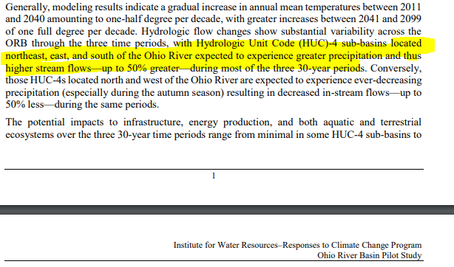

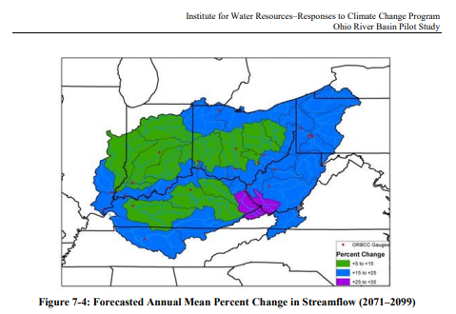

Table 1. 2022-23 CTP Work Tasks
# | Task Description | 2022-23
Special Project 1 | Map Riverine Flood Impacts of Vulnerably Disadvantaged Communities with Higher Stream Flow Change Forecast Models.  - USACE forecast models predict higher stream flows in the future for central and southern West Virginia. In addition to forecasted higher stream flows, many of the disadvantaged communities in this region have a moderate to high Social Vulnerability Index. Small, incorporated communities in which large tracts of the community are in the Special Flood Hazard Area are especially vulnerable to climate change riverine flood impacts. Many of the vulnerable communities were established in the early-20th century along narrow river valleys and steep mountainsides during the boom of coal mining and timbering extraction industries. Specifically, this project will map the riverine flood impacts of vulnerably disadvantaged communities facing higher stream flow change forecast models. The targeted five disadvantaged communities (Clendenin, Rainelle, White Sulphur Springs, Camden-on-Gauley, and Richwood) incorporate the new 2016 flood studies recently published by FEMA. Both 2D and 3D maps will show changes in the floodplain forecast models and substantial damage impact on the built environment, including critical facilities, for the following scenarios: (1) Base Flood, (2) 500-YR Flood, and (3) Climate Change Flood Model. This activity will also incorporate the largest flood disaster mitigated reconstruction dataset in the State to date since the devastating April 1977 flood of the Tug Fork Basin in which the USACE Section 202 Mitigation Program was established in 1981. Primary objectives of this project are to communicate the flood risk facing these disadvantaged communities based on current and future climate changing models, and to evaluate how various flood protection measures (e.g., elevated structures from mitigated reconstruction) implemented recently in these communities will adapt to changing environmental factors due to the impacts of climate change.  Climate Change Mapping:  - Forecast mapping models will be performed for five incorporated communities where new preliminary flood studies (PMRs - Physical Map Revisions) resulting from the June 2016 devastating flood have been completed by FEMA with the most current hydrology, high water marks, etc. The five communities of interest located in four counties are:  - Camden-on-Gauley (Webster County). Chosen for high BFE increase and high substantial damage model flood estimates.  - Rainelle and White Sulphur Springs (Greenbrier County). High number of mitigation reconstruction projects.  - Richwood (Nicholas County). High number of structures in the floodway.  - Clendenin (Kanawha County). High number of mitigated reconstruction projects.  - Incorporate Water Surface Elevation data at the following flood frequency and climate change scenarios:  - Base Flood: 1% Annual Chance (100-yr) WSEL  - 500-YR Flood: 0.2% Annual Chance (500-yr) WSEL  - Climate Change: 500-YR + 2 feet, or BFE + 3 feet (input from FEMA Region III). Water Surface Elevation (WSEL) and Depth Grids will be computed by redelineating the cross-sections.  - Product Outputs  - Water Surface Elevation (WSEL) and Depth Grids for three flood scenarios: Base Flood, 500-YR Flood, and Climate Change Flood Model  - Building flood loss damage loss estimates for all three scenarios  - Maps will show changes in floodplain forecast models and impact on the built environment. Show degree of increased flood depths for built environment including critical facilities affected by climate change riverine models.  - 2D/3D maps of different flood inundation scenarios  - Build Environment statistics and visualization  - Determine if recent mitigated reconstruction for towns like Rainelle and Clendenin will be affected by the climate change models. Generate 3D flood visualizations to communicate risk by showing:  - Substantial damage by Base Flood, 500-YR Flood, and Climate Change Flood Model  - 2016 Flood High Water Marks  - Elevated Mitigated Structures  - Critical Facilities  - Compute Hazus substantial flood loss (damage dollar and percent) estimates to quantify degree of flooding using FEMA’s Flood Assessment Structure Tool. Compare substantial damage estimates for Base Flood, 500-Year Flood, BFE+3 Climate Change Flood  - Published Report of findings  - 3D Flood Risk Visualization Movies. Flood Risk Communications and Recommended Adaptive Measures.  - Develop 3D Flood Visualization with voice narration to explain risk assessment of flood model estimates. Discuss mitigated structures and recommend flood adaptive measures (e.g., build to higher flood protection standards, open space preservation) for climate change models showing areas of significant vulnerability.  - Movie would show substantial damage estimates for different flood scenarios: Base Flood, 500-Year Flood, BFE+3 Climate Change Flood.  - Communicate the climate forecast models to communities for hazard mitigation and community resiliency planning  - Communities targeted: Camden-on-Gauley, Clendenin, Rainelle, Richwood, and White Sulphur Springs  - Mitigated Structures: Show pictures of mitigated structure in movie. If possible, include 3D view drone footage of communities with mitigated reconstruction.  - Reference information could include June 2016 Flood high-water marks, critical facilities, mitigated structures, etc.  - Include legend and title for viewers  - See flood visualization movie of Harpers Ferry for basic concept  <<  Harpers Ferry Flood Risk 3D Visualization Movie >>  https://data.wvgis.wvu.edu/pub/RA/_resources/3Dflood/HarpersFerry_Jefferson_3D_Flood_2020_mp4.mp4  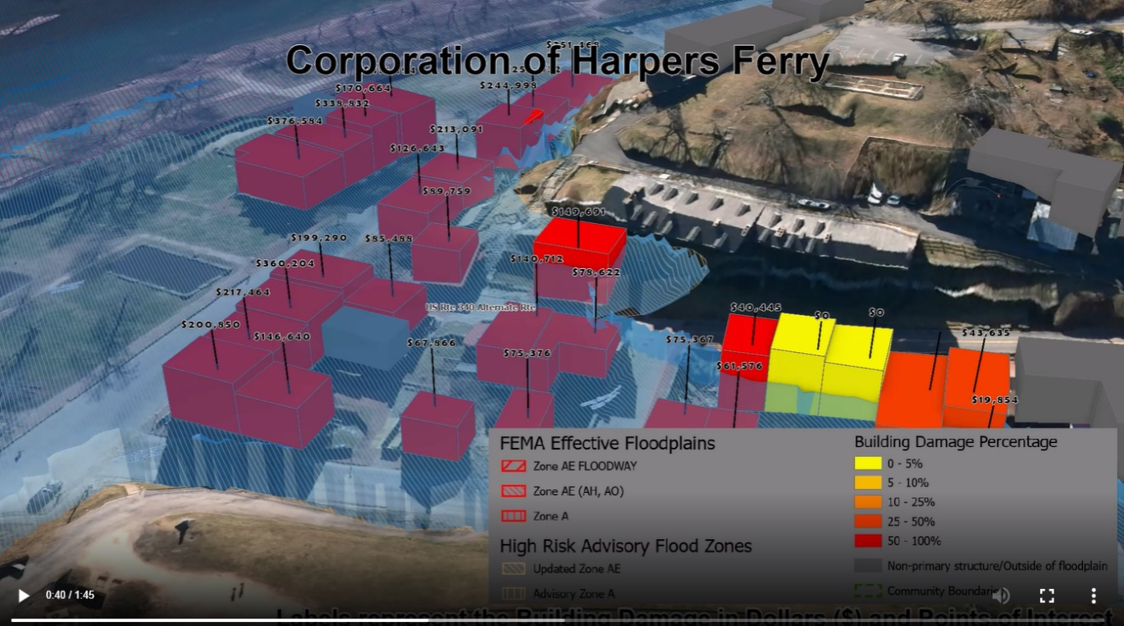  Social quantitative index or value for the selected disadvantaged communities  - The communities are located in counties which have a moderately high Social Vulnerability Index.  - All five disadvantaged communities had a negative population growth rate between the 2010 and 2020 censuses. FEMA's report Community Resilience Indicator Analysis: County-Level Analysis of Commonly Used Indicators from Peer-Reviewed Research uses population change as a risk factor. A reduction in population reduces local tax income and community resources to respond to a disaster.  - WVU Geography Professor Jamie Shinn has long-term and ongoing research in Greenbrier County on the impacts of the flood (Shinn and Caretta 2020; Caretta et al. 2021), including on the intersections of flood recovery and the COVID-19 pandemic (Shinn, under review). Her current research focuses on three towns in Greenbrier County heavily impacted by the 2016 floods, which span the length of the county – Rainelle, Ronceverte, and White Sulphur Springs – and the resulting socio-economic hardships these communities face today. Like the communities of Greenbrier County, the other disadvantaged communities of Clendenin (Kanawha County), Richwood (Nicholas County), and Camden-on-Gauley (Webster County) face similar socio-economic challenges.  For the climate change map scenario, will there be physical climate model run or just adding constant (2’ and 3’) values?  - Both. We will evaluate both FEMA flood map BFE plus constant (2’ and 3’ values) and the First Street Foundation climate model. The First Street Foundation Flood model is a nationwide probabilistic flood model at 3-meter resolution that shows the risk of flooding at any location in the contiguous 48 states due to rainfall (pluvial), riverine flooding (fluvial), and coastal surge flooding. The First Street Foundation Flood Model takes changing environmental factors into account by applying global climate model projections to forecast how flood risk will change over the next 30 years. Specifically, the climate model outputs flood depth in centimeters at the low, medium, and high CMIP 4.5 climate scenarios for the 2, 5, 20, 100, and 500 year storms this year, in 15 years and in 30 years. | 50,000
  Municipality | Community Type | Population Growth Rate
  Rainelle town | Incorporated | -20.9%
  White Sulphur Springs city | Incorporated | -9.1%
  Clendenin town | Incorporated | -30.4%
  Richwood city | Incorporated | -19.1%
  Camden-on-Gauley town | Incorporated | -25.4%
Special Project 2 | [UPDATE THE WV BUILDING LEVEL RISK ASSESSMENT (BLRA) FROM NEW FLOOD STUDIES AND STAKEHOLDER INPUTS]  The 2018 CDC Social Vulnerability Index for West Virginia shows seven counties with high vulnerability and 22 counties with moderate to high vulnerability. These social vulnerability factors may weaken a community’s ability to prevent human suffering and financial loss in a disaster. The findings of the First Street Foundation’s October 2021 risk assessment report states that West Virginia's built environment of critical facilities tops all other states for being vulnerable to flooding in current and future climate changing conditions. As for the built environment susceptible to riverine flooding, it is important to update the statewide building level risk assessment when new data sources become available (new flood studies, advisory flood height mapping, mitigated structures, elevation certificates - elevated building diagrams 5-8, LOMAS, etc.) so more accurate flood loss models and risk assessment products can be published in support of the State’s flood reduction activities, especially those communities which are socially vulnerable in the Sate. Updates to critical facilities and other structures of significance shall be a priority in quantifying the degree of flood risk. Benefits to communities include the continued validation of primary floodplain structures, expansion on base level risk assessment information for further hazard reduction and planning efforts, and the use of risk assessment information for Community Rating System (CRS) insurance discounts.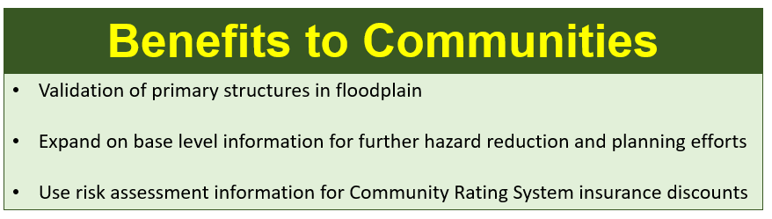  Methodology: The statewide building-level risk assessment will be updated with building characteristics (building value, occupancy class, area, stories, etc.) from a new data pull of the statewide tax assessment database that occurs once per year. The Center will use change detection along with remote sensing (aerial imagery, building footprints) and tax assessment records (compare with previous year) methods to identify new or removed structures from the floodplain. With new input data, revise the flood loss estimates using FEMA’s Flood Assessment Structure Tool (FAST). The Center will update and publish various risk assessment products for community engagement. Refer to the BLRA Cycle documents for more information.  - BLRA Cycle Diagram of WV Building-Level Flood Risk Assessment procedures  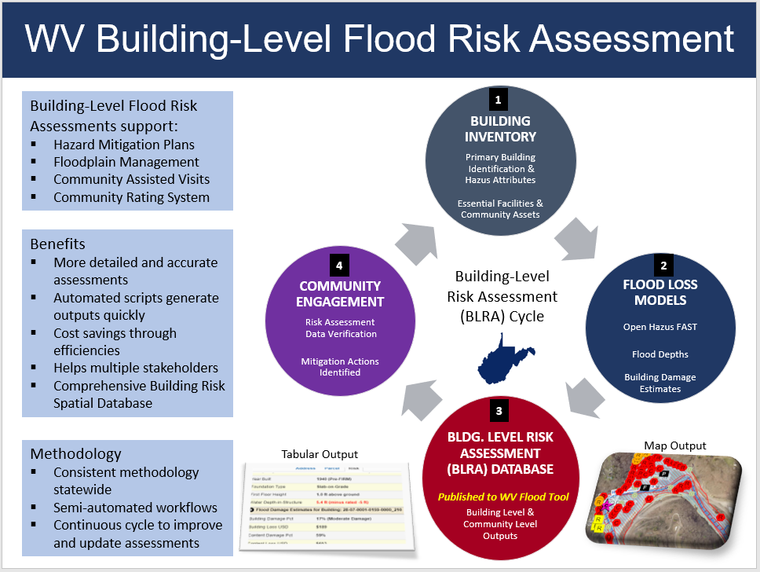  The processing/validation procedures of the WV Building Level Risk Assessment (BLRA) are more accurate and comprehensive than a typical Hazus Level 2 analysis (it is a step up and should be called a Hazus Level 3). The enhanced processing and verification steps include:  - Visual aerial photography checks of every primary structure using the highest temporal and spatial resolution imagery.  - Building attribute checks by detailed tax assessment records. Customized online tax assessment web reports provide a per structure breakdown including multiple buildings (one-to-many relationship) in a single parcel. Building sketch diagrams are available for residential properties to distinguish characteristics of multiple building in a single parcel.  - Building land use codes from the tax assessment database are converted to Hazus specific/generalized occupancy classes including manufactured homes (RES2 occupancy class).  - The Building Year combined with the Initial FIRM Date determines the Pre/Post-FIRM status of each structure. (If the SFHA was not present when the structure was constructed, then a “Post-FIRM regulated to Pre-FIRM status” is tracked in the BLRA database).  - User-modified values for all Hazus input variables (Value, Occupancy Class, FFH, Area, Stories) can be entered to override building attributes compiled from tax assessment records.  - Each structure is assigned a unique Building Identifier (Parcel ID + Address) to relate structures to other risk assessment and mitigation databases. In the WV Flood Tool, the user can zoom to the structure by entering the building identifier in the Search function.  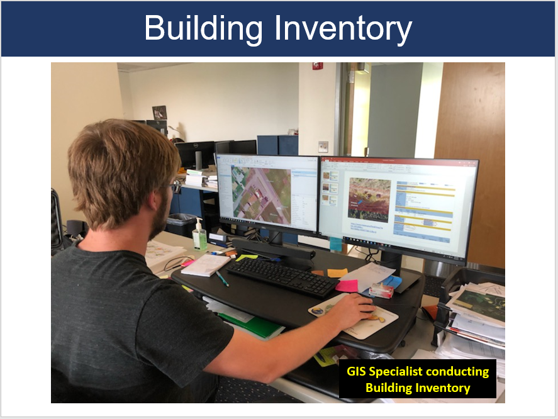  WV Building Level Risk Assessment (BLRA) Data Sources:  - Statewide BLRA Geodatabase (98,467 building points)  - BLRA County Files organized by WV Planning & Development Regions  - BLRA Data Extract Tables: High Building Value, High Damage Loss, High Minus Ratings  - BLRA Statewide Top Lists: Building Value, Flood Depth, Damage Loss $, Damage Loss %, Minus Rated, Mitigated Structures  Refer to the Index Guide spreadsheet named “RA_Info_Index.xlsx” to access various risk assessment products (products, reports, tables, graphics) published in support of FEMA’s Hazard Mitigation Plans and NFIP/CRS activities.  Example building level risk assessment table with map links to WV Flood Tool  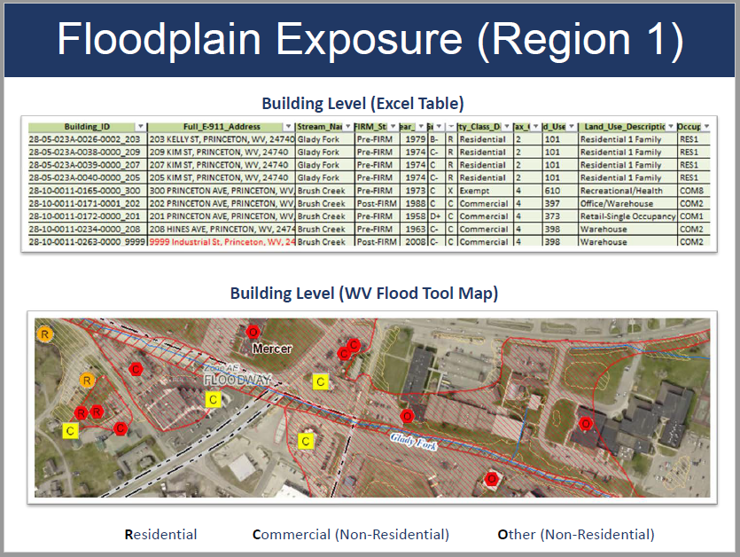  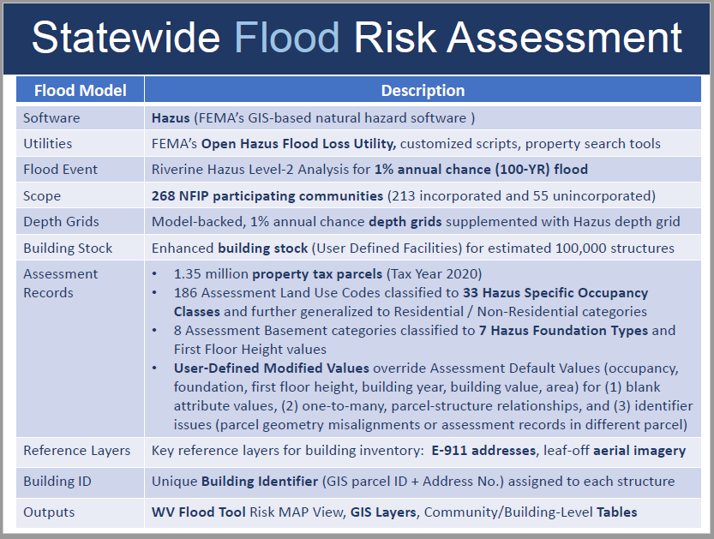  What is the project footprint and correlation with new Flood Studies availability?  - The project footprint is most of the counties in the State. New floodplains and depth grids are the result of active FEMA flood studies (17 counties) and Updated Zone AE Redelineated Floodplains (38 counties) using the new FEMA-purchased 1-meter elevation data (metadata) that is now available statewide. As part of the current CTP 2020-21 activity, the WV GIS Technical Center is creating new Updated AE’s because of the final delivery of the QL2 LiDAR elevation data in fall 2021.  - Floodplain and depth grids from FEMA restudies take priority over Updated AE Redelineation mapping for enhancing the Building Level Risk Assessment (BLRA). Redelineated Updated AE floodplains and depth grids are being generated using the new LiDAR 1-meter that was delivered in fall 2020 and covers 38 counties. A major goal is for all flood risk products to be created from the newest topographic 1-meter grids.  Are the seven counties with high SVI covered in this BLRA?  Yes, this special project covers all counties in the State including the seven counties (Gilmer, Fayette, Mingo, McDowell, Mercer, Raleigh, and Summers counties) with high SVI. New Draft NFHL depth grids just became available for Summers County. McDowell, Mercer, and Mingo counties are active flood studies and draft depth grids should be available in the near future. As these products become available, the WV GIS Technical Center will coordination will FEMA’s mapping contractors (AECOM, Wood Group) to obtain new floodplain and depth grids.  Project 2: CAMP DAWSON EXAMPLE OF UPDATED BUILDING LEVEL RISK ASSESSMENT (BLRA) – NEW REDELINDATED AE FLOODPLAINS AND DEPTH GRIDS  Camp Dawson, Preston County, a military complex on the Cheat River, has one of the highest cumulative building dollar exposures ($276M) and building damage loss estimates ($20M) in the State. A hydrograph on March 1, 2021, predicted major riverine flooding at 22.2 ft. (8 feet above flood stage of 16 feet); however, fortunately the flooding forecast for major flooding did not occur.  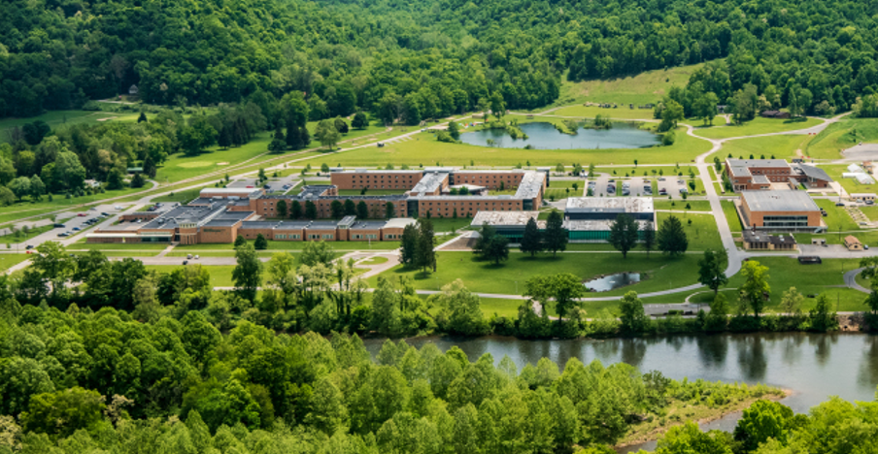  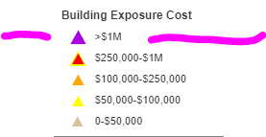  High value building exposure of Camp Dawson structures in AE Zone (WV Flood Tool Risk Map View)  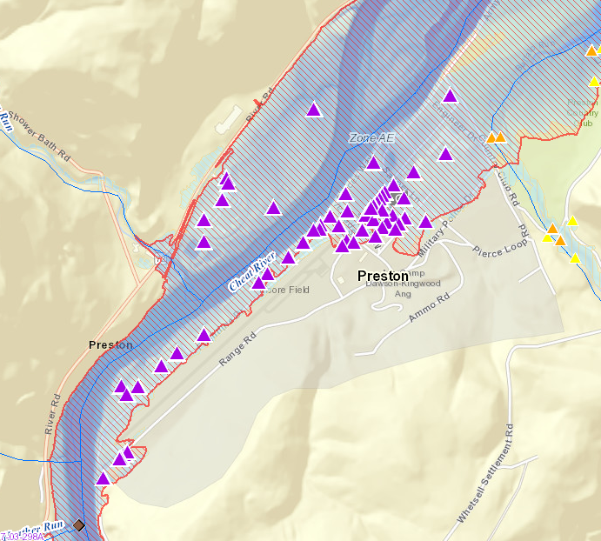  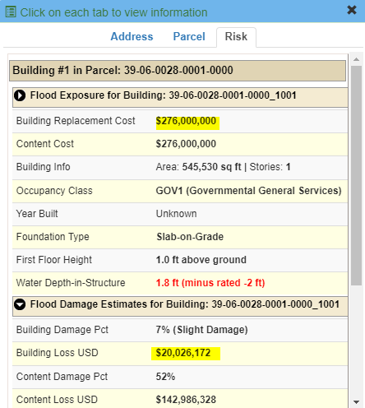  Major Riverine Flooding Forecasted for Camp Dawson on 1 March 2021.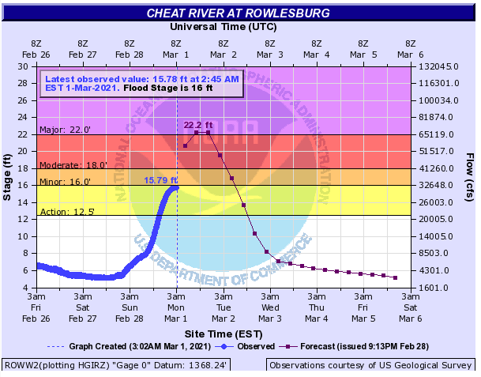  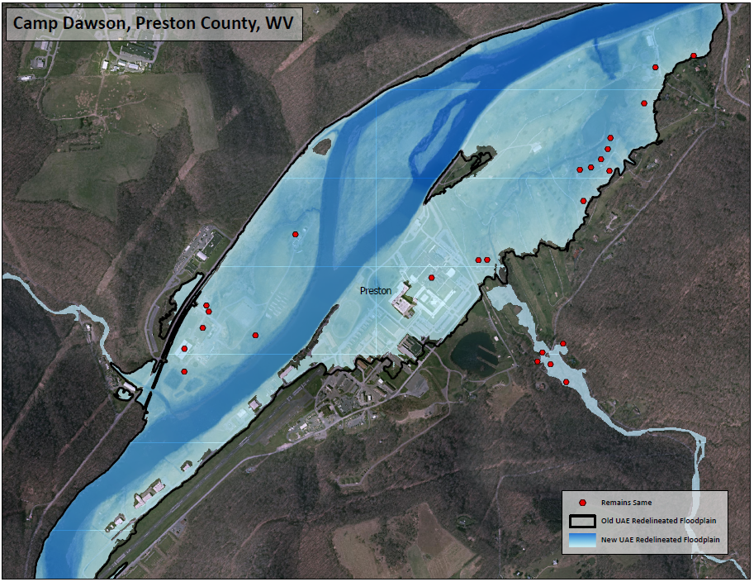  Using the new FEMA LiDAR elevation data, an Updated AE Floodplain Boundary and Depth Grid were created for this location. Although the 1%-annual-chance floodplain boundary does not change much for this location, the depth grid values changed almost a foot in certain locations. To quantify the degree of flood risk, the new depth grid will be used to update the building level damage loss estimates for Camp Dawson to quantify the degree of risk.  Project 2: EXAMPLE FEMA RESTUDY (DRAFT NFHL) FOR SUMMERS COUNTY.  The recently released Draft BFE increased 1 foot along Greenbrier River at the town of Glenray near the Summers-Greenbrier county border. The buildings (blue circles) in the Draft floodplain need to be added to the Building Level Risk Assessment and the flood loss estimates for a 1%-annual chance flood event updated with the new Draft depth grid. LOMA 17-03-1031A will need to be revalidated and most likely will not be valid anymore because of the increased BFE.  Draft NFHL, Summer County, Greenbrier River  https://www.mapwv.gov/flood/map/?wkid=102100&x=-8979620&y=4541333&l=11&v=2  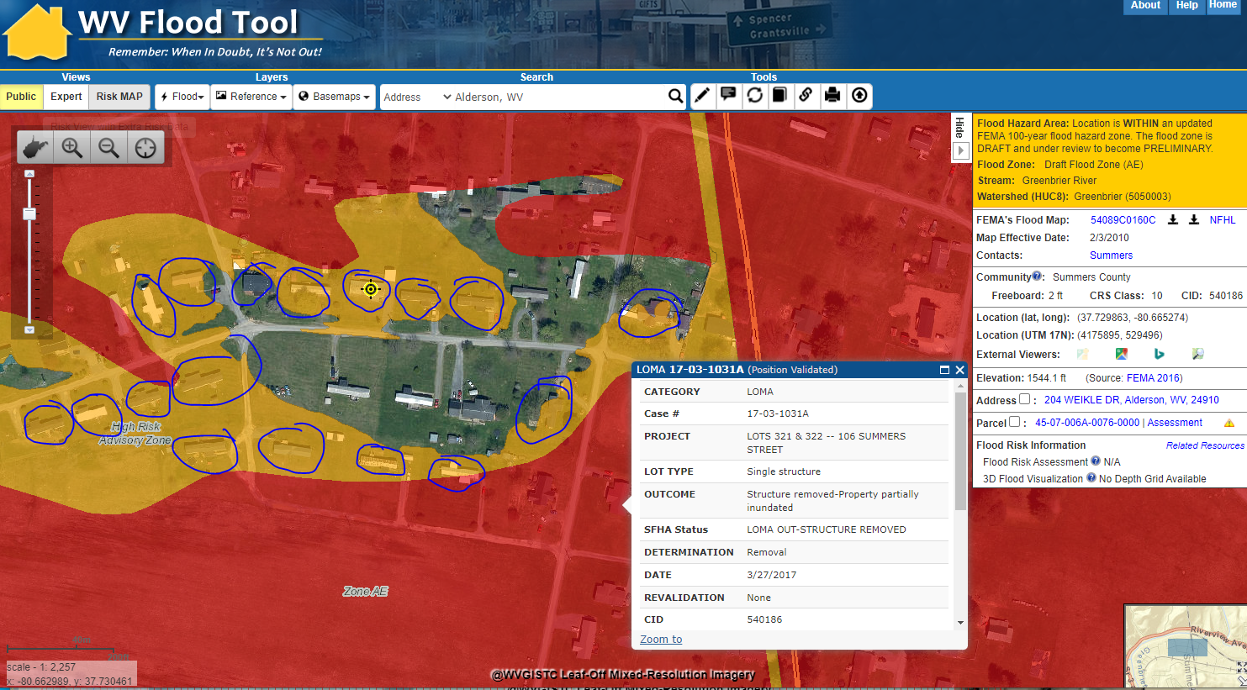  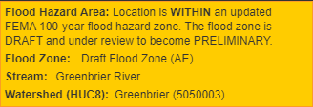  Project 2: EXAMPLE FEMA RESTUDY FOR RAINELLE, GREENBRIER COUNTY  Example of mapped in structures to new SFHA from Preliminary Flood Study of Rainelle, WV. Mapped in structures (orange circles) and flood loss estimates are updated in the statewide Building Level Risk Assessment (BLRA).  Rainelle, WV (Greenbrier County)  https://www.mapwv.gov/flood/map/?wkid=102100&x=-8990631&y=4575596&l=10&v=2  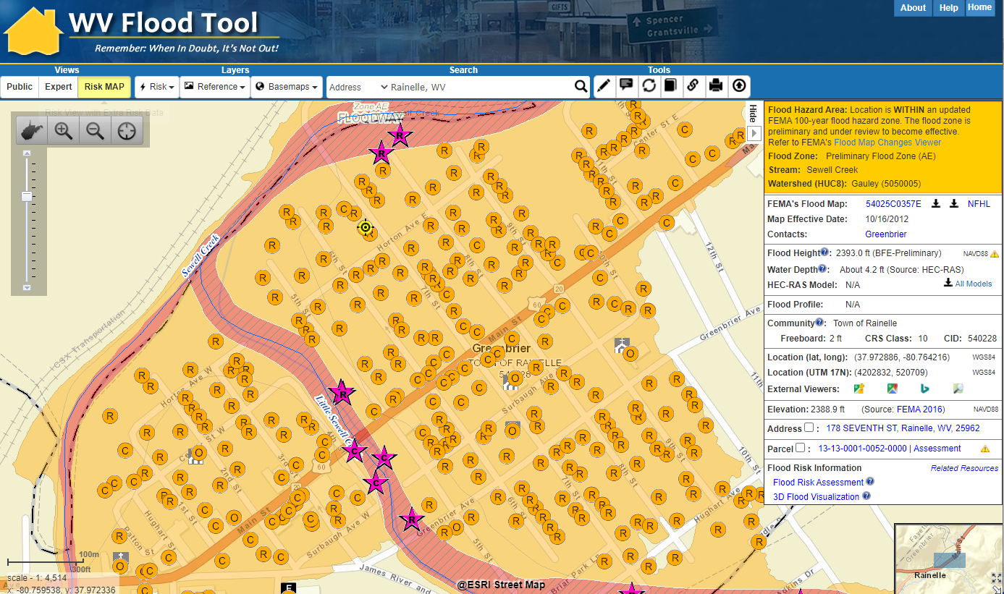  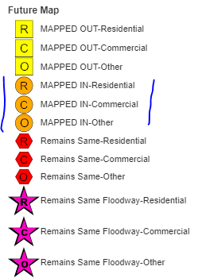 | $35,000
Special Project 3 | [MAP LANDSLIDE INCIDENTS FROM THE NEW FEMA LIDAR FOR 38 COUNTIES].  Landslides are identified in the State Hazard Mitigation Plan as the #2 hazard in West Virginia. Climate change models for West Virginia that forecast heavy precipitation events for mountainous terrain with steep slopes will result in a higher incidence of landslides. This activity will map landslides from the new FEMA-purchased LiDAR delivered in September 2021 that covers 38 counties. Landslide incidents and the type of landslide are used to generate the statewide landslide susceptibility map. The new LiDAR covers physiographic provinces in West Virginia that are most susceptible to landslide hazards. Mapped landslide incidents are published to the WV Flood Tool (RiskMAP View) and WV Landslide Tool. Landslide incidents can also be submitted to the USGS Landslide Inventory.  Resources:  Landslide Incidents | Landslide Susceptibility | Landslide Methodology Scholarly Paper (2020)  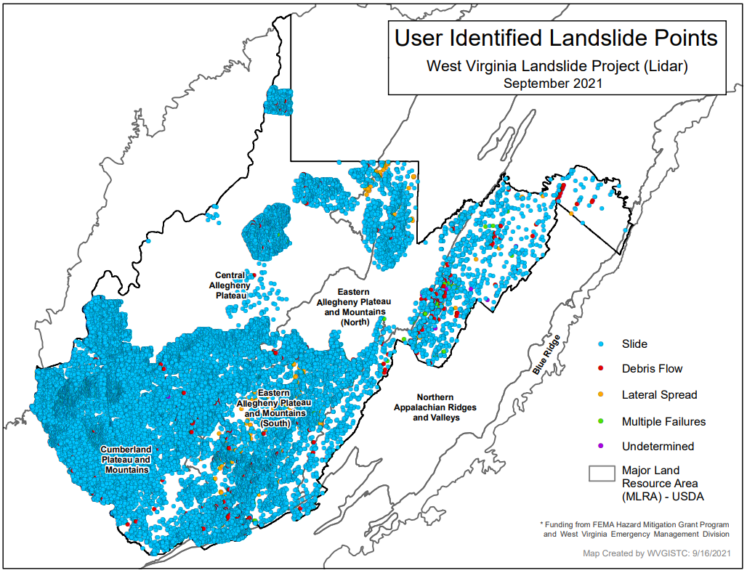  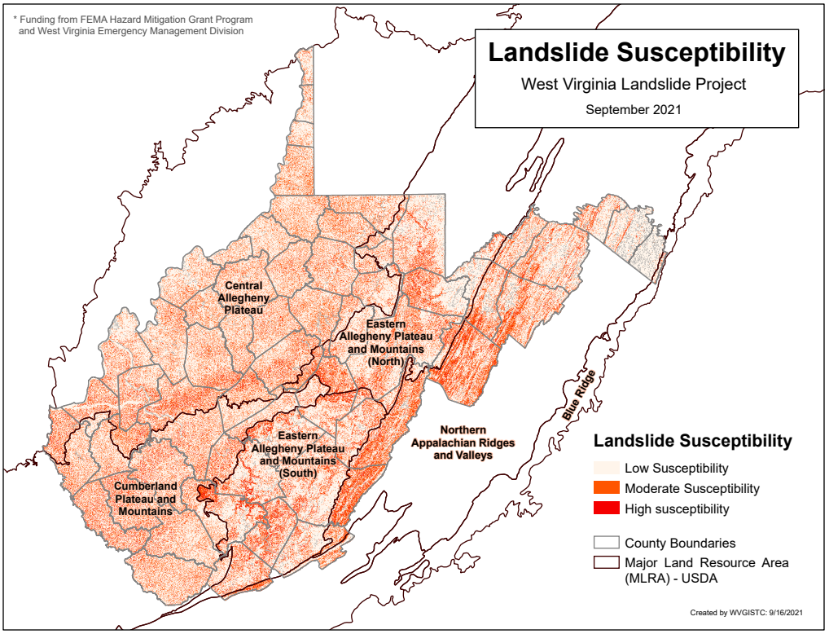  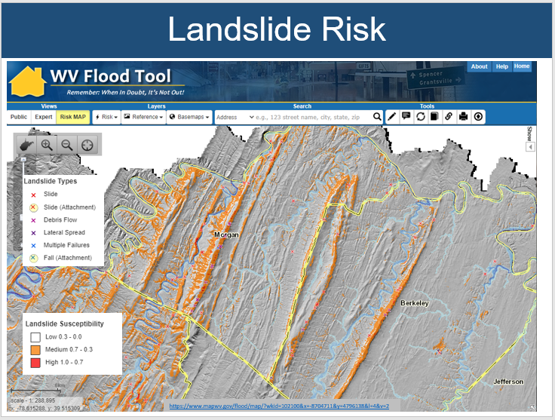  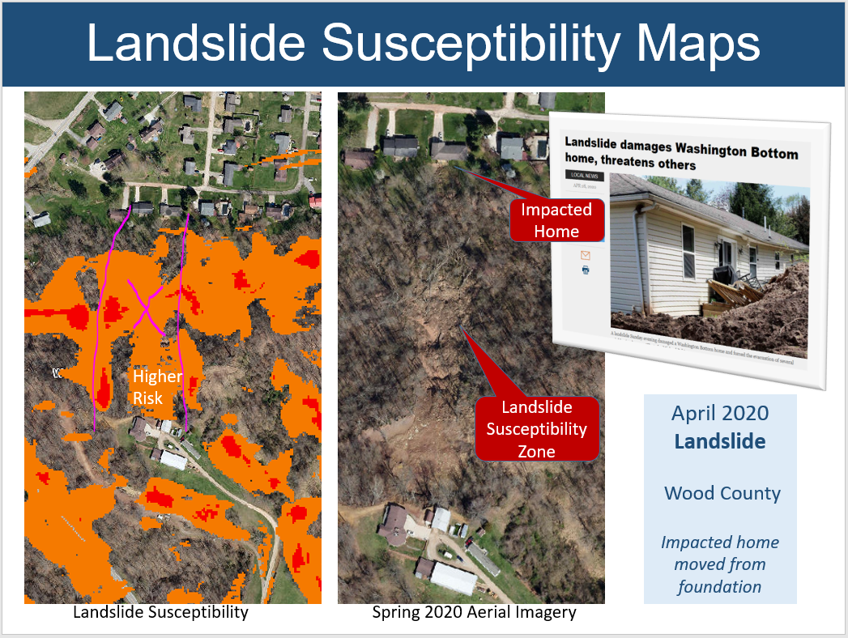  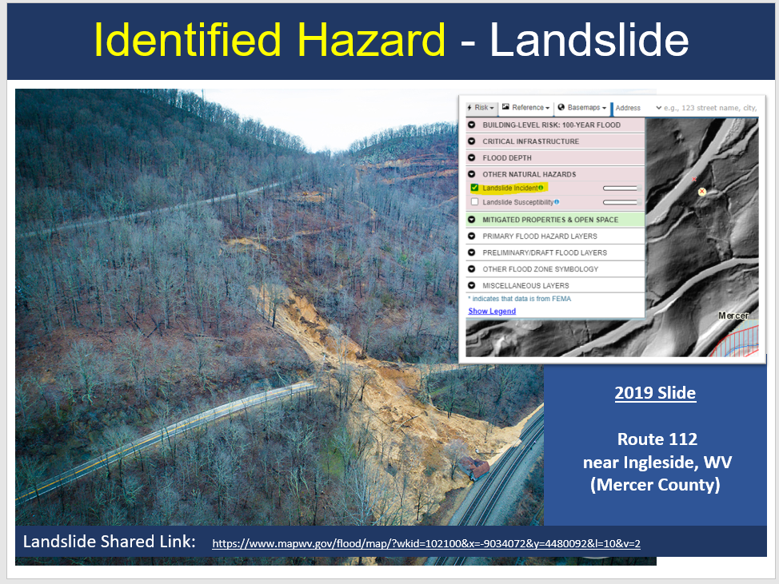  Is climate change (precipitation) part of the plan for this special project option?  - Previous research like the Geomorphic studies of the storm and flood of November 3-5, 1985, in the upper Potomac and Cheat River basins in West Virginia and Virginia provides precipitation and landslide trigger rates that can be incorporated into climate change precipitation models.  - More than 3,000 landslides were triggered by heavy rainfall in the central Appalachian Mountains of West Virginia and Virginia, November 3-5, 1985.  - Ninety-five percent of the landslides triggered by the November storm were slides, slide flows, slumps, or slump flows; the remaining 5 percent can be classified as debris avalanches and slide flows transitional to avalanches.  - The spatial distribution of landslides triggered by the storm was controlled primarily by rainfall, bedrock lithology, surficial lithology, land cover, and slope morphology.  - The triggering rainfall was of moderate intensity and long duration. Two-day storm totals varied from 170 mm (6.7 inches) to more than 240 mm (9.4 inches) in the study area. Most landslides occurred at the northeast end of the study area, where 48-h rainfall totals were more than 200 mm (7.9 inches).  - Intensity and rainfall duration of storms responsible for triggering landslides in the central Appalachians. https://pubs.usgs.gov/bul/1981/report.pdf#page=70  - WVU Geology Professor Charlie Shobe would assist with the climate change data for predictive landslide mapping/modeling. | $15,000
This Agreement supports the goals and objectives of the Cooperating Technical Partners (CTP) Program

- Enhanced Risk Assessment Data: Address gaps in flood hazard data to form a solid foundation for risk assessment, floodplain management, and actuarial soundness of the NFIP.
- Public Awareness/Outreach: Ensure that a measurable increase in the public’s awareness and understanding of flood risk results in a measurable reduction of current and future vulnerability.
- Hazard Mitigation Planning: Lead and support states, and localities to effectively engage in risk-based mitigation planning resulting in sustainable actions that reduce or eliminate risks to life and property from natural hazards.
- Enhanced Digital Platform: Provide an enhanced digital platform that improves management of Risk MAP, stewardship of information produced by Risk MAP, and communication and sharing of risk data and related products to all levels of government and the public.
- Alignment and Synergies: Align risk analysis programs and develop synergies to enhance decision-making capabilities through effective risk communication and management.
 | Total Amount | $100,000

