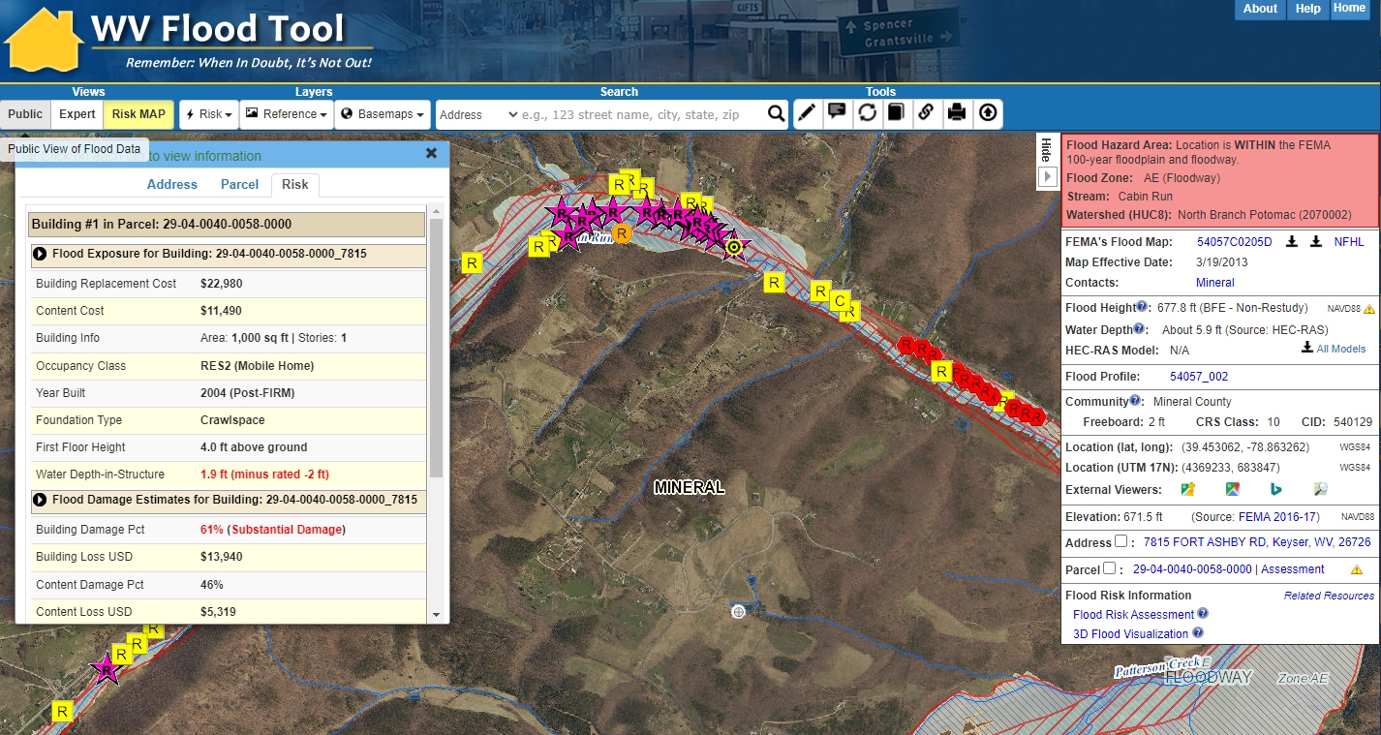



WV Emergency Management Division
COOPERATING TECHNICAL PARTNERS (CTP) PROGRAM MANAGEMENT (PM)
STATEMENT OF WORK (SOW)
PM SOW No. 7

Fiscal Year 2022

This page intentionally left blank

Table of Contents
1. Part 1 – Custom Statement of Work Information 1
1.1. Project and Point of Contact Information 1
1.2. Tasks and Deliverables to be Completed Under this SOW 2
1.3. Schedule and Performance 8
1.4. Standards 10
1.5. Use of Contractors 11
1.6. Reporting and Performance 11
1.7. Privacy and Protection of Personally Identifiable Information 12
Authorized Representative Signatures 13
APPENDIX A: Detailed Scope of NFIP PM Led Activities A-1
APPENDIX B: Detailed Scope of WVU PM Led Activities B-1

Part 1 – Custom Statement of Work Information

Project and Point of Contact Information

Table 1. Project and Point of Contact Information

Information Type | Insert Information
CTP Organization Name: | WV Emergency Management Division
CTP Contractor Working on the activities in this SOW: | WVU GIS Technical Center, West Virginia University
CTP Partnership Agreement Date: | 7/2022
Period of Performance: | 10/1/2022 to 9/30/2023
CTP Project Manager: | Timothy W. Keaton, CFM
FEMA Regional Project Officer (PO):  When necessary, additional FEMA assistance should be requested through the FEMA Regional Project Officer | Robert Pierson, PMP  FEMA Region III
FEMA Funding to Complete this PM SOW: | $250,000

Information Type Insert Information
CTP Estimated Leverage:  Final Leverage dollars or units will be entered as applicable in the Manage Data Development Task Workflow in the Mapping Information Platform (MIP). | N/A
Project Team Coordination Activities:  Throughout the project, all members of the Project Team will coordinate, as needed, to ensure that activities, products, and deliverables meet FEMA requirements and contain accurate, up-to-date information. | - Meetings, teleconferences, and video conferences with FEMA Region III, WVEMD, and other Project Team members biannually at a minimum with additional meetings scheduled as necessary.  - Telephone conversations with FEMA and other Project Team members on a scheduled monthly basis and ad hoc basis, as required  - Email as needed

Tasks and Deliverables to be Completed Under this SOW

NARRATIVE AND AUDIENCE

Table 2. Narrative and Audience

Information Type |  | Description
SOW Narrative: | This CTP PM Project supports statewide global outreach for mapping services that process and integrate new flood and reference GIS layers, tool enhancements, flood risk information, etc. for the WV Flood Tool (www.mapwv.gov/Flood). It also provides mitigation planning technical assistance through specific activities for all 268 flood-prone communities in the State. A comprehensive State Business Plan as a single deliverable for both the Community Outreach and Mitigation Strategies (COMS) Engagement Plan and PM Business Plan will be completed as well. The WV GIS Technical Center at West Virginia University and host of the WV Flood Tool will provide contracting support for all PM activities. An overarching goal of this CTP PM project is to more proactively engage flood-prone communities to use the new statewide building-level risk assessment data for their floodplain management and mitigation planning activities. The major scoping activities are divided by WV NFIP Office Led (Appendix A) and WVU GIS Technical Center led (Appendix B).  This project includes outreach mapping activities that support the goals of FEMA’s NFIP/CRS flood mapping program, including flood risks and hazard identification. It also includes technical assistance activities that will produce and disseminate products and materials to the State and local jurisdictions to develop, evaluate, update, and implement their mitigation plans and strategies. Refer to Appendices A and B for detailed statements of work.
Intended Audience: | Target Audience: Floodplain Managers, Community Planners, Emergency Preparedness Officials, Engineers/Surveyors, Realtors, Lenders, Community Leaders, Property Owners, etc. Supports stakeholders engaged at the state, regional, and community levels.  Project Footprint: State of West Virginia  Through collaboration with Local, State, and Federal entities, the WV Flood Tool delivers quality data that increases public awareness and leads to actions that reduce risk to life and property. To manage the wealth of available data and better communicate flood risk, the WV Flood Tool has maintained a public facing outreach tool for the public, communities, engineering/surveying companies, and others (Insurance companies, lending institutions, real estate companies, etc.) that has provided effective floodplain models, supporting datasets, water-surface elevations, floodplain boundaries, and additional enhanced flood risk information. During the past decade, the functionality and quality of data layers of the WV Flood Tool have progressed, resulting in an increased use of the application. Over time, the WV Flood Tool has become more than just a flood determination tool, and today is routinely used by floodplain managers for building permit applications, floodplain regulations enforcement, pre- and post-disaster assessments, and Community Rating System discounts. For community and emergency planners, the RiskMAP View of the WV Flood Tool now includes structure-level risk assessments and mitigated properties to aid in flood reduction efforts.

PROJECT TASKS AND DELIVERABLES
The following three tasks will be accomplished under this PM SOW:

- State and Local Business Plans and/or Updates (required)
- Global Program Management Activities (completed under the PM SOW when Recipient is also funded for tasks in the Flood Risk Project Mapping Activity Statement (MAS))
- Global Outreach for Mapping
- Training to State, Tribal, Territory, and Local Officials
- Mitigation Planning Technical Assistance
- Staffing
- Technical Pilot Projects
- Mentoring and Best Practices
- Minimal Map Printing
- Coordinated Needs Management Strategy (CNMS)
- Programmatic Quality Assurance / Quality Control (QA/QC) Plans

These tasks and their associated deliverables are in listed in the sections below.

Task 1 - State and Local Business Plans and/or Updates (Required)

Table 3. Task 1 – State and Local Business Plans and/or Updates

PM Task | Mark ‘X” if task will be done under this SOW | (A) FEMA Contribution | (B) Partner Contribution |  | (A+B) Total Project Cost
State and Local Business Plans and/or Updates (required as a condition of PM funding) (see Part 2.1) | ☒ | $5,000 | $0 |  | $5,000
Deliverable |  |  |  | Mark “X” if deliverable will be done under this task
Business Plan (required) |  |  |  | ☒
Other: {Insert additional details} |  |  |  | ☐
Custom Scope Elements
Complete a State Business Plan for delivery to FEMA Region III. The comprehensive Business Plan will be a single deliverable for both the Community Outreach and Mitigation Strategies (COMS) Engagement Plan and PM Business Plan.

Task 3 – Global Outreach for Mapping
Task 3 can be selected under this task if there is no COMS SOW. If a COMS SOW is also completed, the Outreach Plan is required under the Strategic Planning for Community Engagement Task and should not be part of this PM SOW.

Instructions: Please fill out the required information in Table 5 below.

Table 5. Task 3 – Global Outreach for Mapping

PM Task | Mark ‘X” if task will be done under this SOW | (A) FEMA Contribution | (B) Partner Contribution |  | (A+B) Total Project Cost
Global Outreach for Mapping (see Part 2.3) | ☒ | $195,000 | $0 |  | $195,000
Deliverable |  |  |  | Mark “X” if deliverable will be done under this task
Outreach Plan (Refer to COM Program SOW) |  |  |  | ☐
Report detailing outreach and coordination activities, including backup or supplemental information used in writing the report |  |  |  | ☐
Business Plan update describing (in detail) the outreach activities |  |  |  | ☒
Updates to CTP’s website |  |  |  | ☒
Other: Outreach associated with updates to WV Flood Tool |  |  |  | ☒
Custom Scope Elements
WV NFIP PM TASKS: Global Outreach for Mapping Activities spearheaded by State NFIP Office. Contracted to WVU GIS Technical Center. Cost $15,000. (See Appendix A for more details)

- Preload At-Risk Buildings from Statewide Flood Risk Assessment into FEMA’s Substantial Damage Estimator Tool: For pre-disaster planning and preparation, the detailed statewide floodplain building inventory can be preloaded into FEMA’s Substantial Estimator Tool. With the changing climate, especially with the potentially increased building damage impacts from heavy precipitation events that fill rivers and river valleys, it is important that the State and flood-prone communities have their residential/non-residential structures from the WV Building Level Risk Assessment (BLRA) uploaded into FEMA's Substantial Damage Estimator tool.

- Communicate SFHA Map Changes to Affected Property Owners: Template mail merge documents from the FEMA Region 3 "Local Officials Toolkit: What to Do Before and After Your Flood Maps are Finalized" have been created to send to property owners with new flood mapping updates during the appeal period for the restudy. Information about changes in floodplain risk and base floodplain elevation can be communicated to individual homeowners. The base flood elevation is increasing 6 feet, for example, for the highly flood vulnerable and disadvantaged community of Camden-on-Gauley on the Gauley River in Webster County. Mailing addresses of affected property owners are retrieved from the statewide tax assessment database. This activity qualifies for FEMA’s Community Rating System credits.
- Promote LiDAR LOMAs Print Function on the WV Flood Tool: West Virginia now has statewide coverage of QL2 LiDAR data and LiDAR-derived elevation products of one-meter DEMs and 1-foot contours. LiDAR LOMAs can be submitted for qualifying structures using FEMA’s Online LOMA portal. The Flood Tool’s Print Function generates map layouts for the LiDAR submissions using either the contour or point elevation methods. To save disadvantaged communities and homeowners the cost of needing a site elevation survey, communicate to these constituents how the "mapped out" structures (primary building structures symbolized by yellow squares) displayed on the RiskMAP View of the WV Flood Tool may qualify for removal of the structure from the SFHA. The only information required for an Online LOMA submission are a map layout from the Flood Tool and a copy of the deed.

WVU PM TASKS: Global Outreach for Mapping Activities for WV Flood Tool. Cost $180,000. (See Appendix B for more details).

- Global Outreach Services for WV Flood Tool: Statewide global outreach services that process and integrate new flood and reference GIS layers, tool enhancements, flood risk information, etc. for the WV Flood Tool (www.mapwv.gov/Flood). Services include computer programming, data development/geo-processing, customized mapping, and technical support services (Task A). This project also supports two other activities in which a recent nationwide flood risk assessment determined that 46 percent of the roads in the State and 51 percent of the State’s critical facilities — the highest state-level percentages in the Nation — would be closed by flooding based on current and future climate change models. The first subtask (Task B) integrates the WV Building Level Risk Assessment (BLRA) with FEMA’s national inventory so standardized, consistent, and accessible building level information can be exchanged. Another subtask (Task C) enhances transportation flood inundation models on the RiskMAP View of the WV Flood Tool.

Task 5 – Mitigation Planning Technical Assistance

Table 7. Task 5 – Mitigation Planning Technical Assistance

PM Task | Mark ‘X” if task will be done under this SOW | (A) FEMA Contribution | (B) Partner Contribution |  | (A+B) Total Project Cost
Mitigation Planning and Technical Assistance (TA) (see Part 2.5) | ☒ | $50,000 | $0 |  | $50,000
Deliverable |  |  |  | Mark “X” if deliverable will be done under this task
A report detailing the TA provided, including date(s) of TA and type of assistance and state, tribal, or local community stakeholders supported |  |  |  | ☒
Copies of all technical data provided to local, state, and tribal communities |  |  |  | ☒
Other: {Insert additional details} |  |  |  | ☐
Custom Scope Elements
Mitigation Planning Technical Assistance. Cost $50,000. (See Appendix B for more details).
- Document Mitigation Status of 98,467 Flood-Prone Structures: Conduct a comprehensive inventory of existing mitigated structures using the statewide building-level risk assessments to determine how communities have applied flood adaptive measures in response to major flood events. In response to climate change impacts, evaluate if mitigation measures (elevation, barrier, wet floodproofing, dry floodproofing, etc.) along with flood development ordinance standards (e.g., freeboard) are adequate for changing environmental conditions. Focus on the post-FIRM structures with a Minus 3 Rating (lowest floor 3 or more feet below the BFE) to determine if newly constructed properties are properly mitigated. Structure-level mitigated status information will be tracked by the unique building identifier (Parcel ID + Address Number) and WV Flood Tool shared map link. This activity will engage flood-prone communities, thereby providing outreach and training opportunities to encourage communities to adopt higher flood protection standards through ordinances as well as other flood adaptive measures.

- Develop and Verify Community Flood Risk Profiles: Use the building level-risk assessments to create community risk profiles at the regional and state scales. Aggregate key risk factors into Exposure and Flood Model matrices. A Mitigation Matrix of mitigated properties, open space preservation, etc. can be developed as well. The community risk profiles would supplement FEMA’s Flood Risk Dashboards, a snapshot of a community’s flood risk statistics at the time the community is going through a flood mapping update. These community flood risk profiles can be incorporated into the 2023 State Hazard Mitigation Plan Update. It is important to identify disadvantaged communities in the State that may be at higher risk due to climate change impacts and thus require additional focus and support in their flood protection measures.

- Model Potential Mitigation Measures and Communicate to Communities: Use model-backed depth grids and the building-level risk assessment inventory (BLRA) to identify mitigation measures for properties. For example, identify buildings with solid wall crawl spaces which would qualify for flood vents, one of the cheapest mitigation solutions for existing structures. Communicate this mitigation information to communities where types of building foundations are prevalent and would qualify for flood vents. Communicate the cost in savings in flood insurance by installing flood vents and adjusting the lowest floor elevation. Identify grants or other funding sources to help disadvantaged communities with increased flood risk from climate change.

- Engage Communities to Validate Areas of Mitigation (AOMI) on WV Flood Tool: Engage communities to validate AoMIs identified from the statewide risk assessment. Areas of Mitigation (AoMI) are identified by Repetitive Loss structures, Substantial Damage Estimates, Mitigated Properties, Floodway Structures, Flood Depths, High-Water Marks, and Similar Topography. AoMIs support the community prioritization of identifiable measures for hazard reduction planning and actionable mitigation projects. AoMIs are published on the RiskMAP View of the WV Flood Tool.

PERCENTAGE OF TIME SPENT ON TASKS OR ACTIVITIES
Instructions: Table 14 and Table 15 are only required if Staffing is the only PM Task to be performed under this SOW (other than the State/Local Business Plan, which is required). If the CTP is not performing Staffing or is performing multiple activities which include Staffing, these tables may not be required. Coordinate with your FEMA POC on any additional applicability. Based on these guidelines, Tables 14 and 15 are not required for PM SOW.

Schedule and Performance

Table 16. PM Task Deliverables Schedule

SOW Activities | Deliverable | Deliverable Due Date | Submitted To
Business Plan (required) | Business Plan | 6 months from Award date | FEMA Regional Project Officer
Global Outreach for Mapping | Reporting on Outreach Website updates/enhancements | Quarterly | FEMA Regional Project Officer
Mitigation Planning Technical Assistance (TA) | Reporting on TA Activities | Quarterly | FEMA Regional Project Officer

The activities documented in this SOW shall be completed in accordance with Table 16. PM Task Deliverables Schedule. If changes to this schedule are required, the CTP shall coordinate with the FEMA Regional PO and other necessary Mapping Partners in a timely manner. Deliverables must be uploaded to the MIP unless otherwise approved by the FEMA Regional PO and it is the CTP’s responsibility to make sure that final deliverables are stored to the MIP prior to the end of period of performance.

Table 17. Performance Measures Targets
Outcome1 | Output Measurement2 (with customized Target) | Recorded Unit/Scale
Update WV Flood Tool with new hazard data | Flood hazard, risk assessment, and key reference layers updated on the WV Flood Tool (www.mapwv.gov/flood). | Achieved / Not Achieved
Promote Pre-Disaster Planning/Emergency Preparedness of Building Inventory and SDE | Assist three engaged communities with uploading inventoried flood-risk structures into FEMA’s Substantial Damage Estimator (SDE) software. | Achieved / Not Achieved
Communicate SFHA Map Changes to Affected Property Owners | Promote RiskMAP flood study map changes via public outreach notification for a minimum of one county. Use the Building-Level Risk Assessment geodatabase to identify homeowners affected. | Achieved / Not Achieved
LiDAR LOMA Tool | Promote new LiDAR LOMA function on WV Flood Tool with targeted training to floodplain manager community | Achieved / Not Achieved
Identify Mitigation Status of State’s Flood-Prone Structures | Identify mitigation status of buildings (elevated, wet floodproofing, dry floodproofing, etc.). Engage a minimum of 10 communities via courtesy checkups. Update mitigated structures on WV Flood Tool. | Achieved / Not Achieved
Model Potential Mitigation Measures from BLRA and Communicate to Communities | Identify Building-Level Risk Assessment (BLRA) mitigation measures of flood-prone communities in the State for mitigation planning and public outreach. For example, map flood-prone neighborhoods where most of the residential building stock with crawl space foundations qualify for flood vents. Provide technical risk reduction data to State Hazard Mitigation Office for hazard mitigation planning and flood reduction efforts. | Achieved / Not Achieved
Engage Communities to Validate Areas of Mitigation (AOMI) on WV Flood Tool | Engage communities of two Regional Planning & Development Councils to validate AoMIs based upon:  • Buyout Properties  • High Flood Depths or Water Depths-in-Structure  • High-Water Marks  • Non-Residential |Residential building dollar damage estimates  • Substantial Damage Estimates | Achieved / Not Achieved

1 An outcome is an observable and measurable change of knowledge, behavior, skills, and/or efficiency due to CTP project.

2 An output is a direct, specific, & quantifiable product of CTP activities that lead to /indicate success of the intended outcome, expressed in units of measure that enable quantifiable recording of performance

Standards
The standards relevant to this SOW are presented in FEMA Policy 204-078-1 Standards for Flood Risk Analysis and Mapping, Revision 12, dated November 2021 located on FEMA’s website at https://www.fema.gov/flood-maps/guidance-reports/guidelines-standards/standards-flood-risk- analysis-and-mapping-public-review. This Policy supersedes all previous standards included in the Guidelines and Specifications for Flood Hazard Mapping Partners, including all related appendices and Procedure Memorandums. Additional information, along with links to guidance documents, technical references, templates, and other resources that support these standards, may be found on the FEMA Guidelines and Standards website at https://www.fema.gov/guidelines-and-standards- flood-risk-analysis-and-mapping. FEMA reviews standards on an annual basis and the most current version of the policy should be used.

For any Mitigation Planning Technical Assistance activities, coordinate with the FEMA Regional Project Officer to confirm compliance with regional requirements. Additional information is available in FEMA’s Incorporating Mitigation Planning Technical Assistance guidance document, available on the FEMA Guidelines and Standards website at https://www.fema.gov/flood-maps/guidance- reports/guidelines-standards/guidance-femas-risk-mapping-assessment-and-planning.

For CNMS activities, all work shall be performed in accordance with the requirements specified in the most recent Coordinated Needs Management Strategy (CNMS) Technical Reference available at https://www.fema.gov/flood-maps/guidance-reports/guidelines-standards/technical-references- flood-risk-analysis-and-mapping.

Use of Contractors
Check applicable statement in Table 18 below.

Table 18. Use of Contractors

Select One | Description of Contractor Options
☒ | Contractor support may be used for all activities within this SOW, except staffing and mentoring, which must be completed by the CTP. The CTP will identify the name of the CTP contractor for services used as part of this SOW. The CTP shall ensure that the procurement for all contractors used for this Program Management Activity complies with the requirements of 2 Code of Federal Regulations (CFR) Part 200.  Guidance provided in this part includes, but is not limited to, contract administration and record keeping, notification requirements, review procedures, competition, methods of procurement, and cost and pricing analysis. 2 CFR Part 200 may be viewed online at http://www.ecfr.gov/cgi-bin/text- idx?SID=cc011f4fb962e68cb0da4bc91e8fbb43&mc=true&node=pt2.1.200&rgn=div5. Additionally, contractors must not pose a conflict-of-interest issue.  Contractors support will be provided by the WV GIS Technical Center, West Virginia University
☐ | The CTP does not intend to use the services of a contractor for this SOW. No transfer of funds to agencies other than those identified in the approved cooperative agreement application shall be made without prior approval from FEMA. The CTP shall ensure that the procurement for all contractors, if any are used for this SOW, complies with the requirements of 2 CFR Part 200.  Guidance provided in this part includes, but is not limited to, contract administration and recordkeeping, notification requirements, review procedures, competition, methods of procurement, and cost and pricing analysis. 2 CFR Part 200 may be viewed online at http://www.ecfr.gov/cgi-bin/text- idx?SID=cc011f4fb962e68cb0da4bc91e8fbb43&mc=true&node=pt2.1.200&rgn=div5.

Reporting and Performance
Financial Reporting: Because funding has been provided to the CTP by FEMA, financial reporting requirements for the CTP will be in accordance with Cooperative Agreement Funding Opportunity Announcement, Articles of Agreement, or Award Notice for this SOW. The CTP shall also refer to 2 CFR Part 200. The CTP shall provide financial reports to the FEMA Regional PO and Assistance Officer in accordance with the terms of the signed Cooperative Agreement for this SOW.

Performance Reporting: Recipients are responsible for providing a signed performance report using the required list of information shown in the NOFO (or and old SF-PPR, if you prefer) on a quarterly basis throughout the period of performance, including partial calendar quarters and periods where no grant award activity occurs. The CTP shall refer to 2 CFR Part 200 to obtain minimum requirements for progress reporting. The FEMA Regional PO, as needed, may request additional information on progress.

The CTP will meet with FEMA and/or its contractor(s) as frequently as needed to review the progress of the project in addition to the quarterly financial and status submittals. These meetings may alternate between the FEMA Regional Office, the CTP office, and conference calls as necessary.

The CTP must report performance of the grant in conjunction with the progress reporting. The performance of the CTP is measured by Table 17 Performance Measures Targets. If you are completing a PM project in conjunction with a Flood Risk Project MAS, then you shall use the measures outlined in that MAS based on the 2022 CTP Performance Measures Matrix. Quantitative Targets for performance measures are defined using the 2022 CTP Performance Measures Matrix in conjunction with your FEMA Regional PO and defined in Table 17.

Earned Value Data Entry:

COMS SOW/PM SOW tasks are now tracked in the MIP. Cost and schedule performance measures are defined in this SOW. These measures will be used to monitor partner performance and to determine future funding eligibility. Earned Value data entry involves updating cost, schedule, and performance (physical percent complete) in the MIP by the CTP each month for each assigned task. The CTP will contact the region to obtain additional guidance as needed for updating COMS/PM efforts in the MIP.

Privacy and Protection of Personally Identifiable Information
Your organizational access to the MIP signifies that you have access to Personally Identifiable Information (PII). As such, please ensure your organization has coordinated with the region so that each user is meeting the requirements with the new Risk Analysis Management Access Request (RAMSAR) process.

Please contact your FEMA Regional PO for more information.

Authorized Representative Signatures
Each party has caused this SOW to be executed by its duly authorized representative.

Timothy Keaton Date
Project Manager
WVEMD

Robert Pierson Date
Regional Project Officer
Federal Emergency Management Agency, Region 3

APPENDIX A: Detailed Scope of NFIP PM Led Activities
2022-23 CTP PM Scope: WV Focused Flood Reduction and Mitigation Engagement Activities
State: West Virginia
Total Cost: $70,000
Performance Period: October 1, 2022, to September 30, 2023 (12 months)
Plan by Tim Keaton, State CTP Coordinator/Mitigation Planner, WV Emergency Management Division. Subcontract work to WVU GIS Technical Center.
6/29/2029
The CTP Project will consist of eight focused outreach, training, planning, and community engagement activities in support of flood reduction and mitigation programs, to include:

- Develop a Comprehensive State Business Plan
- Preload At-Risk Buildings from Statewide Flood Risk Assessment into FEMA’s Substantial Damage Estimator Tool
- Communicate SFHA Map Changes to Affected Property Owners
- Promote LiDAR LOMAs Print Function on the WV Flood Tool
- Document Mitigation Status of Flood-Prone Structures
- Develop and Verify Community Flood Risk Profiles
- Model Potential Mitigation Measures and Communicate to Communities
- Engage Flood-Prone Communities to Validate Areas of Mitigation (AOMI) on WV Flood Tool
State Business Plan
- Develop a Comprehensive Business Plan: Develop a required comprehensive business plan for the State to fulfill the requirements of the PM and COMS statements of work.
Global Outreach for Mapping
- Preload At-Risk Buildings from Statewide Flood Risk Assessment into FEMA’s Substantial Damage Estimator Tool: For pre-disaster planning and preparation, the detailed statewide floodplain building inventory can be preloaded into FEMA’s Substantial Estimator Tool. With the changing climate, especially with the potentially increased building damage impacts from heavy precipitation events that fill rivers and river valleys, it is important that the State and flood-prone communities have their residential/non-residential structures from the WV Building Level Risk Assessment (BLRA) uploaded into FEMA's Substantial Damage Estimator tool.

- Communicate SFHA Map Changes to Affected Property Owners: Template mail merge documents from the FEMA Region 3 "Local Officials Toolkit: What to Do Before and After Your Flood Maps are Finalized" have been created to send to property owners with new flood mapping updates during the appeal period for the restudy. Information about changes in floodplain risk and base floodplain elevation can be communicated to individual homeowners. The base flood elevation is increasing 6 feet, for example, for the highly flood vulnerable and disadvantaged community of Camden-on-Gauley on the Gauley River in Webster County. Mailing addresses of affected property owners are retrieved from the statewide tax assessment database. This activity qualifies for FEMA’s Community Rating System credits. See SFHA Mail Merge Template and Instructions.

- Promote LiDAR LOMAs Print Function on the WV Flood Tool: West Virginia now has statewide coverage of QL2 LiDAR data and LiDAR-derived elevation products of one-meter DEMs and 1-foot contours. LiDAR LOMAs can be submitted for qualifying structures using FEMA’s Online LOMA portal. The Flood Tool’s Print Function generates map layouts for the LiDAR submissions using either the contour or point elevation methods. To save disadvantaged communities and homeowners the cost of needing a site elevation survey, communicate to these constituents how the "mapped out" structures (primary building structures symbolized by yellow squares) displayed on the RiskMAP View of the WV Flood Tool may qualify for removal of the structure from the SFHA. The only information required for an Online LOMA submission are a map layout from the Flood Tool and a copy of the deed.

Mitigation Planning Technical Assistance
- Document Mitigation Status of 98,467 Flood-Prone Structures: Conduct a comprehensive inventory of existing mitigated structures using the statewide building level risk assessments to determine how communities have applied flood adaptive measures in response to major flood events. In response to climate change impacts, evaluate if mitigation measures (elevation, barrier, wet floodproofing, dry floodproofing, etc.) along with flood development ordinance standards (e.g., freeboard) are adequate for changing environmental conditions. Focus on the post-FIRM structures with a Minus 3 Rating (lowest floor 3 or more feet below the BFE) to determine if newly constructed properties are properly mitigated. Structure-level mitigated status information will be tracked by the unique building identifier (Parcel ID + Address Number) and WV Flood Tool shared map link. This activity will engage flood-prone communities, thereby providing outreach and training opportunities to encourage communities to adopt higher flood protection standards through ordinances as well as other flood adaptive measures.
- Develop and Verify Community Flood Risk Profiles: Use the building level-risk assessments to create community risk profiles at the regional and state scales. Aggregate key risk factors into Exposure and Flood Model matrices. A Mitigation Matrix of mitigated properties, open space preservation, etc. can be developed as well. The community risk profiles would supplement FEMA’s Flood Risk Dashboards, a snapshot of a community’s flood risk statistics at the time the community is going through a flood mapping update. These community flood risk profiles can be incorporated into the 2023 State Hazard Mitigation Plan Update. It is important to identify disadvantaged communities in the State that may be at higher risk due to climate change impacts and thus require additional focus and support in their flood protection measures.

- Model Potential Mitigation Measures and Communicate to Communities: Use model-backed depth grids and the building-level risk assessment inventory (BLRA) to identify mitigation measures for properties. For example, identify buildings with solid wall crawl spaces which would qualify for flood vents, one of the cheapest mitigation solutions for existing structures. Communicate this mitigation information to communities where types of building foundations are prevalent and would qualify for flood vents. Communicate the cost in savings in flood insurance by installing flood vents and adjusting the lowest floor elevation. Identify grants or other funding sources to help disadvantaged communities with increased flood risk from climate change.

- Engage Communities to Validate Areas of Mitigation (AOMI) on WV Flood Tool: Engage communities to validate AoMIs identified from the statewide risk assessment. Areas of Mitigation (AoMI) are identified by Repetitive Loss structures, Substantial Damage Estimates, Mitigated Properties, Floodway Structures, Flood Depths, High-Water Marks, and Similar Topography. AoMIs support the community prioritization of identifiable measures for hazard reduction planning and actionable mitigation projects. AoMIs are published on the RiskMAP View of the WV Flood Tool.
Table 1 below provides more detailed information about the eight tasks and resource links.

Table 1. 2022-23 CTP Work Tasks. Cost $70,000.
Task Descriptions
[FOCUSED OUTREACH, TRAINING, PLANNING, AND COMMUNITY ENGAGEMENT PROJECTS]
Community engagement activities with 296 flood-prone communities. Key stakeholders at the local level are floodplain managers, emergency management officials, community planners, etc. Coordinate closely with WV GIS Technical Center and other state and federal partners.
(1) (1) Develop a Comprehensive Business Plan: Develop a required comprehensive business plan for the State to fulfill the requirements of the PM and COMS statements of work.

(2) Preload At-Risk Buildings from Statewide Flood Risk Assessment into FEMA’s Substantial Damage Estimator Tool: For pre-disaster planning and preparation, the detailed statewide floodplain building inventory can be preloaded into FEMA’s Substantial Damage Estimator Tool. The upload of residential/non-residential structures in the 1% annual chance floodplain can be done at the community, county, or state scales. With the changing climate, especially with the potentially increased building damage impacts from heavy precipitation events that fill rivers and river valleys, it is important that the State and flood-prone communities have their residential/non-residential structures from the WV Building Level Risk Assessment (BLRA) uploaded into FEMA's Substantial Damage Estimator tool. This activity qualifies for FEMA’s Community Rating System credits.

Sample County Building Counts for High-Risk Floodplains
High-Risk Effective Floodplains (Special Flood Hazard Areas)
SFHA (Effective only) | 5,486
Approximate A | 2,598
Detailed AE | 2,306
Detailed AE Floodway | 582
High-Risk Effective and Advisory Floodplains
SFHA | 5,486
Mapped in Advisory A / AE | 1,636
Total High-Risk (Effective & Advisory) 1% Floodplains | 7,122
New data products developed from the statewide risk assessment project include pre-loading the entire statewide flood risk inventory of 98,000 structures into FEMA’s Substantial Damage Estimator Tool. See WV SDE Data Import and Instructions.
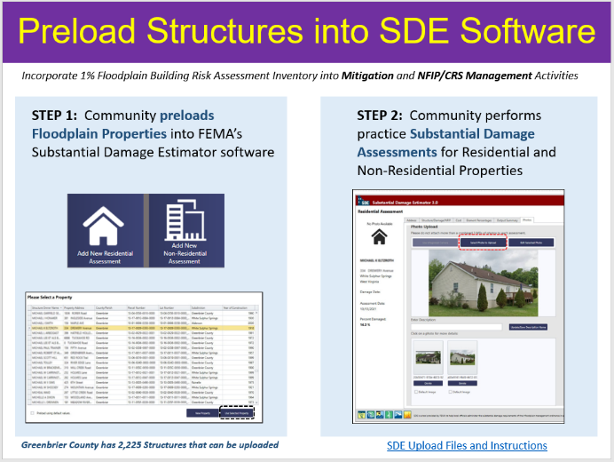

(3) Communicate SFHA Map Changes to Affected Property Owners: Template mail merge documents from the FEMA Region 3 "Local Officials Toolkit: What to Do Before and After Your Flood Maps are Finalized" have been created to send to property owners with new flood mapping updates during the appeal period for the restudy. Information about changes in floodplain risk and base floodplain elevation can be communicated to individual homeowners. The base flood elevation is increasing 6 feet, for example, for the highly flood vulnerable and economically disadvantaged community of Camden-on-Gauley on the Gauley River in Webster County. Mailing addresses of affected property owners are retrieved from the statewide tax assessment database. This activity qualifies for FEMA’s Community Rating System credits. See SFHA Mail Merge Template and Instructions.
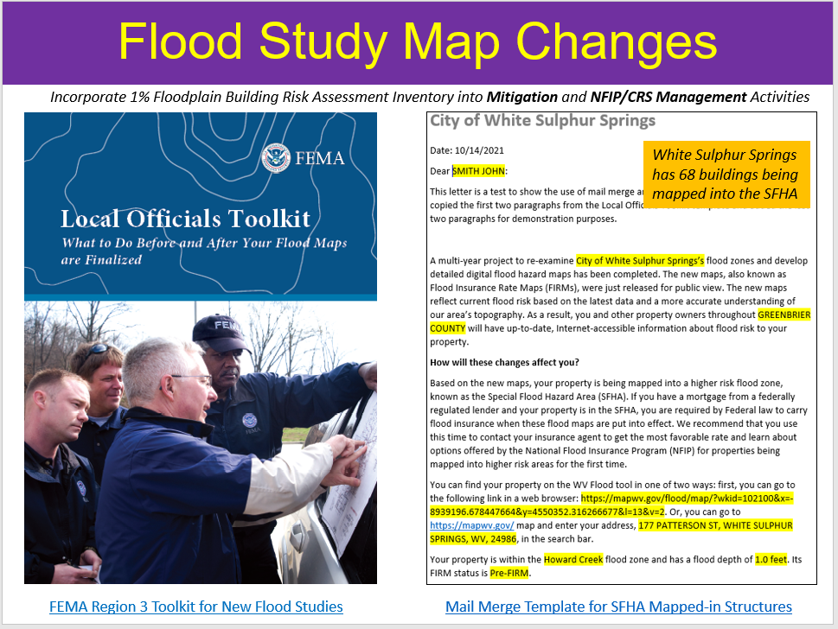

(4) Promote LiDAR LOMAs Function WV Flood Tool: West Virginia now has statewide coverage of QL2 LiDAR data and LiDAR-derived elevation products of one-meter DEMs and 1-foot contours. LiDAR LOMAs can be submitted for qualifying structures using FEMA’s Online LOMA portal. The Flood Tool’s Print Function generates map layouts for the LiDAR submissions using either the contour or point elevation methods. To save disadvantaged communities and homeowners the cost of needing a site elevation survey, communicate to these constituents how the "mapped out" structures (primary building structures symbolized by yellow squares) displayed on the RiskMAP View of the WV Flood Tool may qualify for removal of the structure from the SFHA. The only information required for an Online LOMA submission are a map layout from the Flood Tool and a copy of the deed.
LiDAR LOMA Documentation:
- WV Flood Tool LiDAR LOMA: Instructions | Overview Slides and Guide
- WV LIDAR LOMA Map Layout Examples
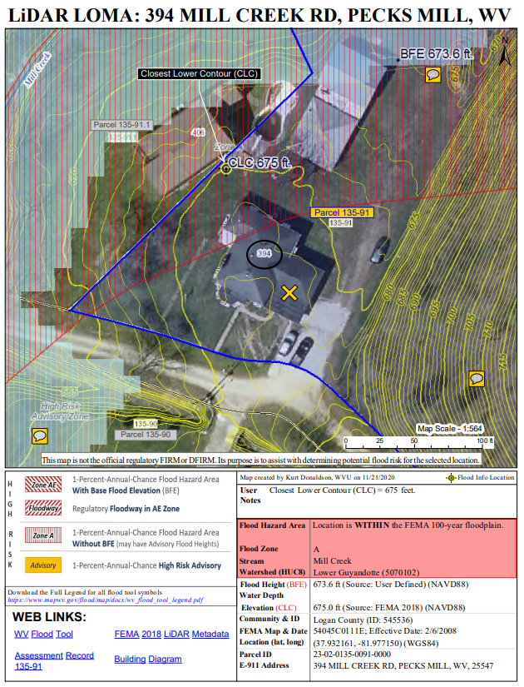

Example LiDAR LOMA Print Layout generated from WV Flood Tool.

(5) Document Mitigation Status of 98,467 Flood-Prone Structures: A comprehensive inventory of existing mitigated structures results in more accurate building level risk assessments and shows how communities have applied flood adaptive measures in response to major flood events. Coordinate closely with the State NFIP Coordinator and other partners to incorporate a mitigation status data field into the Building-Level Risk Assessment Inventory and WV Flood Tool to determine which structures have been mitigated. A data management field will identify the type of mitigation (elevation, barrier, wet floodproofing, dry floodproofing, etc.). Initial focus will target new construction Post-FIRM Minus-3 Rating structures, about 2% of the statewide building inventory of high-risk flood-prone buildings, to determine if these structures are compliant and properly mitigated to the community’s floodplain management development standards. Other tracking data management fields could include if a permit and elevation certificate exist. This activity requires community engagement with the floodplain managers to validate mitigated structures where no elevation certificates, building pictures, or other mitigation project data exists. A data management tracking system will be developed to log contacts and building mitigation status initiated by the State NFIP Office (and its agents) and other interested partners (CRS/ISO Specialist) partners. This information will be shared with partners who monitor or audit floodplain management programs. Structure-level mitigated status information will be tracked by the unique building identifier (Parcel ID + Address No.) and the WV Flood Tool shared map link. This activity will engage flood-prone communities, thereby providing outreach and training opportunities to encourage communities to adopt higher flood protection standards through ordinances as well as other flood adaptive measures.

Top Building Most Vulnerable Lists
Engage the communities with the most vulnerable lists to validate mitigation statuses of buildings.
- BLRA Data Extract Tables: High Building Value, High Damage Loss, High Minus Ratings
- BLRA Statewide Top Lists: Building Value, Flood Depth, Damage Loss $, Damage Loss %, Minus Rated, Mitigated Structures
Mitigated Structures
A comprehensive inventory of mitigated structures results in more accurate building level risk assessments and shows how communities have applied flood adaptive measures in response to major flood events. Sources for verifying first floor heights of elevated structures are elevation certificates, building pictures (step 7” rise, cinder block 8”), and major post-disaster mitigation reconstruction projects (1977 and 2016 floods) described below.

- Post-FIRM Minus Rated Structures
- Mitigated Structures where First Floor Heights > 5 feet
- WV Building Pictures of Mitigated Structures
June 2016 Flood of Central West Virginia: The devastating floods from the June 2016 flood have resulted in the largest regional mitigation project since the historic April 1977 flood in the Tug Fork River Basin. From the June 2016 flood, thousands of buildings were destroyed or damaged, at least 23 people were killed, and communities throughout West Virginia were inundated with floodwaters. A state of emergency was declared in 44 of West Virginia’s 55 counties, and 12 of these counties received a Presidential Disaster Declaration. The National Oceanic and Atmospheric Administration (NOAA) estimated that overall damages from the storm system amounted to over $1 billion (FEMA 2016 Flood Report). A news article dated December 7, 2021, in The Intelligencer / Wheeling News-Register newspaper, reported that as of November 2021, the WV RISE program had completed 350 housing projects and 42 bridges. According to RISE, 90% of its housing projects were complete, with 78% of bridge projects completed. Combined with the 47 demolition projects, $82.4 million has been spent for mitigation measure associated with the June 2016 flood.
Mitigated structures from major June 2016 Flood
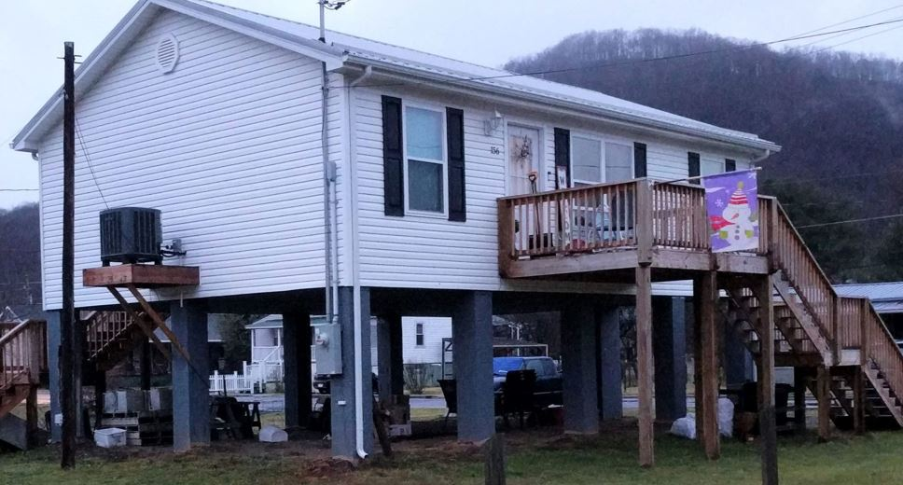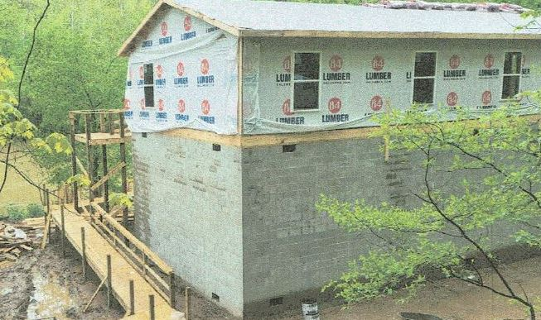

April 1977 Flood of Tug Fork Basin: The Tug Fork Basin was devastated in April 1977 by the flood record of the basin, causing an estimated $698.7 million (October 1996 Price Level) in damages. Comparing the WV RISE mitigation program to the 1977 flood reconstruction program, the USACE Section 202 Non-Structural Project resulted in an estimated 397 housing projects and 257 buyout property acquisitions completed for Mingo and Wayne counties. A significant number of property acquisitions occurred in McDowell County as well. The mitigation projects including high-water marks, close-out reports, and operation manuals completed by 2008.

- USACE Nonstructural Projects from 1977 Flood:
  - Wayne County Nonstructural Project (2006)
  - Upper Mingo County Nonstructural Project (2007)
  - Lower Mingo County Nonstructural Project (2008)

Community Engagement Diagram: 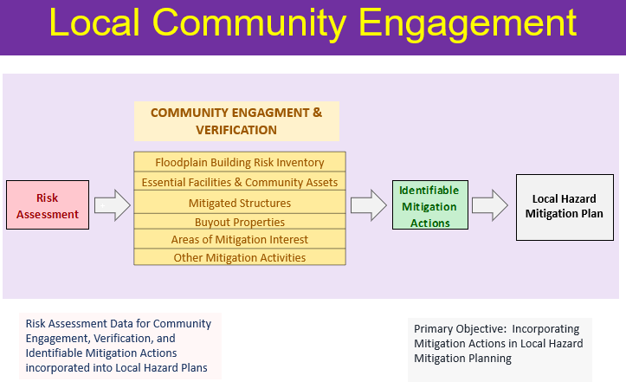

(6) Develop and Verify Community Flood Risk Profiles: Use the building level-risk assessments to create community risk profiles at the regional and state scales. Aggregate key risk factors into Exposure and Flood Model matrices. A Mitigation Matrix of mitigated properties, open space preservation, etc. can be developed as well. The community risk profiles would supplement FEMA’s Flood Risk Dashboards, a snapshot of a community’s flood risk statistics at the time the community is going through a flood mapping update. The profiles are done at the County, Unincorporated, and Incorporated levels (including eight split municipalities across county boundary lines). Risk communities will be compared to statewide mean/medium/maximum statistics. Incorporate WV Building Level Risk Assessment (BLRA) information to FEMA’s Jurisdictional Flood Risk Dashboard templates, web community risk tables, etc. These community flood risk profiles can be incorporated into the 2023 State Hazard Mitigation Plan Update. It is important to identify disadvantaged communities in the State that may be at higher risk due to climate change impacts and thus require additional focus and support in their flood protection measures.
Example Region 4 Community-Level Risk Matrices for Exposure and Flood Loss Models.
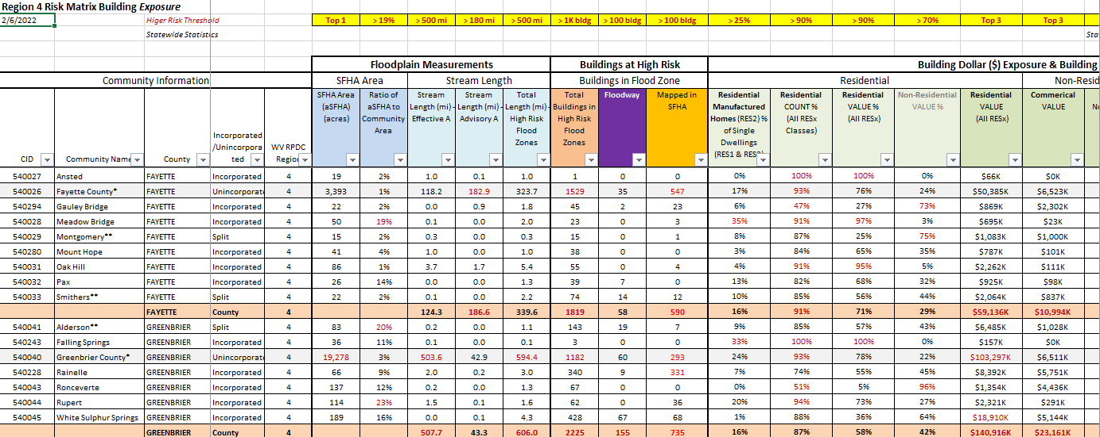

Supplement FEMA’s Jurisdictional Disaster Dashboards with supplemental risk assessment information from the statewide building level risk assessment (BLRA).
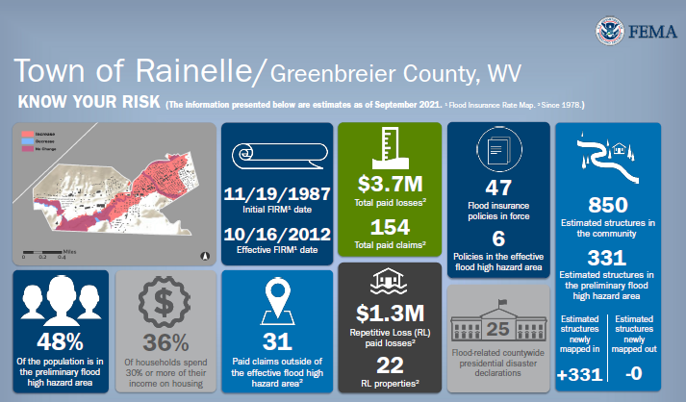
Example Jurisdictional Dashboards

(7) Model Potential Mitigation Measures and Communicate to Communities: Use model-backed depth grids and the building-level risk assessment inventory (BLRA) to identify mitigation measures for properties. For example, identify buildings with solid wall crawl spaces which would qualify for flood vents, one of the cheapest mitigation solutions for existing structures. Communicate this mitigation information to communities where types of building foundations are prevalent and would qualify for flood vents. Communicate the cost in savings in flood insurance by installing flood vents and adjusting the lowest floor elevation.
- 4,716 Non-Residential Structures to consider for Dry Floodproofing. Dry Floodproofing Criteria: Building Non-Residential (Commercial and Other Residential), Not in floodway (velocity not > 10 feet/sec), Flood Depth < 3 feet

- 10,038 Residential Structures to consider for Wet Floodproofing. Wet Floodproofing Criteria > Building Residential (Occupancy Class (RES1, RES3A, RES3B), Foundation Code = Perimeter Wall (Crawl Space), Not in floodway, Flood Depth < 12 feet

USACE Nonstructural Flood Risk Management Matrix:
https://usace.contentdm.oclc.org/digital/collection/p16021coll11/id/708/
Heat maps show the Kanawha River Valley as a high potential target area for residential mitigation.
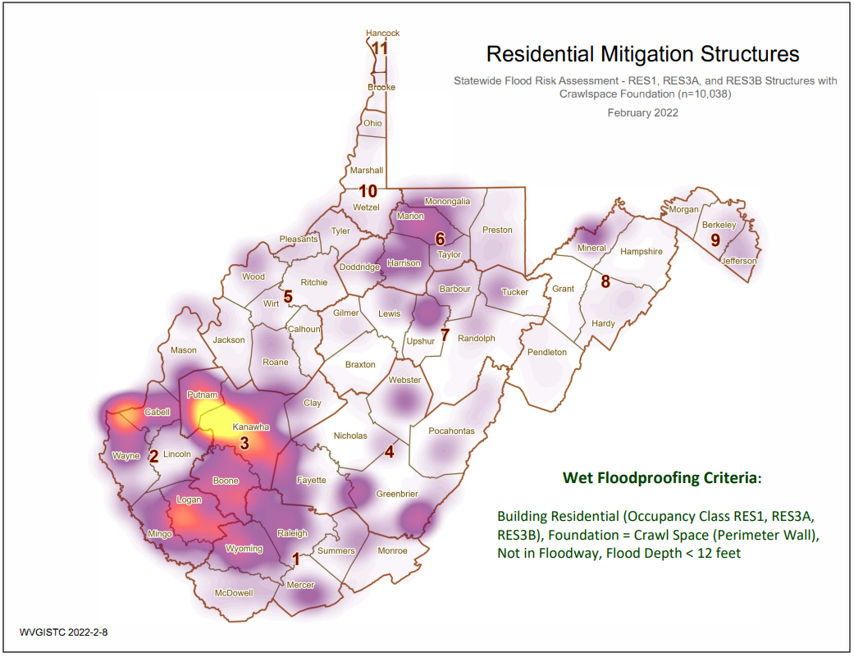

The RiskMAP View of the WV Flood Tool shows a high-risk advsisory flood zone in the city of St. Albans (Kanawha County) where are large number of residential “mapped-in” structures (orange circles) with elevated crawl space foundations (green diamonds) would be eligible for flood vents, one of the cheapest wet floodproofing mitigation measures for homeowners to considers. Vew online map of area for mitigation consideration.
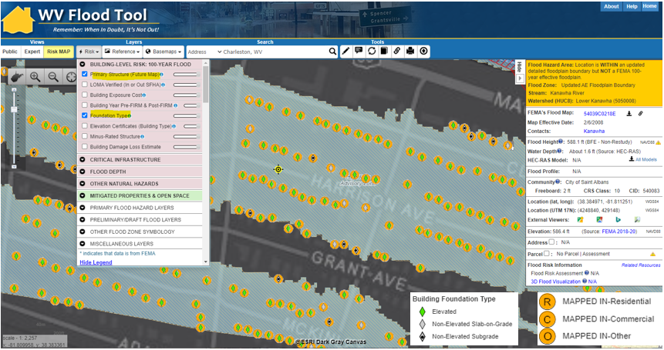
Flood-prone residential structures in St. Albans in which crawl space foundations and the flood depth would qualify for flood vents. See Google Street/3D Map View of structures.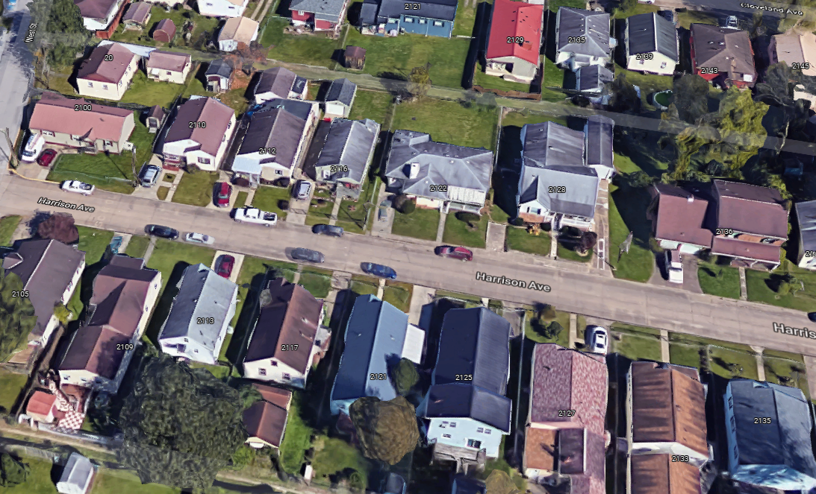

- (8) Engage Communities to Validate Areas of Mitigation (AOMI) on WV Flood Tool.
Engage communities to validate AoMIs identified from the statewide risk assessment. Areas of Mitigation (AoMI) are identified by Repetitive Loss structures, Substantial Damage Estimates, Floodway Structures, Mitigated Properties, Flood Depths, High-Water Marks, and Similar Topography. See statewide graphic of Areas of Mitigation Interest (AoMI) mapped to date. AoMIs support the community prioritization of identifiable measures for hazard reduction planning and actionable mitigation projects. AoMIs are published on the RiskMAP View of the WV Flood Tool.
AoMI determination layers may include:
- Buyout Properties
- High Flood Depths or Water Depths-in-Structure
- High-Water Marks
- Non-Residential |Residential building dollar damage estimates
- Substantial Damage Estimates
Area of Mitigation Interest (AoMI) for Rainelle, WV. Area of interest includes buyout properties, high-water marks, building damage estimates, and structures in the floodway. View map link on WV Flood Tool.
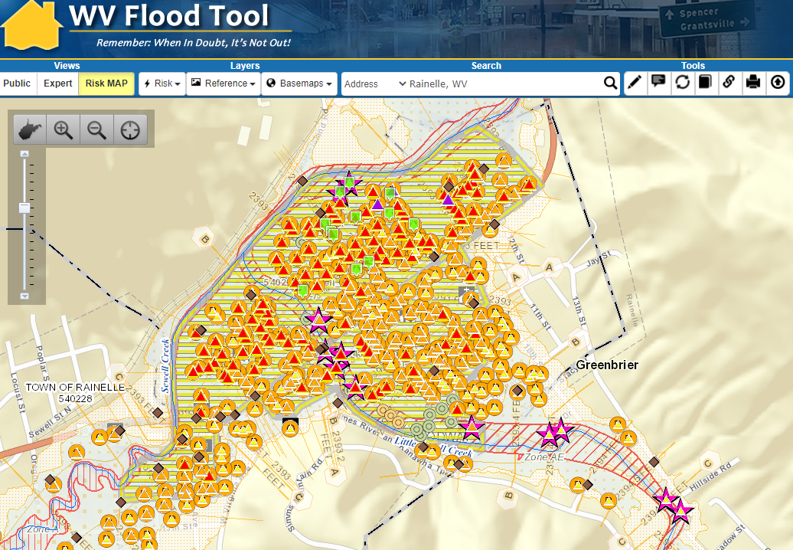

Project Total: $70,000

APPENDIX B: Detailed Scope of WVU Led PM Activities
2022-23 CTP Services and Projects performed by West Virginia University
State: West Virginia
Total Costs: $180,000 Base CTP Funding (Global Outreach for Mapping activities)
Performance Period: October 1, 2022, to September 30, 2023 (12 months)
Plan by Kurt Donaldson, Manager, WV GIS Technical Center, West Virginia University
6/28/2022

EXECUTIVE SUMMARY
Global Outreach Services – CTP Base Funding. Cost $180,000
Global Outreach Services for WV Flood Tool.
- Statewide global outreach services that process and integrate new flood and reference GIS layers, tool enhancements, flood risk information, etc. for the WV Flood Tool (www.mapwv.gov/Flood). Services include computer programming, data development/geoprocessing, customized mapping, and technical support services (Task A). This project also supports two other activities in which a recent nationwide flood risk assessment determined that 46 percent of the roads in the State and 51 percent of the State’s critical facilities — the highest state-level percentages in the Nation — would be closed by flooding based on current and future climate change models. The first subtask (Task B) integrates the WV Building Level Risk Assessment (BLRA) with FEMA’s national inventory so standardized, consistent, and accessible building level information can be exchanged. Another subtask (Task C) enhances transportation flood inundation models on the RiskMAP View of the WV Flood Tool. See Table 1 for more detailed information.

Table 1. 2022-23 CTP Work Tasks
# | Task Description | 2022-23
CTP Base Funding  Task A | [GLOBAL OUTREACH SERVICES FOR WV FLOOD TOOL]  Statewide global outreach services that process and integrate new flood and reference GIS layers, tool enhancements, flood risk information, etc. for the WV Flood Tool (www.mapwv.gov/Flood). Services include computer programming, data development/geoprocessing, customized mapping, and technical support services. It supports new initiatives such as the WV Building Level Risk Assessment (BLRA) with FEMA’s national inventory so standardized, consistent, and accessible building level information can be exchanged. Another task includes to enhance transportation flood inundation models for roads, railroads, and bridges to WV Flood Tool. This project supports disadvantaged, vulnerable communities subject to changing climate conditions in which models predict substantially higher stream flow conditions for watershed basins location south and east of the Ohio River. The WV Flood Tool and global outreach services support stakeholders in pre-disaster actions around adaptation, resilience, and mitigation. The global outreach supports FEMA’s NFIP/CRS Program objectives to:  - Maintain consistent national standards while interjecting a tailored, local focus  - Use local data and integrate at state level to facilitate floodplain management  - Utilize local experience and knowledge  - Provide training and technical assistance  - Provide communities with state-based CRS credits  - Support Risk MAP Program Goals of Flood Hazard Data, Public Awareness and Outreach, Risk Planning, Enhanced Digital Platform, and Alignment and Synergies  Through collaboration with Local, State, and Federal entities, the WV Flood Tool delivers quality data that increases public awareness and leads to actions that reduce risk to life and property  To manage the wealth of available data and better communicate flood risk, the WV Flood Tool has maintained a public facing outreach tool for the public, communities, engineering/surveying companies, and others (Insurance companies, lending institutions, real estate companies, etc.) that has provided effective floodplain models, supporting datasets, water-surface elevations, floodplain boundaries, and additional enhanced flood risk information. During the past decade, the functionality and quality of data layers of the WV Flood Tool have progressed, resulting in an increased use of the application. Over time the WV Flood Tool has become more than just a flood determination tool, and today is routinely used by floodplain managers for building permit applications, floodplain regulations enforcement, pre- and post-disaster assessments, Community Rating System discounts, and flood risk planning. For risk assessment and planning, the RiskMAP View includes structure-level risk assessments and mitigated properties to aid in flood reduction efforts. This initiative enables the website and the WV Flood Tool's global outreach program to adapt and remain relevant as both the datasets and technology continue to evolve.  Specific tasks under global outreach services in support of the WV Flood Tool include:  New Flood Map Products:  - Incorporate new regulatory and non-regulatory flood hazard layers into the WV Flood Tool. Publish all the flood layers, query layers, geoprocessing layers, models, and attributes according to standardized procedures and cartographic design.  - Effective and Preliminary National Flood Hazard Layers (e.g., Countywide RiskMAP Studies, 2016 Flood PRM Reaches in Southeastern WV)  - Add effective or draft/preliminary NFHL, WSEL, and Flood Depth  - Advisory Flood Heights and Base Flood Elevations  - For Preliminary Flood Heights, in Flood Query Results Panel link Preliminary Flood Zones to FEMA’s Map Changes Viewer  - Flood Study Status Graphics  - Active Flood Studies  - Advisory Flood Heights  - FEMA R3 Project Status Graphic  - Floodplain Boundary, WSEL, Depth Layers  - Floodplain Boundary: Advisory A Zones  - WSEL: Advisory A Flood Heights (Advisory Base Flood Elevations)  - Depth Grid: Model-Backed (HEC-RAS) Advisory A Depth Grids  - Other Flood or Flood-Related Layers  - Elevation Certificates  - LOMAs, LOMRs (including Location-Verified LOMAs to correct parcel or structure)  - Panel Index (GeoIndex)  - Mitigated Buyout Properties  - Flood Query Results Layers: Flood Zone Designation, Stream Name/Flood Source, Model Download  - USGS High Water Marks and Stream Gages  - H&H Hydrologic/Hydraulic Downloadable Models  - Structure (bridges, culverts, etc.) Data Files (data files are needed)  - Flood Manager List on WV Flood Tool  - Model-Backed Studies. The statewide Hazus depth grid created in 2010 is inaccurate and thus has a negative impact on building-level flood risk assessments and flood visualizations. Adding model-backed depth grids from flood studies improves the coverage and accuracy of the statewide depth grid, a flood risk assessment priority of attaining model-backed, gridded flood-risk depth grids for all 1-percent flood zones in West Virginia. In addition, model-backed Base Flood Height values provide important information for the Flood Query Results Panel and for processing LiDAR LOMAs using the Print Function of the WV Flood Tool. Lastly, depth grid errors associated with mapping issues identified from anomalous building level risk assessments are forwarded to Region 3 for CNMS problem area tracking.  - Follow WV GIS Technical Center’s procedural guide for creating Flood Depth/Water Surface Elevation Grids and Redelineated AE Floodplains. The methodology creates a Water Surface TIN from the NHFL X-Sections, converts the WSEL TIN to a grid, and then subtracts the Ground Elevation Grid from the WSEL Grid to create the Water Depth Grid.  Application Programming Development:  - Execute software programming updates for desktop and mobile versions. Modify programming code of JavaScript application (www.mapwv.gov/flood) to enhance tool functions, messages, data layers, and cartography. Update flood risk information to the WV Property Search Tool, a companion product of the WV Flood Tool, to allow users to identify, for example, new structures built in flood zones. Make other tool enhancements based on requests from WV NFIP Coordinator.  Desktop Version: https://www.mapwv.gov/flood  Mobile Version: https://www.mapwv.gov/flood/mmap  Property Search and Report: https://www.mapwv.gov/property  - Enhance tool functions based on feedback or new opportunities. Program other application enhancements to include synchronizing with FEMA’s National Flood Hazard Layer (NFHL) web services and FEMA Map Store products. Evaluate consuming NFHL web services with performance testing and other suitability measures. Program failover protocols for external web map services consumed by the Flood Tool. Enhance the WV Flood Tool to leverage the statewide building-level flood risk assessments generated from a Hazard Mitigation Grant.  - In addition, the application programming development will include application updates to enhance tool functions, messages, data layers, and cartography.  Update Flood Query Panel with New Flood Risk Data:  - Develop and publish new risk assessment and mitigated layers to the WV Flood Tool, specifically  - Mitigated Structures (wet floodproofing, dry floodproofing)  - Elevation Certificates (focus on elevated Building Diagrams 5-8)  - Dam Inundation Zones (for query purposes only)  - 500-Year Depth Grids from new flood studies (both AE and A zones)  Update Flood Query Panel with New Flood Risk Data:  - Maintain and enhance Flood Query Results Panel with Dam Inundation Zones and 500-year flood depth values.  - Dam Inundation Zones: The WV Flood Tool’s query result panel for the RiskMAP View can be updated to alert a location that falls within a failed dam inundation zone. New flood inundations zones have been made available by the WV Conservation Agency and USACE for select dams. In addition, risk assessments can be done by performing an intersection between the built-up environment and flood inundation zones.  - WV Dam Inundation Viewer of 168 High Risk Dams from the WV Conservation Agency  - USACE Dam Inundation Viewer: https://nid.usace.army.mil/viewer/index.html  - Summersville Dam Example: https://nid.sec.usace.army.mil/viewer/index.html?dsLibrary=NID-MD00069,NID-WV06702&x=-80.901&y=38.223&z=15  - 500-Year Flood Zone Depth Values: FEMA’s new RiskMAP studies are generating 500-year depth grids for riverine flooding. This information can be added to the RiskMAP View of the WV Flood Tool. The only way now to determine 500-year depths on the Flood Tool are by viewing the Flood Profiles of detailed studies.  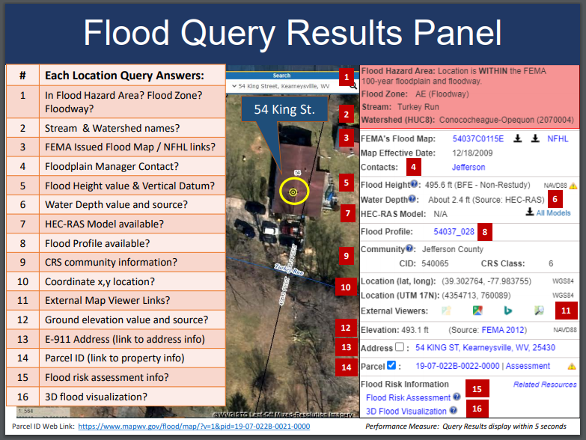  << Query Results Panel >>  Reference Data:  - Process and integrate new reference data to make the WV Flood Tool more accurate and current and for which communities can receive FEMA CRS credits. This task includes the publishing and caching of web map services that support the Flood Tool. The new FEMA-purchased LiDAR and derived elevation products are quite large in file size and require extensive computer processing and quality control checks before being published to the WV Flood Tool. Key reference data sets are ground elevation, parcels/assessment records, E-911 addresses, and aerial imagery.  - HI-RESOLUTION TOGPOGRAPHIC DATA:  - Update the WV Flood Tool with other reference layers (leaf-off aerial photography, E-911 site addresses, and property parcels/assessment records) that are essential in identifying flood risk structures with the WV Flood Tool.  - Accurate, high-resolution LiDAR-derived elevation products such as one-foot contours and one-meter DEMS that are incorporated into the WV Flood Tool are beneficial for floodplain determinations, LIDAR LOMAs, LAGs, water depth flood visualizations, flood risk studies, etc.  - PROPERTY PARCELS AND ASSESSMENT RECORDS: Update statewide parcel layer and assessment records to WV Flood Tool. Accurate and current parcels and assessment attributes are essential to identifying flood risk structures in the WV Flood Tool  - Statewide Parcel Products (annual update) for Flood tool:  - Master surface parcel file and standardized assessment attributes  - Sketch diagrams for building identification of residential properties  - Parcel history (17 years) to search previous owners or deed book numbers. Important for improving positional accuracy of LOMAs and Buyout Properties.  - Integrate surface parcel geometry for all 55 West Virginia counties  - Join assessment records for commercial and residential properties for current tax year  - Join parcels to more than 20,000 full-version tax maps  - Coordinate parcel development with WV Property Tax Division and county assessors  - Intersect parcels/assessment records with flood zones and classify according to risk (high, moderate, low)  - E-911 ADDRESSES: Update E-911 site and street addressing layers and address matching geocoding services for Flood Tool. Accurate and current E-911 site addresses are essential to identifying flood risk structures in the WV Flood Tool.  - AERIAL PHOTOGRAPHY: Add new 2022 leaf-off aerial photography for multiple counties to Flood Tool. Coordinate with county, state, and federal agencies through new West Virginia Orthoimagery Program. Accurate and current leaf-off aerial photography is essential to identifying flood risk structures in the WV Flood Tool.  - OTHER LAYERS: Update other reference layers (e.g., community boundaries, wetlands, public lands) that support FEMA CRS/NFIP programs and the WV Flood Tool. Accurate and current reference layers are important to Communities for state-base CRS credits and for users referencing features of interest.  - Resource Link: WV Flood Tool’s Reference Layers  Technical Services:  Perform outreach and training services to include developing print and online educational materials, delivering presentations, administering email listserv, and participating in Flood Tool coordination meetings and data exchange with State NFIP, FEMA, USACE, NRCS, and other cooperators. Provide technical support to the Flood Hazard community like specifications (e.g., HEC-RAS downloadable model specifications) for contracts and other technical queries associated with flood and reference data. Enhance the WV Flood Tool to effectively increase flood risk communications for the public and communities. Educate and outreach to counties about submitting their locally produced address, parcel, imagery, and elevation data for inclusion in the Flood Tool.  - Technical Services include:  - Promotional materials (flyers, videos, etc.)  - Presentations (webinars, meetings, etc.)  - Update content of Flood Tool launch page  - Update listserv and contact list of community floodplain managers  - Coordination meetings and project scoping for USACE WV Silver Jackets projects that support WV Flood Tool  - Standardized Data Exchange  - Instructional videos for Flood Tool and WV Building Level Risk Assessment (BLRA)  - Updating WV Flood Tool and Flood Risk Assessment Glossary  - Update various WV Flood Tool Resources web pages and links  - Bundle FEMA and other agency risk assessment and mitigation resources for the WV floodplain management community (Permits, Elevation Certificates, Mitigation Resources, Model Floodplain Management Ordinance, etc.)  - 70% of WV floodplains are Approximate A Zones and not detailed studies. Identify future potential detailed studies where there are large numbers of floodplain structures in Approximate A Zone stream reaches with high flood depths (> 10 feet). See graphic.  - Technical support for local and state hazard mitigation plan updates. Accessed by an Index Guide spreadsheet named “RA_Info_Index.xlsx,” risk assessment products include GIS layers, tables, subject reports, 3D Visualizations, and community profile risk matrices to supplement FEMA’s Community Flood Risk Dashboards. | $155,000
CTP Base Funding  Task B | [WV BUILDING LEVEL RISK ASSESSMENT (BLRA) INTEGRATION WITH FEMA’S USA STRUCTURES PROGRAM]  Over the past several years, the number of distressed counties in West Virginia has been steadily increasing. For FY 2022, West Virginia will have 17 distressed counties (most economically depressed counties) and 11 at-risk counties (counties at-risk of becoming economically distressed). Identifying and exchanging risk assessment/mitigation data at the building level is necessary to assist decision-makers supporting disadvantage communities in which devastating riverine flooding is projected to increase during this century.  Standardized structure-level information is required to support local and State hazard mitigation planning as well as other flood reduction efforts. This activity will tie in the WV Building Level Risk Assessment (BLRA) with FEMA’s national inventory so standardized, consistent, and accessible building level information can be exchanged. Primary objectives of this activity include:  - Increase the 70% match rate to above 90% between the WV Flood Risk Building Inventory and FEMA’s USA Structures. The WV Best Leaf-Off photography statewide coverage is the highest temporal and resolution imagery in the State. West Virginia ranks as the third most forested state in the nation and often has a dense forested canopy that makes identify structures remotely more difficult. Leaf-off imagery provides a reliable source for identifying building footprints.  - Collaborate on generating comprehensive building footprints with unique identifiers and complete building risk assessment attributes.  - Coordinate in exchanging accurate, property-level flood risk and mitigated information in an efficient manner with FEMA and other local, state, and federal partners.  - Collaborate specifically with Region 3 and FEMA Headquarters Geospatial Officer Chris Vaughan.  Comparison of current USA Structures to WV BLRA:  < Current Match between USA Structures and WV BLRA >>  - 2021 USA Structures (for WV): 1,085,876 structure footprints  - WV BLRA: 98,467 points of primary structures located in the 1%-annual-chance floodplain  - 69,575 WV BLRA points intersect with USA Structures (70% match rate)  << Match between Microsoft Building Footprints and WV BLRA >>  - 2018 Microsoft Footprints (for WV): 1,020,048 structure footprints  - WV BLRA: 98,467 points of primary structures located in the 1%-annual-chance floodplain  - 80,659 WV BLRA points intersect with USA Structures (82% match rate)  - BLRA Points that don’t match lie outside of, or missing, Microsoft’s building footprint outline.  << W BLRA Points (red) intersect with FEMA’s USA Structures (green footprints). Black building outlines are Microsoft footprints. >>  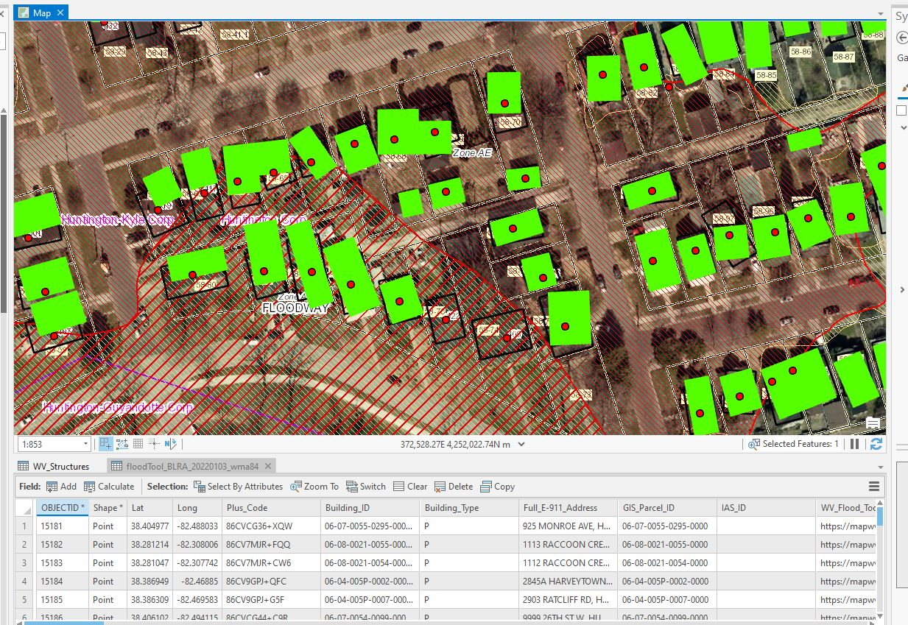 | 15,000
CTP Base Funding  Task C | [ENHANCE TRANSPORTATION FLOOD INUNDATION MODELS FOR ROADS, RAILROADS, AND BRIDGES TO WV FLOOD TOOL]  In West Virginia, according to nonprofit First Street Foundation’s October 2021 report titled "The 3rd National Risk Assessment: Infrastructure on the Brink," 46 percent of the roads in the state and 51 percent of the state’s critical facilities — the highest state-level figures in the Nation — would be closed by flooding. Using modeling that incorporates climate change, First Street’s risk assessment report quantifies the huge current and future number of critical facilities and road segments that would be shut down by an average flood. Because of the vulnerability to the State’s transportation infrastructure, the WV GIS Technical Center will update and improve on its flood inundation models for roads, railroads, and bridges for a 1%-annual-chance (100 yr.) event.  Specifically, this activity will develop and publish transportation inundation models for a 1%-annual-chance flood event:  - Bridges Inundated: Use the FEMA-purchased LiDAR to identify each bridge deck elevation and then compare with available base flood elevations to determine if the bridge will be inundated by a 1%-annual-chance flood event. This activity will be conducted statewide for all major bridges from a WV DOT bridge source where base flood elevations exist.  - Roads and Railroads: Update existing road and railroad inundation models from new flood map restudies that produce new base flood elevations. Where no model-backed depth grids exist, substitute with the less accurate Hazus depth grid.  - Publish all transportation inundation models to the WV Flood Tool.  - Update community-level risk assessment transportation inundation reports. Communicate results of inundation models to stakeholders of hazard mitigation plan updates.  << WV Transportation Flood Inundation Model on RiskMAP View of WV Flood Tool >>  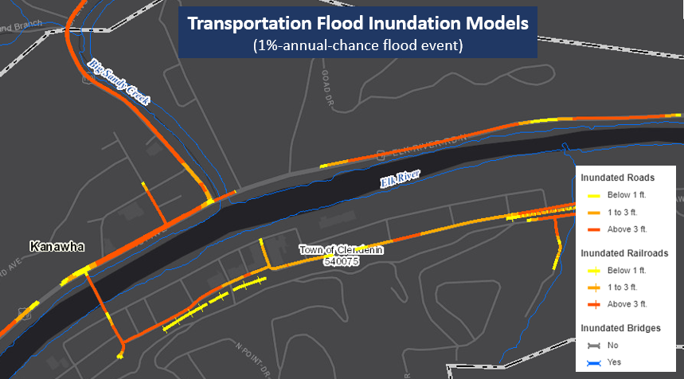  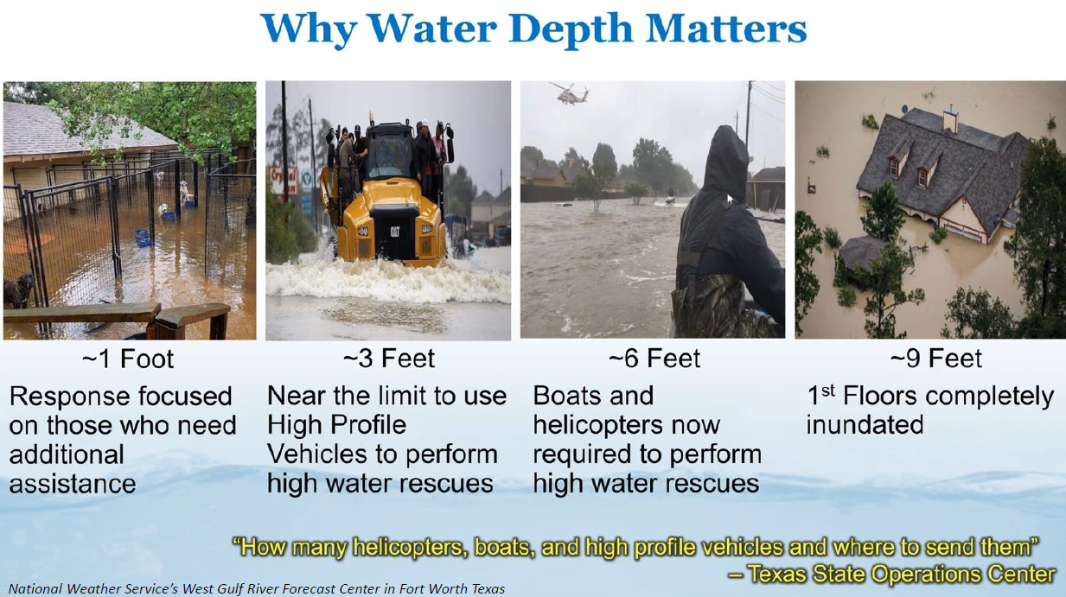  << Highest Road Flooding Risk in the Nation >>  According to the nonprofit First Street Foundation’s October 2021 report titled "The 3rd National Risk Assessment: Infrastructure on the Brink," 46 percent of the roads in the state and 51 percent of the state’s critical facilities — the highest state-level figures in the Nation — would be closed by flooding.  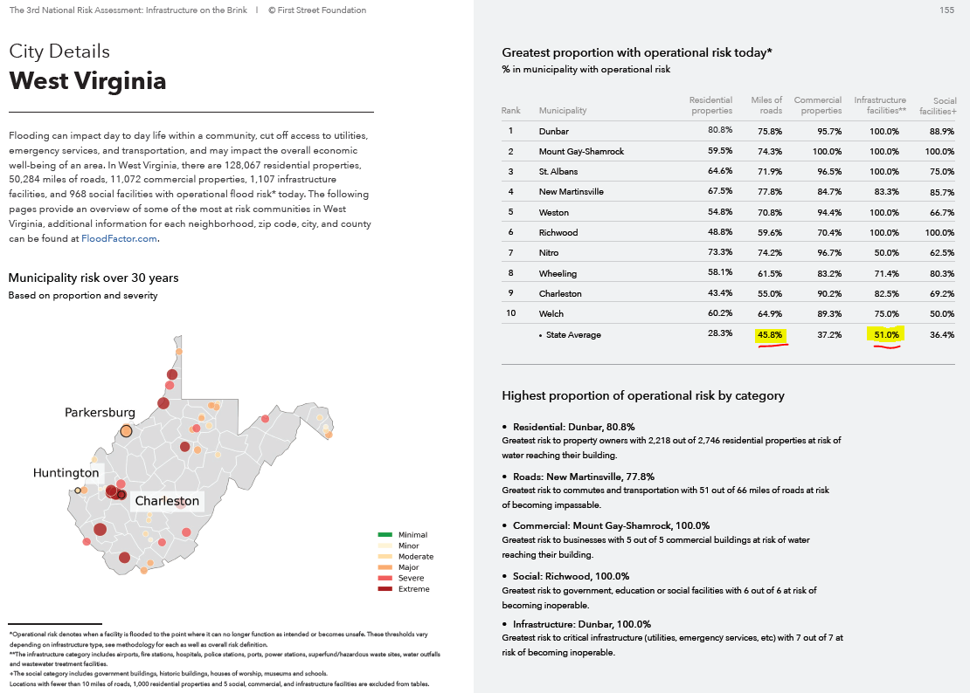 | 10,000
This Agreement supports the goals and objectives of the Cooperating Technical Partners (CTP) Program

- Enhanced Risk Assessment Data: Address gaps in flood hazard data to form a solid foundation for risk assessment, floodplain management, and actuarial soundness of the NFIP.
- Public Awareness/Outreach: Ensure that a measurable increase in the public’s awareness and understanding of flood risk results in a measurable reduction of current and future vulnerability.
- Hazard Mitigation Planning: Lead and support states, and localities to effectively engage in risk-based mitigation planning resulting in sustainable actions that reduce or eliminate risks to life and property from natural hazards.
- Enhanced Digital Platform: Provide an enhanced digital platform that improves management of Risk MAP, stewardship of information produced by Risk MAP, and communication and sharing of risk data and related products to all levels of government and the public.
- Alignment and Synergies: Align risk analysis programs and develop synergies to enhance decision-making capabilities through effective risk communication and management.

 | Total Amount | $180,000

