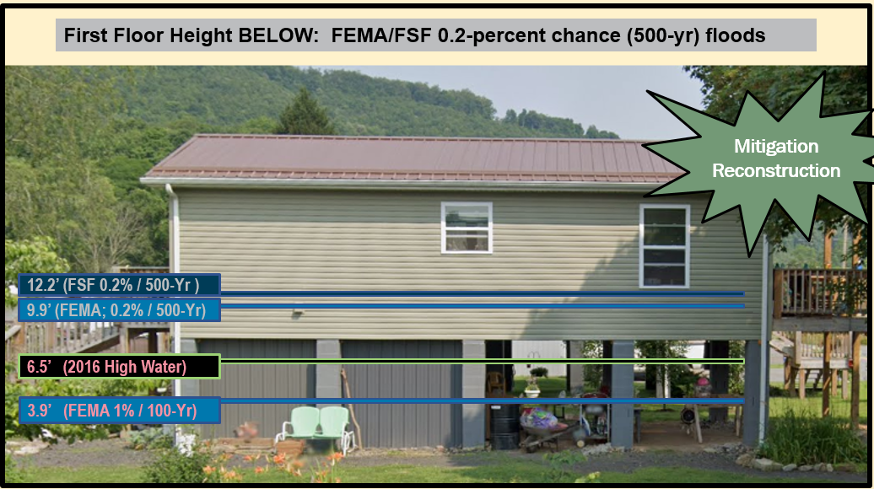



WV Emergency Management Division
COOPERATING TECHNICAL PARTNERS (CTP)
FEMA-APPROVED COMMUNITY OUTREACH AND MITIGATION STRATEGIES (COMS)
STATEMENT OF WORK (SOW)
COMS SOW No. 2

Fiscal Year 2023

This page intentionally left blank

Table of Contents
1. Part 1 – Custom Statement of Work Information 4
1.1. Project and Point of Contact Information 4
1.2. Tasks and Deliverables to be Completed Under this SOW 6
1.3. Schedule and Performance 17
1.4. Standards 19
1.5. Use of Contractors 20
1.6. Reporting and Performance 20
1.7. Privacy and Protection of Personally Identifiable Information 21
Authorized Representative Signatures 22
APPENDIX A: Scope of State NFIP Office COMS Tasks A-1
APPENDIX B: Scope of WVU Led COMS Tasks B-1
APPENDIX C: WV Equity and Climate Change Statements C-1

Part 1 – Custom Statement of Work Information

Project and Point of Contact Information

Table 1. Project and Point of Contact Information

Information Type | Insert Information
Project Name/Title (if applicable) | WVEMD CTP COMS 2023-24
CTP Organization Name: | WV Emergency Management Division
CTP Contractor Working on the activities in this SOW:  Optional, only if contractors have already been identified; contractor support may be engaged for all activities except Staffing and Mentoring, which must be completed by the CTP | WVU GIS Technical Center, West Virginia University
Sub-Recipient Working on the activities in this SOW:  Optional, only if sub-recipients have already been identified; contractor support may be engaged for all activities except Staffing and Mentoring, which must be completed by the CTPS | N/A
CTP Partnership Agreement Date: | 8/2023
Period of Performance: | 10/1/2023 to 9/30/2024
CTP Project Manager: | Timothy W. Keaton, CFM
FEMA Regional Project Officer (PO):  When necessary, ask for FEMA assistance through the FEMA Regional PO | Kristen Jones (primary contact)  Senior Risk Analysis Management and Program Analyst | Mitigation | Region 3

Information Type Insert Information
FEMA Funding to Complete this SOW: | $250,000
CTP Estimated Leverage:  Final leverage dollars or units will be entered as applicable in the Manage Data Development Task Workflow in the Mapping Information Platform (MIP). The leverage noted here is an estimate of leverage available at the time when the scope is prepared. It may be refined at any time in the project. See Estimating the Value of Partner Contributions to Flood Mapping Projects “Blue Book” (Blue Book) | N/A
Project Team Coordination Activities:  During the project, all members of the Project Team will coordinate, as needed, to see that activities, products and deliverables meet FEMA requirements and contain accurate, up- to-date information. | - Meetings, teleconferences, and video conferences with FEMA Region III, WVEMD, and other Project Team members biannually at a minimum with additional meetings scheduled as necessary.  - Telephone conversations with FEMA and other Project Team members on a scheduled monthly basis and ad hoc basis, as required.  - Email as needed

Tasks and Deliverables to be Completed Under this SOW

NARRATIVE AND AUDIENCE

Table 2. Narrative and Audience

Information Type | Insert Information
SOW Narrative: | This CTP project focuses on mitigation support, communication and outreach to communities, and mitigation planning technical assistance activities as well as support for the WV Flood Tool. Specifically, the tasks for this year’s CTP COMS grant will:  - Create a climate of understanding and ownership of the WV Flood Tool in support of the Risk MAP flood risk study process among stakeholders  - Organize and Train Substantial Improvement / Substantial Damage Teams for Flood Disasters  - Engage the Floodplain Management Community to Submit NFIP Repetitive Loss (RL) AW-501 Worksheets and FMA Grant Applications  - Organize and Publish Resource Toolkit of Floodplain Management and Mitigation Documents  - Document Mitigation Status of Statewide Flood-Prone Structures  - Provide Global Outreach Services for the WV Flood Tool  - Deliver Technical Support Services for LiDAR LOMAs  - Perform Building Cluster Analysis for CNMS Risk MAP Discovery of Potential Approximate A Zones for Upgrade to Zone AE Detailed Mapping  - Develop, Verify, and Publish Flood Risk Profiles at State, Regional, Community, and Watershed/Stream Levels.  - Update the WV Building Level Risk Assessment (BLRA) from New Data Sources (e.g., Flood Studies, Building Characteristics)  - Communicate SFHA Map Changes to Affected Property Owners  - Support Local Hazard Mitigation Plans with Flood/Landslide Risk Assessment Data  - Perform Detailed Riverine Flood Impact and Mitigation Studies of Vulnerably Disadvantaged Communities using recently published FEMA and First Street Foundation Flood Models  This project includes mitigation, outreach, technical support activities that that support the goals of FEMA’s NFIP/CRS and Risk MAP programs. It also includes technical assistance activities that will produce and disseminate products and materials to the state and local jurisdictions to develop, evaluate, update, and implement their mitigation plans and strategies. This CTP COMS Project supports statewide global outreach services that process and integrate new flood and reference GIS layers, tool enhancements, flood risk information, etc. for the WV Flood Tool (www.mapwv.gov/Flood). In addition, an overarching goal of this CTP COMS project is to more proactively engage flood-prone communities to use the new statewide building-level risk assessment data for their floodplain management and mitigation planning activities.  The major scoping activities are divided by WV NFIP Office Led (Appendix A) and WVU GIS Technical Center led (Appendix B). Refer to Appendices A and B for detailed statements of work.
Intended Audience: | Target Audience: Floodplain Managers, Community Planners, Emergency Preparedness Officials, and Citizens of affected communities.  Project Footprint: State of West Virginia  Through collaboration with Local, State, and Federal entities, the WV Flood Tool delivers quality data that increases public awareness and leads to actions that reduce risk to life and property. To manage the wealth of available data and better communicate flood risk, the WV Flood Tool has maintained a public facing outreach tool for the public, communities, engineering/surveying companies, and others (Insurance companies, lending institutions, real estate companies, etc.) that has provided effective floodplain models, supporting datasets, water-surface elevations, floodplain boundaries, and additional enhanced flood risk information. During the past decade, the functionality and quality of data layers of the WV Flood Tool have progressed, resulting in an increased use of the application. Over time, the WV Flood Tool has become more than just a flood determination tool, and today is routinely used by floodplain managers for building permit applications, floodplain regulations enforcement, pre- and post-disaster assessments, and Community Rating System discounts. For community and emergency planners, the RiskMAP View of the WV Flood Tool now includes structure-level risk assessments and mitigated properties to aid in flood reduction efforts.

PROJECT TASKS AND DELIVERABLES
The following 10 tasks can be accomplished under this COMS SOW:

- COMS Engagement Plan (Required).
- Strategic Planning for Community Engagement.
- Meetings and Process Facilitation.
- Mitigation Support.
- Communication and Outreach to Communities.
- Training and Community Capability Development.
- Mitigation Planning Technical Assistance.
- Pilot Projects.
- Internal Partner Support Activities:
  - Mentoring.
  - Staffing.

Task 1 – Develop COMS Engagement Plan (Required)

Table 3. Task 1 – Develop COMS Engagement Plan

COMS Task | Mark “X” if task will be done under this SOW | (A) FEMA Contribution | (B) Partner Contribution |  | (A+B) Total Project Cost
COMS Engagement Plan (required as a condition of COMS funding) | ☒ | $5,000 | $0 |  | $5,000
Deliverable |  |  |  | Mark “X” if deliverable will be done under this task
Task 1: COMS Engagement Plan (required) ($5K) |  |  |  | ☒
Combined COMS Engagement and Business Plan |  |  |  | ☒
Other: {Insert additional details} |  |  |  | ☐
Custom Scope Elements
- Complete a Comprehensive State Business Plan. Complete a State Business Plan for delivery to FEMA Region III. The comprehensive Business Plan will be a single deliverable for both the Community Outreach and Mitigation Strategies (COMS) Engagement Plan and PM Business Plan. The comprehensive plan will advance the NFIP/CRS and Risk MAP programs in West Virginia. The COMS Engagement and Business Plan will adhere to the guiding principles detailed in Appendix C of the NOFO FY23 CTP Program.

Task 4 – Mitigation Support

Table 6. Task 4 – Mitigation Support

COMS Task | Mark “X” if task will be done under this SOW | (A) FEMA Contribution | (B) Partner Contribution |  | (A+B) Total Project Cost
Mitigation Support | ☒ | $157,000 | $0 |  | $157,000
Deliverable |  |  |  | Mark “X” if deliverable will be done under this task
Action Identification and Advancement Strategy (i.e., a summary of the partners’ approach to encourage mitigation action by community) |  |  |  | ☐
Quarterly projections indicating the potential collection of Actions Identified and Advanced Strategy |  |  |  | ☐
Summary of new Actions Advanced or status updates on existing Actions Advanced through this coordination |  |  |  | ☒
Other Task 2: Create a climate of understanding and ownership of the WV Flood Tool in support of the Risk MAP flood risk study process among stakeholders. ($25K) |  |  |  | ☒
Other Task 3: Organize and Train Substantial Improvement / Substantial Damage Teams for Flood Disasters ($15K) |  |  |  | ☒
Other Task 4: Engage the Floodplain Management Community to Submit NFIP Repetitive Loss (RL) AW-501 Worksheets and FMA Grant Applications. ($10K) |  |  |  | ☒
Other Task 5: Organize and Publish Resource Toolkit of Floodplain Management and Mitigation Documents. ($7K) |  |  |  | ☒
Other Task 6: Document Mitigation Status of Statewide Flood-Prone Structures. ($11K) |  |  |  | ☒
Other Task A: Provide Global Outreach Services for the WV Flood Tool. ($110K) |  |  |  | ☒
Other Task B: Deliver Technical Support Services for LiDAR LOMAs. ($6K) |  |  |  | ☒
Other Task C: Perform Building Cluster Analysis for CNMS Risk MAP Discovery of Potential Approximate A Zones for Upgrade to Zone AE Detailed Mapping. ($5K) |  |  |  | ☒
Other Task D: Develop, Verify, and Publish Flood Risk Profiles at State, Regional, Community, and Watershed/Stream Levels. ($9K) |  |  |  | ☒
Other Task E: Update the WV Building Level Risk Assessment (BLRA) from New Data Sources (e.g., Flood Studies, Building Characteristics) ($27K) |  |  |  | ☒
Custom Scope Elements
Mitigation Support State NFIP Led Tasks - $73K (See Appendix A for more details)

- Create a climate of understanding and ownership of the WV Flood Tool in support of the Risk MAP flood risk study process among stakeholders. Support training and educational activities that promote the WV Flood Tool to the public, floodplain managers, surveyors, disaster and mitigation planners, community leaders, insurance and real estate agents, etc. Educational activities shall focus on both the basic and more advanced mapping functions available on the WV Flood Tool. Targeted outreach activities shall include new advisory and regulatory map flood layers, base flood elevations and elevation certificates, LiDAR LOMAs, and various risk assessment and mitigation datasets. This global outreach for mapping task includes engaging communities to validate Areas of Mitigation Interest (AoMI) on the WV Flood Tool based on available flood characteristic and risk assessment datasets. In addition, this task tracks all the active and planned flood map studies funded by FEMA and incorporates this mapping information in the comprehensive business plan. This activity also compiles the most current local floodplain manger contact information which is periodically published to the WV Flood Tool. The WV Flood Tool and its risk assessment data sets also support Community Rating System (CRS) credits (mapping, open space preservation, bSF/aSFHA program variables, etc.).

- Organize and Train Substantial Improvement / Substantial Damage Teams for Flood Disasters. For pre- and post-disaster planning, the State NFIP Office shall provide Substantial Improvement (SI) / Substantial Damage (SD) training to include organizing damage assessment teams for flood disasters. For pre-disaster planning and preparation, the detailed statewide floodplain building inventory on the WV Flood Tool can be preloaded into FEMA’s Substantial Estimator (SDE) Tool. With the changing climate, especially with the potentially increased building damage impacts from heavy precipitation events that fill rivers and river valleys, it is important that the state and flood-prone communities have their residential/non-residential structures from the WV Building Level Risk Assessment (BLRA) uploaded into FEMA's Substantial Damage Estimator tool. Where applicable, the WV Flood Tool can provide the specific flood map (flood zone, effective map date, BFE, etc.) and building information (appraisal value, building year, number of stories, residential/non-residential occupancy class, etc.) required for substantial damage inspections, determinations, letters, and appeals. The WV Flood Tool also has the ability to identify SI / SD fifty-percent damage thresholds from appraisal building values of tax assessment records compiled for the past 20 years. Training will be coordinated with the Disaster Recovery Reform Act Section 1206. In addition to coordinated support from FEMA Region III and the floodplain management community, the WVU GIS Technical Center will provide technical assistance in pre-loading flood map and building data into FEMA’s SDE Tool for NFIP communities.

- Engage the Floodplain Management Community to Submit NFIP Repetitive Loss (RL) AW-501 Worksheets and FMA Grant Applications. For mitigation technical assistance, the State NFIP Office will make a coordinated effort to improve the community submission of Repetitive Loss AW-501 worksheets and Flood Mitigation Assistance (FMA) grant applications for eligible NFIP structures. The WVU GIS Technical Center can provide technical assistance to include: (1) geocoding RL properties to the correct jurisdiction; (2) identifying if an RL building still exists based on aerial photography and tax assessment records, (3) and determining if the RL building is a historic building listed on the State or National Historic Registry. This task aligns with the NFIP Community Rating System (CRS) program requirements, and any FMA grant applications will be coordinated with the State Mitigation Office.

- Organize and Publish a Resource Toolkit of Floodplain Management and Mitigation Documents. The State NFIP office will organize and publish basic floodplain management and mitigation documents into a useful resource toolkit for local floodplain managers. The WV Flood Tool and other websites will provide access to these technical assistance documents. FEMA Region III, State Resiliency Office, State Mitigation Office, and local floodplain managers will review the resource document toolkit, providing feedback and recommendations. The resource toolkit will complement scheduled training by the State NFIP Office to include WV Floodplain Management 101, CFM Refresher, and Basic/Advanced Floodplain Management courses.
- Document Mitigation Status of Statewide Flood-Prone Structures. Conduct a comprehensive inventory of existing mitigated structures using the statewide building level risk assessments to determine how communities have applied flood adaptive measures in response to major flood events. In response to climate change impacts, evaluate if mitigation measures (elevation, barrier, wet floodproofing, dry floodproofing, etc.) along with flood development ordinance standards (e.g., freeboard) are adequate for changing environmental conditions. This activity will focus on the post-FIRM structures with a Minus 3 Rating (lowest floor 3 or more feet below the BFE) to determine if newly constructed properties are properly mitigated. Structure-level mitigated status information will be tracked by the unique building identifier (Parcel ID + Address Number) and WV Flood Tool shared map link. This activity will engage flood-prone communities, thereby providing outreach and training opportunities to encourage communities to adopt higher flood protection standards through ordinances as well as other flood adaptive measures. Furthermore, this mitigation verification activity will align with scheduled CAV’s (Community Assisted Visits) and CAC’s (Community Assisted Contacts) sponsored by the State NFIP Office and FEMA Region III. Lastly, the mitigation status review of high-value, high damage loss, or high minus-rated properties (including critical facilities) will be provided as a complimentary service for any NFIP communities in West Virginia.

Mitigation Support WVU Led Tasks - $157K (See Appendix B for more details)
- Provide Global Outreach Services for the WV Flood Tool. Statewide global outreach services that process and integrate new flood and reference GIS layers, tool enhancements, flood, and landslide risk information, etc. for the WV Flood Tool (www.mapwv.gov/Flood). Services include computer programming, data development/geo-processing, customized mapping, and technical support services (Task A). This task includes developing outreach materials along with in-person and remote training courses for the WV Flood Tool. For this CTP year, the professional surveyors of West Virginia have requested training at their annual conference in February 2024 about the WV Flood Tool. Customized training for the surveyors will focus on what distinguishes the WV Flood Tool from FEMA’s NFHL Viewer and Flood Insurance Rate Maps (FIRMs). For example, the WV Flood Tool provides BFEs for Approximate A Zones and high-resolution elevation date for qualifying LIDAR LOMAs. FEMA does not provide these map services. In addition, the WV Flood Tool publishes Elevation Certificates, Verified LOMA locations, HEC-RAS stream models, and 1%-annual-chance advisory floodplains / BFE’s / depth grids not available by FEMA maps services. See Table B-1 below for more details and scope of these services.

- Deliver Technical Support Services for LiDAR LOMAs. West Virginia now has statewide coverage of QL2 LiDAR data and LiDAR-derived elevation products of one-meter DEMs and 1-foot contours. LiDAR LOMAs can be submitted for qualifying structures using FEMA’s Online LOMA portal. The Flood Tool’s Print Function generates map layouts for the LiDAR submissions using either the contour or point elevation methods. To save disadvantaged communities and homeowners the cost of needing a site elevation survey, this activity will communicate to these constituents how the "mapped out" structures (primary building structures symbolized by yellow squares where future map conditions exist) displayed on the RiskMAP View of the WV Flood Tool may qualify for removal of the structure from the SFHA. The only information required for an Online LOMA submission are a map layout from the Flood Tool and a copy of the deed. The WVU GIS Technical Center will support the state and local floodplain management community with the submission of LiDAR LOMAs when a field survey is not required, to include assisting floodplain managers with the online submissions to FEMA.

- Perform Building Cluster Analysis for CNMS Discovery of Potential Approximate A Zones for Upgrade to Zone AE Detailed Mapping. A statewide Approximate Zone A cluster analysis was performed in February 2022 from the statewide Building-Level Risk Assessment project in which Approximate A Zone candidates were identified and entered by a FEMA contractor (WSP USA) into FEMA’s Coordinated Needs Management Strategy (CNMS) geospatial database. For this specific activity, a more refined and detailed study will be done for the Kanawha River Basin watersheds and other watersheds in the state where future Risk MAP Discovery activities are scheduled. This information is beneficial for the initial Discovery Phase of the Risk MAP process. Refer to FEMA’s Guidance for Flood Risk Analysis and Mapping.
- Develop and Verify Flood Risk Profiles at State, Regional, Community, and Watershed/Stream Levels. Use the building level-risk assessments to organize and curate community flood risk profiles at various geographic scales: state, regional, county, community (incorporated/unincorporated), watershed, stream, and user-defined Area of Mitigation Interest (AoMI) in support of hazard mitigation plans and other Risk MAP activities. Aggregate key risk factors Risk/Loss indicators (hazard, exposure, vulnerability, loss estimates) and by mitigation measures (mitigated properties, opens space preservation, loss avoidance, etc.). These community flood risk profiles will be beneficial for Risk MAP projects planned and implemented at the federal, state, and local levels. The community risk and mitigation profiles shall supplement FEMA’s Flood Risk Dashboards, a snapshot of a community’s flood risk statistics published at the time the community is participating in Risk MAP projects. Importantly, the community risk dashboards include social vulnerability factors to identify disadvantaged communities in the state that may be at higher risk due to climate change impacts and thus require additional focus and support in their flood protection measures. This mitigation support activity supports the WV Flood Resilience Framework initiative advocated by the State Resiliency Office. Landslide hazard community profiles will be considered in future CTP grant cycles. Refer to Appendix A for more information.

- Update the WV Building Level Risk Assessment (BLRA) from New Data Sources (e.g., Flood Studies, Building Characteristics) so more accurate Hazus flood loss models and risk assessment products can be published in support of the state’s flood reduction activities, especially those communities which are socially vulnerable in the state. Appendix B lists equity and climate change statements and resources that show the majority of communities West Virginia are disadvantaged. That is, these communities are at or above the threshold for one or more environmental, climate, or other burdens, and (2) at or above the threshold for an associated socioeconomic burden. In addition, the findings of the First Street Foundation’s October 2021 risk assessment report states that West Virginia's built environment of critical facilities tops all other states for being vulnerable to flooding in current and future climate changing conditions. Consequently, for the built environment susceptible to riverine flooding, it is important to update the statewide building level risk assessment when new data sources become available (new flood studies, advisory flood height mapping, mitigated structures, elevation certificates - elevated building diagrams 5-8, LOMAS, etc.) so more accurate Hazus flood loss models and risk assessment products can be published in support of the state’s flood reduction activities, especially those communities which are socially vulnerable in the State. Specifically, the project footprint is a majority of the state as defined where new flood models from FEMA and First Street Foundation intersect with disadvantaged/distressed areas identified by the CEJST Screening Tool and ARC Map. In addition, updates to critical facilities and other structures of significance shall be a priority in quantifying the degree of flood risk. Benefits to communities include the continued validation of primary floodplain structures, expansion on base level risk assessment information for further hazard reduction and planning efforts, and the use of risk assessment information for Community Rating System (CRS) insurance discounts. Besides technical support for hazard mitigation plans, updates from the Building Level Risk Assessment contribute to other CTP tasks such as SFHA Change Letter Communication Outreach, CNMS Discovery Mapping, Detailed Flood Studies, WV Flood Resiliency Framework, LiDAR LOMAs, Mitigation Plans, SDE Building Pre-loading, and other RiskMAP initiatives.

Task 5 – Communication and Outreach to Communities

Table 7. Task 5 – Communication and Outreach to Communities

COMS Task | Mark “X” if task will be done under this SOW | (A) FEMA Contribution | (B) Partner Contribution |  | (A+B) Total Project Cost
Communication and Outreach to Communities | ☒ | $8,000 | $0 |  | $8,000
Deliverable |  |  |  | Mark “X” if deliverable will be done under this task
Newly developed messaging and outreach materials that frame flood risk in a manner that is accessible for all communities identified for this task |  |  |  | ☒
Newly developed outreach materials that help community officials connect with their constituents to inform them of flood risk and ways to reduce their risk |  |  |  | ☒
Report on outreach activities |  |  |  | ☒
Other Task F: Communicate SFHA Map Changes to Affected Property Owners ($8K) |  |  |  | ☒
Custom Scope Elements
Communication and Outreach to Communities – $8K (See Appendix B for more details)
- Communicate SFHA Map Changes to Affected Property Owners. Template mail merge documents from the FEMA Region 3 "Local Officials Toolkit: What to Do Before and After Your Flood Maps are Finalized" have been created to send to property owners with new flood mapping updates during the appeal period for the restudy. Information about changes in floodplain risk and base floodplain elevation can be communicated to individual homeowners. The base flood elevation is increasing 6 feet, for example, for the highly flood vulnerable and disadvantaged community of Camden-on-Gauley on the Gauley River in Webster County; and more than 3 feet in Marlinton on the Greenbrier River in Pocahontas County. Mailing addresses of affected property owners are retrieved from the statewide tax assessment database. This activity qualifies for FEMA’s Community Rating System credits. See SFHA Mail Merge Template and Instructions. Refer to Appendix A for more information.

Task 7 – Mitigation Planning Technical Assistance

Table 9. Task 7 – Mitigation Planning Technical Assistance

COMS Task | Mark “X” if task will be done under this SOW | (A) FEMA Contribution | (B) Partner Contribution |  | (A+B) Total Project Cost
Mitigation Planning Technical Assistance (see Part 2.7) | ☒ | $12,000 | $0 |  | $12,000
Deliverable |  |  |  | Mark “X” if deliverable will be done under this task
Copies of all technical data provided to local, state and tribal communities |  |  |  | ☒
A report detailing the technical assistance provided including date(s) of technical assistance, type of assistance and communities’ stakeholders supported |  |  |  | ☒
Other Task G: Support Local Hazard Mitigation Plans with Flood/Landslide Risk Assessment Data ($7K) |  |  |  | ☒
Other Task H: Perform Detailed Riverine Flood Impact and Mitigation Studies of Vulnerably Disadvantaged Communities using recently published FEMA and First Street Foundation Flood Models ($5K) |  |  |  | ☒
Custom Scope Elements
Mitigation Planning Technical Assistance - $12K (See Appendix B for more details)
- Support Local Hazard Mitigation Plans with Flood/Landslide Risk Assessment Data. This mitigation planning technical assistance task supports mitigation planners and consultants with various risk assessment products for updating their local hazard mitigation plans. The risk assessment and mitigation products were generated from the HMGP Statewide Multi-Hazard Risk Assessment Project and select data sets are updated each year. The multi-hazard data includes riverine flooding, landslides, and dam failure. Refer to the catalog or Risk Information Index to access various risk assessment products (reports, tables, graphics, risk dashboards, etc.) published in support of FEMA’s Hazard Mitigation Plans and NFIP/CRS activities. See the 2022 TEIF-TEAL Close-out Report about risk assessment and mitigation products as well.

- Perform Detailed Riverine Flood Impact and Mitigation Studies or Vulnerably Disadvantaged Communities using recently published FEMA and First Street Foundation Flood Models. The USACE forecast models predict higher stream flows in the future for central and southern West Virginia. In addition to forecasted higher stream flows, many of the disadvantaged communities in this region have a moderate to high Social Vulnerability Index. Small, incorporated communities in which large tracts of the community are in the Special Flood Hazard Area are especially vulnerable to climate change riverine flood impacts. Many of the vulnerable communities were established in the early-20th century along narrow river valleys and steep mountainsides during the boom of coal mining and timbering extraction industries. Specifically, this project will map the riverine flood impacts of five vulnerably disadvantaged communities facing higher stream flow change forecast models using recently published FEMA and First Street Foundation Flood Models. The targeted five disadvantaged communities will be in the distressed areas of southern West Virginia where active FEMA flood studies have generated new flood map products. Both 2D and 3D maps will show changes in the floodplain forecast models and substantial damage impact on the built environment, including critical facilities, for the following scenarios: (1) Base Flood, (2) 500-YR Flood, and (3) Climate Change Flood Model. This past year First Street Foundation flood depth and climate data were purchased for the entire state to support this task. This project will support an NSF CIVIC grant that incorporates the social science impacts of devastating floods and recommendations for making communities more resilient, along with the development of a new statewide initiative called the WV Flood Resiliency Framework. Community engagement in the form of presenting the risk vulnerability analysis/recommendations and receiving feedback from community stakeholders is an important element of this activity.

Schedule and Performance
Instructions: Identify each deliverable for all activities included in this COMS SOW in Table 15. COMS Deliverables Schedule. Examples are provided in italics in the first row. Deliverables can be listed individually or grouped by a single date. Add more rows to the table as needed. Due dates will be discussed with the FEMA Regional PO.

Table 15. COMS Deliverables Schedule

SOW Activities | Deliverable | Deliverable Due Date | Submitted To
COMS Engagement Plan (required) | COMS Engagement Plan | 9 months from Award date | FEMA Regional Project Officer
Mitigation Support (MS) | Reporting on MS Activities | Quarterly | FEMA Regional Project Officer
Communication and Outreach to Communities | Reporting on Outreach Activities | Quarterly | FEMA Regional Project Officer
Mitigation Planning Technical Assistance (TA) | Reporting on TA Activities | Quarterly | FEMA Regional Project Officer

Table 16. Performance Measures Targets

Outcome1 | Output Measurement2 (with customized Target) | Recorded Unit/Scale
Update WV Flood Tool with new hazard data | Flood hazard, risk assessment, and key reference layers updated on the WV Flood Tool (www.mapwv.gov/flood). | Achieved / Not Achieved
WV Flood Tool training | - Develop and publish training materials.  - Provide in-person and remote training. | Achieved / Not Achieved
Deliver Technical Support Services for LiDAR LOMAs | Provide technical support and training for LiDAR LOMA function on WV Flood | Achieved / Not Achieved
SI / SD Training including SDE Software | - Training scheduled and executed.  - SDE Teams organized, and disaster simulated training.  - Pre-load community flood map and building level data into SDE software. | Achieved / Not Achieved
NFIP Repetitive Loss (RL) AW-501 Worksheet Submissions | Engage 10 or more NFIP communities | Achieved / Not Achieved
Floodplain Management Resource Toolkit | Organize and publish resource toolkit to website | Achieved / Not Achieved
Document Mitigation Status of Statewide Flood-Prone Structures | Activity aligned with CAV’s and CAC’s. | Achieved / Not Achieved
Support Local Hazard Mitigation Plans | Provide access to various risk assessment products (reports, tables, graphics, risk dashboards, etc.) | Achieved / Not Achieved
Identify Approximate A Zones for upgrade to Detailed AE Zones | Perform analysis and submit to CNMS contractor for Risk MAP Discovery. | Achieved / Not Achieved
Perform Detailed Riverine Flood Impact and Mitigation Studies of Vulnerably Disadvantaged Communities | Create 2D and 3D maps for five disadvantaged communities that will show changes in the floodplain forecast models and substantial damage impact on the built environment, including critical facilities, for the following scenarios: (1) Base Flood, (2) 500-YR Flood, and (3) Climate Change Flood Models. | Complete detailed flood impact studies for five disadvantaged communities with new FEMA and First Street Foundation Flood Models  Achieved / Not Achieved
Update the WV Building Level Risk Assessment (BLRA) from New Data Sources | Update Hazus flood loss models and risk assessment products associated with inventoried floodplain buildings. New model inputs consist of:  - Depth Grids: Incorporate 1-meter resolution depth grids from regulatory (Risk MAP) and non-regulatory (Updated AE Redelineation, Advisory Flood Heights) flood studies. Incorporate flood depths for nearly all 55 counties.  - Tax Year 2023 Building Characteristics: Updated building replacement values, occupancy class, stories, etc. from 1.4 million tax assessment data parcels.  - Mitigated Structures: Incorporated elevated first-floor heights and foundation types (open, closed) from mitigated structure datasets: elevation certificates, building pictures, etc. | Update BLRA of 98,000 flood-prone structures in State from new data sources (e.g., depth grids, tax assessment records, mitigated structures)  Achieved / Not Achieved
Communicate SFHA Map Changes to Affected Property Owners | Customized for communities with new Risk MAP updates. | Achieved / Not Achieved
Develop and Verify Flood Risk Profiles at State, Regional, Community, and Watershed/Stream Levels. | Update flood risk assessment and mitigation indicators. Flood profiles published in report and web formats. | Achieved / Not Achieved

Standards
The standards relevant to this SOW are presented in FEMA Policy 204-078-1 Standards for Flood Risk Analysis and Mapping, Revision 13 (dated December 2022).

This Policy supersedes all previous standards in the Guidelines and Specifications for Flood Hazard Mapping Partners. This includes all related appendices and procedure memoranda. Find more information and links to guidance documents, technical references, templates, and other resources that support these standards on the FEMA Guidelines and Standards website. This is at: Guidelines and Standards for Flood Risk Analysis and Mapping Activities Under the Risk MAP Program. FEMA reviews standards each year. Please use the most current version of the policy.

CTPs and their sub-awardees must also comply with the regulations in Title 44 of the Code of Federal Regulations (CFR). They must also comply with the appropriate year CTP Notice of Funding Opportunity (NOFO) and Agreement Articles. CTPs should work with their regional office to determine any additional requirements.

1 An outcome is an observable and measurable change of knowledge, behavior, skills and/or efficiency as a result of a CTP project.

2 An output is a direct, specific and quantifiable product of CTP activities that lead to/indicate success of the intended outcome. Outputs are expressed in units of measure that enable quantifiable recording of performance.

Use of Contractors
Check the applicable statement in Table 17.

Table 17. Use of Contractors

Select One | Description of Contractor Options
☒ | Contractor support may be engaged for all activities within this SOW, except staffing and mentoring, which must be completed by the CTP. Guidance provided in this part includes, but is not limited to, contract administration and recordkeeping, notification requirements, review procedures, competition, methods of procurement, and cost and pricing analysis. 2 CFR Part 200 may be viewed online at: Part 200 - Uniform Administrative Requirements, Cost Principles, and Audit Requirements for Federal Awards  Additionally, contractors must not pose a conflict-of-interest issue or be active in writing the SOW.  Contractors support will be provided by the WV GIS Technical Center, West Virginia University
☐ | The CTP does not intend to engage the services of a contractor for this SOW. No transfer of funds to agencies other than those identified in the approved cooperative agreement application shall be made without prior approval from FEMA. The CTP will identify the name of the CTP contractor for services engaged as part of this SOW. The CTP shall ensure that the procurement for all contractors engaged for this COMS Activity complies with the requirements of 2 CFR Part 200.  Guidance provided in this part includes, but is not limited to, contract administration and recordkeeping, notification requirements, review procedures, competition, methods of procurement, and cost and pricing analysis. Additionally, contractors must not pose a conflict-of-interest issue.

Reporting and Performance
Financial Reporting: Because FEMA has provided funding to the CTP, financial reporting requirements for the CTP will be set by the terms of the NOFO, Articles of Agreement, or Award Notice for this SOW. The CTP shall also refer to 2 CFR Part 200. The CTP shall provide financial reports to the FEMA Regional PO and Assistance Officer per the terms of the signed Cooperative Agreement for this SOW.

Performance Reporting: CTPs must provide a signed performance report (using the list of required information shown in the NOFO). The CTP will submit the report quarterly during the period of performance. Reports will be required for partial calendar quarters and periods when no grant award activity occurs. An old Standard Form-Performance Progress Report (SF-PPR) may be substituted for the performance report, if preferred. The CTP shall refer to 2 CFR Part 200 for the minimum requirements for progress reporting. The FEMA Regional PO, as needed, may request additional information on progress.

The CTP will meet with FEMA and/or its contractor(s) as frequently as needed to review the progress of the project. These meetings are in addition to the quarterly financial and status submittals. These meetings may alternate between the FEMA Regional Office, the CTP office and conference calls as necessary.

The CTP must report performance of the grant along with the progress reports. Table 16. Performance Measures Targets shows which performance measures the CTPs will use to track performance. If you are completing a COMS project alongside a Flood Risk Project MAS, use the relevant measures in the 2023 CTP Performance Measures Matrix. Quantitative Targets for performance measures are defined using the 2023 CTP Performance Measures Matrix in conjunction with your FEMA Regional PO and those defined in Table 16.

CTPs are responsible for entering their quarterly performance of each measure into the CTP Performance Measures Reporting Tool (Tool) each quarter, unless otherwise directed by their FEMA Regional PO. Each output measurement identified above must have a quarterly performance reported in the Tool within one month of the end of the quarter. Quarterly performance data can be exported from the Tool and attached to the Quarterly Report that must be uploaded to FEMA GO.

Earned Value Data Entry:

The CTP must report on the earned value of projects that are in the MIP each month. They must explain variances outside of the tolerance defined in Table 16. Performance Measures Targets. The FEMA Regional Offices must implement a Corrective Action Plan (CAP) when a CTP is outside of the tolerance. A CAP must define the reason for the variance and the intended resolution. FEMA Regional Offices shall coordinate with FEMA Headquarters (HQ) when CAPs are developed.

COMS SOW/PM SOW tasks are now tracked in the MIP. Cost and schedule performance measures are defined in this SOW. These measures will be used to monitor CTP performance and to determine future funding eligibility. Earned Value data entry involves the CTP updating cost, schedule and performance (physical % complete) in the MIP each month for each assigned task. The CTP may contact the FEMA Regional Office to obtain additional guidance (as needed) for updating COMS/PM efforts in the MIP.

Privacy and Protection of Personally Identifiable Information
A CTP’s organizational access to the MIP provides you access to PII. Please have your organization coordinate with the FEMA Regional Office. Each user must currently meet the new Risk Analysis Management Access Portal (RAP) process requirements.

Please contact your FEMA Regional PO for more information.

Authorized Representative Signatures
Each party has caused this SOW to be executed by its duly authorized representative.

Timothy Keaton Date
Project Manager
WV Emergency Management Division

Kristen Jones Date
Regional Project Officer
Federal Emergency Management Agency, Region, Region 3

APPENDIX A: Scope of State NFIP Office COMS Tasks
2023-24 CTP COMS Scope: WV Focused Flood Reduction and Mitigation Engagement Activities
State: West Virginia
Total Cost: $73,000
Performance Period: October 1, 2023, to September 30, 2024 (12 months)
Plan by Tim Keaton, State NFIP Coordinator, WV Emergency Management Division. Technical support from the WVU GIS Technical Center.
8/6/2023
The State NFIP Office led COMS tasks will consist of six focused outreach, training, planning, and community engagement activities in support of flood reduction and mitigation programs, to include:

- Complete a Comprehensive State Business Plan
- Create a climate of understanding and ownership of the WV Flood Tool in support of the Risk MAP flood risk study process among stakeholders.
- Organize and Train Substantial Improvement / Substantial Damage Teams for Flood Disasters. Document Mitigation Status of Flood-Prone Structures
- Engage the Floodplain Management Community to Submit NFIP Repetitive Loss (RL) AW-501 Worksheets and FMA Grant Applications
- Organize and Publish a Resource Toolkit of Floodplain Management and Mitigation Documents
- Document Mitigation Status of Statewide Flood-Prone Structures
State Business Plan ($5K)
- Complete a Comprehensive State Business Plan. Complete a State Business Plan for delivery to FEMA Region III. The Community Outreach and Mitigation Strategies (COMS) Engagement Plan and PM Business Plan. The Community Outreach and Mitigation Strategies (COMS) Engagement Plan will advance the NFIP/CRS and Risk MAP programs in West Virginia. The COMS Engagement and Business Plan will adhere to the guiding principles detailed in Appendix C of the NOFO FY23 CTP Program.
Mitigation Support ($68K)
- Create a climate of understanding and ownership of the WV Flood Tool in support of the Risk MAP flood risk study process among stakeholders. Support training and educational activities that promote the WV Flood Tool to the public, floodplain managers, surveyors, disaster and mitigation planners, community leaders, insurance, and real estate agents, etc. Educational activities shall focus on both the basic and more advanced mapping functions available on the WV Flood Tool. Targeted outreach activities shall include new advisory and regulatory map flood layers, base flood elevations and elevation certificates, LiDAR LOMAs, and various risk assessment and mitigation datasets. This global outreach for mapping task includes engaging communities to validate Areas of Mitigation Interest (AoMI) on the WV Flood Tool based on available flood characteristic and risk assessment datasets. In addition, this task tracks all the active and planned flood map studies funded by FEMA and incorporates this mapping information in the comprehensive business plan. This activity also compiles the most current local floodplain manger contact information which is periodically published to the WV Flood Tool. The WV Flood Tool and its risk assessment data sets also support Community Rating System (CRS) credits (mapping, open space preservation, bSF/aSFHA program variables, etc.).

- Organize and Train Substantial Improvement / Substantial Damage Teams for Flood Disasters. For pre- and post-disaster planning, the State NFIP Office shall provide Substantial Improvement (SI) / Substantial Damage (SD) training to include organizing damage assessment teams for flood disasters. For pre-disaster planning and preparation, the detailed statewide floodplain building inventory on the WV Flood Tool can be preloaded into FEMA’s Substantial Estimator (SDE) Tool. With the changing climate, especially with the potentially increased building damage impacts from heavy precipitation events that fill rivers and river valleys, it is important that the state and flood-prone communities have their residential/non-residential structures from the WV Building Level Risk Assessment (BLRA) uploaded into FEMA's Substantial Damage Estimator tool. Where applicable, the WV Flood Tool can provide the specific flood map (flood zone, effective map date, BFE, etc.) and building information (appraisal value, building year, number of stories, residential/non-residential occupancy class, etc.) required for substantial damage inspections, determinations, letters, and appeals. The WV Flood Tool also can identify SI / SD fifty-percent damage thresholds from appraisal building values of tax assessment records compiled for the past 20 years. Training will be coordinated with the Disaster Recovery Reform Act Section 1206. In addition to coordinated support from FEMA Region III and the floodplain management community, the WVU GIS Technical Center will provide technical assistance in pre-loading flood map and building data into FEMA’s SDE Tool for NFIP communities.

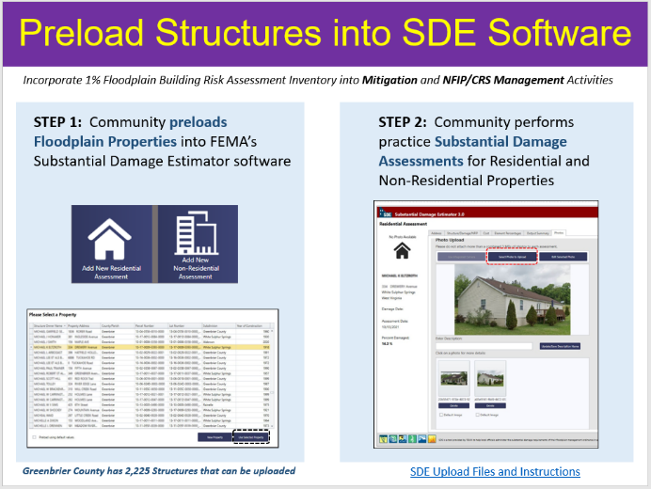
Figure A-1. New data products developed from the statewide risk assessment project include pre-loading the entire statewide flood risk inventory of 98,000 structures into FEMA’s Substantial Damage Estimator Tool. See WV SDE Data Import and Instructions along with example community SDE imports for Greenbrier County, Charleston, and Rowlesburg.

- Engage the Floodplain Management Community to Submit NFIP Repetitive Loss (RL) AW-501 Worksheets and FMA Grant Applications. For mitigation technical assistance, the State NFIP Office will make a coordinated effort to improve the community submission of Repetitive Loss AW-501 worksheets and Flood Mitigation Assistance (FMA) grant applications for eligible NFIP structures. The WVU GIS Technical Center can provide technical assistance to include: (1) geocoding RL properties to the correct jurisdiction; (2) identifying if an RL building still exists based on aerial photography and tax assessment records, (3) and determining if the RL building is a historic building listed on the State or National Historic Registry. This task aligns with the NFIP Community Rating System (CRS) program requirements, and any FMA grant applications will be coordinated with the State Mitigation Office.

Repetitive Loss (RL) Properties have data quality issues: Of 3,132 RL structures evaluated in 2019, only 73% could be geocoded. In addition, some RL structures have been removed and parcels are vacant. Statewide RL Graphics: RL Community | RL Structures
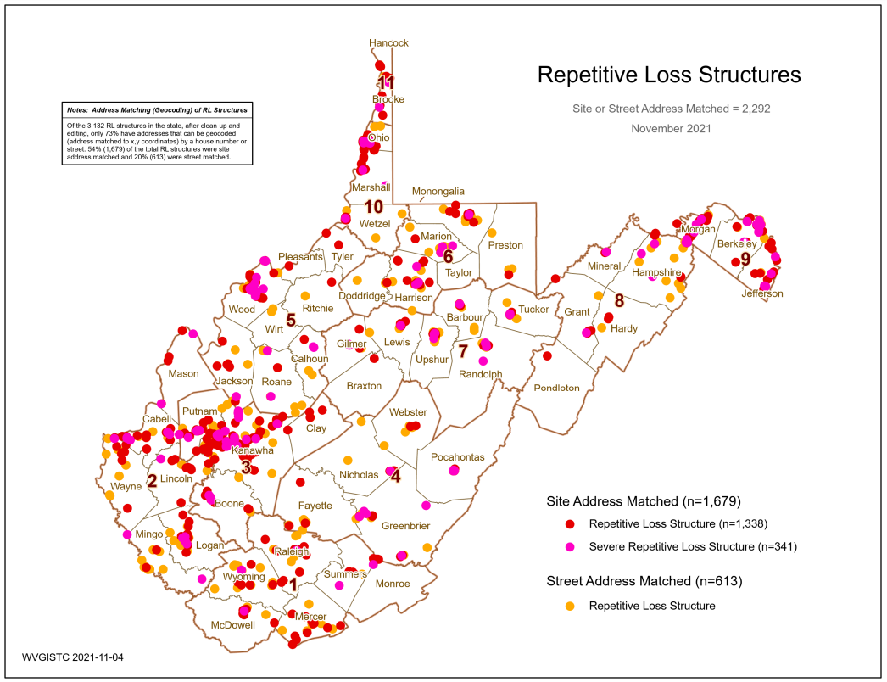
Figure A-2. RL Structures geocoded for West Virginia

- Organize and Publish a Resource Toolkit of Floodplain Management and Mitigation Documents. The State NFIP office will organize and publish basic floodplain management and mitigation documents into a useful resource toolkit for local floodplain managers. The WV Flood Tool and other websites will provide access to these technical assistance documents. FEMA Region III, State Resiliency Office, State Mitigation Office, and local floodplain managers will review the resource document toolkit, providing feedback and recommendations. The resource toolkit will complement scheduled training by the State NFIP Office to include WV Floodplain Management 101, CFM Refresher, and Basic/Advanced Floodplain Management courses.

Figure A-3. The Resources Document Toolkit on the WV Flood Tool has not been updated since 2017. Other WV CTP resource sites need to be updated as well.
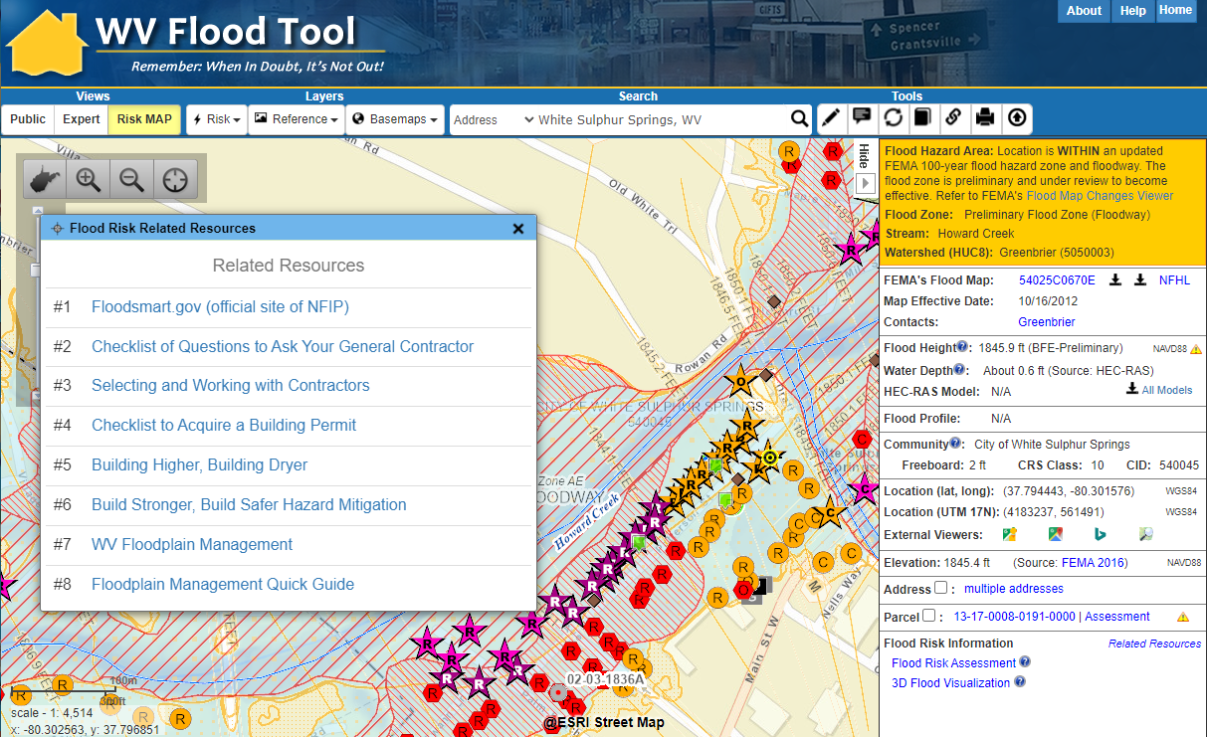

- Document Mitigation Status of Statewide Flood-Prone Structures. Conduct a comprehensive inventory of existing mitigated structures using the statewide building level risk assessments to determine how communities have applied flood adaptive measures in response to major flood events. In response to climate change impacts, evaluate if mitigation measures (elevation, barrier, wet floodproofing, dry floodproofing, etc.) along with flood development ordinance standards (e.g., freeboard) are adequate for changing environmental conditions. This activity will focus on the post-FIRM structures with a Minus 3 Rating (lowest floor 3 or more feet below the BFE) to determine if newly constructed properties are properly mitigated. Structure-level mitigated status information will be tracked by the unique building identifier (Parcel ID + Address Number) and WV Flood Tool shared map link. This activity will engage flood-prone communities, thereby providing outreach and training opportunities to encourage communities to adopt higher flood protection standards through ordinances as well as other flood adaptive measures. Furthermore, this mitigation verification activity will align with scheduled CAV’s (Community Assisted Visits) and CAC’s (Community Assisted Contacts) sponsored by the State NFIP Office and FEMA Region III. Lastly, the mitigation status review of high-value, high damage loss, or high minus-rated properties (including critical facilities) will be provided as a complimentary service for any NFIP communities in West Virginia.

Minus Rated Structures in West Virginia requiring Mitigation Status (first floor height) Verification.
  - Minus Rated with FIRM Status (20% Post-FIRM, 71% Pre-FIRM, 9% Unknown)
  - Top Minus-Rated Post-FIRM Structures. Structures >= 3 ft. Water Depth-in-Structure. Table on graphic lists top 20 Post-FIRM structures with water depth values >= 17 ft.
    - Total Post-FIRM (n=4,223)
    - 3-5 ft. (n=1,111)
    - 10-15 ft. (n=187)
    - >= 15 ft. (n=46)
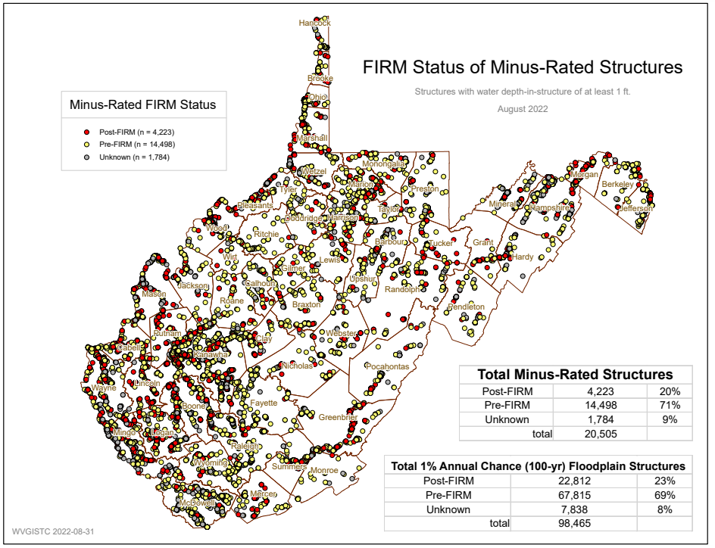
Figure A-4. Minus Rated Structures with FIRM Status

APPENDIX B: Scope of WVU Led COMS Tasks

2023-24 CTP COMS Services and Projects performed by West Virginia University
State: West Virginia
Total Cost: $177,000
Performance Period: October 1, 2023, to September 30, 2024 (12 months)
Plan by Tim Keaton, State NFIP Coordinator, WV Emergency Management Division. Subcontract work to WVU GIS Technical Center.
8/6/2023
Special Community Outreach Mitigation Strategies (COMS) projects performed by the WVU GIS Technical Center, to include:

The WVU led COMS tasks are organized by four scoping activities, to include:
- Provide Global Outreach Services for the WV Flood Tool
- Deliver Technical Support Services for LiDAR LOMAs
- Perform Building Cluster Analysis for CNMS Identification of Potential Approximate A Zones for Upgrade to Zone AE Detailed Mapping
- Develop and Verify Flood Risk Profiles at State, Regional, Community, and Watershed/Stream Levels
- Update the WV Building Level Risk Assessment (BLRA) from New Data Sources (e.g., Flood Studies, Building Characteristics)
- Communicate SFHA Map Changes to Affected Property Owners
- Support Local Hazard Mitigation Plans with Flood/Landslide Risk Assessment Data
- Perform Detailed Riverine Flood Impact and Mitigation Studies or Vulnerably Disadvantaged Communities using recently published FEMA and First Street Foundation Flood Models

Mitigation Support ($157K)

- Provide Global Outreach Services for the WV Flood Tool. Statewide global outreach services that process and integrate new flood and reference GIS layers, tool enhancements, flood and landslide risk information, etc. for the WV Flood Tool (www.mapwv.gov/Flood). Services include computer programming, data development/geo-processing, customized mapping, and technical support services (Task A). This task includes developing outreach materials along with in-person and remote training courses for the WV Flood Tool. For this CTP year, the professional surveyors of West Virginia have requested training at their annual conference in February 2024 about the WV Flood Tool. Customized training for the surveyors will focus on what distinguishes the WV Flood Tool from FEMA’s NFHL Viewer and Flood Insurance Rate Maps (FIRMs). For example, the WV Flood Tool provides BFEs for Approximate A Zones and high-resolution elevation date for qualifying LIDAR LOMAs. FEMA does not provide these map services. In addition, the WV Flood Tool publishes Elevation Certificates, Verified LOMA locations, HEC-RAS stream models, and 1%-annual-chance advisory floodplains / BFE’s / depth grids not available by FEMA maps services. See Table B-1 below for more details and scope of these services.

Table B-1. Detailed task description for WV Flood Tool.
Task Description
[GLOBAL OUTREACH SERVICES FOR WV FLOOD TOOL]
The WV Flood Tool and global outreach services support stakeholders in pre-disaster actions around adaptation, resilience, and mitigation. The global outreach supports FEMA’s NFIP/CRS Program objectives to:

- Maintain consistent national standards while interjecting a tailored, local focus
- Use local data and integrate at state level to facilitate floodplain management
- Utilize local experience and knowledge
- Provide training and technical assistance
- Provide communities with state-based CRS credits
- Support Risk MAP Program Goals of Flood Hazard Data, Public Awareness and Outreach, Risk Planning, Enhanced Digital Platform, and Alignment and Synergies

Through collaboration with Local, State, and Federal entities, the WV Flood Tool delivers quality data that increases public awareness and leads to actions that reduce risk to life and property

To manage the wealth of available data and better communicate flood risk, the WV Flood Tool has maintained a public facing outreach tool for the public, communities, engineering/surveying companies, and others (Insurance companies, lending institutions, real estate companies, etc.) that has provided effective floodplain models, supporting datasets, water-surface elevations, floodplain boundaries, and additional enhanced flood risk information. During the past decade, the functionality and quality of data layers of the WV Flood Tool have progressed, resulting in an increased use of the application. Over time the WV Flood Tool has become more than just a flood determination tool, and today is routinely used by floodplain managers for building permit applications, floodplain regulations enforcement, pre- and post-disaster assessments, Community Rating System discounts, and flood risk planning. For risk assessment and planning, the RiskMAP View includes structure-level risk assessments and mitigated properties to aid in flood reduction efforts. This initiative enables the website and the WV Flood Tool's global outreach program to adapt and remain relevant as both the datasets and technology continue to evolve.

Specific tasks under global outreach services in support of the WV Flood Tool include:

New Flood Map Products:
- Incorporate new regulatory and non-regulatory flood hazard layers into the WV Flood Tool. Publish all the flood layers, query layers, geoprocessing layers, models, and attributes according to standardized procedures and cartographic design.

- Effective and Preliminary National Flood Hazard Layers (e.g., Countywide RiskMAP Studies, 2016 Flood PRM Reaches in Southeastern WV, Advisory Flood Heights)
  - Add effective or draft/preliminary NFHL, WSEL, and Flood Depth
  - Advisory Flood Heights and Base Flood Elevations
  - For Preliminary Flood Heights, in Flood Query Results Panel link Preliminary Flood Zones to FEMA’s Map Changes Viewer
- Flood Study Status Graphics
  - Active Flood Studies
  - Advisory Flood Heights
  - FEMA R3 Project Status Graphic
- Floodplain Boundary, WSEL, Depth Layers
  - Floodplain Boundary: Advisory A Zones
  - WSEL: Advisory A Flood Heights (Advisory Base Flood Elevations)
  - Depth Grid: Model-Backed (HEC-RAS) Advisory A Depth Grids
- Other Flood or Flood-Related Layers
  - Elevation Certificates
  - LOMAs, LOMRs (including Location-Verified LOMAs to correct parcel or structure)
  - Panel Index (GeoIndex)
  - Flood Profiles (Detailed Studies only)
  - Mitigated Buyout Properties
  - Flood Query Results Layers: Flood Zone Designation, Stream Name/Flood Source, Model Download
  - USGS High Water Marks and Stream Gages
  - H&H Hydrologic/Hydraulic Downloadable Models
  - Structure (bridges, culverts, etc.) Data Files (data files are needed)
  - Flood Manager List on WV Flood Tool

- Model-Backed Studies. The statewide Hazus depth grid created in 2010 is inaccurate and thus has a negative impact on building-level flood risk assessments and flood visualizations. Adding model-backed depth grids from flood studies improves the coverage and accuracy of the statewide depth grid, a flood risk assessment priority of attaining model-backed, gridded flood-risk depth grids for all 1-percent flood zones in West Virginia. In addition, model-backed Base Flood Height values provide important information for the Flood Query Results Panel and for processing LiDAR LOMAs using the Print Function of the WV Flood Tool. Lastly, depth grid errors associated with mapping issues identified from anomalous building level risk assessments are forwarded to Region 3 for CNMS problem area tracking.

- Follow WV GIS Technical Center’s procedural guide for creating Flood Depth/Water Surface Elevation Grids and Redelineated AE Floodplains. The methodology creates a Water Surface TIN from the NHFL X-Sections, converts the WSEL TIN to a grid, and then subtracts the Ground Elevation Grid from the WSEL Grid to create the Water Depth Grid.
Application Programming Development:
- Execute software programming updates for desktop and mobile versions. Modify programming code of JavaScript application (www.mapwv.gov/flood) to enhance tool functions, messages, data layers, and cartography. Update flood risk information to the WV Property Search Tool, a companion product of the WV Flood Tool, to allow users to identify, for example, new structures built in flood zones. Make other tool enhancements based on requests from WV NFIP Coordinator.

Desktop Version: https://www.mapwv.gov/flood
Mobile Version: https://www.mapwv.gov/flood/mmap
Property Search and Report: https://www.mapwv.gov/property

- Enhance tool functions based on feedback or new opportunities. Program other application enhancements to include synchronizing with FEMA’s National Flood Hazard Layer (NFHL) web services and FEMA Map Store products. Evaluate consuming NFHL web services with performance testing and other suitability measures. Program failover protocols for external web map services consumed by the Flood Tool. Enhance the WV Flood Tool to leverage the statewide building-level flood risk assessments generated from a Hazard Mitigation Grant.
- Incorporate 3D flood building visualizations for mitigated structures.
- In addition, the application programming development will include application updates to enhance tool functions, messages, data layers, and cartography.

Update Flood Query Panel with New Flood Risk Data:
- Develop and publish new risk assessment and mitigated layers to the WV Flood Tool, specifically
- Mitigated Structures (wet floodproofing, dry floodproofing)
- Elevation Certificates (focus on elevated Building Diagrams 5-8)
- Dam Inundation Zones (for query purposes only)
- 500-Year Depth Grids from new flood studies (both AE and A zones)

Update Flood Query Panel with New Flood Risk Data:
- Maintain and enhance Flood Query Results Panel with Dam Inundation Zones and 500-year flood depth values.

- Dam Inundation Zones: The WV Flood Tool’s query result panel for the RiskMAP View can be updated to alert a location that falls within a failed dam inundation zone. New flood inundations zones have been made available by the WV Conservation Agency and USACE for select dams. In addition, risk assessments can be done by performing an intersection between the built-up environment and flood inundation zones.
- WV Dam Inundation Viewer of 168 High Risk Dams from the WV Conservation Agency
- USACE Dam Inundation Viewer: https://nid.usace.army.mil/viewer/index.html
- Summersville Dam Example: https://nid.sec.usace.army.mil/viewer/index.html?dsLibrary=NID-MD00069,NID-WV06702&x=-80.901&y=38.223&z=15

- 500-Year Flood Zone Depth Values: FEMA’s new RiskMAP studies are generating 500-year depth grids for riverine flooding. This information can be added to the RiskMAP View of the WV Flood Tool. The only way now to determine 500-year depths on the Flood Tool are by viewing the Flood Profiles of detailed studies.

<< Query Results Panel >>
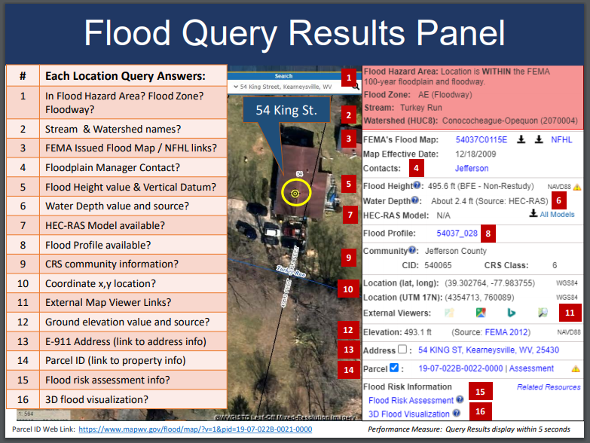

Reference Data:
- Process and integrate new reference data to make the WV Flood Tool more accurate and current and for which communities can receive FEMA CRS credits. This task includes the publishing and caching of web map services that support the Flood Tool. The new FEMA-purchased LiDAR and derived elevation products are quite large in file size and require extensive computer processing and quality control checks before being published to the WV Flood Tool. Key reference data sets are ground elevation, parcels/assessment records, E-911 addresses, and aerial imagery.

- HI-RESOLUTION TOGPOGRAPHIC DATA: Processed FEMA LiDAR is published to the WV Elevation Download Tool. This includes the LiDAR derived elevation products to include DEMs and contours. All new elevation data has been published on the WV Flood Tool as part of the Cooperating Technical Partners (CTP) program. Accurate, high-resolution LiDAR-derived elevation products such as one-foot contours and one-meter DEMS that are incorporated into the WV Flood Tool are beneficial for floodplain determinations, LIDAR LOMAs, LAGs, water depth flood visualizations, flood risk studies, etc.
    - Metadata: https://www.mapwv.gov/lidar-metadata
    - Elevation Download Site: https://data.wvgis.wvu.edu/elevation/
    - FEMA-Purchased LiDAR Projects: Project coverage graphic

- PROPERTY PARCELS AND ASSESSMENT RECORDS: Update statewide parcel layer and assessment records to WV Flood Tool. Accurate and current parcels and assessment attributes are essential to identifying flood risk structures in the WV Flood Tool
- Statewide Parcel Products (annual update) for Flood tool:
  - Master surface parcel file and standardized assessment attributes
  - Sketch diagrams for building identification of residential properties
  - Parcel history (17 years) to search previous owners or deed book numbers. Important for improving positional accuracy of LOMAs and Buyout Properties.
- Integrate surface parcel geometry for all 55 West Virginia counties
- Join assessment records for commercial and residential properties for current tax year
- Join parcels to more than 20,000 full-version tax maps
- Coordinate parcel development with WV Property Tax Division and county assessors
- Intersect parcels/assessment records with flood zones and classify according to risk (high, moderate, low)
- E-911 ADDRESSES: Update E-911 site and street addressing layers and address matching geocoding services for Flood Tool. Accurate and current E-911 site addresses are essential to identifying flood risk structures in the WV Flood Tool.
- AERIAL PHOTOGRAPHY: Add new 2023 county leaf-off aerial photography for multiple counties to Flood Tool. Coordinate with county, state, and federal agencies through West Virginia Orthoimagery Program. Add 2020 and 2022 leaf-on map services on WVU Servers to increase zoom in levels on WV Flood Tool for users. Accurate and current leaf-off aerial photography is essential to identifying flood risk structures in the WV Flood Tool.
- BUILDING FOOTPRINTS: Building footprints are being created from the statewide aerial imagery as an alternate product to the 2018 Microsoft building footprints. These new building footprints will be published to the WV Flood Tool. Building footprints are used for identifying flood risk structures and for 3D flood visualizations on the WV Flood Tool.

- OTHER LAYERS: Update other reference layers (e.g., community boundaries, wetlands, public lands) that support FEMA CRS/NFIP programs and the WV Flood Tool. Accurate and current reference layers are important to Communities for state-base CRS credits and for users referencing features of interest.
- RESOURCE LINK: WV Flood Tool’s Reference Layers

Technical Services:
- Perform outreach and training services to include developing print and online educational materials, delivering presentations, administering email listserv, and participating in Flood Tool coordination meetings and data exchange with State NFIP, FEMA, USACE, NRCS, and other cooperators. Provide technical support to the Flood Hazard community like specifications (e.g., HEC-RAS downloadable model specifications) for contracts and other technical queries associated with flood and reference data. Enhance the WV Flood Tool to effectively increase flood risk communications for the public and communities. Educate and outreach to counties about submitting their locally produced address, parcel, imagery, and elevation data for inclusion in the Flood Tool.
- Technical Services include:
  - Promotional materials (flyers, videos, etc.)
  - Presentations (webinars, meetings, etc.)
  - Update content and resources sections of Flood Tool launch page
  - Update listserv and contact list of community floodplain managers
  - Coordination meetings and project scoping for USACE WV Silver Jackets projects that support WV Flood Tool
  - Standardized Data Exchange
  - Instructional videos for Flood Tool and WV Building Level Risk Assessment (BLRA)
  - Maintain WV Flood Tool and Flood Risk Assessment Glossary
- Update various WV Flood Tool Resources web pages and links
- Bundle FEMA and other agency risk assessment and mitigation resources for the WV floodplain management community (Permits, Elevation Certificates, Mitigation Resources, Model Floodplain Management Ordinance, etc.).

- Deliver Technical Support Services for LiDAR LOMAs. West Virginia now has statewide coverage of QL2 LiDAR data and LiDAR-derived elevation products of one-meter DEMs and 1-foot contours. LiDAR LOMAs can be submitted for qualifying structures using FEMA’s Online LOMA portal. The Flood Tool’s Print Function generates map layouts for the LiDAR submissions using either the contour or point elevation methods. To save disadvantaged communities and homeowners the cost of needing a site elevation survey, this activity will communicate to these constituents how the "mapped out" structures (primary building structures symbolized by yellow squares where future map conditions exist) displayed on the RiskMAP View of the WV Flood Tool may qualify for removal of the structure from the SFHA. The only information required for an Online LOMA submission are a map layout from the Flood Tool and a copy of the deed. The WVU GIS Technical Center will support the state and local floodplain management community with the submission of LiDAR LOMAs when a field survey is not required, to include assisting floodplain managers with the online submissions to FEMA.

LiDAR LOMA Documentation.
- WV Flood Tool LiDAR LOMA: Instructions | Overview Slides and Guide
- WV LIDAR LOMA Map Layout Examples

Figure B-2. Example LiDAR LOMA Print Layout generated from WV Flood Tool.
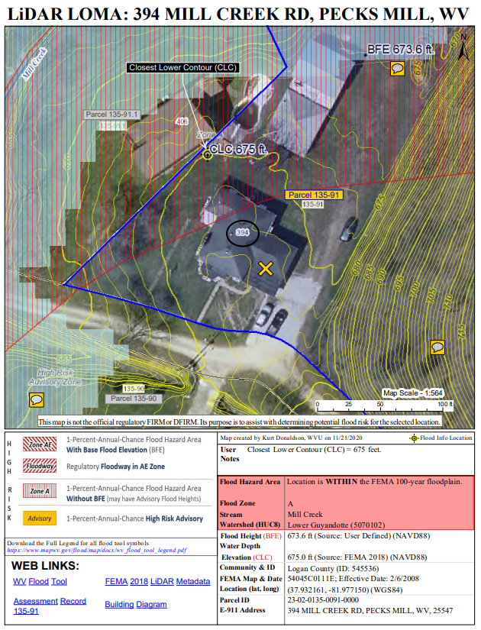

Coordinated Needs Management Strategy ($10K)
- Perform Building Cluster Analysis for CNMS Discovery of Potential Approximate A Zones for Upgrade to Zone AE Detailed Mapping. A statewide Approximate Zone A cluster analysis was performed in February 2022 from the statewide Building-Level Risk Assessment project in which Approximate A Zone candidates were identified and entered by a FEMA contractor (WSP USA) into FEMA’s Coordinated Needs Management Strategy (CNMS) geospatial database. For this specific activity, a more refined and detailed study will be done for the Kanawha River Basin watersheds and other watersheds in the state where future Risk MAP Discovery activities are scheduled. This information is beneficial for the initial Discovery Phase of the Risk MAP process. Refer to FEMA’s Guidance for Flood Risk Analysis and Mapping.

Need Justification: In West Virginia, nearly 70% of WV floodplains are Approximate A Zones and not detailed studies. Advantages of detailed studies.

Specifications: Detailed Studies versus Approximate A Studies
- Detailed studies use more refined hydrologic modeling in a lot of cases instead of just using regression equations.

- Detailed studies include floodway and a hydraulic models with structure survey and bathymetric survey.

- Detailed studies have extra FEMA products such as a “floodway data table” and “flood profiles” in the FIS reports.

- FEMA can’t publish BFE’s on their products unless it is “a detailed study” per federal regulations. Consequently, FEMA utilizes States’ websites to display BFE’s for Approximate A Zones.

Methodology and Rankings: A detailed analysis for building clusters will be conducted for flood depths ≥ 5 feet and ranked accordingly to 12 evaluation factors. Physical building factors are based on (1) building counts, (2) building dollar exposure, (3) building damage dollar exposure estimates, (4) substantially damaged estimates, and (5) building types. Depth grids factors are (6) extreme flood depths ≥ 10 feet and (7) depth grid accuracy. Mapping cost-effectiveness factors are the (8) stream length of building clusters for Zone AE, (9) building density per square mile, (10) estimated Zone AE study cost per mile, (11) Zone A building cluster adjacent an existing Zone AE study, and (12) legacy county boundary mapping issues.

Figure B-3. Evaluation Factors for Upgrading Approximate A Zones to Detailed Zone AE
12 Evaluation Factors for Ranking Zone A Building Clusters with High Flood Depths

- Physical Building Factors: Type, Exposure, & Damage
  - Building Count
  - Building Dollar ($) Exposure
  - Building Damage Dollar ($) Loss Estimates
  - Substantially Damaged Loss (%) Estimates
  - Building Types
    - Residential versus Non-Residential
    - Essential facilities and Community Assets
- Depth Grids Factors: Extreme Flood Depths, Depth Grid Accuracy
- Extreme flood depths of structures ≥ 10 feet (verify not flood study error)
- Depth Grid Accuracy
    - Model-backed HEC-RAS depth grid (more accurate)
    - 2010 Hazus depth grid (less accurate)
- Mapping Cost Effectiveness Factors
- Stream length of building clusters for Zone AE conversion
- Building density per square mile (Building Count / Cluster Stream Length)
- Estimated Zone AE study cost per mile ($2,500 per mile)
- Zone A building cluster adjacent to existing Zone AE
- Legacy county boundary mapping issue (Zone AE mapping stopped at county border)

Example Statewide Study of Zone A Structure Cluster Analysis: A broad Zone A structure vulnerability and spatial density analyses were performed for three flood depths at ≥ 5 feet, ≥ 10 feet, and ≥ 15 feet. More detailed studies at the watershed level are proposed for this CNMS activity in support of Risk MAP Discovery phases.
- Zone A Cluster Analysis Graphics: Flood Depths for ≥ 5 feet, ≥ 10 feet, and ≥ 15 feet
- Spreadsheet Flood Source Tables: Summary Building-Level Risk Assessment Factors per River/Stream Cluster and Top Building Flood Depths per River/Stream
- Report: Methodology and map links to potential candidates for AE Zone Detailed Studies
- BLRA: Statewide Building-Level Risk Assessment (BLRA) source geodatabase for cluster analysis

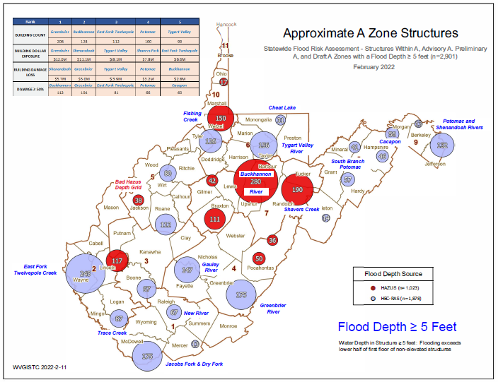
Figure B-4. Zone A Building Cluster Analysis for Upgrading Approximate A Zones to Detailed Zone AE

WV Flood Tool’s Risk MAP View – Building Damage Loss Estimate Percent Layer: In the Risk MAP View of the WV Flood Tool, the risk assessment layer, Building Damage Loss Estimate (%), provides a relationship between high flood depths and flood loss estimates of substantially damaged structures (> 50% damage). High building-level damage percentages typically correlate to structures in Approximate A Zones with high base flood depths for a 1% annual chance flood. This risk assessment layer assists in viewing graphically stream candidates for Zone A to Zone AE conversion.

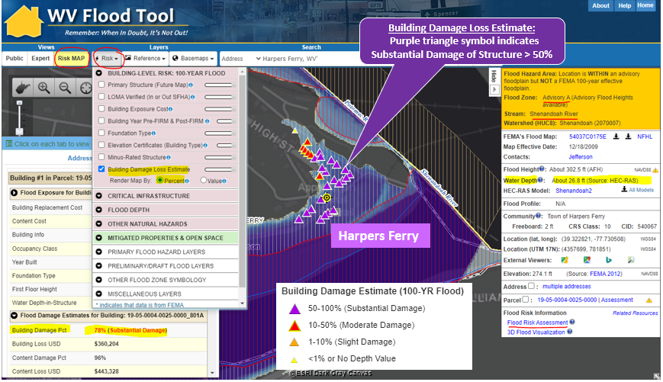
Figure B-5. WV Flood Tool’s 1%-Annual Chance Damage Loss Layer generated from FEMA Hazus is used for graphically viewing clusters of high-damage structures and potential candidates for Zone AE upgrade mapping.

- Develop and Verify Flood Risk Profiles at State, Regional, Community, and Watershed/Stream Levels. Use the building level-risk assessments to organize and curate community flood risk profiles at various geographic scales: state, regional, county, community (incorporated/unincorporated), watershed, stream, and user-defined Area of Mitigation Interest (AoMI) in support of hazard mitigation plans and other Risk MAP activities. Aggregate key risk factors Risk/Loss indicators (hazard, exposure, vulnerability, loss estimates) and by mitigation measures (mitigated properties, opens space preservation, loss avoidance, etc.). These community flood risk profiles will be beneficial for Risk MAP projects planned and implemented at the federal, state, and local levels. The community risk and mitigation profiles shall supplement FEMA’s Flood Risk Dashboards, a snapshot of a community’s flood risk statistics published at the time the community is participating in Risk MAP projects. Importantly, the community risk dashboards include social vulnerability factors to identify disadvantaged communities in the state that may be at higher risk due to climate change impacts and thus require additional focus and support in their flood protection measures. This mitigation support activity supports the WV Flood Resilience Framework initiative advocated by the State Resiliency Office. Landslide hazard community profiles will be considered in future CTP grant cycles.

Example Community Risk Assessment Matrices, Dashboards, Rankings:
- Flood Risk Factor Matrices
- Flood Risk Dashboards
- Greenbrier Study Dashboards
- Community Risk Rankings

- Update the WV Building Level Risk Assessment (BLRA) from New Data Sources (e.g., Flood Studies, Building Characteristics) so more accurate Hazus flood loss models and risk assessment products can be published in support of the state’s flood reduction activities, especially those communities which are socially vulnerable in the state. Appendix B lists equity and climate change statements and resources that show the majority of communities West Virginia are disadvantaged. That is, these communities are at or above the threshold for one or more environmental, climate, or other burdens, and (2) at or above the threshold for an associated socioeconomic burden. In addition, the findings of the First Street Foundation’s October 2021 risk assessment report states that West Virginia's built environment of critical facilities tops all other states for being vulnerable to flooding in current and future climate changing conditions. Consequently, for the built environment susceptible to riverine flooding, it is important to update the statewide building level risk assessment when new data sources become available (new flood studies, advisory flood height mapping, mitigated structures, elevation certificates - elevated building diagrams 5-8, LOMAS, etc.) so more accurate Hazus flood loss models and risk assessment products can be published in support of the state’s flood reduction activities, especially those communities which are socially vulnerable in the State. Specifically, the project footprint is a majority of the state as defined where new flood models from FEMA and First Street Foundation intersect with disadvantaged/distressed areas identified by the CEJST Screening Tool and ARC Map. In addition, updates to critical facilities and other structures of significance shall be a priority in quantifying the degree of flood risk. Benefits to communities include the continued validation of primary floodplain structures, expansion on base level risk assessment information for further hazard reduction and planning efforts, and the use of risk assessment information for Community Rating System (CRS) insurance discounts. Besides technical support for hazard mitigation plans, updates from the Building Level Risk Assessment contribute to other CTP tasks such as SFHA Change Letter Communication Outreach, CNMS Discovery Mapping, Detailed Flood Studies, WV Flood Resiliency Framework, LiDAR LOMAs, Mitigation Plans, SDE Building Pre-loading, and other RiskMAP initiatives.

- Resources:

- BUILDING LEVEL RISK CYCLE. Refer to this directory for detailed documentation about how the building level risk assessment cycle (BLRA) creates the building-level risk assessments. See Task 1 of the Data Development tasks for community-wide building inventory which is required for the landslide hazard risk assessment. The building attributes can be updated annually when new statewide tax assessment database is published.
- PRESENTATION. Flood Risk Assessment Presentation (2022) PDF | PPTX

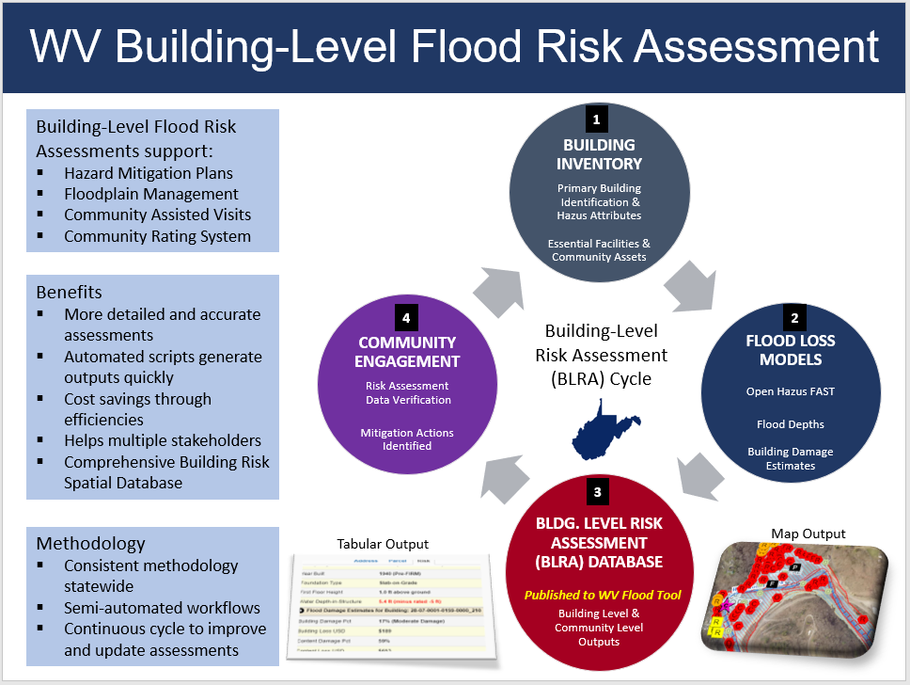
Figure B-6. Building-Level Risk Assessment Cycle (updated annually)

Figure B-7. Statewide Building-Level Flood Risk Assessment (BLRA) using FEMA Hazus Methodology
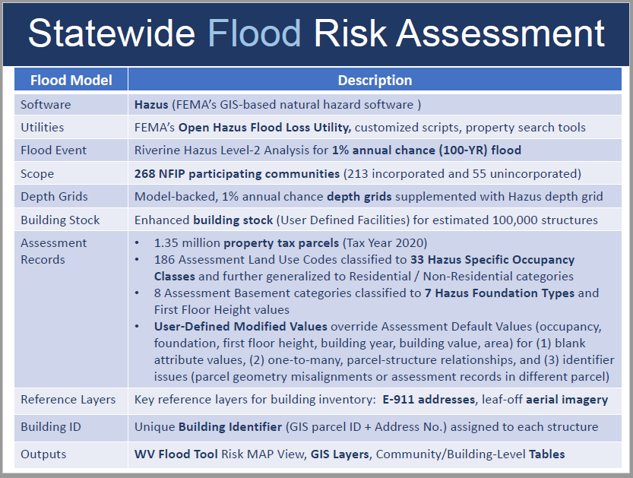

Figure A-5. Building-Level Risk Assessment: Tabular and Graphical (WV Flood Tool) Outputs
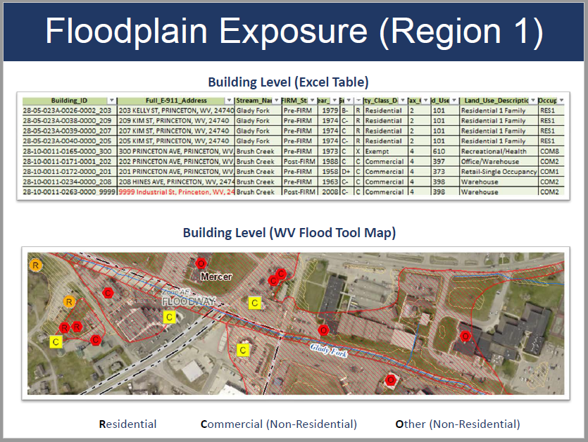

Communication and Outreach to Communities ($8K)
- Communicate SFHA Map Changes to Affected Property Owners. Template mail merge documents from the FEMA Region 3 "Local Officials Toolkit: What to Do Before and After Your Flood Maps are Finalized" have been created to send to property owners with new flood mapping updates during the appeal period for the restudy. Information about changes in floodplain risk and base floodplain elevation can be communicated to individual homeowners. The base flood elevation is increasing 6 feet, for example, for the highly flood vulnerable and disadvantaged community of Camden-on-Gauley on the Gauley River in Webster County; and more than 3 feet in Marlinton on the Greenbrier River in Pocahontas County. Mailing addresses of affected property owners are retrieved from the statewide tax assessment database. This activity qualifies for FEMA’s Community Rating System credits. See SFHA Mail Merge Template and Instructions.

Example Outreach Letters. Mapped Out SFHA, Mapped In SFHA, Mapped in Floodway

  - Clendenin, WV
  - White Sulphur Springs, WV

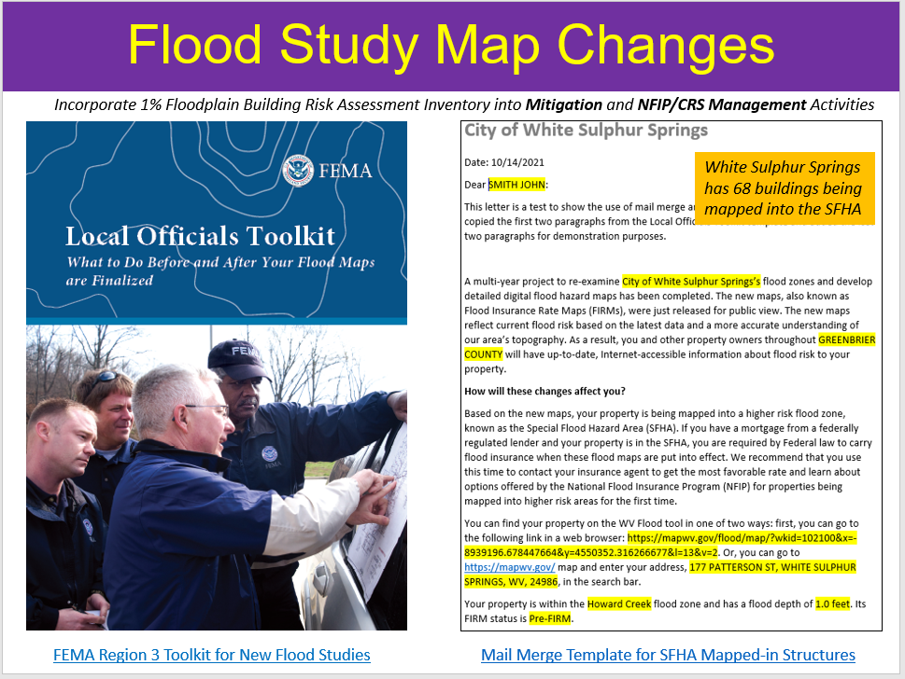
Figure B-8. SFHA Change Letters using FEMA Local Officials Toolkit

Figure B-9. Example SFHA Change Letter instructions to Community.

Enclosed are examples of outreach letters for your communities to notify owners of structures that are being “mapped in” the Special Flood Hazard Area (SFHA), "mapped in floodway" or “mapped out” of the SFHA for the new FEMA flood maps becoming effective July 5, 2023. Both Word and PDF formats are provided. Please use the links below to access the letters, map attachments, and address lists. Please review and let us know if any changes have to be made before your mailing.

The text for these template letters was modified from FEMA’s R3 Local Officials Toolkit. We also generated a map layout of each structure with a change in SFHA status; this printed map layout identified by a unique building identifier can be included with the 2-page information letter.

(1) Merged Letters (Word Doc and PDF).
- Rainelle Mapped-In SFHA, Mapped-In Floodway, and Mapped-Out SFHA
- Rupert Mapped-In SFHA and Mapped-Out SFHA
- White Sulphur Springs Mapped-In SFHA, Mapped-In Floodway, and Mapped-Out SFHA
- Greenbrier Unincorporated Mapped-In SFHA, Mapped-In Floodway, and Mapped-Out SFHA
(2) Map Attachments for each property organized by “In”, “Floodway”, and “Out” folders (for inclusion with letters). Properties are identified by a unique building Identifier consisting of the Parcel Identifier and Address Number.
Rainelle | Rupert| White Sulphur Springs | Greenbrier Unincorporated

(3) Address Lists sorted by owner name (let us know if you want us to create mailing labels). The address lists are combinations of tax assessment owner addresses and E-911 resident addresses.
https://data.wvgis.wvu.edu/pub/RA/_engage/Local/SFHA_Change/Greenbrier/Address_Lists/

(4) Summary table of letters:
Community Name | Letters & Attachments Status | Letter Date | Mapped-In Letters Count | Mapped-In Floodway* Letters Count | Mapped-Out Letters Count | Total Letter Count
Greenbrier Unincorporated | Completed | 6/5/2023 | 268 | 70 | 173 | 511
Rainelle | Completed | 5/30/2023 | 284 | 38 | 1 | 323
Rupert | Completed | 6/6/2023 | 35 | 0 | 5 | 40
White Sulphur Springs | Completed | 5/30/2023 | 61 | 54 | 116 | 231
Letter Count Sum: |  |  | 648 | 162 | 295 | 1,105
* Also including mapped from SFHA to new Floodway

(5) The LOMAs were revalidated with the issuance of new flood maps and may be superseded. The final Summary of Map Actions (SOMA) for the county can be viewed here: Greenbrier County

Since the WV GIS Technical Center generated the mail merge letters for all mapped in/in floodway/out SFHA structures shown on the WV Flood Tool’s RiskMAP View (www.mapwv.gov/Flood), all the communities have to do is download the files, then print, validate, and mail the letters.

Please contact us if you have any questions or need assistance.

Mitigation Planning Technical Assistance ($12K)
- Support Local Hazard Mitigation Plans with Flood/Landslide Risk Assessment Data. This mitigation planning technical assistance task supports mitigation planners and consultants with various risk assessment products for updating their local hazard mitigation plans. The risk assessment and mitigation products were generated from the HMGP Statewide Multi-Hazard Risk Assessment Project and select data sets are updated each year. The multi-hazard data includes riverine flooding, landslides, and dam failure. Refer to the catalog or Risk Information Index to access various risk assessment products (reports, tables, graphics, risk dashboards, etc.) published in support of FEMA’s Hazard Mitigation Plans and NFIP/CRS activities. See the 2022 TEIF-TEAL Close-out Report about risk assessment and mitigation products as well.

Resources Available: Technical support for local and state hazard mitigation plan updates. Accessed by an Index Guide spreadsheet named “RA_Info_Index.xlsx,” the risk assessment products include GIS layers, tables, subject reports, 3D Visualizations, and community profile risk matrices to supplement FEMA’s Community Flood Risk Dashboards.

Figure B-10. Risk Assessment Information Index provides access to risk assessment and mitigation data products in support of local hazard mitigation plans and other Risk MAP activities.
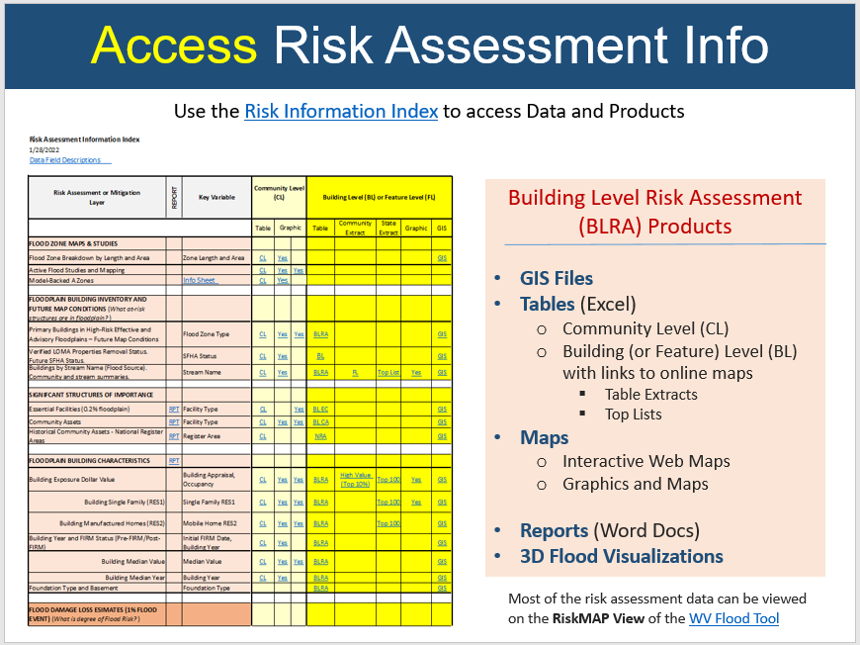

Figure B-11. Example Community Risk Assessment and Mitigation Dashboards.
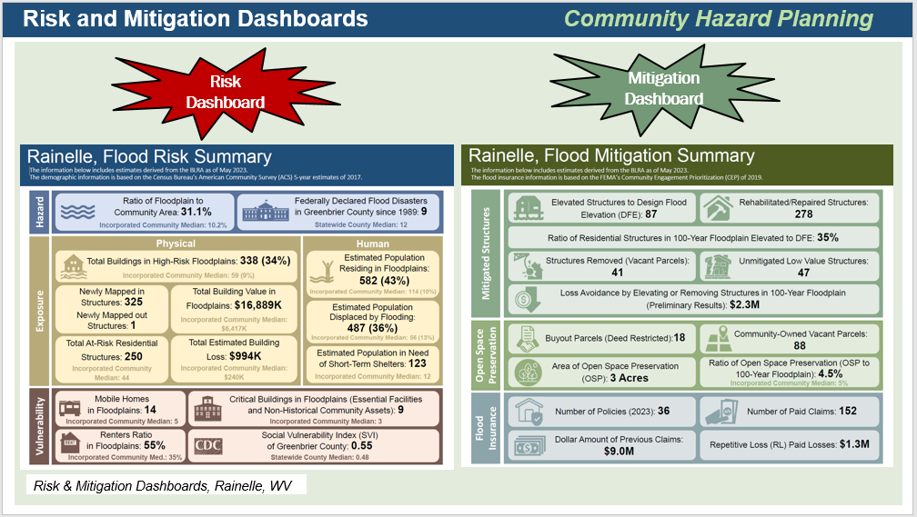

Figure B-12. Risk Indicator Tables and Matrices.
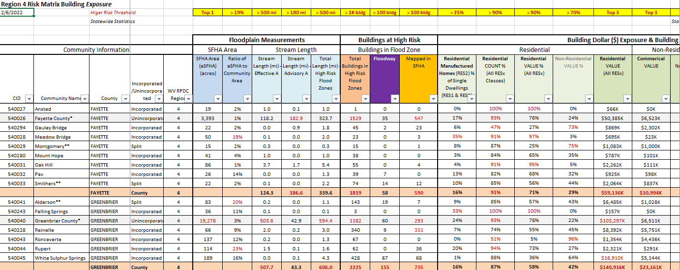

- Perform Detailed Riverine Flood Impact and Mitigation Studies of Vulnerably Disadvantaged Communities using recently published FEMA and First Street Foundation Flood Models. The USACE forecast models predict higher stream flows in the future for central and southern West Virginia. In addition to forecasted higher stream flows, many of the disadvantaged communities in this region have a moderate to high Social Vulnerability Index. Small, incorporated communities in which large tracts of the community are in the Special Flood Hazard Area are especially vulnerable to climate change riverine flood impacts. Many of the vulnerable communities were established in the early-20th century along narrow river valleys and steep mountainsides during the boom of coal mining and timbering extraction industries. Specifically, this project will map the riverine flood impacts of five vulnerably disadvantaged communities facing higher stream flow change forecast models using recently published FEMA and First Street Foundation Flood Models. The targeted five disadvantaged communities will be in the distressed areas of southern West Virginia where active FEMA flood studies have generated new flood map products. Both 2D and 3D maps will show changes in the floodplain forecast models and substantial damage impact on the built environment, including critical facilities, for the following scenarios: (1) Base Flood, (2) 500-YR Flood, and (3) Climate Change Flood Model. This past year First Street Foundation flood depth and climate data were purchased for the entire state to support this task. This project will support an NSF CIVIC grant that incorporates the social science impacts of devastating floods and recommendations for making communities more resilient, along with the development of a new statewide initiative called the WV Flood Resiliency Framework. Community engagement in the form of presenting the risk vulnerability analysis/recommendations and receiving feedback from community stakeholders is an important element of this activity.

Examples of Detailed Greenbrier Study (Rainelle and White Sulphur Springs) Resources

- View NSF Video of Greenbrier Community Flood Studies (supported by FEMA FY22 CTP Project)
- Greenbrier Study Report | Appendix | Community Slide Presentation (May 2023). FEMA CTP Report in development.
- Greenbrier Study Resources
- WV Plan Implementation and Grants Development (PIGD) Presentation June 2023

Figure B-13. Community Engagement Meetings for Rainelle and White Sulphur Springs, WV (Greenbrier County)
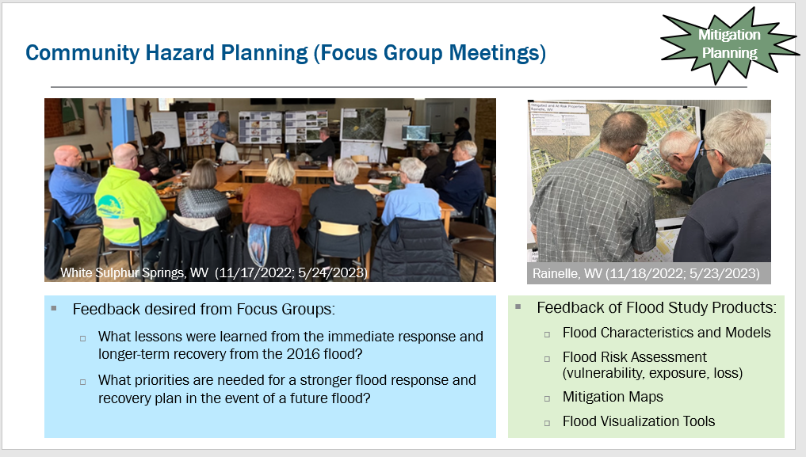

Figure B-14. Mitigation Reconstruction vulnerable to 0.2-percent annual chance flood
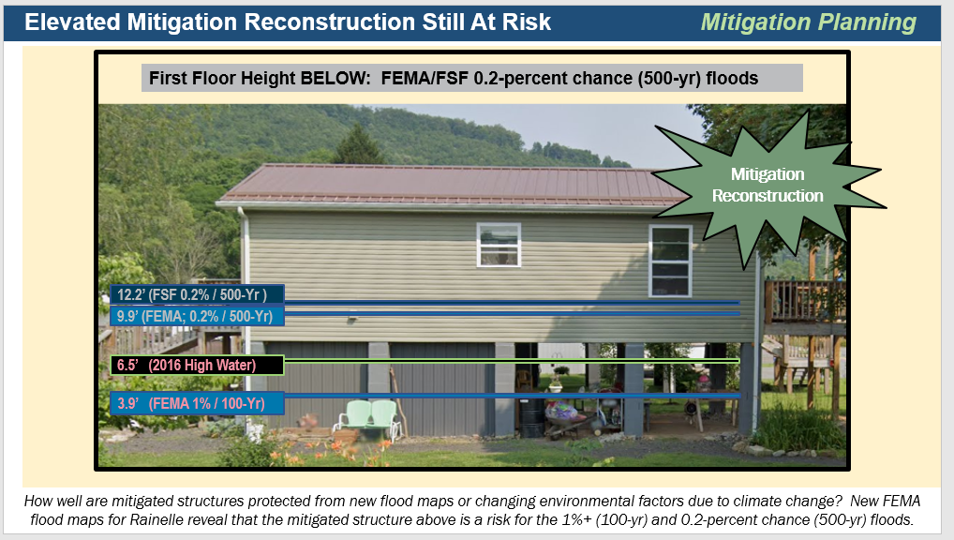

Figure B-15. First Street Foundation Flood Models for Rainelle, WV
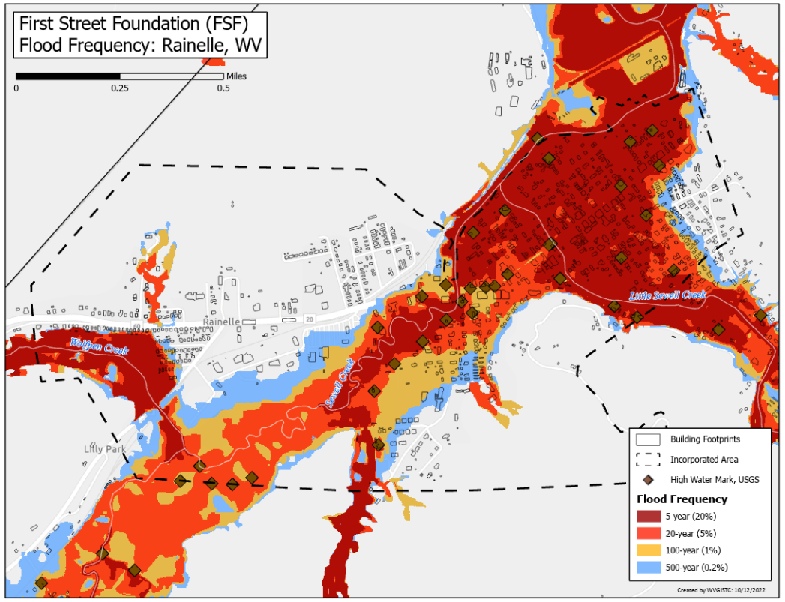

Figure B-16. New FEMA Flood Study Models
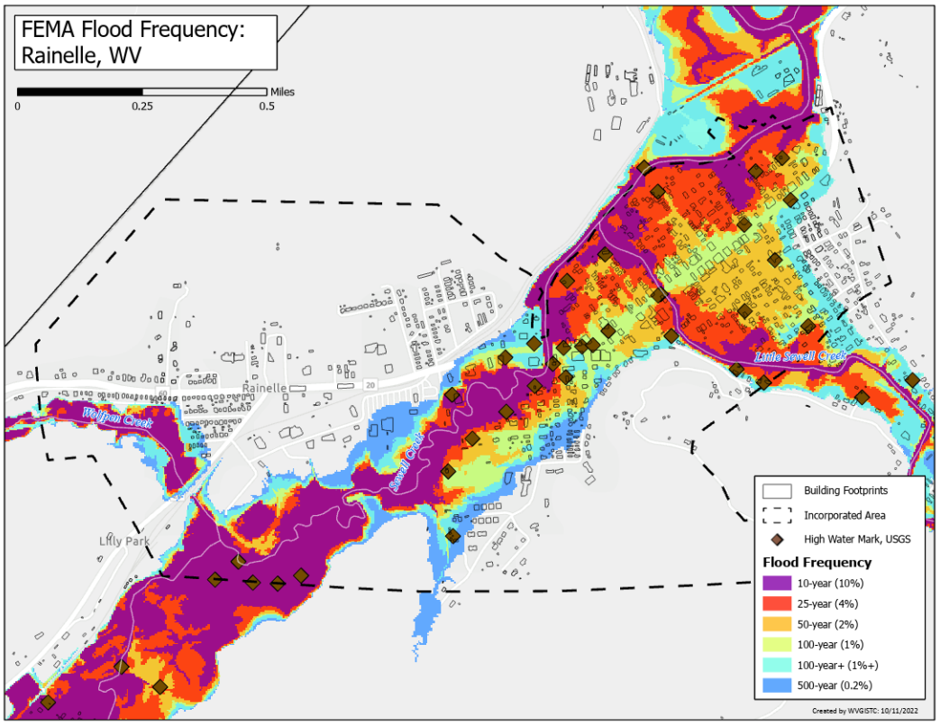

APPENDIX C: WV Equity and Climate Change Statements

- The Climate and Economic Justice Screening Tool (CEJST) by the Council on Environmental Quality (CEQ) is an interactive map and uses datasets that are indicators of burdens in eight categories: climate change, energy, health, housing, legacy pollution, transportation, water and wastewater, and workforce development. The tool uses this information to identify communities that are experiencing these burdens. These are the communities that are disadvantaged because they are overburdened and underserved. The majority of census tracts in West Virginia are considered disadvantaged. CEJST Screening Tool | Justice40 Analysis Disadvantaged
- For FY 2023, The Appalachian Regional Commission released the FY 2023 interactive map of county economic status and distressed areas in Appalachia. The classification system compares each county in the region to national averages to understand how counties are performing in areas such as unemployment rate, per capita market income, and poverty rates. 18 of West Virginia’s counties are labeled as “distressed,” meaning that they are in the worst 10% of US counties. Another 15 counties in the state are “at risk,” meaning they are in between the worst 10 to 25% of US counties. That means more than half of the state’s counties are either distressed or at-risk. Over the past several years, the number of distressed counties in West Virginia has been steadily increasing. ARC Report | Online Map
- The 2020 CDC Social Vulnerability Index for West Virginia shows 14 counties with high vulnerability and 14 counties with moderate to high vulnerability. These social vulnerability factors may weaken a community’s ability to prevent human suffering and financial loss in a disaster. CDC Online Map.

- West Virginia ranked 1st highest in the nation for the prevalence of poor physical health, poor mental health, and activity limitations due to poor physical or mental health. Source: WV DHHR.

- A 2023 Census report says that eleven counties in West Virginia are in persistent poverty. The counties are Barbour, Braxton, Clay, Fayette, Lincoln, Logan, McDowell, Mingo, Monongalia, Summers, and Webster counties. According to the detailed report, 14.4% of West Virginians live in persistent poverty census tracts, and approximately 16.8% of West Virginians are considered impoverished. The report states that areas considered to be in persistent poverty have had a poverty rate of at least 20% for more than 30 years. Based U.S. Census Bureau data from 1989 to 2019, approximately 10.6% of counties in America and 6.1% of the country’s population lived in persistent poverty counties. Census Release | Report | WV Census Tracts
- West Virginia has numerous small communities in which large tracts of the jurisdiction are in the Special Flood Hazard Area and thus especially vulnerable to climate change riverine flood impacts. Many of the vulnerable communities were established in the early-20th century along narrow river valleys and steep mountainsides during the boom of coal mining and timbering extraction industries.
- In West Virginia, according to nonprofit First Street Foundation’s October 2021 report titled "The 3rd National Risk Assessment: Infrastructure on the Brink," 46 percent of the roads in the state and 51 percent of the state’s critical facilities — the highest state-level figures in the Nation — would be closed by flooding. Using modeling that incorporates climate change, First Street’s risk assessment report quantifies the huge current and future number of critical facilities and road segments that would be shut down by an average flood.
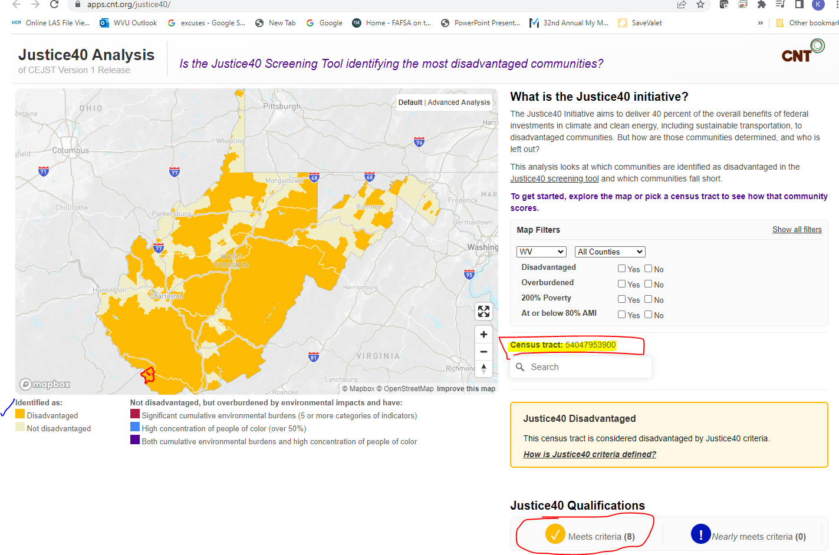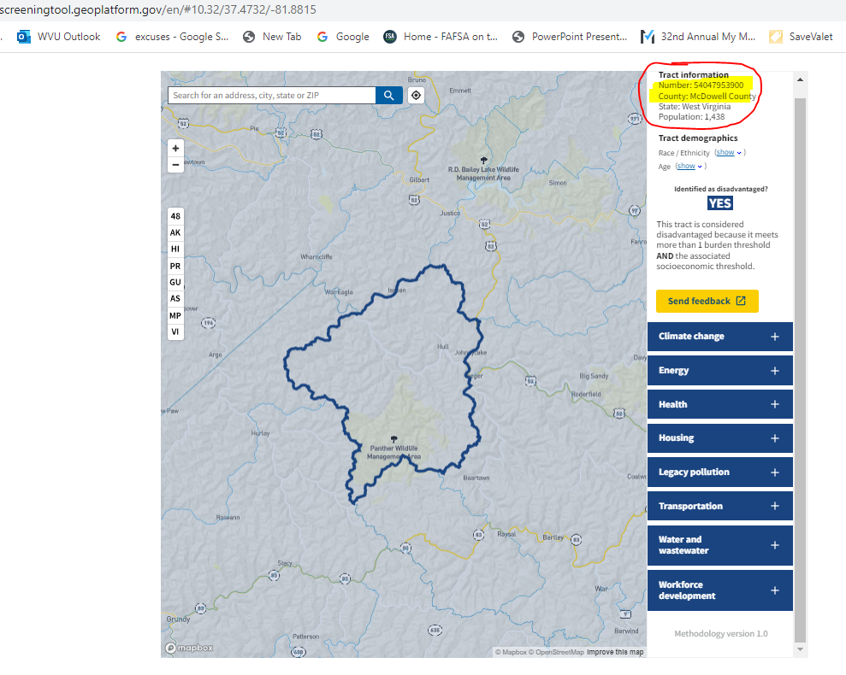
Figure C-1. CEJST Screen Tool utilized for Mitigation COMS FY23 Projects. Most of West Virginia is “disadvantaged.”
Figure C-2. Example of all 8 environmental, climate, and socioeconomic indicators impacted for census tract in McDowell County.
https://screeningtool.geoplatform.gov/en/#10.32/37.4732/-81.8815

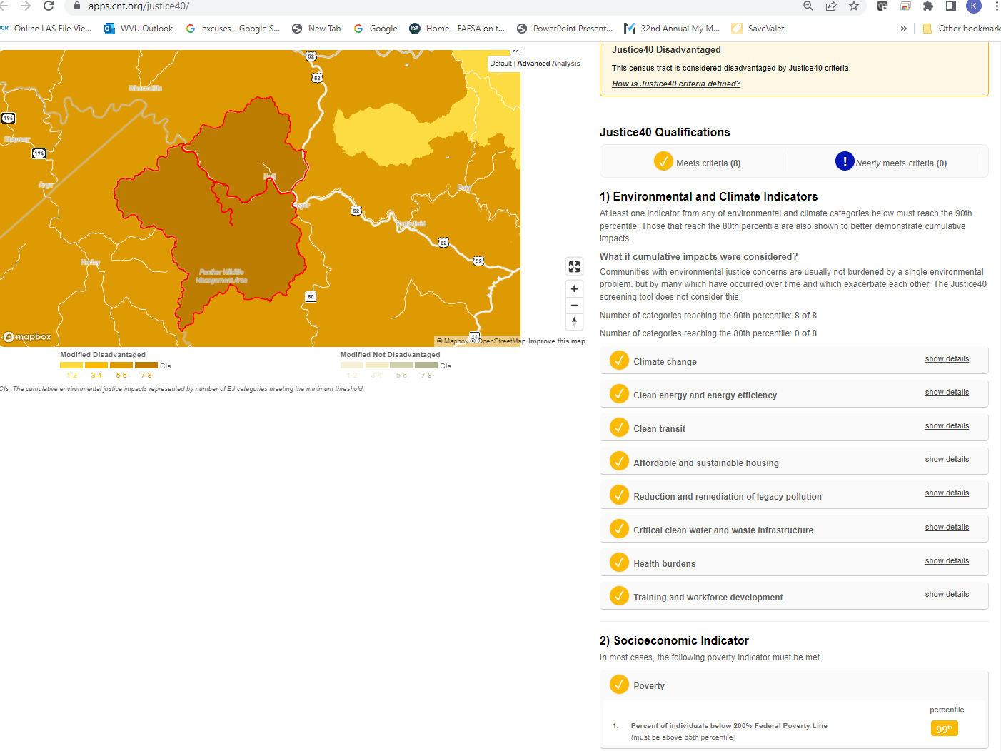
Figure C-3. All 8 environmental, climate, and socioeconomic indicators impacted for census tract in McDowell County.
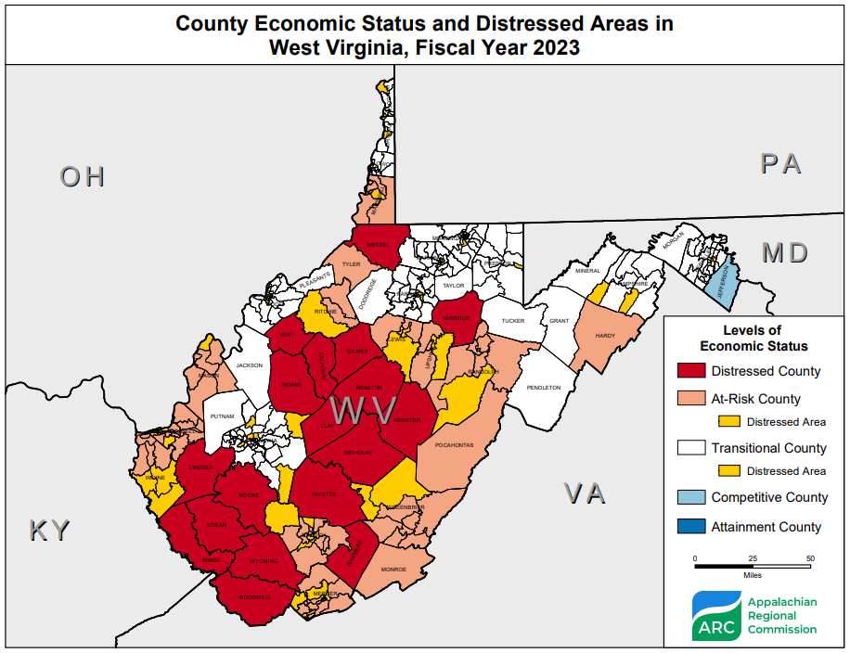
Figure C-4. 2023 ARC Distressed Areas in West Virginia

- USACE Ohio River Basin Climate Change Models (Figure 1) forecast substantial stream flow increases for West Virginia. According to the report, watershed sub-basins located northeast, east, and south of the Ohio River are expected to experience greater precipitation and thus higher stream flows – up to 50% greater – during the period 2011-2099. See pages 15 and 16 of the report showing forecasted percent changes in Annual Mean Streamflow for three time periods: 2011-2040, 2041-2070, and 2071-2099. The potential impacts to infrastructure in these sub-basins where climate change models forecast higher stream flows is dramatic and potentially devastating.
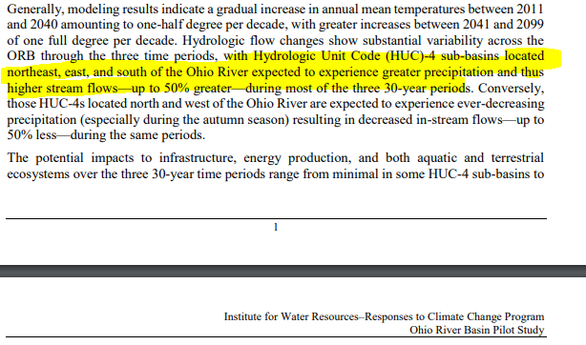
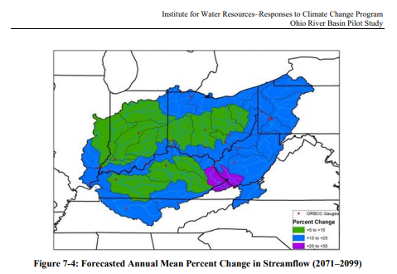

Extract from Ohio River Basin Climate Change study in which West Virginia will experience greater precipitation and thus higher stream flows.

Figure C-5. USACE Climate Models indicate greater precipitation and higher stream flows
- A climate seminar hosted by FEMA Region 3 in July 2022 presented climate tools such as NOAA’s Climate and Hazard Mitigation Planning CHaMP and Climate Explorer Tools which show historical and future climate precipitation/temperature trends. For West Virginia, recorded climate data shows that average temperatures have increased over the last 50 years for the states in FEMA Region 3 by 2.5 to 3.5 degrees Fahrenheit. The climate model projections show an increase in precipitation and temperature for both Low and High Emission futures (2022 to 2099) for West Virginia.
NOAA’s Climate and Hazard Mitigation Planning (CHaMP) Tool: https://champ.rcc-acis.org/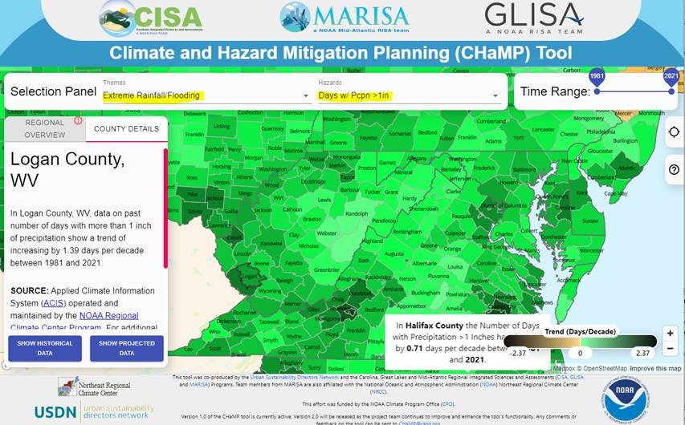
Figure C-6. NOAA’s Climate and Hazard Mitigation Planning (CHaMP) Tool

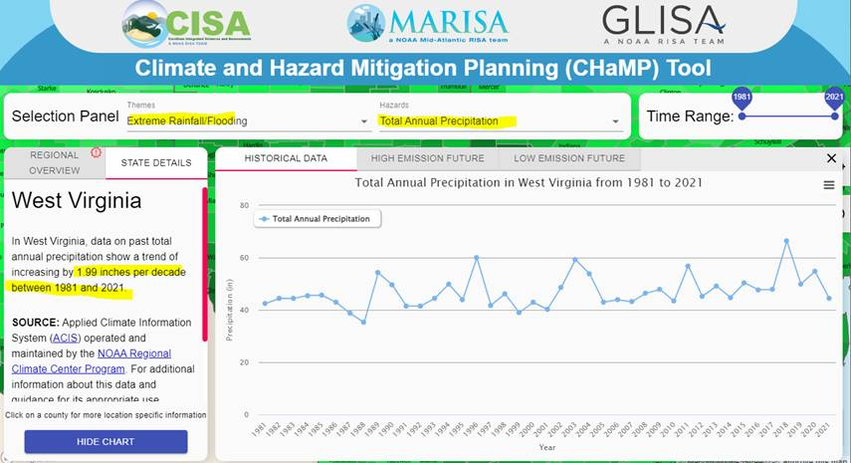

Figure C-7. NOAA’s Climate and Hazard Mitigation Planning (CHaMP) Tool
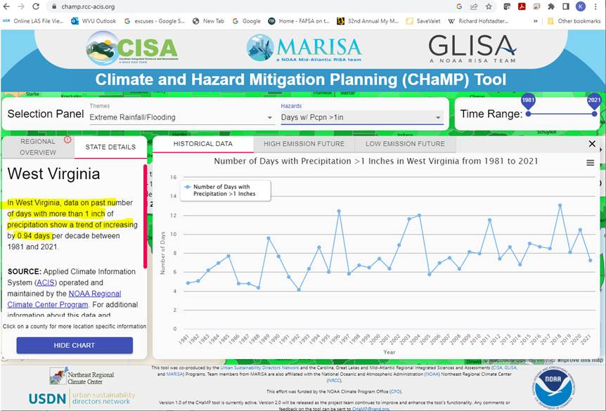
Figure C-8. NOAA’s Climate and Hazard Mitigation Planning (CHaMP) Tool

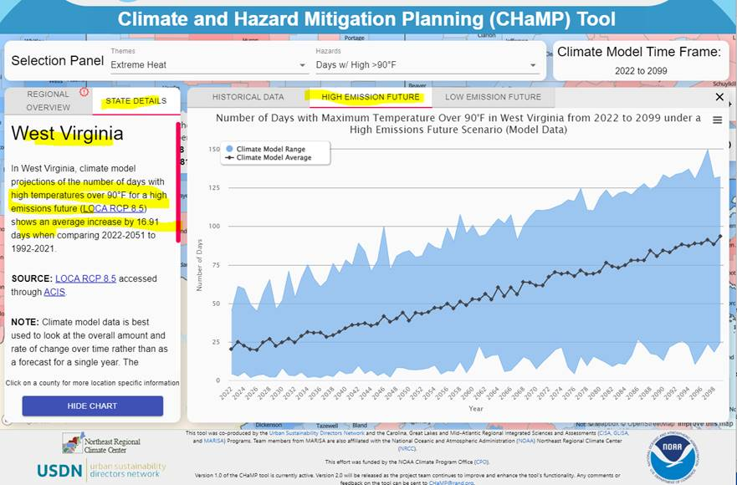
Figure C-9. NOAA’s Climate and Hazard Mitigation Planning (CHaMP) Tool
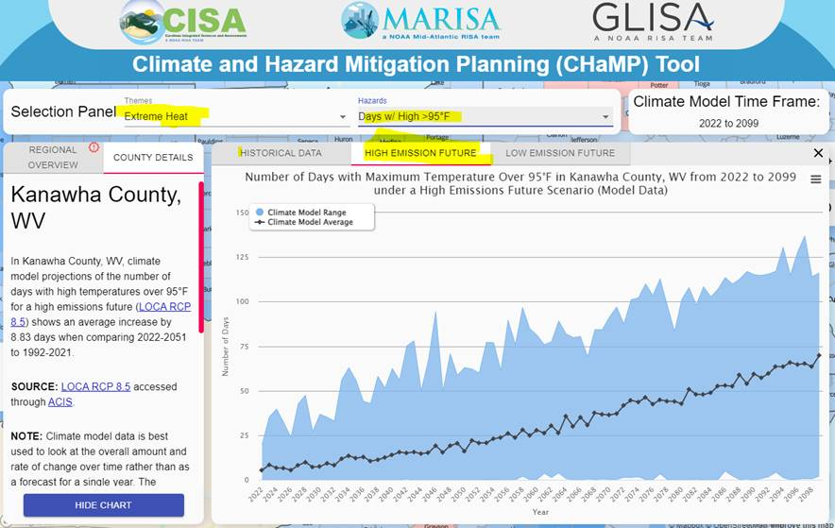

Figure C-10. NOAA’s Climate and Hazard Mitigation Planning (CHaMP) Tool

Climate Explorer Tool: https://crt-climate-explorer.nemac.org/

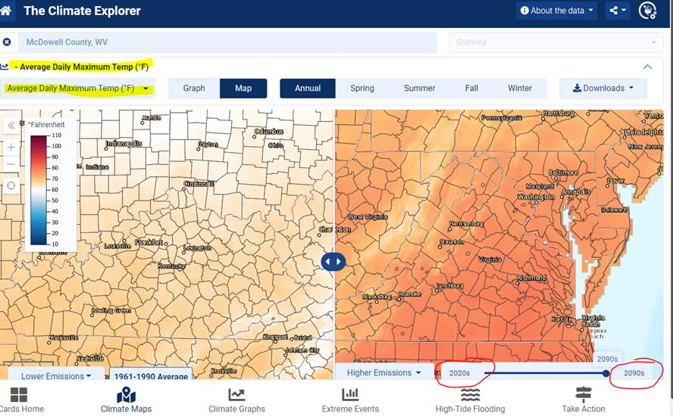
Figure C-11. NOAA’s Climate Explorer Tool

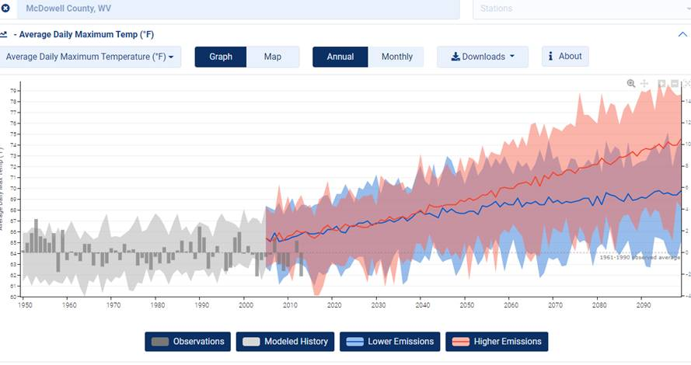

Figure C-12. NOAA’s Climate Explorer Tool

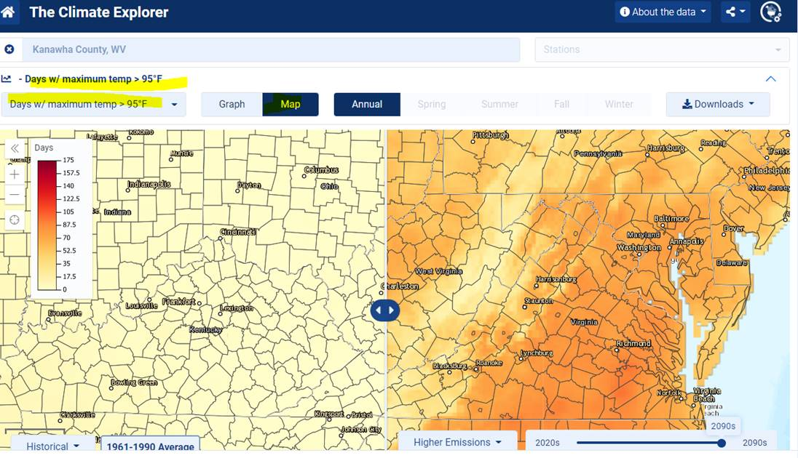
Figure C-13. NOAA’s Climate Explorer Tool

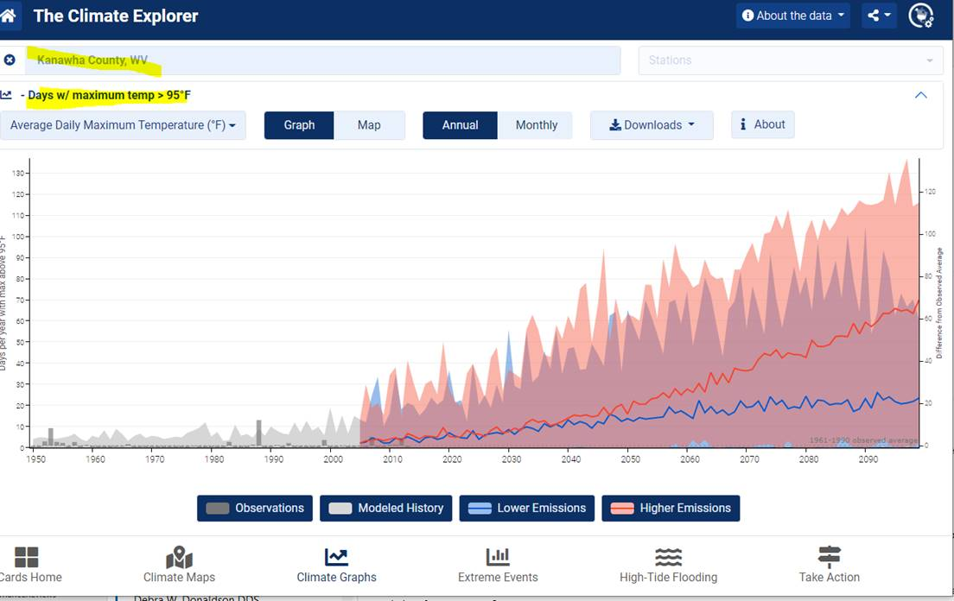
Figure C-14. NOAA’s Climate Explorer Tool

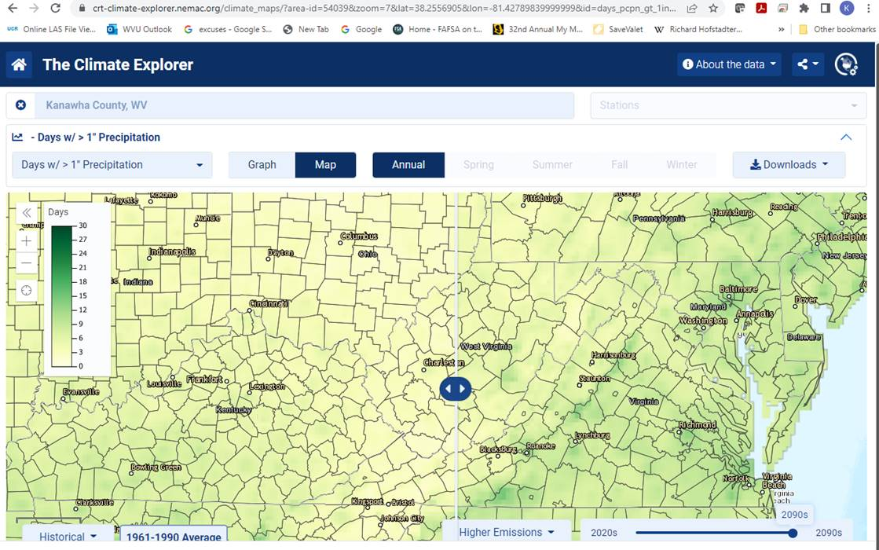
Figure C-15. NOAA’s Climate Explorer Tool

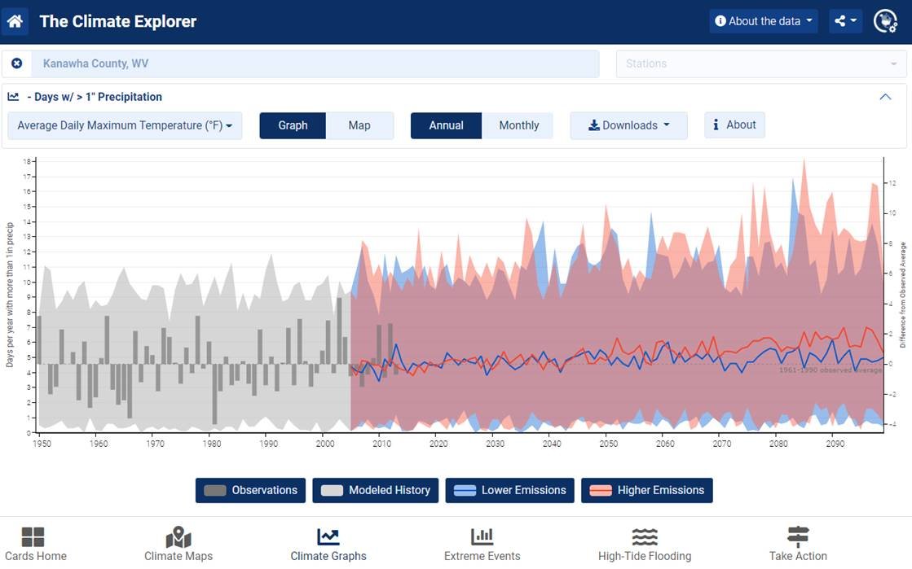
Figure C-16. NOAA’s Climate Explorer Tool

