Community Outreach Mitigation Strategies (COMS)

<< ENGAGEMENT PLAN >>

State of West Virginia

SUBJECT: COMS Engagement Plan required for Cooperating Technical Partners (CTP) Program

To Whom It May Concern:
Below are five major goals related to recommendations and associated mitigation activities of future Risk MAP projects, mitigation support and training tasks. All five goals support FEMA’s Risk MAP and NFIP/CRS programs for building flood resiliency in communities.
* * *

RISK MAPPING, ASSESSMENT AND PLANNING (RISK MAP)

Goals 1 and 2 are associated with Risk Mapping, Assessment and Planning (Risk MAP) projects. Besides new flood maps, Risk MAP projects provide datasets for more accurate base flood elevation determinations and hazard mitigation analysis to make communities more resilient.

Goal 1: SPECIAL MAP PROJECT/MITIGATON SUPPORT. Obtain model-backed Advisory Flood Heights (AFH) for all Approximate A Zones in West Virginia. This has been a primary goal of the state since 2010. Refer to AFH status graphic.
Specific COMS Task: Special COMS Project to generate model-backed water surface elevations for all A Zones.
Justification and Need:
- Accurate advisory flood heights and corresponding depth values are needed for technical assistance activities in support of floodplain management, risk communication, and identifying and advancing mitigation action.
- A total of 41 counties, or 3/4ths of the state, have model-backed water surface elevations and flood depths for A Zones. There are currently 14 counties that have no Advisory Flood Heights for Approximate A Zones. Additionally, there are counties (e.g., McDowell and Kanawha counties) where model-backed advisory flood heights are not fully mapped for all the high-risk Zone A floodplains located on the effective FIRMs.
- For many rural counties with few metropolitan centers, most of the flood zones mapped in the county are Approximate A Zones. For 15 of the 55 counties in West Virginia, the percentage of Approximate A Zones is greater than 90%.
- The contour interpolation method is not always a suitable method for determining water surface elevations in A Zones, especially if the floodplain boundary does not generally conform to the contour lines. Inaccurate water surface elevation determinations for buildings in the Approximate A Zones may underestimate the flood risk facing communities.
- Besides the Advisory Flood Height grids, the model-backed flood depth grids are a flood risk product that is very important for statewide building-level risk damage loss assessments for a 1%-annual-chance (100-yr) flood event. The Hazus software generated base flood depth grids created in 2010 for the state are much less accurate and thus need to be replaced by model-backed depth grids.
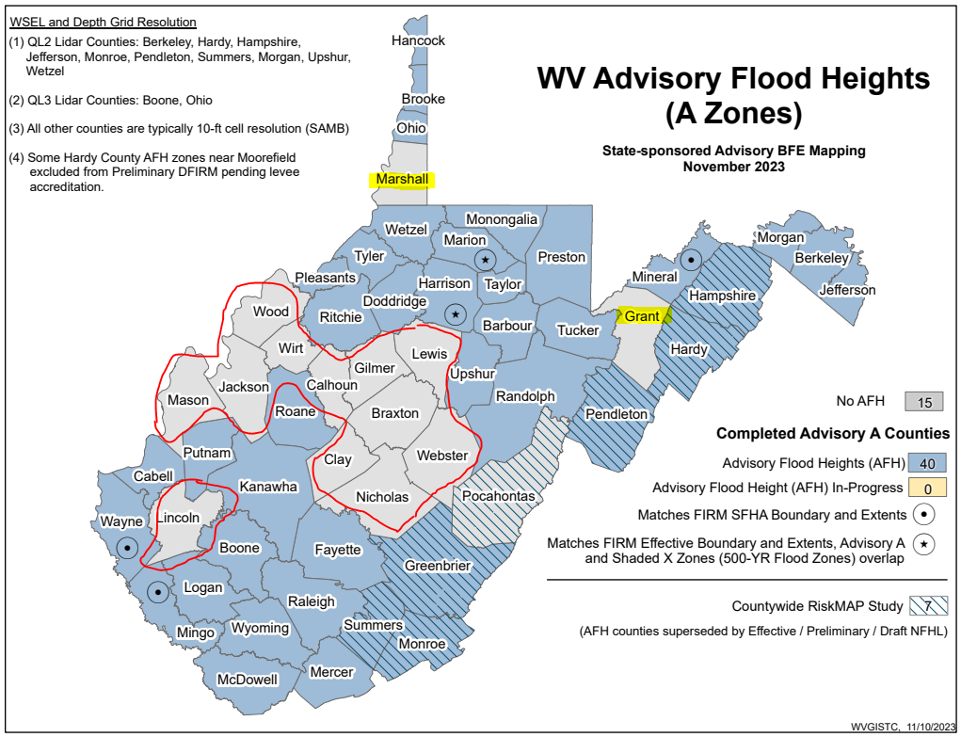
Figure 1. Advisory Flood Heights are still needed for 12 counties. Re-scoped funding obligated for Grant and Marshall Counties. Advisory Flood Heights Status Graphic.
Recommendations and Action Plan:
- 100% Advisory Flood Height Coverage in 5 Years or Less. Prioritize the completion of Advisory Flood Height studies ahead of Risk MAP studies for the remaining 14 counties in West Virginia which the AFH studies can then be incorporated into subsequent Risk MAP studies.
  - Recommend to FEMA Region III that obtaining Advisory Flood Heights for the 14 Approximate A Zones is a VERY HIGH priority for the state.
  - For 13 of the 14 remaining counties, the percentage of Approximate A Zones is more than 50% of the county.
  - The percentage of Approximate A Zones is greater than 90% for Wirt (98%), Nicholas (94%), Lewis (91%), and Grant (90%) counties signifies the acute need for Advisory Flood Heights for these rural counties.
  - The cost for obligating funding for the remaining 12 Advisory Flood Height counties ($350 per mile) for a total of 2,720 Approximate Zone A miles is $875,641.
  - Until 100% Advisory Flood Height coverage is obtained for the entire state, the State NFIP Office will continue its partnership with the USACE Huntington Office for generating site-specific Advisory Flood Height determinations for unstudied Approximate A Zones. Refer to the USACE Scope of Practice and Guidelines for this activity.
- State-Sponsored Mapping. Use obligated CTP funding for a state-sponsored mapping project to create advisory flood heights for Marshall and Grant counties in northern West Virginia. This state-sponsored mapping activity will be completed in 2025.

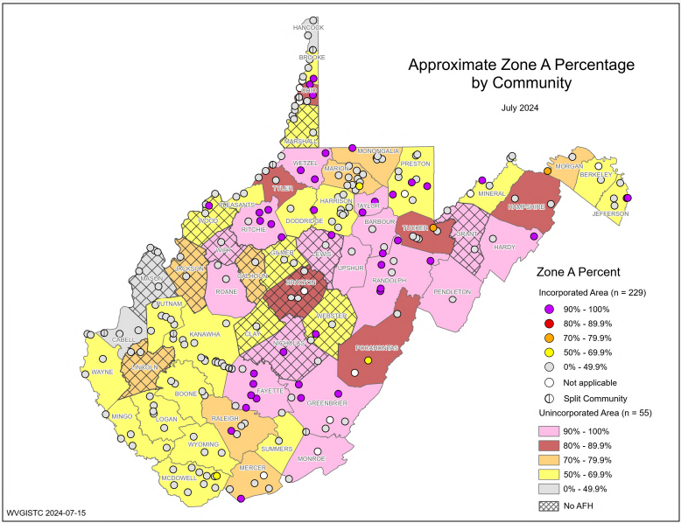
Figure 2. Approximate Zone A percentage. Community | County status graphics

Table 3. The cost for obligating funding for the remaining 12 Advisory Flood Height counties ($350 per mile) for a total of 2,720 Approximate Zone A miles is $875,641.
 | Detailed AE Zones |  | Approximate A Zones
County | Stream Length(mi)-Zone AE | Detailed Zone AE % | Stream Length (mi)- Zone A | Approx. Zone A % | AFH Completion Cost ($350 per mile) | Watersheds
BRAXTON | 40 | 13% | 250 | 87% | $87,591 | Elk, Little Kanawha
CALHOUN | 30 | 21% | 111 | 79% | $38,969 | Little Kanawha
CLAY | 76 | 46% | 87 | 54% | $30,611 | Elk
GILMER | 68 | 31% | 146 | 69% | $51,125 | Little Kanawha
GRANT | 15 | 10% | 127 | 90% | CTP Obligated Funds | South Branch Potomac, North Branch Potomac
JACKSON | 113 | 27% | 292 | 73% | $102,235 | Lower Kanawha, Upper-Ohio Shade
LEWIS | 26 | 9% | 271 | 91% | $94,714 | Little Kanawha, Little Musringum-Middle Island
LINCOLN | 116 | 29% | 273 | 71% | $95,690 | Twelvepole, Lower Guyandotte, Coal
MARSHALL | 74 | 41% | 92 | 59% | CTP Obligated Funds | Upper Ohio-Wheeling
MASON | 239 | 71% | 85 | 29% | $29,778 | Racoon-Symmes, Lower Kanawha, Upper-Ohio Shade
NICHOLAS | 26 | 6% | 387 | 94% | $135,310 | Gauley, Elk
WEBSTER | 132 | 40% | 190 | 60% | $66,630 | Gauley, Elk, Little Kanawha
WIRT | 4 | 2% | 179 | 98% | $62,496 | Little Kanawha
WOOD | 193 | 43% | 230 | 57% | $80,493 | Lower Kanawha, Little Kanawha, Little Musringum-Middle Island, Upper-Ohio Shade
 | 1,153 |  | 2,720 |  | $875,641

Goal 2: MITIGATION SUPPORT. For FEMA’s active Risk MAP flood studies, coordinate risk assessment, communications outreach, and mitigation activities. Currently the southern half and Eastern Panhandle regions of West Virginia are undergoing new Risk MAP flood studies using the new FEMA-purchased QL2 lidar-derived elevation data. Refer to the online and static graphics of FEMA’s active flood studies.

Specific COMS Tasks: This goal fulfills the Mitigation Support task and other Community Outreach and Mitigation Strategies tasks listed in Table 2 of the fiscal year 2024 Cooperating Technical Partners (CTP) Program.

Justification and Need:
- Accurate flood risk maps are required for technical assistance activities related to community engagement, risk communication, and for identifying and advancing mitigation action.
- The FIRM effective dates for many communities are greater than 10 years.
- The new FEMA-purchased QL2 data provide a much more accurate topographic base for new FIRMs and thus will result in more exact FEMA flood maps.
- The nationwide 1-square mile watershed standard needs to be applied for all flood studies to more accurately depict the flood risk in the headwaters of smaller watersheds. For example, during the major 2016 flood along Jordan Creek near Clendenin, WV (Kanawha County), multiple houses were swept away, and a fatality occurred in a low-risk Zone X area of the floodplain.
- A high proportion, or seventy percent of the Special Flood Hazard Areas in the state, are Approximate A Zones. Refer to the Flood Zone A/AE graphic. The ratio of Zone A to Zone AE is more than 70% for 28 of the 55 counties.
- Based on risk assessments at the stream reach level, consideration should be given to upgrading Approximate A Zones to Detailed Study AE Zones.
- Risk MAP meetings provide opportunities for community engagement and identifying flood reduction measures.
- When new flood maps become effective, the statewide count of primary structures in the high-risk flood zones should be updated. The associated risk assessments at the structure level and aggregate geographic scale levels for floodplain building counts should be updated as well.
- Model-backed flood depths are essential for showing the degree of flooding for building-level risk assessments. Upon the publication of new FIRMs, besides updating the FEMA regulatory and flood risk products on the WV Flood Tool, the new flood depths should be applied to updating the building-level risk assessments of all structures in the Special Flood Hazard Area are required to be updated as well.
Recommendations and Action Plan:
- Advisory Flood Heights. Recommend Risk MAP projects should be prioritized to complete Advisory Flood Heights for all Approximate A Zones in the state. During the Risk MAP Discovery phase, questionable WSEL/depth values should be studied.
  - Recommend to FEMA that all Approximate A Zones are mapped to the national standard 1-square mile watershed and that the watershed mapping resolution of each county be tracked by FEMA.
  - Of the estimated 14,255 miles of Special Flood Hazard Areas in the state, the flood studies comprised 70% Approximate A Zones and 30% Detailed AE Zones. The Approximate A Zone miles are increasing as Risk MAP studies map in more detail the smaller watersheds.
  - Model-backed depth values are inputs for building-level risk assessments and spurious WSEL/depth values should be documented for flood study refinements.
  - FEMA and First Street Foundation flood depth values for a 1% annual chance flood event should be analyzed for all 98,000 floodplain structures to evaluate both flood models.
- Upgrade Approximate A Zones to AE Zone Detailed Studies. During FEMA’s Discovery Phase of Risk MAP studies, the state should identify Approximate A Zone stream reaches with a high density of structures and loss potential for upgrading to detailed studies. Approximate A Zone Analysis using the 12 evaluation factors in Table 7 should be conducted during each Risk MAP Discovery phase to identify Zone A stream reach candidates that should be recommended for upgrade to Zone AE. Refer to previous Zone A Structure Analysis studies for examples.
  - Typically, detailed studies use more refined hydrologic modeling instead of just using regression equations. In addition, detailed studies include the floodway and hydraulic models with structure and bathymetric surveys. Extra FEMA products such as the “floodway data table” and “flood profiles” are only included in detailed studies. Per federal regulations, FEMA cannot publish base flood elevations for Approximate A Zones like is done on the WV Flood Tool.
  - Fewer miles of floodplain in West Virginia are detailed studies because of the higher costs. Prices differ by mapping contractor, but the costs are approximately $350 per Zone A mile and $2,500 per Zone AE mile.
  - This activity supports FEMA’s Coordinated Needs Management Strategy (CNMS) in which the data collection and population of the Geographic Information System (GIS) data model used to assess FEMA’s inventory of floodplain studies and support flood map revision and production planning.
A Zone Structure Clusters : A broad Zone A structure vulnerability and spatial density analyses were performed for three flood depths at ≥ 5 feet, ≥ 10 feet, and ≥ 15 feet. More detailed studies at the watershed level are proposed for this CNMS activity in support of Risk MAP Discovery phases. See documentation.

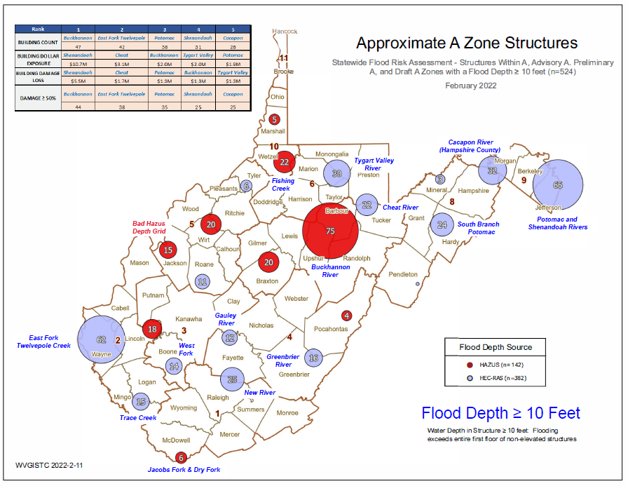
Figure 4. Zone A Building Cluster Analysis for Upgrading Approximate A Zones to Detailed Zone AE. Zone A Cluster Analysis should be incorporated into Risk MAP Discovery phase at the watershed scale to upgrade Approximate A Zones to Detailed AE Studies.

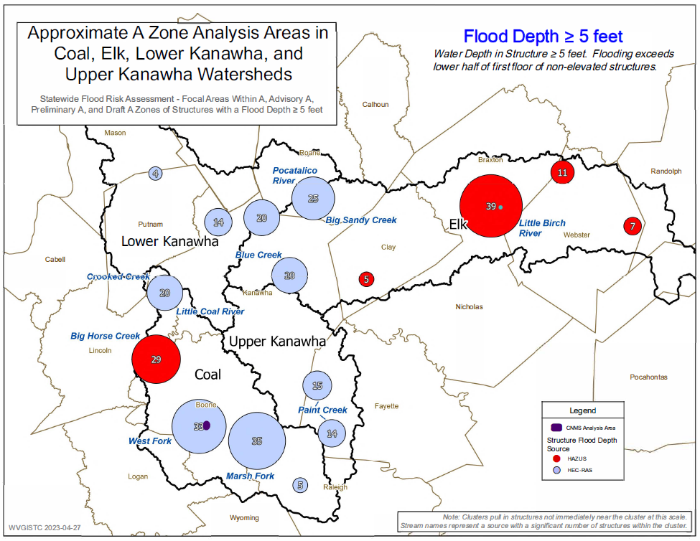
Figure 5. More refined Zone A Cluster Analysis for Kanawha River Basin Watersheds. View report and graphics.

Figure 6. More refined Zone A Cluster Analysis for Gauley and Lower New Watersheds. View report and graphics.

Table 7. Twelve evaluations factors listed below can be utilized for ranking clusters of Approximate A Zone structures as candidates for Zone AE Detailed Flood Studies.

12 Evaluation Factors for Ranking Zone A Building Clusters with High Flood Depths
- Physical Building Factors: Type, Exposure, & Damage
  - Building Count
  - Building Dollar ($) Exposure
  - Building Damage Dollar ($) Loss Estimates
  - Substantially Damaged Loss (%) Estimates
  - Building Types
    - Residential versus Non-Residential
    - Essential facilities and Community Assets
- Depth Grids Factors: Extreme Flood Depths, Depth Grid Accuracy
- Extreme flood depths of structures ≥ 10 feet (verify not flood study error)
- Depth Grid Accuracy
    - Model-backed HEC-RAS depth grid (more accurate)
    - 2010 Hazus depth grid (less accurate)
- Mapping Cost Effectiveness Factors
- Stream length of building clusters for Zone AE conversion
- Building density per square mile (Building Count / Cluster Stream Length)
- Estimated Zone AE study cost per mile ($2,500 per mile)
- Zone A building cluster adjacent to existing Zone AE
- Legacy county boundary mapping issue (Zone AE mapping stopped at county border)

Methodology and Rankings: Physical building factors are based on (1) building counts, (2) building dollar exposure, (3) building damage dollar exposure estimates, (4) substantially damaged estimates, and (5) building types. Depth grids factors are (6) extreme flood depths ≥ 10 feet and (7) depth grid accuracy. Mapping cost-effectiveness factors are the (8) stream length of building clusters for Zone AE, (9) building density per square mile, (10) estimated Zone AE study cost per mile, (11) Zone A building cluster adjacent an existing Zone AE study, and (12) legacy county boundary mapping issues.
Specifications: Detailed Studies versus Approximate A Studies
- Detailed studies use more refined hydrologic modeling in a lot of cases instead of just using regression equations.
- Detailed studies include floodway and hydraulic models with structure survey and bathymetric survey.
- Detailed studies have extra FEMA products such as a “floodway data table” and “flood profiles” in the FIS reports.
- FEMA can’t publish BFE’s on their products unless it is “a detailed study” per federal regulations. Consequently, FEMA utilizes States’ websites to display BFE’s for Approx. A Zones

Need Justification: In West Virginia, nearly 70% of WV floodplains are Approximate A Zones and not detailed studies. Advantages of detailed studies.

- Interagency Coordination and Hazard Library. Recommend interagency coordination and alignment of flood studies between all relevant federal, state, and local agencies (FEMA, USACE, NRCS, NGS, WV SRO, WV DOT, etc.). To facilitate coordination efforts, a Hazard Library of relevant Risk MAP documents specific to West Virginia is being developed and should be online this year. An example of coordination is the new vertical datum conversion standard for flood risk analysis and mapping.
- Risk MAP Mitigation Activities. Flood risk studies provide opportunities for flood risk communications and risk reduction activities. Besides the local floodplain managers and emergency officials, the engagement with elected officials and executives is required too. (WVU Task F)
  - Watershed and Community Risk Assessments. FEMA Risk MAP meetings at the various developmental mapping phases (Discovery, Flood Risk Review, Community Coordination and Outreach) provide excellent opportunities for risk assessment and flood reduction efforts. Along with FEMA community risk profiles, more detailed supplemental risk assessment data and analysis will be provided by the state for Risk MAP community engagement meetings at various geographic scales (state, region, county, community, watershed, stream, and building-level scales) to prioritize emergency preparedness and mitigation efforts. This next year a new interactive flood risk tool named the “WV Risk Explorer” will be released to the public to view riverine flood risk assessments based on 27 flood factors for floodprone communities and counties. (WVU Task E)
  - Higher Standards. Since new floodplain management ordinances must be adopted with new FIRMs, updating the ordinance provides an opportunity to implement higher standards such as increasing the freeboard safety factor or stricter regulations of recreational vehicles. If necessary, review and update the Floodplain Management Ordinance Model for the state.
  - Mitigation Support Measures. Identify appropriate mitigation measures at community meetings that can be enacted immediately (e.g., promote Swift Current funding for repetitive loss structures; prepare mitigation letters of support for congressional direct funding to relocate the E-911 center in Pocahontas County out of the floodplain). Use the statewide risk assessment data to prioritize mitigation activities.
  - SFHA Change Letters. The state has created SFHA change letter templates for communities to mail to property owners affected by new FEMA flood maps. The flood risk outreach letters target property owners mapped into the SFHA or Floodway as well as owners mapped out of the SFHA. Superseded LOMAs must be verified before letters are sent.
  - LiDAR LOMAs. Until new flood maps with the LiDAR topographic data are created, LiDAR LOMAs should be considered. More than 15,000 structures located in advisory floodplains (Preliminary/Draft NFHL, Advisory A Zones, Redelineated Updated AE) and viewable as “mapped-out” structures on the RiskMAP View may be eligible for LiDAR LOMAs.

MITIGATION SUPPORT

Goal 3: MITIGATION SUPPORT. Leverage Risk MAP data, analyses, products, and/or processes to support communities to advance mitigation action. The WV Tool and new risk tools being developed support risk communications and mitigation measures.
Specific COMS Task: Mitigation Support is one of the Community Outreach and Mitigation Strategies tasks listed in Table 2 of the fiscal year 2024 Cooperating Technical Partners (CTP) Program.
- WV Flood Tool. Provide global outreach services for the WV Flood Tool which provides the public with flood risk determination and building-level risk assessments at the property scale level. (WVU Task A)
- Building-Level Risk Assessments (BLRA). Update building-level flood risk assessments for structures in the high-risk flood zones using the best available Risk MAP data and products. New Risk MAP studies always trigger updating the identification and risk assessment of all structures in high-risk flood zones. Publish updated building-level assessments to the Risk MAP View of the WV Flood Tool. (WVU Task B)
- WV Risk Explorer. Develop, verify, and publish flood risk profiles at eight geographic scale levels: State, Regional, County, Community, Unincorporated Area, Incorporated Place, Watershed, and Streams. A new risk tool named the WV Risk Explorer will allow communities to quickly view risk factors affecting their jurisdictions. (WVU Task C)
- WV Flood Visualizations. Create flood visualizations at the viewshed and building level scales to communicate flood risk to the public more effectively. Incorporate high water marks of previous major flood disasters in flood models. Additionally, compare flood frequency flood depths between FEMA and First Street Foundation flood models. (WVU Task D)
- WV Hazard Library. Organize and publish an online WV Hazard Library of which contents include resources related to flood resiliency research, hazard risk assessments, floodplain management, and mitigation activities. (WVU Task E)

MITIGATION PLANNING TECHNICAL ASSISTANCE
Goal 4: MITIGATION PLANNING TECHNICAL ASSISTANCE. Encourage hazard mitigation plan implementation and advance community hazard mitigation actions through technical assistance that supports the Mitigation Planning Process and Risk MAP projects.
Specific COMS Task: Mitigation Planning Technical Assistance is one of the Community Outreach and Mitigation Strategies tasks listed in Table 2 of the fiscal year 2024 Cooperating Technical Partners (CTP) Program.
- Support Local Hazard Mitigation Plans with Flood/Landslide Risk Assessment Data and Products. The new risk tools named the WV Risk Explorer and WV Hazard Library will help to accomplish the goal of supporting hazard mitigation plans by making risk assessment data localized to West Virginia more accessible to hazard planners. (WVU Task H)

TRAINING AND COMMUNITY DEVELOPMENT

Goal 5: TRAINING AND COMMUNITY CAPABILITY DEVELOPMENT. Promote risk awareness and mitigation actions at the community level by way of training and outreach events. These training and outreach meetings -- coordinated with FEMA Region -- focus on community engagement, risk communication, floodplain management, flood study coordination, and identifying and advancing mitigation actions. This task also includes the creation of customized floodplain management resources for the state. Targeted audiences include the public while specialized training and outreach activities focus on the community development of stakeholders that include floodplain managers, emergency preparedness officials, risk planners, and elected officials.
Specific COMS Tasks: These outreach events support the Training and Community Capability Development Task as well as other Community Outreach and Mitigation Strategies tasks listed in Table 2 of the fiscal year 2024 Cooperating Technical Partners (CTP) Program. This goal supports both FEMA’s Risk MAP and NFIP/CRS programs for building flood resiliency in communities.
- Maintain and/or utilize personnel to support COMS activities (such as attending Risk MAP meetings or meetings hosted by FEMA Regions).
- Create a climate of understanding and ownership of the WV Flood Tool in support of the Risk MAP flood risk study phases among stakeholders.
- Promoting new training resources for State and Local Officials. Sponsored by the State NFIP Office, a new standardized Permit Application is being created by the company TETRA TECH for the local floodplain managers.
- Provide supplemental training and technical outreach services to:
  - Increase CRS participation by communities in the state. The Community Rating System (CRS) is a voluntary incentive program that recognizes and encourages community floodplain management practices to exceed the minimum requirements of the National Flood Insurance Program (NFIP).
  - Reduce repetitive loss structures via the submission of Repetitive Loss (RL) AW-501 Worksheets and FMA grant applications
  - Meet the new requirements of FEMA’s Redesigned NFIP Compliance Audit Program which include the National Violation Tracker (NVT) property database.

- Examples of FUTURE training and outreach events:
- WV Flood Tool and Ordinance Administration Class (July 22-26).
  - Tuesday July 23: Monongalia County 911/OES Offices (the new building) from 10a-2p. (Hap can give you directions or google the new center @ the Industrial Park)
  - Wednesday July 24: Hardy County Armory 10a-2p
  - Thursday July 25: Fayette County OES/911 10a-2p
  - Friday July 26: WVEMD Office at TC Energy Building 11th floor conference room (1700 Maccorkle Ave SE, Charleston, WV 25314) 10a-2p
- Community Rating System (August 26-29) New River Conference Center (497 Mall Road, Oak Hill, WV)
- G-273 Managing Floodplain Development in NFIP (October 2024 and April-May 2025)
- Advance NFIP Class (March 2025)
- SD/SI TBD (Computers)
- 1 Day Floodplain Management
- ½ Day Floodplain Training
- Examples of PREVIOUS training and outreach events:
  - CTP Conference Roanoke
  - Train the Trainer – Philadelphia
  - CAP Summit – Harpers Ferry
  - WV Floodplain Managers Conference (June 2024)
  - Risk MAP Flood Risk Review (FRR) Meeting – Jefferson County (April 2024)
  - Risk Map Community Coordination & Outreach (CCO) Meetings – Hampshire and Pocahontas counties (April 2024)
  - Risk Reduction Consultation (April 4, 2024)
  - Building Flood Resiliency in WV Communities – Charleston, WV (March 12-13)
  - WV Surveyors Conference presentation – Stonewall Jackson (February 8, 2024)
  - Flood Resiliency Week – Capitol (February 14, 2024)
  - Multi-Hazard Extreme Flood Event
  - NFIP-SHMO Conference – Rehoboth Beach, DE (November 2023)
  - G273 Class – Flatwoods (November 6-9, 2023)
  - Elevations Certificate Virtual Training (October 2023)
  - Greenbrier County Appeal (September 2023)
  - Hurricane CAC (September 7, 2023)
  - Substantial Damage Teams in Action after the August 2023 storms
  - WV State Fair (August 2023)
  - SDE Team Training – Oak Hill (August 1-2, 2023)
  - Risk MAP Discovery Meetings May-July 2023 for Watersheds: Lower New, Gauley, Coal, Upper Kanawha, Lower Kanawha, and Elk

PLAN CONTRIBUTORS

COMS Plan contributors and contact information.

Timothy W. Keaton, CFM  NFIP/CTP Coordinator  WV Emergency Management Division  1700 MacCorkle Avenue, SE, 6th Floor  Charleston, WV 25314  Office: 304-414-7659  tim.w.keaton@wv.gov | Kurt Donaldson, GISP, CFM  Manager  WV GIS Technical Center  West Virginia University  98 Beechurst Ave.  Morgantown, WV 26505  (304) 293-9467  kdonalds@wvu.edu

