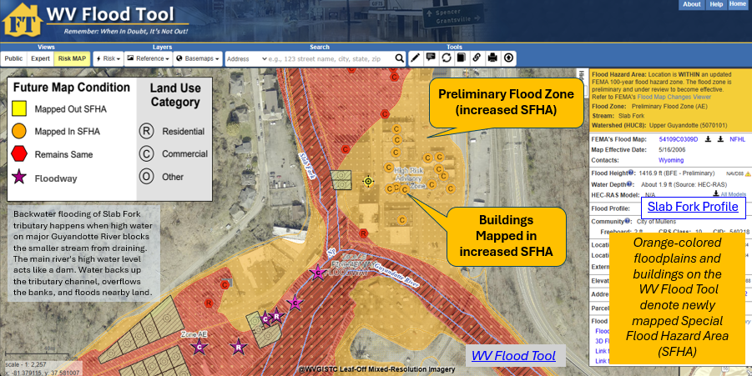

WV Emergency Management Division
COOPERATING TECHNICAL PARTNERS
PROJECT MANAGEMENT STATEMENT OF WORK
PM SOW No. 8


Fiscal Year 2026

This page intentionally left blank
Table of Contents
1. Part 1 – Custom Statement of Work Information 2
1.1. Project and Point of Contact Information 2
1.2. Tasks and Deliverables to be Completed Under this Statement of Work 3
1.3. Schedule and Performance 9
1.4. Guidelines and Standards 11
1.5. Use of Contractors 11
1.6. Reporting and Performance 12
1.7. Privacy and Protection of Personally Identifiable Information 12
APPENDIX A: Additional Descriptions of WVU Led PM Tasks 13

  - Part 1 – Custom Statement of Work Information
    - Project and Point of Contact Information
Table 1. Project and Point of Contact Information
Information Type | Description
Project Name/Title (if applicable) | WVEMD CTP26 PM 2026-27
CTP Organization Name: | WV Emergency Management Division (WVEMD)
CTP Contractor Working on the activities in this Statement of Work: | N/A
Sub-Recipient Working on the activities in this Statement of Work: | WV GIS Technical Center, West Virginia University
CTP Partnership Agreement Date: | 8/2026
Period of Performance: | 10/1/2026 to 9/30/2027
CTP Project Manager: | Julie R. Sears, CFM
FEMA Regional Project Officer:  When necessary, ask for FEMA assistance through the FEMA Regional Project Officer | Lee Brancheau  FEMA Region III
FEMA Funding to Complete this Project Management Statement of Work: | $175,000
CTP Estimated Leverage: | N/A
Project Team Coordination Activities:  During the project, all members of the Project Team will coordinate, as needed, to see that activities, products and deliverables meet FEMA requirements and contain accurate, up-to-date information. | - Meetings, teleconferences, and video conferences with FEMA Region III, WVEMD, and other Project Team members biannually at a minimum with additional meetings scheduled as necessary.  - Telephone conversations with FEMA and other Project Team members on a scheduled monthly basis and ad hoc basis, as required  - Email as needed
    - Tasks and Deliverables to be Completed Under this Statement of Work
      - Narrative and Audience
Table 2. Narrative and Audience
Information Type | Description
Statement of Work Narrative: | The CTP Project includes global outreach services for mapping and for training to state and local officials. It funds the ongoing maintenance and updates for localized risk assessment tools for analysis and visualization, namely the WV Flood Tool (https://www.mapwv.gov/flood) and the WV Risk Explorer (https://www.wvfrf.org/wvre) hosted by the West Virginia GIS Technical Center at West Virginia University. It will process and integrate new flood and reference GIS layers, risk assessments, tool enhancements, hazard-related resources, etc. for the WV Flood Resiliency Framework (https://www.wvfrf.org), a virtual hub of risk assessment, visualization, planning, and training resources for building community flood resiliency in West Virginia. An overarching goal of this CTP PM Project is to more proactively engage flood-prone communities to use these customized flood reduction web tools.
Intended Audience: | Target Audience: Floodplain Managers, Community Planners, Emergency Preparedness Officials, Engineers/Surveyors, Realtors, Lenders, Community Leaders, Property Owners, etc. Supports stakeholders engaged at the state, regional, and community levels.  Project Footprint: State of West Virginia  Through collaboration with Local, State, and Federal entities, the WV Flood Tool delivers quality data that increases public awareness and leads to actions that reduce risk to life and property. To manage the wealth of available data and better communicate flood risk, the WV Flood Tool has maintained a public facing outreach tool for the public, communities, engineering/surveying companies, and others (Insurance companies, lending institutions, real estate companies, etc.) that has provided effective floodplain models, supporting datasets, water-surface elevations, floodplain boundaries, and additional enhanced flood risk information. During the past decade, the functionality and quality of data layers of the WV Flood Tool have progressed, resulting in increased use of the application. Over time, the WV Flood Tool has become more than just a flood determination tool and today is routinely used by floodplain managers for building permit applications, floodplain regulations enforcement, pre- and post-disaster assessments, and Community Rating System discounts. For community and emergency planners, the RiskMAP View of the WV Flood Tool now includes structure-level risk assessments and mitigated properties to aid in flood reduction efforts. The new WV Risk Explorer provides additional tools to quantify and visualize riverine flood risk at multiple geographic scales.
      - Project Tasks and Deliverables
The following 8 tasks can be accomplished under this Project Management Statement of Work. The yellow highlighted tasks will be realized for this project.
- State and Local Business Plans and/or Updates (required).
- Global Project Management Activities (completed under the Project Management Statement of Work when the CTP is also funded for tasks in the Flood Risk Project Mapping Activity Statement).
- Global Outreach for Mapping.
- Training to State, Local, Tribal, and Territorial Officials.
- Staffing.
- Mentoring and Best Practices.
- Minimal Map Printing.
- Programmatic Quality Assurance/Quality Control Plans.
        - Task 1 - State and Local Business Plans and/or Updates (Required)
This task is required as a condition of Project Management funding.
Table 3. Task 1 – State and Local Business Plans and/or Updates
Project Management Task | Check box can be used to indicate if task will be done under this Statement of Work. | (A) FEMA Contribution | (B) Partner Contribution | (A+B) Total Project Cost
State Business Plan Update | ☒ | $5,000 | $0 | $5,000

Deliverable | Check boxes can be used to indicate if deliverable will be done under this task.
Business Plan (WVEMD Task 1) | ☒

Custom Scope Elements
WVEMD PM State Business Plan ($5K)
- Complete State Business Plan. Update the State Business Plan for delivery to FEMA Region III that advances the NFIP/CRS and Risk MAP programs in West Virginia. The Business Plan will adhere to the guiding principles specified by FEMA. (WVEMD Task 1)

        - Task 3 – Global Outreach for Mapping
Instructions: Table 5 can serve as an example for describing Global Outreach for Mapping for Task 3.
Table 5. Task 3 – Global Outreach for Mapping
Project Management Task | Check box can be used to indicate if task will be done under this Statement of Work. | (A) FEMA Contribution | (B) Partner Contribution | (A+B) Total Project Cost
Global Outreach for Mapping | ☒ | $122,000 | $0 | $122,000

Deliverable | Check boxes can be used to indicate if deliverable will be done under this task.
Report detailing outreach and coordination activities including backup or supplemental information used in writing the report | ☐
Business Plan update describing (in detail) the outreach activities | ☐
Updates to CTP website and state flood hazard identification tools | ☒
Other WVU Task A: Provide Global Outreach Services for the WV Flood Tool. ($84K) | ☒
Other WVU Task B: Update the WV Building Level Risk Assessment (BLRA) from New Data Sources (e.g., Flood Studies, Building Characteristics). ($14K) | ☒
Other WVU Task C: Develop, verify, and publish flood risk profiles at eight geographic scale levels: State, Regional, County, Community, Unincorporated Area, Incorporated Place, Watershed, and Rivers/Streams on the WV Risk Explorer. ($13K) | ☒
Other WVU Task D: Create flood visualizations at the viewshed and building-level scales to communicate riverine flood risk to the public more effectively. ($2K) | ☒
Other WVU Task E: Catalog and publish new resources to online WV Hazard Library. ($9K) | ☒

Custom Scope Elements
Global Outreach for Mapping - WVU Led Tasks - $122K (See Appendix A for more information)
- Provide Global Outreach Services for the WV Flood Tool. Statewide global outreach services that process and integrate new flood and reference GIS layers, tool enhancements, flood and landslide risk information, etc. for the WV Flood Tool (www.mapwv.gov/Flood). Maintain the WV Flood tool at a high level of performance and availability to include periodic system administrative and cyber security updates. Services include computer programming, data development/geo-processing, customized mapping, technical support, training, and Community Rating System credits for communities. WV Flood Tool and global outreach tasks include:
  - New effective and advisory flood layers (flood zones, depth/WSEL grids, cross-sections, BFE lines, LOMAs/LOMRs, LOMAs-verified (in or out SFHA), flood profiles, panel index, FEMA map and HEC-RAS model downloadable links, etc.)
  - Hazus depth grids where model-backed depth grids do not exist
  - Flood zone query programming logic and cartography to support floodplain management, risk assessment, and mitigation mapping layers
  - High water marks and Stream Gages
  - Elevation Certificates
  - Freeboard and CRS ratings display on Flood Query Results Panel
  - Risk assessment layers (primary structures, essential facilities, historical and non-historical community assets, building exposure cost, building characteristics (e.g., foundation type and building year/FIRM status), damage loss estimates, etc.
  - 1% damage loss models for primary structures, roads, and bridges
  - Other hazard layers such as landslides and dams/levees
  - Reference layers (parcels, addresses, leaf-off imagery, legal boundaries, etc.). Update the State’s 1.4 million tax parcels of the WV Property Viewer to reveal properties that intersect high, moderate, or low flood risk zones
  - Contact listing of all the local floodplain managers on the WV Flood Tool
  - Technical documentation associated with the WV Flood Tool.
  - Consulting and outreach mapping services to include support for local Hazard Risk Assessment plans
Importantly, the WV Flood Tool publishes Elevation Certificates, Verified LOMA locations, HEC-RAS stream models, and 1%-annual-chance advisory floodplains / BFE’s / depth grids not available by FEMA maps services. (WVU Task A)

- Update the WV Building Level Risk Assessment from New Data Sources (e.g., Flood Studies, Building Characteristics, Mitigated Structures) at the property-level scale. Update building-level flood risk assessments for structures in the high-risk flood zones using the best available Risk MAP data and products. New Risk MAP studies always trigger building-level risk assessment updates of all structures in high-risk flood zones and essential facilities (hospitals, schools, police stations, fire stations, and E-911 offices) in the moderate risk flood zones. To compute Hazus loss damage estimates and population displacements for a 1% annual chance (100-yr) flood event, capture the following building characteristics for each structure: building value, building year, foundation type, occupancy class, stories, area, and first floor height. Publish detailed building-level assessments to both WV Flood Tool’s Risk MAP View and the Building-Level Risk Tools (primary and significant structures) of the WV Risk Explorer. (WVU Task B)
- Develop, verify, and publish flood risk profiles aggregated at eight geographic scale levels: State, Regional, County, Community, Unincorporated Area, Incorporated Place, Watershed, and Streams. Update various riverine risk factors that support Risk Map, Risk Report, and Risk Dashboards of the WV Risk Explorer, all part of a suite of localized risk assessment tools for analysis and visualization to build community flood resilience in West Virginia. (WVU Task C)
- Create flood visualizations at the viewshed and building level scales to communicate flood risk to the public more effectively. Create flood visualizations (3D Movies, Viewsheds, Building Profiles, Story Maps) at the community and building level scales to communicate riverine flood risk more effectively to the public. Catalog flood visualizations in the WV Hazard Library. (WVU Task D)
- WV Hazard Library. Catalog and publish new documents and visual media to the WV Hazard Library. Allows the public to search documents and visual media for hazard information relevant to West Virginia. Users can search by topic, media type, or geographic extent. The Hazard Library consists of major collections for risk assessments, flood events, and mitigation reduction efforts (mitigation measures, hazard planning, floodplain management, Risk MAP studies, flood models, etc.). The classification system of the Hazard Library is flexible in that additional subjects can be added. (WVU Task E)

        - Task 4 – Training to State, Local, Tribal, and Territorial Officials
Table 6. Task 4 – Training to State, Local, Tribal, and Territorial Officials
Project Management Task | Check box can be used to indicate if task will be done under this Statement of Work. | (A) FEMA Contribution | (B) Partner Contribution | (A+B) Total Project Cost
Training to State & Local Officials | ☒ | $48,000 | $0 | $48,000

Deliverable | Check boxes can be used to indicate if deliverable will be done under this task.
Other WVEMD Task 2: WVEMD Floodplain Management Training and Outreach. ($45K) | ☒
Other WVU Task F: WVU Training and Outreach organized by WVEMD for WV Flood Tool. ($3K) | ☒

Custom Scope Elements
WVEMD Training and Outreach to State/Local Officials - $45K

- Promote risk awareness and mitigation actions at the community level by way of training and outreach events. These training and outreach meetings -- coordinated with FEMA Region III -- focus on community engagement, risk communication, floodplain management, flood study coordination, and identifying risk reduction actions. This task also includes the creation of customized floodplain management resources for the state. Targeted audiences include the public while specialized training and outreach activities focus on the community development of stakeholders that include floodplain managers, emergency preparedness officials, risk planners, and elected officials. Refer to the PM Business Plan for previous and future training/outreach events. (WVEMD Task 2)
WVU Training to State/Local Officials for WV Flood Tool - $3K
- WVU Training and Outreach. Provide outreach and training services organized by WVEMD for the WV Flood Tool. (WVU Task F)

      - Percentage of Time Spent on Tasks or Activities
Based on these guidelines, Tables 11 and 12 are not required for PM SOW.
    - Schedule and Performance
Table 13. Project Management Task Deliverables Schedule
Statement of Work Activities | Deliverable | Deliverable Due Date | Submitted To
Business Plan (required) | Business Plan | 2 months from Award date | FEMA Regional Project Officer
Global Outreach for Mapping | Reporting on Outreach Mapping Activities | Quarterly | FEMA Regional Project Officer
Training to State/Local Officials | Reporting on Training Activities | Quarterly | FEMA Regional Project Officer

Table 14. Performance Measures Targets
Outcome and Output Measure (from funding opportunity) | Output Measurement (with customized Target) | Recorded Unit/Scale
Update Business Plan | Business Plan Updated | Achieved / Not Achieved
Update WV Flood Tool with new hazard data | Flood hazard, risk assessment, and key reference layers updated on the WV Flood Tool (www.mapwv.gov/flood). | Achieved / Not Achieved
WV Risk Explorer | Online interactive WV Risk Explorer for community risk assessments released | Achieved / Not Achieved
WV Hazard Library | Catalog and publish new hazard resources to online WV Hazard Library | Achieved / Not Achieved
Flood Visualizations | Complete flood visualizations at the building or viewshed scales. Catalog visualizations in the Hazard Library for user access. | Achieved / Not Achieved
Support Local Hazard Mitigation Plans | Provide access to various risk assessment products (reports, tables, graphics, risk dashboards, GIS data, etc.) | Achieved / Not Achieved
 | - Develop and publish training materials  - Provide in-person and remote training | Achieved / Not Achieved
Update the WV Building Level Risk Assessment (BLRA) from New Data Sources | Update Hazus flood loss models and risk assessment products associated with inventoried floodplain buildings. New model inputs consist of:  - Depth Grids: Incorporate 1-meter resolution depth grids from best available sources for all 55 counties.  - Tax Year 2027 Building Characteristics: Updated building replacement values, occupancy class, stories, etc. from 1.4 million tax assessment data parcels.  - Mitigated Structures: Incorporate elevated first-floor heights and foundation types (open, closed) from mitigated structure datasets: elevation certificates, building pictures, etc. | Update BLRA of 97,000 flood-prone structures in State from new data sources (e.g., depth grids, tax assessment records, mitigated structures)  Achieved / Not Achieved
    - Guidelines and Standards
The standards relevant to this Statement of Work are presented in FEMA Policy 204-078-1 Standards for Flood Risk Analysis and Mapping, Revision 14.
This Policy supersedes all previous standards in the Guidelines and Specifications for Flood Hazard Mapping Partners. This includes all related appendices and procedure memoranda. The CTP can find more information and links to guidance documents, technical references, templates, and other resources that support these standards on the FEMA Guidelines and Standards website. This is at: Guidelines and Standards for Flood Risk Analysis and Mapping Activities Under the Risk MAP Program. FEMA reviews standards each year. Please use the most current version of the policy.
    - Use of Contractors
Table 15 can serve as an example for presenting funding opportunity requirements and indicating the correct contractor option. The CTP must indicate their selection of the applicable statement as noted in Table 15.
Table 15. Use of Contractors
Check box can be used to indicate option. | Description of Contractor Options
☒ | The CTP does not intend to engage the services of a contractor for this Statement of Work. No transfer of funds to agencies, other than those identified in the approved cooperative agreement application, will be made without prior approval from FEMA. The CTP must ensure that the procurement for all contractors, if any are engaged for this Statement of Work, complies with the requirements of Title 2 CFR Part 200 - Part 200 - Uniform Administrative Requirements, Cost Principles, and Audit Requirements for Federal Awards.  Guidance provided in this part includes, but is not limited to, contract administration and recordkeeping, notification requirements, review procedures, competition, methods of procurement, and cost and pricing analysis. Refer to Title 2 CFR Part 200.  The WV GIS Technical Center at West Virginia University is acting as a sub-recipient of the CTP project to maintain and update the WV Flood Tool and the WV Risk Explorer. Because these specific platforms are custom-built research and public safety tools developed directly by West Virginia University (WVU) researchers, the scope of work extends far beyond standard technical or IT contracting.
    - Reporting and Performance
Financial Reporting: Because FEMA has provided funding to the CTP, financial reporting requirements for the CTP shall be set by the terms of the funding opportunity, Articles of Agreement, or Award Notice for this Statement of Work. The CTP must also refer to Title 2 CFR Part 200. The CTP must provide financial reports to the FEMA Regional Project Officer and Assistance Officer per the terms of the signed Cooperative Agreement for this Statement of Work.
Performance Reporting: CTPs must provide a signed performance report (using the list of required information shown in the funding opportunity). The CTP must submit the report quarterly during the period of performance. Reports will be required for partial calendar quarters and periods when no grant award activity occurs. An old Standard Form-Performance Progress Report (SF-PPR) may be substituted for the performance report, if preferred. The CTP must refer to Title 2 CFR Part 200 for the minimum requirements for progress reporting. The FEMA Regional Project Officer, as needed, may request additional information on progress.
The CTP must meet with FEMA and/or its contractor(s) as frequently as needed to review the progress of the project. These meetings are in addition to the quarterly financial and status submittals. These meetings may alternate between the FEMA Regional Office, the CTP office and conference calls as necessary.
The CTP must report performance of the grant along with the progress reports. Table 14. Performance Measures Targets shows which performance measures the CTPs will use to track performance. If the CTP is completing a Project Management project alongside a Flood Risk Project Mapping Activity Statement, they should use the relevant measures in the 2026 CTP Performance Measures Matrix. Quantitative Targets for performance measures are defined using the 2026 CTP Performance Measures Matrix in conjunction with the FEMA Regional Project Officer and those defined in Table 14.
CTPs are responsible for entering their quarterly performance data each quarter, unless otherwise directed by their FEMA Regional Project Officer. Each output measurement identified above must have a quarterly performance reported within one month of the end of the quarter.
Project Management Statement of Work tasks are now tracked in the Mapping Information Platform. The CTP may contact the FEMA Regional Office to obtain additional guidance (as needed) for updating Project Management efforts in the Mapping Information Platform.
    - Privacy and Protection of Personally Identifiable Information
Your organizational access to the Mapping Information Platform signifies that you have access to Personally Identifiable Information (e.g., Names, Addresses, and Phone Numbers). Please ensure that your organization has coordinated with the FEMA Regional Office. Each user must currently meet the new requirements of the Risk Analysis Management (RAM) Access Portal (RAP) process.
In addition, as noted in the funding opportunity, the recipient and subrecipient must take reasonable cybersecurity and other measures to safeguard information including protected personally identifiable information (PII) and other types of information per Title 2 Code of Federal Regulations Section 200.303(e).
Please contact the FEMA Regional Project Officer for more information.

APPENDIX A: Additional Descriptions of WVU Led PM Tasks

- WV Flood Tool. Provide Global Outreach Services for the WV Flood Tool. Statewide global outreach services that process and integrate new flood and reference GIS layers, tool enhancements, flood and landslide risk information, etc. for the WV Flood Tool (www.mapwv.gov/Flood). Services include computer programming, data development/geo-processing, customized mapping, technical support and training services. (WVU Task A)

Figure A-1. Example Preliminary Map changes on WV Flood Tool for McDowell County.

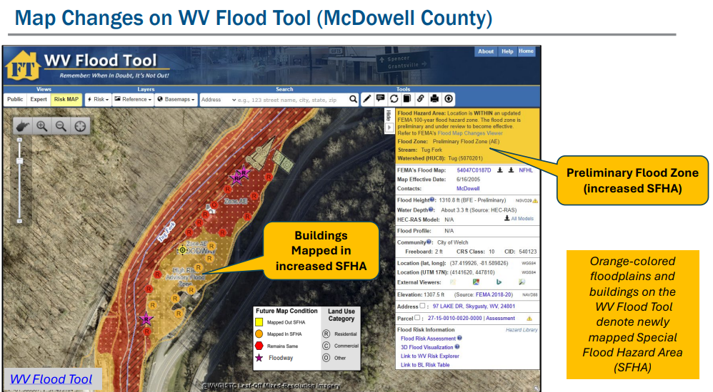

Table A-1. Detailed task description for WV Flood Tool.
Task Description
[GLOBAL OUTREACH SERVICES FOR WV FLOOD TOOL]
The WV Flood Tool and global outreach services support stakeholders in pre-disaster actions around adaptation, resilience, and mitigation. The global outreach supports FEMA’s NFIP/CRS Program objectives to:
- Maintain consistent national standards while interjecting a tailored, local focus
- Use local data and integrate at state level to facilitate floodplain management
- Utilize local experience and knowledge
- Provide training and technical assistance
- Provide communities with state-based CRS credits
- Support Risk MAP Program Goals of Flood Hazard Data, Public Awareness and Outreach, Risk Planning, Enhanced Digital Platform, and Alignment and Synergies

Through collaboration with Local, State, and Federal entities, the WV Flood Tool delivers quality data that increases public awareness and leads to actions that reduce risk to life and property
Specific tasks under global outreach services in support of the WV Flood Tool include:
New Flood Map Products:
- Incorporate new regulatory and non-regulatory flood hazard layers into the WV Flood Tool. Publish all the flood layers, query layers, geoprocessing layers, models, and attributes according to standardized procedures and cartographic design.

- Effective and Preliminary National Flood Hazard Layers (e.g., Countywide RiskMAP Studies, Advisory Flood Heights)
  - Add effective or Draft/Preliminary NFHL, WSEL, and Flood Depth
  - For Preliminary Flood Heights, in Flood Query Results Panel link Preliminary Flood Zones to FEMA’s Map Changes Viewer
  - Advisory Flood Heights (AFH) and Base Flood Elevations
- Flood Study Status Graphics
  - Active Flood Studies
  - Advisory Flood Heights
  - FEMA R3 Project Status Graphic
- Floodplain Boundary, WSEL/ Depth Grid Layers
  - Floodplain Boundary: Regulatory and Non-Regulatory Advisory Zones (Preliminary/Draft NFHL; Updated AE or Advisory A Zones)
  - WSEL: Base flood Elevations and Advisory Flood Heights
  - Depth Grid: Model-Backed (HEC-RAS) Advisory A Depth Grids
- Other Flood or Flood-Related Layers
  - Cross-Sections
  - BFE Lines
  - Panel Index (Geo-Index)
  - LOMAs, LOMRs (including Location-Verified LOMAs to correct parcel or structure)
  - Flood Study Profiles for Detailed AE Zones
  - Flood Query Results Layers: Flood Zone Designation, Stream Name/Flood Source, HEC-RAS Engineering Model Download
  - USGS High Water Marks and Stream Gages
  - H&H Hydrologic/Hydraulic Downloadable Models
  - Structure (bridges, culverts, etc.)
  - Mitigated Buyout Properties
  - Elevation Certificates
  - Flood Manager List on WV Flood Tool
- Other Flood or Flood-Related Layers
  - Upgraded cartography to support new FEMA Flood Risk products for Approximate A Zones that include unlabeled cross-sections and HEC-RAS models.
- Model-Backed Studies. The statewide Hazus depth grid created in 2010 is inaccurate and thus has a negative impact on building-level flood risk assessments and flood visualizations. Adding model-backed depth grids from flood studies improves the coverage and accuracy of the statewide depth grid, a flood risk assessment priority of attaining model-backed, gridded flood-risk depth grids for all 1-percent flood zones in West Virginia. In addition, model-backed Base Flood Height values provide important information for the Flood Query Results Panel and for processing LiDAR LOMAs using the Print Function of the WV Flood Tool. Lastly, depth grid errors associated with mapping issues identified from anomalous building level risk assessments are forwarded to Region 3 for CNMS problem area tracking and for Risk MAP Discovery phase.

- Procedural Documentation. Maintain and update technical documentation.
  - Updating Flood Layers on WV Flood Tool. Follow standardized procedures for processing and publishing new flood layers to WV Flood Tool.
  - Updated AE Redelineation. Follow WV GIS Technical Center’s procedural guide for creating Flood Depth/Water Surface Elevation Grids and Redelineated AE Floodplains. The methodology creates a Water Surface TIN from the NHFL X-Sections, converts the WSEL TIN to a grid, and then subtracts the Ground Elevation Grid from the WSEL Grid to create the Water Depth Grid.

Application Programming Development:
- Execute software programming updates for desktop and mobile versions. Modify programming code of JavaScript application (www.mapwv.gov/flood) to enhance tool functions, messages, data layers, and cartography. Update flood risk information to the WV Property Search Tool, a companion product of the WV Flood Tool, to allow users to identify, for example, new structures built in flood zones. Make other tool enhancements based on requests from WV NFIP Coordinator.

Desktop Version: https://www.mapwv.gov/flood
Mobile Version: https://www.mapwv.gov/flood/mmap
Property Search and Report: https://www.mapwv.gov/property
- Enhance tool functions based on feedback or new opportunities. Program other application enhancements to include synchronizing with FEMA’s National Flood Hazard Layer (NFHL) web services and FEMA Map Store products. Evaluate consuming NFHL web services with performance testing and other suitability measures. Program failover protocols for external web map services consumed by the Flood Tool.
- Enhance the WV Flood Tool to leverage the statewide building-level flood risk assessments generated from a Hazard Mitigation Grant.
- Incorporate 3D flood building visualizations for mitigated structures.

Update Flood Query Panel:
Maintain all functions and support for Flood Query Results Panel to include updating flood zone query logic for countywide studies. Follow standard operating procedures for incorporating floodplain layers, water surface elevation and depth grids. Update and publish all the flood layers, query layers (flood zone, stream name, HEC-RAS model) and geoprocessing layers (WSEL, Depth). Ensured the proper flood regulatory and flood risk attribute values are displayed properly in the Flood Query Results Panel. Upgrade flood zone query programming logic to support new FEMA Flood Risk products for Approximate A Zones that include unlabeled cross-sections and HEC-RAS models.

<< Query Results Panel >>
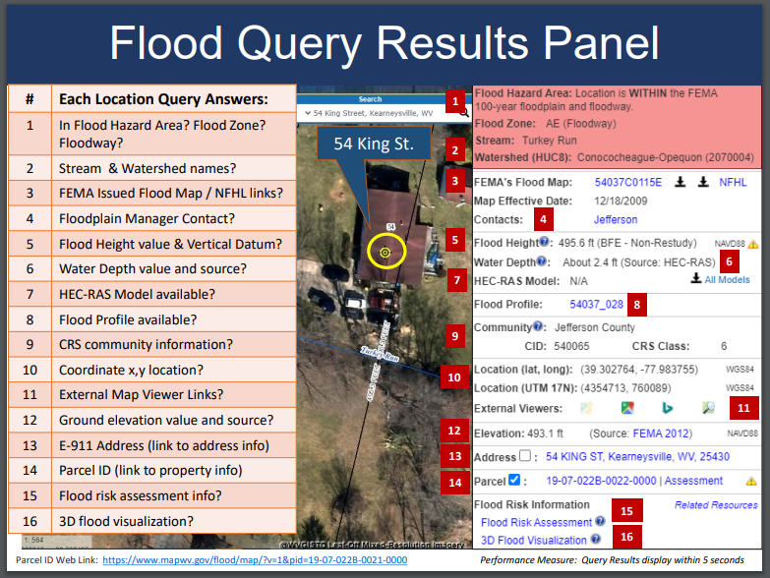

Reference Data Layers:
- Key reference data sets are ground elevation, parcels/assessment records, E-911 addresses, and aerial imagery. Process and integrate new reference data to make the WV Flood Tool more accurate and current and for which communities can receive FEMA CRS credits. This task includes the publishing and caching of web map services that support the Flood Tool. Data processing includes caching of aerial imagery and elevation contours at 15 display levels from 1: 4,622,324 to 1:282 map scales. Besides the WV Flood Tool, there are no FEMA web applications or other publicly accessible web services in the Nation that allow users to view aerial imagery and 1-foot contours for West Virginia at the largest map scale of 1:282. The new FEMA-purchased LiDAR and derived elevation products are quite large in file size and require extensive computer processing and quality control checks before being published to the WV Flood Tool.

- HI-RESOLUTION TOGPOGRAPHIC DATA: Maintain and process new Elevation Products for Flood Tool. This includes the LiDAR derived elevation products to include DEMs and contours. Accurate, high-resolution LiDAR-derived elevation products such as one-foot contours and one-meter DEMS that are incorporated into the WV Flood Tool are beneficial for floodplain determinations, LIDAR LOMAs, LAGs, water depth flood visualizations, flood risk studies, etc.
    - Elevation Products
    - 1- or 2-foot contours (published to the highest zoom level 1:282 on Flood Tool)
    - 1-meter DEM (1-meter DEM elevation sources)
    - 1-meter Hillshade (1-meter DEM elevation sources)
    - Metadata
    - Metadata: https://www.mapwv.gov/lidar-metadata
    - Elevation Download Site: https://data.wvgis.wvu.edu/elevation/
    - FEMA-Purchased LiDAR Projects: Project coverage graphic

- PROPERTY PARCELS AND ASSESSMENT RECORDS: Publish Tax Year 2027 parcel geometry and assessment attributes (1.4 million records) to WV Flood Tool. Accurate and current parcels and assessment attributes are essential to identifying flood risk structures in the WV Flood Tool
- Statewide Parcel Products (annual update) for Flood tool:
  - Master surface parcel file and standardized assessment attributes
  - Integrate surface parcel geometry for all 55 West Virginia counties
  - Join assessment records for commercial and residential properties for current tax year
  - Sketch diagrams for building identification of residential properties
  - Parcel history (25 years) to search previous owners or deed book numbers. Important for improving positional accuracy of LOMAs and Buyout Properties.
  - Intersect statewide parcels/assessment records with flood hazard zones for display on the WV Flood Tool. Associating flood risk information with property parcels allows users to perform queries of parcels by the degree of flood risk using the WV Property Search Tool (Advanced Search Option).
- Intersect parcels/assessment records with flood zones and classify according to risk (high, moderate, low) for display on the WV Property Viewer, a gateway application of the WV Flood Tool
- E-911 ADDRESSES: Perform quarterly updates of E-911 site (1 million address points) and street addressing layers and address matching geocoding services for Flood Tool. Accurate and current E-911 site addresses are essential to identifying flood risk structures in the WV Flood Tool.
- AERIAL PHOTOGRAPHY: Add new 2026-27 county leaf-off aerial photography for multiple counties to Flood Tool. Coordinate with county, state, and federal agencies through West Virginia’s Orthoimagery Program. Accurate and current leaf-off aerial photography is essential to identifying flood risk structures in the WV Flood Tool.
- BUILDING FOOTPRINTS: Maintain current building footprints on the WV Flood Tool. Building footprints are used for identifying flood risk structures and for 3D flood visualizations on the WV Flood Tool.

- OTHER LAYERS: Update other reference layers (e.g., community boundaries, wetlands, public lands) that support FEMA CRS/NFIP programs and the WV Flood Tool. Accurate and current reference layers are important to Communities for state-based CRS credits and for users referencing features of interest.
- RESOURCE LINK: WV Flood Tool’s Reference Layers

Technical Services:
- Perform outreach and training services to include developing print and online educational materials, delivering presentations, administering email listserv, and participating in Flood Tool coordination meetings and data exchange with State NFIP, FEMA, USACE, NRCS, and other cooperators. Provide technical support to the Flood Hazard community like specifications (e.g., HEC-RAS downloadable model specifications) for contracts and other technical queries associated with flood and reference data. Enhance the WV Flood Tool to effectively increase flood risk communications for the public and communities. Educate and outreach to counties about submitting their locally produced address, parcel, imagery, and elevation data for inclusion in the Flood Tool.
- Technical Services include:
  - Promotion Materials (flyers, videos, etc.)
  - Presentations (webinars, meetings, etc.)
  - Update listserv and contact list of community floodplain managers
  - Coordination meetings and project scoping for USACE WV Silver Jackets projects that support WV Flood Tool
  - Standardized Data Exchange
  - Instructional videos for Flood Tool and WV Building Level Risk Assessment (BLRA)
  - Maintain WV Flood Tool and Flood Risk Assessment Glossary
- Update various WV Flood Tool Resources web pages and links
- Bundle FEMA and other agency risk assessment and mitigation resources for the WV floodplain management community (Permits, Elevation Certificates, Mitigation Resources, Model Floodplain Management Ordinance, etc.).

SFHA Change Letters for RiskMAP Studies:
- Communicate SFHA Map Changes to Affected Property Owners. Template mail merge documents from the FEMA Region 3 "Local Officials Toolkit: What to Do Before and After Your Flood Maps are Finalized" have been created to send to property owners with new flood mapping updates during the appeal period for the restudy. Mailing addresses of affected property owners are retrieved from the statewide tax assessment database. This activity qualifies for FEMA’s Community Rating System credits. See SFHA Mail Merge Template and Instructions.

Example Outreach Letters. Mapped Out SFHA, Mapped In SFHA, Mapped in Floodway
  - Clendenin, WV
  - White Sulphur Springs, WV

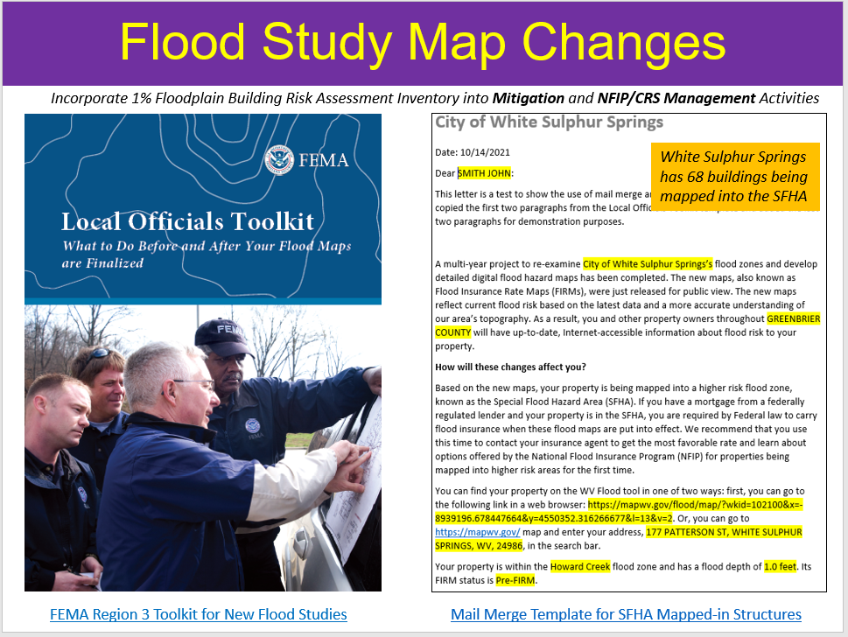
<< SFHA Change Letters using FEMA Local Officials Toolkit >>

SFHA Change Letters for RiskMAP Studies:
Deliver Technical Support Services for LiDAR LOMAs. West Virginia now has statewide coverage of QL2 LiDAR data and LiDAR-derived elevation products of one-meter DEMs and 1-foot contours. LiDAR LOMAs can be submitted for qualifying structures using FEMA’s Online LOMA portal. The Flood Tool’s Print Function generates map layouts for the LiDAR submissions using either the contour or point elevation methods. To save disadvantaged communities and homeowners the cost of needing a site elevation survey, this activity will communicate to these constituents how the "mapped out" structures (primary building structures symbolized by yellow squares where future map conditions exist) displayed on the RiskMAP View of the WV Flood Tool may qualify for removal of the structure from the SFHA. The only information required for an Online LOMA submission are a map layout from the Flood Tool and a copy of the deed. The WVU GIS Technical Center will support the state and local floodplain management community with the submission of LiDAR LOMAs when a field survey is not required, to include assisting floodplain managers with the online submissions to FEMA.
LiDAR LOMA Documentation.
- WV Flood Tool LiDAR LOMA: Instructions | Overview Slides and Guide
- WV LIDAR LOMA Map Layout Examples

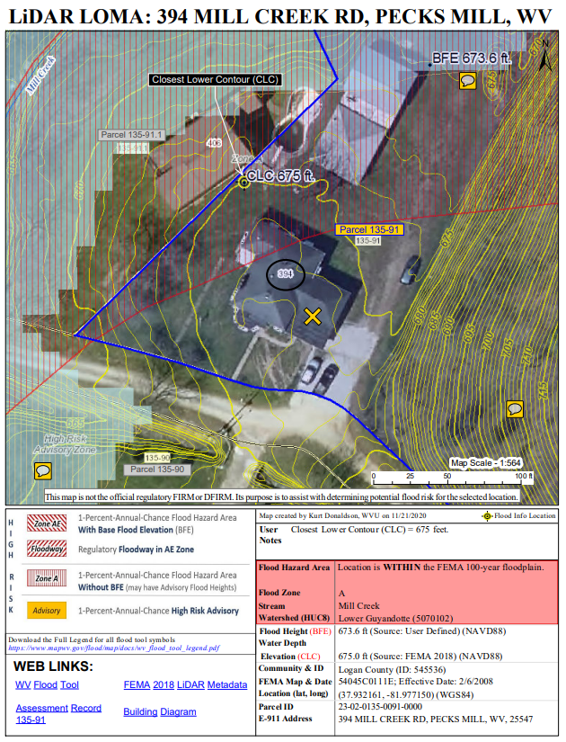
<< Example LiDAR LOMA Print Layout generated from WV Flood Tool. >>

- Building-Level Risk Assessments (BLRA). Update the WV Building Level Risk Assessment from New Data Sources (e.g., Flood Studies, Building Characteristics, Mitigated Structures). Update building-level flood risk assessments for structures in the high-risk flood zones using the best available Risk MAP and building-level data sources. New Risk MAP studies always trigger updating the identification and risk assessment of all structures in high-risk flood zones. Publish updated building-level assessments to the Risk MAP View (graphical view) of the WV Flood Tool and Building-Level Tools (tabular view – Primary Structures and Significant Structures) of the WV Risk Explorer. Building level risk assessments provide detailed risk identification for risk assessments and for map changes from risk map studies. (WVU Task B).

Figure A-2. Building-Level Risk Tools (Primary Structures & Significant Structures) of WV Risk Explorer
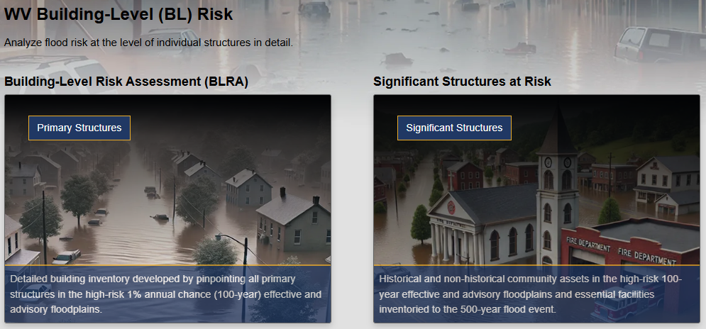

- Example Building-Level Risk Assessments for new Flood Maps: McDowell County | Wyoming County (Building lists are sorted on highest to lowest flood depth for Primary Structures and Significant Structures, with filters applied to show map changes: SFHA buildings mapped in, SFHA building mapped out, net change, Total new SFHA building counts, Floodway building counts and net change)
- Benefits to communities include the continued validation of primary floodplain structures, expansion on base level risk assessment information for further hazard reduction and planning efforts, and the use of risk assessment information for Community Rating System (CRS) insurance discounts. Besides technical support for hazard mitigation plans, updates from the Building Level Risk Assessment contribute to other CTP tasks such as SFHA Change Letter Communication Outreach, CNMS Discovery Mapping, Detailed Flood Studies, LiDAR LOMAs, Mitigation Plans, SDE Building Pre-loading, and other RiskMAP initiatives.
- BUILDING LEVEL RISK CYCLE. Refer to this report for detailed documentation about how the building level risk assessment cycle (BLRA) creates the structure-level risk assessments The building attributes are updated annually when a new statewide tax assessment database is published.
- PRESENTATION. Flood Risk Assessment Presentation (2022) PDF | PPTX

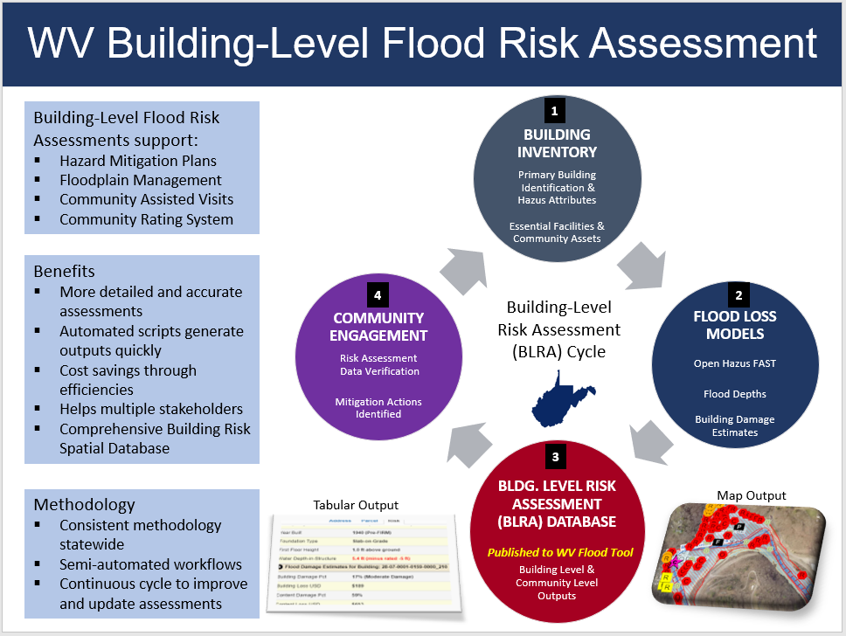
Figure A-3. Building-Level Risk Assessment Cycle (updated annually)

- WV Risk Explorer. Develop, verify, and publish flood risk profiles at eight geographic scale levels: State, Regional, County, Community, Unincorporated Area, Incorporated Place, Watershed, and Streams. Update Risk Maps and Reports on the WV Risk Explorer that allows communities to quickly view cumulative riverine flood hazard scores, rankings, and risk factors affecting their jurisdictions. Risk dashboards for risk assessment data are available as well, as part of a suite of risk assessment and visualization tools for building community flood resilience in West Virginia. (WVU Task C).

Figure A-4. Online WV Risk Explorer Maps and Reports tools allow users to evaluate riverine flood risk at multiple geographic scales.
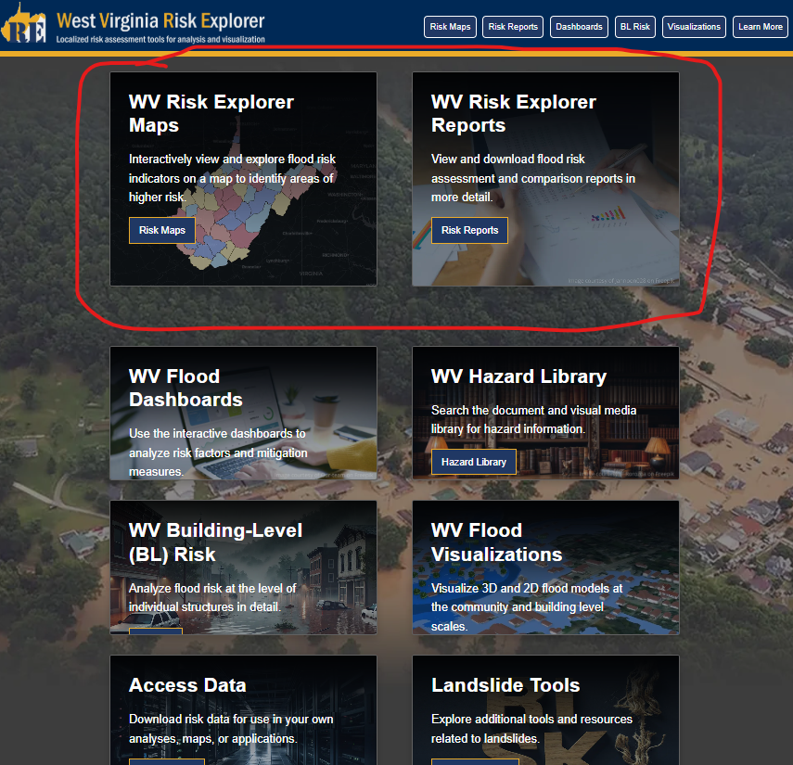

Figure A-5. Example Detailed Risk Assessment Report for Building Counts Risk Factor at 8 Geographic Scales.
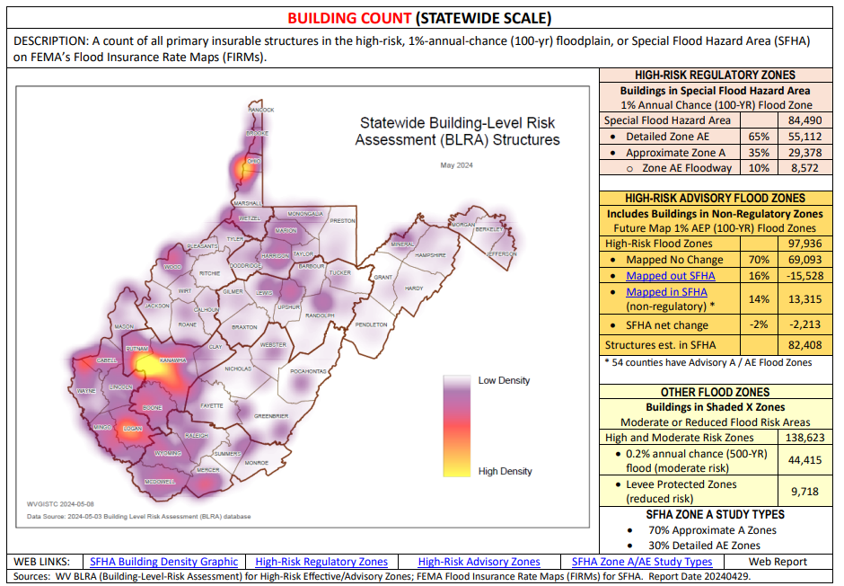

Figure A-6. Riverine flood risk factors for new WV Risk Explorer tool.
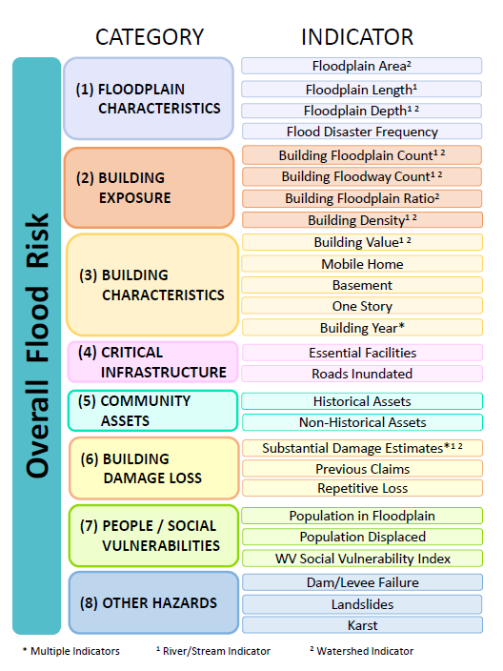

- WV Flood Visualizations. Create flood visualizations at the viewshed and building level scales to communicate flood risk to the public more effectively. Update new flood visualizations on the WV Risk Explorer and WV Hazard Library (WVU Task D).
- Building-Level Visualizations
  - Building Flood Profiles for different sized storms (includes High Water Marks)
  - Building Flood Depth and Damage Assessment (WV Flood Tool)
- Community-Level Visualizations
- Story Maps (graphic or narrated movies at community or viewshed levels)
- Other multimedia (static graphics, videos)
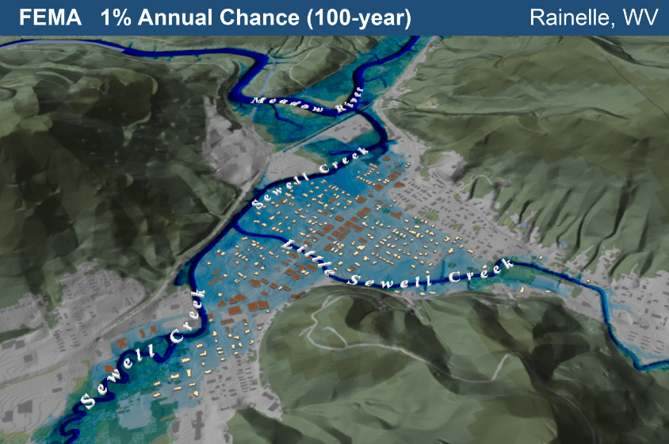
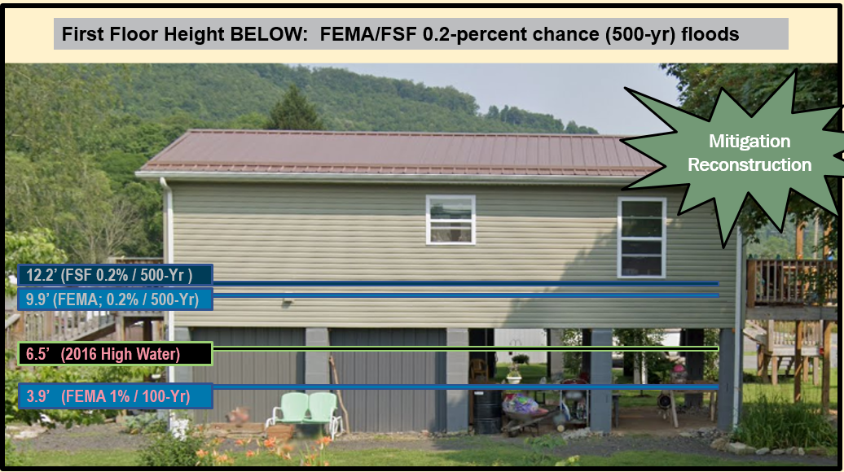
Figure A-7. Building-level and viewshed flood visualizations.
- WV Hazard Library. Catalog and publish new documents and visual media to the WV Hazard Library. Allows the public to search documents and visual media for hazard information relevant to West Virginia. Users can search by topic, media type, or geographic extent. The Hazard Library consists of major collections for risk assessments, flood events, and mitigation reduction efforts (mitigation measures, hazard planning, floodplain management, Risk MAP studies, flood models, etc.). The classification system of the Hazard Library is flexible in that additional subjects can be added. (WVU Task E).

Figure A-8. WV Hazard Library
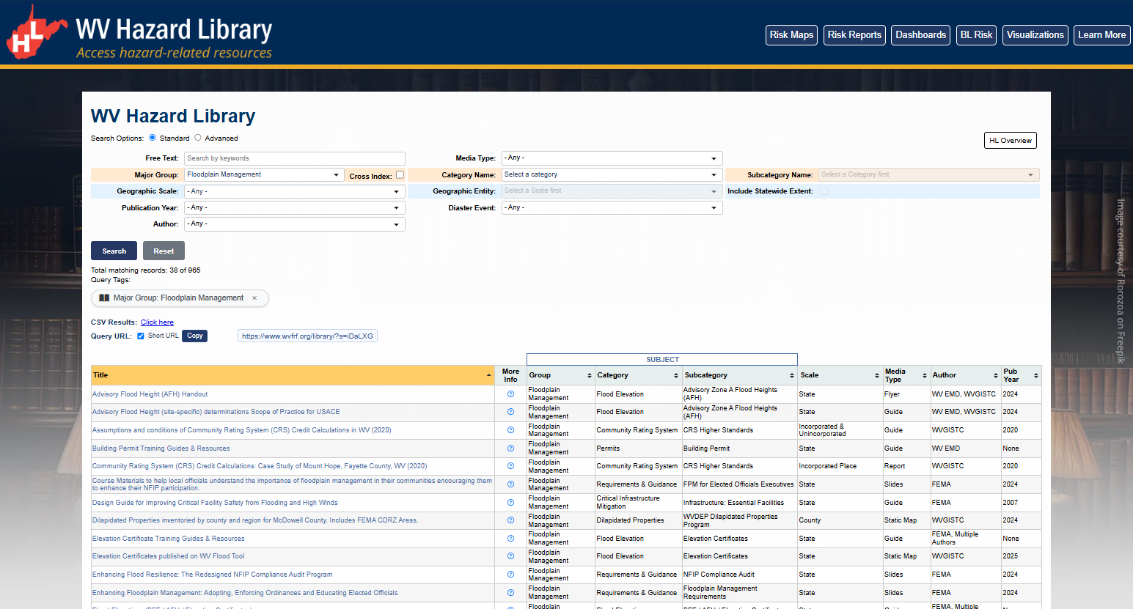

- WVU Training and Outreach. Provide training and outreach services organized by WVEMD for the WV Flood Tool. This task includes developing outreach materials along with in-person and remote training courses for the WV Flood Tool. Customized training often focuses on features that distinguish the WV Flood Tool from FEMA’s NFHL Viewer and Flood Insurance Rate Maps (FIRMs). For example, the WV Flood Tool provides Advisory BFEs for Approximate A Zones and high-resolution elevation date for qualifying LIDAR LOMAs. FEMA does not provide these map services. In addition, the WV Flood Tool publishes Elevation Certificates, Verified LOMA locations, HEC-RAS stream models, and 1%-annual-chance advisory floodplains / BFE’s / depth grids not available by FEMA maps services. (WVU Task F)

