Description: This part of the study estimated the number of displaced individuals and the number of people who need to stay in a short time shelter due to the inundation of 100-year flooding events. The methodology of estimation was derived from FEMA’s Hazus-MH Technical Manual. However, there is a difference between the estimation scale in the model used in this study with FEMA’s model. This difference is because our estimation was based on the buildings located in the flood zones of the communities, whereas the scale used by FEMA is census block. Therefore, we believe that estimations starting at the scale of buildings should produce more accurate results.
DISPLACEMENT & SHELTER NEEDS (Region 9)

Methodology: The estimation is based on the area and depth of inundation. If depth exceeds a certain value, people need to be displaced from their places. According to FEMA, the inundation depth of displacement may vary from six to 12 inches. The latter is the depth in which roads cannot be used, and cars begin to float. Therefore, 12 inches (one foot) for the inundation depth was selected for this study as the displacement threshold.
The number of displaced individuals was calculated as a proportion of the number of people residing in the 100-year flood zones who would experience an inundation equal to or more than one foot deep. For that purpose, the residential buildings located in the 100-year flood zones of three counties of Berkeley, Jefferson, and Morgan with depth values of one foot or more were extracted from the table of building inventory. Then, for each building, the number of the residential units was multiplied by the average household size of the community to estimate the residing population in the building. Finally, the total number of displaced individuals for both incorporated and unincorporated areas was calculated by adding the populations of the above buildings.

Table DS-1. Estimation of Displacement Population
Demographic Data |  |  |  |  | Displaced Population (Residing in Flood Zone)
Community Name | County | Total Community population | Average Residential Household Size | Population Residing in High-Risk Flood Zone | Displaced Population (Residing in Flood Zone) | Displaced Percentage
Berkeley County* | BERKELEY | 93834 | 2.70 | 1720 | 716 | 42%
Martinsburg | BERKELEY | 17451 | 2.40 | 211 | 87 | 41%
SUM | BERKELEY | 111285 |  | 1931 | 803 | 42%
Bolivar | JEFFERSON | 1246 | 2.40 | 7 | 8 | 100%
Charles Town | JEFFERSON | 5766 | 2.50 | 63 | 10 | 16%
Harpers Ferry | JEFFERSON | 236 | 2.10 | 13 | 13 | 100%
Jefferson County* | JEFFERSON | 41907 | 2.60 | 1323 | 578 | 44%
Ranson | JEFFERSON | 4945 | 2.70 | 221 | 46 | 21%
Shepherdstown | JEFFERSON | 1573 | 1.70 | 107 | 104 | 97%
SUM | JEFFERSON | 55673 |  | 1734 | 759 | 44%
Bath | MORGAN | 609 | 2.00 | 166 | 64 | 39%
Morgan County* | MORGAN | 16429 | 2.50 | 1120 | 548 | 49%
Paw Paw | MORGAN | 472 | 2.80 | 56 | 3 | 5%
SUM | MORGAN | 17510 |  | 1342 | 615 | 46%
* Unincorporated Community

Based on the estimations, as the table DS-1 and the chart indicate, Bolivar and Harpers Ferry have the highest percentage of displaced people, followed by Shepherdstown and Martinsburg in incorporated areas. Although Martinsburg is the most populated town in this area, it doesn’t have a high percentage of displacement since the population residing in the flood zones is less than seven percent. In Charlestown, the second most populated town, the percentage of displaced people is 16 percent. Finally, in Harpers Ferry, the least populated town of this region, one hundred percent of the people living in flood zones need to be displaced.

Chart DS-1. Estimation of Displacement Population

Short Term Shelter Needs: During a severe flood event, a percentage of the displaced population will require government-provided short-term shelters. According to FEMA (2017), “A Short-Term Shelter is in an existing facility (or facilities), such as a school, community center, convention center, or church temporarily converted to provide safe, accessible, and secure short-term housing for disaster survivors.” It provides safe and accessible locations with a wide range of services for the survivors for two weeks. Therefore, estimation of the number of individuals in need of the shelters is a significant part of flood risk management and response planning. The methodology of this part of the project was based on the same manual of FEMA mentioned earlier.
Estimation of Shelter Needs: The estimation of shelter needs is related to the probability of using the shelters by displaced population. Thus, we considered six variables, which are effective in estimating shelter needs:
- Family Income (HH Income < $20K; $20K-$30K; $30K-$50K; $50K-$60K; HH Income > $60K)
- Age (Age < 15, 15 < Age < 65, Age > 65)
- Ethnicity (White, African American, Hispanic, Asian/Other)
  - Housing Information of Displaced Population:
- Housing Ownership Type (Owned or Rental)
- Occupancy Type (Details of Occupancy Type is found in Appendix.1)
- Geography: urban versus rural

According to census data (2019), the largest ethnic groups in West Virginia are White (Non-Hispanic) (93%); thus, the ethnicity factor was not applied in our model. However, occupancy type is a significant factor used in the model. The table of occupancy types (Appendix.1) encompasses nine classes in two types of residential and commercial. Therefore, to determine the number of displaced population, we used the occupancy type table and calculated the number of people living in the flood zones with more than 1-foot flood depth.
Family Income is a more effective factor in the process as it determines the economic status of the displaced population. Households with lower incomes are more likely to use the shelters because they would not afford accommodation in hotels or finding shelters on their own during floods. On the other hand, it is expected that their family and friends live in similar economic conditions. Therefore, there is a lower probability for people in poverty to go to their friends or family places in such cases. Age is the secondary factor in the estimation of the shelter population. There is a higher probability that elderly families (65 years or older), and younger less established families use shelters. In our model, two factors of income and age were taken into account more than the other variables.

Table DS-2. Estimation of People with Shelter Needs
Shelter Needs

Community Name | County | Estimated Population Flood Zones with Shelter Needs | Percentage of Population with Shelter Needs | People Accompany Dogs with Shelter Need | People Accompany Cats with Shelter Need
Berkeley County* | BERKELEY | 106 | 6% | 15 | 10
Martinsburg | BERKELEY | 18 | 9% | 3 | 2
SUM | BERKELEY | 124 | 6% | 18 | 12
Bolivar | JEFFERSON | 2 | 28% | 1 | 1
Charles Town | JEFFERSON | 2 | 3% | 1 | 1
Harpers Ferry | JEFFERSON | 2 | 16% | 1 | 1
Jefferson County* | JEFFERSON | 79 | 6% | 12 | 8
Ranson | JEFFERSON | 9 | 4% | 2 | 1
Shepherdstown | JEFFERSON | 21 | 20% | 5 | 4
SUM | JEFFERSON | 115 | 7% | 22 | 16
Bath | MORGAN | 14 | 8% | 3 | 2
Morgan County* | MORGAN | 101 | 9% | 16 | 11
Paw Paw | MORGAN | 1 | 2% | 1 | 1
SUM | MORGAN | 116 | 9% | 20 | 14

Chart DS-2. Estimation of People with Shelter Needs
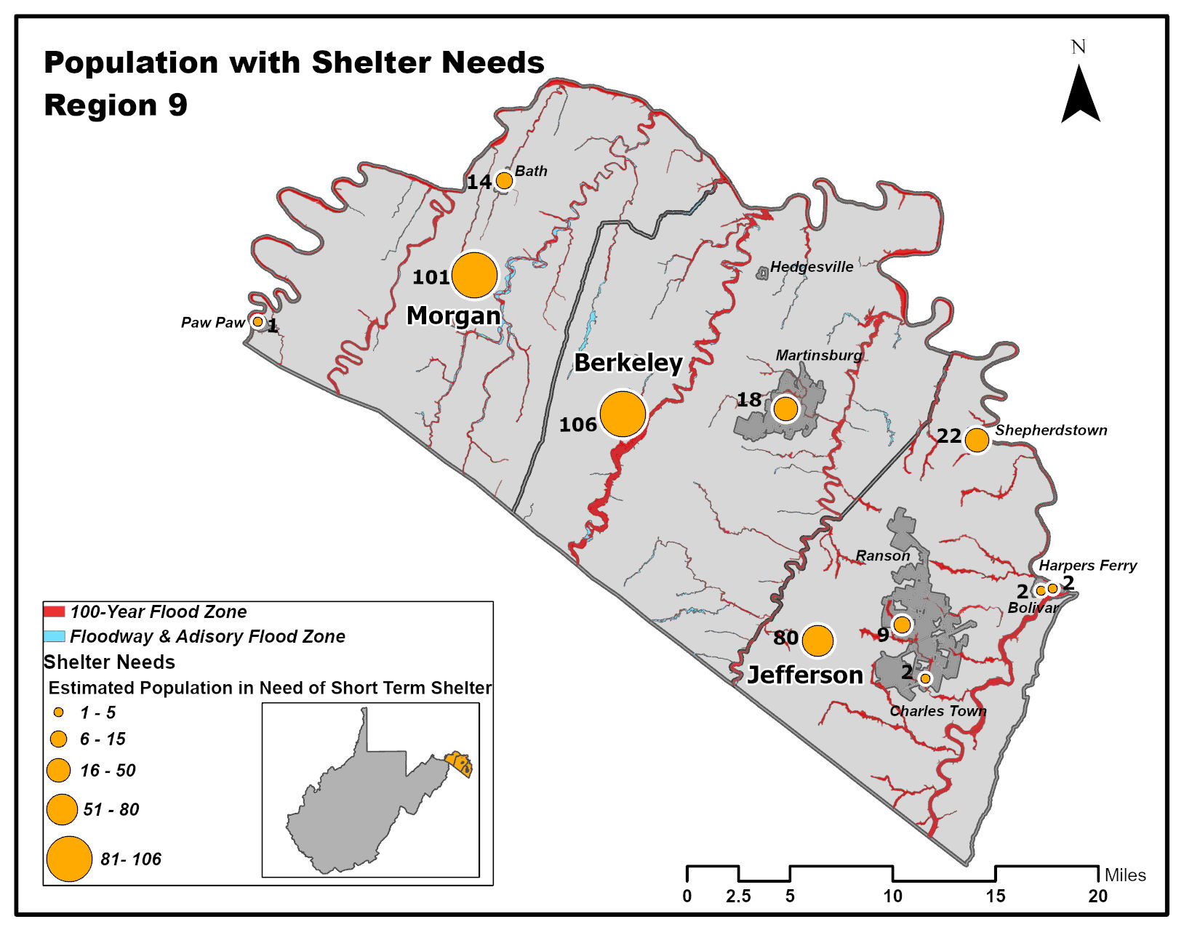

Methodology: In this project, income data of the households and age data of the individuals of the communities in Region nine were downloaded. Then, the data were processed in the categories described by the FEMA’s manual. Next, the percentages of the population in each income and age class were calculated for all of the communities. Finally, assuming that the income intervals of the manual dated back to 1990, we updated the income classes based on the inflation rate, and the available census data, to these categories. Additionally, for calculations of the modification factors, the manual’s percentage of more than $35,000 was changed to a percentage more than $60,000.
The income classes
Income classes:
- Household income up to $20,000 per year;
- Household income greater than $20,000 but less than $30,000 per year;
- Household income from $30,000 to less than $50,000 per year;
- Household income from $50,000 to less than $60,000 per year; and
- Household income of $60,000 or greater per year.
Age categories:
- Individuals less than 16 years of age;
- Individuals from 16 to 65 years of age; and
- Individuals greater than 65 years of age.
Furthermore, we used the equation represented in the manual to calculate the number of individuals in need of shelters:
$$\#STP=\sum_{k=1}^{5}{\sum_{m=1}^{3}{[α_{km}×DP×{HI}_{k}×{HA}_{m}]}}$$
Equation 2. Shelter population

Where:
#STP = Number of people using established shelters
α_{km} = a constant
DP = Displaced population by inundation with equal or more than 1-foot depth
HI_{k} = Percentage of population in the k^{th} income class
HA_{m} = Percentage of population in m^{th} age class
Equation 3 was used to calculate the constant needed above (α_{km}).
$α_{km}=(IW×{IM}_{k})+(AW×{AM}_{k})$
Equation 3. Calculation of the constant
IW = Shelter category weight for income
AW = Shelter category weight for age
IM_{k} = Relative modification factor for income
AM_{m} = Relative modification factor for age
As the income factor is more effective in shelter needs compared to age, the manual recommends the income weight (IW) of 0.8 and the age weight (AW) of 0.2 (retrieved from Table 13.1, in Hazus®-MH technical manual) We used the same values in our model. The relative modification factors for each income and age class (IM_{k} and AM_{k}) were extracted from the relevant table (Table 13.2)in the manual.

References
United States Census Bureau. (2019). American Fact Finder. Retrieved from https://factfinder.census.gov/faces/nav/jsf/pages/community_facts.xhtml
Department of Homeland Security and Federal Emergency Management Agency (FEMA). (n.d.). Hazus®-MH technical manual: Multi-hazard loss estimation methodology, flood model. Washington, D.C.: FEMA. Retrieved from https://www.fema.gov/sites/default/files/2020-09/fema_hazus_flood-model_technical-manual_2.1.pdf

Appendix.1. Type of Occupancy Classes, Used in Shelter Model.
STRUCTURE USE or APPEARANCE (Based on Habitable or Non-Habitable Occupancy)

33 Hazus Building Specific Occupancy Classes |  |  | 10 Building Classes | 7 Building Classes |  | 5 Building Classes
Open Hazus Software Program - Flood Assessment Structure Tool (FAST)  Building-Level Risk Assessment Reports (BLRA) |  |  | 10 Hazus Classes with Residential Breakdown | 7 Hazus Generalized Classes |  | 5 Generalized Classes (NFIP Rates)
Label | Hazus Occupancy Class | Example Descriptions | 10 Hazus Classes with Residential Breakdown
Residential
RES1 | Single Family Dwelling | House | Single Family Home | Residential |  | Single Family
RES2 | Mobile / Manufactured Home | Mobile / Manufactured Home | Mobile Home |  |  | Single Family
 | RES3A Duplex  RES3B 3-4 Units | Family 2-4 Units: Duplex, Multi-Family Small (RES3A, RES3B) | Family 2-4 Units |  |  | 2-4 Family
RES3 | RES3C 5-9 Units  RES3D 10-19 Units  RES3E 20-49 Units  RES3F 50+ Units | Other Residential (> 4 Units): Apartment/Condominium, Multi-Family Medium (RES3C to RES3D), Multi-family Large (RES3E, RES3F) | Multi-Family  &  Other Residential  (> 4 units) |  |  | Other Residential  > 4 units  (Occupancy > 6 months)
RES4 | Temporary Lodging | Hotel/Motel | Multi-Family  &  Other Residential  (> 4 units) |  |  | Other Residential  > 4 units  (Occupancy > 6 months)
RES5 | Institutional Dormitory | Group Housing (military, college) | Multi-Family  &  Other Residential  (> 4 units) |  |  | Other Residential  > 4 units  (Occupancy > 6 months)
RES6 | Nursing Home |  | Multi-Family  &  Other Residential  (> 4 units) |  |  | Other Residential  > 4 units  (Occupancy > 6 months)
Commercial
COM1 | Retail Trade | Store | Commercial | Commercial |  | Non-Residential Business or Commercial  (Occupancy < 6 months)

